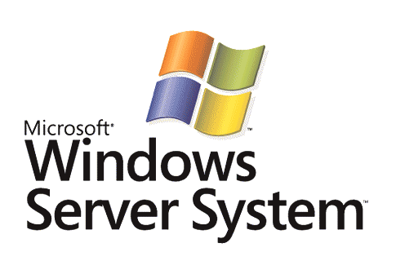

Choosing a Business Process Automation Solution

Microsoft Corporation
Published: September 2005

Abstract
This paper provides a comparative analysis of Microsoft® BizTalk® Server 2004 and IBM WebSphere Business Integration Server v5 in the Business Process Automation (BPA) and integration market. It specifically examines the ways in which each of these solutions provides functionality for BPA, including Enterprise Application Integration (EAI) and Business Process Management (BPM).



The information contained in this document represents the current view of Microsoft Corporation on the issues discussed as of the date of publication. Because Microsoft must respond to changing market conditions, it should not be interpreted to be a commitment on the part of Microsoft, and Microsoft cannot guarantee the accuracy of any information presented after the date of publication.
This White Paper is for informational purposes only. MICROSOFT MAKES NO WARRANTIES, EXPRESS, IMPLIED OR STATUTORY, AS TO THE INFORMATION IN THIS DOCUMENT.
Complying with all applicable copyright laws is the responsibility of the user. Without limiting the rights under copyright, no part of this document may be reproduced, stored in or introduced into a retrieval system, or transmitted in any form or by any means (electronic, mechanical, photocopying, recording, or otherwise), or for any purpose, without the express written permission of Microsoft Corporation.
Microsoft may have patents, patent applications, trademarks, copyrights, or other intellectual property rights covering subject matter in this document. Except as expressly provided in any written license agreement from Microsoft, the furnishing of this document does not give you any license to these patents, trademarks, copyrights, or other intellectual property.
Unless otherwise noted, the example companies, organizations, products, domain names, e-mail addresses, logos, people, places, and events depicted herein are fictitious, and no association with any real company, organization, product, domain name, email address, logo, person, place, or event is intended or should be inferred.
© 2005 Microsoft Corporation. All rights reserved.
Microsoft, BizTalk, the Office logo, SharePoint, SQL Server, Windows, Windows Server, Windows Server System, Visio, and Visual Studio are either registered trademarks or trademarks of Microsoft Corporation in the United States and/or other countries.
All other trademarks are property of their respective owners.
Contents
Executive Summary 1
The Microsoft Business Process Automation Vision 1
BizTalk Server 2004 2
Choosing BizTalk Server Over WBI Server 3
Choosing a Comprehensive and Integrated Solution 3
WBI Server v5 Considerations 4
BizTalk Server 2004 Considerations 5
Answers to Common BizTalk Server Questions 8
Integration and BPM Considerations 9
Integration Requirements 9
BPM Requirements 11
An In-Depth Look at IBM WBI Server Technologies 13
Summary 18
References and Additional Information 19

Executive Summary

The Microsoft Business Process Automation Vision
Business Process Automation (BPA) integrates systems, trading partners and business users through flexible business processes in order to reduce costs, improve operational efficiency, and create new business opportunities. As information technology continues to evolve, an increasing number of connectable systems and business users are brought online. This increases both the benefits and challenges of implementing BPA solutions. Due to the complexities and costs involved in developing and managing connections across these distributed systems and people, BPA has remained an elusive goal for many businesses.
Figure 1: Business Process Automation Stack

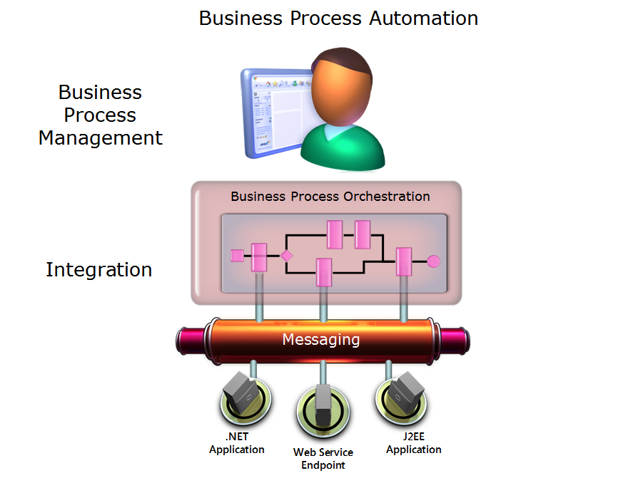

The challenges begin at the foundation: integration. The pace of growth in integration requirements shows no signs of slowing. In addition to an increasing number of points of connectivity, business drivers such as Just-In-Time (JIT) inventory and Real-Time Reporting have introduced extensive functional requirements for accessibility and visibility into the processes that span these connected systems.

Integration solutions have been in the market for over a decade. However, many solutions can complicate integration by adding expensive, difficult-to-use technologies that only address a single aspect of customers’ needs—or that don’t integrate with the other important BPA technologies.
Enterprise Application Integration (EAI) and Business to Business (B2B) scenarios typically require more than existing publish-and-subscribe message brokering technologies, recently re-introduced to the market as the Enterprise Service Bus (ESB), can provide. Real-world solutions often require that an exchange of information be orchestrated by system-to-system workflows that can also correlate messages and manage long-running transactions, a functionality that’s not typically included in an ESB.

BizTalk Server 2004

Microsoft® BizTalk® Server 2004 is a comprehensive, integrated solution designed to help organizations build adaptive, manageable and reliable BPA solutions that can span applications, people and trading partners.
Building upon a solid foundation of integration, BizTalk Server provides Business Process Management (BPM) functionality that’s designed to extend the value of a connected enterprise by enabling end-to-end visibility into business processes across multiple systems through Business Activity Monitoring (BAM). BAM helps customers to realize improved value by using a Business Rules Engine (BRE) to develop flexible business processes with runtime-configurable business logic as well as including the business user in the process. Few processes don’t involve business users in some way, whether it’s for manual approval or exception handling. System-to-human workflow adds connectivity to business users and allows them to collaborate in completing manual steps in the process through familiar Microsoft Office tools and collaborative Microsoft SharePoint® Portals.
These applications are designed to easily plug into the system-to-human workflow models where full-featured, human-to-human workflow applications are required for dynamic workflows and multi-level delegation. Microsoft has worked with its solutions partners to provide tight integration between BizTalk Server 2004 and human-to-human workflow applications such as SourceCode K2.Net, Captaris Workflow, and Ultimus BPM.
Built on the Microsoft Windows Server System™, Microsoft Office System, and Microsoft .NET Framework, BizTalk Server 2004 is designed to provide a comprehensive set of capabilities for integration and BPM. These capabilities are integrated within a Microsoft Visual Studio® .NET development environment and engineered to provide customers with security, high scalability, and performance. Most typically, the BPA return on investment (ROI) comes when integration and BPM are brought together and extended under just such a model—a single, unified model that integrates development, management and interaction.
Customers who desire to realize the benefits of BPA technologies should consider the completeness of the solution platform as well as the degree to which the components are integrated.
This paper reviews the required functional components of a complete BPA solution and evaluates both BizTalk Server and IBM’s WebSphere Business Integration (WBI) implementations.

Choosing BizTalk Server Over WBI Server

Choosing a Comprehensive and Integrated Solution
Now in its third major release, BizTalk Server 2004 is designed to provide customers the comprehensive set of capabilities they need to effectively and efficiently achieve their BPA goals. These new capabilities are inherently integrated into the application architecture of the Windows Server System to provide optimal productivity for developers who work within the familiar development environment of Visual Studio .NET; they allow programmers to leverage industry standards and deliver more secure and reliable business process automation across and within organizational boundaries.
Windows Server System is developed through the Microsoft “integrated innovation” design approach, so solutions built with BizTalk Server 2004 are engineered to work easily with familiar tools from Microsoft Office System as well as to provide information workers the ability to monitor and interact with business processes and participate in business process design. For IT users, this can provide numerous benefits, including operational efficiency through advanced deployment and monitoring capabilities, the ability to meet service level commitments, and the ability to leverage existing IT investments while delivering new capabilities that drive future business growth.
IBM’s WBI Server v5 is comprised of multiple technologies that address specific subsets of BPA functionality. The principal technologies included in the WBI Server v5 suite include WebSphere InterChange Server (WICS) v4.3, WebSphere Business Integration Message Broker (WBI MB) v5, and WebSphere MQ Workflow (MQWF) v3.5.
WBI Server v5 customers may need to develop, integrate, deploy and manage these multiple WebSphere technologies in order to meet their BPA requirements or achieve a comparable functionality to that provided by BizTalk Server 2004. WBI Server v5 customers may also need to adopt or incorporate WebSphere’s integration technologies before they can obtain the full value of a BPA solution. This may require customers to invest additional time and resources to train their IT staff how to use different tools and programming models or to secure additional consulting resources.
BizTalk Server 2004 is designed to provide a comprehensive, integrated solution that delivers important BPA capabilities and functionality within a common set of integrated tools, runtime, and single programming model.
Figure 2: BizTalk Server 2004 and WBI Server v5
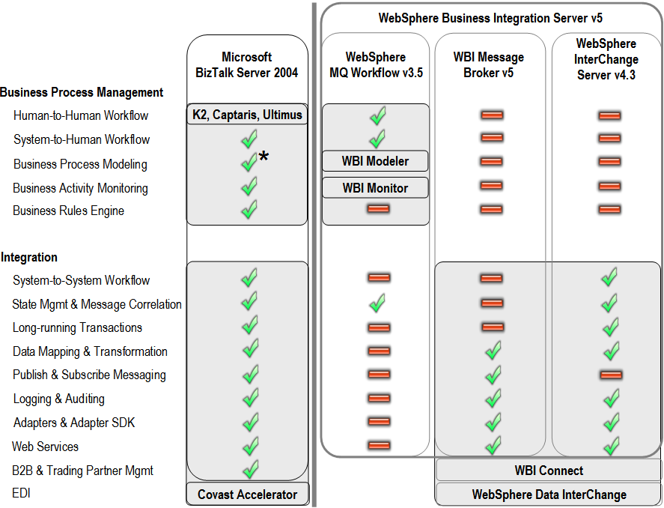

The preceding diagram depicts the functional capabilities of BizTalk Server 2004 compared with the constituent technologies of IBM WBI Server v5. Functional capability categories are discussed and defined in later sections of this document.

As depicted above, the IBM WebSphere approach to BPA appears focused on providing services that leverage many different technologies. These technologies don’t need to be unified into a cohesive platform because the services bind the constituent pieces together. However, for the reasons summarized below, some users may find that WebSphere's productivity, scalability, and flexibility do not meet all of their expectations.

Customers can realistically expect IBM’s WBI, WebSphere Application Server (WAS), and WebSphere Portal to provide solid platforms for Java/J2EE applications. However, in some cases untrained users may find them complex to use and manage for the reasons summarized below. For enterprise customers, an important feature of these platforms may be access to IBM's problem-solving resources.

WBI Server v5 Considerations

WBI Server v5 solutions have various technological heritages. Several of the technologies that make up the WBI solution architecture were acquired from different sources and have not been fully integrated as a singular solution. In comparison, the BizTalk Server solution was developed with the design requirement of providing a unified BPA platform from its first release.

WBI Server v5 components provide redundant tools and functionality. Multiple acquisitions from distinct sources have resulted in redundant tools and functionalities across the WBI solution. IBM’s guidance may vary as to what specific solution should be used in a particular scenario. For example, some integration scenarios are supported by the InterChange Server and WBI Message Broker. However, each of these technologies implements their own, different messaging infrastructure: InterChange Server has an internal, proprietary messaging infrastructure, while WBI Message Broker uses WebSphere MQ as the underlying messaging infrastructure.

WBI Server v5 lacks unified development or management tools. Each of the WBI solution components maintains its own development and management tools. WBI Server v5 does not provide a single centralized management and debugging environment. WBI Server v5 also does not provide a common runtime execution environment, meaning that customers may need to invest time and resources to bridge these solutions together using WebSphere MQ before they use them to integrate applications and automate business processes. Lack of a unified environment can increase project costs and require developers and IT administrators to master multiple tools instead of utilizing their existing skills.

Individually, the constituent WBI Server v5 technologies are incomplete and lack the functionality required for either integration or BPM. While WBI Message Broker and WICS both target integration, they lack key integration functionality requirements: WBI Message Broker does not provide support for long-running transactions or state management; WICS does not provide publish/subscribe messaging. MQWF includes many BPM functional requirements, but lacks a BRE and has a limited ability to provide any integration functionality.

WBI Server v5 can require mastery of multiple tools sets. WBI Server v5 includes technologies that collectively provide multiple development and management tools. This may require customers to learn multiple skill-sets in order to use these technologies. Some WebSphere technologies, such as WICS, provide developer-oriented tools but do not provide tools designed for professionals and business users.

WBI Server v5 solutions typically require complex, custom coding. While some WBI Server v5 technologies (such as WBI MB) provide tools for configuration, they typically require custom code development. Specific examples of required custom coding can be found in WBI MB’s use of the Embedded Structured Query Language (ESQL). WBI MB provides a configuration tool, but developers are often required to code ESQL by hand using a text editor in order to leverage the full functionality of WBI Message Broker.

WebSphere development tools typically require more developer time and cost than BizTalk Server 2004 .NET-based Visual Studio .NET tools. According to The Middleware Company’s Microsoft-commissioned report Comparing Microsoft .NET and IBM WebSphere/J2EE: A Productivity, Performance, Reliability and Manageability Analysis, the .NET implementations studied were completed faster than the RRD implementation, and were also faster than the WSAD implementation.

WBI Server v5 solutions can require expensive consulting resources. According to the IBM-posted Reality Research & Consulting report “IBM Business Partner Profitability,” IBM business partners have reported that customers typically spend $11.60 on services for every dollar spent on IBM middleware. In addition, they reportedly spend an average of $9.10 on hardware and other technology.
WBI Server v5 solutions can cost more to acquire, produce higher TCO, and entail development and management challenges. WebSphere WBI solutions can present higher software license and TCO costs than a BizTalk Server solution. WBI customers may need to purchase multiple software solutions as well as the resources to development and manage these different technologies. According to the Giga Research report “The Total Economic Impact of Developing and Deploying Applications on Microsoft and J2EE/Linux Platforms”, “The J2EE application server and Unix-based database software used in the Linux development and deployment stack drive up product costs and development complexity relative to the comparable Microsoft products”. License and other costs can and do vary based on specific situations and scenarios. For more information on IBM WebSphere pricing, consult IBM’s “Software on-line catalog.” For more information on BizTalk Server 2004 pricing, read “Microsoft BizTalk Server 2004 How to Buy.”

BizTalk Server 2004 Considerations

In contrast to WBI Server v5, BizTalk Server 2004 represents a single, integrated solution designed to support enterprise BPI and to provide customers with the opportunity to more fully realize practical and economic BPI benefits through rapid deployment, flexibility, scalability, security, and manageability.

BizTalk Server: fastest-growing integration server in the market. "With more than 4,000 customers in four years, BizTalk Server is the fastest-growing integration server on the market," says Eric Swift, director of product management for Microsoft’s Business Process and Integration Division, citing a separate study by analyst firm Gartner Group. "What differentiates BizTalk Server from competing products is that it can scale up to an enterprise implementation, yet we also have a number of case studies where it has shown positive return on investment (ROI) on very small implementations, because of its rapid setup, flexibility and manageability." (For more information, read the Microsoft Press announcement “At Four-Year Anniversary, Adoption of Microsoft BizTalk Server Tops 4,000 Organizations.” As of publication, BizTalk Server has accumulated over 4,500 customers.

BizTalk Server: “Leader” in the Gartner 2005 Magic Quadrant. Gartner’s “Magic Quadrant for Integration Backbone Software, 1H05” (April 15, 2005) places Microsoft at the high end of its Leaders quadrant. Placement at the highest end of the quadrant’s execution axis identifies Microsoft as possessing the highest ability to execute of all vendors analyzed. When evaluating the Microsoft platform, it’s important to note that Microsoft is also in the Leaders quadrant of both Gartner’s Magic Quadrant for “Enterprise Application Servers 2Q05” (May 2004) and—for the fourth year in a row—its Magic Quadrant for Web Services-Enabled Software (September 2004).

BizTalk Server 2004: InfoWorld “Technology of the Year” award. BizTalk Server 2004 was selected by InfoWorld magazine as a Technology of the Year Award winner in the Business Process Automation category. Each year the awards are given to recognize technologies that demonstrate promise to make the greatest impact on enterprise information technology (IT) strategies and to identify those enterprise products that have fundamentally altered the IT landscape. "Innovation trumps consolidation," said Steve Fox, editor in chief of InfoWorld. "InfoWorld's annual Technology of the Year Awards highlights the value of more powerful systems, more flexible storage, richer networks, more elegant applications, smoother integration, automated management and granular security. The real winners are the organizations implementing these technologies."

BizTalk Server 2004 development tools are integrated into the Visual Studio. NET integrated development environment. Visual Studio .NET is designed to enable developers to quickly and effectively develop, test and deploy all components of a BPA solution.

The Windows Server System provides common management tools and a security model for BizTalk Server 2004. BizTalk Server 2004 is designed to support industry standards as well as advanced deployment and monitoring tools; it’s also engineered to help IT professionals to meet their service-level commitments and reduce long-term costs. BizTalk Server integrates with Microsoft Operations Manager 2005 (MOM) to provide monitoring and alerting for the entire stack, including Microsoft SQL Server™ and Microsoft Windows Server™.

BizTalk Server integration with Microsoft Office System provides business users with rich, Office-based tools. BizTalk Server 2004 extends design and monitoring tools to business users through Microsoft Office. This helps ensure that empowered business users have visibility into the health and status of business processes as well as access to business processes data.

BizTalk Server is designed to help reduce TCO. BizTalk Server is an integrated solution designed to help customers reduce implementation and management costs through easy-to-use, standards-based solutions. Visual Studio .NET integration provides a rapid application development and deployment environment that can help developers drive their projects to completion—on-time and on-budget. Microsoft Operations Manager 2005 integration provides centralized system monitoring, including alerts, that is designed to help customers reduce their operating costs.

BizTalk Server can provide faster time to value. The BizTalk Server integrated solution is designed to help customers reduce their days-to-solution by providing a comprehensive BPA solution—one that provides integrated development and management using Visual Studio. NET and the Windows Server System. .NET-based solutions have been demonstrated to deploy faster and at a lower cost than WebSphere. According to CheckFree Corporation, “Instead of taking five engineers a period of five months to develop the test application using J2EE and DB2, it took two people just three weeks to complete the same application using the .NET Framework and SQL Server.”

Security for your enterprise data. BizTalk Server is designed to provide secure messaging and support for common security standards, such as PKI Digital Certificates or WS-Security, and to work seamlessly across multiple systems with integrated single sign on for single point authentication. Well-defined security roles and granular security on running system components help enforce appropriate access by authorized users only. BizTalk Server 2004 also has secure default settings that help to ensure that deployments are more secure out-of-the-box.

Secure, scalable solutions for large enterprises. Microsoft’s BPA solution is designed to enable easy deployment and management of integration solutions: solutions engineered to be dependable, secure, scalable, and enterprise-ready.

BizTalk Server 2004 supports enterprise-class scalability, high availability and performance. Simple hardware scale-out with built-in load balancing helps provide BizTalk Server 2004 with enterprise-class scalability. BizTalk Server is engineered to be highly-available and fault-tolerant as well as employ easily-configured and managed SQL Server clustering that has no single point of failure. A growing number of customers find BizTalk Server reliable, scaleable, and secure.

- Balboa Insurance Group. BizTalk Server also provides enterprise-class performance with massive message volumes for customers such as Balboa Insurance Group. Balboa Insurance Group relies on BizTalk Server to process and track 10 million loans. The reliability of BizTalk Server helps ensure a very high success rate for transactions that pass between Balboa and its corporate clients, according to Mike MacKenzie, Senior Vice President of Systems at Balboa Insurance Group. "BizTalk Server has proven very reliable," he says. "Even if we unplug a server and it goes down, it's able to recover any transaction that was in process." MacKenzie adds that the company will be able to easily scale up BizTalk Server in much the same manner as adding Web servers, giving Balboa a cost-effective means of growing the system in tandem with business needs.

- TELUS Geomatics. BizTalk Server supports mission-critical applications such as the TELUS Geomatics Emergency Management System, which helps ensure the safety and security of the residents of Alberta, where reliability and monitoring capabilities are inherent within the technology that makes up the solution. "Our needs boiled down to an issue of scalability and design: how we could effectively interface with other systems and provide secure and reliable messaging between disparate systems," says Earl Bourque, Manager, Technology for TELUS Geomatics.

Interoperability via industry standards. Microsoft provides strong support for industry standards in BizTalk Server 2004—along with Windows Server 2003 and Microsoft .NET. In addition to Microsoft’s presence in the Leaders quadrant of Gartner’s Magic Quadrant for Web Services-Enabled Software (September 2004), Microsoft’s commitment to interoperability is further evidenced in the June 2004 analysis by Jupiter Research that shows that 72% of IT decision makers ranked Microsoft number one in that category.

Microsoft’s support for Web Services and industry-standard protocols includes the WS-* specifications for Web Service interoperability as well as Web Service Description Language (WSDL), XML Schema Definition (XSD), Simple Object Access Protocol (SOAP), and Universal Description, Discovery, and Integration (UDDI). In addition to its market leadership in Web Services technologies, Microsoft supports SSL, LDAP, PKI, IPSEC, 802.1, TCP/IP, DNS, IPX, ODBC, JDBC, SNMP, and support for UNIX API’s including UNIX, POSIX, NFS, NIS, X11, and BSD Sockets, and mainframe connectivity with Microsoft products such as Host Integration Server 2004.

Last, though not an industry standard, it is also relevant to note that interoperability with WebSphere MQ is also supported by BizTalk Server 2004.

Answers to Common BizTalk Server Questions

Is BizTalk Server an ESB?
No, it’s designed to provide more functionality. BizTalk Server 2004 is designed to provide more functionality than a traditional Enterprise Service Broker (ESB). Rather than offer a solution marketed as an ESB, Microsoft provides integration technologies that provide a significant superset of ESB functionality with additional business value.
BizTalk Server 2004 is a business process and integration server. It enables decoupled integration with a wide range of systems, from MSMQ and MQSeries to SAP, Web Services, and many more systems by using a distributed hub-and-spoke topology similar to that of an ESB. Built on top of a persisted bus-like architecture, BizTalk Server provides for all the capabilities of traditional ESBs. In addition, BizTalk Server delivers full support for business process, business activity monitoring, and business rules with built-in management and deployment of connected systems.
With BizTalk Server 2004, customers can manage relationships with thousands of trading partners. A logical separation of relationships and processes helps increase reusability, enabling customers to easily configure new trading partners and handle a great variety of data formats.
With a range of price points based on the size and needs of the customer (including BizTalk Server 2004 Partner Edition at $1,000 USD), BizTalk Server 2004 can provide strong value compared to the traditional ESB vendors.

Does BizTalk Server 2004 enable SOA?
Yes. Service-Oriented Architecture (SOA) is designed to provide the ability to seamlessly “plug and play” applications over time, helping reduce the cost of integration and migration as well as providing the ability to gain visibility inside your IT infrastructure. Still, SOA architectures are distributed and require more extensive management than previous solutions. BPA applications such as BizTalk Server play a key role in combining multiple services into a manageable process. BizTalk Server 2004 provides both “plug and play” application support and visibility: for the IT professional, through the running service-oriented application; for the business user, through Office.

Does BizTalk Server 2004 support BPEL?
Yes. Business Process Execution Language (BPEL) is a standard for business process interoperation in similar manner to the way that WSDL is a standard for business logic interoperation. The BPEL standard enables trading partners to share the public parts of their business processes so they may move quickly complete business to business (B2B) integration. BPEL also enables interoperation between multiple vendors’ BPM implementations. BPEL is important in ensuring business process interoperation across BPM technologies in a manner similar to the way that WSDL was important in ensuring business logic interoperation across application servers.
For more information on BizTalk Server and BPEL, read the white paper “Role of BPEL in Business Process Integration.”

Integration and BPM Considerations
The following section includes a summary analysis of how WBI Server and BizTalk Server each provide the capabilities necessary to meet the functional requirements of a BPA solution. As indicated, customers choosing WBI Server may need to implement three disparate technologies—with redundant functionality, tool sets, and programming models—in order to meet their business needs or obtain an equivalent functionality to that of BizTalk Server 2004.

While individual WBI technologies may meet some of these requirements, customers may also have to purchase or implement additional technologies in order to meet future requirements or realize the full benefits of a BPA solution. BizTalk Server 2004 is designed to provide a comprehensive, integrated solution to meet all BPA requirements in addition to being an evolving platform that can support future requirements.

Integration Requirements
BPA requirements can be broken into two logical groupings: integration and BPM. The following section outlines integration requirements. Customers should consider each vendor’s ability to deliver complete and integrated capabilities necessary to meet these requirements.

Component | Description
System-to-System Workflow | Graphical design and automated execution of flexible model-driven business processes through integration of applications and trading partners
State Management and Message Correlation | Ability to store and retrieve state of long-running business processes and message correlation to guarantee messages are routed to the correct business process instance
Long-running Transactions | Support for short-running ACID transactions, distributed transactions, and long-running business transactions that include compensation logic to handle failure
Logging and Auditing | Track, monitor, and audit message content and context over time, singularly or in aggregate
Publish and Subscribe Messaging | Message brokering functionality that supports the “publish and subscribe” model. This enables multiple applications to subscribe to messages/events and, when that event occurs, the applications are sent the appropriate notification or data
Data Mapping and Transformation | Data conversion between the different data formats used by enterprise applications including message parsing, mapping and enrichment
Adapters and Adapter SDK | Out-of-the-box technology, transport and application connectivity and support for custom adapter development as well as the enablement of single sign on support
Web Services | Support for basic Web services standards including SOAP, WSDL and XSD as well as foundational standards such as TCP/IP, XML and WS-* Web Services Enhancements
B2B and  Trading Partner Management | Configuration and management of messaging connectivity and business process interaction between multiple trading partners
EDI | Support for Electronic Data Interchange (EDI) message formats and protocols

There are several WebSphere technologies that provide integration functionality. In this area, WBI Message Broker provides some of the same functionality as BizTalk Server 2004, but does not support workflow, long-running transactions, or state-management functionality. While WebSphere InterChange Server provides support for many of the integration requirements, it does not support messaging functionality to the same scale and performance levels of the WBI BM. Unlike WBI BM, WICS is not sold separately from the WBI Server bundled solution.

Figure 3: Integration support in BizTalk Server 2004 and WBI Server v5

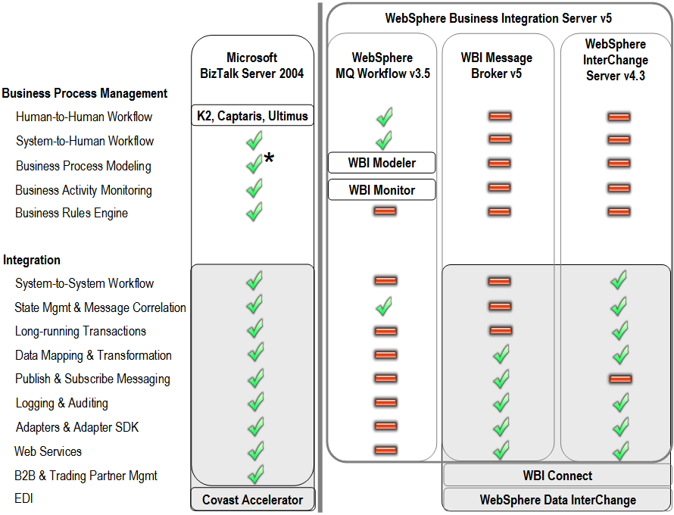

The above figure shows the functional capabilities of BizTalk Server 2004 compared with the technologies included in the IBM WBI Server v5.

Customers should consider asking their IBM sales representative which one of these technologies is right for them. If they choose WBI Message Broker for integration, will they need to also buy a new set of technologies if they later wish to add BPM functionality?

Customers should also consider asking their IBM sales representative about the WICS strategic roadmap. As IBM continues to add redundant functionality and invest in WBI Server Foundation, the future of WebSphere InterChange Server may not be clear. (WBI Server Foundation, a fourth technology that is separate from WBI server, is reviewed in subsequent sections of this document.) Is WICS going to be replaced by WBI Server Foundation and, if so, when and how will customers migrate?

BPM Requirements
The ROI from these technologies typically comes when core integration functionality and BPM are brought together and extended under a single, unified development, management, and interaction model. BPM can provide complete end-to-end visibility into business processes across multiple systems and trading partners through use of BAM, a BRE used for flexible business processes with runtime-configurable business logic, process modeling, and the introduction of business-user interaction and collaboration to these business processes (i.e., human workflow).

Component | Description
Human-to-Human Workflow | Management of human oriented workflow in which process steps are predominately manual plus role-aware multi-level delegation and escalation.
System-to-Human Workflow | Addition of explicit user interactions to workflows in which process steps are predominately automated. Enables business users to participate in business processes by providing access to business process data and functionality.
Business Process Modeling | Graphical business process design tooling targeted at business users. Additional functionality includes process simulation.
Business Activity Monitoring | Real-time access to business process data and critical business performance indicators to improve the speed and effectiveness of business operations.
Business Rules Engine | Defining, managing, and deploying complex runtime-configurable business rules used for one or many business processes across the organization.

IBM provides a single technology option for BPM: WebSphere MQ Workflow. While WebSphere MQ Workflow provides some BPM functionality, it has limited support for integration and is only suited for human workforce management.

Figure 4: BPM support in BizTalk Server 2004 and WBI Server v5

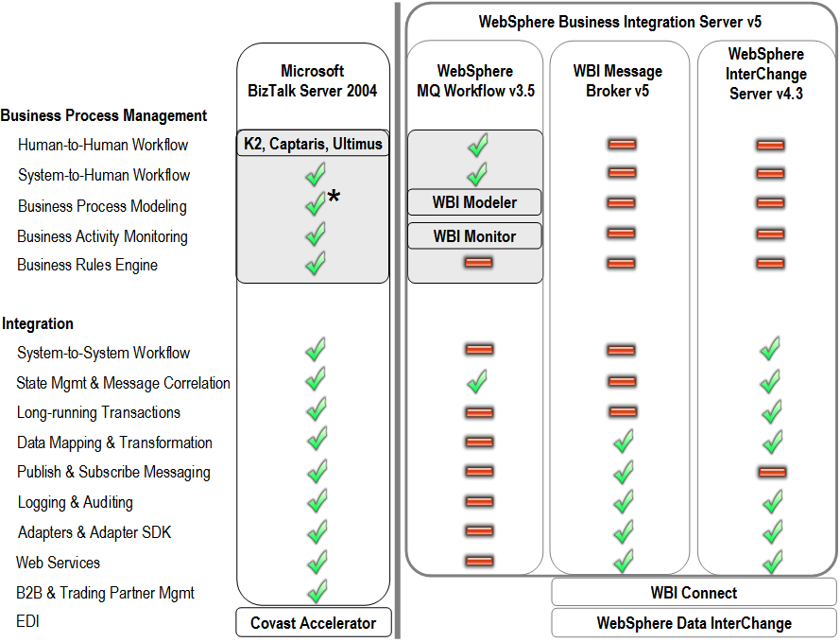
The preceding figure depicts the functional capabilities of BizTalk Server 2004 compared with the technologies included in IBM WBI Server v5.

As mentioned earlier, IBM offers a number of solutions for BPA under the umbrella of its WebSphere brand. Customers should consider asking their IBM sales representative about the strategic roadmap of the WebSphere MQ Workflow. As IBM continues to add redundant functionalities and invest in WBI Server Foundation, the future of MQWF may be unclear to customers.

WBI Server Foundation, a fourth technology separate from WBI server, is reviewed in subsequent sections of this document. Is MQWF going to be replaced by WBI Server Foundation and, if so, when and how will customers migrate?

An In-Depth Look at IBM WBI Server Technologies
This section provides a deeper look into the different technologies that comprise the WBI Server bundle.

WBI Server v5 is a bundle of disparate and redundant technologies. WBI Server is a collection of different technologies that were independently developed or acquired. While these underlying technologies share the WebSphere Business Integration brand name, they provide different runtimes, programming models, and development tools. WBI Server v5 includes the following technologies:

- WebSphere InterChange Server (WICS) v4.3 coordinates business process activities that span multiple applications. WICS is based on a technology acquired from CrossWorlds Software, Inc. in January 2002. WICS is built upon its own proprietary messaging engine.

- WebSphere Business Integration Message Broker (WBI MB) v5 provides transformation and the routing of information between applications. WBI MB evolved from the WebSphere MQ Series Integrator that embedded technology originally obtained from NEON. WBI Message Broker requires WebSphere MQ.

- WebSphere MQ Workflow (MQWF) v3.5 provides technologies for automating and managing human tasks by coordinating long-running tasks—not to be confused with long-running transactions, which it does not natively support. MQWF has a limited ability to integrate with applications other than the MQWF clients provided. WFMQ defines processes in the proprietary Flow Definition Language (FDL) format, which is not compatible with the other WBI Server technology runtimes. MQWF is based on legacy FlowMark technologies and, as its name suggests, requires WebSphere MQ.

The following figure shows the functional capabilities of BizTalk Server 2004 compared with the technologies included in IBM WBI Server v5.

Figure 5: Functional Comparison of BizTalk Server 2004 and IBM WBI Server v5

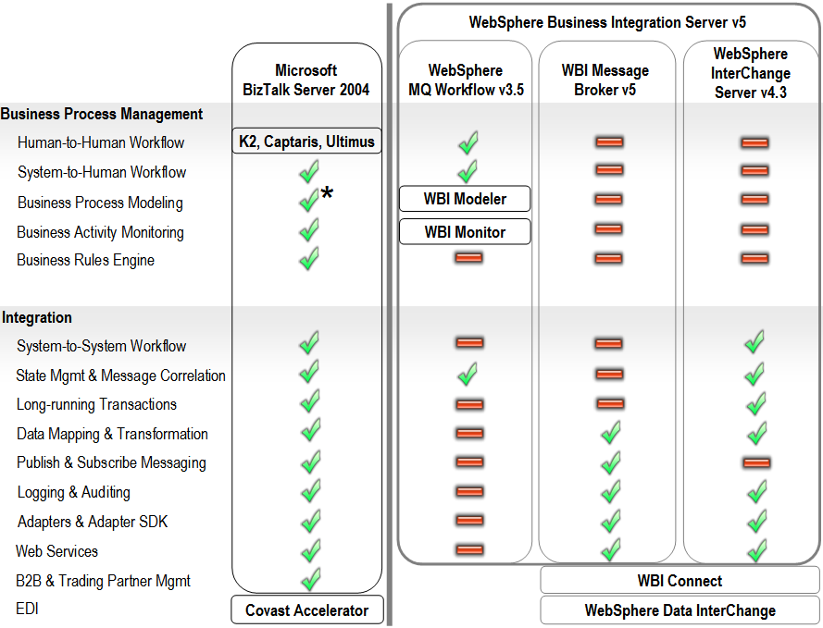

WBI Server v5 does not include native solutions for EDI or B2B exchanges.
- WebSphere Business Connect. For integration scenarios that extend beyond the enterprise in B2B exchanges, an additional WebSphere Business Connect solution is available. WebSphere Business Connect is not included in the WBI Server bundle. This solution allows for secure exchange with partners, trading networks, suppliers and customers. It integrates with both WBI MB and WICS, but does not work with MQWF. BizTalk Server includes support for B2B exchanges and provides Trading Partner Management.

- WebSphere Data Interchange. WDI is not included in the WBI Server bundle. For WBI Server integration scenarios requiring specialized EDI, customers must purchase the additional WebSphere Data Interchange (WDI) solution to obtain this functionality. WDI integrates with WBI MB and WICS, but does not work with MQWF. BizTalk Server 2004 supports EDI message document formats. In addition, Microsoft and its partner, Covast, have jointly developed BizTalk Accelerator, which is available separately and provides additional EDI functionality.

WBI Server Express is a limited-functionality bundle for small and medium businesses. WBI Server Express is a bundled subset of the technologies that is included in the full-featured, full-priced WBI Server solution. IBM released this limited functionality WBI Server Express bundle at software license prices similar to BizTalk Server. However, while WBI Server Express software license costs may be similar to BizTalk Server 2004 software license costs, the functionality of the two solutions is not comparable. In terms of functionality, BizTalk Server 2004 is more appropriately compared with the full-featured, full-priced WBI Server solutions and not the WBI Server Express solution.

Figure 6: Comparison of BizTalk Server 2004 and IBM WBI Server Express v4.4

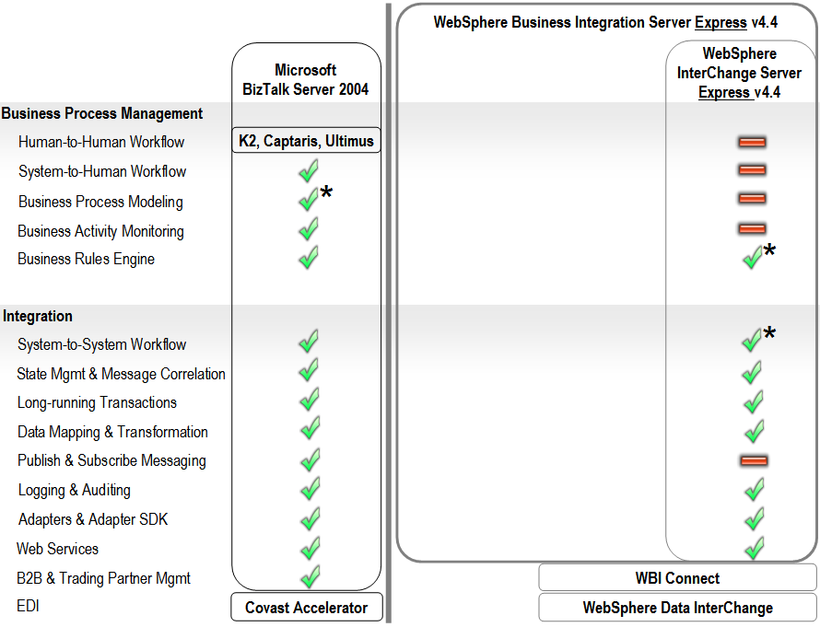
The preceding figure shows the functional capabilities of BizTalk Server 2004 as compared with the technologies included in the IBM WebSphere Business Integration Server Express version 4.4.

WBI Server Express does not include WBI MB or MQWF. WBI Server Express includes WebSphere InterChange Server Express solely for process integration; it does not include other technologies in the WBI Server bundle, such as WBI Message Broker for application integration or MQ Workflow for human-to-human workflow management.

WBI Server Express does not provide a complete toolset. The WBI Server Express Version 4.4 announcement states that while WBI Express Plus includes Process Designer Express for customization of process templates, WBI Express does not. WBI Server Express consequently has a comparatively limited ability to customize or extend the limited number of out-of-the-box, system-to-system workflow templates called collaborations.

Reduced software license costs do not eliminate the need for costly enterprise consulting. The WBI Server Express software license cost has been priced for the mid-market segment, but the technology is the same WebSphere InterChange Server technology that is included in the WBI Server solution. This may require expensive, enterprise-class consulting resources to develop and manage. According to the recent Forrester report “IBM WebSphere is Good, But It Isn’t Magic,” most small and medium-size business customers will discover WebSphere platforms to be too complicated and costly. For more information on IBM WBI Server Express pricing, read “Software on-line catalog.” For more information on BizTalk Server 2004 pricing, read “Microsoft BizTalk Server 2004 How to Buy.”
WBI Server Express has limited adapter connectivity. WBI Server Express allows customers to choose three adapters from a selected list. WBI Server Express Plus allows customers to choose five adapters from this same list. According to the WBI Server Express v4.4 announcement, not all adapters are available for all supported operating systems.
WBI Server Express v4.4 adds limited functionality Business Rules. WBI Server Express v4.4 adds Business Rules functionality that can only be explicitly called from the WebSphere InterChange Server Express v4.4. These Business Rules cannot be called from technologies other than InterChange Server Express collaborations, meaning they are not universally applicable across technologies. These Business Rules are not compatible with the WebSphere InterChange Server v4.3 solution which is included in the WBI Server v5 bundle.
It should be noted that the WBI Express Server Business Rules technology is not related to, or compatible with, Java Rules Beans implemented in the WBI Server Foundation.

WBI Server Foundation is an extension of the WebSphere Application Server. In additional to the WBI Server suite, IBM offers a fourth option for BPA that is targeted at application developers who wish to include integration functionality in their Java applications. WBI Server Foundation is not included in the WBI Server bundle.

WBI Server Foundation has limited integration functionality beyond basic web services and integration with WebSphere MQ via Java Messaging Service (JMS) interfaces. WBI Server Foundation includes some BPM functionality such as modeling via the WBI Modeler and system-to-human workflow via Staff support in the Process Choreographer tool. However, WBI Server Foundation does not include BAM functionality. Its Business Rules implementation is limited to a Rules Beans API and lacks the functionality of a Business Rules Engine.

WebSphere Business Integration Server Foundation (WBS SF) v5.1 is an extension to the WebSphere Application Server. It includes a proprietary J2EE-based process container that hosts the execution of system-to-system workflow.

WebSphere Studio Application Developer Integration Edition (WSAD-IE) is an extension to the WebSphere Studio Application Developer tool set. It includes additional tools for developing business process orchestrations—Process Choreographer—and message document transformations. These tools provide similar functionality to BizTalk Orchestration Designer and BizTalk Mapper.

In WBI Server v5.0, the Process Choreographer was based on the Flow Description Markup Language (FDML), but v5.1 introduced a new Business Process Execution Language (BPEL) Editor. This BPEL Editor is based on a non-standard implementation of the BPEL called BPELJ, which includes proprietary extensions that only run in WBI Server Foundation’s specialized J2EE Business Process Container and which are not compatible with other BPEL-based business process orchestration engines. BPEL was designed to enable heterogeneous interoperability between multiple vendors’ Process Orchestrations. IBM’s introduction of WebSphere specific extensions to BPELJ does not adhere to that model. To support the intended goal of process interoperability, the BizTalk Orchestration Designer supports BPEL import and export functionality. The proprietary, non-standard Staff extension to the BPEL standard adds support for system-to-human workflow functionality.

Management of these processes can be complicated and inflexible on the WBI Server Foundation runtime. Long-running processes are compiled and deployed as Enterprise Java Beans (EJB) Entity Beans. While the use of Entity Beans may initially be transparent to a developer using the graphical BPEL Process Editor, complexity and inflexibility can arise in the deployment and management of these processes, including ridged mapping of the Entity Beans to the persistence database. For example, these long running processes cannot be deployed to a running server. If customers want to deploy a long-running BPEL process to a server, they must first stop the server or they will be unable to create the required tables and data sources. (Source: IBM: “Limitations in deploying business integration applications” Web site).

WebSphere Business Integration Server Foundation runtime and development/management tools are different from the other WBI Server v5 technologies.

The below figure shows the functional capabilities of BizTalk Server 2004 as compared to the technologies included in the IBM WBI Server Foundation v5.1.

Figure 7: Functional Comparison of BizTalk Server 2004 and IBM WBI Server Foundation v5.1

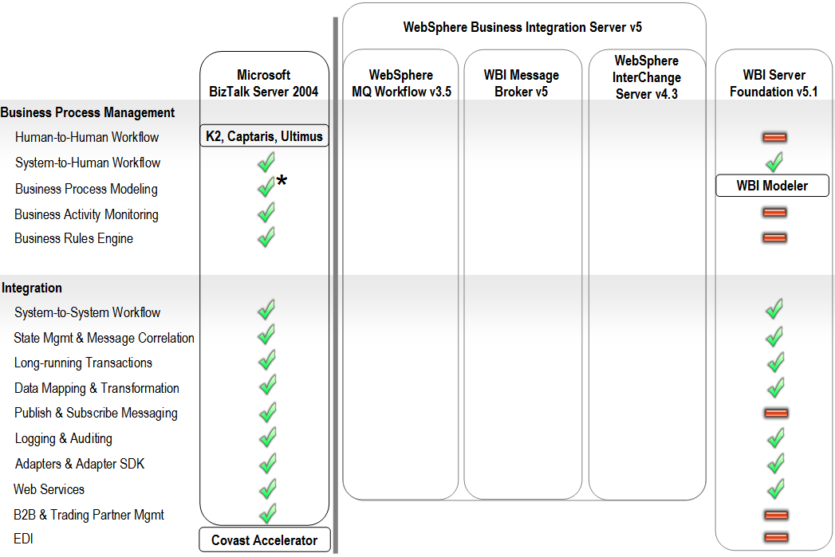

WBI Modeling and Monitoring technologies do not work with many of the WBI Server technologies. Both the WBI Modeler and WBI Monitor solutions are based on technologies obtained from the privately-held company, HoloSofx, which IBM acquired in September 2002.

- WBI Modeler enables trained technical analysts to model and simulate business processes. WBI Modeler supports the export of only these models--with appreciable loss in fidelity—into BPEL and FDL formats. The exported BPEL format can be imported into both WSAD-IE, which is the development environment for the WBI Server Foundation. This exported BEPL format can also be imported into the BizTalk Orchestration Designer. The exported FDL format can be imported into the MQ Workflow Buildtime tools. WBI Modeler does not support import of BPEL or FDL. This means there is no “round-trip” support for changes made in the design tools. WBI Modeler does not provide an export format that is supported by the WBI Message Broker or WebSphere InterChange Server.

BizTalk Server provides Orchestration Designer for Business Analyst (ODBA) tool based on Microsoft Visio® that supports import and export of business process models from the BizTalk Orchestration Designer. While this tool does not support simulations such as the type available from the WBI Modeler, it does provide a simple, familiar tool for business users and developers to exchange process models.

- WBI Monitor provides real-time, limited monitoring of some of the WBI Server solutions. As of version 4.2.4, this solution does not support monitoring of WebSphere InterChange Server and requires explicit coding in the WBI MB solution to send data to WBI Monitor. The WBI Monitor was originally designed to monitor only the MQ Workflow solution and has not received many updates since the HoloSofx acquisition in September 2002.
BizTalk Server is a fully-integrated BAM solution that monitors Key Performance Indicators (KPI) aggregated across business processes managed by BizTalk Server. With BizTalk Server’s BAM capabilities, business analysts can define which business data to collect and how to interpret it. Users can view business activities and perform everyday business operations. BizTalk Server can track the status of each instance of a process, and summarize them across processes for a non-technical user in an Excel Workbook hosted on a Microsoft SharePoint Services site or in Microsoft SQL Server Reporting Services. The BizTalk BAM functionality is a complementary technology to Microsoft Business Intelligence solutions.

WBI Adapters require deployment of numerous WebSphere MQ queues. WBI Adapters provide connectivity to various technology protocols and applications. While WBI has a large collection of adapters, these adapters are not supported by the MQWF solution and both the WBI MB and WBI Server Foundation solutions have access to limited functionality. Because these adapters largely originated from the CrossWorlds acquisition, they were designed for WICS. As a result, only WICS fully exploits the functionality of many of the WBI Adapters.
WBI Adapters can be expensive and challenging to configure and manage: they require WebSphere MQ queues to be configured and monitored for each adapter. For example, in order to support fault-tolerant deployments, numerous WebSphere MQ queues must be clustered and backed up on every server that hosts adapters.

Summary
IBM’s WBI Server v5 is a bundle of disparate and frequently redundant technologies. This collection of technologies, largely acquired from other companies, provides differing runtimes, programming models and development tools. These aggregated technologies must be integrated in order to meet today’s integration and business process management requirements and deliver the full benefits of a BPA solution.

In contrast, BizTalk Server 2004 is a comprehensive, integrated product that allows organizations to build adaptive, manageable, and reliable business process automation solutions that can span applications, people, and trading partners.

BizTalk Server 2004 can be easily differentiated from WBI Server v.5 in several ways. BizTalk Server 2003 is designed to provide:

• A comprehensive and integrated solution
• Rich and easy to use tools suited for specific uses and users
• Lower TCO
• Faster time-to-value
• Secure, scalable solutions for large enterprises
• Interoperability via industry standards

For these and other reasons, BizTalk Server 2004 is a highly-recognized and increasingly popular solution:

• Fastest growing Integration Server in the market
• Leader in the Gartner 2005 Magic Quadrant
• InfoWorld’s “Technology of the Year” Award Winner

BizTalk Server 2004 is designed to deliver unique, integrated tools to developers and IT professionals as well as business analysts, tools that help them reduce complexity and achieve new levels of agility in business process design and optimization. With its enhanced and simplified deployment, configuration and management capabilities, BizTalk Server 2004 provides organizations with a powerful solution to quickly build the next generation of adaptive business process solutions.

Please contact your Microsoft account representative or a Microsoft Certified Partner (MCP) for more information on how your enterprise can realize the potential of Business Process Automation with BizTalk Server 2004. Links and supporting resources are provided in the following “References and Additional Information” section.

References and Additional Information
See the following resources for further information.

BizTalk Server

Microsoft: “BizTalk Server 2004: Building the Smart, Connected Enterprise” http://www.microsoft.com/biztalk/default.mspx

Microsoft: “BizTalk Server 2004 Case Studies”
http://www.microsoft.com/servers/net/casestudies.htm

Microsoft: “BizTalk Server: How to Buy” http://www.microsoft.com/biztalk/howtobuy/pricing.asp

Microsoft PressPass: “At Four-Year Anniversary, Adoption of Microsoft BizTalk Server Tops 4,000 Organizations” (March 1, 2005)
http://www.microsoft.com/presspass/features/2005/mar05/03-01BizTalkServer.asp

Microsoft PressPass: “Microsoft BizTalk Server 2004 Receives InfoWorld's Technology of the Year Award” (February 16, 2005)
http://www.microsoft.com/presspass/press/2005/feb05/02-16biztalkhonoredpr.asp

Microsoft PressPass: “Microsoft Positioned in the Leaders Quadrant in Web Services Magic Quadrant” (September 22, 2004)
http://www.microsoft.com/presspass/press/2004/sep04/09-22MicrosoftMQLeaderPR.mspx

BizTalk Server 2004: Understanding BPM Servers
http://www.microsoft.com/biztalk/techinfo/whitepapers/2004/bpmservers.asp

Understanding BizTalk Server 2004
http://go.microsoft.com/fwlink/?LinkId=21313

BizTalk Server 2004: Developing a BizTalk Server Solution http://www.microsoft.com/biztalk/techinfo/whitepapers/2004/development.asp

BizTalk Server 2004: Business Rules Framework
http://www.microsoft.com/biztalk/techinfo/whitepapers/2004/business_rules.asp

The Role of Business Process Execution Language (BPEL) in Business Process Integration at http://www.gotdotnet.com/team/wsservers/bts2004/bpel_v10.zip

Third-Party Analysis

Oracle: “Oracle Application Server 10g Positioned in Leader Quadrant in Two Gartner Magic Quadrants: Enterprise Application Servers and Integration Backbone Software Suppliers” (circa May 2005)
http://www.oracle.com/appserver/gartner_magicquadrant_0405.html

Nucleus Research: “Market Scorecard – Integration” (September 2004). Note: Nucleus ranks BizTalk Server 2004 as the leading integration product for its capability to deliver return on investment to customers.
http://www.microsoft.com/biztalk/evaluation/news/scorecard_nucleus.mspx

Nucleus Research: “Vendor ROI Scorecard – Microsoft BizTalk Server” (September 2004): Note: Nucleus rates BizTalk Server for deployment, adoption, support, business impact, and vendor placement http://www.microsoft.com/biztalk/evaluation/news/roi_nucleus.mspx

The META Group: “METAspectrum Evaluation: Enterprise Application Integration” (January 13, 2004): Note: METAspectrum's market summary report places Microsoft in the leader category for performance and presence in the enterprise application integration market.
http://www.microsoft.com/biztalk/evaluation/news/meta2004.asp

The Middleware Company: “Comparing Microsoft .NET and IBM WebSphere/J2EE: A Productivity, Performance, Reliability and Manageability Analysis" (September 2004)
http://download.microsoft.com/download/b/0/5/b05a35f6-5b6b-4b7b-ba59-c020da4217d7/middleware_j2ee.pdf

Giga Research: “The Total Economic Impact of Developing and Deploying Applications on Microsoft and J2EE/Linux Platforms” (September 4, 2003)
http://download.microsoft.com/download/5/6/8/568917b1-e15f-4c92-8720-f3f52675d595/Giga_TEI_Study.pdf

Jupiter Research: “Interoperability: How Technology Managers Rate Microsoft and Its Technologies for Development” (April 7, 2004)
http://www.microsoft.com/windowsserversystem/facts/analyses/interop.mspx

Forrester: “IBM WebSphere Is Good, But It Isn't Magic” (March 14, 2005)
http://www.forrester.com/Research/Document/Excerpt/0,7211,36534,00.html

XLMania.com: “Microsoft Positioned in the Leaders Quadrant in Web Services Magic Quadrant” (September 22, 2004)
http://www.xmlmania.com/news_article_1537-Microsoft-Positioned-in-the-Leader-Quadrant-in-Web-Services-Magic-Quadrant.php

Microsoft Customer Evidence and Case Studies

Balboa Insurance Group: “Insurer Turns Complex Paperwork into Streamlined Workflow” (March 17, 2005)
http://www.microsoft.com/resources/casestudies/CaseStudy.asp?CaseStudyID=15096

TELUS Geomatics: “TELUS Geomatics Leverages the Power of BizTalk Server 2004 to Provide Enhanced Emergency Response” (May 10, 2004)
http://www.microsoft.com/biztalk/evaluation/casestudies/casestudy.asp?CaseStudyID=15366

Bank of New York: “’Rock-Solid Application Platform’ Boosts Cost-Effectiveness for The Bank of New York” (April 24, 2003)
http://www.microsoft.com/resources/casestudies/CaseStudy.asp?CaseStudyID=13938

CheckFree Corporation: “Windows Nets 24 Percent Lower TCO over Linux for IBM Mainframe Migration” (March 17, 2005)
http://www.microsoft.com/resources/casestudies/CaseStudy.asp?CaseStudyID=16511

Xerox Corporation case study: “Xerox Adds More Features in Less Time with Visual Studio .NET” (April 30, 2002)
http://www.microsoft.com/resources/casestudies/CaseStudy.asp?CaseStudyID=11587

IBM Web Sites

IBM: Reality Research & Consulting report: “IBM Business Partner Profitability” ftp://ftp.software.ibm.com/software/websphere/partners/download/business-partner-profitability.pdf

IBM: WebSphere Business Integration Server Express v4.4 Announcement (April 2005)
http://www.ibm.com/common/ssi/rep_ca/9/897/ENUS205-089/ENUS205-089.PDF

IBM: WebSphere Business Integration Modeler and Monitor v4.2.4 Announcement (September 9, 2003) http://www.ibm.com/common/ssi/rep_ca/5/897/ENUS203-215/ENUS203-215.PDF

IBM: Software On-Line Catalog
http://www-306.ibm.com/software/info/ecatalog/index.html

IBM: “Limitations in deploying business integration applications”
http://publib.boulder.ibm.com/infocenter/adiehelp/index.jsp?topic=/com.ibm.etools.iedeploy.doc/concepts/climits.html

Additional Resources

For the latest information about Windows Server System, visit the Windows Server System Web site at http://www.microsoft.com/windowsserversystem.

Security

Microsoft: BizTalk Server 2004: Security (Web site)
Examine security mechanisms and deployment methodologies that BizTalk Server 2004 uses to authenticate data, authorize access, and maintain data privacy and integrity.
http://www.microsoft.com/biztalk/techinfo/whitepapers/2004/security.asp

Microsoft: Single Sign-on Services for Microsoft Enterprise Application Integration Solutions (Web site)
Host Integration Server and BizTalk Server both support an extension of Windows Enterprise Security integration called Enterprise Single Sign-On (SSO). Learn how SSO can help solve a key problem that many enterprise organizations experience. Download this paper from the Download Center for the details.
http://download.microsoft.com/download/C/6/5/C65FF9FD-0ED7-47F6-91AB-000E6265EA5B/Enterprise_SSO_Whitepaper.doc

Deployment
Microsoft: BizTalk Server 2004 Technical Deployment Guide for Security
http://www.gotdotnet.com/team/wsservers/bts2004/BTS2004SecureDeployment.zip

Performance

Microsoft: BizTalk Server 2004 Performance Characteristics
http://msdn.microsoft.com/library/default.asp?url=/library/en-us/BTS_2004WP/html/04d20926-20d2-4098-b701-52238a267eba.asp

High Availability

Microsoft: BizTalk Server 2004 Technical Guide for High Availability http://msdn.microsoft.com/library/default.asp?url=/library/en-us/BTS_2004WP/html/922d9b1a-c6f2-4d42-9f7a-2876eac7f50d.asp



