Microsoft Office Home and Student 2007

**Microsoft® Office Home and Student 2007 is the essential office software for home computer users. With the Microsoft Office Fluent™ user interface, enhanced graphics and formatting, new information organization tools, and more reliability and security, Office Home and Student 2007 makes it easier and more enjoyable to create great-looking documents, spreadsheets, and presentations, and organize your notes and information.**

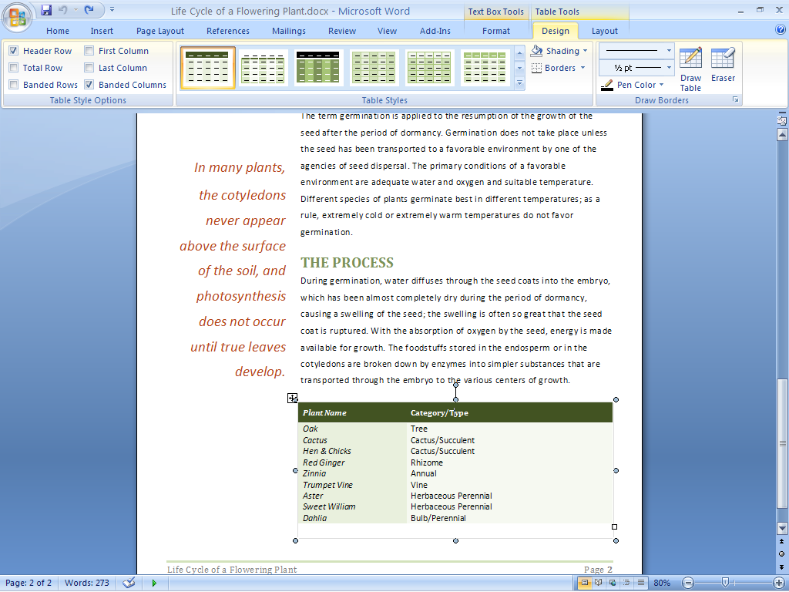

The streamlined workspace and easy–to-browse tabs make program features easier to find and use.

Find Commands and Help Easily

The Office Fluent user interface and enhanced Help system get you started.

Get more out of the Microsoft   
Office system.

The user interface for Microsoft Office Word 2007, Microsoft Office Excel® 2007, and Microsoft Office PowerPoint® 2007 has been redesigned to make program features easier to find and use. Commands are easier to find because they are organized into a set of easy-to-browse tabs that correspond more directly to the things you do most in the Microsoft Office system. Formatting galleries with live previewing take the place of complicated dialog boxes, so you can simply pick and click to get the effects you want.

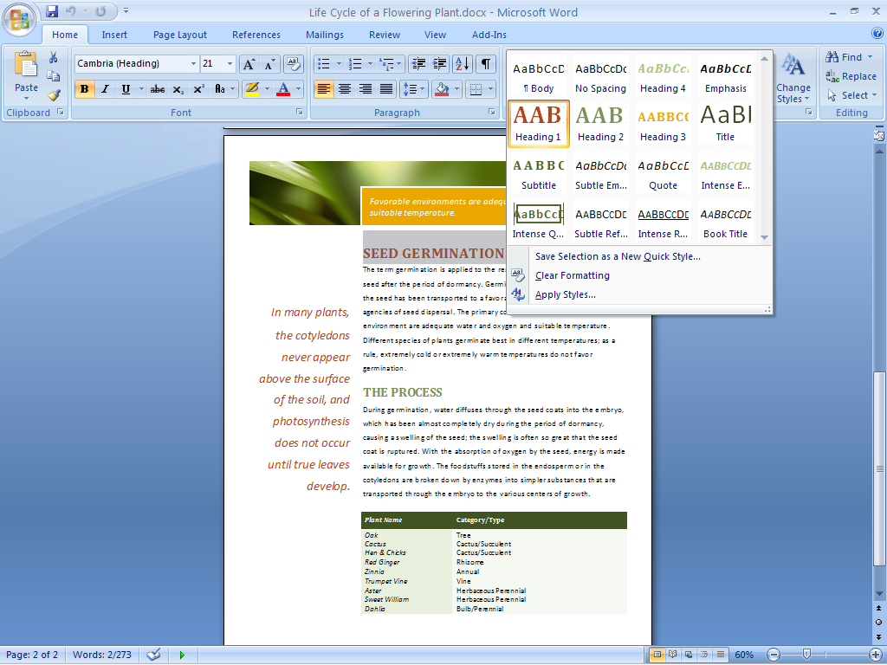

Formatting galleries make it easier to find and apply formatting changes.

Find the help you need.

Office Home and Student 2007 provides more direct links to Help content than ever before. Take advantage of close coordination between Help in the program and Help available on the Internet (when connected). Larger, more informative ScreenTips provide quick access to information about a command.

Get started with ease.

An improved Getting Started experience in Office Home and Student 2007 helps reduce the learning curve for new users. Online tutorials offer step-by-step instructions for using your Microsoft Office system software.

Create High-Quality Documents

New graphics, text tools, and formatting galleries enable you to produce high-quality documents that you can be proud of.

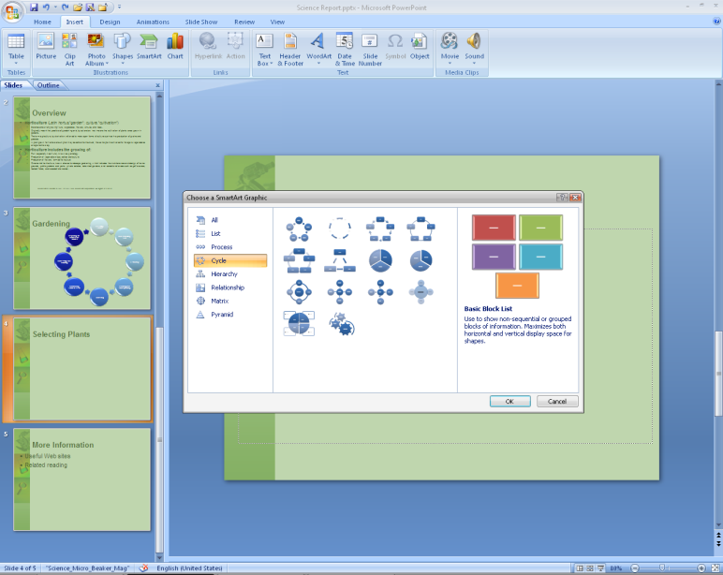

Insert graphics and charts such as these into your documents to make them more appealing.

Preview your changes quickly.

With Live Preview, you can quickly preview proposed changes to your document while you’re working on it without having to repeatedly search through layers of menus. By test-driving your proposed formatting, you can save time and experiment more easily.

Give your work a professional look.

With Office Home and Student 2007, you can give your documents a more professional look by using rich design and typography tools, including 3-D effects, shadows, glows, blurs, and a gallery of many different standard chart and diagram types.

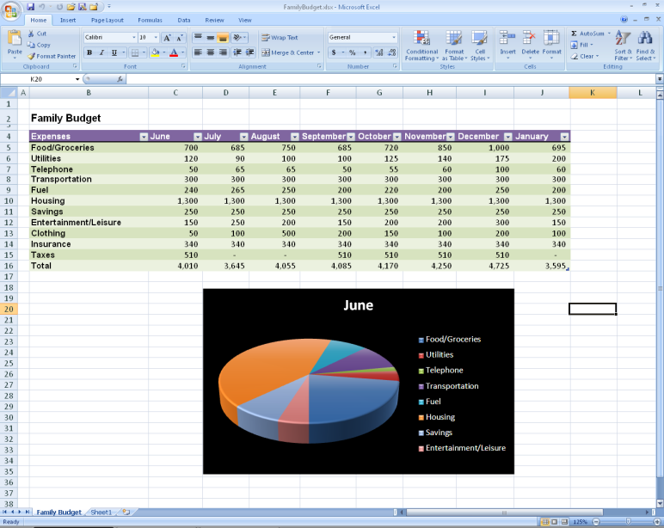

Use the new diagram and improved charting tools to create rich and stunning visuals and charts.

Maintain consistency across applications.

With Document Themes, you can apply and preserve a consistent look for tables and text across Word documents, Excel spreadsheets, and PowerPoint presentations. This predictability means that when you cut and paste objects between programs, the items maintain their appearance.

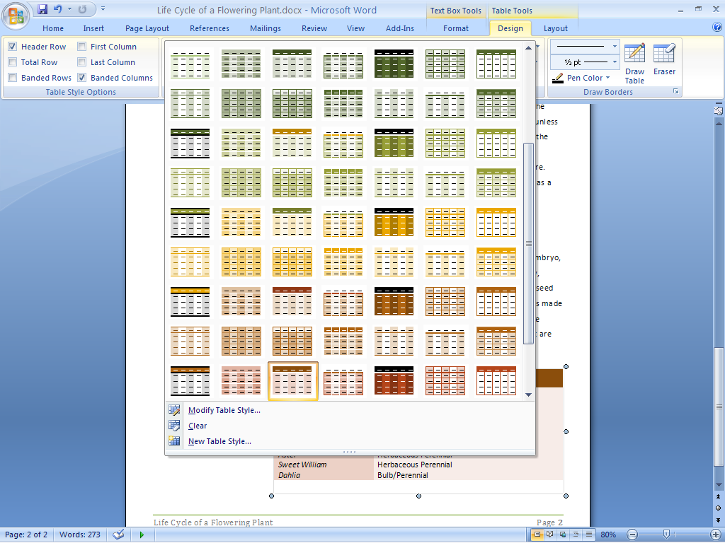

Quick and easy–to-use table styles help your tables look great and consistent across Word documents, Excel spreadsheets, and PowerPoint presentations.

Reduce frustration with bullets and tables.

With the addition of more consistent table, numbering, and bullet features in Office Home and Student 2007, you can reduce time spent reformatting your Word documents.

Organize Your Notes and Information

Microsoft Office OneNote® 2007, included in Office Home and Student 2007, is a digital notebook that helps you gather, organize, and search many types of information in one place.

Gather information.

Gather many different kinds of information—typed text, images, audio and video recordings, digital handwritten notes, Web clippings, and more—on the same page.

Organize your information.

Office OneNote 2007 provides flexible note-taking tools to help you organize information the way you want. Categorize important projects or information in a way that makes sense to you, using an easy-to-use layout of notebooks, sections, and pages. Type or organize content anywhere on the page and track important items with customizable   
note tags.

Find what you need.

The powerful Instant Search feature of Office OneNote 2007 enables you to find information you are looking for quickly. With Instant Search you can even search handwritten notes, the text in images and scanned documents, and spoken words in audio recordings.

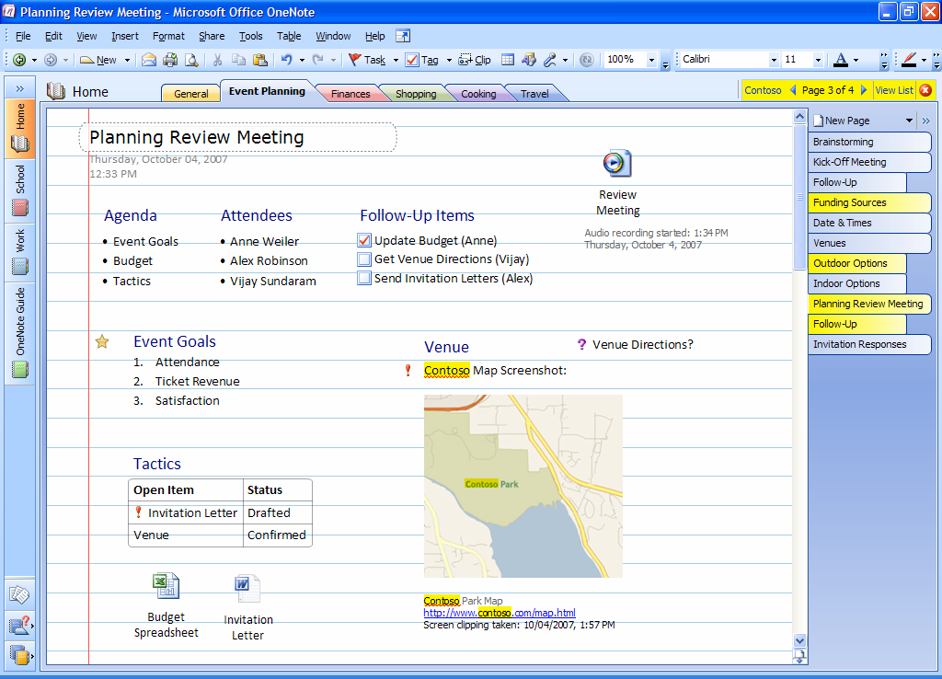

Office OneNote 2007 enables you to gather, organize, and search almost any type of information. The powerful search tool is shown here, with results highlighted in yellow.

Work with Enhanced Security and Reliability

With improved automatic document recovery and the new Document Inspector tool, Office Home and Student 2007 helps you work with more confidence and enhanced security.

Recover and repair documents automatically.

In the unlikely event of a system crash, Office Home and Student 2007 includes an automatic document recovery tool that will help recover and repair documents that you were working on during the crash.

Share documents with greater peace   
of mind.

Detect and remove unwanted comments, hidden text, or personally identifiable information in your documents by using the Document Inspector.

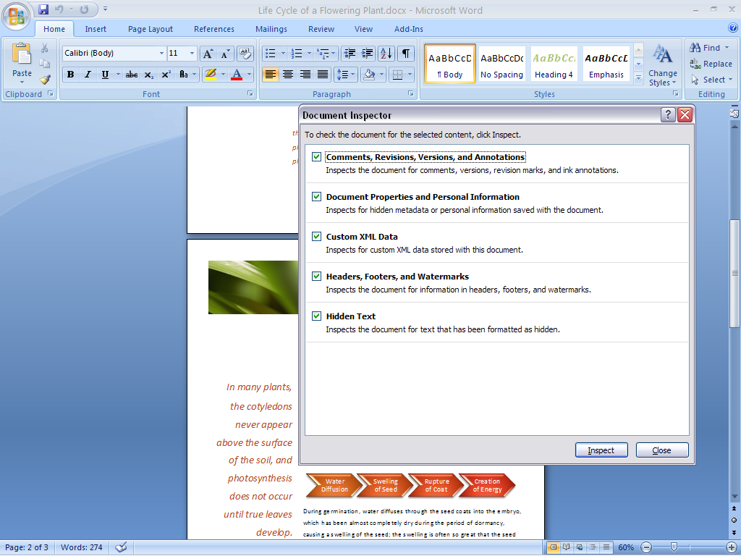

The Document Inspector helps find and remove potentially sensitive “hidden” information from your documents, presentations, and spreadsheets.

For More Information

Learn more about Office Home and Student 2007 and the Microsoft Office system at [www.microsoft.com/office/suites/homeandstudent](http://www.microsoft.com/office/suites/homeandstudent).

For complete system requirements, visit [[www.microsoft.com/office/suites/homeandstudent](http://www.microsoft.com/office/suites/homeandstudent).](http://www.microsoft.com/office/products)

This document is for informational purposes only. MICROSOFT MAKES NO WARRANTIES, EXPRESS OR IMPLIED, IN THIS SUMMARY.

The example companies, organizations, products, domain names, e-mail addresses, logos, people, places, and events depicted herein are fictitious. No association with any real company, organization, product, domain name, e-mail address, logo, person, place, or event is intended or should be inferred.

Microsoft_logo_jpg© 2006 Microsoft Corporation. All rights reserved. Microsoft, Excel, Fluent, the Office logo, OneNote, Outlook, and PowerPoint are either registered trademarks or trademarks of Microsoft Corporation in the United States and/or other countries. All other trademarks are property of their respective owners.