**­**

**Office 2010 provides the best productivity experience across the PC, Phone and Web Browser.**

Office 2010 provides the best productivity experience across the PC, Phone and Web Browser. Microsoft Office 2010 helps you rise to the challenge of today’s business environment without losing sight of what’s needed for IT success. For your people, it means helping them work in a way that’s faster, easier, and more intuitive – whether they’re on the road, in the office, working solo, or as part of a team. For IT, it means leveraging a set of smart, security enhanced, easy-to-integrate tools that work with what you have now, so you can grow your business instead of your budget.

*The information contained in this document represents the current view of Microsoft Corporation on the issues discussed as of the date of publication. Because Microsoft must respond to changing market conditions, it should not be interpreted to be a commitment on the part of Microsoft, and Microsoft cannot guarantee the accuracy of any information presented after the date of publication.*

*This article is for informational purposes only. MICROSOFT MAKES NO WARRANTIES, EXPRESS, IMPLIED OR STATUTORY, AS TO THE INFORMATION IN THIS DOCUMENT.*

*Complying with all applicable copyright laws is the responsibility of the user. Without limiting the rights under copyright, no part of this document may be reproduced, stored in or introduced into a retrieval system, or transmitted in any form or by any means (electronic, mechanical, photocopying, recording, or otherwise), or for any purpose, without the express written permission of Microsoft Corporation.*

*Microsoft may have patents, patent applications, trademarks, copyrights, or other intellectual property rights covering subject matter in this document. Except as expressly provided in any written license agreement from Microsoft, the furnishing of this document does not give you any license to these patents, trademarks, copyrights, or other intellectual property.*

*©2009 Microsoft Corporation. All rights reserved.*

*Microsoft and the Microsoft logo are either registered trademarks or trademarks of Microsoft Corporation in the United States and/or other countries.*

*The names of actual companies and products mentioned herein may be the trademarks of their respective owners.*

*Microsoft Corporation* • *One Microsoft Way* • *Redmond, WA 98052-6399* • *USA*

*This document contains information of a proprietary nature. All information contained herein shall be kept in confidence and shall be for the original recipient’s use only. Any unauthorized reproduction by any other party shall constitute an infringement of copyright.*

**CONTENTS**

Anywhere Access 4

Bring ideas to life 5

Collaboration without Compromise 6

The Practical Platform for IT 7

# Anywhere Access

**Respond more quickly when you’re away from the office.** The new Office Web Apps are online companions to Word, Excel, PowerPoint, and OneNote that let you review and make light edits to documents from a browser.* Feel confident with your data since document formatting and content is maintained when edits are done in the browser and because the Web Apps can be hosted on premise, running on SharePoint. Ultimately, this extends the Office experience by giving you access to your documents when you are away from your PC.

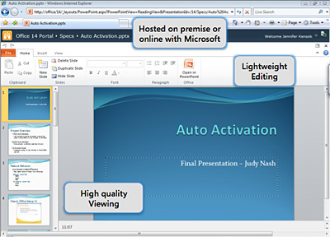

**Keep your people productive on the go with a seamless online/offline experience.** With Microsoft SharePoint Workspace 2010, you can keep all your important SharePoint documents and lists available offline. When you connect, only the changes are synchronized, getting you the updates faster even when faced with a low bandwidth connection. Security is kept in mind since all information shared is encrypted on users’ desktops and as it crosses a corporate network or the internet. Keep your team up to date, your content consistent, and take everything with you wherever you work.

**Keep everyone updated and on task.** Office Mobile enables co-workers in different locations to share, edit, and comment on documents with their smartphones, using a familiar Office experience best suited to mobile devices.** Also, you can use the Web Apps through the browser of a smartphone to make edits and view documents without losing any formatting or content. Extend your Office experience to stay up to date and do much more than just read e-mail from your mobile.

# Bring ideas to life

**Turn intuition into insights with innovations in Excel 2010 such as Sparklines**

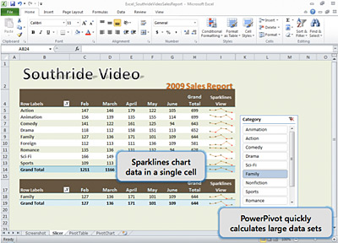

**Turn intuition into insights to make quicker, more informed decisions.** Combine native Excel 2010 functionality with the in-memory engine of PowerPivot to quickly calculate data sets of hundreds of millions of rows from multiple sources at lightning speed. And take advantage of new Sparklines to save real estate on-screen by charting trends in a single cell right next to the corresponding data. These new features in Excel 2010 make rich data analysis more easily accessible to more people and can eliminate the need to spend money on additional Business Intelligence tools.

**Create presentations that help you stand out from the competition.** PowerPoint 2010 introduces new photo and video editing tools that let you trim a video clip, turn a color film into black & white, add artistic effects to photos and more. Office 2010 puts you in the director’s chair, enabling you to create dazzling digital content in PowerPoint 2010 without the need for expensive third-party tools.

**Help increase productivity and reduce training costs.** Office 2010 extends the Ribbon interface throughout most applications, enabling your team to find the commands they need most, regardless of application. And the new Microsoft Office Backstage™ view gives everyone quick access to important operations such as viewing document information, saving, printing, and sharing. The Backstage view is extensible, so it can be customized to surface commands or workflow operations that are most important to people in your organization. It’s all about helping people uncover the right commands to produce better results faster.

# Collaboration without Compromise

**Simplify your inbox with Outlook 2010 with tools such as “Conversation View” and “Quicksteps”**

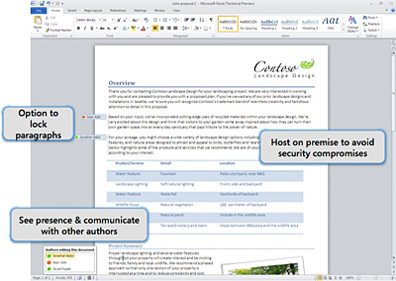

**Get control of your e-mail.** The conversation view, clean up and ignore in Outlook 2010 can remove duplicate information and act like a “mute button” for your inbox. Mail tips provide notices before a message is sent to protect information leakage or embarrassing mistakes. Warnings can be configured by IT to show alerts such as when a message is addressed to a large distribution list or to recipients outside of the company domain. Office 2010 gives your people faster and easier ways to manage their e-mail, which is a top priority as the number of daily messages for most people is on the rise.

**Collaborate better to get things done more quickly and beat deadlines.** Office 2010 enables web-based collaboration, allowing multiple people to edit Excel Web App spreadsheets, build reports or documents like RFPs in Word 2010, and annotate OneNote notebooks in real time, so they can conduct brainstorm sessions, update data and create compelling customer presentations without needing to be in the same room. Since the information can be hosted on premise, there’s no need to make security compromises to enable people to work better together.

**Instantly share a presentation**. Broadcast Slide Show in PowerPoint 2010 allows you to present a slideshow directly from PowerPoint to any audience member who can access a Web browser.** Simply send out an e-mail invitation with a web link and the recipient can follow along in their browser while you control the presentation from your PC. Broadcast Slide Show can be managed through Group Policy and IT can choose between a locally-hosted broadcast service, a free service provided over the Internet through Microsoft PowerPoint Live, or both. Now you can hold spontaneous meetings with customers and partners with security in mind and save on third-party broadcasting tools.

**Combine Business and Social Networking to Share Expertise.** Quickly view e-mails, meetings, or attachments that teammates have sent to you, as well as their SharePoint activities such as posting or tagging documents, updating their status with the Outlook Social Connector for Outlook 2010. It also enables you to connect to third-party popular social networks to connect with customers, prospects and partners outside of the organization. Now you can have a people-centric view of your network right within one of the tools you use most at work. And finally, IT can configure what’s most appropriate for your organization using group policy to enable or limit what networks and data are accessible in Outlook.

# The Practical Platform for IT

**Maximize performance on new & existing hardware.** Office 2010 was built to maximize performance across the hardware you already own, while also positioning you for future hardware investments such as 64-bit chips, advanced graphics cards, and multi-core processors.

**Help improve security with new layered defense.** The Trusted Documents and Protected View features of layered defense combine to first determine the trustworthiness of a document and then, if not trusted, open for viewing in a protected sandbox for users to view before enabling. This tiered approached to document security is new in Office 2010.

**Enhanced connectivity to servers and services.** With Office 2010, use Backstage, Web Apps, and application services such as Excel Services in order to connect with important business information and services, without users having to leave their familiar Microsoft Office environment. This helps to increase participation in server investments and reduce training costs.

**Maintain compliance – accessibility to e-mail to ECM.** Accessibility checker scans documents for issues that will impact users with disabilities and helps eliminates errors before they can cause harm to the business. Retention Policy is an archiving and retention tool that is more flexible to users’ workflow with capabilities such as item-level retention, user-created file application, and exception handling. These are examples of new Office 2010 tools & features that improve an organization’s ability to maintain compliance in a world of increasing information management demands

*\*An appropriate device, Internet connection, and Internet Explorer, Firefox or Safari browser are required. Some mobile functionality requires Microsoft® Office Mobile 2010, which is not included in Office 2010 applications, suites or Web Apps.*

*\*\*An appropriate device, Internet connection, and Internet Explorer, Firefox or Safari browser are required.*