

Why Upgrade to SQL Server 2005

Writer: Daryl Schaal
Technical Reviewers: Jonathan Tom, Rawee Kambhiranond

Published: November 2005
Applies To: SQL Server 2005

Abstract: Business and IT decision makers at many Fortune 1000 companies have become passionate adopters of Microsoft® SQL Server 2005 because it optimizes their IT environment by delivering a more secure and reliable data management and analysis platform. These users have found that SQL Server 2005 provides fundamental advancements in database technology to business users and allows their organizations to unlock value by
- Delivering a trusted next generation data management platform for 24/7 operations of large-scale, multi-terabyte databases.
- Enabling users to make better decisions based on real-time business metrics through advanced analytics, reporting tools and data mining capabilities.
- Providing an improved development environment that enables developers to create secure line-of-business applications quickly and easily add new capabilities for users.
These advances generate business value by enabling businesses to drive profitable growth, improve customer service, reduce IT costs, and add new services.

Copyright

This is a preliminary document and may be changed substantially prior to final commercial release of the software described herein.

The information contained in this document represents the current view of Microsoft Corporation on the issues discussed as of the date of publication. Because Microsoft must respond to changing market conditions, it should not be interpreted to be a commitment on the part of Microsoft, and Microsoft cannot guarantee the accuracy of any information presented after the date of publication.

This White Paper is for informational purposes only. MICROSOFT MAKES NO WARRANTIES, EXPRESS, IMPLIED OR STATUTORY, AS TO THE INFORMATION IN THIS DOCUMENT.

Complying with all applicable copyright laws is the responsibility of the user. Without limiting the rights under copyright, no part of this document may be reproduced, stored in or introduced into a retrieval system, or transmitted in any form or by any means (electronic, mechanical, photocopying, recording, or otherwise), or for any purpose, without the express written permission of Microsoft Corporation.

Microsoft may have patents, patent applications, trademarks, copyrights, or other intellectual property rights covering subject matter in this document. Except as expressly provided in any written license agreement from Microsoft, the furnishing of this document does not give you any license to these patents, trademarks, copyrights, or other intellectual property.

Unless otherwise noted, the example companies, organizations, products, domain names, e-mail addresses, logos, people, places and events depicted herein are fictitious, and no association with any real company, organization, product, domain name, email address, logo, person, place or event is intended or should be inferred.

© 2005 Microsoft Corporation. All rights reserved.

Microsoft, SharePoint, and Visual Studio are either registered trademarks or trademarks of Microsoft Corporation in the United States and/or other countries.

The names of actual companies and products mentioned herein may be the trademarks of their respective owners.

Table of Contents
Introduction 1
Enterprise Data Management 1
Increased availability 2
Security enhancements 2
Improved manageability 3
Exhibit 1: Customer evidence for enterprise data management 3
Business Intelligence 4
Real-time data analysis 5
Self-service reporting 5
Exhibit 2: Customer evidence for business intelligence 6
Developer Productivity 7
Creating new opportunities 8
Faster response times for end users 8
Reduced development time 8
Exhibit 3: Customer evidence of developer productivity 9
Conclusion 10
Benefit from a trusted platform 10
Make better decisions 10
Deliver faster results 11
About the Author 11
Appendix A: Case Studies 11

Introduction
Companies take on many challenges when trying to implement data management solutions because of the proliferation of data and systems within their organizations, the need for reliable and secure access to data, and constant pressure to reduce spending and simplify the information technology (IT) environment.
Microsoft® SQL Server™ 2005 is designed to address these challenges. It provides the next generation of integrated data management and analysis software that can help organizations:
- Deploy and manage mission-critical applications that provide 24-hour-a-day, 7-day-a-week reliability and controlled, secure access.
- Deliver real-time business insight derived from sources across the organization through reports that can be customized by individual users.
- Develop new services and analysis capabilities faster than ever before and with lower costs.
The customer evidence examples in this white paper highlight the significant business value that can be realized by upgrading to SQL Server 2005. This value was measured using standard financial metrics, such as net present value, internal rate of return, and payback.
The compelling business benefits as evidence by these customer examples include:
- Almost effortless upgrades from SQL Server 2000 to SQL Server 2005
- Up to 35 percent faster transaction processing, including improved response times on queries
- Higher availability (99.999 percent) for mission-critical applications and five times faster failover.
- Up to 40 percent faster development environment through Microsoft Visual Studio® and Microsoft .NET Framework integration that results in quicker project completions
- Improved analysis and calculation capabilities that allow developers to provide new services.
- Improved reporting capabilities that allow business decision makers to access information when they need it as well as to create their own ad hoc reports in multiple formats.

Enterprise Data Management
Database administrators are required to deliver a trusted and reliable platform to support continuous, mission-critical applications. SQL Server 2005 is designed to manage an enterprise-wide line of business applications and provide administrators with a highly available and secure environment.
Businesses implementing SQL Server 2005 achieve significant benefits from previous versions of SQL Server through:
- Higher availability (99.999 percent) for maximum uptime and five times faster failover (~3 seconds) with data mirroring to create continuous applications.
- Enhanced performance with up to 35 percent faster transaction processing and 150 percent better database performance in some scenarios.
- Stronger security with larger databases.
- Simplified manageability that reduces administrative needs, enabling administrators to shift from low-level management tasks to more strategic activities.

The following quote from Karl Haas, IT Manager at Koehler Paper illustrates this point.
“We are upgrading from SQL Server 2000 to SQL Server 2005 for our SAP systems to take advantage of database mirroring. Using this technology, we can create complete, up-to-date backups on servers in separate buildings. SQL Server 2000 was very reliable, but the advancements in SQL Server 2005 will ensure we don’t lose any production data.”

For more information on Koehler Paper’s experience, see Exhibit 1 in this paper and the Koehler Paper Case Study.

Increased availability
Many organizations depend on their database applications to keep business-critical operations running and data accessible. Uptime in their database is critical, as any amount of downtime can cause an immediate loss in revenue. SQL Server 2005 provides the capabilities to ensure that organizations can keep their applications up and running 24-hours-a-day, 7-days-a-week. With its database mirroring feature, even a failure of the database can be managed gracefully with no impact to end-users or operations because SQL Server 2005 can be set up to automatically switch to a backup server.
SQL Server 2005 ‘always on, always available’ advanced data management capabilities can dramatically reduce the potential for lost revenue due to a database failure, whether caused by hardware or software. The potential cost savings are enormous for critical applications that can shutdown retail systems, customer service applications, or manufacturing production lines.

Security enhancements
SQL Server 2005 delivers enhanced security features for enterprise data management through multiple levels that include:
- Security settings that default to the most secure option
- Native data encryption
- Automatic password policy enforcement based on domain-level group policy settings
- Fine-grained control over access permissions
Security settings by default provide the first level of security and reduce the risk for data and IP to be compromised, automatically setting up a safe environment for the database right from the start. Database administrators then have the ability to choose what access permissions should be assigned to particular users and groups of users.
SQL Server 2005 can encrypt the data at all levels of access:
- The database can be encrypted.
- Communications with the database can be encrypted so the data is protected while it is traveling over a network.
- The data can be encrypted on the user’s computer.
The server can even be set up to deny access to users who are not set up to encrypt the data.
Strict password policy enforcement, such as requiring long passwords and setting expiration dates for passwords, can be set up for all users. These options help to prevent access by unauthorized users.
Finally, database administrators can control access to all areas of the database at group and user levels. For example, many users only need to create reports for one department. These users can be given read-only access to a portion of the database. Though they have access to everything they need, there is no danger of them inadvertently changing data or accessing restricted information.

Improved manageability
SQL Server 2005 builds on the database management capabilities of SQL Server 2000 with a new management tool, enhanced self-tuning capabilities, and updated programming methods to automate management tasks. These advances can increase the productivity of database administrators by saving the time needed for maintenance, configuration, and tuning. This frees their time to focus on higher-level tasks, such as database architecture.

Exhibit 1: Customer evidence for enterprise data management
Koehler Paper operates five plants in Germany to produce specialty papers. The plants operate 365 days a year. Any unplanned shutdown of the process line results in a significant loss of capacity and revenue. The last time a plant shutdown occurred due to a database issue, it took three days for production to return to normal, resulting in more than U.S. $3,000,000 in lost revenue.
After learning about its new database mirroring capabilities, Koehler Paper was one of the first adopters of Microsoft SQL Server 2005 technology, using its 64-bit capabilities for their SAP applications. Database mirroring involves running two separate databases with the same information. If something happens to one database, software within SQL Server detects the failure and immediately begins using the other database. While failures are rare, if SQL Server 2005 can prevent one plant shutdown over the next five years, the savings provide a 200-percent return on Koehler’s investment.
Koehler Paper benefit summary:
- Reduced chance of plant downtime
- Reduced administrative costs by $150,000 per year
- Return of 50 percent and payback in 15 months
Net present value | U.S. $135,000
Internal rate of return | 178 percent
Payback | Six months

Table 1: Financial benefits for Koehler Paper
The improved availability of SQL Server 2005 is the primary reason Koehler deployed the new software. But SQL Server 2005 has proven to have many other advantages for database administrators at Koehler. Administrators now perform maintenance while the database stays online in many cases. Administrators can also easily make backups before performing maintenance or upgrades. They can undo any changes at the first sign of a problem before the production lines are affected. Reducing administration costs by $150,000 annually will produce a return of 50 percent for Koehler over the next three years with payback in 15 months. To read the entire Koehler Paper’s SQL Server 2005 solution, see Appendix A.
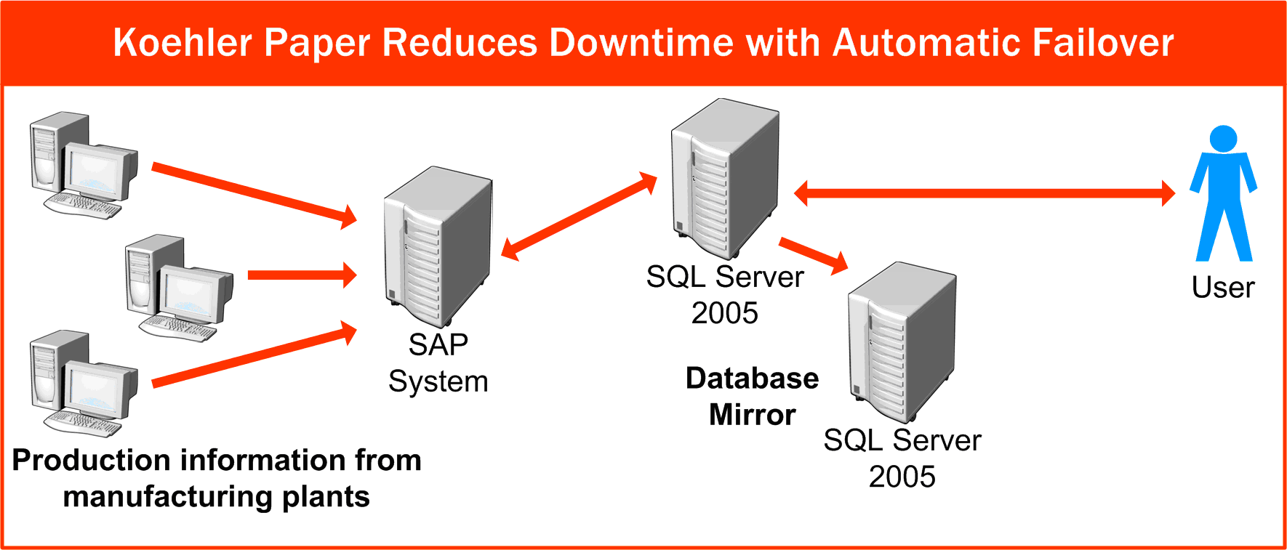
Figure 1: Automatic failover capabilities of SQL Server 2005 will help Koehler avoid costly downtime. Administration costs will also be reduced by more than $150,000 per year.

Business Intelligence
Robust, scalable business intelligence applications built using SQL Server 2005 enable business users to obtain a unified view of their operations and turn data into actionable insight. SQL Server 2005 provides built-in end-to-end business intelligence capabilities, including advanced analytics and data mining, simplified data integration and powerful interactive reporting, organizations of all sizes can achieve breakthrough business performance and a faster return on their information.
Organizations that can quickly address changes in key performance indicators can significantly improve results because issues get resolved immediately rather than when a monthly update is released. The business intelligence features in SQL Server 2005 include:
- New enterprise-capable extract, transform, and load (ETL) solution to load and manage a multi-terabyte data warehouse.
- Up to twice the performance on OLAP dimensions with Unified Dimension Model (UDM).
- New ad hoc reporting with Report Builder, combined with enhanced enterprise reporting.
- Expanded data mining capabilities with five new algorithms.
- Enhanced business productivity through tighter integration with the Microsoft Office System and Visual Studio 2005.
New data mining capabilities help companies discover relationships within the data that can lead to new business strategies. Data mining capabilities are often considered to be beyond the reach of many organizations because they are expensive and complicated to set up. SQL Server 2005 creates an easy-to-use and flexible business intelligence environment that can be used within any organization.

The following quote from Melanie Shook, Manager of Customer Operaiotns, at Recall Corportion illustrates this point.

“The SQL Server 2005 solution moved us past the first hurdle—timely access to the data. We now have the capability to do predicative analysis on this data. The data tells us why customers leave and allows us to act immediately to mitigate the service issue.”

For more information on Recall’s experience, see Exhibit 2 in this paper and the Recall Corporation case study.

Real-time data analysis
SQL Server 2005 Analysis Services provides the capability to perform complex data analysis and reporting on real-time data. With many systems, data analysis and data mining can only be used to discover long-term trends through weekly or monthly reports. SQL Server 2005 enables users to receive immediate feedback about key metrics by creating dashboards and scorecards that track key performance indicators, which provide current information about business operations.
With this knowledge, users can quickly respond to changes in the business environment. The database can even send out notifications through e-mail messages when metrics reach predefined levels. For example, a procurement specialist at a manufacturing plant needs to keep a certain level of inventory on hand. The database can calculate days of inventory at the factory based on the amount of materials, and the projected rate of use. When the days of inventory reaches the minimum required, SQL Server 2005 can notify the buyer, or even place an order automatically.

Self-service reporting
SQL Server 2005 Reporting Services enables business users to create their own ad hoc reports when they want them (see Exhibit 2). The IT department no longer needs to be involved when new reports are needed, freeing them to work on other high-priority tasks. Business users are also more likely to take advantage of the database when they can access information themselves rather than going through the IT department. These reports provide a great supplement to standardized reports that are produced each month.
Ad hoc reporting capabilities enable users to investigate and resolve issues immediately. For example, a user who receives a notification that the average cost to produce an item has risen above its profitable level can immediately investigate the cause of the higher cost.

Exhibit 2: Customer evidence for business intelligence
Recall Corporation provides a full range of document and data management solutions for companies around the globe. Operations at Recall are complex. The company often stores thousands of items at a time for a single customer. Each item has to be meticulously documented so that it can be retrieved easily when needed.
Because Recall lacked a central system to collect and analyze operational data, the company was forced into manual and time-consuming analysis practices, resulting in inconsistent and often untimely reporting. This limited visibility into business processes and decreased the ability of Recall managers to quickly resolve quality issues. Although Recall had high levels of customer satisfaction, the executive team felt that more could be done. They felt they could retain more customers by making Recall services easy to use and by improving service quality to standards never before seen in the industry.
Recall benefit summary:
- Improved customer service
- Reduced customer churn rates by 50 percent
- Reduced costs of collecting data by U.S. $250,000
Net present value | U.S. $930,000
Internal rate of return | 135 percent
Payback | 12 months

Table 2: Financial benefits for Recall Corporation
Recall found a solution using SQL Server 2005. This solution is helping to create a business intelligence platform at Recall which collects data from its many operational systems, and transforms the data into timely information. SQL Server stores the data securely and produces dashboards and reports that managers can access through a Microsoft Office SharePoint® Portal Server intranet.
SQL Server 2005 is also used to give customers direct access to their records through an Internet application. With the new solution in place, Recall is able to offer its customers unparalleled access to their information. Customers can now quickly find the status of any document and conveniently place orders for documents through Recall’s Web site.
The system is expected to reduce Recall’s cost of collecting data by U.S. $250,000 and help decrease customer churn rates by 50 percent. From these benefits, Recall expects to achieve a return of 135 percent on the project with payback in 12 months. To read Recall’s entire SQL Server 2005 solution, see Appendix A.
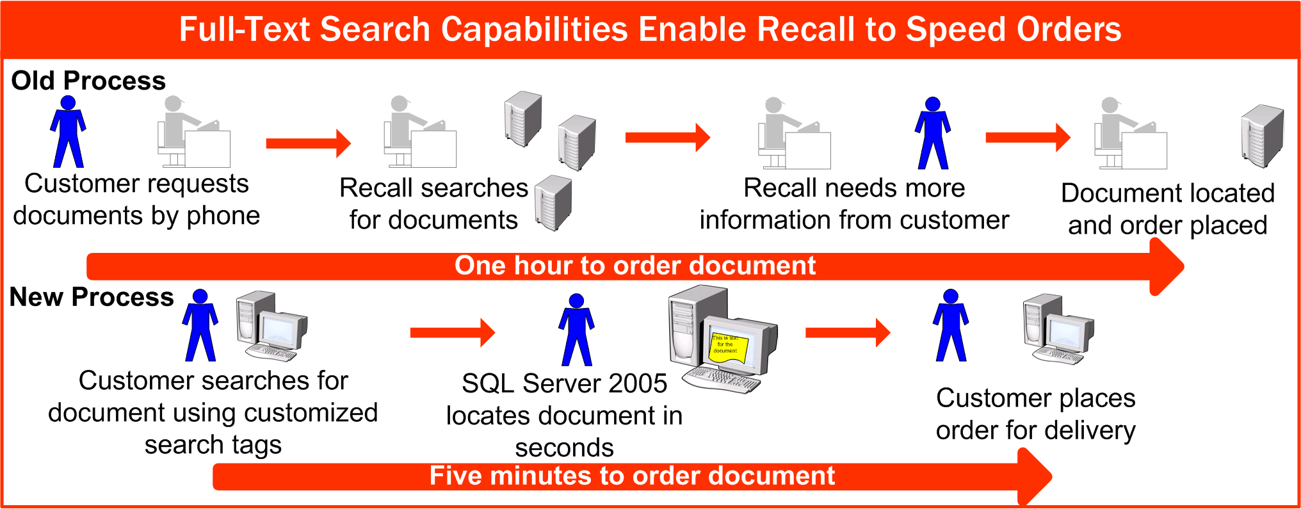
Figure 2: Recall enables customers to access and modify their storage records with SQL Server 2005.

Developer Productivity
SQL Server 2005 enables organizations to use data in ways that were previously cost-prohibitive through advanced programming capabilities that fundamentally alter the way database applications are developed and deployed. These capabilities enable developers to provide the scalable and flexible applications business users require, while reducing the time and cost required to produce them.
Unlike previous versions of SQL Server, SQL Server 2005 delivers an unmatched developer environment that greatly improves productivity across the organizations through:
- Faster and more flexible application development through native support for XML Web Services and SQL CLR.
- New capabilities and features that reduce development time are no longer cost-prohibitive, such as Cachesync to simplify Web development.
- Native data encryption for secure applications.
- Quicker response times for complex analysis requests.
- Integration with Visual Studio 2005 and the .NET Framework speeds up development by up to 40 percent, including 50-70 percent code reduction for most scenarios.
In many cases, organizations running previous version of SQL Server will find that they can offer new service features to customers without incurring significant costs, such as Web-based access to shipping information.

The following quote from Gerald Schinagl, Project Manager for the Sports Database, Austrian Broadcasting Corporation illustrates this point.
“We use SQL Server 2005 Management Studio for nearly all of our development. Previously we had to work with Query Analyzer, Enterprise Manager, and other tools as separate entities. Now everything is done from the same place—from creating tables to firing queries, or previewing the XML that is generated. Our development of XML-based applications is 90 percent faster with Management Studio.”

For more information on Austrian Broadcasting Corporation’s experience, see Exhibit 3 in this paper and the Austrian Broadcasting Corporation (ORF) Case Study.

Creating new opportunities
With SQL Server 2005, developers can access types and sources of data that were previously impossible to store, providing additional analysis opportunities to users. Because these capabilities can be added quickly and easily, organizations find that adding new functionality to their database applications is no longer cost-prohibitive. Companies can also create new business opportunities by providing real-time access to data at prices that are attractive for end-users (see Exhibit 3).
Advances in report generation enable users to create ad hoc reports from real-time data. These self-service capabilities change the way the database can be used in an organization. Previously, developers had to create specific reports for users. Because these reports required programming effort, they were typically tailored for executives making strategic decisions and were based on monthly or weekly data. Changing reporting to a self-service activity based on real-time data enables decision makers at all levels of the company to benefit from the data collected.
Microsoft SQL Server Mobile Edition greatly enhances the capabilities of mobile workers to analyze data while away from the office. Databases or portions of databases can be easily synchronized on to mobile computers so workers can still benefit from access to corporate data while away. For example, salespeople can keep copies of pricing databases on their laptop computers and have access to all the information they need while visiting customers.

Faster response times for end users
Database query response times have improved 70−80 percent for many applications that are converted from SQL Server 2000 to SQL Server 2005. Quicker response times to queries help business users react faster and enable the database to be used for real-time decision making. Queries that might have previously taken several hours can now be completed in a matter of minutes. This provides a whole new level of functionality for end users because analysis can be done on an ad hoc basis rather than exclusively in predefined reports. Companies can use this new accessibility to information to dynamically monitor processes.

Reduced development time
Developers using SQL Server 2005 can reduce the time required to build new applications by as much as 40 percent, including 50-70% code reduction for most scenarios. This time savings is due to the fact that the entire database project can now be completed with one set of developer tools rather than with a different product for each component, such as storing data, manipulating data, querying data, and producing reports. In addition, developers can take advantage of the updated developer tools in SQL Server 2005 to automate the task of converting existing applications to take advantage of its new capabilities.
Organizations benefit from quicker completion of applications because they can use new capabilities earlier. Often, these capabilities provide a competitive advantage for companies by helping them increase profit margins until competitors can develop equivalent technology. Extending this period of advantage by even a few months can result in significant profit increases.
Companies also benefit by reducing the time required from their in-house development staff. SQL Server 2005 reduces the need for specialized knowledge when developing database applications. The simplified user interface enables a large portion of the IT staff to contribute to the development effort. Many companies hire consultants or third-party development firms when creating database applications. SQL Server 2005 can help these firms deliver more secure line-of-business (LOB) applications that are easier to manage and at a much lower cost.

Exhibit 3: Customer evidence of developer productivity
ORF is the national public service broadcasting company in Austria. Sports coverage is one of the primary draws for ORF with a special focus on winter sports. To improve coverage of winter sports for its viewers, ORF wanted to report results faster and improve its reporters’ access to historical data.
ORF turned to SQL Server 2005 because of its improved performance on the complex calculations required to update rankings and statistics as real-time data is entered. SQL Server 2005 can automatically import standard results information from sports organizations that offer XML data, eliminating the need for manual entry. And it is easy for reporters to access the data they need, even on mobile computers, when they are reporting live from an event.
ORF benefit summary:
- Decreased development time enabled project to expand to more sports
- Improved database performance opened new sales opportunities
Net present value | U.S. $53,000
Internal rate of return | 42 percent
Payback | 19 months

Table 3: Financial benefits for ORF
ORF benefited from the enhanced development tools in SQL Server 2005 and found that it could expand its SQL Server project to cover more sports than originally planned. The project expanded from just covering alpine skiing events to the current goal of covering all of the winter Olympic sports for the 2006 Olympic games. ORF estimates that the productivity gains from using SQL Server 2005 are worth 1,600 hours per year in support and development time, which, if converted to dollars, provides a return of 42 percent for the broadcaster.
SQL Server 2005 also opened new business opportunities for ORF. “SQL Server 2005 has become a business enabler because we can now offer access to our data at speeds and prices that are interesting to users, which we could not do with the previous solution,” explains Gerald Schinagl, Project Manager for ORF. ORF plans to deliver data to partner companies over the Internet and should have this service in place for the 2006 Olympic games. ORF also delivers data to its online branch, ORF Online, and the interactive television offering. The old applications were unable to deliver real-time data, so ORF Online entered the sports results manually to keep the Web page up to date. Now ORF Online gets real-time results data directly from the sports database. To read ORF’s entire SQL Server 2005 solution, see Appendix A.
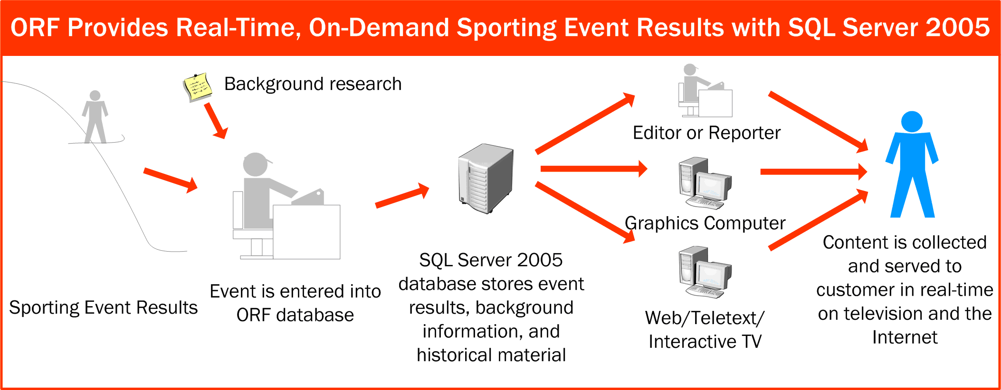
Figure 3: SQL Server 2005 enables ORF to enhance its sports broadcasts with real-time data and graphics. The improved development environment allowed ORF to add many more sports to the database than originally planned.

Conclusion
By optimizing their data management environment with SQL Server 20005, enterprise and midmarket companies are better positioned increase operational efficiency and take advantage of new growth opportunities.

Benefit from a trusted platform
SQL Server 2005 provides a comprehensive and reliable platform to run the most demanding and mission-critical applications. It contains advanced maintenance and backup capabilities that heighten availability and enable developers to create 24-hour-a-day, 7-day-a-week applications. The advanced security features and reduced administration in SQL Server 2005 protect confidential data from theft (or inadvertent exposure) while enabling administrators to shift from low-level tasks to more strategic activities through enhanced management tools and self-tuning capabilities.

Make better decisions
SQL Server 2005 provides significant improvements on business intelligence capabilities over previous releases of SQL Server. These capabilities give organizations the ability to understand the relationships between different parts of their organization, from the supply chain to merchandising strategies to manufacturing schedules. By unlocking valuable information from their data and turning it into actionable insight through analytics and reporting, business decision makers can make better decisions that result in higher revenues and lower costs.
More types of data can be analyzed, giving users a broader picture of their organization. Data analysis can be used to track current performance with key performance indicators so employees can receive real-time feedback. SQL Server 2005 also provides improved analysis capabilities, such as new data mining models, that enable users to see relationships that were previously unknown. Once relationships are discovered across business processes, managers can take advantage of this knowledge to improve decisions and better serve customers.

Deliver faster results
Improved developer tools and environment make applications built on SQL Server 2005 much easier to develop and maintain. Reducing development time by up to 35 percent not only decreases the cost of applications, it also helps companies stay ahead of their competition by releasing new applications faster.
Additionally, self-service reporting frees administrators from handling business users’ data requests, so they can focus on more strategic projects. Users can take advantage of the ad hoc analytics and reporting capabilities in SQL Server 2005 to gain access to real-time data, enabling them to respond faster to changes in key metrics.

For more information:
http://www.microsoft.com/sql/solutions/ssm/upgrade/default.mspx
http://www.microsoft.com/sql/

Did this paper help you? Please give us your feedback. On a scale of 1 (poor) to 5 (excellent), how would you rate this paper?

About the Author
Navigant Consulting, Inc., (NYSE: NCI) A specialized independent consulting firm providing litigation, financial, restructuring, strategic, and operational consulting services to large companies, government agencies, and legal counsel facing the challenges of uncertainty, risk, distress, and significant change. The Company focuses on industries undergoing substantial regulatory or structural change and on the issues driving these transformations. "Navigant" is a service mark of Navigant International, Inc. Navigant Consulting, Inc. (NCI) is not affiliated, associated, or in any way connected with Navigant International, Inc., and NCI's use of "Navigant" is made under license from Navigant International, Inc.

Appendix A: Case Studies
For detailed descriptions of real-world customer experiences using SQL Server 2005, see the following case studies:
Koehler Paper
Recall Corporation
Austrian Broadcast Corporation (ORF)

The metrics were calculated by third-party consulting firm Navigant Consulting Inc., based out of Chicago, Illinois, through interviews with customers who had deployed pre-release versions of the product. The pre-release version of SQL Server 2005, also known as the Community Technology Preview (CTP), is a free Web download available at: http://www.microsoft.com/sql/2005/productinfo/ctp.mspx, September 2005.
While database mirroring will be delivered after the release of SQL Server 2005, this feature is complete, has passed extensive internal testing, and will be generally available in the first half of 2006.

