Demo Script
E-commerce IN MICROSOFT DYNAMICS NAV
The Business Notification Feature

The Business Notification Feature

Introduction
This demo script describes the key functionality in Business Notification in Microsoft Dynamics_{TM} NAV*, in relation to Microsoft Dynamics NAV 4.0.
Business Notification in Microsoft Dynamics NAV helps better control your business processes to quickly identify and resolve business-critical issues.
Business Notification in Microsoft Dynamics is functionality with Microsoft Dynamics NAV that gives you the ability to automatically send notifications and alerts both internally (to employees) and externally (to suppliers, customers and other business partners). These alerts and notifications are sent via emails, based on business rules, determined by your business needs, set-up within your Microsoft Dynamics NAV solution. Microsoft Business Notification enables you to subscribe to the notifications and alerts from a number of out-of-the-box templates and/or more user-specific alerts based on your requirements. Microsoft Business Notification helps you monitor potential deviation of your business processes or status change within your Microsoft Business Solution.
Business Notification in Microsoft Dynamics NAV helps you save time, gain better control over, and integrate, your business processes and gives you to power to prevent, rather than react to, potential show-stoppers in your company processes.
With Business Notification in Microsoft Dynamics NAV you:
- Save time on tracking and monitoring your supply chain process, and focus on decision-making instead.
- Gain better control of your business with a complete overview of what’s happening in your supply chain.
- Integrate your business processes and benefit from the critical data within your business with alerts completely integrated to your Microsoft Dynamics NAV solution.
- Prevent problems occurring in your supply chain, rather than reacting to them after the fact.

Structure
This document contains information that will enable you to demonstrate the functionality in Business Notification in Microsoft Dynamics NAV.

It provides scenarios and instructions that illustrate some of the key features in Business Notification in Microsoft Dynamics NAV.

This demo focuses on the following features:
- Business Notification Scheme Setup
- Subscribing to Notifications:
- Business Notification Worksheet Setup

Target Audience
The demonstration targets potential and existing customers of Microsoft Dynamics NAV, with a main focus on supply chain management, and those who want to gain a better control of their supply chain processes. The demonstration can be done for future users of the system, for sales, purchase and production managers, as well as for any decision maker within a company.
It can also be used to demonstrate the product for our partners in the channel who need to get more familiar with the new alerts and notifications functionality within Microsoft Dynamics NAV 4.0.Important Demo Data Guidelines
In order to use this script, you need to make sure that you follow the exact tasks throughout the demonstration. We have invented the scenarios to make it easier for people to understand how Business Notification in Microsoft Dynamics NAV can be used by employees in the sales, purchase and production departments of a company.

As a general rule, keep to the suggested records during the demo because these records have a large amount of demo data associated with them.

SetUP Instructions
Demo installation requirements:
In order to run this demo, we recommend that you install the Business Notification solution on a server that you can access from clients. The clients are connected to the server via your local network or via a secure connection to your server for remote demos, (for example, when visiting customers)
The software requirements for the server and clients are listed below:
Software components required:
- Microsoft Windows Server 2000 or 2003
- IIS (Internet Information Service) 5 – or 6
- Microsoft SQL 2000A, Developer edition + service pack 3A
- Microsoft SQL- Notification Service
- Business Notification server
- Microsoft Navision database server
- Connection to your SMTP server (for distributing E-mail notifications)

Client software components required:
- Microsoft Windows XP
- Microsoft Navision client
- VPN- software for access to your local network
Before you start, please read the important setup notes below:
Setup Instruction | Reason
- Important!!: Do not change the system date when running this demo!! | Changing the system date would make the SQL-NS server crash, and it would be impossible to recover the lost data.  Note however that there is no problem with the handling of wintertime and summertime changes.
- Create a new purchase order, using the vendor and items of your choice. In the Order Date field, enter todays date (system date), - minus 4 days. Do not enter any promised reciept date in the orderline(s). Remember to release the order. | When searching for unconfirmed orders, the system uses the date in the Order Date field on the Purchase Order form, and checks if any date was entered in the Promised Receipt Date field.  The work date in Microsoft Dynamics NAV (Cronus) will not influence this demo.

DEMO Scenarios

1. Business Notification Scheme Setup
The purchasing dept. at Cronus would like to have better control of their supply chain activities. For example, they would like to avoid late deliveries from their suppliers. To do that, they have several possibilities. One of them is to ask the system to send them notifications when purchase orders have not been confirmed by vendors, 4 days after they were released.
In this scenario, you will use the Business Notification Manager window to set up the system to send notifications to Cronus purchase manager when suppliers haven’t confirmed the delivery of goods
What to do | What to say | Screen shots
- Open the Microsoft Windows start menu. Select All Programs, Business Notification Manager in Microsoft Dynamics NAV. The Business Notification Manager window appears. | Business Notification in Microsoft Dynamics NAV is offered with 6 pre-built templates. These templates are out-of-the box functionality that we provide you with the release of Microsoft Dynamics NAV 4.0. They were developed to cover and solve problems around the supply chain business processes. Using these templates, you will only need to follow a few steps to start using Business Notification in Microsoft Dynamics NAV.  You use the Business Notification Manager window to to set up new, change or delete existing schemes.  You will not need to use this window for a scheme after the scheme is up and running. | 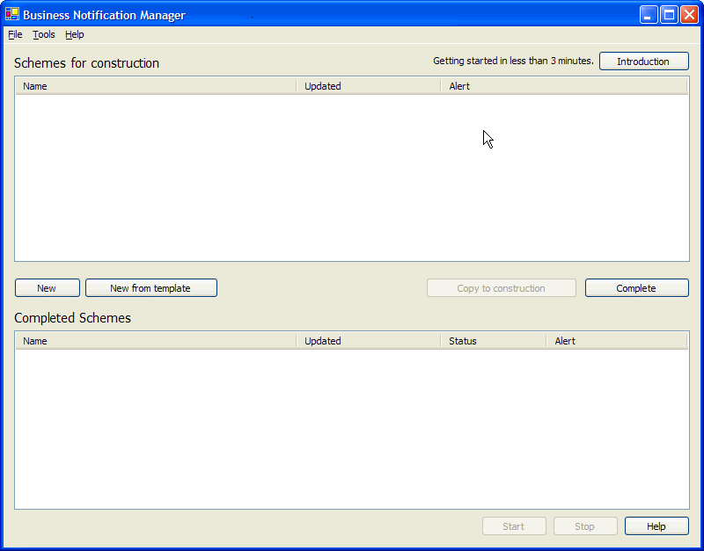

What to do | What to say | Screen shots
- To start setting up the business notification scheme, on the Business Notification Manager window, click New from Template. The Notification Manager – Templates window appears.  - Select Purchase order not confirmed and click New from Template. The Purchase order not confirmed – Notification Scheme window appears. |  | 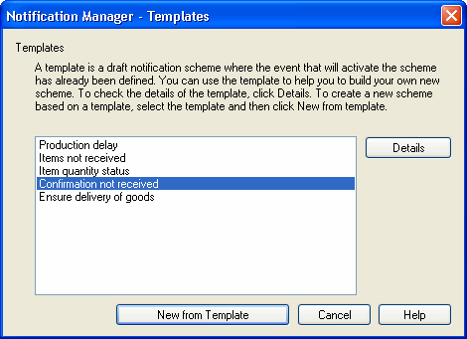
- In the Notification scheme window, in the Scheme Name field, enter a name for the new scheme, for example “Demo Scheme”.  - Click Select Event to view the entities and events avaliable.  Note: Do notselect another event. Doing this would change the template you selected. Viewing this window is only for informational purposes. | Mention that in this window its possible to select an event /entity and in this way define a new scheme from scratch.  Partners can use this window, by selecting a template, to preconfigure schemes. | 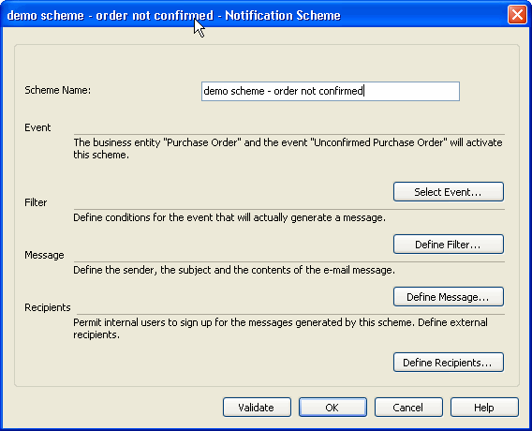

What to do | What to say | Screen shots
- Click OK to return to the Notification Scheme window. | Notification scheme:  Mention that it is possible to set up additional filters, for example you can set up a filter to receive notification only about the purchase orders that are relevant for you. That could be purchase orders regarding specific items or from specific vendors or group of vendors
- In the Notification Scheme window, click Define filter.  Note that viewing this window is only for informational purposes. For this demo, you do not need to set up filters.  - Click OK to return to the Notification Scheme window |  | 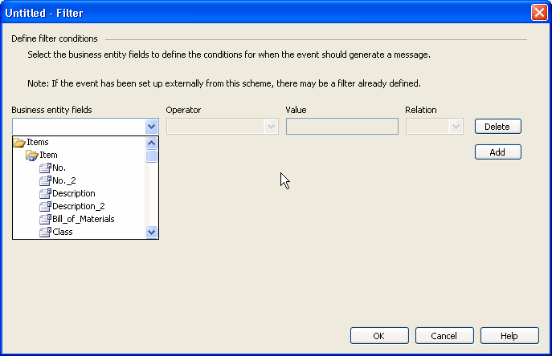
- In the Notification Scheme window, click Define Message. A new window appears.  - In the From field, enter the sender’s e-mail address (your own),  - Enter a subject text in the Subject field, for example “Confirmation Not Received”  - In the Contents field type the message you want to send to the recipient of the email.  Note: Remember to use business entity fields, for example the purchase order number, the Buy_from_Vendor_No., etc.  When finished, click OK to return to the Notification Scheme window | In this window you can enter details about the notification email that will be sent , every time the event occurs, in this case, every time an order confirmation is not received. You can enter different type of information in the Contents field, for example the number of the related purchase order, and other fields from the Microsoft Dynamics NAV application, as well as text, to ensure that the receipient understands what the message is about | 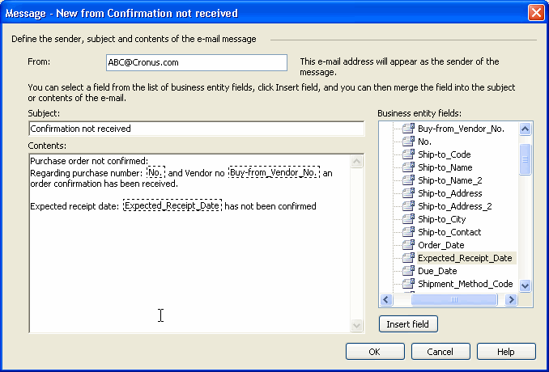
- In the Notification scheme form, click Define recipients. The Recipients window appears.  - In the Recipients window, click the External Recipients tab.  - Click to select “Send message to external recipients”. In the Recipients field, enter the recipient’s email address.  (Note: In this demo we will only select external users, because internal users are selected from Microsoft Windows active directory , which is not accesible in this demo.) | With Business Notification in Microsoft Dynamics NAV you can send notifications to your business partners. In this tab you can define a list of recipients with permissions to subscribe to the event.  In order for internal recipients to avoid spamming, it is not possible for the power user to determine who must receive mails internally. Potential recipients can subscribe and unsubscribe to schemes according to their own needs.  You would normally agree with external recipients before you set this up. | 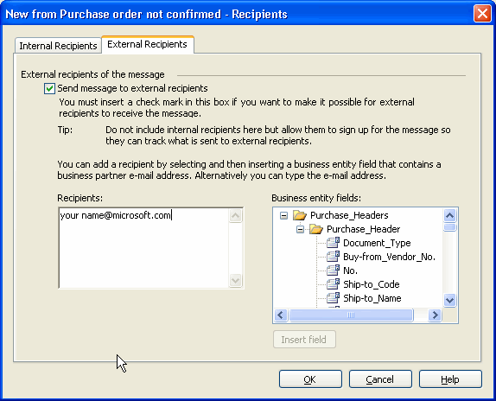

What to do | What to say | Screen shots
- Press the OK button, and The Purchase order not confirmed – Notification Scheme window appears.  - Press the OK button in the Notification Scheme window. | Note that it is possible for the power user to start and stop any scheme at any time . | 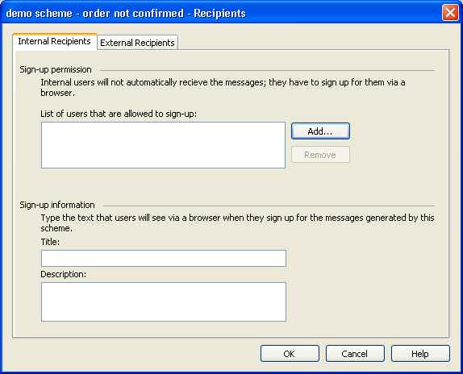
- Now the scheme is ready to be completed. Click Complete in the Notification Scheme window. The scheme is then placed in the run-time environment.  Note: in order for this notification to work, you must activate it. |  | 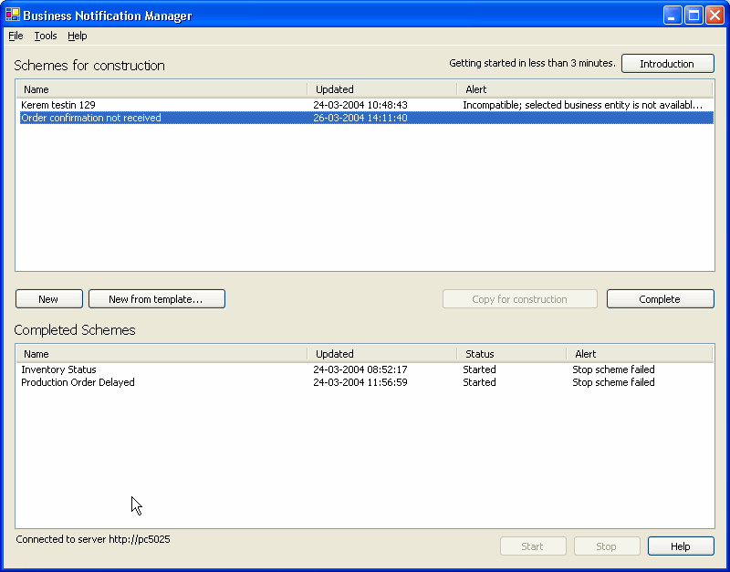
- In the Business Notification Manager window, select the scheme you have just created and click Start | This example demonstrates how fast and easy it is to set up schemes using Business Notification in Microsoft Dynamics NAV. You can set up as many schemes as you would like and have them running concurrently.  Ask if they would like you to show one more example of how to set up a notification scheme. | 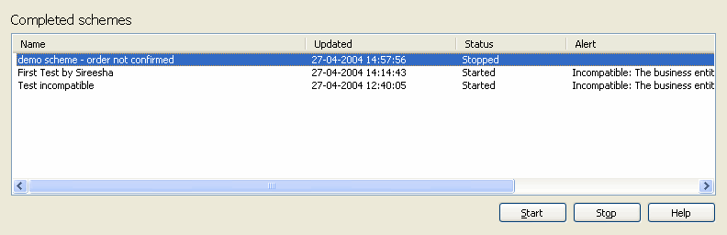

2 Optional Scenario: Subscribing to notifications
Optional Scenario 2: This scenario is an extension to scenario 1. It is optional. To perform this scenario, you need to have access to the Microsoft Windows Active Directory via a network connection. If this is not the case, you should define yourself as an “external recipient”, as showed in scenario 1. Internal recipients are defined as employees within the company, and thus members of Microsoft Windows Active Directory. External recipients are not members of the active directory
In this scenario, we will show how the internal recipient can subscribe to the scheme that the power user has activated in scenario 1.
What to do | What to say | Screen shots
- Open your browser and access the subscription site: (http://<servername >/business notificationssubscribe )  - Click Add New. A list of the avaliable schemes appears. | Users (internal or external recipients) use this site to subscribe and unsubscribe to the schemes, and view schemes status. . This is not done in Microsoft Dynamics NAV In order to enable non-Microsoft Dynamics NAV users to subscribe and to see the status of the scemes they subscribe to  . | 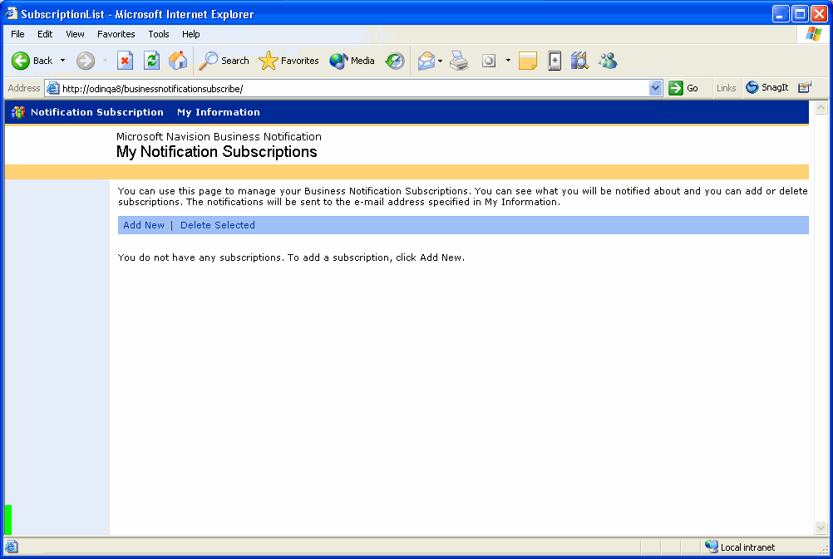
- Click to insert a checkmark in the box related to the schemes you want to subscribe to. | You can subscribe to as many notifications as you need. And unsubscibing is a simple procedure, that only takes a couple of steps. | 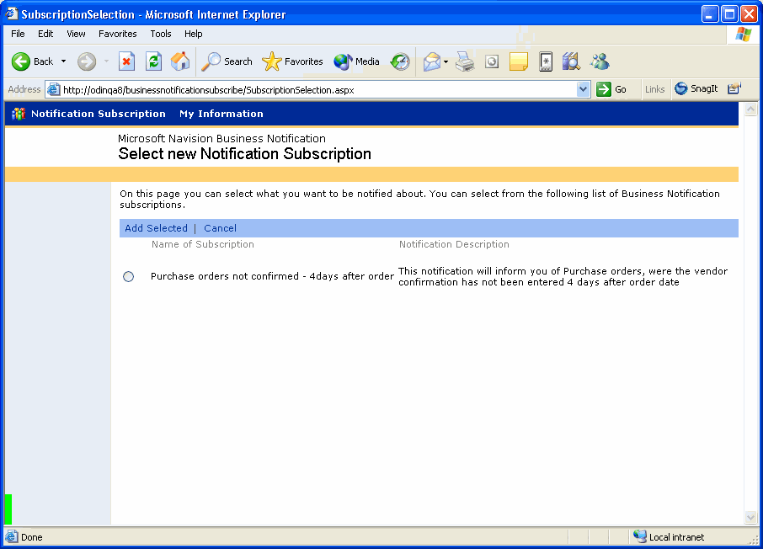

3 The Notification Worksheet Setup
This scenario is a continuation of Scenario1: In the first scenario, we showed you how to set up business notification schemes. In order for these notifications to work, you must set up and run the Business Notification worksheet inside Microsoft Dynamics NAV. This Scenario describes how to set-up and run another of the Out of the Box notifications, the “unconfirmed purchase order” notification.
What to do | What to say | Screen shots
- Before going to the notification worksheet, you must enable the C/AL code to run in Microsoft Dynamics NAV. To do that, in the Microsoft Dynamics NAV menu click Administration /IT-Administration / General Setup /Business Notification Setup. | Explain that in order for the business notifications that you have set up to work, you must define and run events from inside Microsoft Dynamics NAV.
- In the Business Notification Setup window, click to insert a checkmark in the Send Notification field |  | 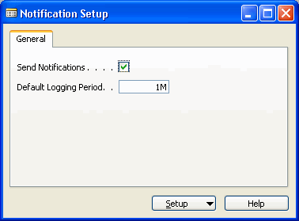

What to do | What to say | Screen shots
- In the Microsoft Dynamics NAV menu, click Purchase, Order Processing, Business Notification Worksheet. The Notification Worksheet window appears.  - In the Batch Name field, select the purchase dept. batch name,. Purchase. Alternatively you could use use the Default batch name.  - Click the AssistButton in the Notification field . The Notifications window appears. | You can use the Notification Worksheet window to run batches for “time-based events”, i.e. events that are triggered by a change of date and something happening or not happening in Microsoft Dynamics NAV. The events that are triggered by the changes made to the contents of a field do not require that you run a periodic batch, because the event happens when the defined field is changed. When the field changes, the relevant data is exported out through a XML-port. | 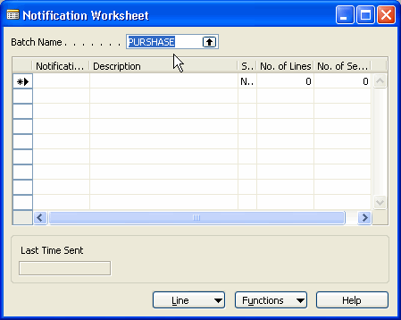
- In the Notifications window, select Unconfirmed Purchase Order (POCONF),and click OK. The notification is now added to the batch in the worksheet | It is possible to have more users or departments run their own batches, with their own events.  Note: In the Notifications window, you can see all the avaliable notifications. In this window you can select one or all of the out of the box notification to the worksheet batch you want to run regularly. | 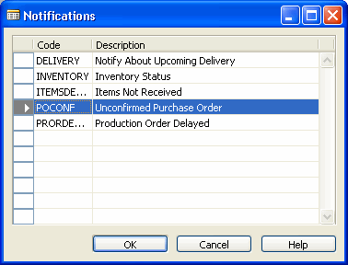

What to do | What to say | Screen shots
- In the Notification Worksheet. Window, click Line, Suggest Notification Lines. The Unconfirmed Purchase Order window appears.  - On the Options tab, you can select the number of days after the order release date you want to be notified In the No. of Days Purch. Ord. field, enter 4 days). Click Ok. | The number of days you enter here should be less than difference between order date and system date.  In this case, when running the batch today, the worksheet will search for e.g. purchase orders that were released with an order date 4 days ago.  The time settings are saved, so you don’t’t have to enter a value every time you run the batch.  This means that there is currently one purchase order that wasn’t confirmed by the supplier within the timeframe you set up.  When the worksheet has found the purchase orders that fulfills the criteria, it is possible to view details and remove those for which you don’t want to send notifications. | 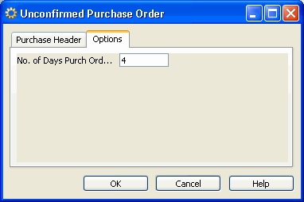
- In the Notification Worksheet window, click OK.  The worksheet batch starts searching for purchase orders that have not been confirmed (promised receipt date field is not filled in, within 4 days after released date). A dialog box informs you that “1 lines were found”, equals one purchase order. Click Ok | After the notification has been sent, the Notification Worksheet window is empty. | 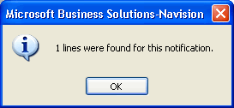
- To have the system send notifications about the unconfirmed purchase order in the Notification Worsheet window click Functions, Send to Business Notification | You can repeat the same procedure tomorrow to check for new unconfirmed purchase orders.  If the system finds unconfirmed purchase orders that were also found previsouly and for which notifications were sent, a message appears to inform the user about it. It is then possible to only send notifications about newly found purchase orders.  This allows you to check which notifications will be sent and avoid sending the same notification to a recipient every day until the confirmation is received.  In the column “No of sent lines” you can see if purchase orders have been sent previously. | 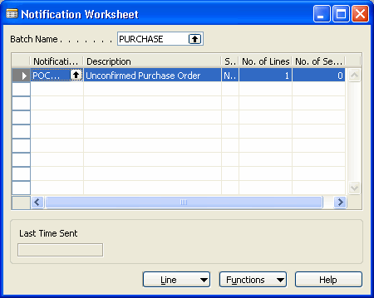
- Open your Microsoft Outlook e-mail account and show the message that you have received The screenshot shown, illustrates what the E-mail looks like in Outlook Express |  | 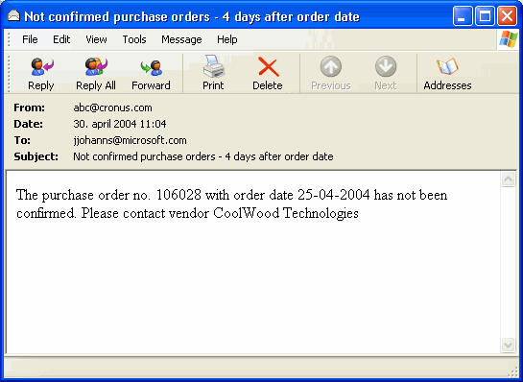

Conclusion
Sum up by repeating the main benefits of Business Notification in Microsoft Dynamics NAV.

Business Notification in Microsoft Dynamics NAV is an easy-to-use functionality within Microsoft Dynamics NAV that generates e-mail messages to your employees, suppliers, partners, and customers to inform and alert them of critical business conditions. It was designed to help you manage your business effectively; focus on information that matters to you. It allows you to better keep track of your supply chain processes, and resolve issues before they become a problem.

Add that, with the help of their Microsoft Certified Partner, Business Notification in Microsoft Dynamics NAV can be tailored to suit the needs of their business.

* Microsoft Dynamics NAV, formerly Microsoft® Business Solutions–Navision®

