
Employee Utilization

Microsoft Dynamics™ SL

Benefits
- Increase productivity
Set goals for billable time, and then track hours and revenues against those goals
by employee, project, department, or other employee grouping.

- Motivate employees
Build and support employee incentive
systems with accurate performance data based on the achievement of billing
and productivity goals.

- Improve analysis accuracy
Incorporate account margins, labor
multipliers, and billing write-ups and
write-downs into realization results without manual calculations.

- Efficiently manage timekeeping
variables
Choose to exclude non-billable time
such as vacation, sick leave, or jury
duty from realization figures.

- Tailor analytical options
Create multiple utilization types, and
summarize data by any time period
and employee grouping you like for convenient analysis.

Get the information necessary to improve the profitability of service professionals and other human resources. Track personnel availability, billable time, revenues, and the realization of established utilization
goals. View timecard line-item detail, or speed up analysis by customizing and summarizing data in a variety of groupings and time periods.

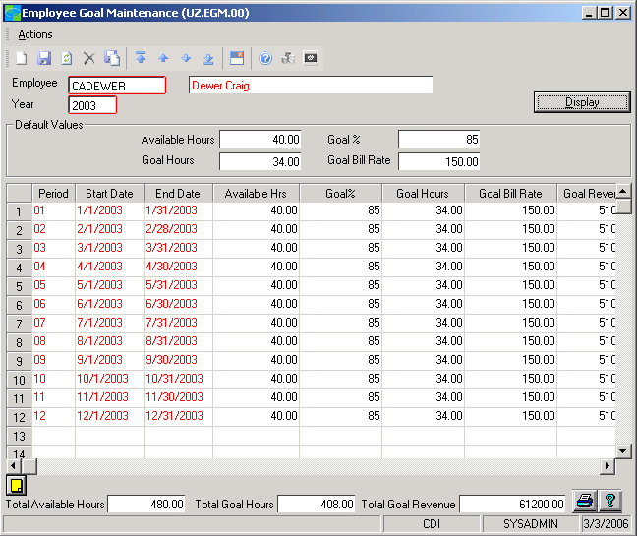

Quickly View
resource goals and performance to adjust to new business demands.

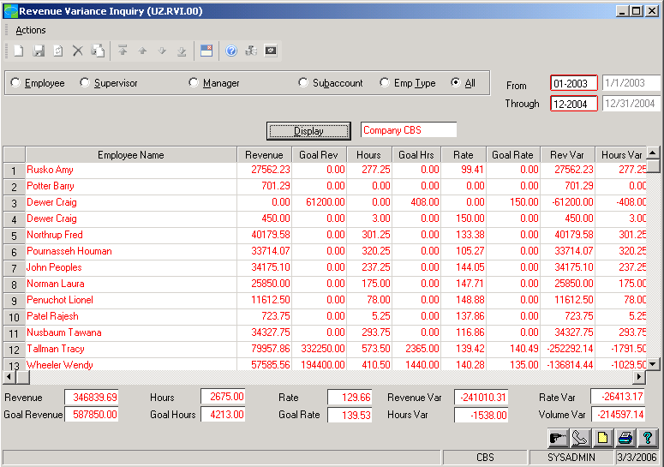

Gain insight
into resource-generated revenue tracked against original goals.

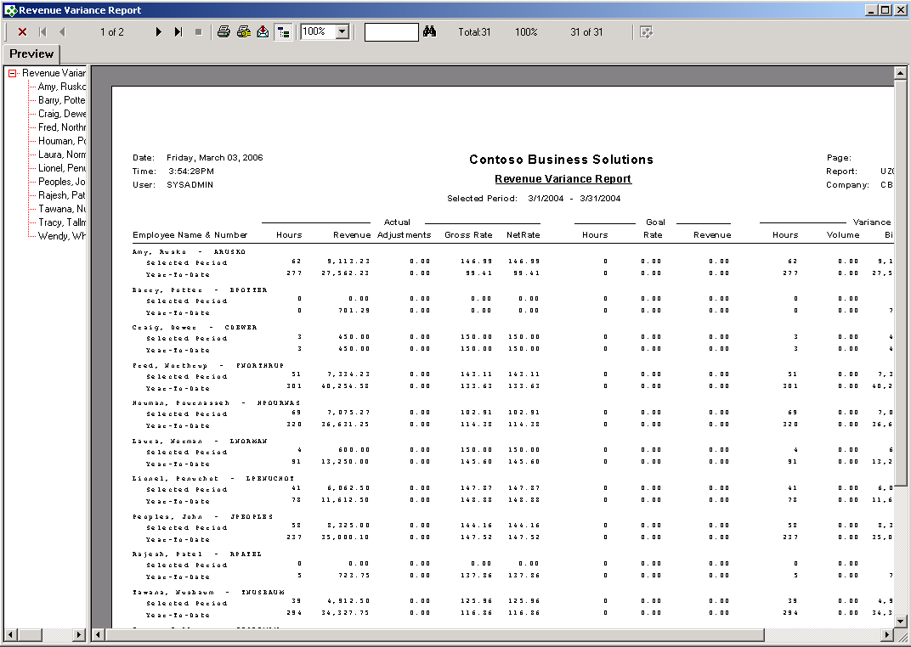

Filter
detailed revenue information
by time period to view revenue variance(s) and monitor overall performance.

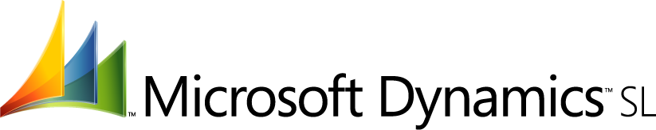

FEATURES

BENEFITS

Productivity Management Support | Easily track available and billable time by employee, project, or  Employee group.
Automated Target Tracking | Establish goals for billable time, utilization percentages, and revenues,  and then automatically calculate realization results over time.
Flexible Data Views | Identify convenient time periods for tracking and summarizing utilization.  Then view information by employee, project, custom groupings such as  departments or labor types, or even timecard line-item detail.
Time-Saving Computations | Automatically account for margins, labor multipliers, write-ups, and  write-downs in the billing process.
Expense Tracking | Determine the overall profitability of employee activity by tracking  related expenses such as travel costs.
One-Time Data Entry | Save time and prevent entry errors by connecting information across  Microsoft Dynamics SL.
Advanced Analysis Options | Instantly export utilization data to Microsoft Excel for advanced analysis.

This document is for information purposes only.
MICROSOFT MAKES NO WARRANTIES, EXPRESS, IMPLIED, OR STATUTORY, AS TO THE INFORMATION IN THIS DOCUMENT.

© 2005 Microsoft Corporation. All rights reserved.
Microsoft, The Microsoft Dynamics Logo, are either registered trademarks or trademarks of Microsoft Corporation or Microsoft Business Solutions ApS in the United States and/or other countries. Microsoft Business Solutions ApS is a subsidiary of Microsoft Corporation.

For more information about Microsoft Dynamics™ SL, visit: http://www.microsoft.com/dynamics/sl

