What language barrier? Find improved tools for translation in Word
Word 2010 has great tools for anyone who’s ever worked with someone—a coworker, customer, or entire market segment—who speaks a language different than their own. And when working in a second or third language, it really helps to have easy translation options readily available.

Using Translation Tools in Word 2010
Translate a word, phrase, whole paragraphs, or even the entire document into a different language with Word 2010’s translation tools.
Step by Step:
- Start with a Word document you’d like to translate, and decide how much you need translated. | 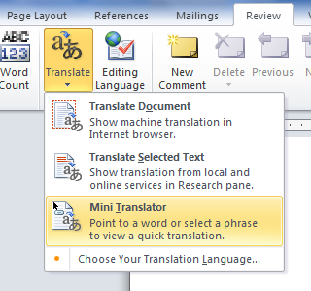
- On the Review tab of the Ribbon, in the Language group, click Translate. You see the following options: Translate Document, Translate Selected Text, and Mini Translator.

- Translate Document takes you out of Word and into the browser, where you see an instant machine-generated translation of your document.
- The Translate Selected Text option opens the Research pane that you may know from earlier versions of Word. You see translations in the Research pane and can easily change translation languages for the selection.
- Finally, the improved Mini Translator allows you to point to a word and view an instant translation in a screen tip.
To enable the Mini Translator, on the Review tab, click Translate and then click Mini Translator. You will be automatically prompted to select a translation language.
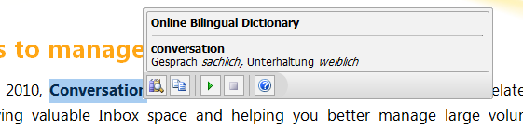
Note: Get extra help from the Mini Translator for English as a second language. Click the green arrow icon, as shown in this image, for English text-to-speech playback of your selected term.

Check out the translation tools in Excel 2010, OneNote 2010, PowerPoint 2010, Publisher 2010 and Outlook 2010 to help you overcome communication barriers today!

