

BizTalk Server 2006
Business Activity Monitoring

Microsoft Corporation
Published: April 2005

Abstract
This paper provides a detailed description of two new Business Activity Monitoring (BAM) features in BizTalk Server 2006; the new BizTalk BAM Portal which works with Sharepoint Portal Services and Alerting/Notification Support which takes advantage of the improved capabilities of SQL Server 2005. Additionally we will review some of the enhancements to the existing BAM features of BizTalk Server.



This is a preliminary document and may be changed substantially prior to final commercial release of the software described herein.
The information contained in this document represents the current view of Microsoft Corporation on the issues discussed as of the date of publication. Because Microsoft must respond to changing market conditions, it should not be interpreted to be a commitment on the part of Microsoft, and Microsoft cannot guarantee the accuracy of any information presented after the date of publication.
This White Paper is for informational purposes only. MICROSOFT MAKES NO WARRANTIES, EXPRESS, IMPLIED OR STATUTORY, AS TO THE INFORMATION IN THIS DOCUMENT.
Complying with all applicable copyright laws is the responsibility of the user. Without limiting the rights under copyright, no part of this document may be reproduced, stored in or introduced into a retrieval system, or transmitted in any form or by any means (electronic, mechanical, photocopying, recording, or otherwise), or for any purpose, without the express written permission of Microsoft Corporation.
Microsoft may have patents, patent applications, trademarks, copyrights, or other intellectual property rights covering subject matter in this document. Except as expressly provided in any written license agreement from Microsoft, the furnishing of this document does not give you any license to these patents, trademarks, copyrights, or other intellectual property.
Unless otherwise noted, the example companies, organizations, products, domain names, e-mail addresses, logos, people, places, and events depicted herein are fictitious, and no association with any real company, organization, product, domain name, email address, logo, person, place, or event is intended or should be inferred.
© 2005Microsoft Corporation. All rights reserved.
Microsoft, Microsoft, Active Directory, BizTalk, Outlook, and Windows are either registered trademarks or trademarks of Microsoft Corporation in the United States and/or other countries.
All other trademarks are property of their respective owners.
Contents
Introduction 1
The BAM Portal 2
Activity Search Page 3
Aggregations Page 3
Alert Manager 5
Alerts and Notification Support 6
Configuring an Instance Data Alert 6
Configuring an Aggregated Data Alert 8
Editing an Alert 10
BAM Interceptor for Pipelines 12
Expose BAM Web Service 13
BAM Manager Enhancements 14
Excel Improvements 15
Summary 16
For more information 17

Introduction
BizTalk Server 2006, Microsoft’s premier server for building solutions for business process and integration, expands on the Business Activity Monitoring (BAM) capability released with BizTalk Server 2004. BAM is a set of tools and services that allow an information worker to monitor transactions, in aggregate or real-time, and get visibility into the key performance indicators of a running business process. Through the course of this document we’ll look at the newly introduced features such as the BAM portal, the ability to create subscriptions and receive notifications. Finally we we’ll highlight the enhancements to existing functionality such as the BAM manager, the Excel design template and the BAM web services.

The BAM Portal
BizTalk Server 2006 introduces a new delivery channel for Business Activity Monitoring. The BAM Portal is web application that enables the transactional data from within the business processes to be fully exposed with the SharePoint Portal Server.
As you can see from Figure 1, The BAM portal is made up of three frames:

- My Views - This is the frame at left, which shows the user any and all views to which they have been granted permission. The user can expand any view to see the various features available to the user for that view context. If there are no views shown, it is because none have yet been created (typically a business analyst task), or permissions have not been granted to the user in question (typically an IT Administrator task)
- Content - This is the right frame through which the various portal pages provide their features. This is the main section of any page
- Banner - This is the frame across the top which holds branding, access links for help, page titles, etc

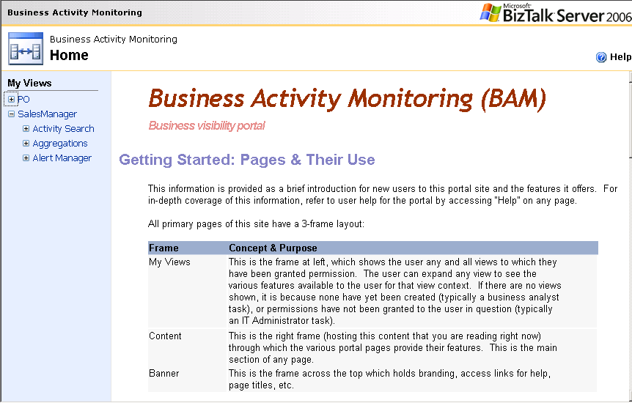
Figure 1: BAM Portal Home Page

Each view available to the user contains three sub pages:
- Activity Search
- Aggregations
- Alert Manager
Let’s take a look at each of these sub pages in more detail.

Activity Search Page
The Activity Search Page is used for performing searches against the BAM data to find specific cases of a particular process. As you can see from Figure 2, the Activity Search Page has 3 main sections inside the Content frame:
- The query – users specify what records to search for based on the value of specific tracked items by adding and removing search clauses;
- The presentation – users specify which items of data (from those available in that view) to return if any records match the search criteria;
- The results – anything matching the search will display in this section.

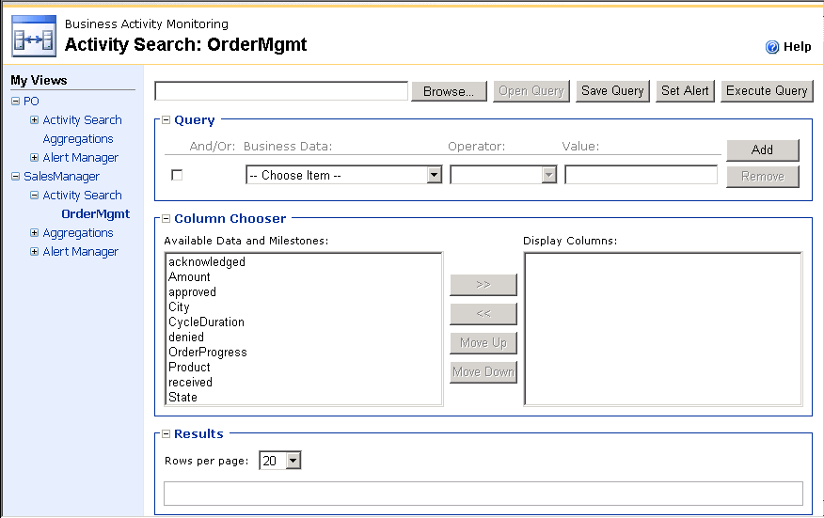
Figure 2: BAM Portal Activity Search Page
Queries can be saved and reused. They can also be the basis for an alert (e.g. notify me any time a purchase order arrives from Contoso Parts Ltd.). Saving, opening, or running queries, as well as setting alerts, are functions exposed as buttons at the top of the page

Aggregations Page
The Aggregations page, as implied by the name, provides a means for presenting aggregate data. As see in figure 3 the aggregations pages contain a graphical chart along with an accompanying pivot table. In some cases, views may not have aggregations associated with them, and therefore there may be nothing to access. This all depends on how the view was originally created. This page compliments the Activity Search. Where Activity Search is use to find specific cases of a particular process, Aggregations are point-in-time snapshots of many cases of a process that collectively speak to the health of that process or the overall business. For example, a user may wish to see a simple pie chart that shows a breakdown of the 1,000 invoices received today in terms of what stage of processing has been reached by each invoice (400 still in “evaluation,” 400 rejected, 100 paid, and 100 still in “fund allocation”).

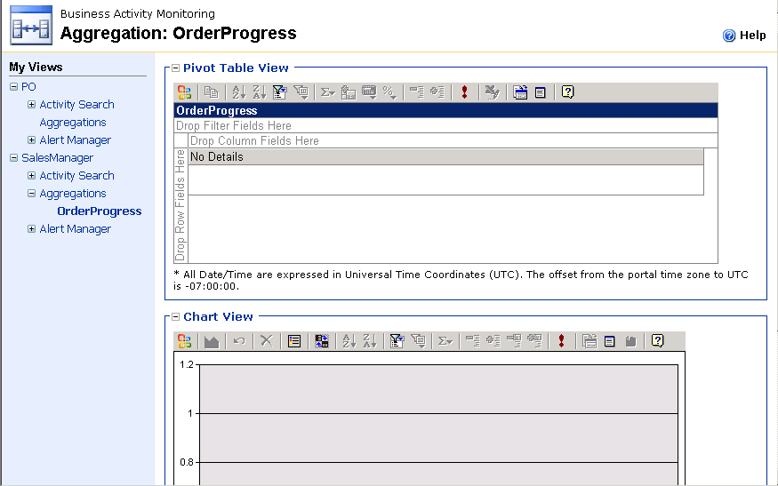
Figure 3: BAM Portal Aggregation Page

Similar to Activity Search, data presented on this page can be the basis for creating an alert (e.g. notify me if there are ever more than 500 invoices in the “evaluation” stage of the process). This is accessed by right-click on any pivot table cell and selecting “Set Alert,” or placing focus in a cell and hitting the “Set Alert” button at the right of the pivot table. See “Alert Manager” page below for construction of an alert.

The user can also select any aggregate amount (e.g. 400 invoices still in “evaluation”) and see the underlying individual cases. This is also accessed through right-click as well as placing focus in a cell and hitting the corresponding “Show Details” button. In response to this action, the user is sent to the Activity Search page, the search itself is automatically constructed for them, and the results are shown (i.e. one record for each of those 400 invoices).

Alert Manager
The Alert Manager page allows a user to create a new alert, or edit an existing one. It is very important to note that the “Set Alert” user action must be initiated from either the Activity Search or Aggregations pages (more on alerts later). Specifically, those other two pages are the means by which the user can define the condition they want to be monitored, either single case (PO arrived from Contoso) or aggregate (invoices in evaluation < 500).

Once the user has employed either the Activity Search or Aggregations page to define the condition, the Alert Manager allows a user to fill in all the relevant facets of an alert, such as who to notify, how (e.g. e-mail), whether others can see and/or subscribe to the alert, etc.

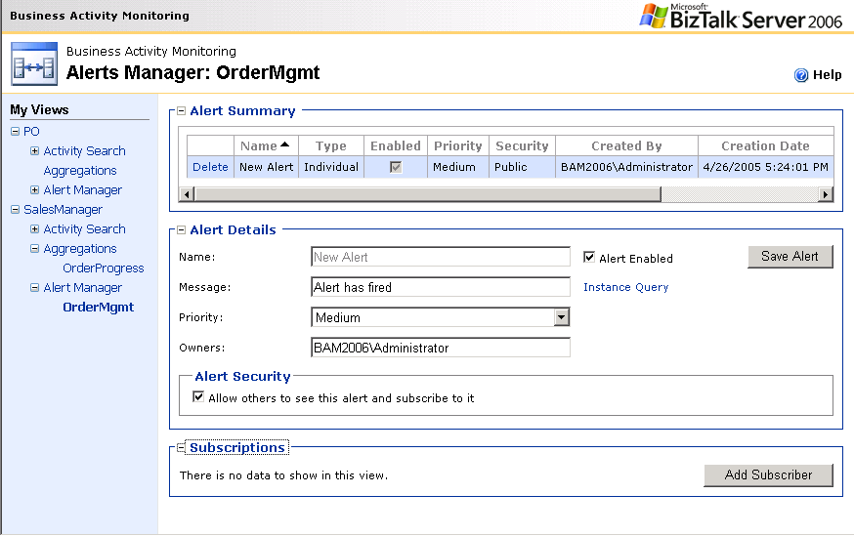
Figure 4: BAM Portal Alert Manager Page

As you can see from Figure 4, the Alert Manager is broken into three sections in the Content frame:
- Alert Summary – this is a data grid that shows the user any alerts defined for the view context which is public.
- Alert Details – users click on rows in the Alert Summary to display in this details section all the facets of how that alert is defined.
- Subscriptions – though sometimes hidden (in the case of new alert creation) this section is where users add themselves to the set of people who are notified when an alert actually fires.

Note: Key new feature, in the BAM portal is the ability to execute live data drill-through (from aggregate to instance)

Alerts and Notification Support
BizTalk Server 2006 introduces the ability to receive notifications or alerts related to BAM events. Out-of-the-box, BizTalk Server 2006 provides threshold alerts based on a specific cell of a multi-dimensional aggregation. Alerts play a vital role in notifying business users about real time changes in their business processes.

Alerts are defined using the “Alert Manager” from the BAM portal. The Alerts Manager page helps the user define an alert by collecting the relevant data. Alerts can be defined against two types of data:
- Instance Data – In this scenario the alert is based on a single occurrence of a condition (e.g. PO total amount over $10,000 with PO evaluation taking longer than a day), these alert are defined using the activity search page
- Aggregated Data – In this scenario the alert is based on aggregation across some span of records.
These types of alerts are defined using the Aggregations page of the BAM activity.

Configuring an Instance Data Alert
Conditional alerts based on a single instance of the data are created using the Activity Search query builder. There is a button called “Set Alert” which invokes the Alerts Manager page as seen in Figure 5.

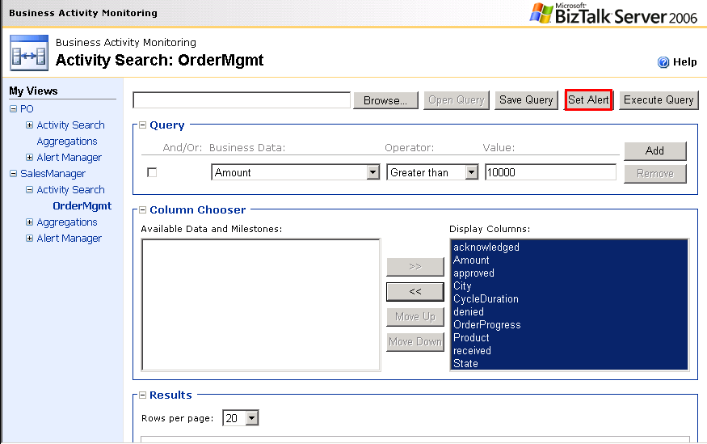
Figure 5: BAM Portal Configuring an Alert

Once the Alert Manager page, as seen in Figure 6, is launched, the user must define:
- The Name of the Alert
- Owner of the Alert
- The Message that should accompany the alert
- Priority of the email notification

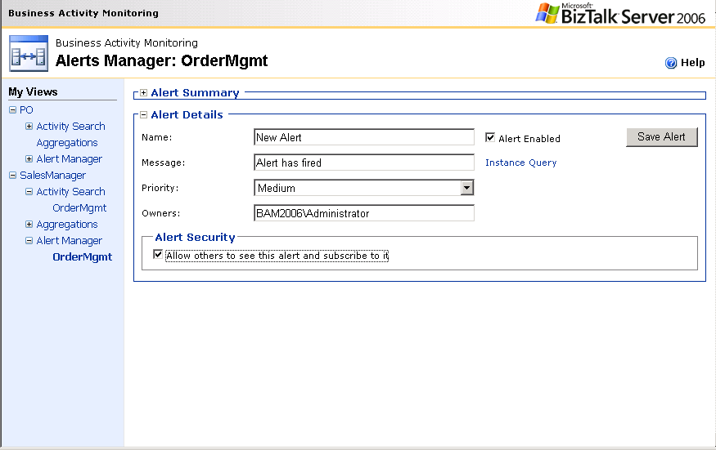
Figure 6: BAM Portal Alerts Manager Page

There are two differences between aggregate and instance alerts:
- Threshold – built into the query, not present as an alert configuration item
- Moving window of underlying data – only applies to aggregation across some span of records.

Configuring an Aggregated Data Alert
Aggregated Alerts are created using the Aggregations Page. As seen in Figure 7, there is a popup menu available when right clicking on the chart view. From this menu there is an item “Create Alert” which invokes the Alerts Manager page as seen in Figure 8.

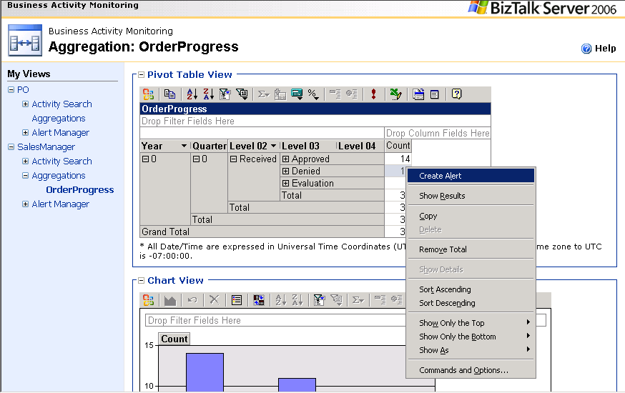
Figure 7: BAM Portal Aggregation Page

The cell is already identified (along with associated axes) via selection, but the user must also define:
- The Name of the Alert
- Owner of the Alert
- A threshold value
- List of subscribers
- Priority of the email notification

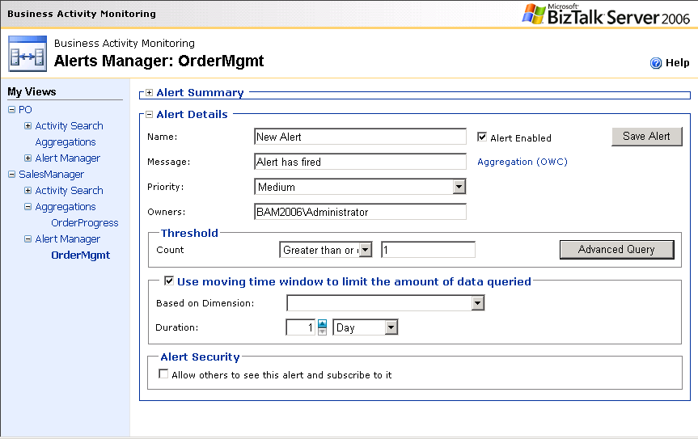
Figure 8: BAM Portal Alerts Creation Page

In the case where the user needs to set an alert on one or more dimensions (values) not shown/available in the aggregation, the Alerts Manager page includes an “Advanced Query” button for invoking a Advanced Query Editor, seen in Figure 9, which allows a user to edit the dimensions used to configure the alert.

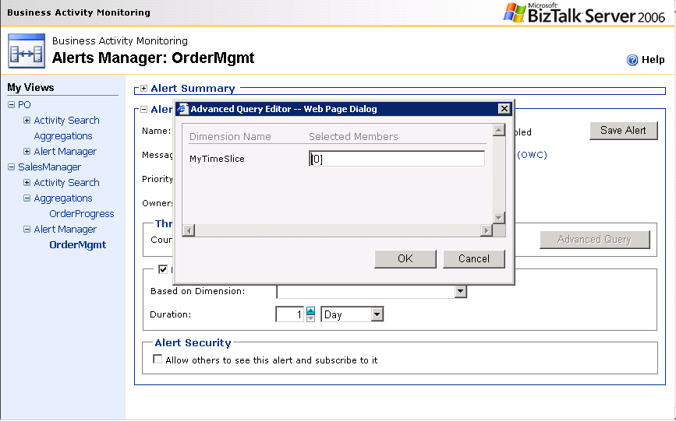
Figure 9: BAM Portal Advanced Query Builder

Editing an Alert
Alert can be edited or managed using the Alert Manager page. As seen in Figure 10, the Alerts Manager page includes information for alerts based on both aggregate and instance data. The summary grid (called “Alerts Summary”) at the top of the page includes a column called “Alert Type” the values of which can be “Individual” or “Aggregate.” The details shown in “Alert Details” section of the page will always be for the row in the grid which has focus.
Figure 10: BAM Portal Editing an Existing Alert

BAM Interceptor for Pipelines
In BizTalk Server 2004, the tracking profile editor was a visual tool that allowed a developer to capture BAM data from an orchestration. Today there are still a significant number of scenarios that require BizTalk Server in pure messaging. To leverage BAM in messaging scenarios, custom pipeline components had to be written using the BAM API (application programming interface).

BizTalk Server 2006 simplifies the process and makes BAM more accessible to messaging and business process scenarios through a newly introduced pipeline interceptor. Additionally, the Tracking Profile Editor “TPE” has been enhanced to support orchestrations, as in BizTalk Server 2004, or retrieve messaging property schemas as seen in Figure 11.

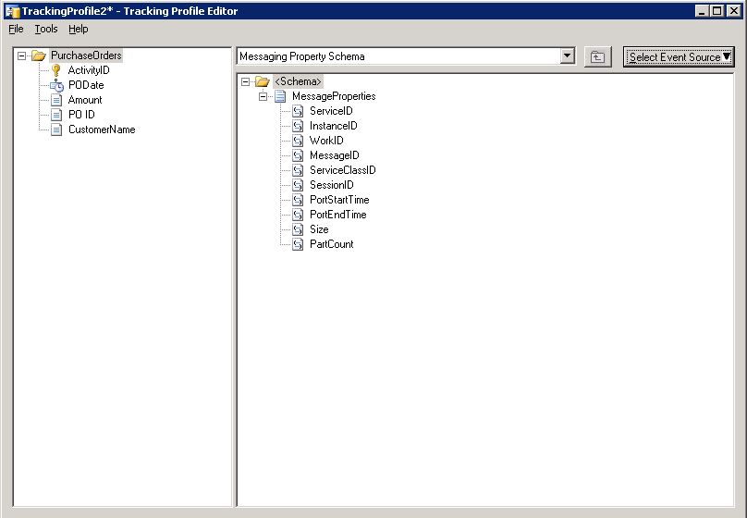
Figure 11: BizTalk Server 2006 Tracking Profile Editor

Expose BAM Web Service
BAM in BizTalk Server 2006 builds on the existing Web Services available in BizTalk Server 2004. The enhanced web services interface now exposes; the query of aggregate and instance data, creation of alerts and retrieval of BAM configurations. This enhanced web services interface means that custom application can be developed, exposing BAM within their user interface.

The BAM web services are grouped into two categories:
- BAM Query Service – The service is used by the BAM Portal to retrieve BAM instance data. The service supports the infrastructure and is not intended to be used directly from your code. The service is not supported and is not documented. To retrieve instance, use the supported techniques described at http://msdn.microsoft.com/library/en-us/BTS06BizProcessMgmnt/html/ae4a8854-d5c2-4b36-a0ef-3f74e138306e.asp?frame=true.
- BamManagementService – The following service provides, consumers the ability to manage subscriptions and alerts among other management operations

BAM Manager Enhancements
The BAM management utility, or BAM Manager, is a command-line utility that consumes the XML defined using the BAM Excel template. Business analysts use the BAM Excel template to define the events and data to track, along with the logical groupings and aggregations of the tracked data views that users can access.

BizTalk Server 2006 introduces a number of enhancements to the BAM manager these enhancements include:
- Change-on-the-Fly – A common complaint from BizTalk Server 2004 customers is not being able to quickly redeploy a business activity that has just a small change (e.g. track one additional item) and being forced to un-deploy and redeploy the entire business activity. This can be tricky given the fact that data has already been collected in the live production environment, and un-deploy/redeploy results in drop/re-creation of the target tables (i.e. potential data loss without manual steps). With BizTalk Server 2006 and the introduction of Change-on-the-Fly, BAM manager will support adding milestone/data items in an activity without resorting to an un-deploy/re-deployment
- Activity and View Management – This includes the ability to retrieve a list of all Activities, Views & Real time-Aggregations “RTA” currently deployed
- Alerts and Subscription Management – This includes the ability to list, delete, disable and enable currently defined alerts; and the ability to add and remove subscriptions against alerts
- Security Management – In BizTalk Server 2004, database owner “dbo” privileges are required to even query metadata of the BAM infrastructure. With BizTalk Server 2006, a new database role called BAM_CONFIG_READER is introduced which accommodates for a granular level of security

Excel Improvements
In BizTalk Server 2006, the design experience is delivered as an Excel Add-in rather than a template workbook as in BizTalk Server 2004. With the BAM add-in installed, a permanent BAM menu item is available from within Excel. The following is a description regarding the different menu options that are available for three basic scenarios:

- Blank Excel Workbook – In this scenario the BAM menu options that are enabled include:
  - Define Activity
  - Define View
  - Import
Note: Import only disabled as described below once an activity is created.
- Design Excel Workbook – In this scenario the BAM menu options that are enabled include:
    - Define Activity
    - Define View
    - Export BAM Definition
- Live Excel Workbook – In this scenario there is only one BAM menu option that is enabled: “BAM Database Connection.” Selecting this option will display the dialog seen in Figure 12.
Figure 12: BAM Database Connection Dialog

The user will enter a SQL Server (machine) name and select a database from the dropdown as shown. There is no “Browse” associated with selecting a SQL Server (like what SQL Enterprise Manager has for “Register Server”). The dropdown for database selection will enumerate all databases found on whatever server the user enters. Unlike typical dialogs of this kind, hitting OK on this dialog will result in prompt to verify

Summary
In this document, we’ve taken a look at some of the new capabilities introduced in BizTalk Server 2006 to further empower the business user. Building on the success of the Business Activity Monitoring capabilities introduced in BizTalk Server 2004, BAM has been enhanced in 2006 to support real-time alerts and notifications. Additionally, BizTalk Server now includes an out-of-the-box BAM Portal so that information workers have easier access to real-time or aggregated data about their running business processes. Also covered were enhancements to BAM Interceptor for Pipelines, BAM Manager, BAM Web Service and BAM Add-in for Excel

For more information:
- http://www.microsoft.com/biztalk.

For the latest information about Windows Server System, see the Windows Server System Web site at http://www.microsoft.com/windowsserversystem.



