

BizTalk Server 2006
Developer Tools Improvements

Microsoft Corporation
Published: April 2005

Abstract
This paper describes some key product enhancements of interest to developers which are included in BizTalk Server 2006. Of particular interest is the Flat File Wizard which greatly simplifies the process of extracting messages for simple, flat files and enhancements to the Orchestration Designer to make the design space much easier to understand.



This is a preliminary document and may be changed substantially prior to final commercial release of the software described herein.
The information contained in this document represents the current view of Microsoft Corporation on the issues discussed as of the date of publication. Because Microsoft must respond to changing market conditions, it should not be interpreted to be a commitment on the part of Microsoft, and Microsoft cannot guarantee the accuracy of any information presented after the date of publication.
This White Paper is for informational purposes only. MICROSOFT MAKES NO WARRANTIES, EXPRESS, IMPLIED OR STATUTORY, AS TO THE INFORMATION IN THIS DOCUMENT.
Complying with all applicable copyright laws is the responsibility of the user. Without limiting the rights under copyright, no part of this document may be reproduced, stored in or introduced into a retrieval system, or transmitted in any form or by any means (electronic, mechanical, photocopying, recording, or otherwise), or for any purpose, without the express written permission of Microsoft Corporation.
Microsoft may have patents, patent applications, trademarks, copyrights, or other intellectual property rights covering subject matter in this document. Except as expressly provided in any written license agreement from Microsoft, the furnishing of this document does not give you any license to these patents, trademarks, copyrights, or other intellectual property.
Unless otherwise noted, the example companies, organizations, products, domain names, e-mail addresses, logos, people, places, and events depicted herein are fictitious, and no association with any real company, organization, product, domain name, email address, logo, person, place, or event is intended or should be inferred.
© 2005Microsoft Corporation. All rights reserved.
Microsoft, Microsoft, Active Directory, BizTalk, Outlook, and Windows are either registered trademarks or trademarks of Microsoft Corporation in the United States and/or other countries.
All other trademarks are property of their respective owners.
Contents
Introduction 1
Flat File Wizard 2
Working with Flat Files? 2
Launching the Flat File Wizard 3
Sample Walkthrough 4
Selecting your Instance 5
Delimiting by Symbol 7
Working with Relative Positions 11
Multi-delimited Repeating Records 15
Orchestration Designer 20
Zoom Support 20
Preserving Collapsed and Expanded Shapes 20
Expression Window 20
Summary 22
For more information 23

Introduction
BizTalk Server is Microsoft premier server for building solutions for business process and integration. BizTalk Server 2006, the 4th major release of the product, builds on the innovation and success introduced by the previous 3 releases: BizTalk Server 2000, 2002, and 2004. The 2006 release includes a number of key new developer tool improvements focused on improving the manageability and reducing repetitive coding requirements. Examples of these enhancements include the Flat File Wizard and the improved Orchestration Designer.

Flat File Wizard
Today many legacy IT systems store and exchange data in flat file formats which must be translated into XML for easy use with web services. In the past this required developers to create their own custom code to parse and serialize data stored in flat files to perform integration tasks. Since the first release, BizTalk server has included out of box parses and serializes that can be used to easily transform between flat files and xml formats. With BizTalk Server 2006 this translation process has been significantly simplified with the introduction of the Flat File Wizard.
Working with a flat file in BizTalk requires that an XSD (XML Schema Definition) exist; occasionally a DTD (document type definition), which is a precursor to xml-based schema definitions, may exist and can be imported into the design tools to automate schema creation. More typically though, you are required to use the BizTalk Schema Design tool and create your schema by hand. Depending on the size and complexity of the flat file this could become a laborious task.
Working with flat files just became a whole lot easier. With the introduction of BizTalk Server 2006 developers have a new tool for dealing with flat files, The Flat File Wizard. When developing an integrated solution with BizTalk, developers have the option to use a flat file instance as the base for creating their schema. Using the wizard, a developer walks through a series of steps allowing them quickly generate a base XSD. Once completed with the wizard they will have a flat file schema that can further be modified using the schema designer or the tool of their choosing.

Working with Flat Files?
Some of the common schemes used for designating data is having each line delimited by a carriage return line feed (CR/LF), data values may be delimited by one or more characters such as comma separated values (CSV) or data may be in fixed length records with static positional and size parameters. The following is a sample flat file for a customer purchase other:
In order to accentuate the message formatting the following color schema is used:
- Red: Represents field tags
- Green: Represents end of line delimiters
- Purple: Represents sections that are fixed positional fields

As you can see from the example it uses several of the previously described methods for representing data. Each purchase order starts with a PO tag and is followed by a date. Every line of the purchase order ends with a CR/LF. There is a repeating field for the customer that is fixed positional. Finally, there is a repeating items field starting with a tag of ITEMS which contains multiple records delimited by commas (,) and data values separated by a pipes (|). We’ll refer to his sample throughout the following steps which describe how to use the wizard.

Launching the Flat File Wizard
Adding a new flat file schema to an existing BizTalk project is accomplished within Visual Studio’s Solution Explorer by right clicking on the BizTalk project. A popup menu will appear which allows you to select Add->New Item as seen in Figure 1.

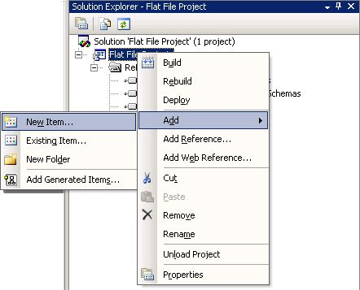
Figure 1: adding a new item to a BizTalk Project

Selecting New Item… will bring up the “Add New Item” dialog. Notice that when Schema Files is selected there will be a new option for Flat File Schema Wizard as seen in Figure 2. By providing a name and clicking Add the wizard will launch.

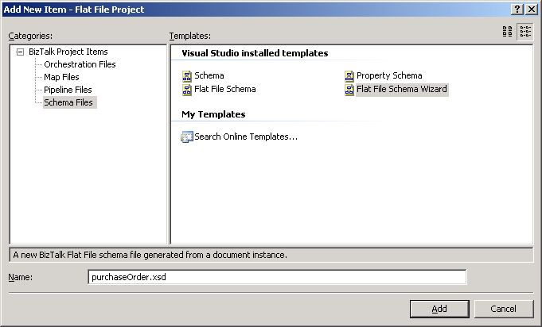
Figure 2: Selecting the Flat File Schema Wizard

Note: Users still have the option of creating a flat file schema from scratch. Selecting the Flat File Schema from the “Add New Item” dialog will launch the schema designer as in previous release of BizTalk Server.

Sample Walkthrough
Now that we know how to launch the flat file wizard, this section will walk you through the steps of creating a schema based off the sample flat file purchase order we’ve already examined. In Figure 3 we see the welcome screen for the flat file wizard. This will appear the first time the wizard is run and can be skipped in the future by selecting the box for “do not show this introduction page again”.

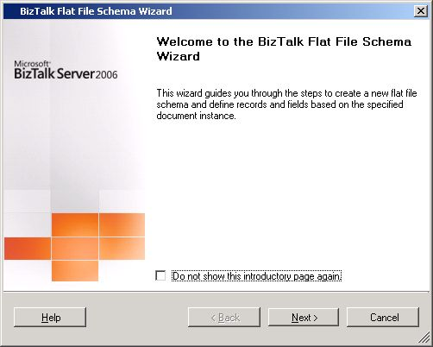
Figure 3: Flat File Wizard Welcome

Selecting your Instance
The first real step is to select instance of the flat file that you would like to generate the schema from. Use the browse button to locate the file. At this stage you will need to provide a record name, target namespace, and select a coding scheme. If you are working with text that is using multi-byte characters you will want to check the box for “count positions in bytes”. A sample for this is provided in Figure 4.

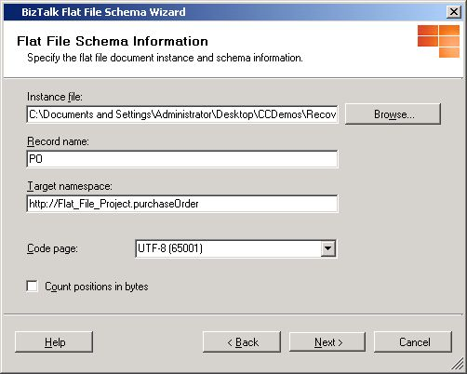
Figure 4 : Selecting the Flat File Instance

Now that we have selected our file it’s time to select what data within the file is needed to create the schema. Use the “select document data” dialog, as seen in Figure 5, to highlight the area of the document that will be used by the wizard. If you want to use the entire document you can press control-A to select all.

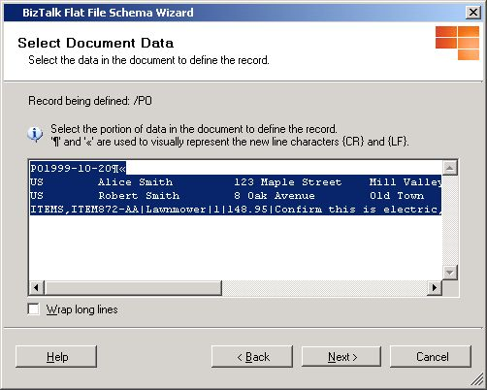
Figure 5: Selecting the Document Data

Delimiting by Symbol
If you recall from our example, each line is delimited by a carriage return line feed. We’ll use this knowledge to create our first level of the schema. At this stage, as seen in Figure 6, we’ll choose “By delimiter symbol” and click Next.

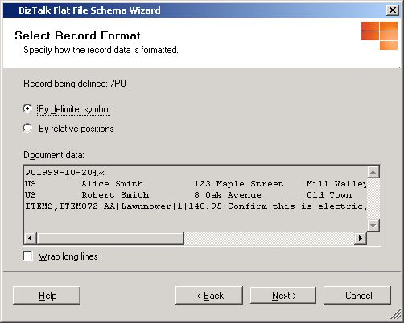
Figure 6: Delimit by Symbol

From the “Delimited Record” dialog, as seen in Figure 7, the user has the ability to specify the delimiter character, the escape character, and a tag identifier. For our example, we’ll use the drop down dialog to select {CR/LF} for the delimiter use a “\” for the escape character and specify the tag identifier as PO.

Note: If you are having trouble seeing all the text from the dialog you can choose to wrap long lines by selecting the check box for “Wrap long lines”.

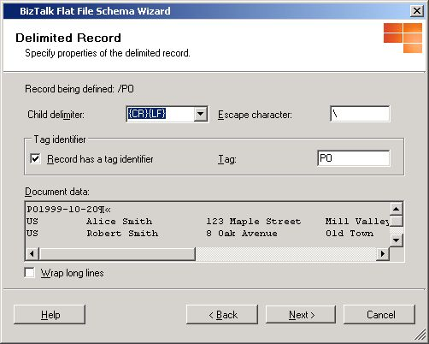
Figure 7: Specifying Delimiter and Tag Identifier

Given the information in the previous dialog, the wizard can begin to identify the different elements within the flat file. Based on the previous settings the wizard located 4 elements from our example as seen in Figure 8. The first element we’ll call date and specify its type as a field element and a data type of date. For the next element we’ll call it customer and specify it as a repeating record. As you can see from the example the 3rd element is simply one of the repeating customer records so we’ll choose to ignore it. Finally, we’ve specified the 4th element, items, as a repeating record because it contains multiple line items.

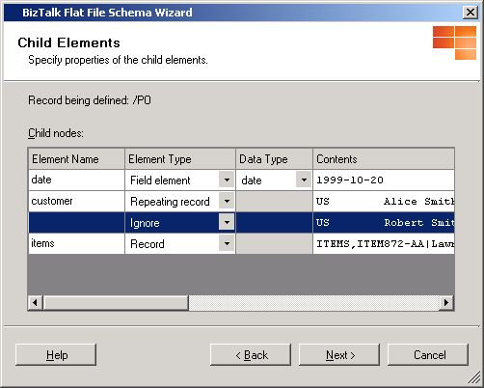
Figure 8: Specifying Child Elements

Once complete the first level of the schema, as seen in Figure 9, is generated. You should note that each of the 3 unique elements defined (date, customer, and items) are represented in this schema.

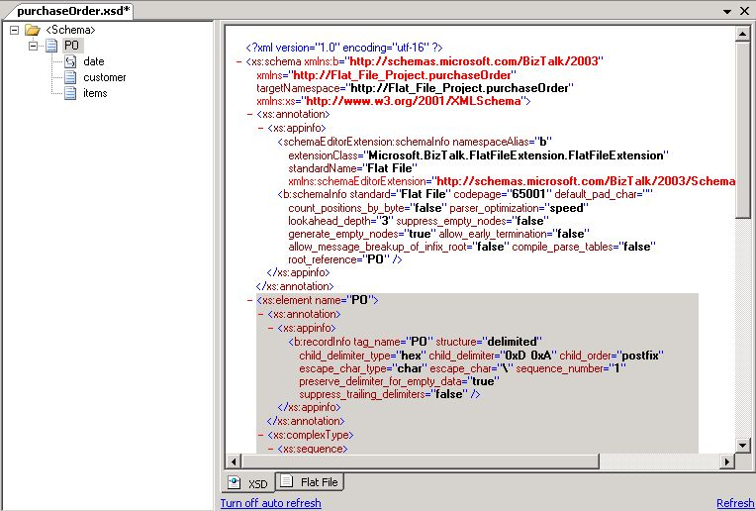
Figure 9: First level of Schema Generated

Keep in mind this is not the final schema. Because we defined the customer and items elements as repeating records the flat file wizard will continue on asking further questions regarding those elements. In Figure 10 we have the opportunity to further describe the customer and items child records. We’ll proceed with the customer record first.
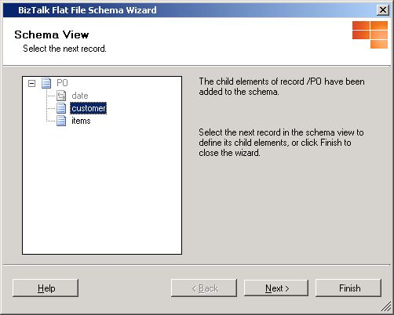
Figure 10: Selecting the next Record to create Child Elements

In order to work with the customer record we’ll need to select the data that represents that element. Since it is a repeating record, either of the lines within the flat file will do. For simplicity sake, we’ll use the first one.

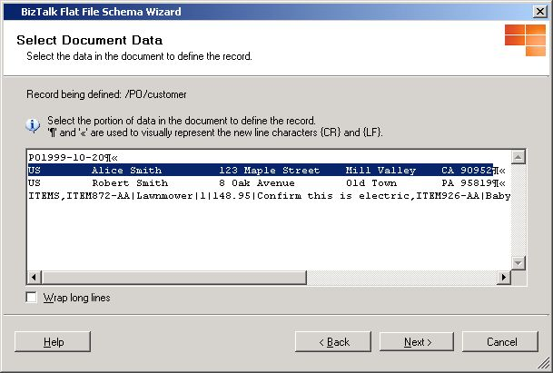
Figure 11: Selecting Child Element Document Data

Working with Relative Positions
If you recall from our example the customer record is a repeating record in which the data is not delimited, but instead is based on fixed positional data. To work with fixed positional data simply select the “By relative positions’ radial as seen in Figure 12 and press Next.

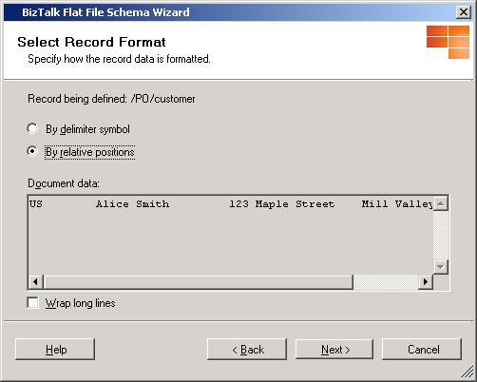
Figure 12: Format by Relative Positions

As seen in Figure 13, the wizard provides a convenient tool for calculating the distance between the fields. Using the mouse select the points which represent where each data field begins. For our example, we do not have a tag identifier, but if required one can be specified at this time as well.
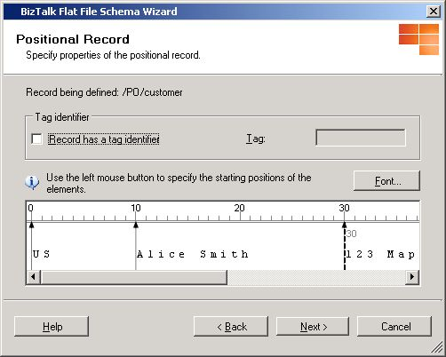
Figure 13: Specifying Record Positions
Just as with delimited elements the wizard will use the previous settings to identify all the child elements for the customer record. For child elements we will use all names, element, and data types as seen in Figure 14.

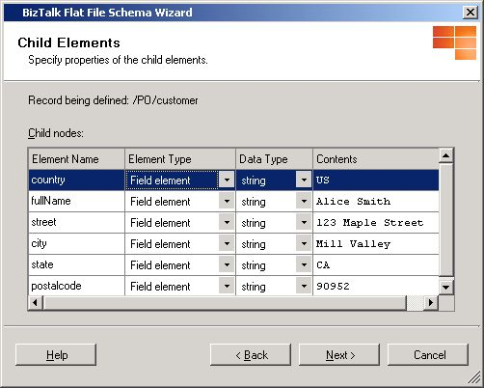
Figure 14: Specifying Child Elements

By clicking next, the next level of the schema for the customer child elements will be created as seen in Figure 15.
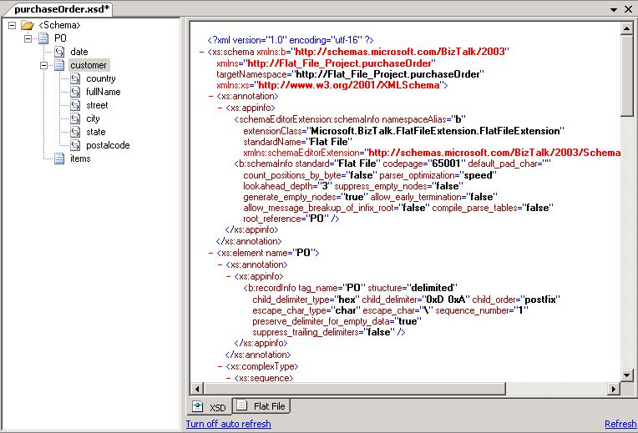
Figure 15: Second Level of Schema Generated

Since we still have to define the items child elements the wizard will continue with the option to further refine the schema. We can define the child elements by selecting items and clicking Next.

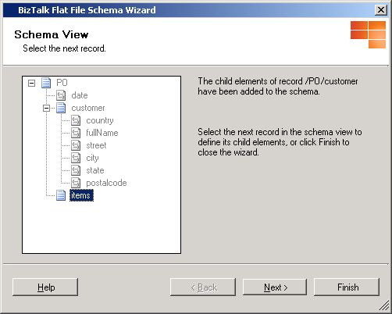
Figure 16 : Defining child elements

There is only one line not yet used in our flat file so we will select the “ITEMS” line and begin further defining our schema.

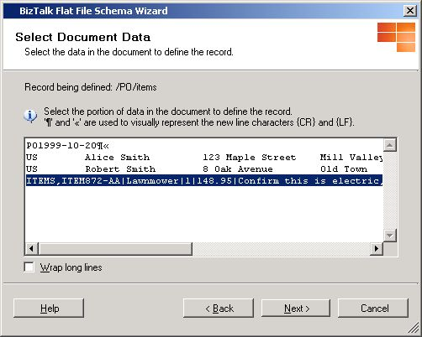
Figure 17: Selecting Child Element Document Data

Multi-delimited Repeating Records
In our example, the items element is a repeating record that itself contains delimited values. Through the remainder of this section we’ll walk through how to use the wizard to create the items child elements and finalize our schema. To start we’ll once again choose to delimit by symbol as seen in Figure 18.
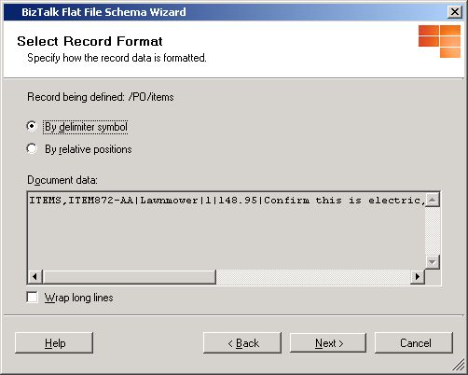
Figure 18: Delimit by Symbol

For the items record, a comma is used to delimit the individual items. As you can see in Figure 19 we’re specifying the child delimiter as a comma, the escape character as a (\), and using ITEMS as the tag identifier.
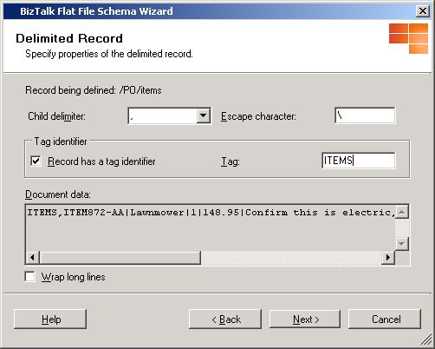
Figure19 : Specifying Delimiter and Tag Identifier

Using the values in the previous page the wizard will identify additional child elements as seen in Figure 20. In our example there is a repeating item record. We’ll specify the first element as a repeating record and give it a name of “item”. Since it is a repeating record we can ignore the second instance. By clicking Next, the next level for the items record will be created in the schema. We’ll continue to define the final part of our schema.
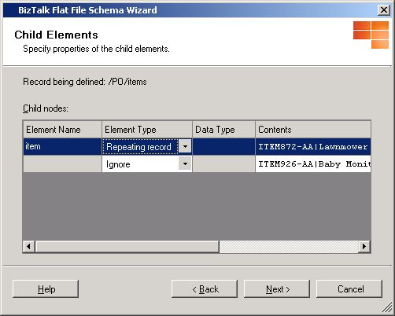
Figure 20: Specifying Child Elements

As you can see from Figure 21 the final missing piece to our schema is the definition of the item record.
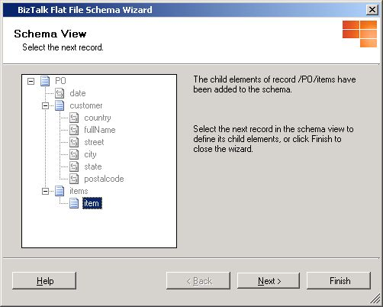
Figure 21: Defining child elements

In Figure 22, we select all the data right of the ITEMS tag. We’ll use this data as the basis for defining the item record.

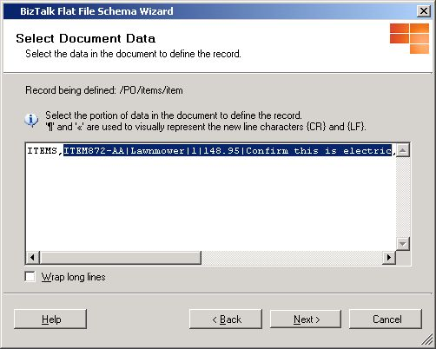
Figure 22: Selecting Child Element Document Data

As before we’ll use the delimiter symbol option as seen in Figure 23.
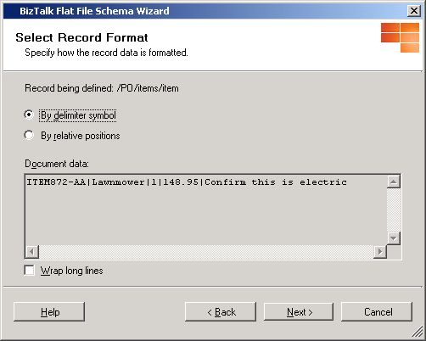
Figure 23 : Delimit by Symbol

The individual elements in the item record are delimited by a pipe (|). As seen in Figure 24, we’ve specified the delimiter as a pipe and the escape character as a (\). There is no tag identifier for this record.

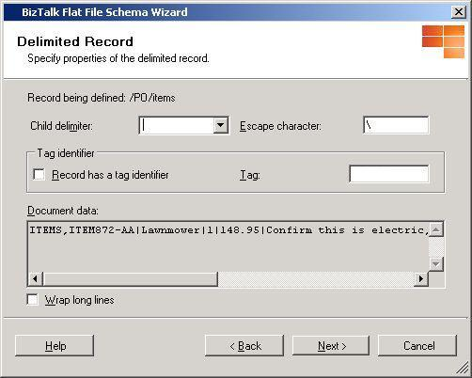
Figure 24: Specifying Delimiter and Tag Identifier

Based off the previous settings the child elements in Figure 25 have been identified. For each of these elements we’ve given them a name and specified them as field elements of string data type.
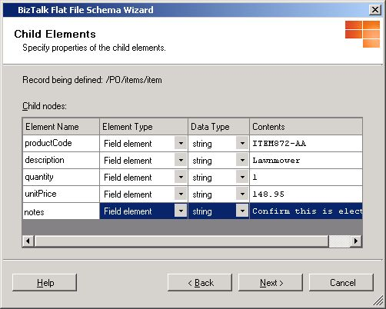
Figure 25: Specifying Child Elements

Now that we’ve defined every node in our schema all that is left is to click Finish!

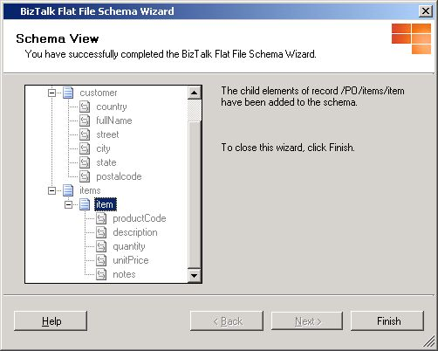
Figure 26 : Finishing

In Figure 27 you can view the final schema. For further refining a developer can use the schema designer within Visual Studio.
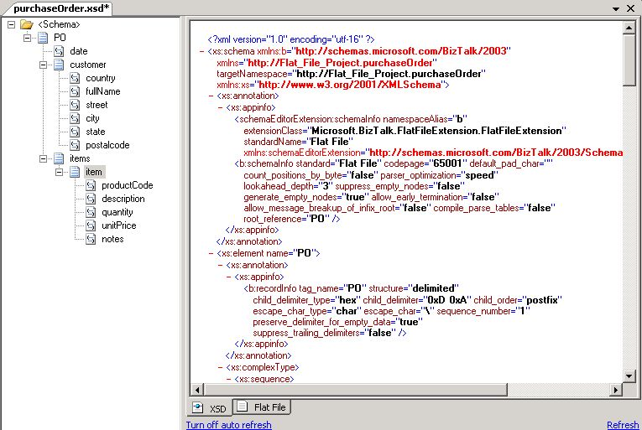
Figure 27 : Final Schema Generated

Orchestration Designer

Zoom Support
The orchestration designer was enhanced in BizTalk Server 2006 to support zoom in/out. By right clicking anywhere within the design surface you’ll get a popup menu allowing you to increase or decrease the size. As seen in Figure 28, zoom support makes dealing with large or complex orchestrations, such as the ones used within a HWS (human workflow services) orchestration less of a real estate challenge.

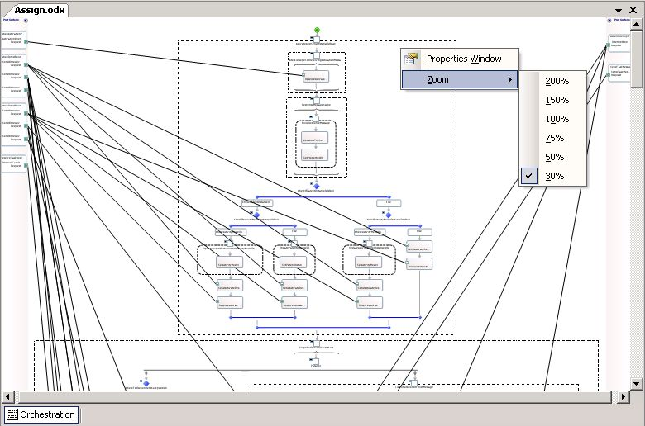
Figure 28: Zoom capability within the Orchestration Designer

Preserving Collapsed and Expanded Shapes
The orchestration designer will preserve settings on expanded and collapsed shapes even if the orchestration is saved to disk and reloaded later.

Expression Window
The Expression Window in BizTalk Server 2006 will continue to have a set-size however that size will be increased to facilitate easier entry of code into an orchestration.

Summary
The BizTalk Server 2006 developer experience is built on Visual Studio 2005 so BizTalk Server customers get the benefit of key new Visual Studio features. In addition BizTalk Server 2006 includes a Flat-File Wizard which increases user productivity when working with flat-files. Several key changes to the orchestration designer include zoom support and preservation of collapsed or expanded shapes when the Orchestration Designer is reloaded.

For more information:
- http://www.microsoft.com/biztalk.

For the latest information about Windows Server System, see the Windows Server System Web site at http://www.microsoft.com/windowsserversystem.



