

BizTalk Server 2006 Setup and Migration

Microsoft Corporation
Published: November 2005

Abstract
One of the primary design goals for BizTalk Server 2006 was to decrease the complexity of the installation and upgrade processes. This paper steps through the setup process with the intent of giving high-level overview of the installation process and to point to areas where it differs from the installation process for BizTalk Server 2004.


This is a preliminary document and may be changed substantially prior to final commercial release of the software described herein.
The information contained in this document represents the current view of Microsoft Corporation on the issues discussed as of the date of publication. Because Microsoft must respond to changing market conditions, it should not be interpreted to be a commitment on the part of Microsoft, and Microsoft cannot guarantee the accuracy of any information presented after the date of publication.
This White Paper is for informational purposes only. MICROSOFT MAKES NO WARRANTIES, EXPRESS, IMPLIED, OR STATUTORY, AS TO THE INFORMATION IN THIS DOCUMENT.
Complying with all applicable copyright laws is the responsibility of the user. Without limiting the rights under copyright, no part of this document may be reproduced, stored in or introduced into a retrieval system, or transmitted in any form or by any means (electronic, mechanical, photocopying, recording, or otherwise), or for any purpose, without the express written permission of Microsoft Corporation.
Microsoft may have patents, patent applications, trademarks, copyrights, or other intellectual property rights covering subject matter in this document. Except as expressly provided in any written license agreement from Microsoft, the furnishing of this document does not give you any license to these patents, trademarks, copyrights, or other intellectual property.
Unless otherwise noted, the example companies, organizations, products, domain names, e-mail addresses, logos, people, places, and events depicted herein are fictitious, and no association with any real company, organization, product, domain name, e-mail address, logo, person, place, or event is intended or should be inferred.
© 2005 Microsoft Corporation. All rights reserved.
Microsoft, Microsoft, Active Directory, BizTalk, Outlook, and Windows are either registered trademarks or trademarks of Microsoft Corporation in the United States and/or other countries.
All other trademarks are property of their respective owners.
Contents
Introduction 1
BizTalk Server Setup 2
Pre-requisite Installation 2
Redistributable Components 2
BizTalk Server 2006 Install Experience 3
Developer and First-Time User Experience 3
Advanced User Experience 14
Setup Logging 14
BizTalk Server Upgrade 15
Summary 17
For More Information 18

Introduction
BizTalk Server 2006 is the fourth release of the product line. BizTalk Server 2006, as its name suggests, will ship in the first half of calendar year 2006. One of the key features in BizTalk Server 2006 is the automatic upgrade experience for existing BizTalk Server 2004 customers. Customers looking to evaluate BizTalk Server should choose BizTalk Server 2004 today, knowing that BizTalk Server 2006 will preserve their investment. In addition to automatic upgrades for BizTalk Server 2004 customers, BizTalk Server 2006 includes a significantly simplified setup program, enabling developers to begin building with BizTalk Server 2006 faster than before.

BizTalk Server Setup
BizTalk Server 2006 provides two key improvements with its setup functionality. First, BizTalk Server 2006 provides multiple ways for customers to ease the installation of prerequisites. And second, BizTalk Server 2006 provides targeted setup experiences—including a simplified setup experience for developers and first time users.

Pre-requisite Installation
While it is still necessary for customers to manually install Windows, Visual Studio 2005 and either SQL Server 2000 or SQL Server 2005 before commencing the BizTalk Server 2006 installation, the BizTalk setup routine now manages the selection of any additional redistributable components required for a successful installation.

Redistributable Components
BizTalk Server requires a number of key redistributable components including: .NET Framework updates, SQLXML 3.0, MSXML 3.0, MDAC 2.8 and OWC11. These components may have service packs applied on a differing timeframe to BizTalk Server, and so customers may need to update them when appropriate.
The BizTalk Server team will create and maintain a single .cab file containing the necessary redistributable updates required for BizTalk Server 2006 installation. As part of the installation process customers may choose to download the .cab file if they are connected to the Internet, or may point to an existing .cab file they have downloaded elsewhere and have available on the installation computer. By using this method, customers will easily obtain the latest versions of all redistributable components in a single file.
By automating the installation of redistributable components the installation of BizTalk Server 2006 has been significantly simplified. Of course customers are still welcome to manually install all updates if they prefer this method.

BizTalk Server 2006 Install Experience
BizTalk Server 2006 includes both a more flexible advanced installation experience and a significantly simpler installation experience for the developer, single-computer user and the first-time user. Customers installing BizTalk Server 2006 must be administrators on their target computer but are recommended to choose a user account with lesser account privileges for the BizTalk Server service account.

Developer and First-Time User Experience
The first-time user experience has been redesigned to prompt the user with the minimum number of questions so you can start building on top of BizTalk Server 2006 quickly.
A typical experience is depicted as follows:

Step 1: Choose Install from the autorun menu.
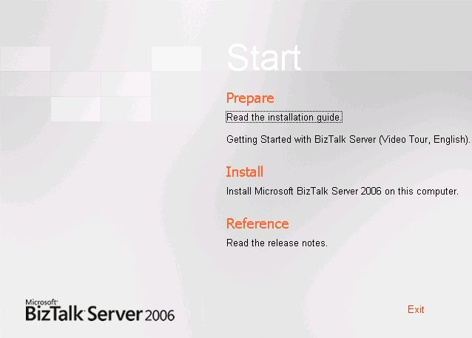

Step 2: Enter customer information.
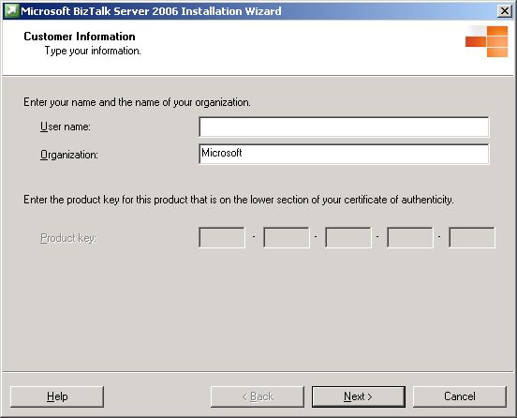

Step 3: Accept the EULA.
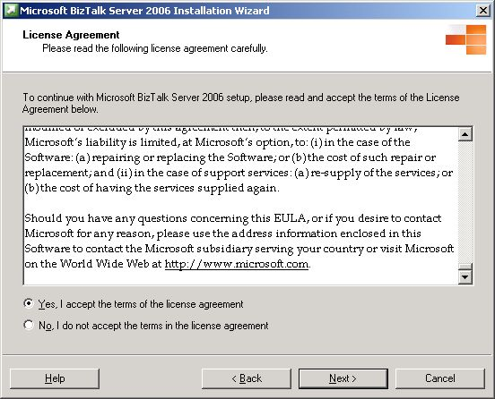

Step 4: Select the components you want to install and click Next. (By default all components are selected that are available on your operating system.) The rules designer is now available as a separate installation item for customers wanting to just use rules.
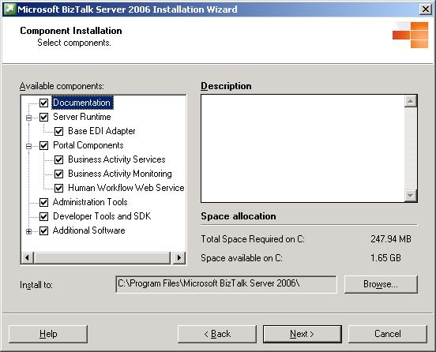

Step 5: The summary screen displays the components being installed and prompts the user to enter a user name and password for an automated experience across reboots (if required). Then the user clicks Install.
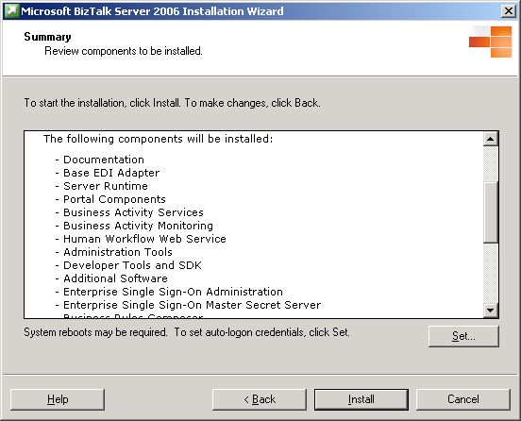

Step 6: BizTalk Server 2006 files are installed on the computer.
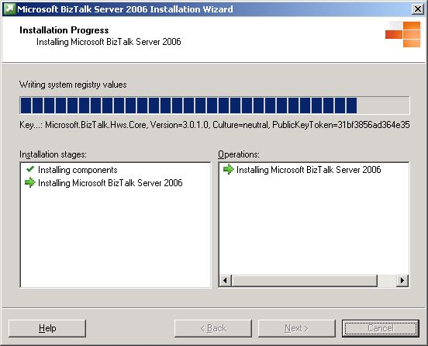:

Step 7: Setup is complete and configuration of the system can be commenced by clicking Finish.
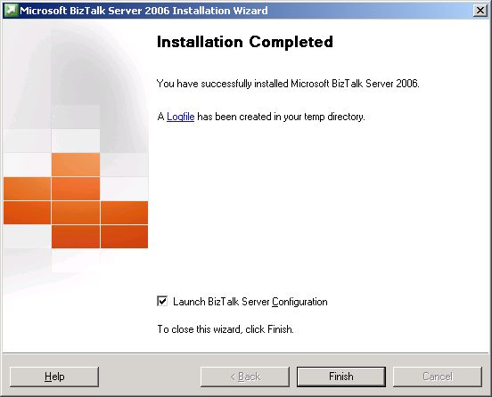:

Step 8: The configuration wizard has been completely redesigned. This is where the greatest decrease in setup time has been noted. If the user chooses the default configuration radio button, they will be prompted to enter the appropriate database server and a single user account and password for the BizTalk runtime components.
If there is a local SQL database on the target computer this database server field is automatically populated. If the user account is an administrator, a dialog box appears prompting the user to consider choosing a more secure nonadministrator account. This single user account is used for all of BizTalk Server 2006 services. The second radio button option, custom configuration, is detailed in the following section called advanced user configuration.

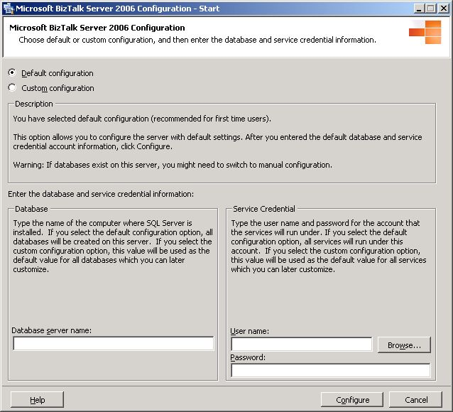

Step 9: A summary of the configuration is displayed and the user simply clicks Configure. At this point, if there configuration issues, such as Windows Sharepoint Services not being installed, the appropriate folder in the configuration tree will be highlighted with a red star and the details of the validation errors will be available.

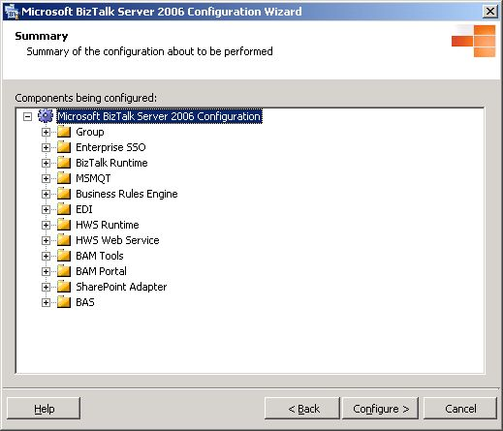

Step 10: BizTalk Server 2006 automatically configures all necessary services. A green tick box indicates success, while a red cross indicates failure.
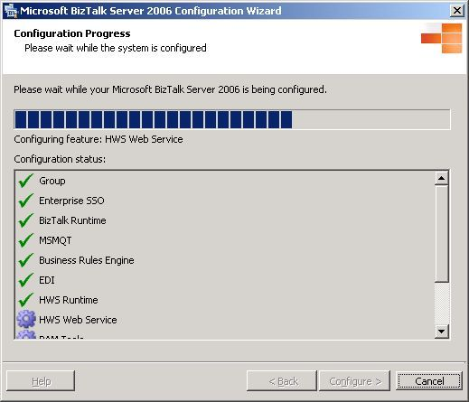

Step 11: If installation is successful, then the process is complete. Should the installation not be successful a red cross will be placed next to the service and clicking the red cross with the mouse will provide a detailed error message explaining the issue and users can launch manual configuration to recover from the error.
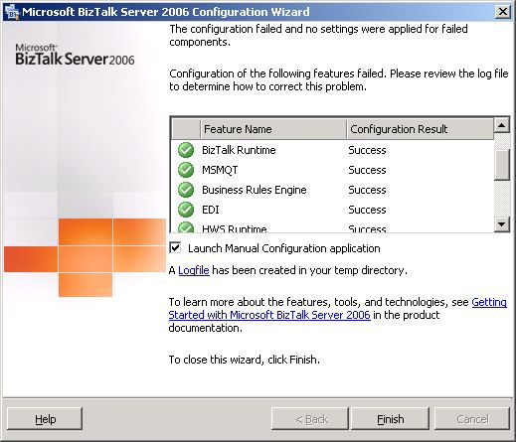

While the setup process is still 11 steps, a review of these steps show many of them are simply pressing the Next button, verifying configuration information. While not appearing to be simpler at first glance, many of these screens are informational clicks.

Advanced User Experience
For the advanced user tasked with deploying BizTalk Server 2006 across multiple CPUs as part of a larger server farm, the setup experience has been redesigned to provide a bidirectional metaphor and greater flexibility. Instead of choosing the default configuration, the user may choose the custom configuration shown in Step 8 previously. Custom configuration is no longer a single directional wizard paradigm. Instead the necessary configuration information is presented in a series of panels enabling customers to refer back and forth between settings. In addition custom configurations may be exported and imported to ease the installation of settings across server farms or development build labs. The “Overview” custom configuration page is shown here:
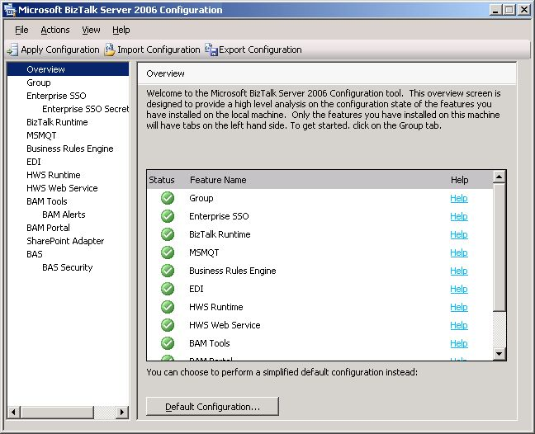

Setup Logging
In addition to the usability enhancements to the setup process the BizTalk Server 2006 setup log file contains significantly more detailed information. A typical setup log file in the user's temporary directory can be as much as 8 megabytes (MB), enabling detailed troubleshooting of configuration issues should they arise.

BizTalk Server Upgrade
Existing BizTalk Server customers have extensive investments in BizTalk Server 2004; it is important to preserve those investments. While much of the code for upgrade is included as part of BizTalk Server 2006 beta 1, it is currently not functioning. Customers should use BizTalk Server 2006 beta 1 to explore the new features of the product. Supported upgrade will be available as part of BizTalk Server 2006 beta 2. Customers wanting to install BizTalk Server 2006 on computers currently running BizTalk Server 2004 should follow standard practices of complete computer and database backup before upgrade, and they should stop all of the BizTalk Server services. There is no supported side-by-side installation of BizTalk Server 2004, and as such, the computer will be upgraded to BizTalk Server 2006. Additionally, the upgrade process is not reversible without recovering from your computer and database backup. When a customer executes the BizTalk Server 2006 setup on a computer where BizTalk Server 2004 is already installed, the upgrade process is triggered after Step 3 previously.
The upgrade screen appears as follows:
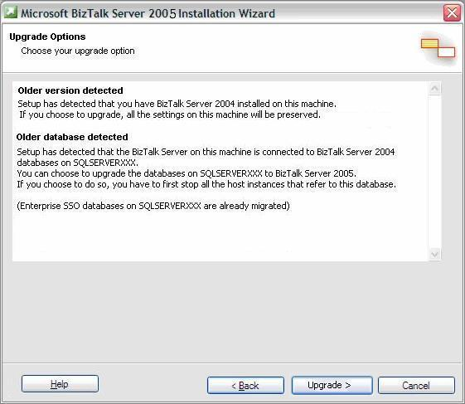

BizTalk Server 2006 setup will upgrade to the latest version by way of single sign-on. Furthermore, assuming BizTalk Server can identify the location of the SQL Server database, and the database is currently online, setup will also upgrade the BizTalk Server databases to the new BizTalk Server database schema. This step may take some time depending on the volume of tracking data stored in the system.
Customers wanting to upgrade their databases from SQL Server 2000 to SQL Server 2005 should complete the database upgrade after they have successfully upgraded BizTalk Server 2004 to BizTalk Server 2006.
Also note that all BizTalk Servers within a single group should be upgraded to BizTalk Server 2006. Interoperability between BizTalk Server 2004 and BizTalk Server 2006 is not supported because of database changes.

Summary
This document has looked at some of the new capabilities introduced in BizTalk Server 2006, including setup and upgrade. Setup is both simplified and more flexible in BizTalk Server 2006. Upgrade has been designed to preserve the customer’s investments in existing BizTalk Server 2004 projects.
For More Information
http://www.microsoft.com/biztalk

For the latest information about Windows Server System, see the Windows Server System Web site at http://www.microsoft.com/windowsserversystem.



