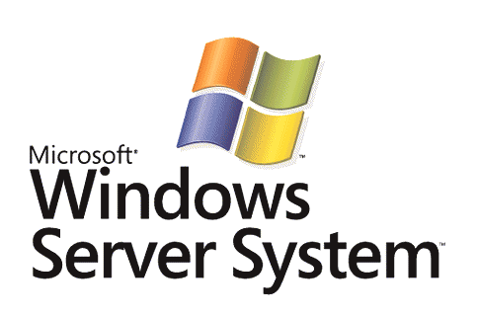

BizTalk Server 2006
Application Deployment & Management

Microsoft Corporation
Published: April 2005

Abstract
One of the key design pillars of BizTalk Server 2006 is to make the server easier to manage so that users could focus on applying the capabilities of BizTalk to their business rather than focusing on the process of managing the server. This paper describes two new, key features of BizTalk Server 2006; the capability to manage BizTalk artifacts as a single application and the ability to monitor a group of artifacts through use of the BizTalk Server Administration Console make BizTalk Server less time consuming to manage.



This is a preliminary document and may be changed substantially prior to final commercial release of the software described herein.
The information contained in this document represents the current view of Microsoft Corporation on the issues discussed as of the date of publication. Because Microsoft must respond to changing market conditions, it should not be interpreted to be a commitment on the part of Microsoft, and Microsoft cannot guarantee the accuracy of any information presented after the date of publication.
This White Paper is for informational purposes only. MICROSOFT MAKES NO WARRANTIES, EXPRESS, IMPLIED OR STATUTORY, AS TO THE INFORMATION IN THIS DOCUMENT.
Complying with all applicable copyright laws is the responsibility of the user. Without limiting the rights under copyright, no part of this document may be reproduced, stored in or introduced into a retrieval system, or transmitted in any form or by any means (electronic, mechanical, photocopying, recording, or otherwise), or for any purpose, without the express written permission of Microsoft Corporation.
Microsoft may have patents, patent applications, trademarks, copyrights, or other intellectual property rights covering subject matter in this document. Except as expressly provided in any written license agreement from Microsoft, the furnishing of this document does not give you any license to these patents, trademarks, copyrights, or other intellectual property.
Unless otherwise noted, the example companies, organizations, products, domain names, e-mail addresses, logos, people, places, and events depicted herein are fictitious, and no association with any real company, organization, product, domain name, email address, logo, person, place, or event is intended or should be inferred.
© 2005Microsoft Corporation. All rights reserved.
Microsoft, Microsoft, Active Directory, BizTalk, Outlook, and Windows are either registered trademarks or trademarks of Microsoft Corporation in the United States and/or other countries.
All other trademarks are property of their respective owners.
Contents
Introduction 1
BizTalk Applications Today and Tomorrow 2
BizTalk 2004 Applications 2
BizTalk 2006 Applications 3
Application Administration and Deployment 4
The BizTalk Server 2006 Administration Console 4
Application Views 4
Group Hub Pages 5
Grouped by Application Monitoring 6
Starting and Stopping a BizTalk Application 7
Application Packaging 8
Application Export 8
Application Import 9
Deploying Applications from Visual Studio 11
Summary 13
For more information 14

Introduction
BizTalk Server is Microsoft premier server for building solutions for business process and integration. BizTalk Server 2006, the 4th major release of the product, builds on the innovation and success introduced by the previous 3 releases: BizTalk Server 2000, 2002, and 2004. The 2006 release includes new capabilities including: an application container for organizing and maintaining BizTalk solutions, an updated management console allowing for scalable management of BizTalk environments, integration with Microsoft Windows installer technology easing the process of staging and deployment, and some new productivity enhancements for the developer including support for the latest releases for Visual Studio.NET 2005.

BizTalk Applications Today and Tomorrow
BizTalk Server 2006 formalizes the concept of a BizTalk application by providing a logical container for housing all the artifacts for a given solution. By leveraging this new concept the effort to deploy and manage applications are significantly reduced compared to previous releases of BizTalk. Through this section we’ll do a comparison of the how applications worked in BizTalk Server 2004 and how they have been improved in BizTalk Server 2006.

BizTalk 2004 Applications
In previous version of BizTalk, the effort to manage multiple applications became challenging as the number of deployed applications grew and the general complexity of those applications increased. For each solution developed there are a set of inter-related artifacts (schemas, maps, pipelines, orchestrations, receive ports, receive locations, send ports, other...) that need to be managed. In BizTalk Server 2004 the idea of a formal application container did not exist. Instead of managing ‘applications”, the BizTalk Explorer or the BizTalk Administration Console can be used to individually manage these artifacts. In the case of creation, only the BTS Explorer provided complete functionality in BizTalk Server 2004. Neither tool provided a scaleable means for dealing with complex application deployments or a way to logically group and manage artifacts relevant to a specific application. The result was a mishmash of BizTalk artifacts (see Figure 1) that required thorough documentation to or access to the original developer to understand their relation.

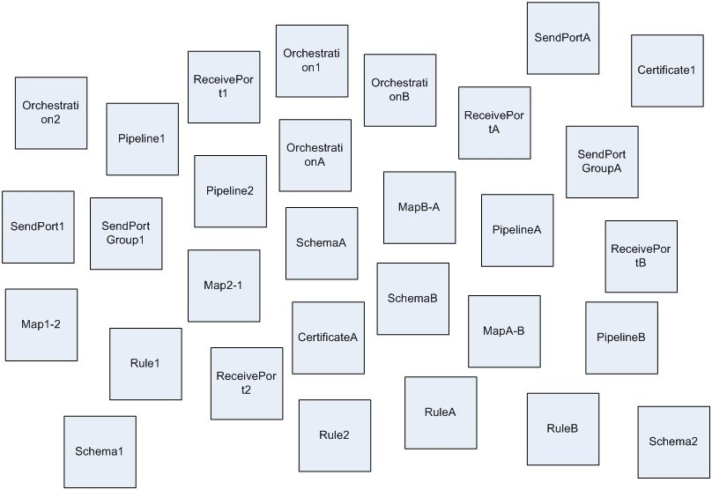
Figure 1 :Applications in BizTalk Server 2004

BizTalk 2006 Applications
To improve the productivity of the developer and administrator, BizTalk Server 2006 introduces the BizTalk "Application”. In BizTalk 2006, an application is a logical grouping of all the BizTalk design-time artifacts (schemas, maps, pipelines, orchestrations), messaging components (receive ports, receive locations and send ports) and other related items such as policies that comprise an integrated business process. Therefore as the number of complex applications increases they can still be individually managed in a simple and intuitive manner.

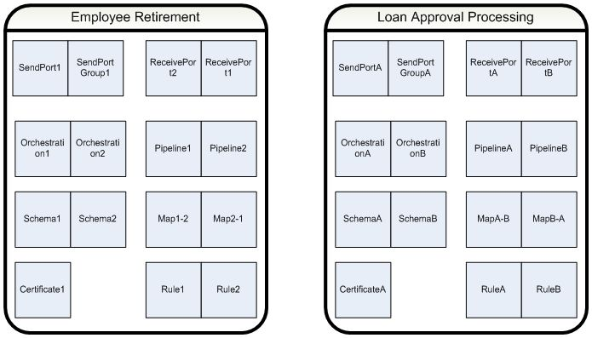
Figure 2 :Application concept in BizTalk Server 2006

The newly designed administration and monitoring tools take advantage of this new concept allowing IT Administrators to be more efficient by managing and configuring BizTalk solutions per application and not just at the individual artifact level. In the next section we’ll go into more detail on how applications are managed and deployed in BizTalk Server 2006.

Application Administration and Deployment
The newly designed BizTalk Administration console was built with applications in mind. Using the administration console you have a complete view of your BizTalk Server environment and have access to new capabilities for importing and exporting applications.

The BizTalk Server 2006 Administration Console
The BizTalk Administration Console is a MMC (Microsoft Management Console) which allows for the ability to create, configure and manage one or more applications across multiple servers. Additionally, the MMC includes the ability to import and export applications for installation across multiple servers or for facilitating moving between staging and production environments. Finally, the console includes the message and service monitoring capabilities previously provided by HAT, the health and activity tracking tool introduced in BizTalk Server 2004. While the administration console provides the runtime monitoring, HAT must still be used for document tracking and orchestration debugging.

Application Views
From Figure 3 you can see the tree view provided in the MMC. Just below the group page is the Applications root. When installing BizTalk Server 2006 into a new environment there are 2 applications created by default; BizTalk.Application.1 (which I’ll refer to as the default application) and BizTalk.System.Application (let’s call this the system application). The system application contains the artifacts required to run built-in applications such BizTalk’s Business Activity Services. The system application contains the components that are part of the base BizTalk runtime and are required by every user application. Users may not modify the system application.
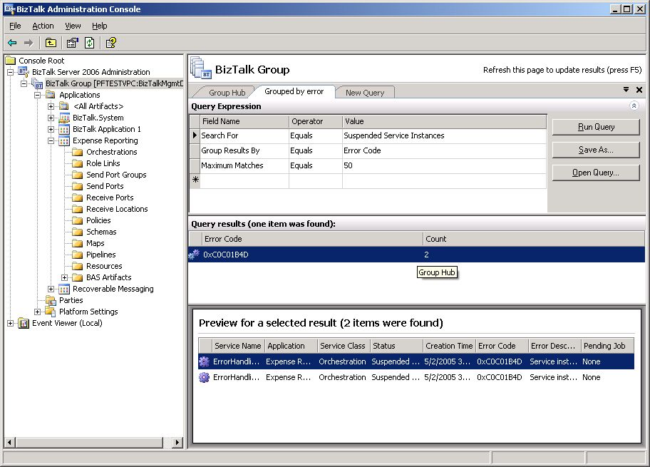
Figure 3 : BizTalk Server 2006 MMC Group Hub Pages

The “BizTalk Application1” is always created in a new or upgraded BizTalk installation. When performing an upgrade from BizTalk Server 2004, pre-existing resources will be deployed into this application. Post upgrade, new applications can be created and existing artifacts can be moved into new locations. By default BizTalk Application1 is set as the default application, but any other application may later be set as the default. This allows for backwards compatibility such that if an application name is not specified on deployment, it will be deployed to the default application.

For a single view of every artifact deployed, the <All Artifacts> node is provided. This view is very similar to the one previously available from Visual Studio’s BizTalk Explorer. The all artifacts container has all every artifact grouped by its type such as: orchestrations, ports, schemas, maps, etc…

Group Hub Pages
The group Hub page is accessed from the BizTalk Group node and provides a complete view into the health of a running BizTalk Server. In the upper right-hand corner are a set of status indicators showing the number of applications that are currently running. If an application has an error or has been stopped, the indicator will change from green to yellow or red. Under the grouped suspended service instances an administrator can view which applications may have processing errors. By clicking on the “Grouped by Application” link a new query page will appear, “Grouped by Application”. From here an application view of monitoring is possible.

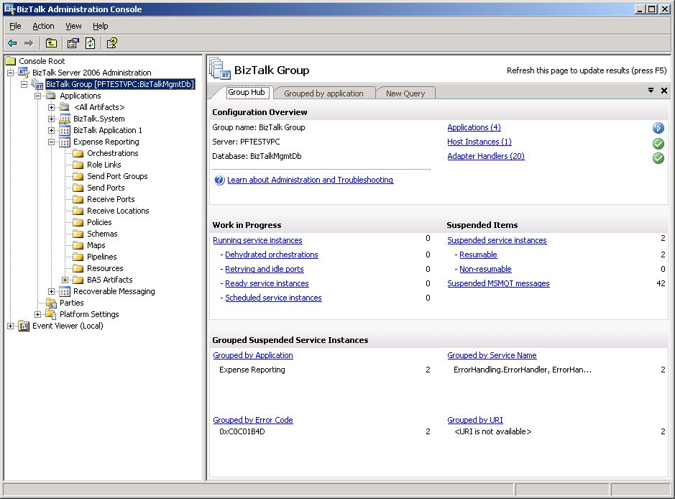
Figure 4 :BizTalk Server 2006 MMC Group Hub Pages

Grouped by Application Monitoring
From Figure 5 you can view the results of selecting the group by application link from the group hub page. This is actually just a custom query page where the default query is looking for suspended services sorted by application name. From the query results you can see a list of the failed applications where you can choose to view all service instances, or perform bulk terminate, suspend or resume on all suspended instances for that application. From the preview pane at the bottom you have the same selections on individual instances or you have the capability to drive into the message details. Also note that by customizing the query expression at the top of the page, custom queries can be created and saved for future use.

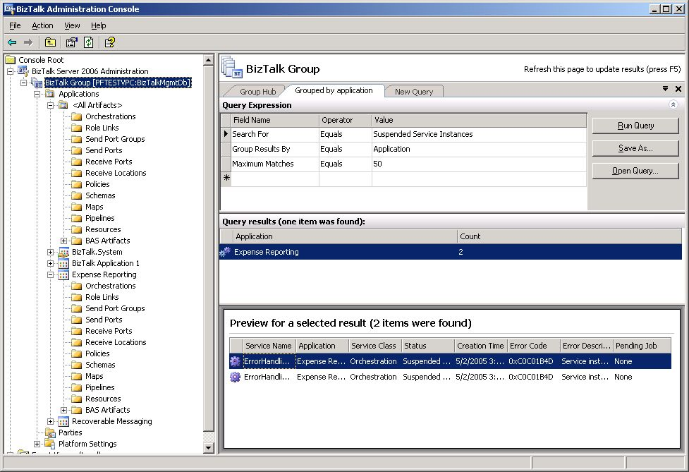
Figure 5 : Application Monitoring

Starting and Stopping a BizTalk Application
The BizTalk Server 2006 Administration console makes it much easier to understand all the dependencies between artifacts and to stop these artifacts in order based on their dependencies before deploying or redeploying. With a single click on the application, all the artifacts contained within will be started in the correct sequence and the application will instantly be ready to process messages (as seen in figure 6).

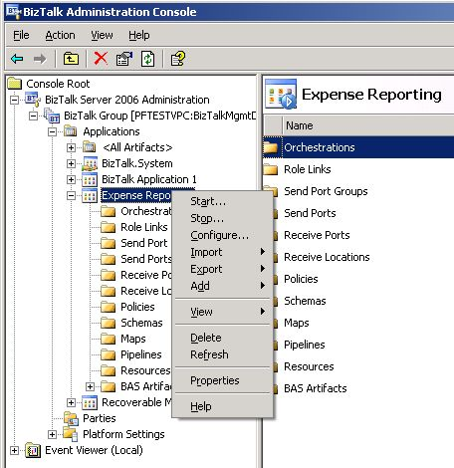
Figure 6 : Application Monitoring

Application Packaging
BizTalk Server 2006 allows entire solutions to be packaged into MSI files using Microsoft Windows Installer technology. The use of Microsoft Windows Installer as a packaging tool replaces the capabilities of SEED provided in previous releases of BizTalk Server. MSI provides a superset of the functionality previously served by SEED and therefore SEED will not be available in BizTalk Server 2006.

Application Export
The creation of an application MSI is accessed through the export capabilities of the BizTalk Administration console. By simply right-clicking on an application node from the tree control a new popup menu will appear as seen in Figure 7.

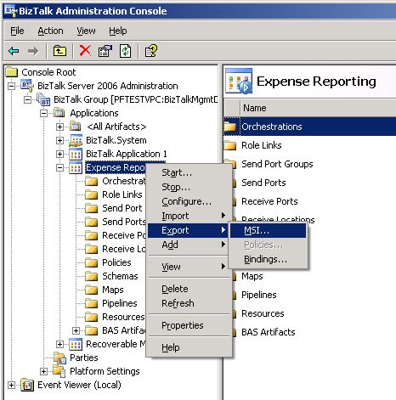
Figure 7 : Exporting Applications via the MMC

By selecting Export->MSI the export wizard in Figure 8 will appear. The wizard will guide you the process of creating your export package by having you select the resource(s), dependencies, and destination location for the MSI. During the process a progress status window is provided and a final summary page with any failures encountered during the export process. This creates an MSI package which is completely self-contained and includes all the binaries and configuration information to recreate the application on another system.

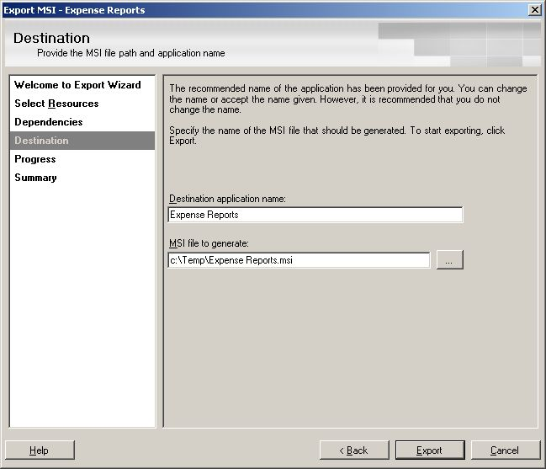
Figure 8 : Export Wizard

Application Import
The unpacking of an application MSI is accessed through the import capabilities of the BizTalk Administration console. Before performing an import into an application, you must make sure that an application is installed. Installing an application is as easy as running the MSI. When the MSI is executed the necessary assemblies will be copied and registered into the GAC (Global Assembly Cache) on the server where the MSI is being run. You must install the application on every server that will run the application.

The second step is to perform the application import. Performing an import sets the configuration for the application including all the necessary port binding. Import need only be run once per application. By simply right-clicking on an application node, or from applications group node, within the tree control a new popup menu will appear as seen in Figure 9.
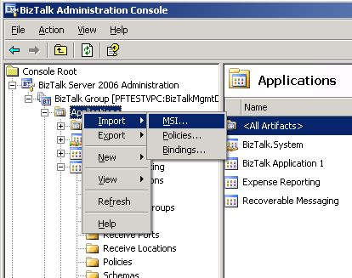
Figure 9 : Importing Applications via the MMC

By selecting Import MSI… the import wizard in Figure 10 will appear. The wizard will guide you the process of importing your application by having you select the location of the installation MSI, choosing your application settings. During the process a progress status window is provided and a final summary page with any failures encountered during the import process.

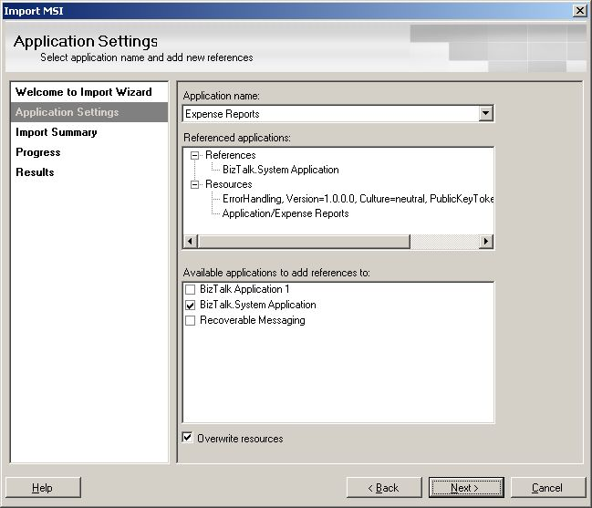
Figure 10 : Import Wizard

Deploying Applications from Visual Studio
When working within a development environment, developers still have the ability to deploy applications directly from Visual Studio 2005. By right clicking on a project from Solution Explorer will display an option to select “Deploy” as seen in Figure 11. If the project has not already been built or if changes have been made since the last time it was built a compilation of the project will be forced before deploying. If the Visual Studio Solution contains more than one BizTalk project, then you can also choose to deploy all the projects in the solution. Deploying from the perspective of the solution will force the projects to be built and deployed in the correct order.

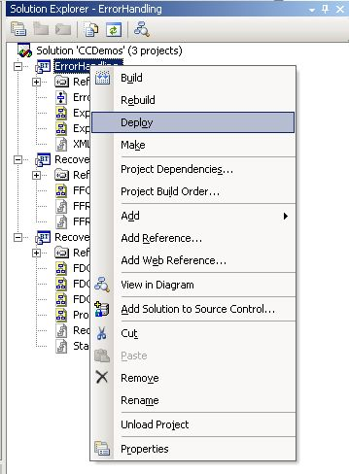
Figure 11 : Solution Explorer Deployment Menu

By default, assemblies will be deployed to the default application we discussed in a previous section. In order to deploy to a different application, the Application Name property needs to be set within the project’s property pages. By right-clicking on the project from within Solution Explorer you can select Properties from the popup menu. The properties page dialog as seen in figure 12 will appear.

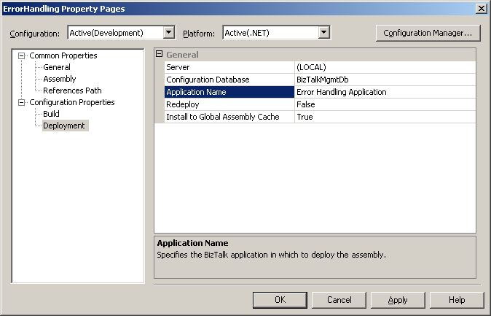
Figure 12 : Deploying Applications from Visual Studio.NET 2005

Select Configuration Properties and then Deployment to set the Application Name.

Summary
BizTalk Server 2006 provides powerful new functionality for creating, managing and deploying BizTalk applications. By taking advantage of these new capabilties IT professionals and developers can create scalable integrated business process solutions which are easy to deploy and simple to manage.
For more information:
- http://www.microsoft.com/biztalk.

For the latest information about Windows Server System, see the Windows Server System Web site at http://www.microsoft.com/windowsserversystem.

