# Sharepoint_logoCover.png­

Executive Summary

Five Ways SharePoint Can Save You Money

In today's uncertain economic climate, business decision makers are under more pressure than ever before to deliver value. Organizations everywhere are tightening their belts and aiming for slower spend in all areas of the business. At the same time, these organizations cannot afford to compromise productivity and efficiency. History has shown that organizations that continue to invest smartly in challenging times often emerge as the dominant player coming out of recessions.

How do you deliver productivity and efficiency? When your work involves managing information, you probably rely on a number of key enterprise solutions to enable productive and effective working practices. These enterprise solutions might include portal solutions, search tools, collaboration platforms, and business intelligence features.

How can you save money without compromising productivity and efficiency? When it comes to getting maximum value from your enterprise solutions, you can approach this in two ways. You can:

* Seek to reduce the total cost of ownership (TCO) of your IT infrastructure.
* Seek to maximize the return on investment (ROI) from your enterprise solutions.

In this paper, we look at how Microsoft SharePoint Products and Technologies can help you to reduce TCO and maximize ROI for your enterprise solutions. SharePoint Products and Technologies provide a comprehensive suite of features in all areas of information management, and can enable you to consolidate all your enterprise solutions into a single, manageable platform. Many of the world's leading companies, such as MTV and the Bank of America, are already realizing benefits from the adoption of these technologies.

The paper focuses on five specific ways in which SharePoint Products and Technologies can save you money. When you adopt SharePoint Products and Technologies in your organization, you can:

* **Reduce IT costs and complexity**, by consolidating multiple product investments into a single infrastructure, by reducing infrastructure and support costs, and by getting all your enterprise solutions under a single product license.
* **Reduce development costs**, by using comprehensive out-of-the-box components, by using built-in integration with the Microsoft Office 2007 suite, and by using the .NET Framework object models to reduce learning curves and development time.
* **Simplify management and training**, by providing a single, easy-to-use interface for end users and for IT administration and governance.
* **Improve employee productivity**, by implementing collaboration workspaces, self-service Web publishing, social computing features, and business process workflow and forms.
* **Enhance the effectiveness of customer service and sales teams**, by aggregating critical information from across the enterprise and by providing rapid, easy access to information.

Each of these points is supported by case studies detailing how high profile organizations have achieved these savings and benefits.

Who Should Read This Paper?

This paper provides information on how you can use SharePoint Products and Technologies to reduce the total cost of ownership (TCO) and maximize the return on investment (ROI) from your expenditure on enterprise solution platforms. These platforms can include portal solutions, collaboration tools, document management platforms, and search tools. This information is relevant to business and technical decision makers who are considering or planning how to consolidate infrastructure, reduce support costs, or streamline business processes.

The information contained in this document represents the current view of Microsoft Corporation on the issues discussed as of the date of publication. Because Microsoft must respond to changing market conditions, it should not be interpreted to be a commitment on the part of Microsoft, and Microsoft cannot guarantee the accuracy of any information presented after the date of publication.

This white paper is for informational purposes only. MICROSOFT MAKES NO WARRANTIES, EXPRESS, IMPLIED OR STATUTORY, AS TO THE INFORMATION IN THIS DOCUMENT.

Complying with all applicable copyright laws is the responsibility of the user. Without limiting the rights under copyright, no part of this document may be reproduced, stored in or introduced into a retrieval system, or transmitted in any form or by any means (electronic, mechanical, photocopying, recording, or otherwise), or for any purpose, without the express written permission of Microsoft Corporation.

Microsoft may have patents, patent applications, trademarks, copyrights, or other intellectual property rights covering subject matter in this document. Except as expressly provided in any written license agreement from Microsoft, the furnishing of this document does not give you any license to these patents, trademarks, copyrights, or other intellectual property.

© 2009 Microsoft Corporation. All rights reserved.

Microsoft, SharePoint, Microsoft Office, .NET Framework, Windows SharePoint Services, ASP.NET, Office SharePoint Server, Business Data Catalog, Windows Workflow Foundation, InfoPath, InfoPath Forms Services, and Office Outlook are either registered trademarks or trademarks of Microsoft Corporation in the United States and/or other countries.

The names of actual companies and products mentioned herein may be the trademarks of their respective owners.

[Executive Summary 2](#_Toc225860740)

[Who Should Read This Paper? 3](#_Toc225860741)

[Current Situation Assessment 6](#_Toc225860742)

[Enterprise Solutions and their Pain Points 6](#_Toc225860743)

[How SharePoint Can Help 7](#_Toc225860744)

[Reduce IT Costs and Complexity 9](#_Toc225860745)

[Consolidate Infrastructure 9](#_Toc225860746)

[Reduce Overheads 10](#_Toc225860747)

[Reduce Development Costs 11](#_Toc225860748)

[Comprehensive Out-of-the-Box Components 11](#_Toc225860749)

[Familiar Development Platform 12](#_Toc225860750)

[Office Integration 12](#_Toc225860751)

[Simplify Management and Training 13](#_Toc225860752)

[Maintenance and Governance 13](#_Toc225860753)

[User Empowerment 13](#_Toc225860754)

[Ease of Use 14](#_Toc225860755)

[Improve Employee Productivity 15](#_Toc225860756)

[Enhance Collaboration 15](#_Toc225860757)

[Automate Business Processes 15](#_Toc225860758)

[Connect Teams 17](#_Toc225860759)

[Manage Web Content 17](#_Toc225860760)

[Enhance Customer Service and Sales Effectiveness 18](#_Toc225860761)

[Improve Access to Information 18](#_Toc225860762)

[Aggregate Critical Data 19](#_Toc225860763)

[Conclusion 20](#_Toc225860764)

Current Situation Assessment

The current economic climate has created a unique set of challenges for organizations in all industry sectors. Business decision makers are under pressure to constrain spending, and that includes IT investment and expenditure. At the same time, businesses must continually seek to maintain and improve their productivity and effectiveness in order to stay competitive in what may be a shrinking market for their goods or services.

IT Spending in the News

Forrester Research slashes IT spending growth forecast for 2009 to 1.6%

[More information...](http://www.computerworld.com.au/article/270315/forrester_slashes_it_spending_forecast_recession_deepens)

IDC revise predictions for growth in enterprise technology spending in the U.S. from 4.2% to 0.9%

[More information...](http://news.cnet.com/8301-1001_3-10095258-92.html)

Gartner cuts predictions for global technology spending growth from 5.8% to 2.3%

[More information…](http://www.reuters.com/article/TechLife/idUSN1338463520081013?pageNumber=2&virtualBrandChannel=0&sp=true)

Enterprise Solutions and their Pain Points

Like many organizations, yours probably relies on enterprise solutions in a number of key areas to facilitate productivity and effectiveness. For example, you might wish to implement:

* Enterprise Content Management solutions. These include tools to aid collaboration, such as shared workspaces with document version management and workflow, and business process integration solutions to capture and manage the flow of information around your organization.
* Portal solutions. These provide a unified entry point and a common infrastructure for sites, workspaces, and Web content across your organization. Portal solutions may be targeted at your employees, your partners, or your customers.
* Search solutions. These provide a platform from which employees can search for relevant, up-to-date information from disparate sources across your organization. Effective search solutions are becoming an increasingly essential tool for large or information-driven organizations – an independent survey by IDC found that the average information worker in the United States spends approximately nine-and-a-half hours per week searching for information (IDC: The Hidden Costs of Information Work, April 2006, Doc #201334).
* Business intelligence solutions. These provide a way of aggregating and summarizing critical information from line-of-business tools, such as inventory management or customer relationship management systems. Business intelligence solutions are used to create clear and often highly visual dashboards for use by customer service representatives, sales executives, and senior management.

These solutions provide an essential service in the day-to-day operations of an enterprise organization. However, they also bring additional overheads and can introduce new demands on your IT resources. Enterprise solutions are generally expensive. In addition to licensing the software, you must invest time and money in implementing the necessary infrastructure. Every new solution you introduce creates additional demands on your IT team, who first must learn how to deploy and manage it and later must devote time to administering and maintaining it. Your end users will require training and mentoring on every new system.

It can also be difficult and costly to integrate enterprise solutions with one another, which is often necessary when you want to provide truly effective business information in your organization. Extending or tailoring these solutions to your specific requirements may demand highly specialized expertise that, needless to say, comes at a premium price.

You may also want to consider the benefits and issues of your enterprise solutions from the perspective of your end users:

* How many different systems do your employees have to use to do their jobs?
* How much time does it take an employee to learn to use each system effectively?
* How easily can an employee find information, share information, or aggregate information from different sources?

It may be many months following the deployment of an enterprise solution before your employees are comfortable using it and fully understand the feature set that it provides.

How SharePoint Can Help

Let's take a look at how SharePoint Products and Technologies can address some of the pain points of enterprise solutions.

Windows SharePoint Services 3.0 (WSS) is the core platform that underpins every product in the SharePoint Products and Technologies suite. WSS provides you with the capability to quickly create Web sites with key collaboration and document management features. Built on ASP.NET and the .NET Framework, WSS exposes a comprehensive, easy-to-use object model that enables developers with experience of ASP.NET and managed code to extend and customize the feature set with ease.

Microsoft Office SharePoint Server 2007 builds on WSS to provide a comprehensive, enterprise ready information management solution. At the same time, because it builds on WSS, it retains all of the extensibility and programmability of the underlying platform. Key features of Office SharePoint Server 2007 include:

* A rich feature set for collaboration, including workspaces, document management, wikis, and social computing features.
* A complete portal framework that you can use to aggregate, manage, and control access to information across your organization.

More Information about SharePoint Products and Technologies

For product information:

[Microsoft Office SharePoint Server](http://www.microsoft.com/Sharepoint/default.mspx)

For technical resources:

[SharePoint Server TechCenter](http://technet.microsoft.com/en-us/office/sharepointserver/default.aspx)

For developers:

[Windows SharePoint Services Developer Center](http://msdn.microsoft.com/en-us/sharepoint/default.aspx)

* True enterprise-class search across SharePoint sites, remote Web sites, document stores, and line-of-business applications.
* A full enterprise content management suite, with tools to aid Web publishing, audience targeting, and records management for all types of online content.
* Comprehensive support for business process integration and workflow.
* A rich business intelligence framework that you can use to aggregate line-of-business data and create business intelligence dashboards.

In a nutshell, Office SharePoint Server 2007 integrates several enterprise solutions into a single, manageable system. This integration and extensibility can help you to reduce the total cost of ownership for your IT infrastructure, by:

* Reducing infrastructure costs and complexity.
* Reducing development costs.
* Simplifying management.
* Minimizing training requirements.

At the same time, the rich feature set and ease of use helps you to maximize your return on investment by:

* Improving employee productivity.
* Enhancing the effectiveness of your business teams.

In the rest of this paper, we'll look at each of these points in more detail, together with some examples of how well-known organizations have reduced costs through the use of SharePoint Products and Technologies.

Reduce IT Costs and Complexity

Major supplier of health insurance saves around U.S.$2 million per year by eliminating policy booklet printing

The Requirement

Independence Blue Cross (IBC) was producing and mailing more than 5 million policy booklets every year, at a cost of over $4 million. The company wanted to move to electronic booklets, but this introduced several new challenges. IBC had to consider how to store and retrieve documents, how to manage security, and how to enable employees to search current and previous versions of its booklets.

The Solution

IBC created a document management, collaboration, and publishing solution based on Office SharePoint Server 2007. The system creates and stores booklets in a document repository, and uses sophisticated metadata management together with Office SharePoint Server’s search capabilities to enable users to quickly locate and retrieve specific versions for specific policies. Policy holders can access a secure members’ portal to download the most current version of their policy booklets.

The Benefits

IBC estimates that the company will save around $2 million per year on printing and shipping costs. At the same time, members receive a better service because they can download booklets immediately rather than waiting for booklets to arrive in the mail.

[More Information…](http://www.microsoft.com/casestudies/casestudy.aspx?casestudyid=4000002203)

In recent years, many organizations have invested heavily in enterprise solutions that manage the flow of information. These enterprise solutions are typically geared around key areas such as enterprise content management, collaboration, search, portal solutions, business process integration, and business intelligence. Such solutions are often supplied by different vendors, built on a variety of technologies, and place additional requirements on your infrastructure and in-house expertise. The solutions are deployed as individual, isolated applications, or require significant integration effort to provide the business information that your information workers require.

Consolidate Infrastructure

Office SharePoint Server 2007 consolidates all these solutions into a single, scalable business platform. The initial benefits are clear. You organization can:

* Plan and deploy infrastructure for a single solution, rather than several.
* License a single solution, rather than several.
* Service and support a single solution, rather than several.

Each component of Office SharePoint Server 2007 is built on a common set of services that ensures flexibility and seamless integration with every other component. For example, you can apply your business process and forms features to your collaboration environment, incorporate business intelligence data into your portal home page, and index content from inside and outside your SharePoint deployment for rapid and effective search, without the usual constraints imposed by integration or customization requirements.

Each component is also designed to interoperate with other software and technologies. For example, the Business Data Catalog (BDC) in Office SharePoint Server 2007 provides a tool for capturing data from line-of-business databases, such as Enterprise Resource Planning (ERP) or Customer Relationship Management (CRM) systems, for search indexing and for business intelligence dashboards and features. As a result, users can aggregate and consume information from a variety of data sources and application platforms in a familiar, easy-to-use interface.

Food manufacturer enhances collaboration and processes – cuts licensing costs by $492,000

[More information…](http://www.microsoft.com/casestudies/casestudy.aspx?casestudyid=4000000194)

Eliminated the need to support storage of multiple document copies – saves $500,000 per year

[More information…](http://www.microsoft.com/casestudies/casestudy.aspx?casestudyid=4000003111)

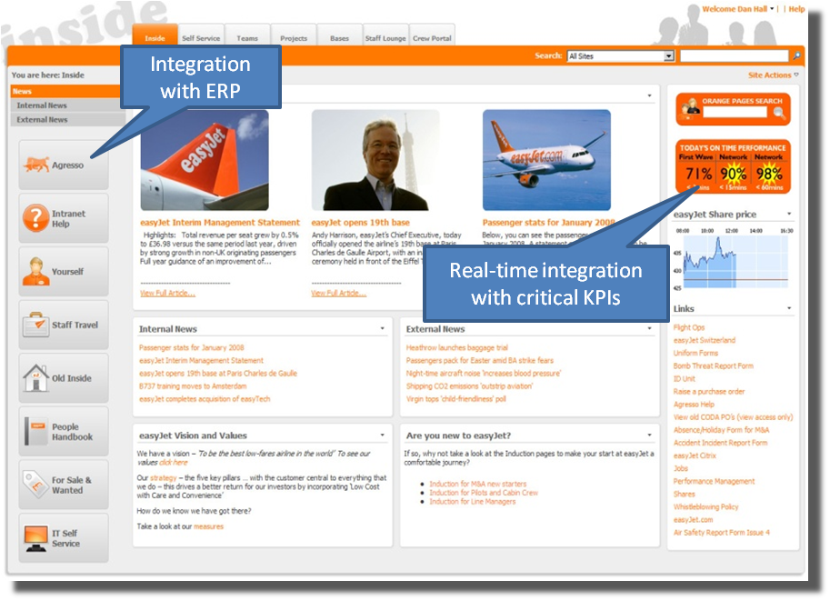

Consolidated disparate storage systems – helpdesk calls reduced by 30%

[More information…](http://www.microsoft.com/casestudies/casestudy.aspx?casestudyid=4000003111)

Reduced Web servers and content management servers by 60% - saves $600,000 per year

[More information…](http://www.microsoft.com/casestudies/casestudy.aspx?casestudyid=4000000158)

Reduce Overheads

By taking full advantage of the Office SharePoint Server 2007 enterprise content management features and collaborative workspaces, you can achieve tangible and often substantial savings on support costs. In a collaborative project, rather than sending work in progress back and forth as email attachments, you can upload documents, spreadsheets, and presentations to a shared workspace with version control. For content that requires approval, instead of printing and circulating forms and documents, you can use business process integration and workflow features to conduct the process online. Finally, rather than printing and shipping key information to customers, you can publish the information to a Web portal where customers can access the latest versions at any time, streamlining revisions and minimizing printing and shipping costs.

Server storage capacity reduced by 50% through consolidation of decentralized file sharing systems

[More information…](http://www.microsoft.com/casestudies/casestudy.aspx?casestudyid=4000003111)

The consequent savings in bandwidth consumption, server storage costs, print costs, and shipping costs can be substantial.

Leading manufacturer empowers workers with business intelligence, workflow, and collaboration tools

The Requirement

As a major producer of dry-cell batteries, flashlights, and wet shave products, Energizer Holdings employs over 14,000 people globally. In addition to using Microsoft Office for everyday tasks, Energizer’s knowledge workers rely on dozens of specialized line-of-business (LOB) applications such as enterprise resource planning and supply chain management tools. Their biggest challenge was to simplify and unify access to data throughout the organization.

The Solution

Energizer now uses a wide range of Office SharePoint Server 2007 features to reduce integration costs and empower workers. Excel Services and the Business Data Catalog help the company to surface data from LOB systems and integrate this data into Microsoft Office applications. Built-in workflows with Web-based forms help them to streamline business processes. Finally, Office SharePoint Server forms the basis of a company-wide intranet to provide unified, searchable access to the aggregated data.

The Benefits

Energizer has boosted the productivity of knowledge workers by simplifying everyday tasks and providing access to live LOB data. Development costs are also reduced as IT workers need to spend far less time on meeting data integration requirements.

[More Information…](http://www.microsoft.com/casestudies/casestudy.aspx?casestudyid=4000002203)

Reduce Development Costs

Let's consider how Office SharePoint Server 2007 can reduce development costs in your organization. As discussed earlier, WSS provides core features for document management and collaboration, including Web site templates, a Web Part framework, data lists, document libraries, and a Windows Workflow Foundation (WF) runtime. Office SharePoint Server 2007 builds on this foundation to provide key enterprise-level features such as user site provisioning and social networking, business intelligence tools, business process integration and forms support, enterprise content management, and full enterprise search. Because these features are built on a common platform and share the same set of core services, seamless integration between your enterprise solutions comes as standard.

Comprehensive Out-of-the-Box Components

The concept of a Web Part framework is central to WSS and Office SharePoint Server 2007, and in many cases should enable you to customize your solutions to your exact requirements without resorting to custom development. In other words, any user with sufficient permissions can add or remove components to or from a Web page. In addition to customizable views of lists and libraries, Office SharePoint Server 2007 ships with over 50 Web Parts that you can add to your sites and pages to provide a broad range of functionality, including search tools, filters, content aggregators, site directory features, and business intelligence dashboard components. There is also a large and growing community of Microsoft partners and third parties who develop Web Parts for a wide range of purposes, all of which are designed to plug directly into your SharePoint infrastructure.

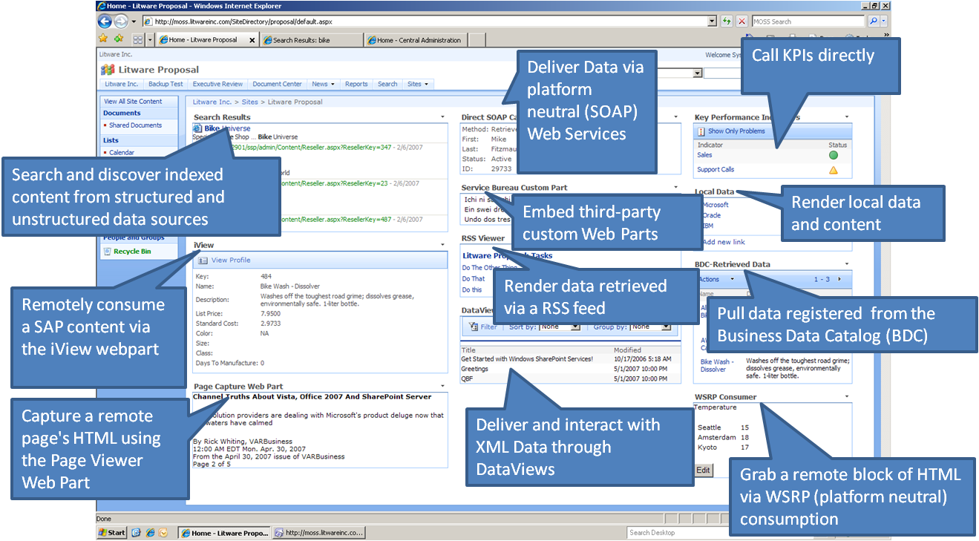

"…we completed the Intranet in less than five months – bringing the portal live in half the time and cost otherwise required."

[More information…](http://www.microsoft.com/casestudies/casestudy.aspx?casestudyid=4000001275)

Argus estimates it saved $500,000 on development of its new portal and shaved eight months off development time

[More information…](http://www.microsoft.com/casestudies/casestudy.aspx?casestudyid=4000000692)

Familiar Development Platform

Despite all this built-in functionality and flexibility, many organizations want to use SharePoint Products and Technologies as a platform to create their own bespoke enterprise solutions. WSS and Office SharePoint Server 2007 are essentially ASP.NET Web applications, so key aspects of development such as master pages, control behavior, and the page lifecycle will be familiar to many Web developers. In addition to this, both WSS and Office SharePoint Server 2007 expose comprehensive object models that make it easy to interact with components such as lists, libraries, sites, and users through .NET managed code languages. In other words, your developers can extend WSS and Office SharePoint Server 2007 by using familiar languages, development tools, and object models – all of which can lead to substantial reductions in development time and cost.

Saved hundreds of thousands of dollars in development time with Office SharePoint Server 2007

[More information…](http://www.microsoft.com/casestudies/casestudy.aspx?casestudyid=4000002909)

WSS and Office SharePoint Server 2007 also expose a rich set of Web services on each site, so your developers can access and manipulate data stored on SharePoint servers from other applications and platforms.

Office Integration

If you use Microsoft Office applications within your organization, SharePoint Products and Technologies provide a seamless storage and collaboration environment. Applications in the Microsoft Office 2007 suite integrate closely with Office SharePoint Server 2007. For example, you can subscribe to SharePoint lists or view tasks and alerts from Outlook, render or extract data from Excel spreadsheets in your portal user interface, and render InfoPath forms through the browser to collect data from your users.

Simplify Management and Training

Fortune 500 construction company saves time, reduces costs, and improves coordination with collaboration portal

The Requirement

Skanska is one of the largest construction and project development companies in the world. The company needed to implement a collaboration portal capable of handling more than 1,500 large and complex active projects with budgets ranging from U.S.$15 million to $1 billion. Project teams can consist of thousands of members, including subcontractors, engineers, architects, consultants, and client teams.

The Solution

Skanska developed a collaboration solution based on Office SharePoint Server 2007. The company has created portals and team sites for extremely large and complex projects, including the design and construction of the New Meadowlands Stadium in New Jersey. Architectural and engineering drawings are uploaded in vast quantities, and relevant teams are automatically alerted to changes that require their review or intervention. Skanska rely heavily on built-in features such as granular security, workflow, and document management.

The Benefits

Skanska has used Office SharePoint Server to develop a collaboration solution capable of supporting ever larger and more complex projects. Benefits include better change management, time and cost savings, and substantial reductions in training overheads.

[More Information…](http://www.microsoft.com/casestudies/casestudy.aspx?casestudyid=4000003041)

Adoption of Office SharePoint Server 2007 as an enterprise solution platform can lead to substantial savings on management and training costs. These savings are achieved through simplified maintenance and governance, delegated administration and user empowerment, and a consistent, familiar environment designed with usability in mind.

Maintenance and Governance

From the IT perspective, management costs are reduced because you only need to support one infrastructure and one set of technologies to provide comprehensive enterprise solution features across the organization. SharePoint Products and Technologies provide a central Web site for all administration, configuration, and maintenance tasks. The administrative user interface is intuitive to use and is consistent across all capabilities–for example, you use the same user interface to manage site provisioning, import user profiles, deploy features, and to set search crawl rules. This simplifies the administrative process and reduces the need for extensive training.

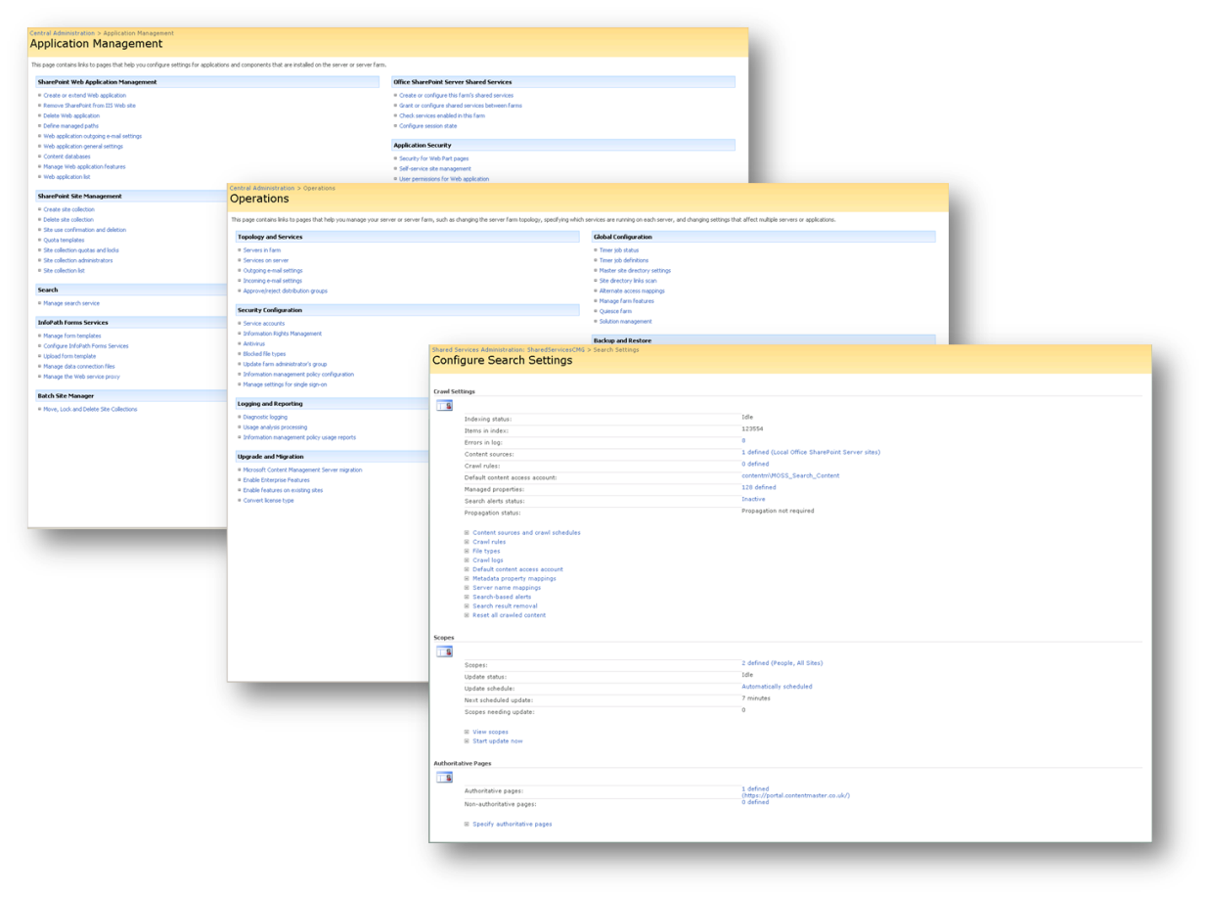

User Empowerment

Reduced helpdesk burden and enabled business users to publish content – saves $70,000 annually

[More information…](http://www.microsoft.com/casestudies/casestudy.aspx?casestudyid=4000002436)

SharePoint Products and Technologies also empower users to comfortably perform tasks that would traditionally be the reserve of the IT team. For example, users can take advantage of straightforward workflows to create, approve, and publish content to a Web site. The IT team can also delegate the day-to-day management of site collections or sites—tasks such as adding or removing users and creating lists and libraries—to key business stakeholders, such as project managers or team leaders, while retaining overall control by imposing site quotas and other conditions.

Moved a paper-based process to a fully automated workflow solution – saves $800,000 per year

[More information…](http://www.microsoft.com/casestudies/casestudy.aspx?casestudyid=4000003444)

Site administrators have total control over the framework in which their users operate. You can require that users check out documents in order to edit them, you can specify how many historical versions of a document should be retained, and you can require that users provide associated metadata when they upload particular types of content to aid organization and retrieval. As a result, users can work with sites and workspaces confidently in the knowledge that the platform will guide them through the business requirements that you have put in place.

"Today, IT can set up an ad hoc SharePoint collaboration site in a few clicks."

[More information…](http://www.microsoft.com/casestudies/casestudy.aspx?casestudyid=4000003342)

Ease of Use

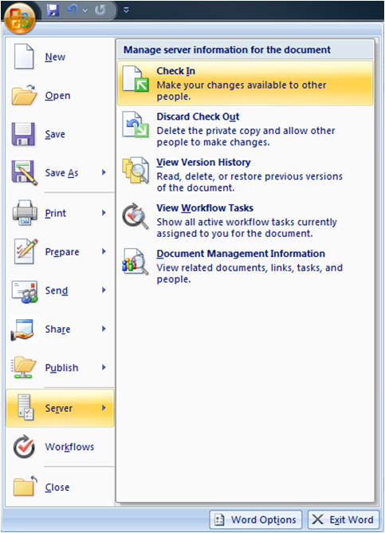When you use SharePoint Products and Technologies to provide an enterprise solution platform for your organization, your users benefit from a consistent, intuitive browser interface for all of their information-driven activities. Information workers who use Office client applications on a regular basis can also leverage their familiarity with the Office environment to hit the ground running with Office SharePoint Server 2007. For example, a user who is editing a document in Office Word 2007 can check the document in, view version history, and edit metadata directly from the client application.

"… we deployed mobile devices and trained police officers in under five minutes while they were mobilizing in a park."

[More information…](http://www.microsoft.com/casestudies/casestudy.aspx?casestudyid=4000001522)

"… training usually takes no longer than a single afternoon."

[More information…](http://www.microsoft.com/casestudies/casestudy.aspx?casestudyid=4000002395)

Improve Employee Productivity

Improving employee productivity is the common thread that binds all of the tools and features in WSS and Office SharePoint Server 2007. Let's take a look at how you can use these features to maximize productivity in key business areas.

Enhance Collaboration

SharePoint team sites and collaboration workspaces provide structured environments that enable teams to share documents, communicate, and work effectively together. Rather than relying on emails, conference calls, and network drives to facilitate teamwork, project managers can quickly provision sites that provide a structured, central environment to connect geographically diverse users. Collaboration features include:

* Document libraries with check-in and check-out features for version management.
* Integration with Microsoft Office 2007 for easy reviews, edits, and updates.

Leading global entertainment company enables the free flow of ideas and content with SharePoint portal solution

The Requirement

MTV Networks International broadcasts television programs, motion pictures, and digital media to more than 508 million households in 161 countries and territories around the world. To remain competitive, MTV must harness creativity and enable workers to communicate ideas and content. Their existing portal solution lacked scalability and created barriers to the flow of ideas, as only IT personnel could publish content.

The Solution

MTV deployed a new intranet portal based on Office SharePoint Server 2007. A key feature of the new portal is self-service content management, which enables creative personnel to publish their own content out to other users, together with automated approval workflows for new content. MTV also make use of other key SharePoint collaboration features, such as wikis and blogs, while search capabilities make it easy for users to find what they are looking for.

The Benefits

Self-service content publishing has enabled workers at MTV to communicate more effectively with internal users and external partners, while collaboration sites have boosted productivity. Standardization on Office SharePoint Server has substantially reduced workload for the IT team.

[More Information…](http://www.microsoft.com/casestudies/casestudy.aspx?casestudyid=4000002398)

* Notifications, alerts, and RSS feeds to keep teams up-to-date.
* Outlook-compatible team calendars to share key dates and deadlines.
* Task lists to assign work items to team members.

Office SharePoint Server 2007 collaboration sites are also easy to govern. You can set permissions and control access at any level of the hierarchy, from entire site collections to individual files. You can customize site templates, so that users create sites that meet organization-wide governance and working practice requirements. Office SharePoint Server 2007 also includes a two-stage recycle bin to provide a safety net if users accidentally delete important files or documents, thus reducing data restore headaches for the IT team.

Automate Business Processes

All organizations need to gather and process information from customers, partners, suppliers, or employees on some level. This information-gathering process presents a number of challenges.

From a business perspective, many organizations now strive to eliminate paper-based forms in order to reduce costs. To improve process efficiency and further reduce costs, your organization should aim to structure the information-gathering process to improve the quality of information collected and subsequently reduce processing errors. You should aim to minimize the number of information-gathering steps in each process, and to streamline each process without introducing new servers or new training requirements.

The information-gathering process introduces a different set of challenges for the IT department. Your IT team should seek to provide a single, integrated forms infrastructure with a consistent, easy-to-use interface for all business processes. They need to maintain security and confidentiality while they collect information from participants, and they need to integrate data from line-of-business systems, such as stock levels and reorder points, to drive the entire process.

"We expect that Office SharePoint Server will allow Sonnenschein to accomplish its strategic business goal of doubling in size over the course of the next two years."

[More information…](http://www.microsoft.com/casestudies/casestudy.aspx?casestudyid=4000002566)

Office SharePoint Server 2007 can help you to meet all of these challenges. Office InfoPath form templates enable you to build data validation, conditional formatting, calculation and many other features into your electronic forms to ensure that you collect high quality data at the first time of asking. You can also integrate data from virtually any external data source into your forms, either to provide the user with essential information or to structure their responses.

Office SharePoint Server 2007 includes a component named InfoPath Forms Services that manages the integration of electronic forms into your SharePoint environment. InfoPath Forms Services provides centralized management, versioning, and deployment for your form templates, and enables you to render forms in browser windows, on mobile devices, and as email messages in Office Outlook 2007. Additionally, InfoPath Forms Services offers full integration with workflow to provide a comprehensive business process automation platform.

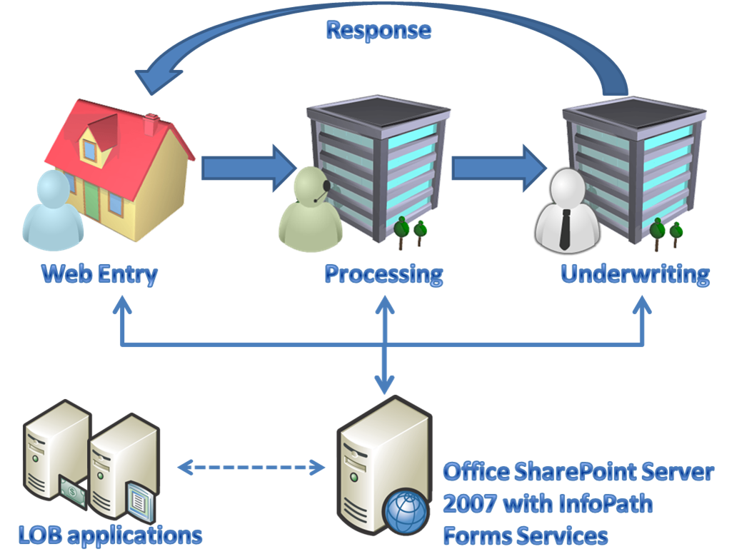

Connect Teams

"With SharePoint Server 2007, we had given people the collaboration tools they needed to become 'rock stars' within the business"

[More information…](http://www.microsoft.com/casestudies/casestudy.aspx?casestudyid=4000002822)

Organizations often contain many people with expertise and experience in different areas. The challenge is in how you capitalize on this, by answering the following questions:

* How do you find an individual with a particular skill?
* How do you encourage people to share their experiences and transfer their knowledge to others?
* How do you quickly assemble a team with the right mix of skills and experience?

Office SharePoint Server 2007 includes a number of social computing features that can help you bring teams together and share expertise within your organization. User sites enable people to provide information about themselves, their skills, and their experiences, while the 'people search' feature uses this information to help you to find the expertise you need.

Ad agency saves hundreds of hours weekly with integrated collaboration solution

[More information…](http://www.microsoft.com/casestudies/casestudy.aspx?casestudyid=4000002631)

Wiki sites and discussion boards encourage teams to share information informally and build a collective intelligence, while blog sites enable individuals to share tips, ideas, and experiences with others within the organization or the broader community. Presence integration features also allow your users to see, at a glance, who else is online for quick questions and comments.

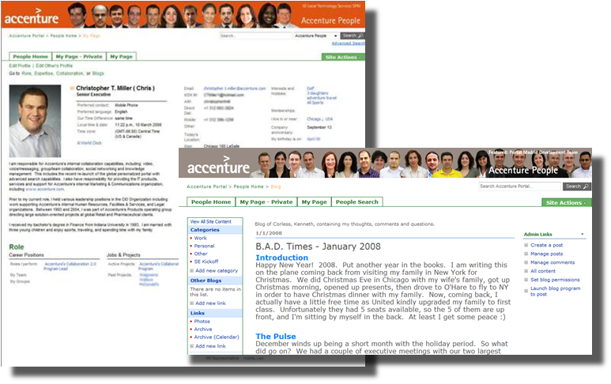

Manage Web Content

Many organizations provide large amounts of Web-based information for customers and partners. This content has a relatively short shelf life and requires continual updating. Without an effective framework in place, this process can become resource intensive and near unmanageable.

"With SharePoint Server 2007, users are empowered to own the content in a way that they never have been before."

Business users post updates in as little as 20 seconds.

[More information…](http://www.microsoft.com/casestudies/casestudy.aspx?casestudyid=4000001672)

Office SharePoint Server 2007 provides comprehensive Web content management features that you can use to manage and streamline the Web publishing lifecycle. Major and minor versioning with approval workflows enables users to create new content that is only visible to select approvers. When the approver gives the go ahead, the new content becomes a major version and replaces the current published content.

"Office SharePoint Server 2007 lets us focus on a whole new level of marketing–it lets us think more creatively, more expansively, about how to better reach and serve our customers"

[More information…](http://www.microsoft.com/casestudies/casestudy.aspx?casestudyid=4000001869)

Other features enable you to specify schedules for the deployment of content from a staging environment to the live site. These publishing schedules can also include an expiry date. For example, if you publish an offer that expires on the 1st July, you can specify that the content should be retired on the 2nd July. As a result, your team can spend less time monitoring your site and manually removing outdated material.

As with many of the features in SharePoint Products and Technologies, user empowerment is central to the effectiveness of these tools. By providing a repeatable deployment process within a reliable framework, you can enable business units to manage their own dynamic internet presence without the burden of constant maintenance and intervention from the IT team.

Vodafone Germany relies on SharePoint to offer employees an easily accessible portal solution and forum to act on the latest sales information.

[More information…](http://www.microsoft.com/casestudies/casestudy.aspx?casestudyid=4000002771)

Enhance Customer Service and Sales Effectiveness

One way to drive down costs within an organization is to enable individuals to use information more effectively. By bringing critical data from disparate sources together and enabling users to access it from anywhere, you can accelerate sales cycles, reduce travel expenses, reduce time wasted searching for information, improve relationship management for suppliers and customers, and realize many other benefits.

Improve Access to Information

"Within a matter of seconds, we can determine… who we should be servicing – and that takes into account all possible variable costs."

[More information…](http://www.microsoft.com/casestudies/casestudy.aspx?casestudyid=4000003023)

Poor access to information, and difficulties in quickly finding information, are key barriers to the effectiveness of customer-facing workers. Consider the scenario where a member of your sales team is onsite with a customer or a potential customer. Can the salesperson securely access your corporate resources from outside the firewall on his or her laptop? How about from a mobile device? And how readily can the salesperson find the information they require?

Office SharePoint Server 2007 can provide secure extranet access for your portal solutions. In combination with enterprise search capabilities and the ability to aggregate data from other platforms, this can make a substantial difference to the effectiveness of your sales team. The salesperson can respond to customers more quickly, and can answer questions onsite that would otherwise have required a trip back to the office. By empowering the sales team with ready access to the information they need, you can expedite the entire sales cycle.

Major technology provider creates intranet sales portal to support field sales teams and cut the sales cycle by half

The Requirement

CDW is a U.S.$8.1 billion technology-solutions company that employs 6,300 people. The company’s field sales teams found the existing sales intranet site increasingly inadequate for finding information quickly and easily. As a result, sales cycles became longer and more costly.

The Solution

CDW created a new intranet sales portal based on Office SharePoint Server 2007. The new site provides centralized access to relevant information such as product documentation, proposal templates, and sales status. The company use the search functionality to index content from a third-party sales application for ease of access. The sales portal also makes extensive use of business intelligence features to create dashboards and reports that summarize sales performance.

The Benefits

CDW estimate that every sales professional saves 10 hours per week previously spent searching for information. Business decisions are based on better information and are subsequently better informed, and the time taken to close sales has been cut by 50%.

[More Information…](http://www.microsoft.com/casestudies/casestudy.aspx?casestudyid=4000002685)

Aggregate Critical Data

Individuals in many different roles within an organization can benefit from tools that aggregate critical information into a single, visual interface–in other words, by having the facts at their fingertips. Executives need summaries of divisional sales performance, activities, and profitability. Regional sales teams may want to display leader boards and track performance against targets. Inventory managers benefit from visual summaries of stock levels and reorder points across different platforms and suppliers. Customer service representatives need an interface that draws key customer information from line-of-business, accounting, and order management tools.

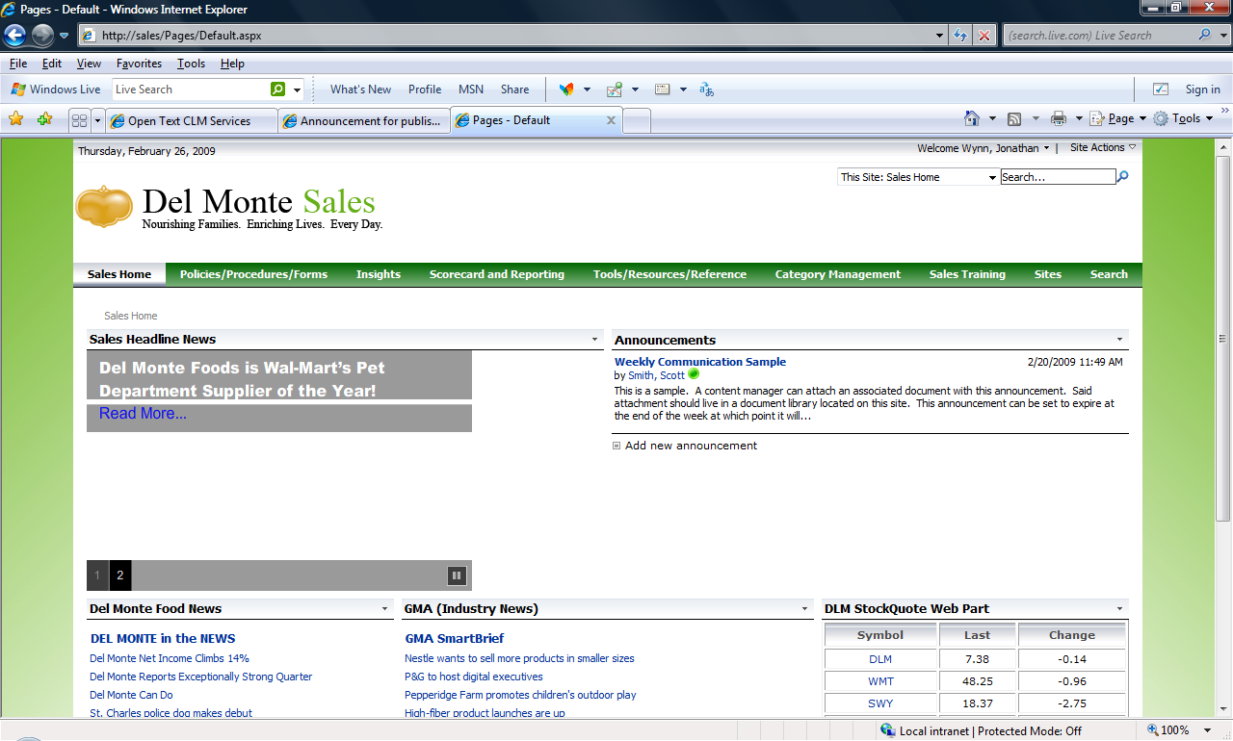

Office SharePoint Server 2007 offers a comprehensive set of tools that you can use to aggregate data and build business intelligence dashboards. Built-in Web Parts enable you to extract and visualize key performance indicators (KPIs) from spreadsheets and other data sources. The BDC enables you to extract and summarize critical data from line-of-business systems. Together with the Web Part framework and the scope for customization, these features can help you to build business intelligence dashboards that provide your employees with the information they need, when they need it.

Conclusion

"We are giving our associates more ways to connect to the firm, we are making life easier for them, and we are enabling them to focus on pleasing their clients."

[More information…](http://www.microsoft.com/casestudies/casestudy.aspx?casestudyid=4000002996)

Enterprise solutions such as collaboration platforms, portal frameworks, enterprise search, and business process automation tools are key enablers of productivity and efficiency in the workplace. However, these solutions also create new demands on your resources. Enterprise solutions are generally expensive, as each solution requires licensing, server and network infrastructure, governance and maintenance, and user education and training. Integrating enterprise solutions to provide an effective platform for your information workers is also often a difficult and costly task.

"We have sped up the flow of information, which enables us to fill orders faster and serve customers better."

[More information…](http://www.microsoft.com/casestudies/casestudy.aspx?casestudyid=4000003331)

SharePoint Products and Technologies provide a consolidated platform for enterprise solutions that can help you reduce costs and improve productivity and effectiveness in several ways. First, you can reduce IT costs and complexity by consolidating all your enterprise solution product investments into a single infrastructure. Rather than licensing, deploying, maintaining, and governing several platforms, each with their own server and network infrastructure requirements, you can use Office SharePoint Server 2007 to provide a unified, centralized platform for all information management activities.

Second, you can drive down development costs by using built-in tools to connect to line-of-business applications (such as Enterprise Resource Planning or Customer Relationship Management systems), comprehensive out-of-the-box components, and full integration with the Microsoft Office suite. When you do need to build on the SharePoint feature set, the .NET Framework object model provides a familiar programming interface that shortens the learning curve for developers.

Third, you can simplify your management and training requirements. Both knowledge workers and the IT team need only learn to use a single product, rather than several different enterprise-level tools. A central user interface for administration reduces the governance burden on the IT team, while an intuitive interface for end users helps to facilitate adoption and minimizes the need for extensive training.

Fourth, you can improve the productivity of your knowledge workers. Collaboration workspaces, document management features, social networking tools, business process automation and workflow features, and self-service content publishing are all designed to empower users and streamline business processes.

Finally, you can enhance the effectiveness of workers in many roles, such as senior management, customer service, and sales teams, through the use of business intelligence features. By aggregating data from line-of-business applications and other data sources across the organization into business intelligence dashboards and reports, you ensure that your teams have the facts at their fingertips. As a result, you improve customer service, slash sales cycles, and boost the effectiveness of people across the organization.

The saying “knowledge is power” originates from the 16th century, yet it offers an increasingly relevant maxim for today's information-driven organizations. By embracing technologies that enable you to share knowledge, drive collaboration, and manage the flow of information, you can cut costs, boost productivity, and gain genuine advantage over your competitors.

For more information on SharePoint Products and Technologies, visit www.microsoft.com/sharepoint.