Reporting Activation Information Using Volume Activation Management Tool 2.0

We often hear from customers asking about tools they can use to track and report activation data for Windows operating systems activated using Key Management Service (KMS) or Multiple Activation Key (MAK). Microsoft’s free [Volume Activation Management Tool (VAMT) 2.0](http://go.microsoft.com/fwlink/?LinkId=183042) can help you monitor activation information. You can even monitor retail activations performed using VAMT.

VAMT 2.0 supports Windows 7, Windows Vista, Windows Server 2008 R2 and Windows Server 2008, plus Office 2010 client suites and applications, Visio 2010 and Project 2010 clients.

VAMT is not meant to replace any tool you already may be using for the purpose of software asset management or license management. Rather it is intended to assist you centrally manage activation and related tasks for the products mentioned above. VAMT can provide important information on license status, and whether installed software is genuine. This information also can help you with license compliance.

Contents

Monitor Using the Product List 1

License Status 3

Computer Information List (CIL) 4

CIL Table 5

More *Using VAMT 2.0* Guidance 7

# Monitor Using the Product List

VAMT’s product list, in the center pane of the UI, is configurable to show attributes used most commonly to monitor activation data, including the license status of each product. These attributes are maintained by VAMT.

To define the categories of information to display, and the order in which to display them, click View in the top menu bar and then click Add/Remove Columns. Make your selections and click **OK**. See Figure 1.

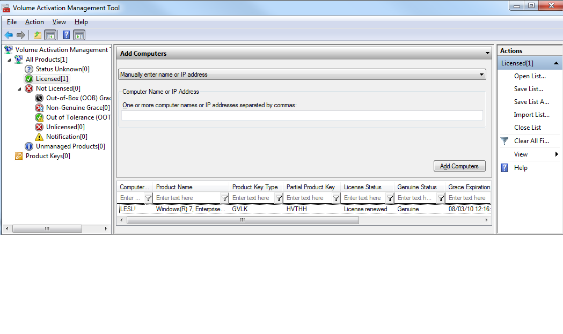

**Figure 1. Common product list fields**

The table below shows the possible columns in the Product List. Some of these are default.

| **Column** | **Description** |
| --- | --- |
| Internal computer GUID | ID created by the VAMT and assigned to keep track of computers during various operations. |
| Computer Name | (Default) – Computer name or IP address (if entered manually). |
| Product Name | (Default) – The name of the discovered product. |
| Product Key Type | (Default) – Displays the current activation type for the product. Read [*Manage Product Keys Using VAMT 2.0*](http://go.microsoft.com/fwlink/?LinkId=184609) for details on product key type. |
| OS Edition | The installed Windows edition. |
| Product Version | The specific product version number, in the format: x.x.xxxx.xxxx |
| License Status | (Default) – Displays the product’s last known license state:  • Out-of-Box (OOB) Grace  • Licensed  • Non-Genuine Grace  • Out-of-Tolerance (OOT) Grace (includes KMS client activation expired)  • Unlicensed  • Notification |
| Grace expiration date | (Default) – Date that grace will expire for a product. For KMS client-activated products, this represents the date that the KMS activation expires. |
| Status of the last action | (Default) –The last action performed on the product and the result. |
| Partial Product Key | The last five characters of a product key. |
| Product ID | The ID that corresponds to the product edition. |
| Domain/Workgroup | The domain or workgroup of a computer. |
| PID | Product ID. A numerical representation of the 5x5 product key. Often used by MS during customer support calls. |
| Installation ID (IID) | The ID sent to Microsoft to get a corresponding CID. The IID is generated when retail, MAK, KMS host key. |
| Pending Confirmation ID (CID) | Confirmation ID received from Microsoft. Paired with the IID, these IDs allow a client product to activate. |
| Genuine Status | (Default) – The genuine status as returned by the Microsoft hosted activation service. |
| Date of Last Status Update | (Default) – The time stamp of the last status update for a product. |

VAMT provides a point-in-time view of the computers and products that it manages. It cannot provide an ongoing view of your environment. You should refresh the status from time to time. You can easily get an update license status.

1. Select one or more products, to update their status.
2. On the Actions menu, select Update Status and choose a credential option. Choose Alternate Credentials if you are only updating products that require administrator credentials different from the ones you are currently logged into the computer with.
3. If you are supplying alternate credentials, at the prompt, type the appropriate user name and password and click OK.
4. VAMT will display the Collecting product information dialog box while it collects the status of all selected products. When the process is finished, the updated license status of each product will appear in the product list view in the center pane.

Click the nodes in VAMT’s left pane to determine which products are in an unlicensed state, so you can take corrective action if necessary. Understanding which products are properly licensed or not can assist with license compliance.

# License Status

A critical piece of information to track is the license status of the products that VAMT manages. Above we described how to update a product’s status. Here we explain each status.

* Status Unknown – Display all products that the VAMT has not collected or cannot collect license status for. This includes any computers that have been added but whose installed products have not yet been discovered.

• Licensed – Display all products that have been activated by a valid product key.

• Not Licensed – This is the parent node for all products whose licensing status is not Licensed:

• **Out-of-Box (OOB) Grace** – Display all products that are still within the initial grace period allowed by Windows, Windows Server or Microsoft Office 2010 prior to required activation.

• Non-Genuine Grace – Applicable only to systems running Windows Vista RTM edition. Indicates the system has failed online genuine validation and is in 30 day grace period.

• Out of Tolerance (OOT) Grace – Display all products that have had hardware or BIOS changes significant enough to require reactivation, and all KMS client products that have not renewed their activation within the 180 days activation renewal period.

• Unlicensed – Activation status cannot be determined. It may indicate tampering of activation related binaries and configuration values. Applies only to Windows Vista RTM or retail editions of Office 2010 products.

• Notification – Display all products that are either past the activation grace period or failed validation. These products will be subject to a notification experience but continue to run with full functionality.

• Unmanaged Products - Display all discovered products that do not support activation methods managed by the VAMT. This only includes Windows XP SP2 or later and Windows Server 2003 SP1 or later installations.

# Computer Information List (CIL)

VAMT stores data in the Computer Information List, or CIL, an XML file created when you save or export data. See Figure 2. The CIL is required for certain types of activation, including local reactivation and activating in disconnected environments. However, we suggest that you always save VAMT data in a CIL. You may also want to save a backup copy.

We also recommend that you restrict access to VAMT and the CIL to only those personnel with a reason to see the product keys and activate products. Secure access to the CIL file on the local hard drive by encryption, or set permissions for the folder where the CIL is stored. Make sure that you similarly protect the backup location if you create a back up file e.g. for disaster recovery.

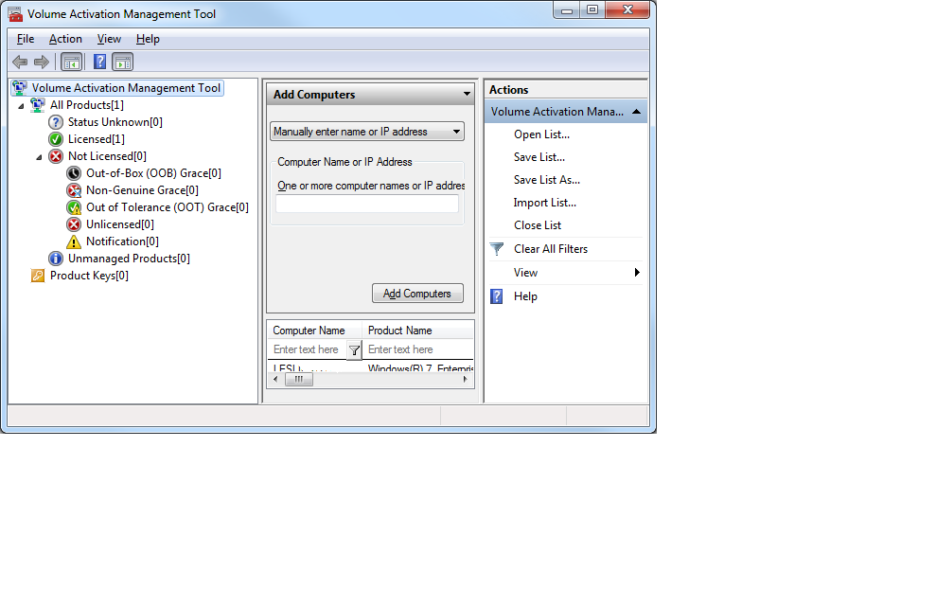

**Figure 2. CIL options in VAMT 2.0**

You can save a CIL with all personally identifiable information (PII) or excluding PII. See Figure 3. You may need to save the CIL without PII if you are transporting the CIL outside a secure environment. This scenario is detailed in [*Activation in Disconnected Environments Using VAMT 2.0*](http://go.microsoft.com/fwlink/?LinkId=184609).

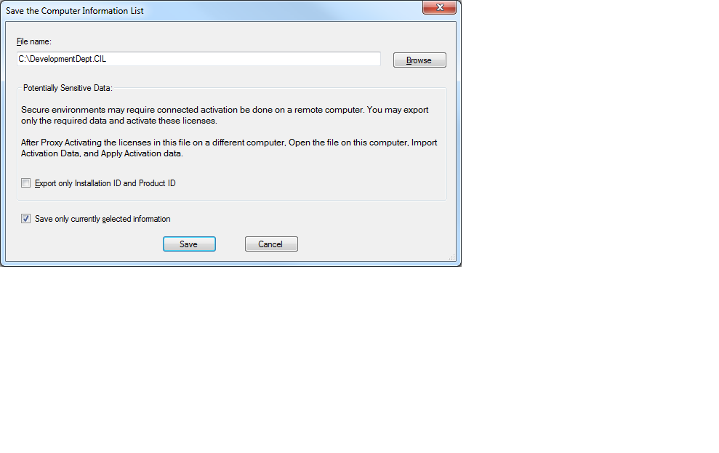

**Figure 3. Save the CIL**

The table at the end of this document lists all the tags in a complete CIL. The VAMT Help File includes two sample CILs: a complete CIL and one with PII excluded.

# CIL Table

The following table lists all tags contained in a complete CIL file. Selecting the Export only Installation ID and Product ID option in the Save List As dialog box excludes all Personally Identifiable Information (PII) from the CIL. The right column indicates the fields that are excluded from the CIL file only when the Export only Installation ID and Product ID option is selected from the Save List As dialog box from the context-sensitive Actions menu.

| **Name** | **Definition** | **Excluded During Secure Export** |
| --- | --- | --- |
| SoftwareLicensingData | Parent XML tag that includes all data in the CIL file. |  |
| SoftwareLicensingData: Version | The version number of the CIL format used. |  |
| Computers | Parent XML tag that includes the list of all computers. |  |
| Computer: Name | Name of computer. | X |
| Computer: OSVersion | Operating System Version. | X |
| Computer: OSEdition | Operating System Edition. | X |
| Computer: NetworkType | The network type of the computer (either domain or workgroup) | X (Value will be “None”) |
| Computer: NetworkName | Domain or workgroup name. | X |
| Computer: Id | Unique ID that represents a computer assigned by the VAMT. |  |
| MacAddresses | Parent XML tag that includes the list of MAC addresses. | X |
| MacAddress | Computer Network MAC Address. | X |
| Products | Parent XML tag that includes the list of products. |  |
| Product | Parent XML tag that includes all information for an installed product. |  |
| Sku: Id | GUID that identifies the channel and edition of the product. |  |
| Sku: Name | Name of the product. |  |
| Sku: ApplicationId | GUID that identifies the license application ID. |  |
| Sku: Description | Channel and edition information of the product. | X |
| LicenseInfo: LicenseStatus | The licensing status of the product. | X (Value will be “None”) |
| LicenseInfo: LicenseStatusReason | Result code of that last action that the VAMT has performed for this product. |  |
| LicenseInfo: GracePeriodRemaining | The remaining grace period, in minutes. | X (Value will be “None”) |
| LicenseInfo: GenuineStatus | The status returned by Windows Genuine Advantage or Office Genuine Advantage server after validation. | X (Value will be “None”) |
| LicenseInfo: TokenEnabled | Reserved; set to 0 |  |
| LicenseInfo: LicenseIsAddon | Indicates if the product has an add-on license. |  |
| Version | The version of the product. | X |
| PartialProductKey | Last five characters of the installed product key. Returns null if a product key is not installed. | X |
| ProductKeyId | Digital representation of the 25-character product key for the installed product. |  |
| KeyType | The type of the product key. |  |
| InstallationId | The Installation ID (IID) retrieved when a retail product key, a KMS host product key, a MAK, or a certain type of OEM product key is installed for a product. |  |
| ConfirmationID | The Confirmation ID (CID) pending installation for a given product. | X |
| LastErrorCode | The error code of the last action performed on a product. | X |
| LastActionState | The status of the last action performed on a product | X |
| LastUpdateTime | Time when the last action was performed for a product. |  |
| ProductKeys | Parent XML tag that includes the list of product keys. | X |
| ProductKey: Value | The 25-character product key. | X |
| ProductKey: Description | The description of the 25-character product key, as defined by Microsoft. | X |
| ProductKey: RemainingActivationCount | The remaining activation count for the 25-character product key returned by the Microsoft online activation server. | X |
| ProductKey: SupportedEditions | The supported editions for this 25-character product key. | X |
| ProductKey: Type | The type of 25-character product key. | X |
| ProductKey: Id | Digital representation of the 25-character product key. | X |
| ProductKey: Remarks | The remarks on this 25-character product key entered by the user. | X |

# More *Using VAMT 2.0* Guidance

Check out the other [*Using VAMT 2.0*](http://go.microsoft.com/fwlink/?LinkId=184609) documents:

* Manage Product Keys Using VAMT 2.0
* Product Activation Using VAMT 2.0
* Activation in Disconnected Environments Using VAMT 2.0

You can watch video demos of several VAMT tasks at [www.technet.com/volumeactivation](http://www.technet.com/volumeactivation).[1] The Helpfile in the [VAMT 2.0 download](http://go.microsoft.com/fwlink/?LinkId=183042) has detailed information on how to perform many tasks using the tool.

1. Several of these demos use VAMT 1.2 but the process is the same using VAMT 2.0.