
Enhance Client Satisfaction using Microsoft Office OneNote 2003
How consultants can proactively deliver client solutions with increased efficiency

Introduction
Meet Joe Andreshak. Joe is a business process consultant. Litware, Inc. has hired him to evaluate their current online ordering process flow. Like many small businesses that expanded quickly, the order fulfillment process at Litware has outgrown its systems. Without the proper visibility into their supply chain, they are unable to keep up with customer expectations.
Joe's tasks for the next month involve meeting with employees of the operations department to document how the order processes currently work, identifying more streamlined ways of processing orders, and determining the cost and schedule of implementing the changes.
Without a good way to manage his notes, Joe spent a lot of extra time typing up meeting notes, aggregating information from his research, managing and organizing the information he collected, and figuring out how to share his information with team members and clients.
Now Joe uses Microsoft® Office OneNote™ 2003. OneNote provides a single place for information workers like Joe to capture information more efficiently, organize information more effectively, and reuse and share notes more easily.

OneNote helps transform information into business impact
OneNote combines the flexibility of paper note-taking with the ability to search, collaborate, organize, insert, and use your notes in other contexts using a laptop, desktop or Tablet PC. Let's take a closer look at OneNote, and how it can help teams access and share information, enable more timely decisions and minimize time to perform routine tasks.

Improve how teams and organizations share and retain information
Accessing and sharing information can be difficult when team members are dispersed or meet infrequently. Paper notes containing crucial ideas or action items are often hidden on one person’s desk, inaccessible to other team members. OneNote helps ensure accountability and ownership of tasks, keep a team up-to-date on project information, and reduce the risk of losing knowledge within a group or organization.
- Ramp up new team members quickly. With all information archived and readily accessible in a central location, information can be handed off to new team members as others roll off a project. Both client and consultant teams can be more confident that new team members can get up to speed in minimal time.
- Collaborate more effectively. Updates made to OneNote files saved to a shared workspace in a Microsoft Windows® SharePoint™ Services site are available to everyone else. A whole team can work together to flesh out details related to a project, putting all notes in a single repository.
- Share notes easily. E-mail notes directly from OneNote with Microsoft Office Outlook® 2003 to team members or publish and send as Web pages or .one files without having to deal with the extra step of transcribing or photocopying them. Save time and minimize the risk of inaccuracies or losing information.
- Create more accountability. Create customized note flags in OneNote to assign tasks to team members and easily track their assignments. Convert tasks in OneNote into tasks in Outlook 2003 to share them with team members.

Make more informed decisions
With the rapid pace of the work environment, information workers must be able to make quick decisions confidently, knowing that the information in their notes is reliable and up to date.
- Get better access to information. Use the key word search to find relevant information in your notebook for making key decisions. These searches can be confined to specific areas of your notebook, or expanded to search your entire notebook for appropriate information. Immediately get a clickable list of all pages where the word appears.
- Capture more comprehensive information. Because you can take notes by capturing information in virtually any format--typed notes, handwritten notes, graphics, audio recordings, information from other applications--all your notes and information are available in a central location.
- Ensure more accurate information. Audio notes capture the full conversation in an interview or meeting. The recording automatically synchronizes with the typed or written notes you took at that time.

Spend more time on business critical tasks
By providing better, faster tools with which to perform ordinary, yet essential note-taking tasks, OneNote creates more time for you to devote to client solutions. The intuitive notebook structure and rich authoring features, that are similar to other Office applications, enable information workers to get started on OneNote right away.
- Capture information more effectively. In addition to the ability to take notes in various formats and from different sources, OneNote offers a convenient smaller window called a side note, which is similar to a digital “sticky note.” Side notes make it easy to capture research from the Web or other documents, or to jot down quick notes such as contact information or a tangential idea.
- Organize information more efficiently. Rearrange notes flexibly on the page. Use note flags to highlight important items in your notes and then sort them by date, type of note flag, or section of your notebook.
- Reuse information more easily. Distribute and share notes quickly by e-mailing them directly from your notebook or publishing them as Web pages, reducing time and effort spent transcribing paper notes. Also, easily drag and drop information from OneNote into other Office applications such as Microsoft Office PowerPoint® and Microsoft Office Word.

OneNote Improves the Consultant's Life
Now that we've seen the benefits OneNote provides, let's see how it helps Joe in his day to day work. Joe's day is typically filled with online research, meetings with client teams, and discussions with other members of the project team.
Before using OneNote, Joe would take notes on paper during a meeting and have the extra step of typing them up later to distribute to the other participants. Inevitably, some details from the meeting or tasks assigned to individuals got lost or forgotten during this process.
While researching, Joe took notes on his notepad, but ended up with bookmarks in his browser, printed Web pages placed into a manila folder, and sticky notes attached to various paper documents to highlight the important parts. Finding the desired information at a moment's notice was difficult at best.
When it came time to preparing a presentation, Joe had to collect all of the information scattered across all these sources, chase down sources and details, and type information that was only in handwritten form.
Now that Joe uses OneNote, let's look over his shoulder as he goes through a day.

Thursday, 7:00 am
At Joe’s desk.
Joe arrives at work to find several new messages in his e-mail inbox, and several voice mails. One of the messages is from a team member asking Joe to review a PowerPoint presentation. Joe glances at his inbox and his calendar, and realizes that he doesn’t have time to do it now. He opens a side note, jots down his initial thoughts, and adds a note flag to highlight it as an item for follow-up later.
After listening to a lengthy voice mail from the team’s senior manager, Joe opens up another side note. He writes down the key points on two steps in the business process that the senior manager wants Joe to research further.
Joe answers the remaining items in his inbox, and then opens OneNote. On a new page, he creates an agenda for a meeting with the client’s customer service department.

9:00 am
During an on-site client meeting.
As the meeting with Carole Poland, Litware's customer service manager and Mike Hines, an e-mail support specialist progresses, they cover several agenda topics. Joe is able to effortlessly organize his notes into new pages within various sections of his notebook.
Mike has some extended insights on key points concerning customer-critical services. Rather than write it all down during the meeting, Joe records an audio note to capture what Mike is saying. Moreover, Mike’s comments are synchronized to Joe’s typed information, making it easy to listen to specific sections of the audio recording later.
For each of the questions that deals with shopping cart transactions, Joe adds a custom note flag that marks it as being assigned to the development group, and flags other follow-up items for the Customer Satisfaction group. He then creates a task in Outlook to assign it to Wanida Benshoof, the development manager, and sends it to her via e-mail. This enables Wanida, who is back at the office, to get started on some of the details of the project before Joe even returns.
Figure 1 show the OneNote interface.

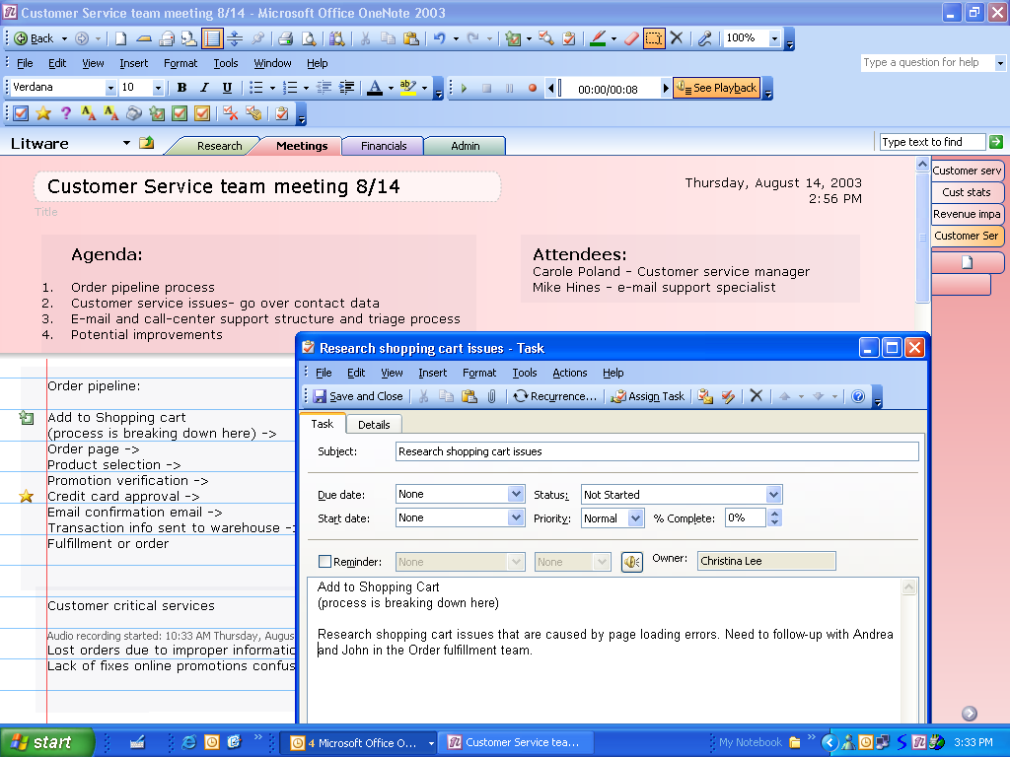

Figure 1: Joe sends an Outlook task for the Development team to research issues further.

1:00 pm
Sharing notes with the team.
Back at his office, Joe quickly rearranges his meeting notes into more logical groups by dragging and dropping them, and then e-mails them to the meeting participants. He then selects all of the pages of the Potential Improvements section, and saves them to the shared workspace on the Microsoft Windows SharePoint Portal Server. This creates a shared team notebook, where his teammates can continue to add details to the notes as the project progresses.

2:30 pm
Doing research with OneNote.
Joe has action items of his own as a result of the meeting. It is his responsibility to find the results of any published studies about user responses to automated voice systems.
He surfs the Internet, searching for relevant information. As he works he keeps a side note open, and drags relevant information from the browser or other applications into the side note. OneNote automatically adds the URL of the Web pages from which he gathered the information.
Figure 2 shows the OneNote side note
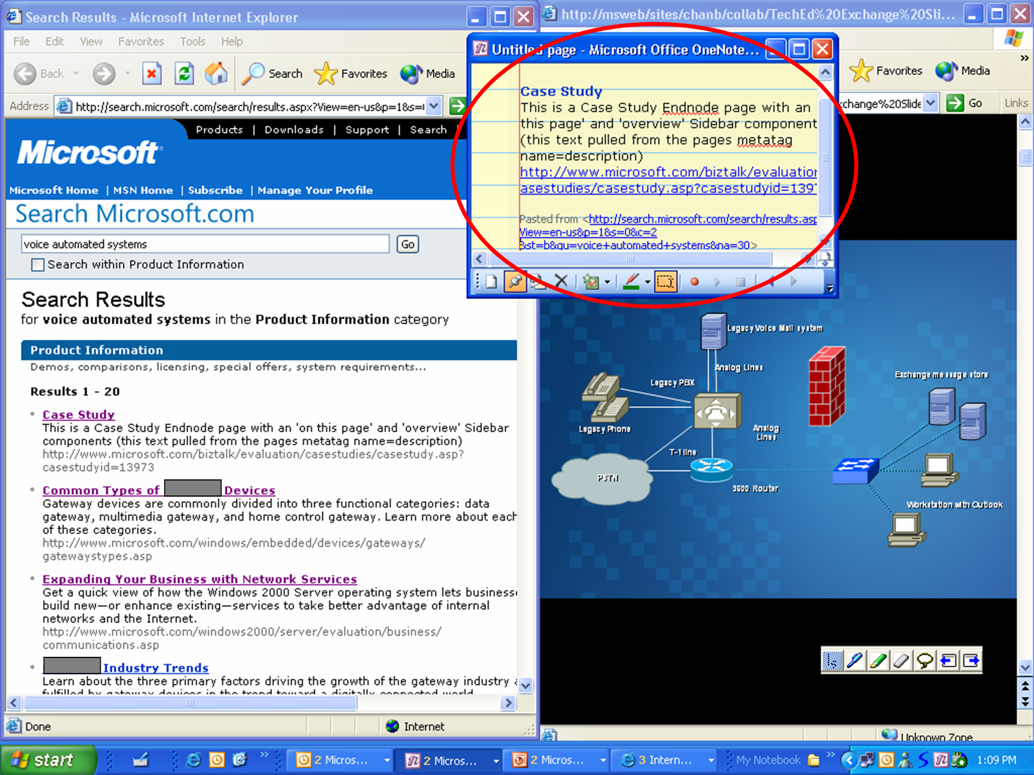

Figure 2: Joe uses a side note as he captures information from the web and a PowerPoint presentation.
As he collects research, Joe goes back over the meeting notes. He realizes that a few of the written notes are so abbreviated he doesn’t remember why they are relevant, so he listens to the audio note. Because the recording was synchronized to his typed notes, he quickly jumps to the exact part of the discussion he needs to clarify.
While Joe is working, his senior manager drops by and asks about the credit card approval process he had described to Joe over voicemail. Joe types the words “credit card” into the Find box in OneNote and is able to give the manager a quick summary of his findings without having to fumble through his notebook. Joe’s speedy response impresses the senior manager with his preparedness.

5:00 pm
Wrapping things up.
After following up on more e-mails, Joe finds that all of his action items associated with earlier meetings of the day are already complete with the help of OneNote. He can now focus on his PowerPoint presentation for Friday's status meeting with senior management.
Joe’s notes are already organized, making it easy to construct his slides. Joe extracts key points, drags them into his presentation and copies the charts into PowerPoint. In no time the presentation is ready for the morning meeting.
Before going home, Joe goes over his to do list for the next week, adds a few items to his calendar, and sits back to reflect on the project. He is prepared, ready, and has the time to think about next steps with his client's project and to follow-up with new project leads.

Conclusion
OneNote provides Joe with all the advantages of traditional note-taking and storage while offering a much more effective and flexible way to manage, prioritize, and share notes. Because OneNote makes it easy to share and collaborate among teams or organizations, everyone has access to the information, supporting more informed decisions and effective knowledge management. OneNote helps busy professionals become more productive, creating more time to develop valuable solutions for their clients.

August 2003
This document is for informational purposes only. MICROSOFT MAKES NO WARRANTIES, EXPRESS OR IMPLIED, AS TO THE INFORMATION IN THIS DOCUMENT.
© 2003 Microsoft Corporation. All rights reserved.
The example companies, organizations, products, people and events depicted herein are fictitious. No association with any real company, organization, product, person or event is intended or should be inferred.
Microsoft, the Office logo, OneNote, Outlook, PowerPoint, Sharepoint, Windows and Windows Server are either registered trademarks or trademarks of Microsoft Corporation in the United States and/or other countries. The names of actual companies and products mentioned herein may be the trademarks of their respective owners.

Joe Andreshak is a fictitious name used as an example.
Requires Windows Server 2003

