



Microsoft Office SharePoint Server 2007 Deployment at MTV Networks

White Paper

Published August 2008

Abstract

As an entertainment company, MTV Networks must continually work to ensure the free flow of information. However, the company’s previous portal infrastructure required IT involvement in order to publish new content and an excessive amount of attention from IT personnel. The company standardized on Microsoft® Office SharePoint® Server 2007, which today hosts intranets and multiple Internet sites for MTV Networks and Viacom. The new portal platform has improved end-user communication and collaboration, increased IT staff efficiency, and provided an extensible, reliable, scalable, and cost-effective solution. This white paper examines the move to Microsoft Office SharePoint Server 2007 in detail, including the previous portal environment and the challenges that this environment presented, requirements and selection process for a new portal solution, development process and architecture, new portal environment and capabilities, how various business units and IT groups are benefiting, and future plans.

The information contained in this document represents the current view of Microsoft Corp. on the issues discussed as of the date of publication. Because Microsoft must respond to changing market conditions, it should not be interpreted to be a commitment on the part of Microsoft, and Microsoft cannot guarantee the accuracy of any information presented after the date of publication.

This white paper is for informational purposes only. MICROSOFT MAKES NO WARRANTIES, EXPRESS OR IMPLIED, IN THIS SUMMARY.

Complying with all applicable copyright laws is the responsibility of the user. Without limiting the rights under copyright, no part of this document may be reproduced, stored in, or introduced into a retrieval system, or transmitted in any form, by any means (electronic, mechanical, photocopying, recording or otherwise), or for any purpose, without the express written permission of Microsoft.

Microsoft may have patents, patent applications, trademarks, copyrights or other intellectual property rights covering subject matter in this document. Except as expressly provided in any written license agreement from Microsoft, the furnishing of this document does not give you any license to these patents, trademarks, copyrights or other intellectual property.

Unless otherwise noted, the example companies, organizations, products, domain names, e-mail addresses, logos, people, places and events depicted herein are fictitious, and no association with any real company, organization, product, domain name, e-mail address, logo, person, place or event is intended or should be inferred.

© 2008 Microsoft Corp. All rights reserved.   
  
Microsoft, Active Directory, BizTalk, InfoPath, SharePoint, SQL Server, Visual Studio, Windows, and Windows Server are trademarks of the Microsoft group of companies. All other trademarks are property of their respective owners.

Contents

Introduction and Overview 1

Previous Portal Environment and Challenges 2

Requirements for a New Solution 3

Decision Process 6

New Portal Platform 7

Corporate Intranet 8

Internet Sites 13

Meeting Continued Demand for New Business Value 18

Improved Operations 19

Future Plans 20

Conclusion 21

For More Information 22

# Introduction and Overview

A leading global entertainment content company, Viacom reaches more than 508 million households in 161 countries and territories through television programs, motion pictures, and digital media, as delivered through approximately 160 TV channels and 325 online properties. MTV Networks, the company’s largest division, includes brands such as MTV, VH1, Nickelodeon, Nick at Nite, COMEDY CENTRAL, Spike TV, and TV Land. Two other divisions include BET Networks, a leading provider of entertainment content for African Americans and consumers of Black culture, and Paramount Pictures Corporation, which creates and distributes filmed entertainment.

As an entertainment company, MTV Networks must continually work to ensure that its brands remain strong, vibrant, and deeply connected to the audiences they serve. “To remain competitive, we need to ensure the free flow of information,” says Dave Mitchell, Vice President of Application Development at MTV Networks. “In our business, success is all about creativity—about coming up with the next big idea. Staying in touch with our audiences requires constantly reinventing ourselves, which means taking peoples’ ideas and making them part of a greater knowledge pool.”

However, the company’s previous portal infrastructure wasn’t helping people share information and ideas. End users could not publish their own content, collaborate effectively, nor find the information they needed. Demand for a solution that empowered end users led to a proliferation of smaller, departmental portal solutions, which, having been implemented using a mix of different technologies, resulted in increased IT costs, reliability issues, and an excessive support burden for IT personnel.

MTV Networks addressed those issues by standardizing on Microsoft® Office SharePoint® Server 2007, on which the company deployed a new intranet portal, a Viacom corporate portal, and multiple Internet sites. Self-service content publishing is helping groups across the company communicate better, while rich collaboration and search features enable people to find and share information. From an IT perspective, the company’s new standardized portal platform integrates well with existing IT infrastructure and delivers new capabilities in a reliable, scalable, and cost-effective manner.

This white paper examines the move to Office SharePoint Server 2007 in greater detail, including:

* Previous portal environment and the challenges presented
* Requirements and selection process for a new portal solution
* Development process and architecture for the new solution
* New portal environment and key capabilities
* How various business units and IT groups are benefiting
* Future plans

# Previous Portal Environment and Challenges

In 2002, to facilitate communication, MTV Networks deployed a corporate intranet portal based on Plumtree Software. Within a few years, however, the company’s needs had changed to the point that the portal was deemed inadequate. “The business problem was actually slow to emerge—it was really more of an evolution of our needs,” says Mitchell. “Our first-generation portal was great for companywide communication, but it didn’t empower employees to communicate and collaborate directly with each other. It’s not easy to put people in a room, have a conversation, and get something done, especially when someone is in France and someone else is in Singapore.”

One problem was the difficulty in publishing new content, which, for most business units, required assistance from Mitchell’s team. “Original users trained to publish content had moved on to new roles and, in many cases, nobody was willing to take over or capable of doing so,” says Mitchell. “After a few years, it got to the point that only IT personnel had the skills to publish content, and having a single group trying to keep the entire company in touch with each other wasn’t working. Content on the portal had degraded to the point that much of it was several years old, with the most popular destination being the cafeteria menu.”

The need for custom software development to do anything new increased the burden placed on Mitchell’s team. “Everything was very structured and rigid, and we had to write code to make even the smallest changes,” says Evan Stark, Manager of Application Development in Mitchell’s group. “Developers would copy the ASP code from one part of the portal, clone it, and then start making changes. We ended up with lots and lots of old code that was hard to maintain and, as individual developers moved on, knowledge of how the code worked was lost.”

Because of the corporate portal’s limitations, many business groups had deployed their own portal solutions, often turning to external vendors for custom solutions that were handed over to internal IT personnel to manage and support. This proliferation of technologies led to additional hardware and software costs, an increased support burden, and reliability issues that limited end-user productivity and kept IT personnel in a reactive mode.

“We had portal solutions and technologies from several different vendors, as well as some portals that were homegrown,” says Brian Amirian, Vice President of Server and Storage Technologies at MTV Networks. “That led to issues with backup, recovery, and scalability, with way too much time—and money—being spent on basic maintenance and support.”

# Requirements for a New Solution

In 2005, MTV Networks began looking for a new solution. “We wanted to reinvent our corporate intranet and make it a more useful business tool, with support for self-service content publishing, collaboration, and workflows,” says Mitchell. “We also envisioned making it a single source of information for people across the company, which meant expanding its reach beyond our 5,000 domestic employees to include all 10,000 employees of MTV Networks worldwide, and possibly to other Viacom divisions as well.”

## Top-Level Vision

At an executive level, the vision was for a new portal solution in which people could easily work, accessing and sharing information and ideas to help the company succeed. Executives envisioned the portal as a single tool with which employees could tap into a broad range of resources, from company news to the information hosted in back-end systems. They saw the new portal as a way to help ensure that valuable institutional knowledge would not be lost but instead would be collected in one place and made broadly accessible to all.

“As we continue to move to a digital production environment, IT plays a larger role in our ability to remain competitive,” says Joe Simon, Senior Vice President and Chief Information Officer at MTV Networks. “Everybody used to gather in a large room to hash through a storyboard, but it no longer needs to work that way. Instead, people around the world need to be able to communicate and collaborate electronically, which provides the potential for huge increases in efficiency.”

## End-User Requirements

Requirements for the new solution were largely determined by end-user feedback. “Our primary focus was in how best to meet the needs of end users,” says Mitchell. “And their requirements were both large and small, ranging from the need to collaborate with people on the other side of the globe to looking up a phone number for someone in the same building.”

From an end-user perspective, the company identified several requirements:

* **Self-service content publishing.** MTV Networks had to push content ownership out to business users, who know their own content better than anyone else does and who prefer to manage it on their own. “The challenge was delivering a user-friendly solution so that people focused on being creative wouldn’t get bogged down by the technology,” says Mitchell.
* **Rich collaboration tools.** People needed to be able to come together on the portal from across the globe, sharing ideas and information in a broad range of formats and without organizational or geographic boundaries. “Regardless of someone’s job role, they need to be able to find, connect, and collaborate with others who have similar objectives and goals,” says Mitchell. “As one executive told me, ‘I have ideas all the time. Give me somewhere to put them where others can find them, and make it easy.’”
* **Comprehensive search.** MTV Networks needed to ensure that people could easily find what they needed on the portal. “We needed to go beyond content management and collaboration to incorporate knowledge management,” says Janni Plattner, a business analyst on Mitchell’s team. “To reduce duplication of effort and accelerate the proliferation of best practices, we needed a single search tool that could span Web site content, shared files, information on people, and more.”
* **Stronger visual identity.** The new portal solution had to support the company’s many different brand identities, without extensive custom development. “Brand identity is everything in our business,” says Mitchell, “so it’s important that we reinforce those brands in everything we do, even with an internal business tool.”

## Application Development Requirements

For Mitchell’s small team, the challenge was to find a solution that could empower employees without technical skills to take ownership of the portal from a day-to-day perspective thereby freeing the team to focus on more value-added tasks. “Whatever we built, we had to support it with the same amount of resources that supported the old portal,” says Mitchell. “There’s no way that I’ll ever be able to staff for an internal business tool like we do for MTV.com.”

Mitchell’s team knew that getting the new corporate intranet portal up and running would be only the beginning, after which the team would need to start building solutions that ran on the portal. “Every group has its own unique needs, and we need to bring all that together to drive an overall long-term portal strategy,” says Plattner. “Groups are usually happy with basic features at first, but it’s not long before they start coming back to us for more advanced capabilities. In selecting a new portal platform, we considered not only what it would take to get it up and running initially but also how easily we could build on it to deliver all the other things that people would eventually need.”

## Operational Requirements

From a data center perspective, MTV Networks wanted to reduce the time and costs required to support the company’s portal infrastructure. “Without a single platform to leverage, we had problems with backup and recovery, scalability, and day-to-day support of the environment. Way too much time was spent on maintenance and reactive procedures rather than thinking about the future and architecting new solutions.”

One requirement was a scalable solution that could support the entire company with minimal infrastructure. “Server consolidation was a huge goal,” says Amirian. “We had about 15 to 20 servers supporting the Plumtree portal, but we didn’t want to consolidate because nobody knew which parts of the portal were running where or which data sources they were talking to. It was all very fragile, and there were way too many potential points of failure.”

The group also wanted to ease the pain caused by rapid, grass-roots adoption of Windows® SharePoint Services sites, which were quickly proliferating as a means of sharing files and other information. “All content was stored in a single database, which had grown to several hundred gigabytes,” says Amirian. “The process of restoring a single file could take hours or days and we had to do that every few weeks. Things had reached the point where we almost told users to keep copies of important files somewhere else, because we weren’t going to restore them anymore.”

Concludes Amirian, “The new portal initiative gave us the chance for a fresh start—a way to look at all our portal needs in this day and age and to architect a solution the right way. Of course, it had to be reliable, scalable, and easy to manage—ideally within our existing processes and skill sets.”

# Decision Process

Although Mitchell’s group took a lead role in recommending a platform to use, as he puts it, “It was a companywide decision from a number of different sources. My group is closest to the problems encountered by business users, so we were in a position to offer an opinion on what would work best for them. We also funneled information from stakeholders to the office of the CIO and the office of the technical architect.”

Part of the answer to which portal platform could best meet user needs came from the rapidly growing number of Windows SharePoint Services sites, of which there were 60 at the time. However, these were standalone sites that had grown from the bottom up, with no organization or structure and with so many new requests that it was overwhelming for the IT team. “One group would get a SharePoint site, and another group would see it and want one too,” says Plattner. “We knew that if we could do it again we would take a top-down, enterprise-wide approach to meeting demand for SharePoint sites, which, thanks to a collection of fast, easy wins, was quickly growing.”

SharePoint technology also offered the best fit with the rest of the company’s IT infrastructure, which included technologies such as Microsoft Exchange Server and the Active Directory® service. “We’ve always been a heavy user of Microsoft software and wanted a solution that would integrate seamlessly with technologies we already use,” says Mitchell. “Not only would this minimize the IT effort to support the solution, but also it would ensure that we could easily integrate the portal with existing systems to extend the information delivered to end users.”

In addition, because a smaller group can support it, Office SharePoint Server can deliver lower long-term costs. “The cost savings we’ll realize will come from increased efficiency,” says Mitchell. “However, costs of any type weren’t our primary concern; we were more interested in the value delivered to end users.”

Having decided on Microsoft technology, MTV Networks still had a problem: Microsoft Office SharePoint Portal Server 2003, the product available at the time, lacked essential capabilities, such as the ability to easily limit who could access what information on the portal. The answer was Office SharePoint Server 2007, which, although not yet released, promised to solve the deal-breakers that were preventing the company from adopting SharePoint Portal Server 2003. “The risk was that, at the time we were evaluating solutions, Office SharePoint Server 2007 was still prerelease software,” says Mitchell. “However, the breadth of the product and its strong alignment with our business goals was compelling enough that, in the spring of 2006, we made the decision to move forward.”

# New Portal Platform

After obtaining a beta version of Microsoft Office SharePoint Server 2007, Mitchell’s team spent several months experimenting with it while they waited for the final version to be released. “We stumbled around quite a bit due to the lack of available documentation at the time,” he recalls, “eventually coming to the conclusion that, as early adopters, our chances of success would be greatly improved if we enlisted some outside expertise.”

In May 2007, Mitchell’s team enlisted the aid of David Joye, a consultant sourced through Microsoft Services. “When I first came in, they were having some issues with an overall design,” says Joye. “Organizations often go with a very light architecture because of the costs, but too few servers can hurt performance and thus hinder adoption. By adding a few more front-end servers and moving some services onto them, we were able to substantially improve performance.”

The deployment of Microsoft Office SharePoint Server 2007 using in-house resources stemmed from Mitchell’s desire to keep knowledge developed during the process within his team. “I wanted the expertise to remain within my team, as a center of excellence that we could leverage moving forward,” he says. “So we jumped into learning SharePoint Server and outsourced responsibility for supporting the existing portal to India.”

MTV Networks launched its new intranet on Office SharePoint Server 2007 in mid-2007, expanding its use to other roles in the following months. Today, the company is hosting several sites on the same instance of Office SharePoint Server, including:

* **MTV Networks’s intranet,** which was deployed in June 2007 and currently supports all 5,000 of the division’s domestic employees.
* **Viacom corporate intranet,** which was deployed a few months later and is used by some 200 employees in the Viacom corporate organization.
* **Internet sites** such Viacom.com and TVLandPress.com, which support communication with external groups such as consumers, investors, and the press.

The entire infrastructure is hosted on eight server computers, which run the Windows Server® 2003 operating system. Six of those are front-end servers (four for the corporate intranet and two for the other sites), which are supported by two servers that function as shared services providers for indexing and servicing queries.All content is stored on a database server cluster running Microsoft SQL Server® 2005 data management software. The portal solution also integrates with the company’s telecommunications, space planning, and human resources systems, as achieved through the use of the Active Directory directory service and Microsoft Identity Integration Server 2003. Viacom used the Microsoft Visual Studio® 2005 Professional Edition development system and Microsoft Office SharePoint Designer 2007 for development.

# Corporate Intranet

MTV Networks’s new intranet (see Figure 1) has yielded strong benefits for end users, who are taking advantage of self-service content publishing to communicate more efficiently. At the same time, built-in workflows, rich collaboration tools, and enterprise search features are helping people easily find and share information.

“We’re first and foremost a content company,” says Simon, “and SharePoint Server supports the move to a digital environment. Today we can collaborate not only on the sharing of content, but also on how that content is created. This reduces both time-to-market and costs, which means we can produce more content for the same amount of dollars. And in our business, the more content we can produce, the greater our chances of creating a hit.”

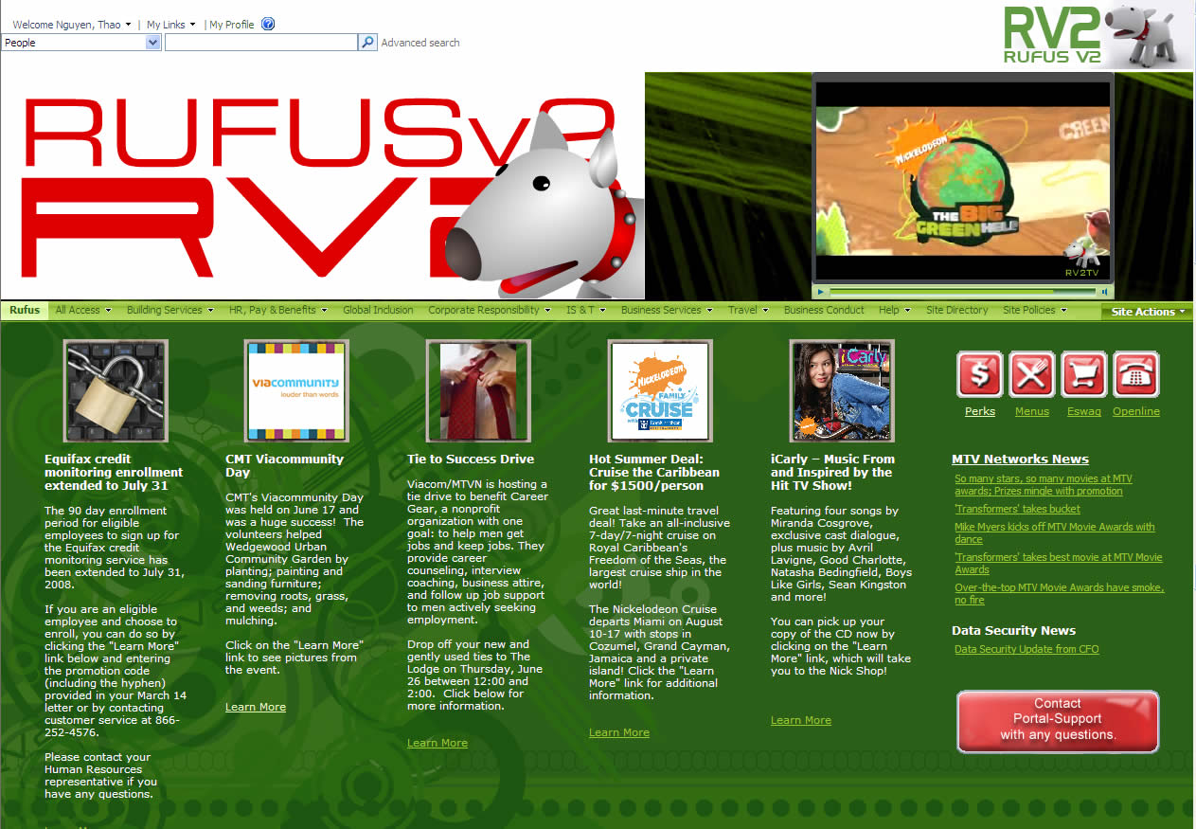

Figure 1: Rufus, MTV Networks’s new intranet, enables employees to easily communicate, collaborate, and find information.

Groups across the company are benefiting from the company’s deployment of Office SharePoint Server 2007. One such group is the Content Distribution and Marketing group, which, as Mitchell puts it, “has taken the out-of-the-box collaboration features provided by SharePoint Server 2007 and run with them.” Even the company’s legal group uses Office SharePoint Server, as a way to help track legal proceedings.

One executive who is a big fan of Office SharePoint Server 2007 is Jacques Tortoroli, Executive Vice President and Chief Financial Officer for MTV Networks, who maintains his own blog. “When I met with Jacques, he pointed to a desktop full of paper and said ‘I want this all gone,’” recalls Mitchell. “Today, the Controller’s office has a collaboration site and a Controller’s portal, which provides access to financial information, risk management tools, and so on. That‘s just one example of how business groups across the company are benefiting from strong partnerships with the IT organization.”

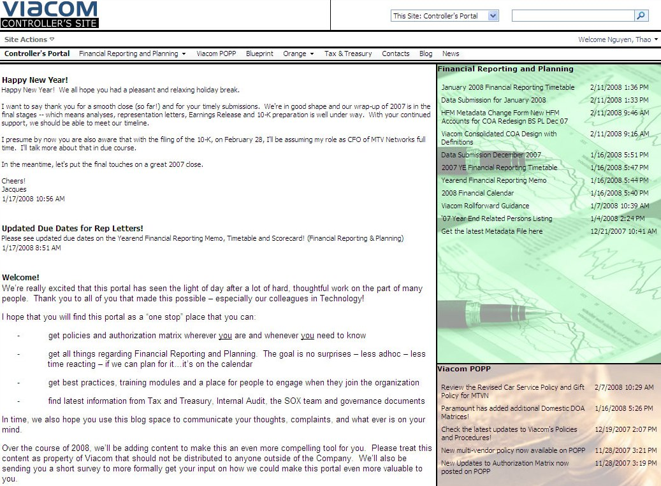

Figure 2: The Viacom Controller’s portal is now hosted on Office SharePoint Server 2007.

## Self-Service Content Publishing

The company’s intranet portal currently hosts more than 110 sites for various groups, all of which are empowered to manage their own content. “Today, end users publish content using an edit-in-place environment, with built-in workflows for content approval,” says Mitchell. “Each site typically has two to three administrators within the business group who, when they need to publish something, can make it happen fast.”

Continues Mitchell, “Distributing content ownership in this way accomplishes two things. First, you can have a tremendous amount of content on the portal and keep it all fresh—it’s not funneled through one bottleneck. Second, with hundreds of content owners around the company, each responsible for a small part of the whole, it’s not a terrible burden on any small group of people, and people aren’t burdened with content management responsibilities that turn into a full-time job. Rather, it’s something that people can do incrementally to the responsibilities they already have.”

Adds Plattner, “An added benefit of using SharePoint Server for both intranet and Internet sites is that business groups who own one of each type of site can apply the same content management skills across both. Similarly, if someone moves to a job in a different group, they’ll be able to apply the same content management skills there too. The content may change, but the skills needed to publish it will remain the same, which helps control costs.”

By pushing content ownership to business users, Mitchell’s team has been able to step out of an operational role and remain focused on delivering new value. “Business users are able to quickly and effectively manage the sites to a fairly detailed level,” he says. “While we’re available for technical support or to help with new ideas, we don’t have a lot of day-to-day involvement after new sites are deployed.”

## Rich Collaboration Tools

Office SharePoint Server 2007 also provides a single place where employees can share and find information. Today, whether someone is in marketing or sales or research, they can go to collaboration sites to share information and work together in a broad range of ways, including document and meeting workspaces, wikis, blogs, and more. “We have more than 150 such sites today, and that number is growing faster than ever,” says Mitchell. “Groups and departments are embracing them wholeheartedly, to the point that they’re more in demand than new portal sites.”

Those capabilities have increased end-user productivity, especially for the unstructured tasks that take up a large part of the day. “SharePoint Server has brought a lot of efficiencies to everyday tasks for groups across the company,” says Plattner. “Without it, there could be dozens of e-mails flying back and forth just to, say, track down the latest version of a creative brief. SharePoint collaboration sites provide a single version of the truth and one place to find it—a common place people can go to when they need to track projects, share files, and communicate with each other.”

## Controlled Access to Information

Control over site access is also handled by the individual site administrators. “The security features of SharePoint Server were huge for us because people need to have confidence that what they’re sharing can only be accessed by the proper people,” says Mitchell. “Other products might have let us, as an IT organization, control who can access what, but SharePoint Server enabled us to give that control to business users and step completely out of a day-to-day operational role.”

Such features have made the portal a viable tool in a far broader range of scenarios. “Content on the old portal was primarily limited to non-sensitive information,” he says, “whereas the new portal is great for sharing sensitive information as well. For example, on our controller’s portal, authorized users can share sensitive financial data in a way that helps protect it from prying eyes and, in many ways, provides better security than sharing reports by e-mail or interoffice mail. SharePoint Server is great for such uses because it provides all the data retention and auditing features we need.”

## Built-In Workflows

Built-in workflows help streamline structured processes, such as approving new content before publication. Similar workflows can easily be set up for other processes, unburdening employees from having to manually manage such workflows and track progress. For example, users can attach a document approval workflow to a document, specify who needs to approve it, and the workflow will assign tasks to those people. Approvers are notified of tasks by e-mail and can approve or reject a document by clicking on a form, with the originator kept informed on status by e-mail.

“The built-in SharePoint workflows are great because they’re task-driven and focus on human interaction,” says Plattner. “Anyone can take advantage of the out-of-the-box workflows built into SharePoint Server. And if we need to create simple additional workflows, as we’ve done for a few groups, SharePoint Designer lets us do so without writing any code.”

For workflows requiring interaction with other systems, MTV Networks is augmenting Office SharePoint Server 2007 with the integration and business process orchestration features of Microsoft BizTalk® Server. One such solution now in development will automate the process of provisioning new employees. “The new application will integrate with back-end systems for space planning, telecommunications, and security, reducing the time and effort required to process a new employee by at least 80 percent,” says Mitchell.

## Enterprise Search

Another key factor in the company’s decision to use Office SharePoint Server 2007 was its enterprise search capabilities, which the company augmented with software from Ontolica. “We needed to go beyond content management and collaboration to incorporate knowledge management,” says Plattner. “The Enterprise Search feature in SharePoint Server allows people to have one location to search for files, people, Web site content, and more. By having a single search tool that spans all those areas, we can reduce duplication of effort and accelerate the adoption of best practices across the company. Even today, when we're using only the most basic capabilities of Enterprise Search, it’s way better than what we had before.”

## Integration

The company’s new portal solution integrates with other back-end systems to provide a single source for commonly needed information. “For lots of people, it’s the small things that are really helpful,” says Mitchell. “They may need to know who works for whom, look up a phone number, or find an office location, and all of those capabilities had to be brought together. SharePoint Server enables us to easily do that because it’s a Microsoft product, and the information people need is in other Microsoft products. People don’t know that phone numbers are in one database, addresses are in another, and job titles are in a third—they don’t care, and they shouldn’t have to care. They just want the information available and up-to-date. With SharePoint Server, we can reach out to other systems and pull together that information in a way that, to end users, is magical. And for my team, it’s not onerous.”

## Application Development

In addition to delivering rich out-of-the-box capabilities, Office SharePoint Server 2007 provides a platform upon which MTV Networks can build and host new applications and tools. The division has already developed several, ranging from tools for managing press clippings and trademark requests to the ability to manage basic employee profile information. Many of these applications take advantage of built-in features of Office SharePoint Server, such as its workflow support and InfoPath® Forms Services, to deliver highly useful tools that can be accessed directly on the portal.

“Operational efficiency has been improved by taking a lot of paper forms, converting them to InfoPath forms, exposing them through InfoPath Forms Services, and using SharePoint workflows or BizTalk Server to manage routing, approval, integration with other systems, and so on,” reports Joye. “One advantage of using SharePoint Server as a development framework for such solutions is that it provides rich functionality with respect to things like security, user roles, and integration with other Microsoft software.”

# Internet Sites

Shortly after deploying the MTV Networks and Viacom intranet portals, MTV Networks began using its Office SharePoint Server 2007 infrastructure to host Internet sites. Two groups with such sites are the Viacom corporate communications group and the TV Land communications group, both of which are taking advantage of the content management capabilities they use on the intranet portal to communicate with external constituents as well.

## Viacom.com

The Viacom corporate communications group is a team of four people whose responsibilities include maintaining the company’s main Internet site. “Viacom.com is one of the main places where people both inside and outside the company look for information such as our history, brands, financial performance, annual reports, corporate governance, executive biographies, and so on,” says Kristin Heitmann, Manager of Corporate Communications for Viacom.” As such, various events such as quarterly earnings releases are key drivers for publishing new content on the site.”

In the past, the process of updating Viacom.com was tedious, and publishing content required assistance from Mitchell’s team. “It was a lengthy, complicated process to add or change content on the site,” recalls Heitmann. “We had to notify IT personnel ahead of time, and they had to do a lot of the work. Because of the difficulty of publishing new content, the Web site was really stagnant and didn’t accurately reflect Viacom as a company or its many dynamic brands.”

The process was especially onerous for IT staff at the end of each quarter, when members of Mitchell’s team would need to work late into the night to support the publishing of financial results on the Web. “We had to wait for the business side to get the proper clearances and approvals for the materials to be posted, stage them, wait for them to review the site, and then wait for any last-minute changes to the materials,” says Plattner. “By the time final content was provided to post, it could be midnight or one in the morning—and we had to be back in a few hours to take the new content live.”

Soon after Office SharePoint Server 2007 was deployed, Mitchell’s and Heitmann’s teams began working on how it could help address those challenges. “One problem we faced was that we didn’t always know all the news that the divisions were generating, so we wanted a way for them to be able to publish some of their own content,” says Heitmann. “At the same time, we needed to have control over review and approval of that content to ensure consistency and accuracy. Of course, we also maintain a lot of the content ourselves and wanted to reduce the bottlenecks associated with doing so.”

The out-of-the-box capabilities of Office SharePoint Server 2007 turned out to be the perfect answer to those needs. “Self-service content publishing enables us to post more information and keep it current, making the process as easy as editing a Microsoft Office Word document,” says Heitmann.

Adds Plattner, “Now that we’ve rebuilt Viacom.com on SharePoint Server, the business is empowered to meet its own needs. They handle the actual posting of materials and SharePoint Server manages the approval workflows, even to the point of taking the new content live at a specified time so nobody needs to spend the long hours in the office.”

With Office SharePoint Server 2007, Heitmann’s team has also been able to make content on Viacom.com more dynamic. “We can easily publish pictures and video, which the old site didn’t effectively support,” says Heitmann. “Because the process is so easy, we’ve been able to divide the work so that nobody needs to be responsible for the whole site. Everyone knows that new content goes live every Monday afternoon, which keeps the pressure on to make sure content stays fresh and ensure that Viacom remains seen as a vibrant, dynamic company.”

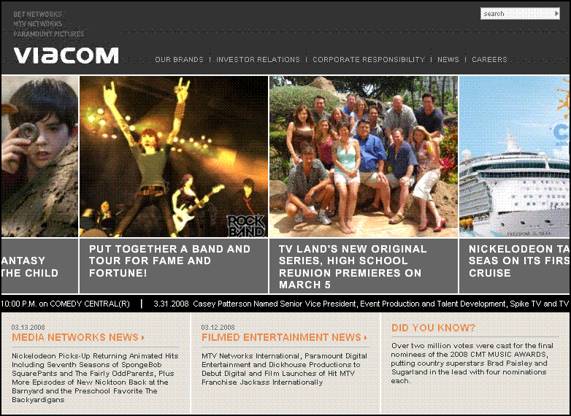

Figure 3: Viacom’s public Internet site is hosted on Office SharePoint Server 2007 as well.

## TV Land Press

Another group enjoying similar benefits is the communications team for TV Land, which delivers around-the-clock programming for fans of classic television shows. Within TV Land, the communications department is responsible for promoting everything that is coming up on the network, as well as what’s happening off-air and on the TVLand.com Web site.

“It’s our job to work with the media, as a way to get the message out to consumers about what’s coming up on the network,” says Paul Ward, who was Senior Vice President of Communications for TV Land. “One of the challenges we face is that there are so many entertainment choices and all of us are vying for attention. To that end, when working with the media, you really have to be nimble and able to accommodate them almost instantaneously.”

Not long ago, when Ward’s team needed to get press materials to media outlets, it would fax press releases and send artwork and tapes via overnight messenger. “We were frustrated by how slow and costly the alternatives were,” says Ward, “and needed to be able to serve the media with all of our press materials in a more timely fashion. We became aware of other brands and networks that had created external Web sites for media professionals to access, and we were eager to set one up for ourselves.”

In late 2007, after turning to Mitchell’s team for assistance, the TV Land communications group launched an Internet site based on Office SharePoint Server 2007. “The site is designed solely for media professionals,” says Ward. “Thanks to SharePoint Server, anyone in the media can go to TVLandPress.com and have access to just about every piece of information available about TV Land.”

With self-service content publishing, Ward’s team is now far less dependent on traditional methods of content delivery. “Today, members of the press can come to our Web site and have access to everything they’re looking for—from press releases, streaming video, and artwork to information about everything we're doing on-air, off-air, and on TVLand.com,” says Ward. “There are numerous benefits to having our materials on this site, not the least of which is that we can instantly update it when we need to get new information out to the media.”

Ward’s team also is taking advantage of Office SharePoint Server 2007 to extend the shelf life of content while keeping information on the portal relevant and fresh. “In the past, when we produced a short video about what's happening at TV Land, we would typically use it once,” says Ward. “By posting that video on the Web, we can continue to use it as a sales tool. At the same time, materials expire, and we don’t want the press wading through old content to find what they need. With TVLandPress.com, we can set a timer that will automatically remove content at a predetermined time—and just as easily push new content live in the same way.”

With the new site in place, Ward’s team has noticed an improvement in productivity. “Instead of photocopying press releases and ordering transfers of videos, we can focus on building stronger relationships,” says Ward. “Today we can steer someone to the information they need while we have them on the phone instead of assembling and sending materials and then having to follow up to confirm that the package arrived and the recipient reviewed what we sent. We're thrilled with how TVLandPress.com increases our productivity and enables us to engage more effectively.”

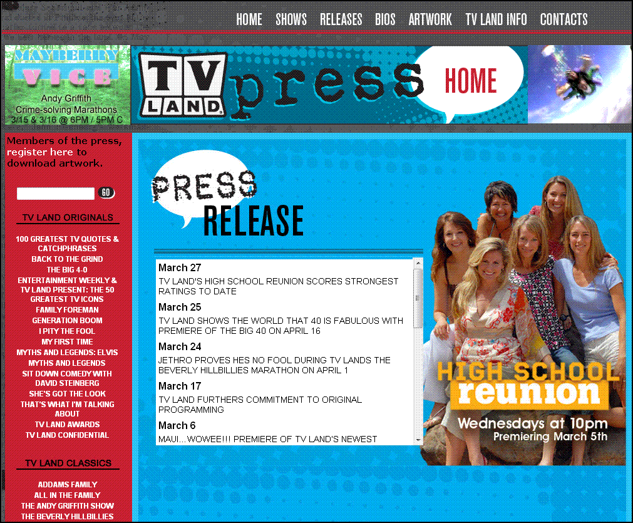

Figure 4: TVLandPress.com provides media professionals with self-service access to a wealth of information.

In addition, the new site has helped reduce costs. “We no longer need to physically send materials to several hundred people, which is saving a lot of money,” says Ward. It wasn’t that long ago that we used to order several hundred copies of a tape and then send them overnight to three, four, or five hundred people, the costs for which were astronomical,” says Ward. “By making materials available online, we've not only been able to deliver them faster, but we’ve saved a lot of money.”

With the site having now been live for several months, other groups around the company are starting to take notice. “TVLandPress.com is a testimonial to how valuable an asset a site like ours can be,” says Ward. “Other brands within our company are envious of what we've done with the site. Thanks to the flexibility and effectiveness of the SharePoint technology, and the efforts of our IT department, TVLandPress.com has become a useful and efficient destination.”

One group that has asked for a site similar to TVLandPress.com is the Nickelodeon communications group, which approached Mitchell’s team after having limited success with building something similar on its own. “We took on a content management solution that had originally been sourced to an external vendor,” says Mitchell. “They never completed the project and, after a year of work, had delivered a clunky tool that, to business users, wasn’t very usable. We’ll be able to deliver what they need in one-tenth the time because we can reuse a lot of what we built for TVLandPress.com.”

# Meeting Continued Demand for New Business Value

With collaboration features and control over content publishing handed off to end users, Mitchell’s group is able to focus on the delivery of new value. “One of the magical things about all this,” says Mitchell “is that I currently run a companywide portal with four to five people. We’ve been able to do that by empowering end users to meet many of their own needs, with a tool that’s intuitive and flexible enough that we don’t need to provide a lot of technical support. Today, instead of publishing content, my team is focused on high-end design and delivering new functionality. I can’t imagine another portal solution where you can support a global enterprise with four to five people.”

That’s not to say that Mitchell’s team isn’t still heavily involved in delivering new functionality. “One thing we’ve found in building up our SharePoint environment is that the level of end-user needs and requests from various business groups can vary greatly,” says Mitchell. “MTV Networks consists of a variety of brands, each with its own identity and requirements, and we’re fielding requests from all over the business. Instead of business units looking for their own solutions and hiring outside companies to implement them, people across the company are rallying around SharePoint as a common solution.”

As people across the company get used to the new portal, Mitchell’s team is seeing an increase in the number of requests for customized sites. “People who start with an out-of-the-box site now will usually want a custom site later,” he says. “In cases where only minor customization is required, I send that work offshore. We can turn around 10 new sites a month in this way—often at such a low cost that I don’t even need to charge it back to a business group. A high-end site that requires lots of custom coding and design is still a capital request, and we have six such sites on deck now. Either way, after the new site is live, its management is handled by business users.”

Regardless of where new features are developed, having a common platform enables MTV Networks to capitalize on the work done across all SharePoint sites. “People tend to see what’s been done for others and want it too,” he says. “SharePoint has allowed us to leverage the custom development work we’ve done across several groups because their sites all run on a shared platform. Our corporate communications group, TV Land Press, and corporate compliance group all needed a way to track user registrations. With SharePoint, we leveraged the same solution for all three sites.”

When it’s not servicing requests for new sites and functionality, Mitchell’s team is working to expand the role of Office SharePoint Server 2007 in other ways. “What we’ve done so far is just the start of how we plan to use SharePoint,” says Mitchell. “And with most of the routine work done offshore, my strongest resources are free to press forward. We’re already working on increasing the portal’s reach to include all 10,000 employees of MTV Networks worldwide, as well as possibly other Viacom divisions. There is a host of potential ways we can leverage SharePoint, and we’ve only just scratched the surface.”

# Improved Operations

A consolidated portal solution also is improving efficiency for Amirian’s Server and Storage Technologies group, which, having felt the pain caused by a piecemeal portal infrastructure, took an active role in architecting a new solution upon which the company can eventually consolidate. “Availability, scalability, and reliability were all critical requirements,” says Amirian. “It was also important that the solution ran on commodity hardware and software, could be supported with standard tools, processes, and procedures, and would enable us to leverage existing IT personnel and skill sets.”

Deployment was completed in a short time, and the solution is now paying off for Amirian’s team. “Not only are there fewer servers to manage and fewer cycles required to operate the environment, but all servers can be supported in the same way, with the same skills,” says Amirian. “SharePoint Server fit very well with our existing IT infrastructure and integrated seamlessly with the Microsoft technologies that we already had in place, eliminating the need for any radical rearchitecture of the environment.”

In addition, the new solution has proven easily manageable. “We can support SharePoint Server with existing resources and skill sets, leveraging economies of scale to keep costs low,” says Amirian. “Lots of existing skills were transferable to the new portal environment, and the learning curve was low because it’s all Microsoft software.”

The solution’s scalability has also proved beneficial. “We didn’t need to invest in a lot of new infrastructure to get SharePoint Server up and running,” says Amirian, “and the platform’s performance and scalability will allow us to avoid building up a large portal environment as usage grows. We’ve already scaled to more than a hundred portal sites with little or no modifications to the platform, and I’m fairly confident that we’ll be able to keep up with the performance demands of our customers well into the future.”

Consolidation on Office SharePoint Server 2007 has improved backup and recovery as well. “With our previous portal infrastructure, there were as many backup and recovery schemes as there were different portal solutions,” says Amirian. “Today, the ‘first line of defense’ against accidentally deleted user files is the users themselves, who can restore a deleted or previous version of a file in the same way they would restore a file from the Recycle Bin on their desktops. In the rare event that my team does have to do a restore, there’s a single process to follow that is orders of magnitude faster than before.”

Amirian sees costs continuing to decline as the company expands its use of SharePoint Server. “I see more and more consolidation onto SharePoint Server, which will allow us to avoid the costs of maintaining multiple solutions. We’ll eventually reach a point where it’s all on SharePoint Server, when the barriers to collaboration will have been reduced to nothing and my team will be able to focus on new projects rather than maintaining legacy systems.”

# Future Plans

With the new portal environment now deployed, Mitchell’s team is expanding its reach to include MTV Networks’s 5,000 international employees. “Today, with different countries on different platforms, the head of international operations can’t reach his entire organization on a single portal,” says Mitchell. “Our target is to go global with SharePoint Server by mid-2009, at which point our disparate portals around the world will have been replaced with a single global solution.”

In deploying Office SharePoint Server 2007 globally, the company will take advantage of SharePoint Server language packs. “One of the reasons that many people outside of the United States don’t use the portals that are available to them today is because it’s not in their native language, which makes the portal appear irrelevant to them,” says Mitchell.

Mitchell expects to add four to six servers to the existing Office SharePoint Server 2007 infrastructure, which is hosted in the company’s New Jersey data center. “Our plan is to host the entire infrastructure in New Jersey and rely on the speed of our network,” says Mitchell. “Our ultimate plan is to bring all Viacom divisions into the fold—we would then have 24,000 seats. Paramount’s portal is already hosted on the same SharePoint Server infrastructure, although they manage it on their own, and there’s talk about bringing the BET Networks division onto SharePoint Server as well.”

Beyond the global rollout, Mitchell foresees taking advantage of other features that are built into Office SharePoint Server 2007. ‘’We’re using features like blogs and wikis, but there are tools and functions within SharePoint Server that we haven’t really begun to explore at this early stage, when we’ve been focused primarily on deployment and standardization. The future looks great as far as being able to use SharePoint to continue generating excitement and delivering new functionality for business users.”

One key area of focus will be the use of Office SharePoint Server 2007 as the starting point for more and more business processes. “The portal already knows who I am, where I work, and where I sit,” says Mitchell. “It shows me a screen of information that’s relevant to me, the communities in which I’m a participant, and information from various sources, allowing me to collaborate and, more importantly, to conduct business workflows. Soon I’ll be able to kick off the process for hiring a new employee and generate the request for things like a new phone number and office space online—things that, in the past, used to require me to fill out forms, send e-mails, and generate all sorts of paperwork that had to be completed and faxed. All of these things begin to roll into the portal, which provides a means of standardizing processes and optimizing business efficiency across the globe.”

# Conclusion

Using Office SharePoint Server 2007, MTV Networks is replacing a mix of heterogeneous, hard-to-support portal technologies with a consolidated portal infrastructure that already supports a new intranet portal, a Viacom corporate portal, and multiple Internet sites. Self-service content publishing is helping groups across the company to communicate better with both internal and external constituents, while rich collaboration and search features enable people to work more productively and to easily share information in a business where the free flow of ideas and content is critical to business success.

From an IT perspective, the new standardized portal platform integrates well with existing IT infrastructure and delivers new capabilities in a reliable, scalable, and cost-effective manner. The application development team no longer needs to be involved with day-to-day administration or assist with content management, freeing higher-end technical resources to focus on the delivery of additional functionality that, thanks to a common portal platform, can be utilized across the company. Consolidation on a single platform has also improved life for data center personnel, who are able to maintain the solution using existing tools, processes, and procedures, taking advantage of economies of scale to keep solution’s total costs to a minimum.

Just as important, standardization on Office SharePoint Server 2007 provides MTV Networks with a solution that will serve the division well into the future. “We now have a portal platform that can grow with us as a company,” says Mitchell, “which is a good thing because, now that we’ve met initial requirements, we’re already starting to take things to the next level. Thanks to strong partnerships with the business, we have some early wins under our belt and the IT organization is seen as a strong provider of new business value. The fact that business users are coming to us on their own and saying ‘Can we do this with SharePoint?’ is clearly an indicator of success. We’re supporting a process. We’re not becoming the process.”

# For More Information

For more information about Microsoft products and services, call the Microsoft Sales Information Center at (800) 426-9400. In Canada, call the Microsoft Canada Information Centre at (877) 568-2495. Customers who are deaf or hard-of-hearing can reach Microsoft text telephone (TTY/TDD) services at (800) 892-5234 in the United States or (905) 568-9641 in Canada. Outside the 50 United States and Canada, please contact your local Microsoft subsidiary. To access information using the World Wide Web, go to:   
[www.microsoft.com](http://www.microsoft.com)

For more information about Microsoft Office SharePoint Server 2007, visit the Web site at:  
[www.microsoft.com/sharepoint](http://www.microsoft.com/sharepoint)

For more information about MTV Networks, visit the Web site at:   
[www.viacom.com/ourbrands/medianetworks/mtvnetworks/Pages/  
default.aspx](http://www.viacom.com/ourbrands/medianetworks/mtvnetworks/Pages/default.aspx)