


Microsoft® Office Programs and SharePoint® Products and Technologies Integration – Fair, Good, Better, Best

White Paper

April 2007

For the latest information, go to http://www.microsoft.com/office for Office and http://www.microsoft.com/sharepoint for SharePoint.

The information contained in this document represents the current view of Microsoft Corporation on the issues discussed as of the date of publication. Because Microsoft must respond to changing market conditions, this document should not be interpreted to be a commitment on the part of Microsoft, and Microsoft cannot guarantee the accuracy of any information presented after the date of publication. The information represents the product at the time this document was printed and should be used for planning purposes only. Information is subject to change at any time without prior notice.
This document is for informational purposes only. MICROSOFT MAKES NO WARRANTIES, EXPRESS OR IMPLIED, IN THIS DOCUMENT.
© 2007 Microsoft Corporation. All rights reserved.
Microsoft, Excel, InfoPath, MSDN, the Office logo, Outlook, PivotChart, PivotTable, PowerPoint, SharePoint, SQL Server, Visual Studio, Windows, Windows Server, and Windows Vista are either registered trademarks or trademarks of Microsoft Corporation in the United States and/or other countries. All other trademarks are the property of their respective owners.

Abstract
This paper describes how different versions of Office programs work together with the 2003 and 2007 versions of SharePoint technologies. Although an overview of the integration features of Office 2000 versus Office XP with Windows SharePoint Services 3.0 and Office SharePoint Server 2007 is provided, the paper’s focus is on the integration features of the Office 2003 Editions versus the 2007 Office Suites with the 2007 SharePoint technologies.
The increasing levels of functional capabilities have been deemed “fair” for Office 2000, “good” for Office XP, “better” for the Office 2003 Editions, and “best” for the 2007 Office Suites in terms of how they work together with SharePoint.
A detailed comparison of how the Office 2003 Editions versus the 2007 Office Suites, namely, Office Professional Plus 2007 and Office Enterprise 2007, work with Windows SharePoint Services 3.0 and Office SharePoint Server 2007 will be provided.
The paper concludes that in order to realize the best user experience with Office and SharePoint integration features, the client programs must be upgraded to a 2007 Microsoft Office Suite, namely, Office Professional Plus 2007 or Office Enterprise 2007 and the server technologies must be upgraded to either Windows SharePoint Services 3.0 or Office SharePoint Server 2007.

Table of Contents
Abstract iii
Table of Contents iv
Introduction 1
“Fair” with Microsoft Office 2000 1
“Good” with Microsoft Office XP 1
“Better” with the Microsoft Office 2003 Editions 1
“Best” with the 2007 Microsoft Office Suites 1
Achieving the Best by Upgrading Both Clients and Servers 1
Overview of Office and SharePoint Integration Features 3
Office 2000 vs. Office XP vs. Office 2003 Editions with Windows SharePoint Services 3.0 or Office SharePoint Server 2007 3
Office 2003 Editions vs. 2007 Office Suites with Windows SharePoint Services 3.0 or Office SharePoint Server 2007 4
SharePoint Integration Features Not Available in Office Standard 2007 5
Office FrontPage 2003 vs. Office SharePoint Designer 2007 with Windows SharePoint Services 3.0 or Office SharePoint Server 2007 5
Details of Office and SharePoint Integration Features 8
Enterprise Content Management 8
Excel Services 12
Electronic Forms 15
Outlook and SharePoint Integration 18
Access and SharePoint Integration 20
Groove and SharePoint Integration 23
Conclusion 25
For More Information 26
2007 Microsoft Office System 26
Microsoft SharePoint Products and Technologies 26
Appendix 27
Client Program, Server License, and Client Access License Requirements 27

Introduction
Microsoft Office client programs and SharePoint products and technologies are natural partners in a productive, networked computing environment. Microsoft is committed to integrating the power of work sharing tools and the Web into the productivity applications that most users already know. Microsoft Office 2000, Microsoft Office XP, the Microsoft Office 2003 Editions, and the 2007 Microsoft Office Suites provide increasing levels of integration between Microsoft Office programs and SharePoint products and technologies. The varying levels of integration can be summarized as fair, good, better, and best and is further explained in the following sections, each of which provides an overview of integration features between a specific version of the Microsoft Office programs and the 2007 version of SharePoint products and technologies.

“Fair” with Microsoft Office 2000
Microsoft Office 2000 provides simple file operations against and basic interactions with Windows SharePoint Services, allowing users to open and save documents on SharePoint sites from their Office 2000 applications and receive alerts in Outlook 2000.

“Good” with Microsoft Office XP
Microsoft Office XP provides a good level of data integration with Windows SharePoint Services, including interactive access to data stored on SharePoint sites, allowing users to export list data to Excel XP and view properties and metadata for files stored on SharePoint sites.

“Better” with the Microsoft Office 2003 Editions
Microsoft Office 2003 Editions provide a very good level of integration with Windows SharePoint Services, allowing users to create documents, organize team meetings and activities, access and analyze data from SharePoint sites, and use FrontPage 2003 to customize lists or Web Parts on SharePoint sites. Users can also use the data integration between the Office 2003 Editions and Windows SharePoint Services to move data to and from the SharePoint site and create databases linked to data stored on SharePoint sites.

“Best” with the 2007 Microsoft Office Suites
The 2007 Microsoft Office Suites provide the best level of rich, contextual integration with Windows SharePoint Services and Office SharePoint Server, allowing users to interact with SharePoint sites without leaving their Office programs and to have two-way synchronization with collaborative information and documents as well as business data stored on SharePoint sites.

Achieving the Best by Upgrading Both Clients and Servers
If you are currently using Office 2000, Office XP, or Office 2003 with Windows SharePoint Services 2.0 or SharePoint Portal Server 2003, and you upgrade to Windows SharePoint Services 3.0 or Office SharePoint Server 2007, your client integration experience with Office and SharePoint integration features will not change. The converse, upgrading your Office programs to 2007 but continuing to work with Windows SharePoint Services 2.0 or SharePoint Portal Server 2003, results in less than the best user experience due to the following shortcomings:
- Cannot search files stored in the new 2007 OpenXML-based file formats.
- No file type icons in the Document Library for the new 2007 file formats.
- Cannot add users to a Windows SharePoint Services 2.0 site using the Address Book button.
- Cannot maintain 2-way synchronization between an Excel 2007 native file and a SharePoint List. For more information, refer to the “Writeback to SharePoint” section on the Excel Team Blog’s “Deprecated features for Excel 2007” entry.
Therefore, to achieve the best user experience with Office and SharePoint integration features, you must upgrade the clients to a 2007 Microsoft Office Suite, namely, Office Professional Plus 2007 or Office Enterprise 2007 and the servers to either Windows SharePoint Services 3.0 or Office SharePoint Server 2007.

Overview of Office and SharePoint Integration Features

Office 2000 vs. Office XP vs. Office 2003 Editions
with Windows SharePoint Services 3.0 or Office SharePoint Server 2007
The following table shows the richness of the integration features of Office 2000 versus Office XP versus the Office 2003 Editions with Windows SharePoint Services 3.0 and Office SharePoint Server 2007. These integration features are identical to what you would experience with Windows SharePoint Services 2.0 and SharePoint Portal Server 2003 as previously described in the Good, Better, Best Office and SharePoint Integration whitepaper or webpage.
Feature | Office 2000 | Office XP | Office 2003 Editions
Save and open files from SharePoint sites | Yes (Excel, FrontPage, PowerPoint, Microsoft Project, Word) | Yes (Excel, FrontPage, PowerPoint, Microsoft Project, Visio, Word) | Enhanced (Excel, FrontPage, InfoPath, OneNote, Outlook, PowerPoint, Microsoft Project, Publisher, Visio, Word)
Create new documents in Web browser | No | Yes (Excel, FrontPage, PowerPoint, Word) | Yes (Excel, FrontPage, InfoPath, PowerPoint, Microsoft Project, Publisher, Word)
Collect metadata automatically | No | No | Enhanced (Excel, PowerPoint, Word)
Promote and demote file properties and metadata automatically | Data stored, but not displayed (Excel, FrontPage, PowerPoint, Word) | Yes (Excel, FrontPage, PowerPoint, Word) | Enhanced (Excel, FrontPage, InfoPath, PowerPoint, Visio, Word)
Track document versions | No. Use Web browser to view and manage document versions. | No. Use Web browser to view and manage document versions. | Enhanced (Excel, PowerPoint, Visio, Word)
Check-out and check-in documents | No. Use Web browser to manually check-out and check-in documents. | No. Use Web browser to manually check-out and check-in documents. | Enhanced (Excel, PowerPoint, Visio, Word). Use Web browser to manually check-out and check-in other types of documents.
Manage Microsoft Project documents, risks, and issues | No | No | Yes
Upload multiple documents | No | No | Yes
Inline discussions | Yes | Yes | Yes
Microsoft Office Components for SharePoint | No | No | Yes
Person Names Smart Tag | No | No | Yes
Integration with Microsoft Business Solutions | No | No | Yes

Office 2003 Editions vs. 2007 Office Suites
with Windows SharePoint Services 3.0 or Office SharePoint Server 2007
The following table shows the richness of the integration features of the Office 2003 Editions versus the 2007 Office Suites (specifically, Office Professional Plus 2007 or Office Enterprise 2007) with Windows SharePoint Services 3.0 and Office SharePoint Server 2007. For a feature comparison between the various 2007 Office Suites, refer to the 2007 Microsoft Office Suites Comparison whitepaper or webpage. For a feature comparison between the 2003 and 2007 versions of SharePoint products and technologies, refer to the SharePoint Products Comparison worksheet. For specific product licensing requirements for each of the key integration feature areas, refer to the Appendix.
Office and SharePoint Integration Feature | 2003 Clients | 2007 Clients
Enterprise Content Management  Publish documents to server to enable content management tasks in the client (e.g., start and/or participate in approval or review workflows from within the Office client), access content management features from within client (e.g., auto-generated document properties) |  | 
Information Rights Management
Protect documents from unauthorized access or distribution from within the Office client applications. For more information, go to http://blogs.msdn.com/ecm/archive/2006/06/09/624520.aspx.
PowerPoint Slide Libraries  Publish slides to server where they can be easily shared, access slides on Slide Library from within PowerPoint, receive notification if slide on server changes. | 
Excel Services
Publish Excel spreadsheets to server for centralized management, browser-based spreadsheet viewing and access control.
Electronic Forms
Publish forms to server to enable browser-based access for data collection, initiate workflows and additional forms management tasks from InfoPath client.
Outlook and SharePoint Integration
Keep synchronized copy of SharePoint Calendars, Tasks, and Contacts and offline access to SharePoint Document Libraries in Outlook.
Access and SharePoint Integration
Move Access data to a SharePoint site where it can be centrally managed and accessible by the client or a browser.
Groove and SharePoint Integration
Take a synchronized copy of SharePoint Document Libraries offline in a Groove Workspace.
OneNote and SharePoint Integration
Store a Shared Notebook in a SharePoint Document Library, which enables collaborative content editing by multiple OneNote users. For more information, go to http://office.microsoft.com/en-us/onenote/HA101726991033.aspx.
= Limited or no access to features
= Partial access to features
= Full access to features

SharePoint Integration Features Not Available in Office Standard 2007
- Initiate document workflows and complete workflow tasks from within the Microsoft Office applications.
- Publish presentations and individual Office PowerPoint 2007 slides to slide libraries for later reuse.
- Publish spreadsheets to Report Center and specify parameters and viewing permissions for spreadsheets and specific cells published to Report Center.
- Create printable labels and barcodes from metadata and insert barcodes and labels into Microsoft Office documents.
- Complete, collect, and organize Office InfoPath 2007 e-mail forms in Office Outlook 2007.
- Host embedded, fully customizable InfoPath forms in Office Word 2007, Office Excel 2007, and Office PowerPoint 2007.
- Complete forms in Programmable Task Panes.
- Complete custom fields and execute custom business logic in Document Information Panel forms.
Refer to the 2007 Microsoft Office Suites Comparison whitepaper or webpage for more details.

Office FrontPage 2003 vs. Office SharePoint Designer 2007
with Windows SharePoint Services 3.0 or Office SharePoint Server 2007
FrontPage 2003 and SharePoint Designer 2007 were specifically designed to be the premier customization tools for their respective versions of SharePoint technologies. Therefore, FrontPage 2003 is not compatible with Windows SharePoint Services 3.0 or Office SharePoint Server 2007 while SharePoint Designer has limited compatibility with Windows SharePoint Services 2.0 and SharePoint Portal Server 2003.
The following table shows the richness of the integration features of the FrontPage 2003 versus SharePoint Designer 2007 with their respective versions of SharePoint technologies.
Feature | FrontPage 2003 | SharePoint Designer 2007
SharePoint site customization
Enjoy deep editing support for the technologies underlying SharePoint products, including ASP.NET 2.0, cascading style sheets (CSS), and Windows Workflow Foundation.
ASP.NET master pages
Full support for ASP.NET master pages enables you to centralize changes to your site and help ensure a consistent look and feel across multiple pages.
Cascading style sheets
Make format and layout changes to entire SharePoint sites simply by editing the master page and modifying the SharePoint CSS. Office SharePoint Designer 2007 includes a CSS task pane for applying and editing CSS rules, a CSS Style Application Toolbar, and a CSS property grid.
Professional-grade design environment
Richly interact with a user interface that you can use to open, dock, and undock precisely the combination of task panes you want to help you design your site. Use task panes to identify and manipulate tag properties, CSS properties, and table and cell formats; insert SharePoint and ASP.NET 2.0 controls, and more.
Interact with your data
Write information back to data sources, including SharePoint lists, SQL databases, and XML files, using custom form support.
Add business logic to your Workflow Designer
Take advantage of the power of Workflow Designer. Set up custom workflow conditions and actions, link them to your SharePoint data, and deploy them with a single click, without installing server code.
Support for interactive ASP.NET pages
Office SharePoint Designer 2007 provides the same level of support as Microsoft Visual Studio 2005 for ASP.NET control hosting, property grid editing, insertion from a toolbox palette, and Microsoft IntelliSense technology in Code View.
Site backup and restore
Save your site, including all of the pages and SharePoint list data, and restore it on another server.
Contributor settings
Exercise more control over your site. Use SharePoint permission levels to define the customization actions each user of Office SharePoint Designer 2007 can perform on your Web site.
Reset to Site Definition
Undo changes to the home page, master page, or other server-deployed pages in the site definition using the Reset to Site Definition command.
Error checking
Check for broken links, unused pages, cascading style sheets usage, and master page usage.
= Feature included in FrontPage 2003
= Improved in SharePoint Designer 2007
= New in SharePoint Designer 2007
For a comprehensive comparison between FrontPage 2003 and SharePoint Designer 2007, refer to this Version Comparison webpage. For detailed information about SharePoint Designer 2007, refer to its Product Guide.

Details of Office and SharePoint Integration Features

Enterprise Content Management
The key capabilities are:
- Workflow operations such as document review and approval.
- Automatic application of metadata based on content type associated with a SharePoint Document Library.
- Customizable Document Information Panel that enables metadata to be captured from the user proactively within the authoring application (Word 2007, Excel 2007, or PowerPoint 2007).
- PowerPoint Slide Libraries for sharing slides and keeping them current.

Enterprise Content Management
2003 Client experience | 2007 Client Experience
Workflows disconnected from client authoring/review experience in that all interactions with SharePoint must be done via a browser.  Issue: More difficult to modify work habits leading to lower participation in workflow process, efficiency benefits not fully realized. | Out-of-the-box and custom workflows (e.g., approval and review integrated into client authoring/review experience).  Benefit: Increased participation in workflow process delivers increased efficiency.
Metadata must be entered manually through difficult to find dialog box or separately via a browser.  Issue: Reduced compliance with metadata requirements limits ability to manage content. | Metadata automatically added with content type. Custom properties forms – leads to easier experience for end-users leading to greater compliance with metadata requirements.  Customizable Document Information Panel that enables metadata to be captured from the user proactively.  Benefit: More effective content management and improved search.
The PowerPoint Slide Library does not have any integration with PowerPoint 2003, so the slides must be downloaded using a browser and then manually opened and copied into an existing or new presentation. Moreover, no checking against the Slide Library for updates can be performed by PowerPoint 2003.  Issue: Barriers to usage are too high for most users to derive any benefit from this server capability. | Integrated experience with PowerPoint Slide Libraries -- accessible within PowerPoint 2007 client, built-in check for updates and replacement of slides.  Benefit: Easier adoption of slide library capability and more complete realization of benefits.

Workflow Operations
2003 Client experience | 2007 Client Experience
Since there’s no integration with the Office 2003 clients, the user has to upload the document into the SharePoint document library via a browser and then initiate the workflow from there.  Likewise, a participant in the workflow process must move back and forth between e-mail, Office 2003 clients, and the SharePoint site to execute the required tasks. | The following screenshots illustrate the 2007 Office experience with the Office SharePoint Server 2007 built-in workflows. It represents a typical user experience.  The key thing to note here is that the user fully participates in the workflow process (except the notification vie e-mail) from within Word – no bouncing back and forth between multiple applications. This streamlined experience is more likely to be easily adopted by end-users.
- Create Document in Word 2003  - Save to Local Hard Disk  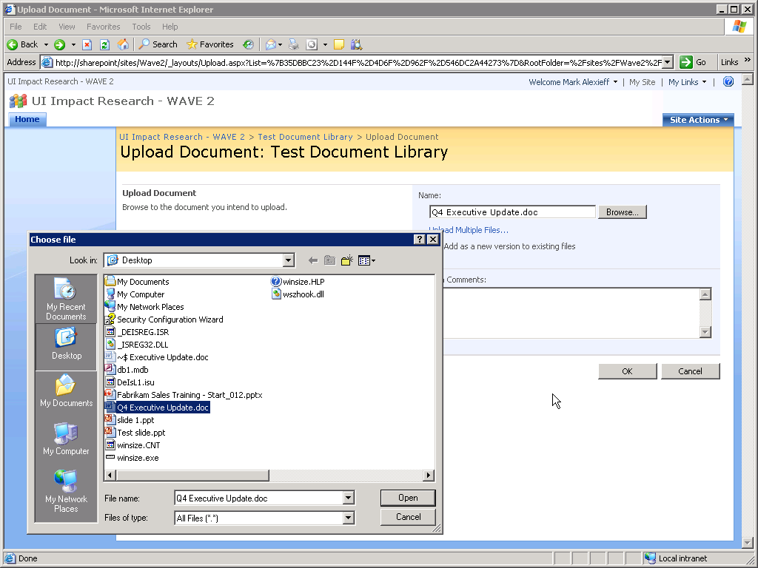  - Open Browser, upload documents to SharePoint Document Library  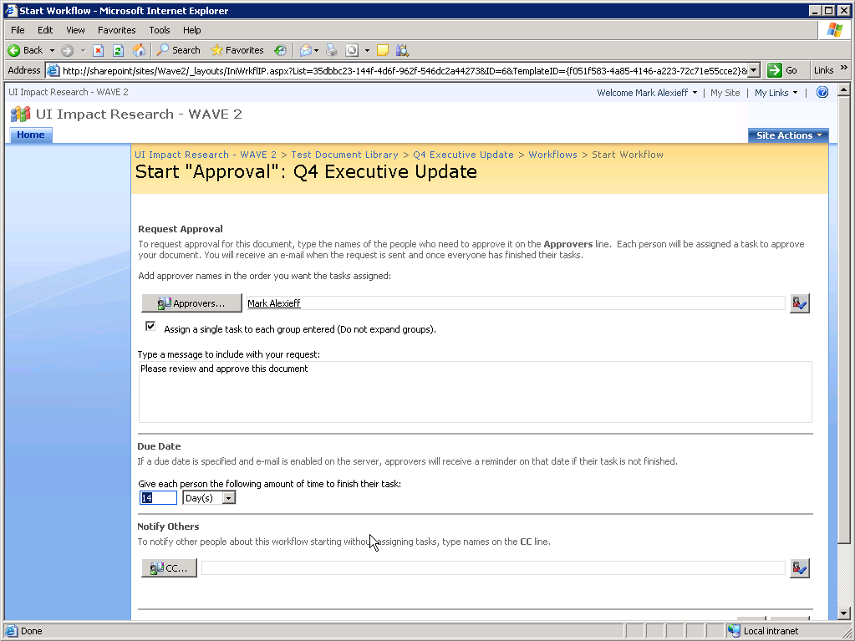 | - Create Document in Word 2007  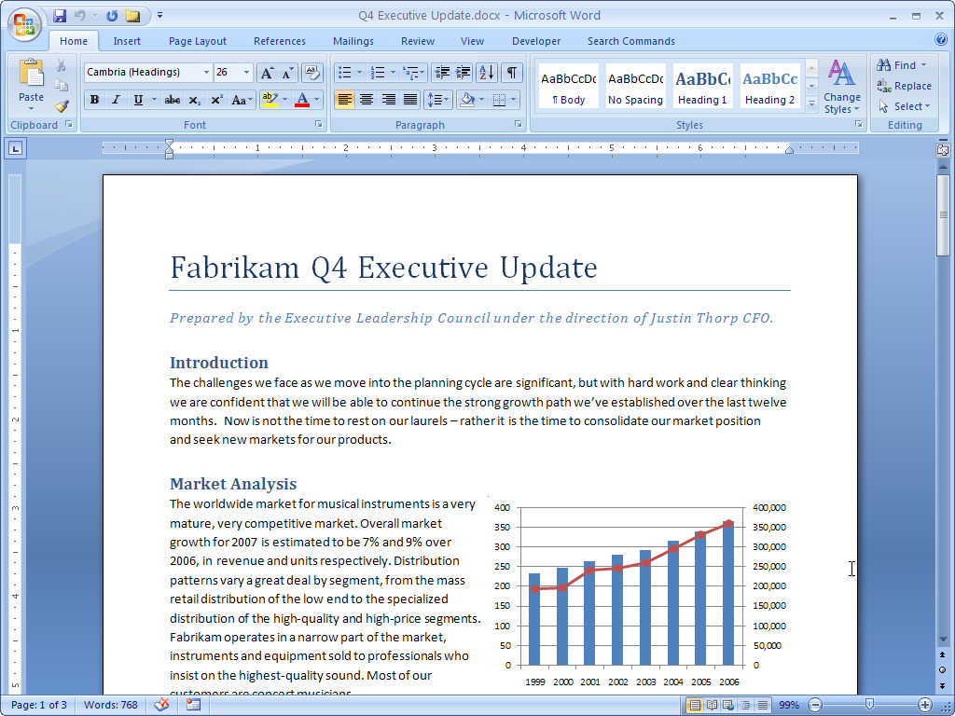  - Publish Document to Content Management Server  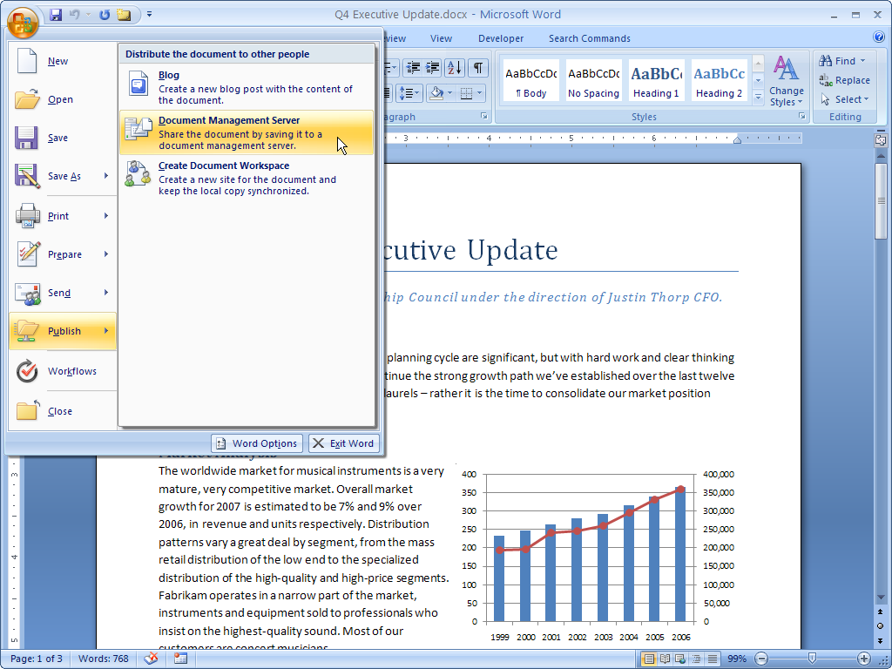
- In Browser Start Workflow  - Workflow Participant receives e-mail with link to document and task  - Review Documents in Word 2003  - Return to Email to open Task in Browser  - Complete Task in Browser  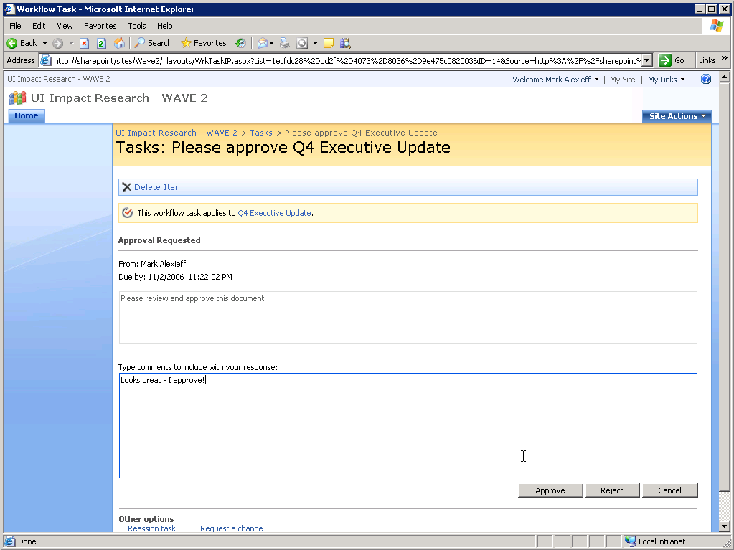 | - Start Workflow in Word 2007  - Workflow Participants get task in e-mail  - Review Document in Word 2007  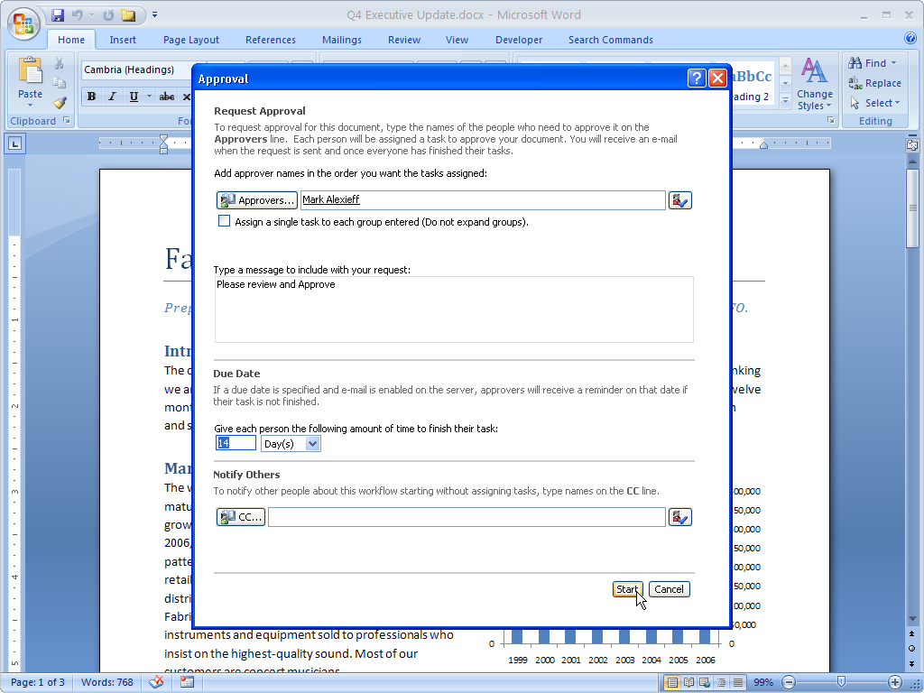  - Complete Task in Word 2007  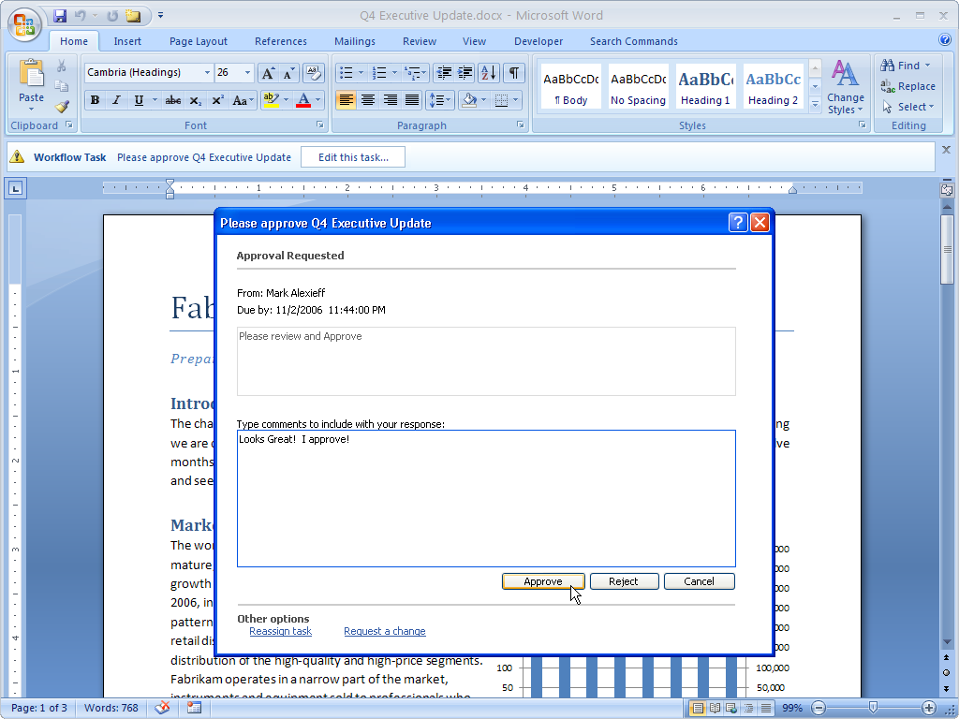

PowerPoint Slide Library
2003 Client Experience | 2007 Client Experience
The PowerPoint Slide Library capability of the Office SharePoint Server can be accessed from PowerPoint 2003, but the user must save each slide and then drag and drop it into the Slide Library (viewed in explorer mode) or upload each slide via a browser. In addition, to get slides from the Slide Library into PowerPoint 2003 – multiple dialog boxes must be navigated. Finally PowerPoint 2003 does not have the ability to check the Slide Library for updates to an inserted slide. | By contrast the experience with PowerPoint 2007 is streamlined and straightforward. Slides are easily published from within PowerPoint. Slide libraries are easily accessible from within PowerPoint. Unlike PowerPoint 2003, PowerPoint 2007 will check for update to slides when they have been inserted from a PowerPoint Slide library.
- Copy slide to new presentation  - Save single slide presentation  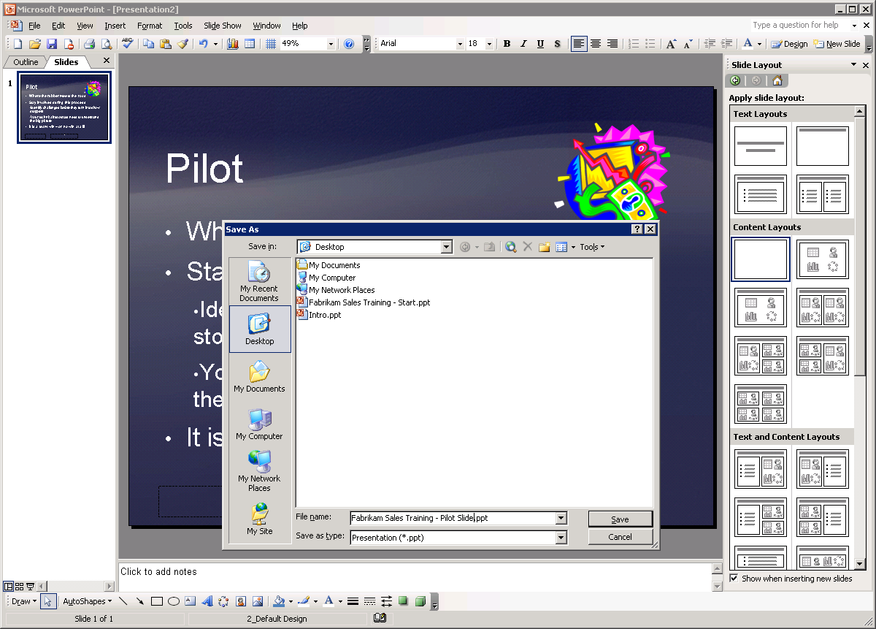  - Open Slide Library in Browser  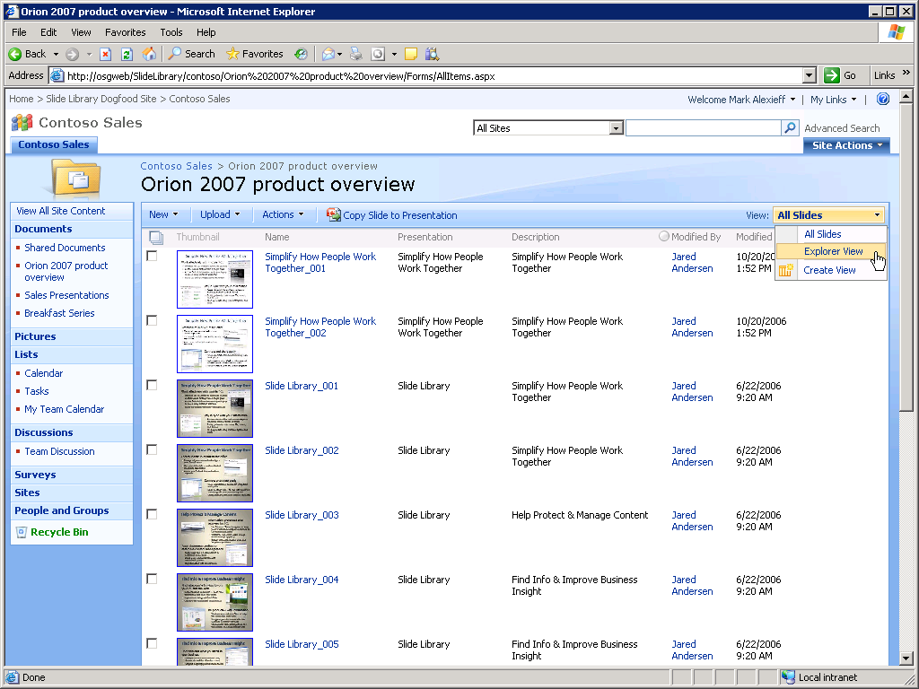 | - Create Presentation In PowerPoint 2007  - Publish to Slide Library from PowerPoint 2007  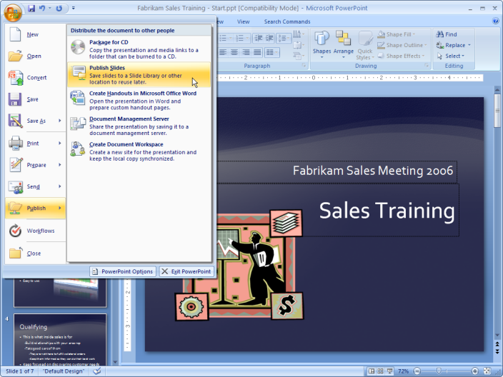  - Select Multiple Slides  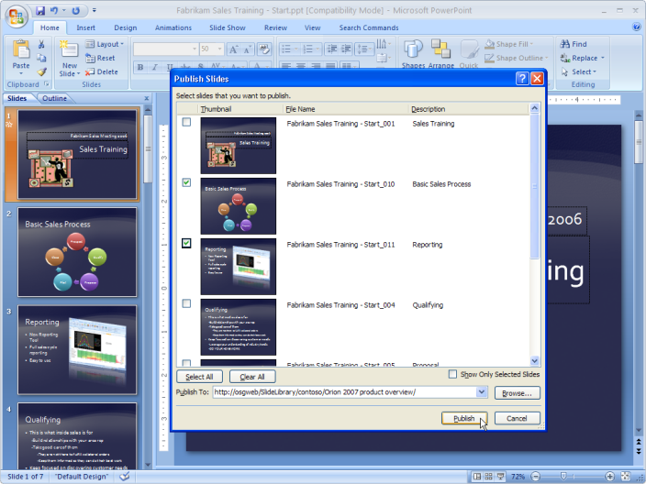
- Switch to explorer view  - Drag and Drop File to Library  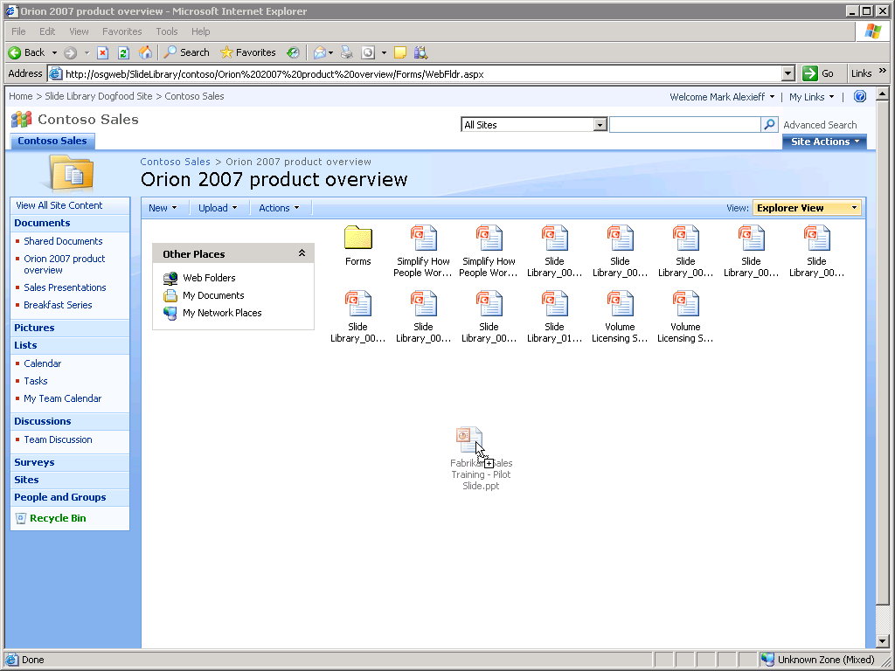  - Insert Slide from Files  - No Checking or Updates  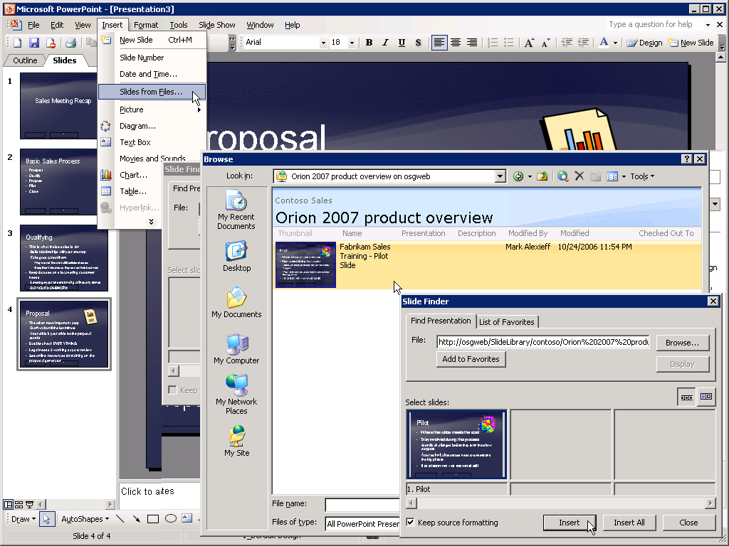 | - Insert Slide(s) from Slide Library  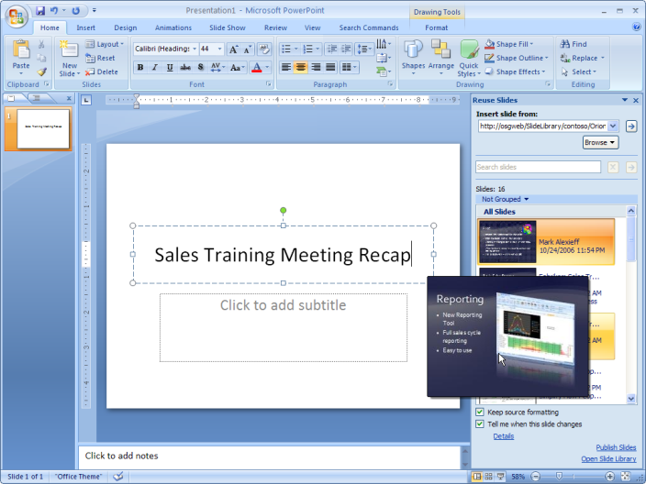  - Checking for Updates  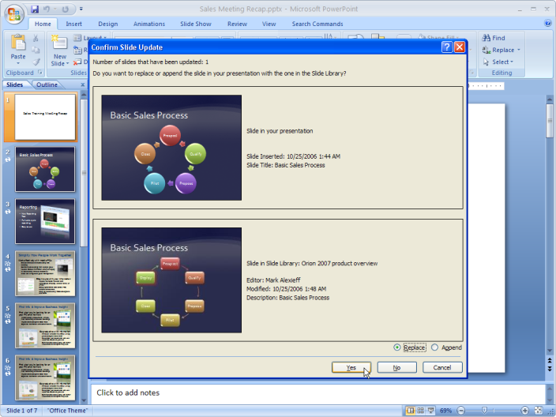

Excel Services
Excel Services delivers a broad set of capabilities that enable more secure, centralized access to spreadsheet data. Excel services enables spreadsheets to be viewed using a browser, as well as providing access to spreadsheets via web services. Excel Services provides the core services that enable parts of Excel spreadsheets to be used as components of dashboards on SharePoint sites.

Excel Services
2003 Client Experience | 2007 Client Experience
No direct integration between the Excel client and the Office SharePoint server. The .XLS files can be saved as .XLSX files and then uploaded to the support site where they can be viewed in a browser, but control over what can be viewed and the establishment of parameters for browser-based input requires the Excel 2007 client.  Issue: Limited access to the full range of capabilities offered will reduce usage of this feature. | Integrated Excel workbook publishing experience encourages full utilization of the Excel services to publish spreadsheets in a controlled and manageable fashion.  Benefit: Publishing is as easy as saving a spreadsheet to your hard disk and a full range of control is available from within the client to control display and access to the spreadsheet.
Excel Services requires spreadsheets to be in Office Open XML formats (.XLSX). Users must save the spreadsheet they have created in the .XLSX format before uploading it to the Excel Services site. This process must be done “manually” and is somewhat cumbersome. Excel 2003 does not support the ability to control which portions or components of the spreadsheet will display. For example if a workbook has multiple spreadsheets, one of which might have confidential information, there is no way to prevent it from displaying on SharePoint site. (You need the Excel 2007 client to control component visibility when publishing the workbook) Likewise, the Excel 2003 client does not enable specification of input (or parameter) cells. | Excel 2007 provides a streamlined full-featured experience with Excel Services. The publishing process is integrated into the Excel 2007 client. Two key capabilities are enabled in the Excel 2007 client that are not supported by the Excel 2003 client. First the ability to specify which components of the workbook will be visible when published to the Excel Services site. Second, the ability to configure input cells in the workbook. This capability provides users with the ability to publish spreadsheets that perform calculations and return results based on user input.
- Create Spreadsheet in Excel 2003  - Save as .xlsx file (after installing file format compatibility kit)  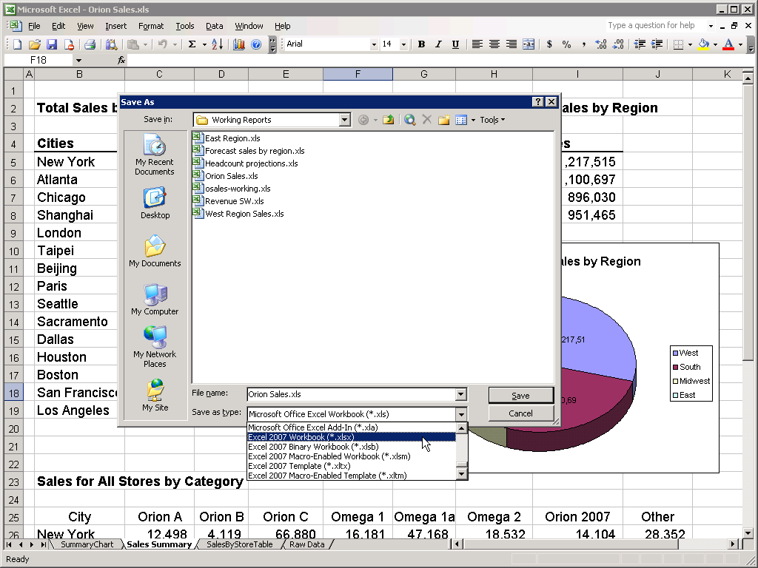 | - Create spreadsheet in Excel 2007  - Publish to Report Library  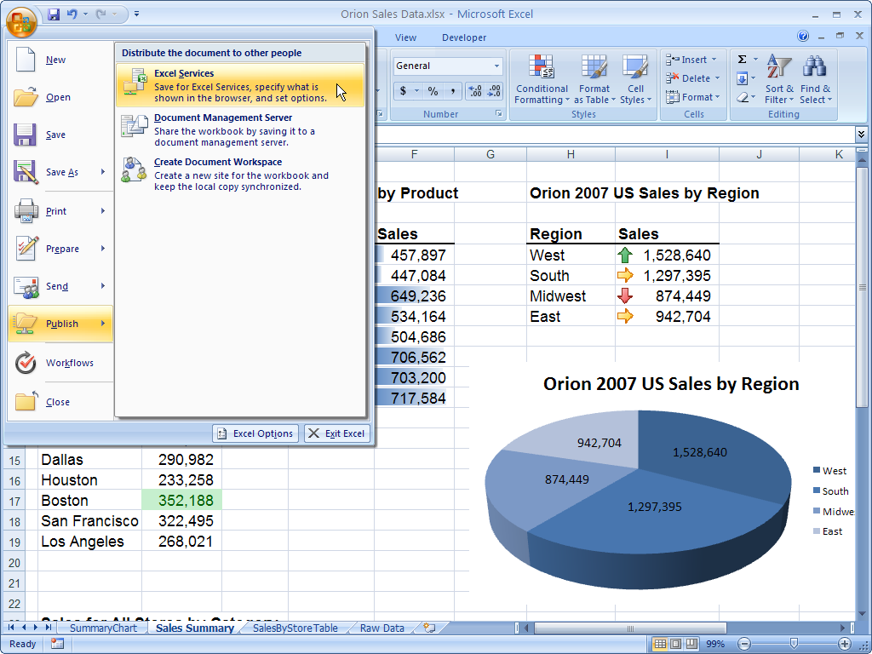
- Open Report Library in Browser  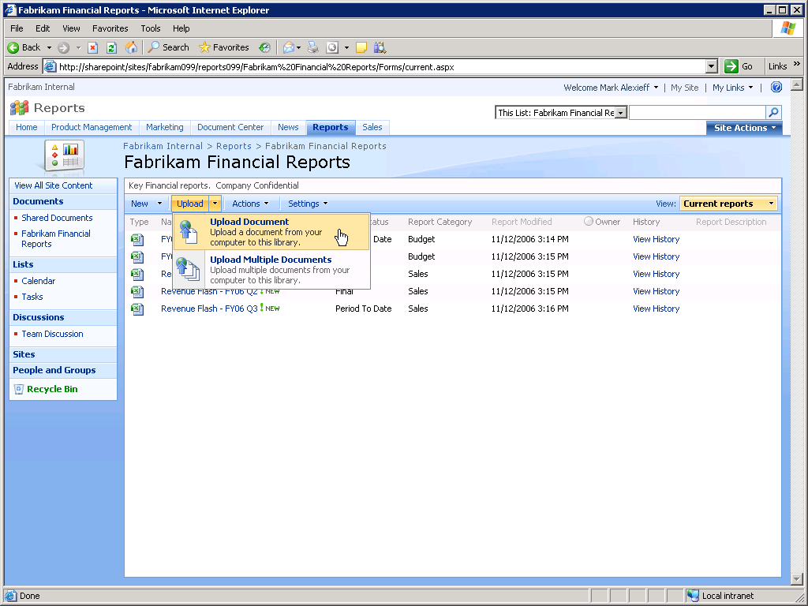  - Upload .xlsx file  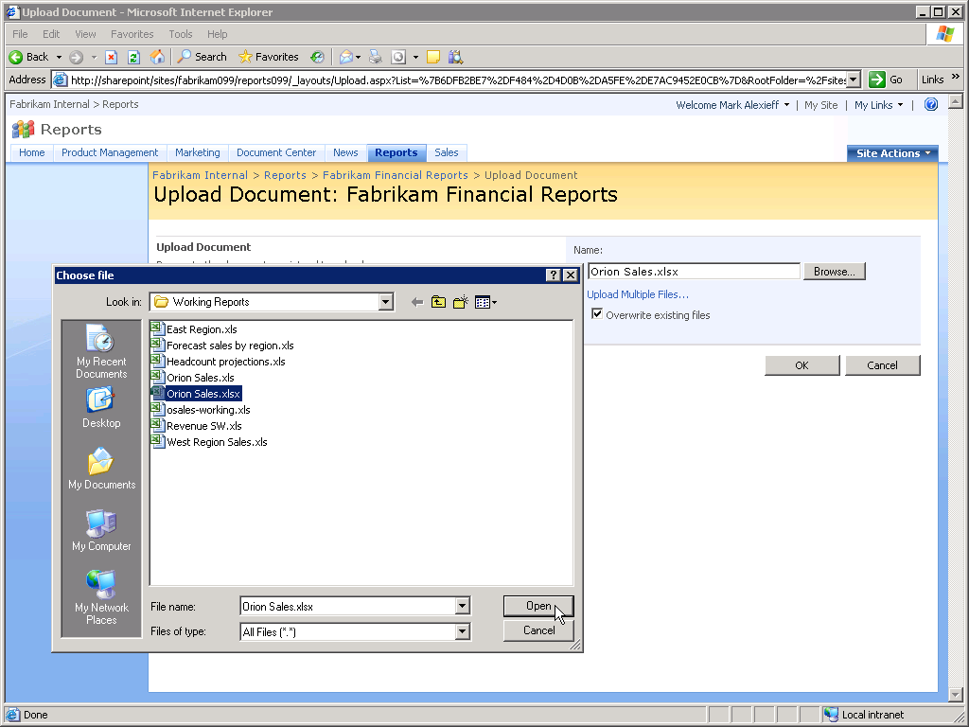  - Spreadsheet will display in Browser  - No control of component visibility  - No ability to configure input cells  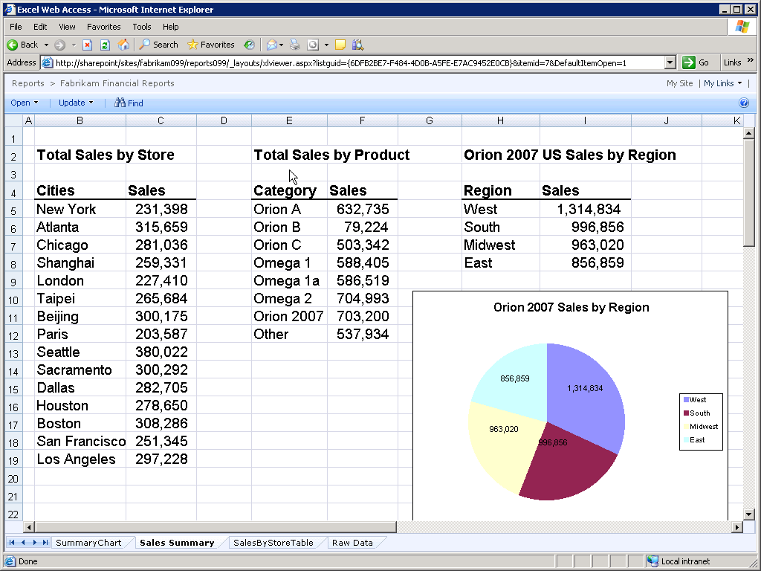 | - Specify component visibility  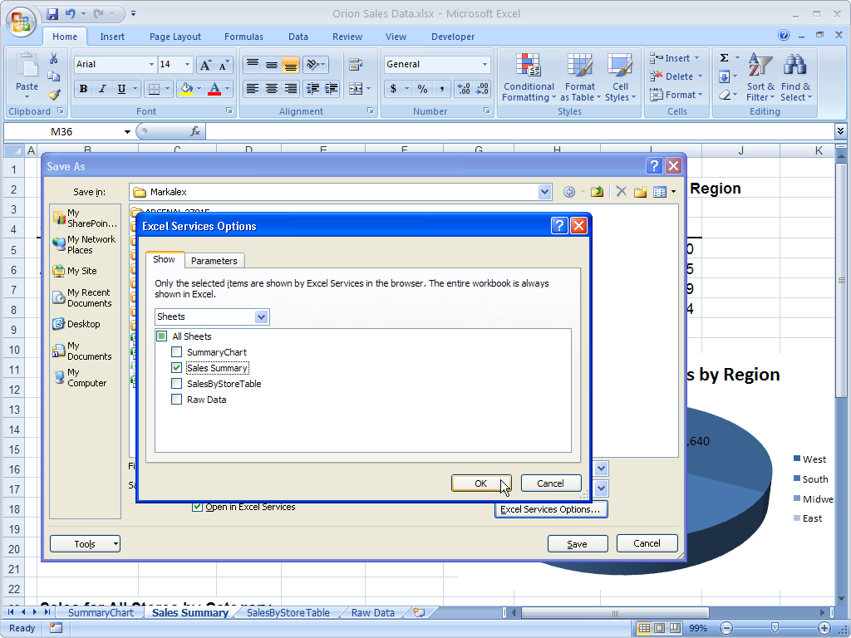  - Configure input cells  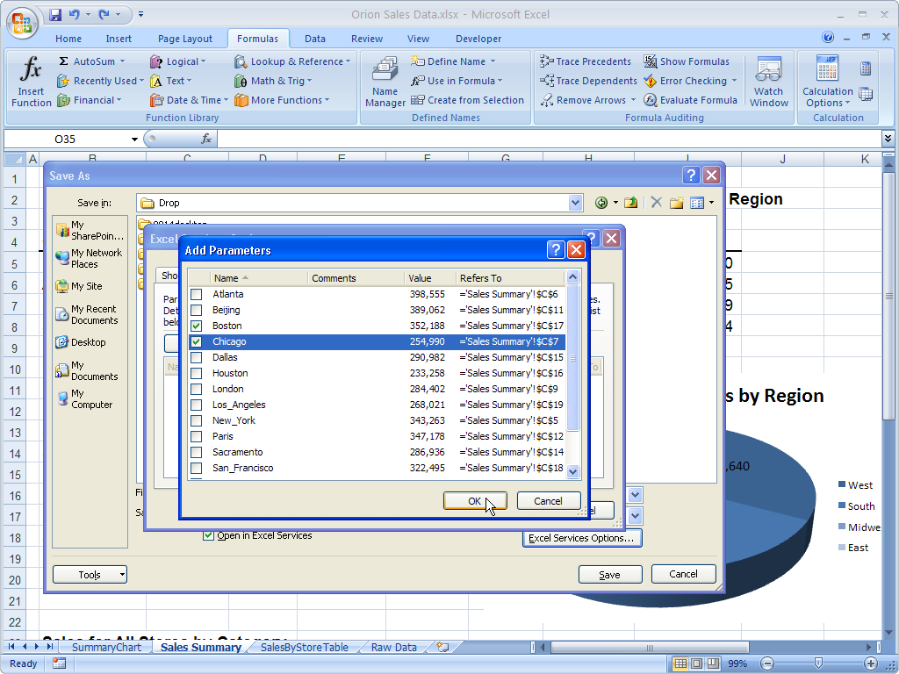  - Work with Spreadsheet in Browser  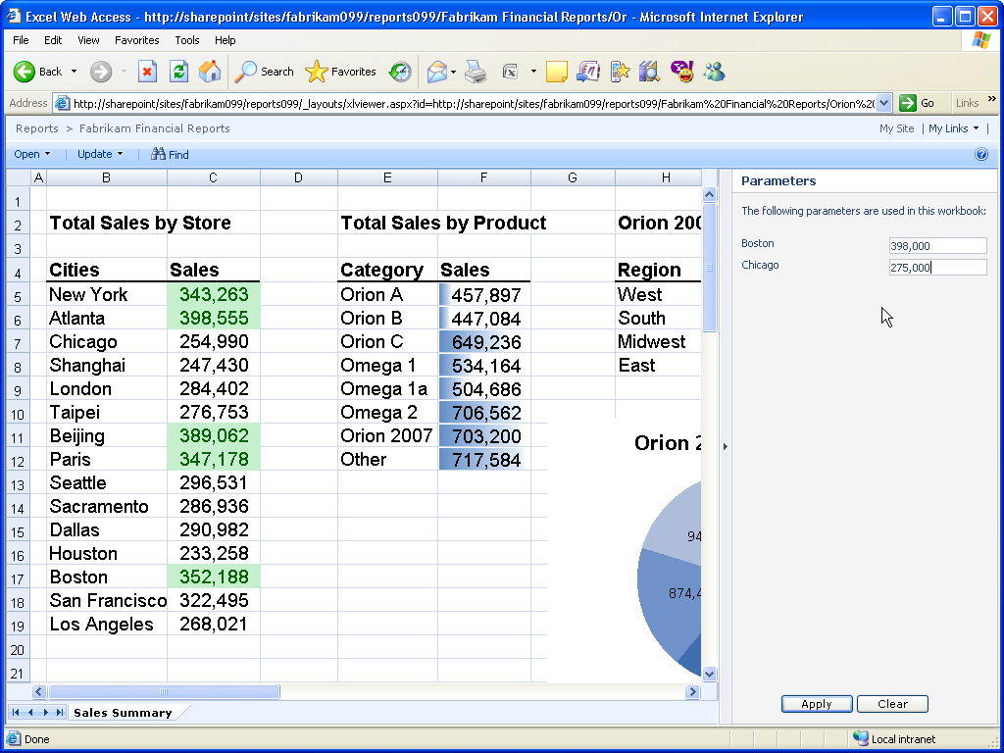

Electronic Forms
InfoPath Forms Services enables forms to be published to the server (requires InfoPath 2007), browser-based completion of forms, and forms to be sent via and completed within an e-mail message (requires Outlook 2007).

Electronic Forms
2003 Client Experience | 2007 Client Experience
InfoPath client required to fill out forms.  Issue: Requirement to use InfoPath client to fill out forms introduces barriers to usage and adoption limiting the value of InfoPath to the customer. | Integration between InfoPath 2007 and Office SharePoint Server 2007 greatly increases the utilization of electronic forms in a number of ways. InfoPath 2007 and InfoPath Forms Services enable browser rendering of forms, browser-based form fill-in and e-mail distribution and completion of forms.  Benefit: More effective streamlined data collection using electronic forms.
Once a form has been published to a SharePoint Server 2007 forms library a link to the library can be sent to individuals. The challenge for these individuals is that they must learn the process of filling out a form in a forms library. To do this they must click on the “new” button on the SharePoint site. This launches InfoPath 2003 in which the form can be completed. Saving the form populates the fields in the list on the SharePoint site. This unfamiliar process can be daunting for users and decrease the likelihood that the process will be used consistently.  With InfoPath 2003 forms cannot be published to the Office SharePoint 2007 server for e-mail or browser based completion. | With InfoPath 2007 and SharePoint Server 2007 the publishing process is streamlined with a wizard. Once the form is published it can be emailed to others who can fill out the form within the Outlook 2007 client. In addition, a link to the form can be sent to people. Clicking on the link launches the form in a browser in which the form can be filled out. Submitting the form by clicking on “Submit” button in either the browser or the e-mail message saves the form to the SharePoint server and populates appropriate fields in the SharePoint list. The key benefit is that the InfoPath client is not required to complete the forms and user can stay within the applications they are most comfortable with.
- Create Form in InfoPath 2003  - Publish to Forms Server  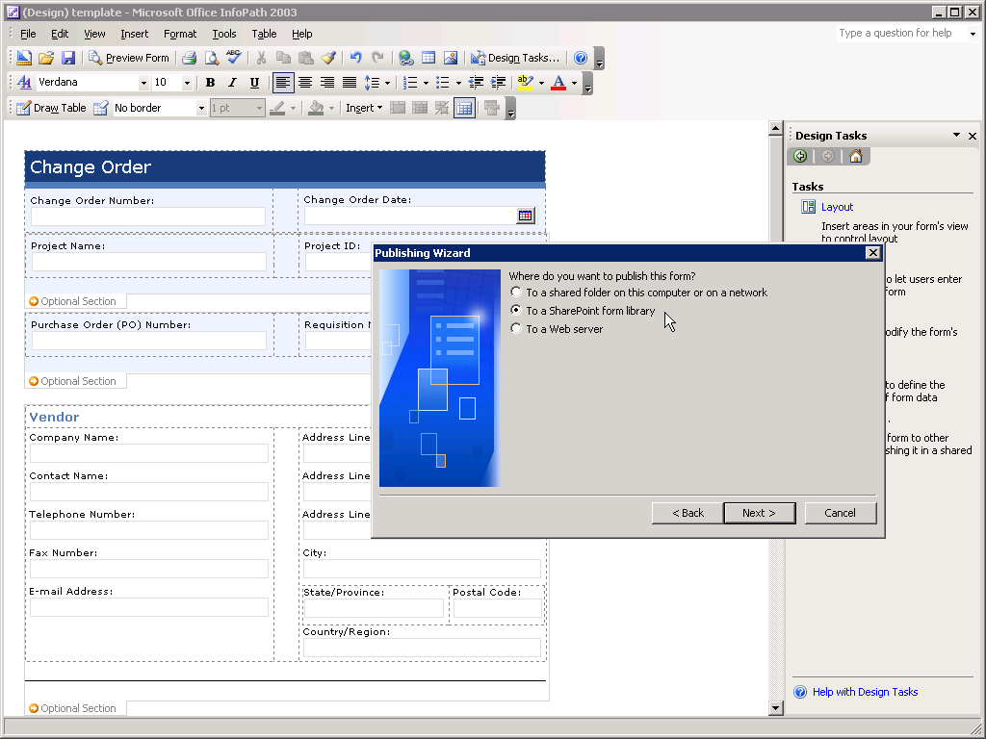  - E-mail Request to complete  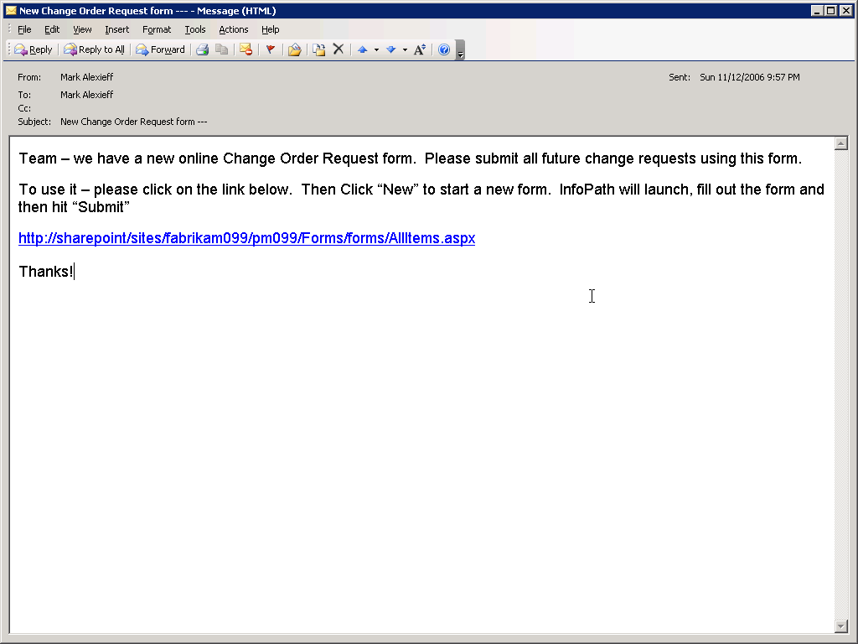 | - Create form in InfoPath 2007  - Publish for e-mail and browser  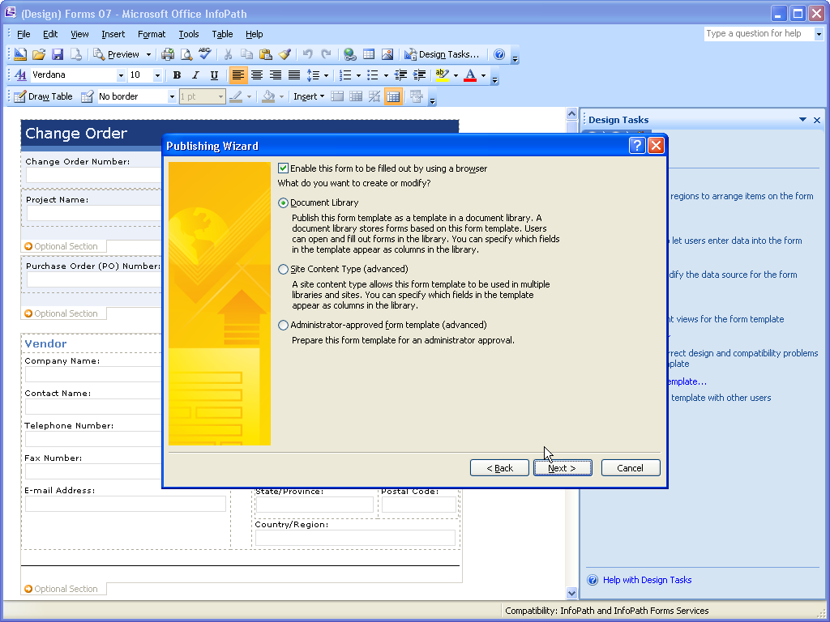  - Send e-mail invitations to complete form  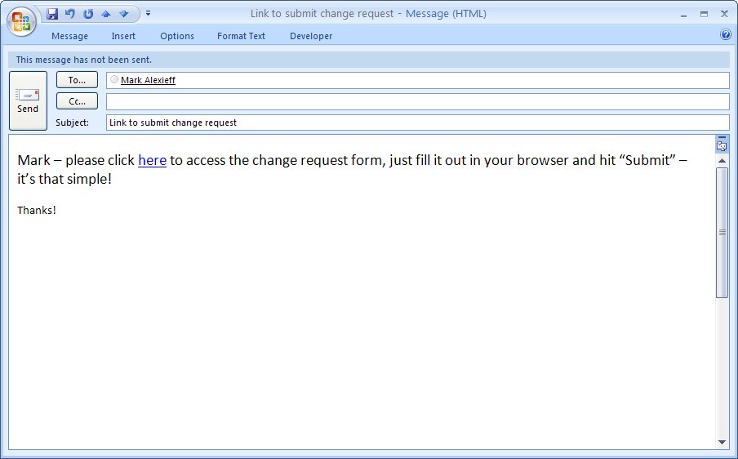  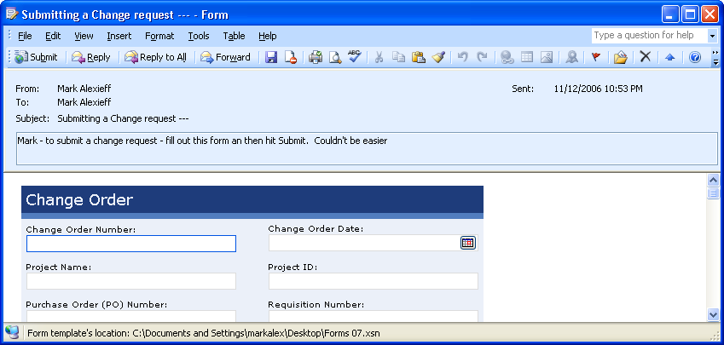
- Open new form in library  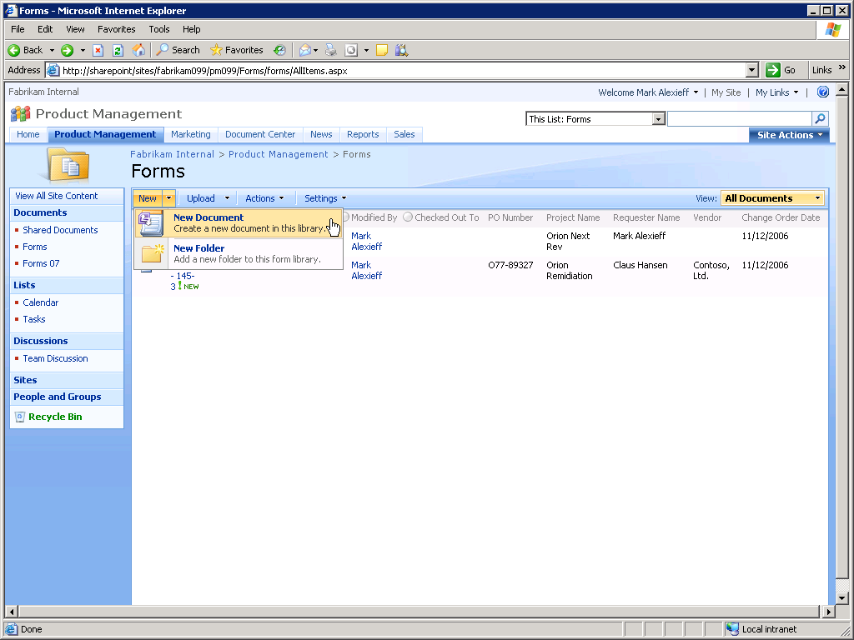  - Complete form in InfoPath 2003  - No browser form completion  - No e-mail form completion  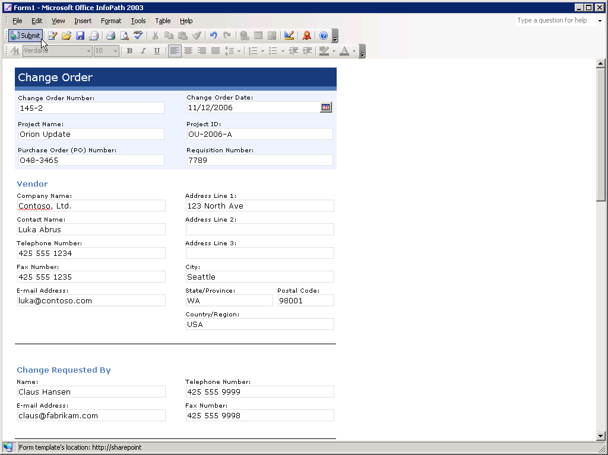 | - Complete Form in browser  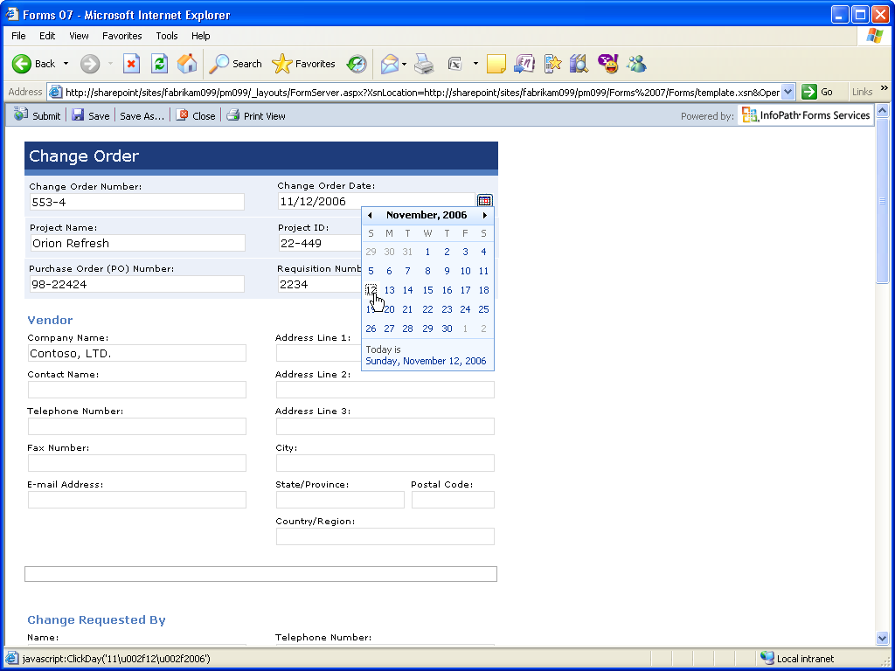  - Complete Form in e-mail  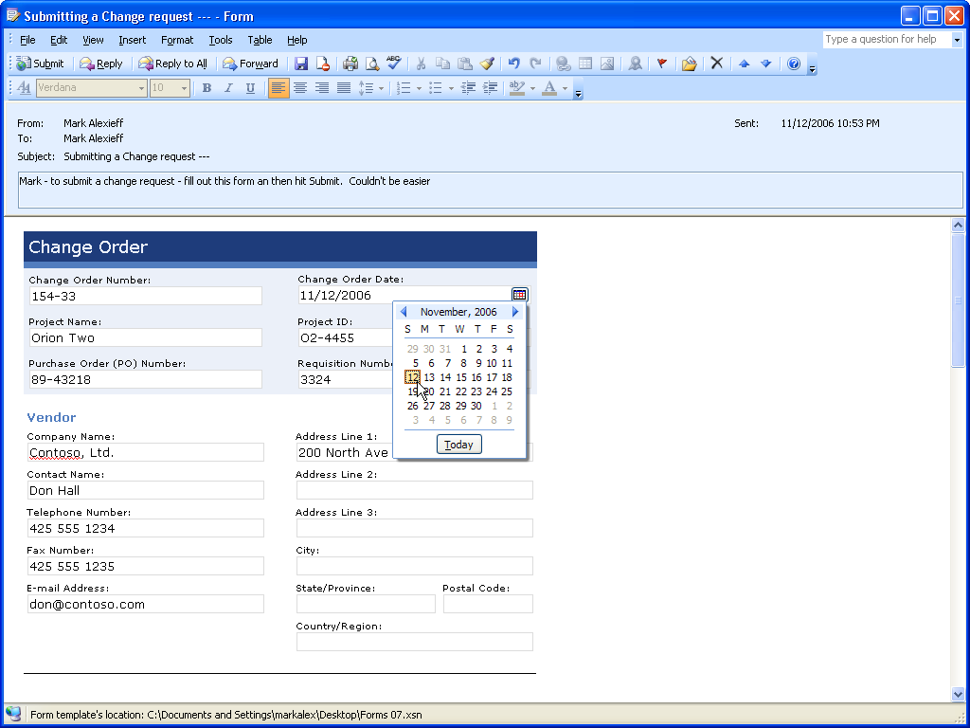

Outlook and SharePoint Integration
Extends the utilization of SharePoint calendars, tasks, contact, and document libraries through offline access and integration with Outlook experience.

Outlook and SharePoint Integration
2003 Client Experience | 2007 Client Experience
Read-only view of SharePoint team calendars and no ability to overlay them with personal calendars.  Issue: SharePoint team calendars are not seamlessly integrated into existing work habits. | One-click process to connect SharePoint calendars to Outlook 2007 with bi-directional synchronization.  Benefit: Shared team calendars become more accessible through users’ primary scheduling tool and are more easily integrated into existing work habits – stimulating utilization.
No ability to copy contents of SharePoint Server lists and libraries for offline access in Outlook folders.  Issue: Access to SharePoint Server managed data limited to times when a network connection is available. | Easy process to copy contents of SharePoint lists and libraries to Outlook 2007 folders for off-line access.  Benefit: Easy offline access to SharePoint managed data stimulates team site usage by eliminating requirement to be connected.
The major issues with Outlook 2003 integration with SharePoint calendars is that only read-only access is provided. The process of connecting a SharePoint calendar is straightforward but the side-by-side viewing mode is not as user-friendly as it could be. Any changes to the SharePoint calendars must be done on the SharePoint site. The inconvenience of this process (having to leave Outlook) reduces the attractiveness of SharePoint calendaring to users and reduces adoption. | Outlook 2007 offers two key advantages over the 2003 experience with regard to accessing SharePoint calendars. First the Overlay view makes it much easier to spot conflicts between the two calendars. Second, Outlook 2007 provides read/write access to SharePoint calendar items. In addition to enabling full edit access to SharePoint calendar appointments, appointments can be dragged and dropped from one calendar to another. Because it is so much easier to work with SharePoint calendars from within the familiar Outlook environment, user adoption of the capability is enhanced.
- Connect Calendar to Outlook  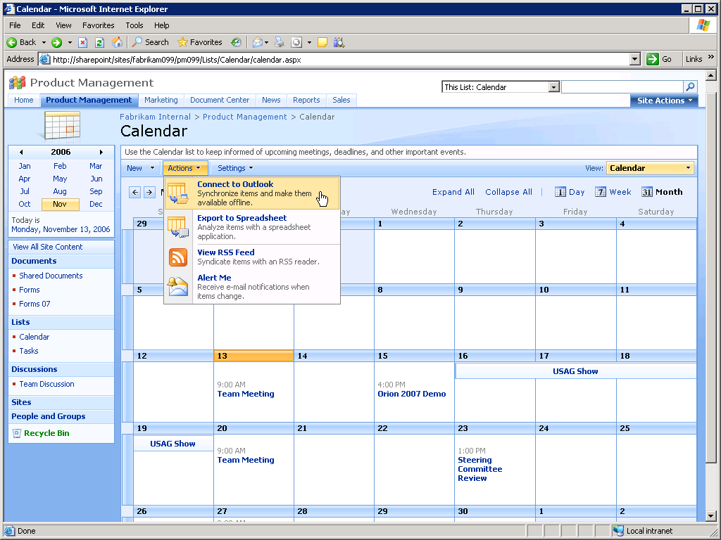  - Side by Side Display  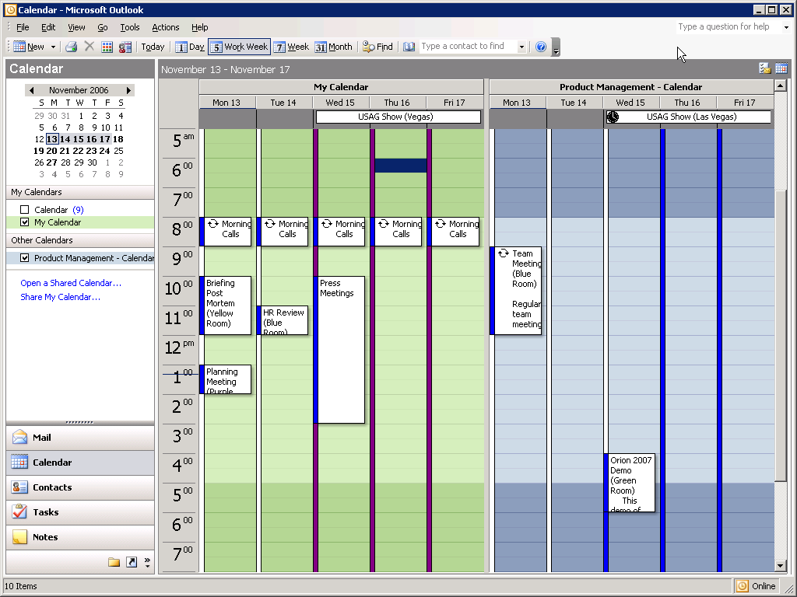  - View Appointment in Outlook  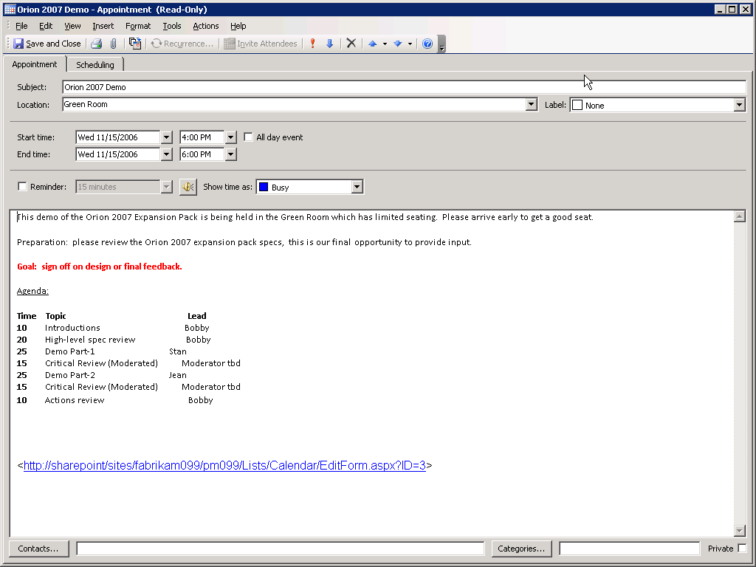 | - Connect Calendar to Outlook  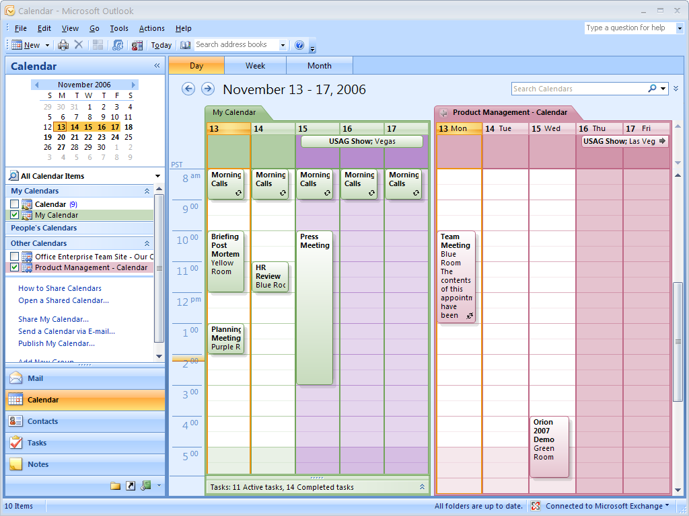  - Overlay View  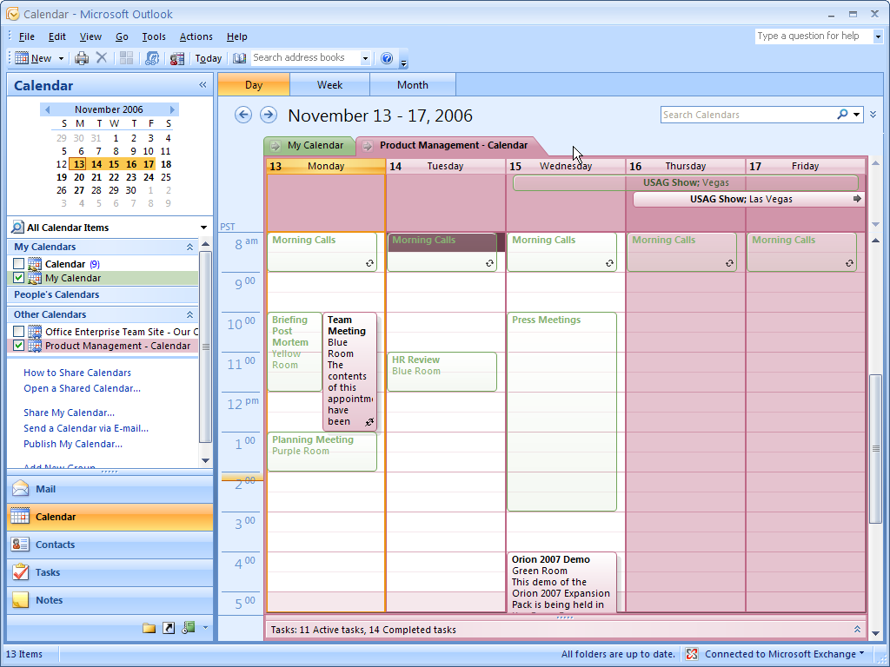  - Create new appointment on team calendar  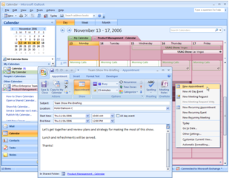
- Read-Only Access  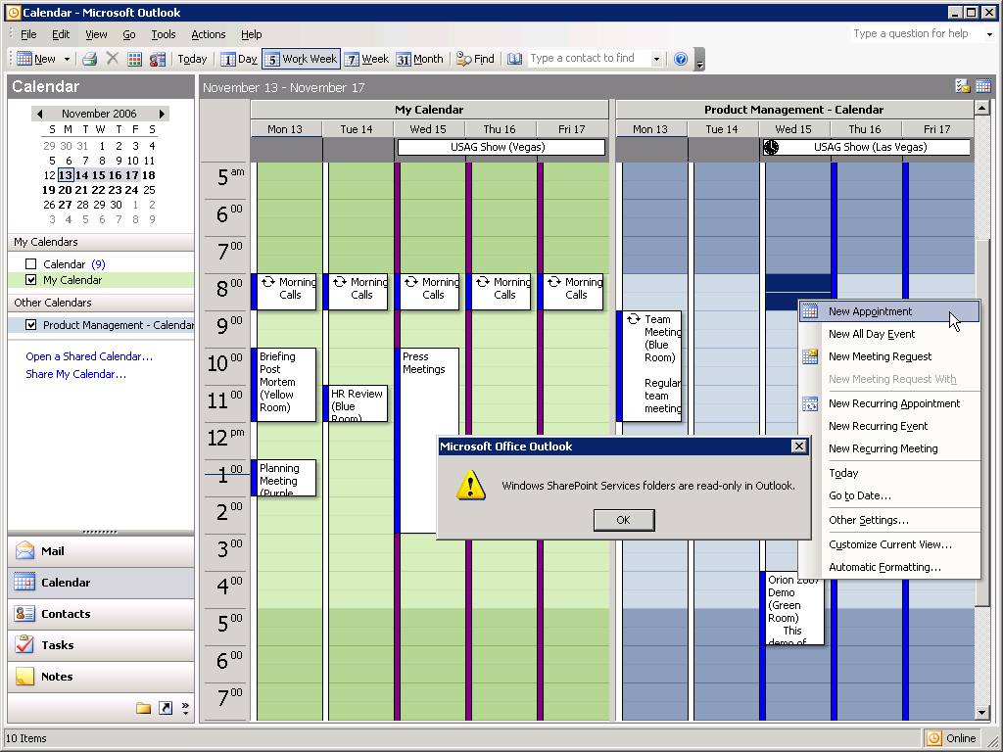 | - Appt. appears on Team Calendar  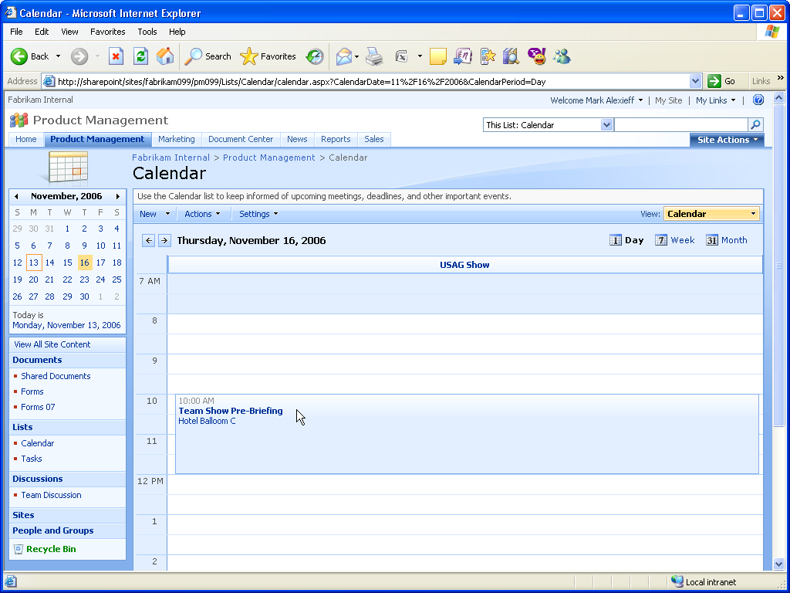

Access and SharePoint Integration
Provides wizard driven process to move entire Access databases to SharePoint site (tables, forms, reports etc.) with complete support for SharePoint data types, ability to interact with databases stored on SharePoint using Access client or browser, and support of offline access to database.

Access and SharePoint Integration
2003 Client Experience | 2007 Client Experience
Access 2003 provides a limited ability to integrate Access databases with SharePoint sites. Individual tables can be exported to SharePoint v3.0 sites (no link is maintained). Individual SharePoint lists can be linked into Access 2003 databases.  Issues: Access 2003 does not support the new data types introduced in Office SharePoint Server 2007 nor does it have the ability to take this data offline. Integration process is cumbersome and no ability to move entire database to SharePoint site in one step. As a result, Access databases remain isolated on the individual desktop where they create business risks because they are unmanaged. | Access 2007 provides a smoothly integrated experience by enabling transfer of the Access database to the Windows SharePoint Services v3.0 site where the data can be centrally managed. The data can be accessed either through the Access 2007 client or directly from the SharePoint site using a browser.  Benefit: Access data is centrally managed reducing business risk and improving security.
Access 2003 provides a limited set of capabilities for integrating data with Windows SharePoint Services v3.0 sites. Individual tables can be moved to the SharePoint site where they appear as list. When this is done no link is maintained with the table on the local machine.  Lists on a SharePoint site can be linked to tables in an Access 2003 database. Doing this enables a link to be maintained between the SharePoint list and the Access table. Editing one will update the other.  These capabilities are of limited use however in solving the problem of local storage of key business data in local Access databases. | By contrast, Access 2007 enables the entire database including tables, forms, reports to be moved to the SharePoint site in one streamlined process. Note the upper right screen shot – the orange tables indicate that they are linked to list on the SharePoint site.  Once moved to the site, the data can be accessed either via the Access client or directly with the browser. Note the screen shot in the lower right: it shows a browser renditions of a form designed in Access – no additional work was required to create this form.  Access 2007 and SharePoint integration provides an excellent, flexible solution to the problem of decentralized Access databases.
- Create database in Access 2003  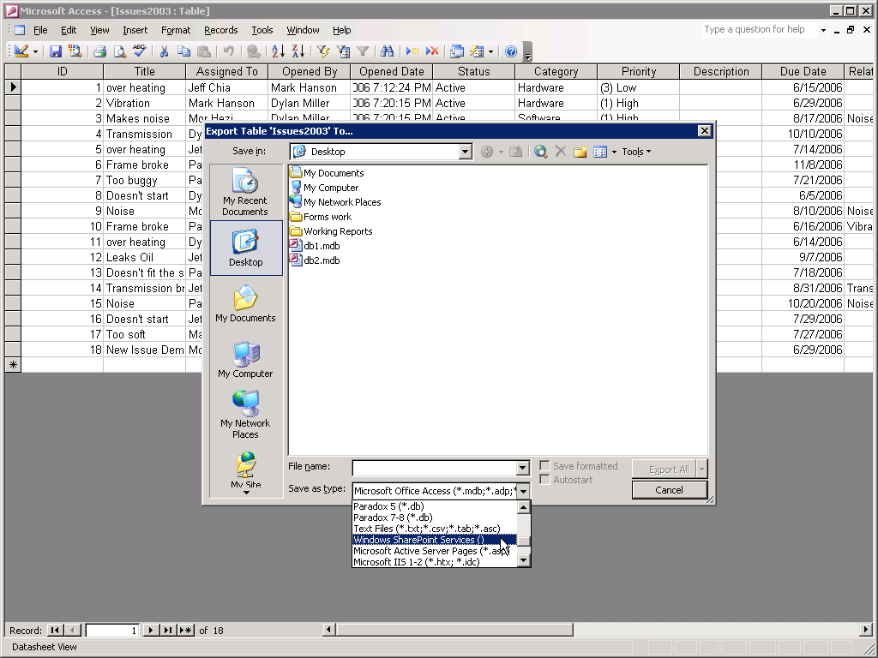 | - Create database in Access 2007  Move complete database to SharePoint site  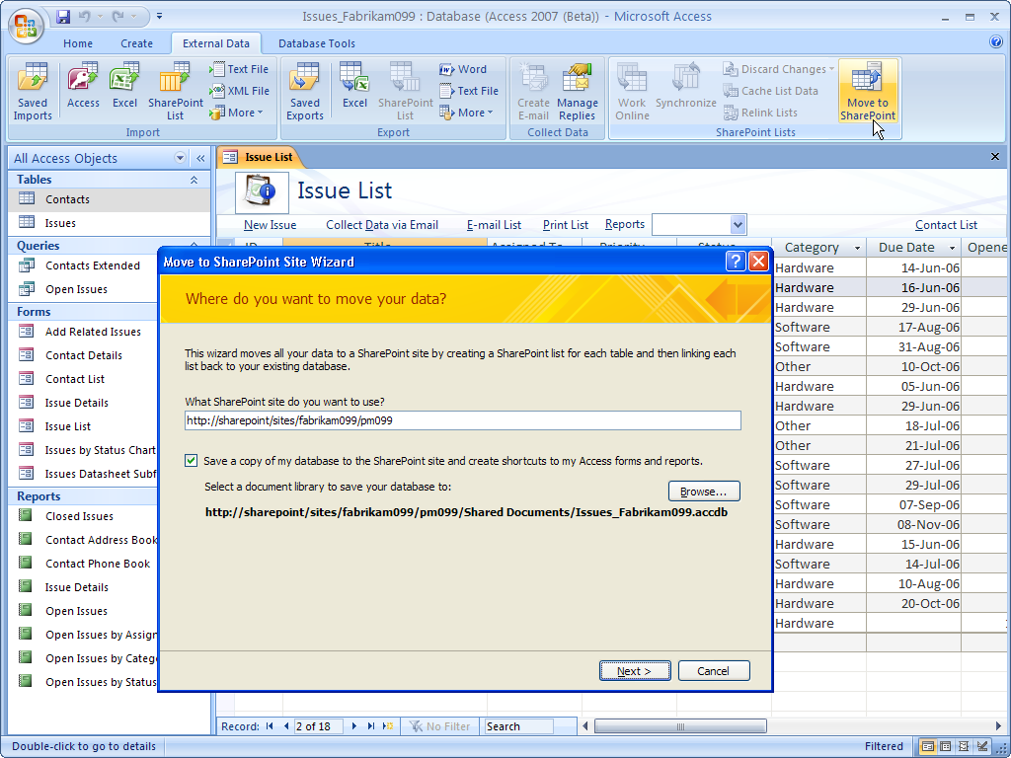
- Export Table to SharePoint site  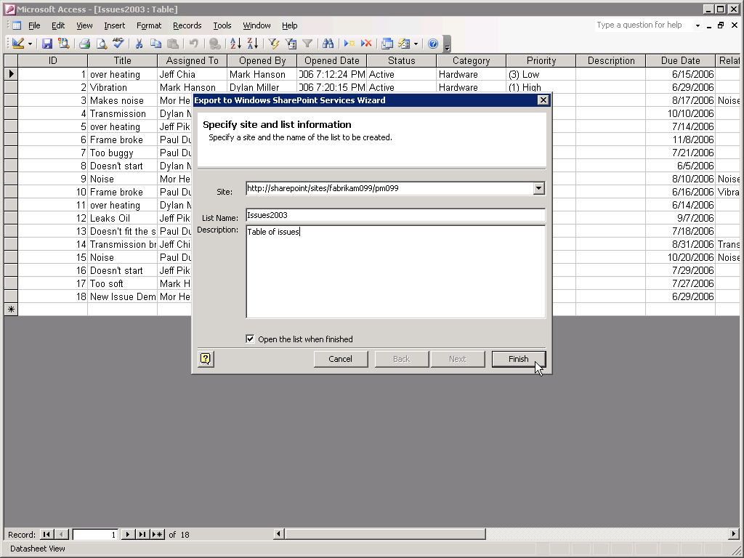  - Non-linked access to list in browser  - Link to SharePoint List from Access 2003  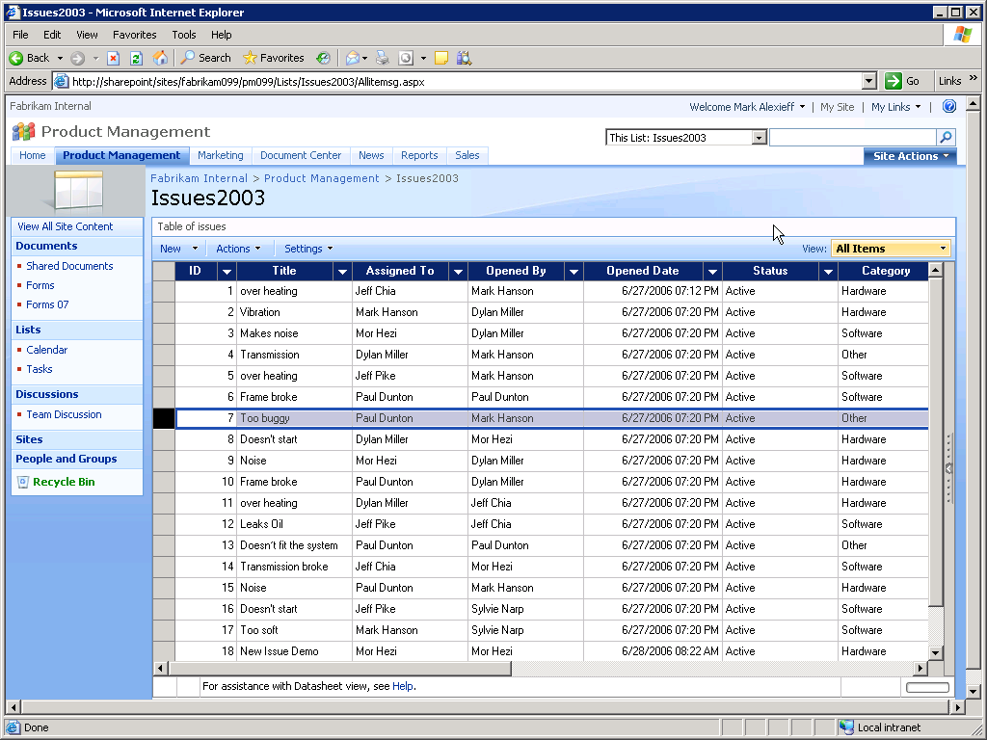  - Edit Data in Table with Browser  - Edit Data directly in Table in Access 2003  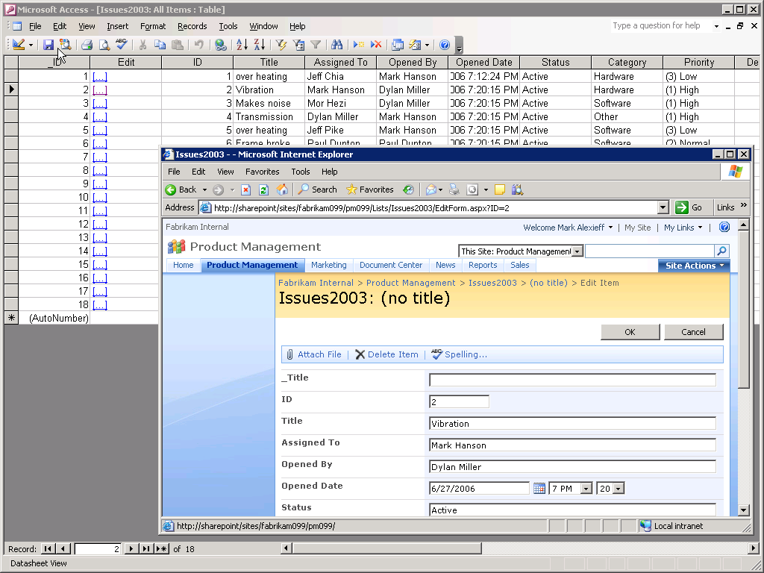 | - Data tables are linked to SharePoint Lists  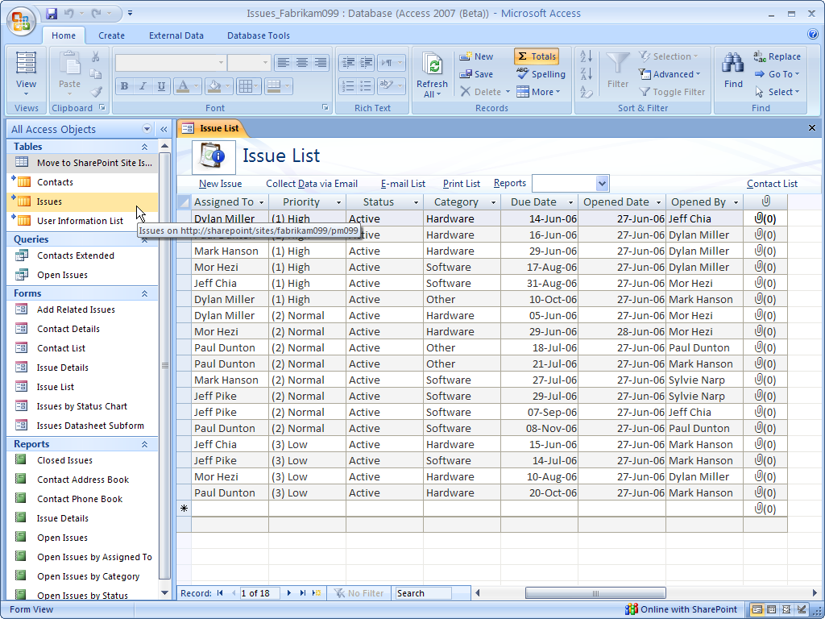  - Data tables are linked to SharePoint Lists  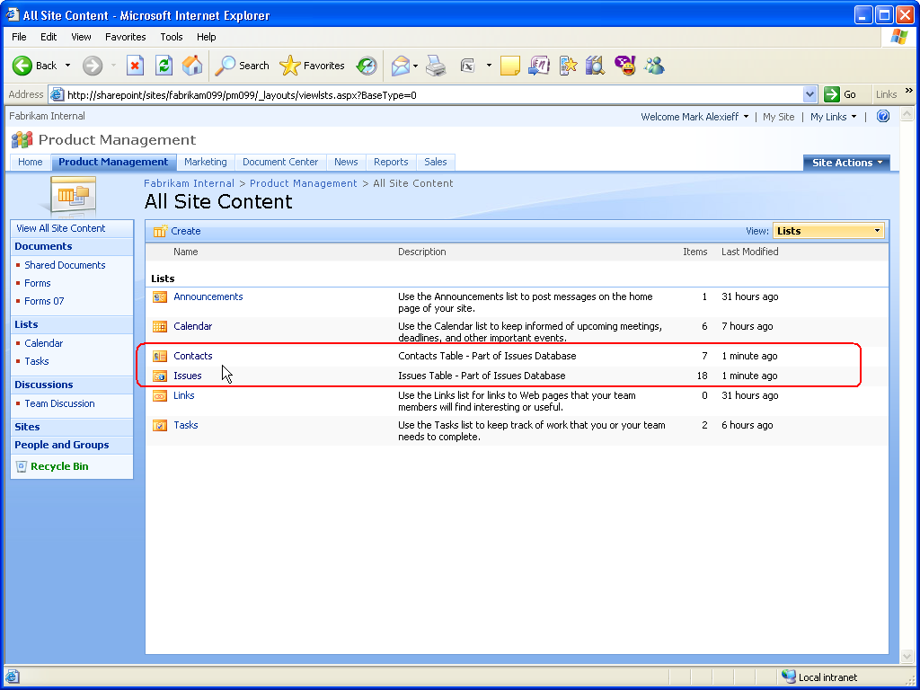  - Access Forms converted to browser forms  - Continue to use Access 2007 client with this data  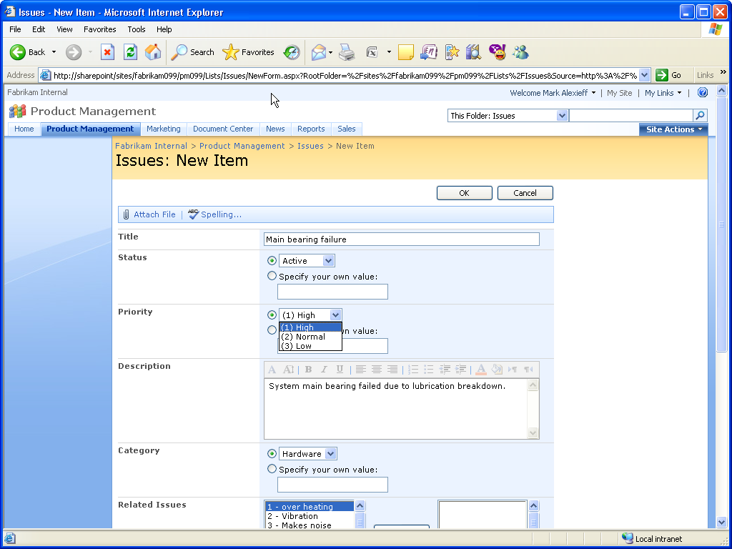

Groove and SharePoint Integration
Enables Groove users to have offline access to SharePoint document libraries.

Groove and SharePoint Integration
2003 Client Experience | 2007 Client Experience
Groove 3.1 does not support direct access to contents of SharePoint Server 2007 document libraries. Contents of libraries can be added to workspace but no synchronization service provided.  Issue: Limited ability to combine usage of SharePoint server team sites and Groove workspaces. | Adding documents to a Groove Workspace is a easy to mange process that automates the synchronization of the copies.  Benefit: Improved utilization of the tools and more effective collaboration especially for highly mobile users who are frequently disconnected.
Integrating Groove 3.1 and SharePoint document libraries can be done in a limited fashion. Files residing in a SharePoint document library can be added to the Groove 3.1 workspace. No synchronization service is provided between the Groove workspace and the SharePoint document library and the files quickly can get out of sync. | Groove 2007 provides a streamlined experience for connecting workspaces to SharePoint document libraries. A special purpose “SharePoint Files” tool makes the process of bringing files into the groove workspace easy. The Groove 2007 client provides synchronization services. If the file is modified in the Groove workspace – notification is provided reminding the user to synchronize. All synchronizations are previewed prior to execution.
- Add files to Groove 3.1 Workspace  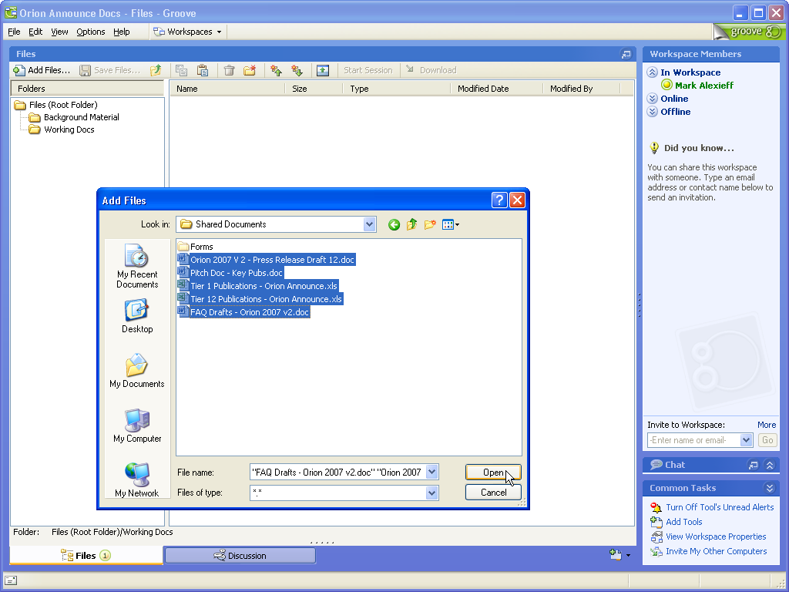 | - SharePoint Files tool to get files  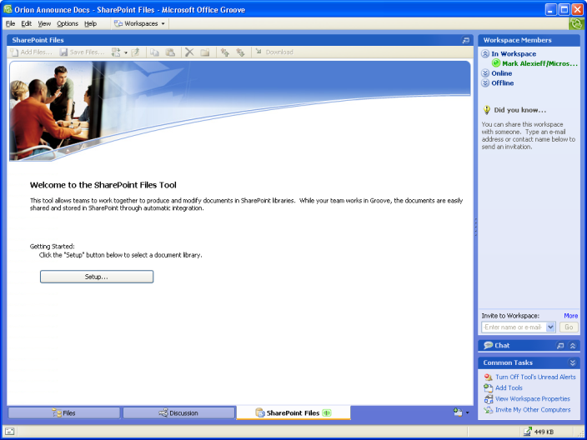
- File is edited on SharePoint Site  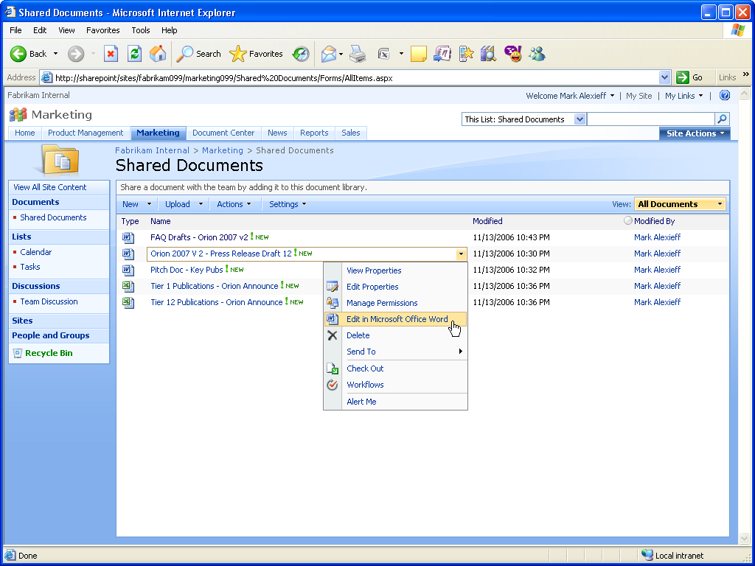  - Files are out of sync  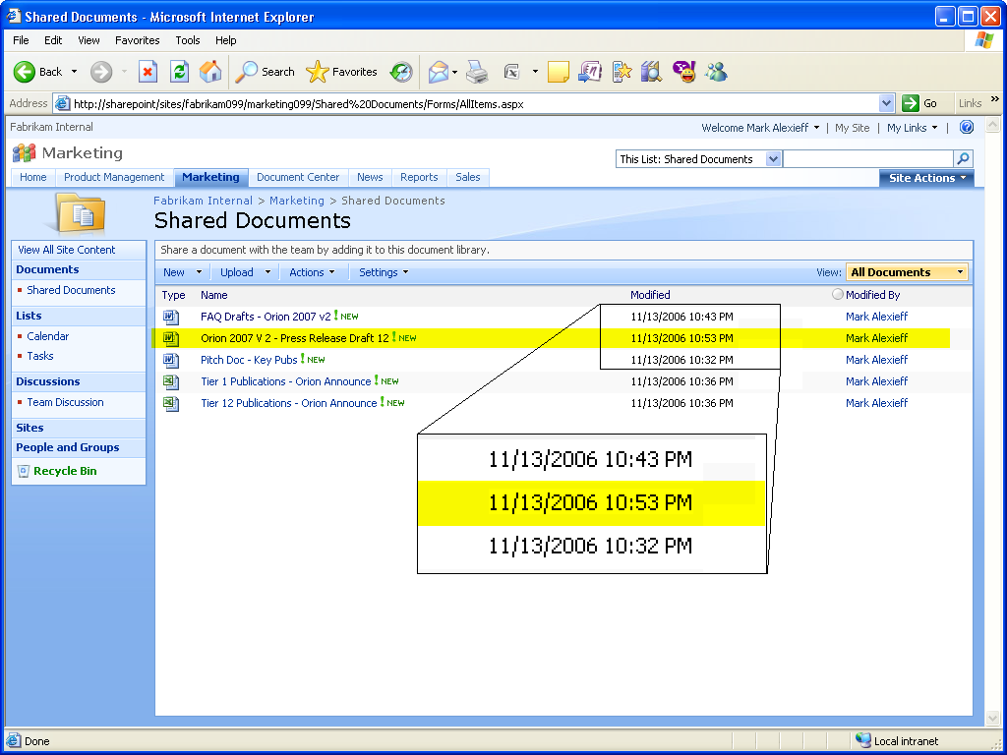  - Files are out of sync  - Changed file must be re-added to Groove 3.1 workspace  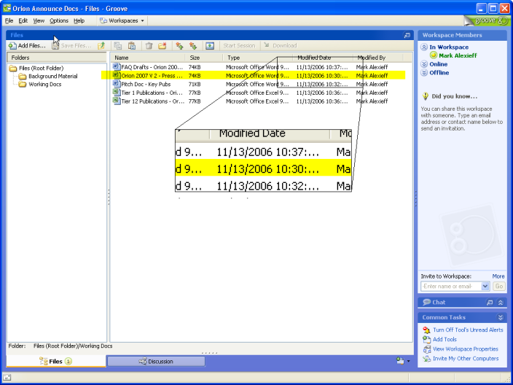 | - SharePoint Files tool to get files  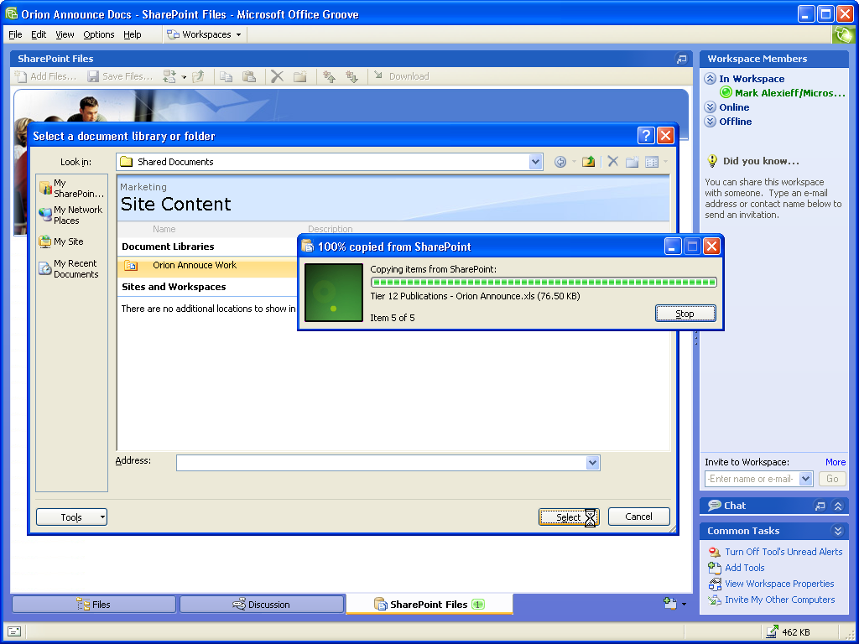  - Synchronization notification provided  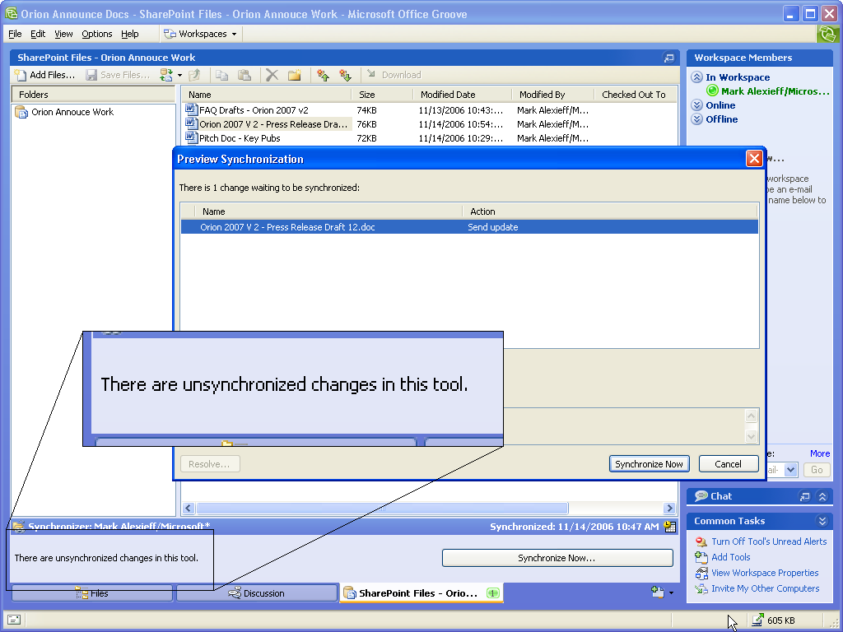  - Re-synchronize to get updates from site  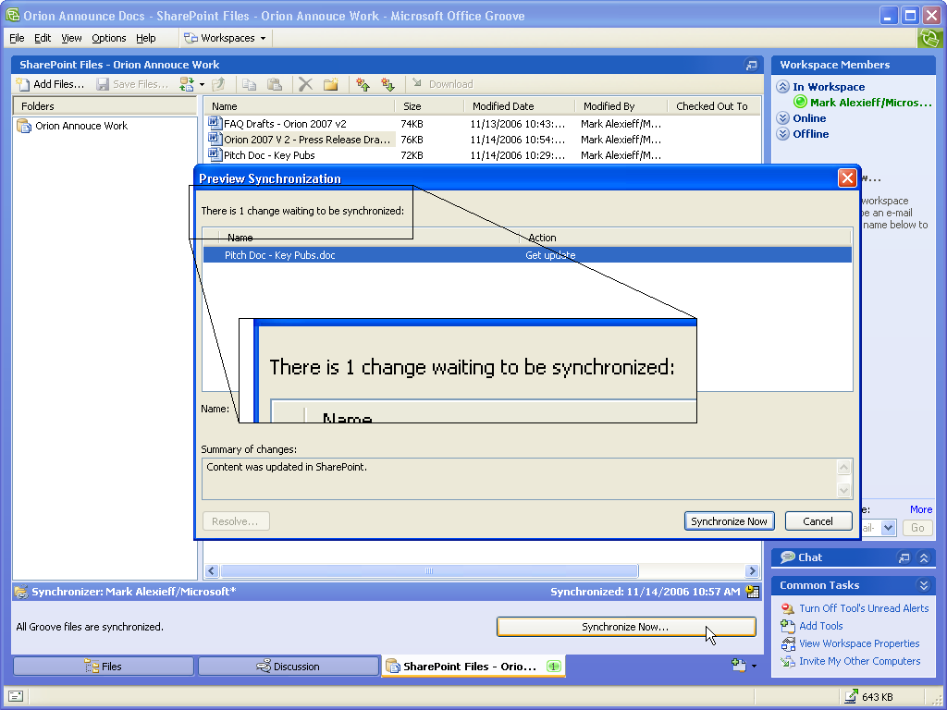

Conclusion
Microsoft Windows SharePoint Services 3.0 and Office SharePoint Server 2007 provide advanced collaboration and enterprise content management capabilities for end users through rich, contextual integration with Office Professional Plus 2007 and Office Enterprise 2007. These latest versions of their respective platforms were developed together for maximum integration, with the expressed purpose of enabling the most powerful user experience possible. While the 2007 Office Suites and Windows SharePoint Services 3.0 and Office SharePoint Server 2007 provide much new and improved functionality compared to their previous versions, the combined deployment of the latest client programs and server technologies is necessary to achieve the best Office and SharePoint integration features.
By leveraging the best Office and SharePoint integration features, you will be able to collaborate more productively, manage your enterprise’s information content and people driven processes more effectively, and improve your business insight more rapidly.

For More Information

2007 Microsoft Office System
- Home: http://www.microsoft.com/office
- 2007 Office Suites Comparison
- Office Enterprise 2007 Product Guide

Microsoft SharePoint Products and Technologies
- Product Marketing Home Page: http://www.microsoft.com/sharepoint
- Community Portal Home Page: http://mysharepointcommunity.com
- SharePoint 2007 Products Comparison
- SharePoint Services 3.0 Feature Guide
- SharePoint Services 3.0 vs. SharePoint Services 2.0 Comparison
- SharePoint Server 2007 Feature Guide
- SharePoint Server 2007 vs. SharePoint Portal Server 2003 Comparison

Appendix

Client Program, Server License, and Client Access License Requirements
The following table shows the Office 2003 or 2007 client program, SharePoint server license, and client access license requirements for each of the major Office and SharePoint integration feature.

Client Program, Server License, and Client Access License Requirements
Office and SharePoint Integration Feature | Client(s) | Server(s) | CAL(s)
Enterprise Content Management  Publish documents to server to enable content management tasks in the client (e.g., start and/or participate in approval or review workflows from within the Office client), access content management features from within client (e.g., auto-generated document properties) | Word, Excel, PowerPoint | Microsoft Office SharePoint Server (MOSS) 2007 | MOSS Standard CAL
Information Rights Management  Protect documents from unauthorized access or distribution from within the Office client applications. | Excel, InfoPath, Outlook, PowerPoint, Word | Windows Server 2003 w/ Windows Rights Management Services (WRMS) | WRMS CAL  Windows Server CAL
PowerPoint Slide Libraries  Publish slides to server where they can be easily shared, access slides on Slide Library from within PowerPoint, receive notification if slide on server changes. | PowerPoint | MOSS | MOSS Standard CAL
Excel Services  Publish Excel spreadsheets to server for centralized management, browser-based spreadsheet viewing and access control. | Excel | MOSS | MOSS Standard CAL + MOSS Enterprise CAL
Electronic Forms (Complete)  Publish forms to server to enable browser-based access for data collection, initiate workflows and additional forms management tasks from InfoPath client. | InfoPath | MOSS | MOSS Standard CAL + MOSS Enterprise CAL
Electronic Forms (Limited)  Publish forms to server to enable browser-based access for data collection. | InfoPath | Office Forms Server (OFS) | OFS CAL
Outlook/SharePoint Integration  Keep synchronized copy of SharePoint Calendars, Tasks, and Contacts and offline access to SharePoint Document Libraries in Outlook. | Outlook | WSS 3.0  - or -  MOSS | Windows Server CAL - or -  MOSS Standard CAL
Access/SharePoint Integration  Move Access data to a SharePoint site where it can be centrally managed and accessible by the client or a browser. | Access | WSS 3.0  - or -  MOSS | Windows Server CAL - or -  MOSS Standard CAL
Groove/SharePoint Integration  Take synchronized copy of SharePoint Document Libraries offline in a Groove Workspace. | Groove | WSS 3.0  - or -  MOSS | Windows Server CAL - or -  MOSS Standard CAL
OneNote/SharePoint Integration  Store a Shared Notebook in a SharePoint Document Library, which enables collaborative content editing by multiple OneNote users. | OneNote | WSS 2.0 or 3.0  - or -  SPS 2003 or MOSS | Windows Server CAL - or -  SPS 2003 CAL or MOSS Standard CAL

