**Microsoft® Office PerformancePointTM Server 2007-*Monitoring***

PerformancePoint Monitoring

Optimizing Performance Management and Strategic Decision-Making

Today’s organizations want to drive business performance with easy-to-use applications and tools that reflect the way their employees and processes work. They need an integrated and flexible performance management solution that not only provides an historical view of where they’ve been, but also a sense of where they are headed. Microsoft addresses these needs with a single, flexible and affordable solution, Microsoft Office PerformancePoint Server 2007. Based upon the trusted technologies already in use in companies today, PerformancePoint Server can help organizations monitor, analyze, plan and report on the status of the company with confidence.

Microsoft® Office PerformancePoint™ Server 2007 is an integrated performance management application that provides robust monitoring, analytics, and planning capabilities. Office PerformancePoint Server 2007 enables businesses to articulate goals, monitor business activity, identify and analyze issues, collaborate and take action.

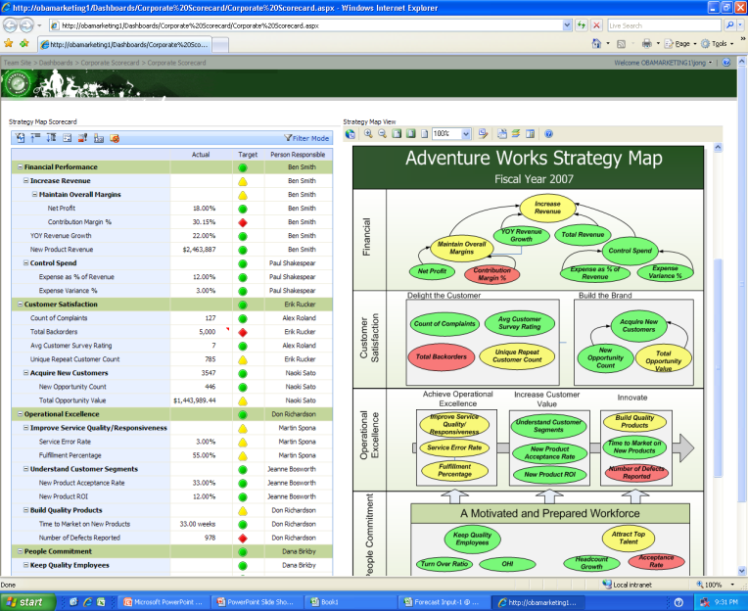

Easily customize the scorecard view by function or role.

Monitoring with Office PerformancePoint   
Server 2007

Monitoring and measuring performance results are key functions of any successful business. Office PerformancePoint Server 2007 enables business users to define and use scorecards and key performance indicators (KPIs) to drive accountability and alignment across the organization.

Rich visualization and up-to-date performance dashboards and scorecards help business users align their actions with strategic goals.

All users can gain insight into business drivers and collaborate more efficiently using detailed, contextual business analysis gained from structured information as well as unstructured information.

Information is delivered in the collaborative and familiar environment of the Microsoft Office system. Templates and wizards enable business users to quickly build, manage, and share scorecards that help them monitor the health of the business and track key initiatives.

The Office PerformancePoint Server 2007 monitoring functionality is certified by the Balanced Scorecard Collaborative and provides a deep and flexible model for building performance management applications.

**Benefits**

Office PerformancePoint Server 2007 helps users:

* Align business activity across the enterprise  
  Businesses benefit when strategy and accountability can be driven across business operations. Finance, operations, HR, marketing, sales, IT, and other groups can all benefit from easy-to-use scorecarding.
* Make scorecarding a part of all activities  
  Scorecards and KPIs reflect planning, budgeting, and forecasting changes in real time to help users understand the business drivers, challenges, and opportunities they face. Monitoring becomes a part of the regular, day-to-day management process.
* **Gain deep contextual insight**

Office PerformancePoint Server 2007 includes rich drill-down capabilities, personalized scorecards, reports, and analysis tools to combine structured information with unstructured data. Users gain deeper insight, which can help them make better and faster business decisions.

Enhance the partnership with IT  
IT staffs spend a lot of time providing business users with information. Because Office PerformancePoint Server 2007 gives business users the functionality to quickly set up their own performance dashboards and scorecards, IT is freed for more critical functions such as meeting security and compliance requirements.

Key Features

Powerful monitoring functionality in PerformancePoint Server includes:

Flexibility and personalization  
Office PerformancePoint Server 2007 empowers users by providing a flexible, end user focused development environment with extensive out-of-the-box functionality for defining and creating scorecards. This makes it easy to visualize strategy and drill down into reports to see lower levels of detail. The user-friendly design, wizards, and familiar Microsoft Office environment empower all users to quickly build, personalize, manage, and use scorecards, while focusing on the business, instead of on the tools.

* **Scalability for broad use**PerformancePoint Server 2007 scalability and high performance enable business information to be delivered to a broad number of users. Performance dashboards and scorecards are built to address all types of users, and can be published for both online and offline users.
* **Rich visualization**  
  Rich visualization capabilities including strategy maps, accountability mapping, and Microsoft Office system integration make business information more actionable. They enable users to better understand the context of performance and take appropriate action.

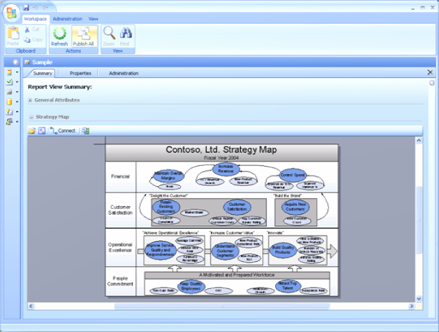

**Visualization** tools make information easy to understand.

System Requirements

PerformancePoint Server 2007 is based on the following Microsoft programs and technologies:

* Windows Server® 2003 SP1, Standard Edition, or later
* Microsoft Windows SharePoint® Services 3.0/ Microsoft Office SharePoint® Server 2007
* Microsoft Windows® XP Professional SP2, or later
* Microsoft Office 2003 SP2, or later
* Microsoft SQL Server™ 2005 SP2, Standard Edition, or later
* Windows Installer 3.1, or later
* Microsoft .NET Framework 2.0
* Microsoft Internet Information Services 6.0
* ASP.NET 2.0

**For More Information**

For more information about Microsoft Office PerformancePoint Server 2007, visit <www.microsoft.com/performancepoint>.

For more information about Microsoft Business Intelligence solutions, visit [www.microsoft.com/BI](http://www.microsoft.com/BI)...

© 2008 Microsoft Corporation. All rights reserved. Microsoft, Excel, the Office logo, PerformancePoint, SharePoint, SQL Server, Windows, and Windows Server are either registered trademarks or trademarks of Microsoft Corporation or the Microsoft group of companies. All other trademarks are property of their respective owners. 060108