|  |
| --- |
| *Microsoft® Windows® SharePoint® Services combines a robust, extensible platform with rich, out-of-the-box functionality to make it easier for teams to work together, communicate, and collaborate.* |

Windows SharePoint Services is a versatile technology in Microsoft Windows Server™ 2003 that organizations and business units of all sizes can use to help increase the efficiency of business processes and improve team productivity. With tools for collaboration that help people stay connected across organizational and geographic boundaries, Windows SharePoint Services gives people access to the information they need.

Built on Windows Server 2003, Windows SharePoint Services also provides a foundation platform for building Web-based business applications that can flex and scale easily to meet the changing and growing needs of your business. Robust administrative controls for managing storage and Web infrastructure give IT departments a cost-effective way to implement and manage a high-performance collaboration environment. With a familiar, Web-based interface and with the ability to work smoothly with everyday tools including those available in the 2007 Microsoft Office system, Windows SharePoint Server is easy to use and can be deployed rapidly.

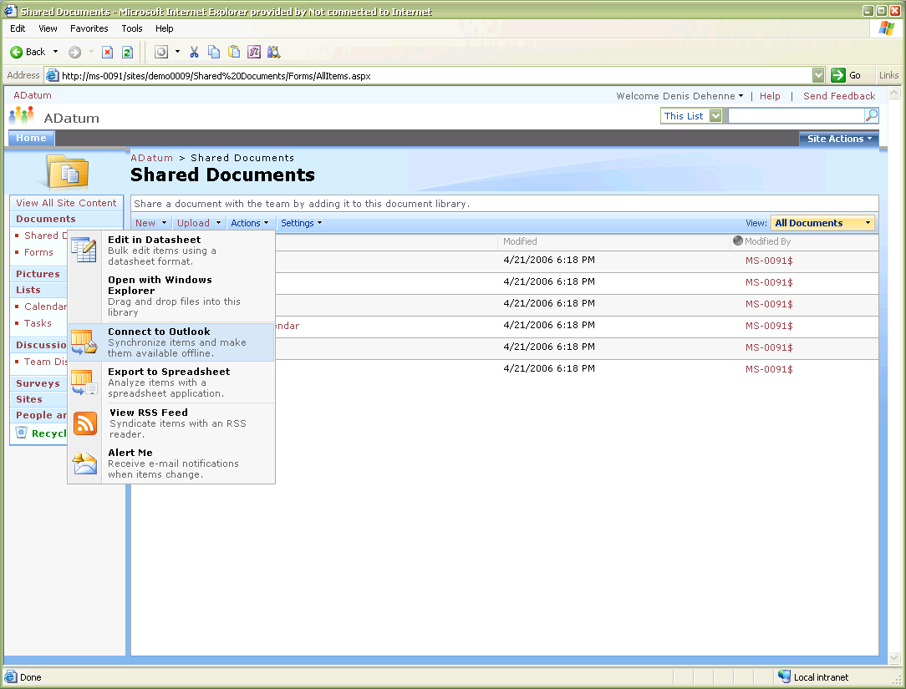

Collaborate Easily and Effectively

Windows SharePoint Services helps teams stay connected and productive by providing easy access to the people, documents, and information they need to make more informed decisions and get the job done. Enhancements in Windows SharePoint Services 3.0 make it easier than ever to share documents, track tasks, use e-mail efficiently and effectively, and share ideas and information.

• Provides a single workspace for teams to coordinate schedules, organize documents, and participate in discussions—within the organization and over the extranet.

• *Enhanced* Easily author and manage documents, and help to ensure their integrity with enhanced features including the option to require document check-out before editing, the ability to view past revisions and restore to previous versions, and the ability to set document-specific security controls.

• *Enhanced* Help people and teams stay on task with a variety of communication features that let users know when actions are required or important changes are made to existing information or documentation, including announcements, sophisticated alerts, surveys, discussion boards, and *(new for 3.0)* RSS.

• *New!* Provide creative forums for brainstorming ideas, building knowledge bases, or simply gathering information in an easy-to-edit format with new templates for implementing blogs (also known as weblogs) and wikis (Web sites that can be quickly edited by team members—no special technical knowledge required).

• *New!* Stay productive while mobile with enhanced support for offline synchronization through Microsoft Office Outlook® 2007, which enables users to manage document libraries, lists, calendars, contacts, tasks, and discussion boards even offline, and to synchronize changes when reconnected to the network.

Synchronize information with Office Outlook 2007, or syndicate via RSS.

Get Started Quickly

As a built-in component of Windows Server 2003, Windows SharePoint Services makes it easy for IT departments to implement a dependable, scalable collaboration infrastructure with minimal administrative time and effort. The ability for Windows SharePoint Services to work smoothly with familiar tools for authoring, publishing, organizing, and finding information, including those within the Microsoft Office system, helps users get up to speed quickly.

• *Enhanced* Simplify the creation and navigation of workspaces with the improved user interface and site creation tools in Windows SharePoint Services 3.0 that provide easy-to-use templates, professional-looking site themes, and the ability to rearrange site navigation from within the browser.

Enhanced user interface assists in site navigation.

• *Enhanced* Make it easy for users to get up to speed quickly by providing them with the ability to work with familiar productivity tools such as those found in the Microsoft Office system. Users can create workspaces, post and edit documents, and view and update calendars on SharePoint sites, all while working within Microsoft Office system files and programs.

• *Enhanced* Customize workspaces with new application templates that provide custom scenarios for building workflows on the Windows SharePoint Services platform that address specific business processes or sets of tasks.

Deploy a Manageable Infrastructure

Deployment of Windows SharePoint Services 3.0 increases control over and enhances security of your organization’s data and information resources. Help reduce the dependency of business units on your company’s IT department for site provisioning, implementation, backup, and support. Whether you’re a contributor to a team site, a site owner, or a server administrator, Windows SharePoint Services 3.0 provides exceptional administrative controls for managing content, users, and sites so that individuals and teams can operate efficiently and effectively.

• *Enhanced* Increase the security of business information with enhanced administrative controls that help decrease cost and complexity associated with site provisioning, management, support, operations, and backup and restore.

• *New!* Give IT better control over your organization’s infrastructure with new and improved services for controlling access to information and setting policies for site creation that enable security controls to be set as deep down as the item level.

• *New!* Empower site managers and teams without compromising security by enabling them to initiate and control their own self-service workspaces and tasks, and manage the participation and access of others, all within parameters set by IT.

• *New!* Provide a more robust document storage environment with document storage, Recycle Bin item retrieval, and version control features built in to team workspaces.

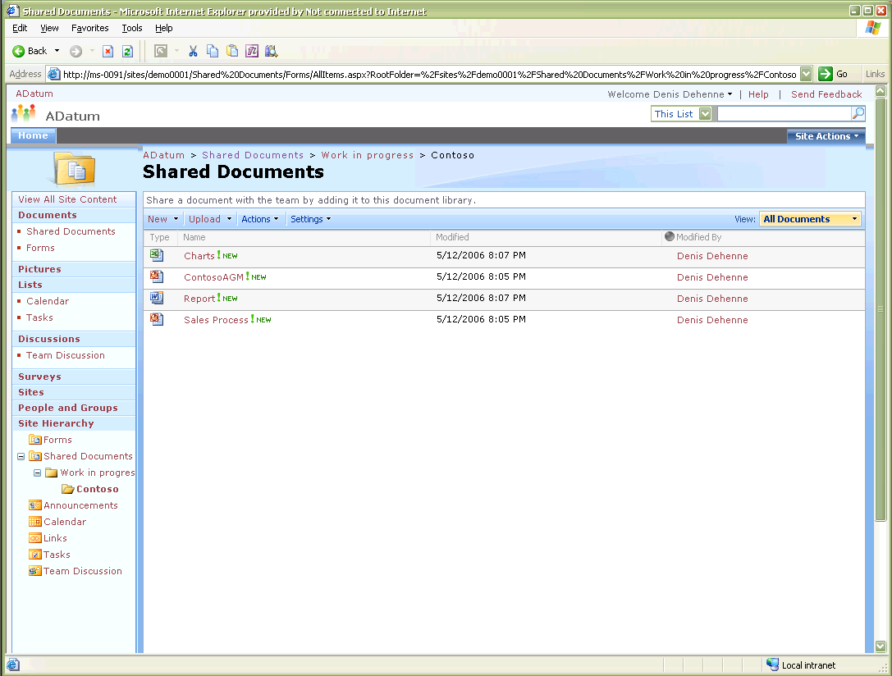

• *Enhanced* Easily manage and configure Windows SharePoint Services by using a Web browser or command-line utilities, and enable a variety of custom and third-party administration solutions using the Microsoft .NET Framework.

Provide a Foundation for Web-Based Applications

With Windows SharePoint Services 3.0, IT professionals can tailor or extend the Windows SharePoint Services foundation to create new, efficient, Web-based tools and services specific to the organization, department, business process, or industry vertical. Through a highly customizable and extensible platform, companies can tie these new tools and services to existing line-of-business applications, capitalizing on existing IT investments and valuable information stored in back-end systems.

• *Enhanced* Manage business documents more easily with enhanced document library support and a common repository for document storage.

• *Enhanced* Take advantage of the ability to work smoothly with Microsoft Office SharePoint Server 2007, which expands the platform services and common framework for document management exposed by Windows SharePoint Services to offer enterprise-wide functionality for records management, search, workflows, portals, personalized sites, and more.

• *New!* Use Microsoft Office SharePoint Designer 2007 to quickly and easily customize SharePoint sites and build reporting tools and applications tailored to specific tasks without writing or deploying new code.

• *New!* Content types enable you to define custom metadata for documents. Working smoothly with 2007 Microsoft Office system client applications enables you to edit metadata through the Document Information Panel.

**System requirements**

Before you install and configure Windows SharePoint Services 3.0, make sure your server computer has the recommended hardware and software. For both single-server and server farm deployments, your computers must meet the following hardware and software requirements:

**Hardware requirements**

Single Server Deployment: A computer with processor clock speeds of 2.5 gigahertz (GHz) or higher; a minimum of 1 gigabyte (GB) of RAM, 2 GB of RAM recommended; disk space up to 2 GB for installation minimum, 5 GB or more minimum for data. You will also require fast broadband Internet access for downloads and activation.

Server Farm Deployment: Computers with processor clock speeds of 2.5 gigahertz (GHz) or higher; a minimum of 1 gigabyte (GB) of RAM, 2 GB of RAM recommended; SQL Server 2000 SP3 (or later) or SQL 2005 system with dual processors of 2.5 GHz and 2 GB RAM minimum; disk space up to 2 GB for installation minimum, 5 GB or more minimum for data. You will also require fast broadband Internet access for downloads and activation.

**Software requirements**

Computer running Microsoft Windows Server 2003 with Service Pack 1 (SP1) or Windows Server 2003 x64; Microsoft .NET Framework 3.0.

The computer must be configured as a Web server running Microsoft Internet Information Services (IIS) 6.0 with common files, Simple Mail Transfer Protocol (SMTP) service, and World Wide Web service.

The computer must be using the NTFS file system. Windows Server 2003 includes a conversion utility (Convert.exe) that you can use to convert an existing file allocation table (FAT) volume to NTFS without losing data.

**Web browsers:**

Any Microsoft Windows, Macintosh, or UNIX client computer can use Windows SharePoint Services provided it runs one of the following Web browsers:

Level 1 Web Browsers - *Level 1 Web browsers take advantage of advanced features provided by ActiveX controls and provide the most complete user experience. Level 1 browsers offer full functionality on all SharePoint sites, including the Central Administration Web site.*

* For Windows systems: Microsoft Internet Explorer 6.0 or later; Windows Internet Explorer 7.0 or later

Level 2 Web Browsers - *Level 2 Web browsers provide basic functionality, so that users can both read and write in SharePoint sites and perform site administration. However, because ActiveX controls are supported only in Level 1 browsers, and due to the functionality differences within different browsers, a different user experience might be provided and there could be some variances from the user experience from the Level 1 browsers.*

* For Windows systems: Firefox 1.5 or later; Mozilla 1.7 or later; Netscape Navigator 8.1 or later
* For UNIX/Linux systems: Firefox 1.5 or later; Netscape Navigator 7.2 or later
* For Macintosh systems: Firefox 1.5 or later; Safari 2.0 or later

For more information about Microsoft Windows SharePoint Services, visit <http://www.microsoft.com/sharepoint> or contact your local Microsoft Certified Solutions Partner.

© 2006 Microsoft Corporation. All rights reserved. This datasheet is for informational purposes only. MICROSOFT MAKES NO WARRANTIES, OR IMPLIED, IN THIS SUMMARY. Microsoft, Internet Explorer, Outlook, SharePoint, Windows, the Windows logo, Windows Server, and Windows Server System are either registered trademarks or trademarks of Microsoft Corporation in the United States and/or other countries. PSN-WSS-DS-1-1-10.