



Network Access Protection Platform Architecture

Microsoft Corporation
Published: June 2004
Updated: February 2008

Abstract
Network Access Protection (NAP) is a new platform and solution that controls access to network resources based on a client computer’s identity and compliance with corporate governance policy. NAP allows third-party software vendors and system integrators to create complete solutions for validating and enforcing system health requirements for network access or communication. NAP is supported by Microsoft® Windows Server® 2008, Windows Vista™, and Windows® XP Service Pack 3. This white paper describes the architecture of the NAP platform and the details of how NAP works for enforcement methods that are provided with Windows Server 2008, Windows Vista, and Windows XP Service Pack 3.

The information contained in this document represents the current view of Microsoft Corporation on the issues discussed as of the date of publication. Because Microsoft must respond to changing market conditions, it should not be interpreted to be a commitment on the part of Microsoft, and Microsoft cannot guarantee the accuracy of any information presented after the date of publication.
This White Paper is for informational purposes only. MICROSOFT MAKES NO WARRANTIES, EXPRESS, IMPLIED OR STATUTORY, AS TO THE INFORMATION IN THIS DOCUMENT.
Complying with all applicable copyright laws is the responsibility of the user. Without limiting the rights under copyright, no part of this document may be reproduced, stored in or introduced into a retrieval system, or transmitted in any form or by any means (electronic, mechanical, photocopying, recording, or otherwise), or for any purpose, without the express written permission of Microsoft Corporation.
Microsoft may have patents, patent applications, trademarks, copyrights, or other intellectual property rights covering subject matter in this document. Except as expressly provided in any written license agreement from Microsoft, the furnishing of this document does not give you any license to these patents, trademarks, copyrights, or other intellectual property.
© 2008 Microsoft Corporation. All rights reserved.
Microsoft, Active Directory, Vista, Windows, and Windows Server are either registered trademarks or trademarks of Microsoft Corporation in the United States and/or other countries.
All other trademarks are property of their respective owners.
Contents
Introduction 1
NAP Platform Architecture 2
NAP Client Architecture 7
NAP Enforcement Client 8
IPsec NAP EC 8
EAPHost NAP EC 9
VPN NAP EC 9
DHCP NAP EC 9
System Health Agent 9
NAP Agent 9
NAP Server-side Architecture 11
Server-side NAP Platform Components 14
NAP Enforcement Server 14
NAP Administration Server 14
NPS Service 14
System Health Validator 15
Communication Between Client and Server NAP Components 15
How NAP Works 18
IPsec-protected Communication 18
Noncompliant NAP Client 21
802.1X-Authenticated Connections 22
Noncompliant NAP Client 23
Remote Access VPN Connections 23
Noncompliant NAP Client 25
DHCP Address Configuration 25
Noncompliant NAP Client 27
Summary 28
Related Links 29

Introduction
Network Access Protection (NAP) is a new set of operating system components in Windows Server 2008, Windows Vista, and Windows XP Service Pack 3 that provides a platform for system health validated access to private networks. The NAP platform provides an integrated way of validating the health state of a network client that is attempting to connect to or communicate on a network and limiting the access of the network client until the health policy requirements have been met.
To validate access to a network based on system health, a network infrastructure needs to provide the following areas of functionality:
- Health state validation Determines whether the computers are compliant with health policy requirements.
- Network access limitation Limits access for noncompliant computers.
- Automatic remediation Provides necessary updates to allow a noncompliant computer to become compliant without user intervention.
- Ongoing compliance Automatically updates compliant computers so that they adhere to ongoing changes in health policy requirements.
Windows Server 2008, Windows Vista, and Windows XP Service Pack 3 provide the following NAP enforcement methods:
- Internet Protocol security (IPsec) enforcement for IPsec-protected communications
- 802.1X enforcement for IEEE 802.1X-authenticated connections
- Virtual Private Network (VPN) enforcement for remote access VPN connections
- Dynamic Host Configuration Protocol (DHCP) enforcement for DHCP-based address configuration
- Terminal Server (TS) Gateway connections
The NAP platform provides a client and server-side architecture through which policy validation, network access limitation, automatic remediation, and ongoing compliance can occur through additional components supplied by third-party software vendors or Microsoft.
The NAP platform requires servers running Windows Server 2008 and clients running Windows Vista, Windows Server 2008, or Windows XP with Service Pack 3.
Note The NAP platform is not the same as Network Access Quarantine Control, which is a capability provided with Windows Server 2003 to provide additional protection only for remote access (dial-up and VPN) connections. For more information about Network Access Quarantine Control, see Network Access Quarantine Control in Windows Server 2003 at http://www.microsoft.com/technet/network/vpn/quarantine.mspx.

NAP Platform Architecture
Figure 1 shows the components of a NAP-enabled network infrastructure.
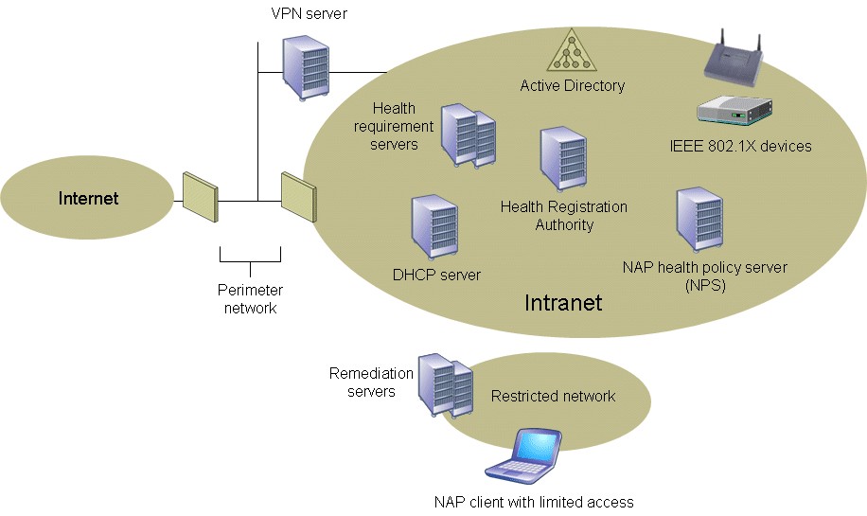
Figure 1: Components of a NAP-enabled network infrastructure
The components of a NAP-enabled network infrastructure consist of the following:
- NAP clients Computers that support the NAP platform for system health-validated network access or communication.
- NAP enforcement points Computers or network access devices that use NAP or can be used with NAP to require the evaluation of a NAP client’s health state and provide restricted network access or communication. NAP enforcement points use a Network Policy Server (NPS) that is acting as a NAP health policy server to evaluate the health state of NAP clients, whether network access or communication is allowed, and the set of remediation actions that a noncompliant NAP client must perform. Examples of NAP enforcement points are the following:
- Health Registration Authority (HRA) A computer running Windows Server 2008 and Internet Information Services (IIS) that obtains health certificates from a certification authority (CA) for compliant computers.
- VPN server A computer running Windows Server 2008 and Routing and Remote Access that allows remote access VPN connections to an intranet.
- DHCP server A computer running Windows Server 2008 and the DHCP Server service that provides automatic Internet Protocol version 4 (IPv4) address configuration to intranet DHCP clients.
- Network access devices Ethernet switches or wireless access points that support IEEE 802.1X authentication.
- NAP health policy servers Computers running Windows Server 2008 and the NPS service that store health requirement policies and provide health state validation for NAP. NPS is the replacement for the Internet Authentication Service (IAS), the Remote Authentication Dial-In User Service (RADIUS) server and proxy provided with Windows Server 2003. NPS can also act as an authentication, authorization, and accounting (AAA) server for network access. When acting as a AAA server or NAP health policy server, NPS is typically run on a separate server for centralized configuration of network access and health requirement policies, as Figure 1 shows. The NPS service is also run on Windows Server 2008-based NAP enforcement points that do not have a built-in RADIUS client, such as an HRA or DHCP server. However, in these configurations, the NPS service is acting as a RADIUS proxy to exchange RADIUS messages with a NAP health policy server.
- Health requirement servers Computers that provide current system health state for NAP health policy servers. For example, a health requirement server for an antivirus program tracks the latest version of the antivirus signature file.
- Active Directory® Domain Service The Windows directory service that stores account credentials and properties and Group Policy settings. Although not required for health state validation, Active Directory is required for IPsec-protected communications, 802.1X-authenticated connections, and remote access VPN connections.
- Restricted network A separate logical or physical network that contains:
- Remediation servers Computers that contain health update resources that NAP clients can access to remediate their noncompliant state. Examples include antivirus signature distribution servers and software update servers.
- NAP clients with limited access Computers that are placed on the restricted network when they do not comply with health requirement policies.
The interactions for the computers and devices of a NAP-enabled network infrastructure are the following:
- Between a NAP client and an HRA
The NAP client uses the HyperText Transfer Protocol (HTTP) or an HTTP over Secure Sockets Layer (SSL) protected session to send its current system health state to the HRA and request a health certificate. The HRA uses HTTP or the protected HTTP over SSL session to send remediation instructions (if the NAP client is noncompliant) or a health certificate to the NAP client.
- Between a NAP client and an 802.1X network access device (an Ethernet switch or a wireless access point)
The NAP client acting as an 802.1X client uses Protected Extensible Authentication Protocol (PEAP) messages sent over EAP over LAN (EAPOL) to perform authentication of the 802.1X connection and to indicate its current system health state to the NAP health policy server. An 802.1X client is also known as an 802.1X supplicant. The NAP health policy server uses PEAP messages to either indicate remediation instructions (because the 802.1X client is noncompliant) or that the 802.1X client has unlimited access to the network. PEAP messages between the 802.1X client and NAP health policy server are routed through the 802.1X network access device.
- Between a NAP client and a VPN server
The NAP client acting as a VPN client uses Point-to-Point Protocol (PPP) messages to establish a remote access VPN connection and PEAP messages over the PPP connection to indicate its current system health state to the NAP health policy server. The NAP health policy server uses PEAP messages to either indicate remediation instructions (because the VPN client is noncompliant) or that the VPN client has unlimited access to the intranet. PEAP messages between the VPN client and NAP health policy server are routed through the VPN server.
- Between a NAP client and a DHCP server
The NAP client acting as a DHCP client uses DHCP messages to obtain a valid IPv4 address configuration and to indicate its current system health state. The DHCP server uses DHCP messages to allocate either an IPv4 address configuration for the restricted network and indicate remediation instructions (if the DHCP client is noncompliant), or an IPv4 address configuration for unlimited access (if the DHCP client is compliant).
- Between a NAP client and a remediation server
While the NAP client has unlimited access to the intranet, it accesses the remediation server to ensure that it remains compliant. For example, the NAP client periodically checks an antivirus server to ensure that it has the latest antivirus signature file or a software update server, such as Windows Update Services, to ensure that it has the latest operating system updates.
If the NAP client has limited access, it can communicate with the remediation server to become compliant, based on instructions from the NAP health policy server. For example, if during the health validation process the NAP health policy server determined that the NAP client does not have the most current antivirus signature file, the NAP health policy server instructs the NAP client to update its local signature file with the latest file that is stored on a specified antivirus server.
- Between an HRA and a NAP health policy server
The HRA sends RADIUS messages to the NAP health policy server that contain the NAP client's system health state.
The NAP health policy server sends RADIUS messages to:
- Indicate that the NAP client has unlimited access because it is compliant. Based on this response, the HRA obtains a health certificate and sends it to the NAP client.
- Indicate that the NAP client has limited access until it performs a set of remediation functions. Based on this response, the HRA does not issue a health certificate to the NAP client.
Because the HRA in Windows Server 2008 does not have a built-in RADIUS client, it uses the NPS service as a RADIUS proxy to exchange RADIUS messages with the NAP health policy server.
- Between an 802.1X network access device and a NAP health policy server
The 802.1X network access device sends RADIUS messages to transfer PEAP messages sent by an 802.1X NAP client.
The NAP health policy server sends RADIUS messages to:
- Indicate that the 802.1X client has unlimited access because it is compliant.
- Indicate a limited access profile to place the 802.1X client on the restricted network until it performs a set of remediation functions. A limited access profile can consist of a set of IP packet filters or a virtual LAN (VLAN) identifier (ID) to confine the traffic of a noncompliant 802.1X client.
- Send PEAP messages to the 802.1X client.
- Between a VPN server and a NAP health policy server
The VPN server sends RADIUS messages to transfer PEAP messages sent by a VPN-based NAP client.
The NAP health policy server sends RADIUS messages to:
- Indicate that the VPN client has unlimited access because it is compliant.
- Indicate that the VPN client has limited access through a set of IP packet filters that are applied to the VPN connection.
- Send PEAP messages to the VPN client.
Like the HRA, the VPN server uses the NPS service as a RADIUS proxy to exchange RADIUS messages with the NAP health policy server.
- Between a DHCP server and a NAP health policy server
The DHCP server sends RADIUS messages to the NAP health policy server that contains the DHCP client's system health state.
The NAP health policy server sends RADIUS messages to the DHCP server to:
- Indicate that the DHCP client has unlimited access because it is compliant.
- Indicate that the DHCP client has limited access until it performs a set of remediation functions.
Like the HRA, the DHCP server uses the NPS service as a RADIUS proxy to exchange RADIUS messages with a NAP health policy server.
- Between a NAP health policy server and a health requirement server
When performing network access validation for a NAP client, the NAP health policy server might have to contact a health requirement server to obtain information about the current requirements for system health. For example, the NAP health policy server might have to contact an antivirus server to check for the version of the latest signature file or to contact a software update server to obtain the date of the last set of operating system updates.
Figure 2 summarizes these interactions.
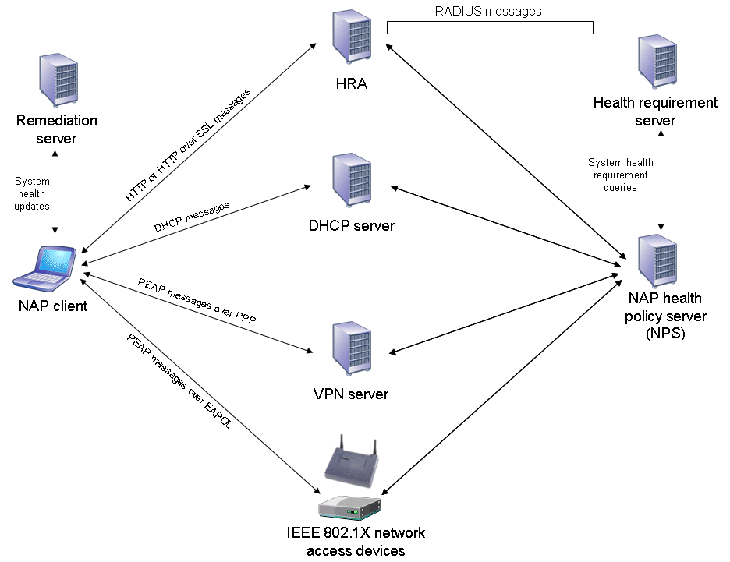
Figure 2: Interactions between NAP platform components
The exception to this set of interactions is when a Windows-based NAP enforcement point—the HRA, the VPN server, or the DHCP server—is also acting as a NAP health policy server. In this case, the NAP enforcement point and the NAP health policy server are the same computer. This configuration is appropriate for a small network configuration in conjunction with a single-server networking infrastructure product such as Microsoft Small Business Server. However, on an enterprise network, there are always multiple DHCP servers and typically multiple VPN servers. In this case, using a separate NAP health policy server allows you to centralize the configuration of network access and system heath requirement policies, rather than configuring them at each NAP enforcement point.
The following sections of this white paper examine the details of the client and server-side architecture of NAP and the NAP processes for IPsec-protected communication, 802.1X authentication, a remote access VPN connection, and DHCP configuration for a NAP client.

NAP Client Architecture
A NAP client is a computer running Windows Vista, Windows Server 2008, or Windows XP with Service Pack 3 that includes new components and updated versions of existing components for the NAP platform. Figure 3 shows the architecture of the NAP platform on a NAP client.
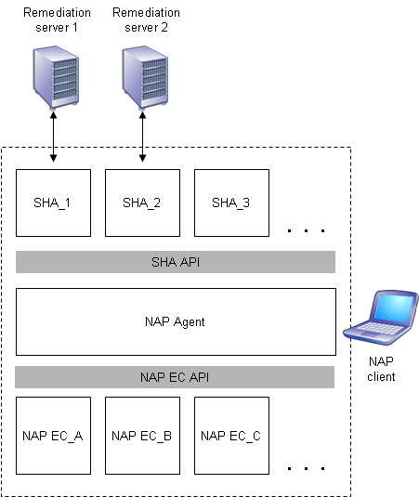
Figure 3: NAP platform architecture on the NAP client
The NAP client architecture consists of the following:
- A layer of NAP enforcement client (EC) components Each NAP EC is defined for a different type of network access or communication. For example, there is a NAP EC for remote access VPN connections and a NAP EC for DHCP configuration. The NAP EC can be matched to a specific type of NAP enforcement point. For example, the DHCP NAP EC is designed to work with a DHCP-based NAP enforcement point. Some NAP ECs are provided with the NAP platform and third-party software vendors or Microsoft can provide others.
- A layer of system health agent (SHA) components A component that maintains and reports one or multiple elements of system health. For example, there might be an SHA for antivirus signatures and an SHA for operating system updates. An SHA can be matched to a remediation server. For example, an SHA for checking antivirus signatures is matched to the server that contains the latest antivirus signature file. SHAs do not have to have a corresponding remediation server. For example, an SHA can just check local system settings to ensure that a host-based firewall is enabled. Windows Vista and Windows XP Service Pack 3 include a Windows Security Health Validator SHA that monitors the settings of the Windows Security Center. Third-party software vendors or Microsoft can provide additional SHAs to the NAP platform.
- NAP Agent Maintains the current health state information of the NAP client and facilitates communication between the NAP EC and SHA layers. The NAP Agent is provided with the NAP platform.
- SHA application programming interface (API) Provides a set of function calls that allow SHAs to register with the NAP Agent, to indicate system health status, respond to queries for system health status from the NAP Agent, and for the NAP Agent to pass system health remediation information to an SHA. The SHA API allows vendors to create and install additional SHAs. The SHA API is provided with the NAP platform and is documented in the Platform Software Development Kit (SDK) at http://msdn2.microsoft.com/en-us/library/aa369712.aspx.
- NAP EC API Provides a set of function calls that allow NAP ECs to register with the NAP Agent, to request system health status, and pass system health remediation information to the NAP Agent. The NAP EC API allows vendors to create and install additional NAP ECs. The NAP EC API is provided with the NAP platform and is documented in the Platform SDK.
To indicate the health state of a specific SHA, an SHA creates a statement of health (SoH) and passes it to the NAP Agent. An SoH can contain one or multiple elements of system health. For example, the SHA for an antivirus program can create an SoH containing the state of the antivirus software running on the computer, its version, and the last antivirus signature update received. Whenever an SHA updates its status, it creates a new SoH and passes it to the NAP Agent. To indicate the overall health state of a NAP client, the NAP Agent uses a system statement of health (SSoH), which includes version information for the NAP client and the set of SoHs for the installed SHAs.
The following sections describe the components of the NAP client architecture in further detail.

NAP Enforcement Client
A NAP EC requests some level of access to a network, passes the computer's health status to a NAP enforcement point that is providing the network access, and indicates the limited or unlimited network access status of the NAP client to other components of the NAP client architecture.
The NAP ECs for the NAP platform supplied in Windows Vista, Windows Server 2008, and Windows XP Service Pack 3 are the following:
- An IPsec NAP EC for IPsec-protected communications
- An EAPHost NAP EC for 802.1X-authenticated connections
- A VPN NAP EC for remote access VPN connections
- A DHCP NAP EC for DHCP-based IPv4 address configuration
- A TS Gateway NAP EC for TS Gateway connections
Notes For Windows XP Service Pack 3, there are separate NAP ECs for 802.1X-authenticated wired and wireless connections.

IPsec NAP EC
The IPsec NAP EC is a new component that obtains the SSoH from the NAP Agent and sends it to the HRA along with a request for a health certificate. The IPsec NAP EC is known as the IPsec Relying Party EC in the NAP Client Configuration snap-in. The IPsec NAP EC also interacts with the following:
- The certificate store to store the health certificate.
- The IPsec components in Windows to ensure that the health certificate is used for IPsec-protected communication.
- The host-based firewall (such as Windows Firewall) so that the IPsec-protected traffic is allowed by the firewall.

EAPHost NAP EC
The EAPHost NAP EC is a new component that obtains the SSoH from the NAP Agent and sends it as a PEAP-Type-Length-Value (TLV) message for 802.1X-authenticated connections. The EAPHost NAP EC is known as the EAP Quarantine EC in the NAP Client Configuration snap-in.

VPN NAP EC
The VPN NAP EC is new functionality in the Remote Access Connection Manager service that obtains the SSoH from the NAP Agent and sends it as a PEAP-TLV message for remote access VPN connections. The VPN NAP EC is known as the Remote Access Quarantine EC in the NAP Client Configuration snap-in.

DHCP NAP EC
The DHCP NAP EC is new functionality in the DHCP Client service that uses industry standard DHCP messages to exchange system health messages and limited network access information. The IPsec DHCP EC is known as the DHCP Quarantine EC in the NAP Client Configuration snap-in. The DHCP NAP EC obtains the SSoH from the NAP Agent. The DHCP Client service fragments the SSoH, if required, and puts each fragment into a Microsoft vendor-specific DHCP option that is sent in DHCPDiscover, DHCPRequest or DHCPInform messages. DHCPDecline and DHCPRelease messages do not contain the SSoH.

System Health Agent
An SHA performs system health updates and publishes its status in the form of an SoH to the NAP Agent. The SoH contains information that the NAP health policy server can use to verify that the client computer is in the required state of health.
An SHA is matched to a System Health Validator (SHV) on the server-side of the NAP platform architecture. The corresponding SHV returns a statement of health response (SoHR) to the NAP client, which is passed by the NAP EC and the NAP Agent to the SHA, informing it of what to do if the SHA is not in a required state of health. For example, the SoHR sent by an antivirus SHV could instruct the corresponding antivirus SHA to request the latest version of the antivirus signature file from an antivirus signature server. The SoHR can also include the name or IP address of the antivirus signature server.
An SHA can use a locally installed system health component (not shown in Figure 3) to assist in system health management functions in conjunction with a remediation server. For example, a software update SHA can use the locally installed software update client software to perform version checking and installation and update functions with the software update server (the remediation server).

NAP Agent
The NAP Agent provides the following services:
- Collects the SoHs from each SHA and caches them. The SoH cache is updated whenever an SHA supplies a new or updated SoH.
- Stores the SsoH and supplies it to the NAP ECs upon request.
- Passes notifications to SHAs when the limited network access state changes.
- Passes SoHRs to the appropriate SHAs.

NAP Server-side Architecture
Figure 4 shows the NAP server-side architecture consists of NAP enforcement points and a NAP health policy server. The NAP platform server-side architecture includes new components and updated versions of existing components.
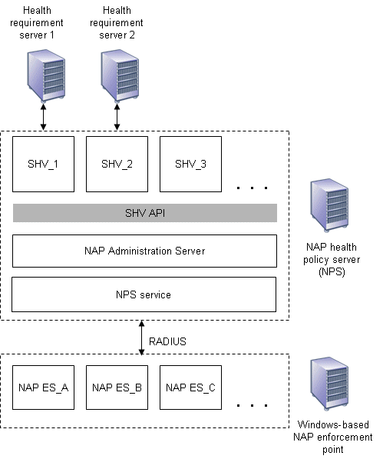
Figure 4: The server-side NAP platform architecture
A Windows-based NAP enforcement point has a layer of NAP Enforcement Server (ES) components. Each NAP ES is defined for a different type of network access or communication. For example, there is a NAP ES for remote access VPN connections and a NAP ES for DHCP configuration. The NAP ES is typically matched to a specific type of NAP-capable client. For example, the DHCP NAP ES is designed to work with a DHCP-based NAP client. Third-party software vendors or Microsoft can provide additional NAP ESs for the NAP platform.
A NAP ES obtains the SSoH from its corresponding NAP EC and sends it to an NAP health policy server as a RADIUS vendor-specific attribute (VSA) of a RADIUS Access-Request message.
The NAP health policy server has the following components:
- NPS service Receives the RADIUS Access-Request message, extracts the SSoH, and passes it to the NAP Administration Server component. The NPS service is provided with Windows Server 2008.
- NAP Administration Server Facilitates communication between the NPS service and the SHVs. The NAP Administration Server component is provided with the NAP platform.
- A layer of System Health Validator (SHV) components Each SHV is defined for one or multiple types of system health elements and can be matched to an SHA. For example, there might be an SHV for an antivirus program. An SHV can be matched to one or multiple health requirement servers. For example, an SHV for checking antivirus signatures is matched to the server that contains the latest signature file. SHVs do not have to have a corresponding health requirement server. For example, an SHV can just instruct NAP-capable clients to check local system settings to ensure that a host-based firewall is enabled. Windows Server 2008 includes the Windows Security Health Validator SHV. Additional SHVs are provided by third-party software vendors or by Microsoft as add-ons to the NAP platform.
- SHV API Provides a set of function calls that allow SHVs to register with the NAP Administration Server component, receive SoHs from the NAP Administration Server component, and send SoHRs to the NAP Administration Server component. The SHV API is provided with the NAP platform.
The most common configuration for NAP server-side infrastructure will consist of NAP enforcement points providing network access or communication of a specific type and separate NAP health policy servers providing system health validation and remediation. It is possible to install the NPS service as a NAP health policy server on individual Windows-based NAP enforcement points. However, in this configuration, each NAP enforcement point must then be separately configured with network access and health policies. The recommended configuration is to use separate NAP health policy servers.
The overall NAP architecture consists of the following sets of components:
- The three NAP client components (an SHA layer, the NAP Agent, and a NAP EC layer)
- The four NAP server-side components (an SHV layer, the NAP Administration Server, the NPS service, and a NAP ES layer on Windows-based NAP enforcement points)
- Health requirement servers
- Remediation servers
Figure 5 shows the relationships between the components of the NAP platform.
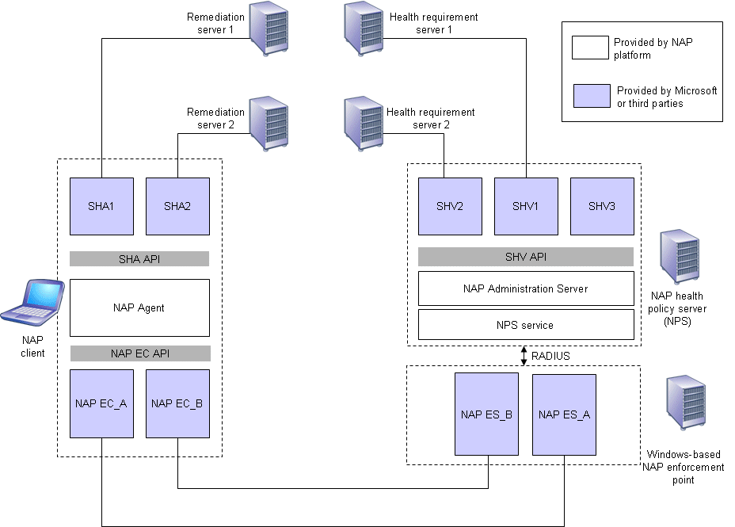
Figure 5: Relationships between NAP platform components
Notice the matching of the following sets of components:
- NAP ECs and NAP ESs can be matched.
For example, the DHCP NAP EC on the NAP client is matched to the DHCP NAP ES on the DHCP server.
- SHAs and remediation servers can be matched.
For example, an antivirus SHA on the client is matched to an antivirus signature remediation server.
- SHVs and health requirement servers can be matched.
For example, an antivirus SHV on the NAP health policy server can be matched to an antivirus health requirement server.
Third-party software vendors can extend the NAP platform in the following ways:
- Create a new method by which the health of a NAP client is evaluated
Third-party software vendors must create an SHA for the NAP client, an SHV for the NAP health policy server, and, if needed, health requirement and remediation servers. If the health requirement or remediation servers already exist, such as an antivirus signature distribution server, then only the corresponding SHA and SHV components need to be created. In some cases, health requirement or remediation servers are not needed.
- Create a new method for enforcing health requirements for network access or communication
Third-party software vendors must create a NAP EC on the NAP client. If the enforcement method uses a Windows-based service, third-party software vendors must create a corresponding NAP ES that communicates with a NAP health policy server using the RADIUS protocol or by using the NPS service installed on the NAP enforcement point as a RADIUS proxy.

Server-side NAP Platform Components
The following sections describe the server-side NAP platform components in greater detail.

NAP Enforcement Server
A NAP ES allows some level of network access or communication, can pass a NAP client's health status to a NAP health policy server for evaluation, and, based on the response, can provide the enforcement of limited network access.
The NAP ESs included with Windows Server 2008 are the following:
- An IPsec NAP ES for IPsec-protected communications
For IPsec-protected communication, the HRA passes the NAP client's health status information to the NAP health policy server.
- A DHCP NAP ES for DHCP-based IP address configuration
The DHCP NAP ES is new functionality in the DHCP Server service that uses industry standard DHCP messages to communicate with the DHCP NAP EC on a NAP client. DHCP enforcement for limited network access is done through DHCP options.
- A TS Gateway NAP ES for TS Gateway server-based connections
For remote access VPN and 802.1X-authenticated connections, new functionality in the NPS service uses PEAP-TLV messages between NAP clients and the NAP health policy server. VPN enforcement is done through IP packet filters that are applied to the VPN connection. 802.1X enforcement is done at the 802.1X network access device by applying IP packet filters to the connection or by assigning the connection a VLAN ID corresponding to the restricted network.
For more information about enforcement behavior for IPsec-protected communication, IEEE 802.1X-authenticated connections, remote access VPN connections, and DHCP configuration, see "How NAP Works" in this paper.

NAP Administration Server
The NAP Administration Server component provides the following services:
- Obtains the SSoH from the NAP ES through the NPS service.
- Distributes the SoHs in the SSoH to the appropriate SHVs.
- Collects the SoHRs from the SHVs and passes them to the NPS service for evaluation.

NPS Service
RADIUS is a widely deployed protocol enabling centralized authentication, authorization, and accounting for network access that is described in Requests for Comments (RFCs) 2865 and 2866. Originally developed for dial-up remote access, RADIUS is now supported by wireless access points, authenticating Ethernet switches, VPN servers, Digital Subscriber Line (DSL) access servers and other network access servers.
NPS is the implementation of a RADIUS server and proxy in Windows Server 2008. NPS replaces the Internet Authentication Service (IAS) in Windows Server 2003. For the NAP platform, the NPS service has been updated to include the NAP Administration Server component, support for the SHV API and installable SHVs, and options for configuring health policies.
Based on the SoHRs from the SHVs and the configured health policies, the NPS service creates a System Statement of Health Response (SSoHR), which indicates whether the NAP client is compliant or noncompliant and includes the set of SoHRs from the SHVs.

System Health Validator
An SHV receives an SoH from the NAP Administration Server and compares the system health status information in the SoH with the required system health state. For example, if the SoH is from an antivirus SHA and contains the version number of the last virus signature file, the corresponding antivirus SHV can check with the antivirus health requirement server for the latest version number to validate the NAP client's SoH.
The SHV returns an SoHR to the NAP Administration Server. The SoHR can contain information about how the corresponding SHA on the NAP client can meet current system health requirements. For example, the SoHR sent by the antivirus SHV could instruct the antivirus SHA on the NAP client to request the latest version of the antivirus signature file from a specific antivirus signature server by name or IP address.

Communication Between Client and Server NAP Components
The NAP Agent component can communicate with the NAP Administration Server component through the following process:
- The NAP Agent passes the SSoH to the NAP EC.
- The NAP EC passes the SSoH to the NAP ES.
- The NAP ES passes the SSoH to the NPS service.
- The NPS service passes the SSoH to the NAP Administration Server.
The NAP Administration Server can communicate with the NAP Agent through the following process:
- The NAP Administration Server passes the SoHRs to the NPS service.
- The NPS service passes the SSoHR to the NAP ES.
- The NAP ES passes the SSoHR to the NAP EC.
- The NAP EC passes the SSoHR to the NAP Agent.
An SHA can communicate with its corresponding SHV through the following process:
- The SHA passes its SoH to the NAP Agent.
- The NAP Agent passes the SoH, contained within the SSoH, to the NAP EC.
- The NAP EC passes the SoH to the NAP ES.
- The NAP ES passes the SoH to the NAP Administration Server.
- The NAP Administration Server passes the SoH to the SHV.
The SHV can communicate with its corresponding SHA through the following process:
- The SHV passes its SoHR to the NAP Administration Server.
- The NAP Administration Server passes the SoHR to the NPS service.
- The NPS service passes the SoHR, contained within the SSoHR, to the NAP ES.
- The NAP ES passes the SoHR to the NAP EC.
- The NAP EC passes the SoHR to the NAP Agent.
- The NAP Agent passes the SoHR to the SHA.
Figure 6 shows the communication process from NAP client components to NAP server-side components.
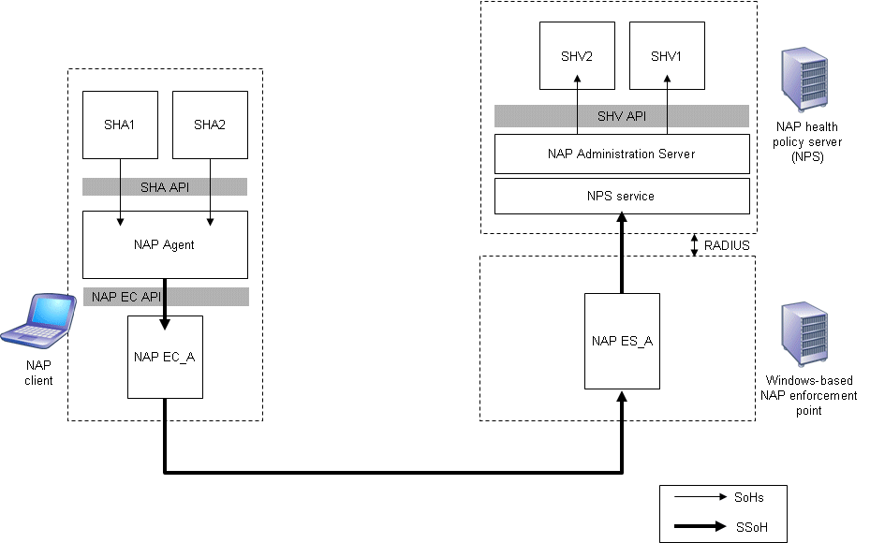
Figure 6: Communication process from NAP client components to NAP server-side components
Figure 7 shows the communication process from NAP server-side components to NAP client components.
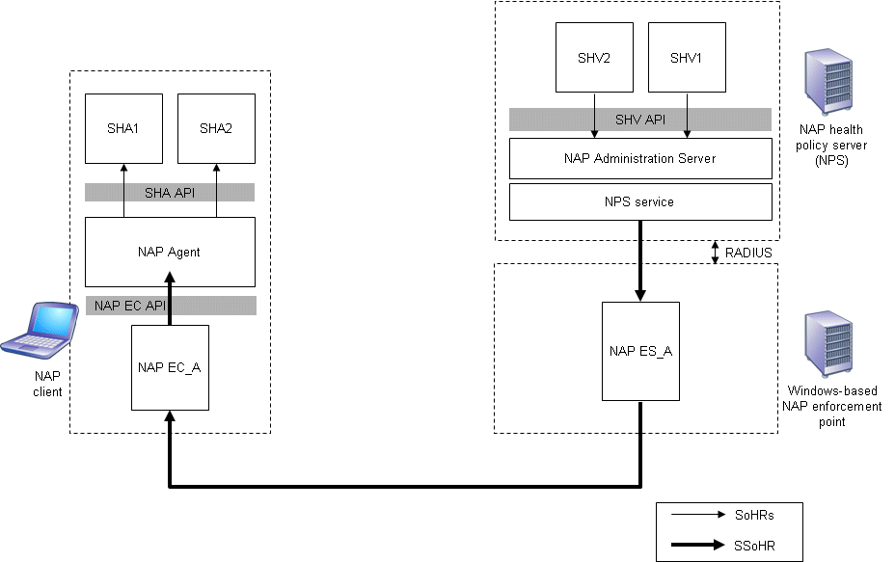
Figure 7: Communication process from NAP server-side components to NAP client components

How NAP Works
The following sections describe how the components of the NAP platform provide for system health status reporting, network policy compliance verification, network access limitation, and automatic remediation for IPsec-protected communication, IEEE 802.1X-authenticated connections, remote access VPN connections, and DHCP IP address configuration.

IPsec-protected Communication
IPsec enforcement limits communication for IPsec-protected NAP clients by dropping incoming communication attempts that are sent from computers that cannot negotiate IPsec protection using health certificates. Unlike 802.1X and VPN enforcement, IPsec enforcement is performed by each individual computer, rather than at the point of entry into the network. Because you can take advantage of IPsec policy settings, the enforcement of health certificates can be done for all the computers in a domain, specific computers on a subnet, a specific computer, a specific set of Transmission Control Protocol (TCP) or User Datagram Protocol (UDP) ports, or for a set of TCP or UDP ports on a specific computer.
IPsec enforcement divides a physical network into three logical networks. A computer is a member of only one logical network at any time. The logical networks are defined in terms of which computers have health certificates and which computers require IPsec authentication with health certificates for incoming communication attempts. The logical networks allow for limited network access and remediation and provide compliant computers with a level of protection from noncompliant computers.
IPsec enforcement defines the following logical networks:
- Secure network The set of computers that have health certificates and require that incoming communication attempts use health certificates for IPsec authentication. On a managed network, most server and client computers that are members of the Active Directory domain would be in the secure network.
- Boundary network The set of computers that have health certificates but do not require that incoming communication attempts use health certificates for IPsec authentication. Computers in the boundary network must be accessible to computers on the entire network.
- Restricted network The set of computers that do not have health certificates that include noncompliant NAP client computers, guests on the network, or computers that are not NAP-capable such as computers running versions of Windows that do not support NAP or Apple Macintosh or UNIX-based computers.
Based on the definition of the three logical networks, the following types of initiated communications are possible:
- Computers in the secure network can initiate communications with computers in all three logical networks. Communications initiated to computers in the secure network or boundary network are authenticated with IPsec and health certificates. Communications initiated to non-NAP-capable computers in the restricted network are not authenticated with IPsec.
Computers in the secure network will accept communications initiated from computers in the secure and boundary networks that are authenticated with IPsec, but will not accept communications initiated from computers in the restricted network.
For example, a client computer in the secure network can request a Web page from a Web server in the secure network. However, a client computer in the restricted network cannot. The requirements for initiated communication can be configured on a TCP or UDP port basis to limit specific types of traffic. For example, it is possible to require IPsec authentication with health certificates for Remote Procedure Call (RPC) traffic, but not Web traffic. In this case, a client computer in the restricted network could request a Web page from a Web server in the secure network, but not be able to use RPC to connect to that same server.
- Computers in the boundary network can initiate communications with computers in the secure or boundary networks that are authenticated with IPsec and health certificates or with computers in the restricted network that are not authenticated with IPsec.
Computers in the boundary network will accept communications initiated from computers in the secure and boundary networks that are authenticated with IPsec and health certificates and from computers in the restricted network that are not authenticated with IPsec.
Members of the boundary network will typically only consist of the HRA and NAP remediation servers. Servers in the boundary network must be accessible from noncompliant NAP clients in the restricted network (to perform initial remediation functions and obtain health certificates) and from compliant computers in the secure network (to perform ongoing remediation functions, renew health certificates, and to manage the computers in the boundary network).
A computer is member of the secure or boundary network for the time specified in the validity period of the health certificate. Before the health certificate expires, the IPsec-protected NAP client contacts the HRA to obtain a new health certificate. The validity time period for health certificates can be configured on the HRA and is typically on the order of hours, rather than years in the case of computer or user certificates.
- Computers in the restricted network can initiate communications with computers in the restricted and boundary networks. Computers in the restricted network cannot initiate communications to computers in the secure network (unless specifically allowed through the IPsec policy settings of the computers in the secure network).
Computers in the restricted network will accept communications initiated from computers in all three logical networks.
Figure 8 summarizes the logical networks and the types of initiated communications that are allowed.
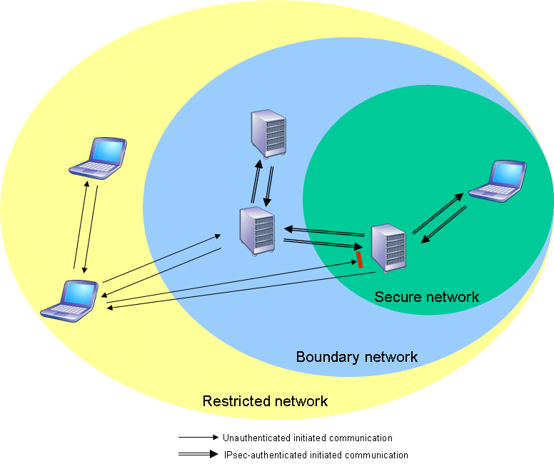
Figure 8: Logical networks with IPsec enforcement
To obtain a health certificate and become a member of the secure network, a NAP client using IPsec enforcement starts up on the network and uses the following process:
- When the computer starts, the host-based firewall is enabled but does not allow any exceptions so that no other computer can initiate communications with it. At this point, the computer is in the restricted network because it does not have a health certificate. The computer can communicate with other computers in the restricted and boundary networks and can access the Internet. However, it cannot initiate communications with computers in the secure network.
- The NAP client obtains network access and an IP address configuration.
- The IPsec NAP EC sends its credentials and its SSoH to the HRA using HTTP or a protected HTTP over SSL session.
- The HRA passes the SSoH to the NAP health policy server in a RADIUS Access-Request message.
- The NPS service on the NAP health policy server receives the RADIUS Access-Request message, extracts the SSoH, and passes it to the NAP Administration Server component.
- The NAP Administration Server receives the SSoH and forwards the SoHs to the appropriate SHVs.
- The SHVs analyze the contents of their SoHs and return SoHRs to the NAP Administration Server.
- The NAP Administration Server passes the SoHRs to the NPS service.
- The NPS service compares the SoHRs to the configured set of network and health policies and creates the SSoHR.
- The NPS service constructs and sends a RADIUS Access-Accept message with the SSoHR as a RADIUS VSA to the HRA.
- The HRA sends the SSoHR back to the IPsec NAP EC.
- The IPsec NAP EC passes the SSoHR to the NAP Agent.
- The NAP Agent passes the SoHRs in the SSoHR to the appropriate SHAs.
- If the NAP client is compliant, the HRA also issues a health certificate.
The NAP client removes any existing health certificates if needed and adds the newly-issued health certificate to its computer certificate store. The IPsec NAP EC configures IPsec settings to authenticate using the health certificate for IPsec-protected communications and configures the host-based firewall to allow incoming communications from any peer that uses a health certificate for IPsec authentication. The NAP client is now a member of the secure network.
The IPsec NAP EC performs steps 3-14 whenever new SoH information arrives at the NAP Agent or when the health certificate is about to expire.

Noncompliant NAP Client
If the NAP client is noncompliant, the NAP client does not have a health certificate and cannot initiate communication with computers in the secure network. The NAP client performs the following remediation process to become a member of the secure network:
- Each SHA analyzes its SoHR, and based on the contents, performs the remediation as needed to correct the NAP client's system health state.
- Each SHA that required remediation passes an updated SoH to the NAP Agent.
- The NAP Agent collects the updated SoHs from all of the SHAs that required remediation, creates a new SSoH, and passes it to the IPsec NAP EC.
- The IPsec NAP EC uses HTTP or a protected HTTP over SSL session to sends its new SSoH to the HRA.
- The HRA receives the SSoH and sends it to the NAP health policy server in a RADIUS Access-Request message.
- The NPS service on the NAP health policy server receives the RADIUS Access-Request message, extracts the SSoH, and passes it to the NAP Administration Server.
- The NAP Administration Server receives the SSoH and forwards the SoHs to the appropriate SHVs.
- The SHVs analyze the contents of their SoHs and return SoHRs to the NAP Administration Server.
- The NAP Administration Server passes the SoHRs to the NPS service.
- The NPS service compares the SoHRs to the configured set of health policies and creates the SSoHR.
- The NPS service constructs and sends a RADIUS Access-Accept message containing the SSoHR to the HRA.
- The HRA receives the RADIUS Access-Accept message, extracts the SSoHR, and sends it to the NAP client using HTTP or the HTTP over SSL session. Because the NAP client is now compliant, the HRA issues the NAP client a health certificate.

802.1X-Authenticated Connections
IEEE 802.1X enforcement instructs an 802.1X-capable access point to use a limited access profile, either a set of IP packet filters or a VLAN ID, to limit the traffic of the noncompliant computer so that it can reach only resources on the restricted network. For IP packet filtering, the 802.1X-capable access point applies the IP packet filters to the IP traffic that is exchanged with the 802.1X client and silently discards all packets that do not correspond to a configured packet filter. For VLAN IDs, the 802.1X-capable access point applies the VLAN ID to all of the packets exchanged with the 802.1X client and the traffic does not leave the VLAN corresponding to the restricted network.
The following process occurs when a NAP-capable 802.1X client connects to an 802.1X network access device:
- Either the 802.1X network access device or the 802.1X client initiates 802.1X authentication using the EAPOL protocol.
- The NAP health policy server sends an EAP-Request/Identity message to the EAPHost NAP EC on the 802.1X client.
- The EAPHost NAP EC responds with an EAP-Response/Identity message that contains the user or computer name of the 802.1X client. For all subsequent PEAP-based messages, the logical communication occurs between the NAP health policy server and the EAPHost NAP EC on the 802.1X client, using the 802.1X network access device as a pass-through device. Messages between the 802.1X network access device and the NAP health policy server are a series of RADIUS Access-Request, Access-Challenge, and Access-Accept messages.
- The NAP health policy server sends an EAP-Request/Start PEAP message to the 802.1X client.
- The 802.1X client and the NAP health policy server exchange a series of TLS messages to negotiate a protected TLS session.
- The NAP health policy server sends a request for the SSoH to the 802.1X client using a PEAP-TLV message.
- The EAPHost NAP EC queries the NAP Agent for the SSoH.
- The EAPHost NAP EC passes the SSoH to the NAP health policy server using a PEAP-TLV message.
- The NAP health policy server, which is also acting as a AAA server, requests that the 802.1X client authenticate itself using its user or computer credentials, using a PEAP authentication method such as PEAP-Microsoft Challenge Handshake Authentication Protocol version 2 (MS-CHAP v2).
- The 802.1X client authenticates itself against the NAP health policy server using the negotiated PEAP authentication method.
- The NPS service on the NAP health policy server extracts the SSoH from the PEAP-TLV message sent in step 8 and passes it to the NAP Administration Server component.
- The NAP Administration Server component passes the SoHs in the SSoH to the appropriate SHVs.
- The SHVs analyze the contents of their SoHs and return SoHRs to the NAP Administration Server.
- The NAP Administration Server passes the SoHRs to the NPS service.
- The NPS service compares the SoHRs to the configured set of health policies and creates the SSoHR.
- The NPS service sends a PEAP-TLV message containing the SSoHR to the 802.1X client.
- The NPS service sends a RADIUS Access-Accept message to the 802.1X network access device.
- If the 802.1X connection is limited, the RADIUS Access-Accept message also contains an access profile to limit the traffic of the 802.1X client to the restricted network.
- If the 802.1X connection is unlimited, the RADIUS Access-Accept message does not contain an access profile to limit network access. After the 802.1X connection completes, the NAP client will have unlimited network access.
- The 802.1X client and 802.1X network access device complete the 802.1X-authenticated connection.
- The EAPHost NAP EC extracts the SSoHR in the PEAP-TLV message received from the NAP health policy server and passes it to the NAP Agent.
- The NAP Agent passes the SoHRs to the appropriate SHAs.

Noncompliant NAP Client
If the NAP client is noncompliant, the 802.1X connection has the limited access profile applied and the NAP client can only reach the resources on the restricted network. The following process performs the remediation required for unlimited network access:
- Each SHA analyzes its SoHR, and based on the contents, performs the remediation as needed to correct the NAP client's system health state.
- Each SHA that required remediation passes an updated SoH to the NAP Agent.
- The NAP Agent collects the updated SoHs from all of the SHAs that required remediation, creates a new SSoH, and passes it to the EAPHost NAP EC.
- The EAPHost NAP EC restarts 802.1X authentication and sends its SSoH for health validation.
- Health validation succeeds and the 802.1X client has unlimited network access.

Remote Access VPN Connections
VPN enforcement uses a set of remote access IP packet filters to limit the traffic of the VPN client so that it can only reach the resources on the restricted network. The VPN server applies the IP packet filters to the IP traffic that is received from the VPN client and silently discards all packets that do not correspond to a configured packet filter.
The following process occurs when a NAP-capable VPN client connects to a NAP-capable VPN server:
- The VPN client initiates a connection to the VPN server.
- The VPN server sends an EAP-Request/Identity message to the VPN NAP EC on the VPN client.
- The VPN NAP EC on the VPN client (a component of the Remote Access Connection Manager service) responds with an EAP-Response/Identity message that contains the user name of the VPN client.
- The VPN server sends the EAP-Response/Identity message as a RADIUS Access-Request message to the NAP health policy server. Similar to 802.1X enforcement, for all subsequent PEAP-based messages, the logical communication occurs between the NAP health policy server and the VPN NAP EC on the VPN client, using the VPN server as a pass-through device. Messages between the VPN server and the NAP health policy server are a series of RADIUS Access-Request, Access-Challenge, and Access-Accept messages.
- The NAP health policy server sends an EAP-Request/Start PEAP message to the VPN client.
- The VPN client and the NAP health policy server exchange a series of TLS messages to negotiate a protected TLS session.
- The NAP health policy server sends a request for the SSoH to the VPN client using a PEAP-TLV message.
- The VPN NAP EC queries the NAP Agent for the SSoH.
- The VPN NAP EC passes the SSoH to the NAP health policy server using a PEAP-TLV message.
- The NAP health policy server, which is also acting as a AAA server, requests that the VPN client authenticate itself using its client credentials using a PEAP authentication method such as PEAP-MS-CHAP v2.
- The VPN client authenticates itself to the NAP health policy server using the negotiated PEAP authentication method.
- The NPS service on the NAP health policy server extracts the SSoH from the PEAP-TLV message sent in step 9 and passes it to the NAP Administration Server component.
- The NAP Administration Server component passes the SoHs in the SSoH to the appropriate SHVs.
- The SHVs analyze the contents of their SoHs and return SoHRs to the NAP Administration Server.
- The NAP Administration Server passes the SoHRs to NPS.
- The NPS service compares the SoHRs to the configured set of health policies and creates the SSoHR.
- The NPS service sends a PEAP-TLV message containing the SSoHR to the VPN client.
- The NPS service sends a RADIUS Access-Accept message to the VPN server.
- If the VPN connection is limited, the RADIUS Access-Accept message also contains a set of IP packet filters that limit the traffic of the VPN client to the restricted network.
- If the VPN connection is unlimited, the RADIUS Access-Accept message does not contain IP packet filters to limit network access. After the VPN connection completes, the NAP client will have unlimited network access.
- The VPN client and VPN server complete the VPN connection.
- The VPN NAP EC extracts the SSoHR in the PEAP-TLV message received from the NAP health policy server and passes it to the NAP Agent.
- The NAP Agent passes the SoHRs to the appropriate SHAs.

Noncompliant NAP Client
If the VPN client is noncompliant, the VPN connection has the packet filters applied, and the VPN client can only reach the resources on the restricted network. The following process performs the remediation required for unlimited network access:
- Each SHA analyzes its SoHR, and based on the contents, performs the remediation as needed to correct the NAP client's system health state.
- Each SHA that required remediation passes an updated SoH to the NAP Agent.
- The NAP Agent collects the updated SoHs, creates a new SSoH, and passes it to the VPN NAP EC.
- The VPN NAP EC passes the new SSoH to the NAP health policy server using a PEAP-TLV message.
- The NPS service on the NAP health policy server extracts the SSoH from the PEAP-TLV message and passes it to the NAP Administration Server component.
- The NAP Administration Server component passes the SoHs in the SSoH to the appropriate SHVs.
- The SHVs analyze the contents of their SoHs and return an SoHR to the NAP Administration Server.
- The NAP Administration Server passes the SoHRs to the NPS service.
- The NPS service compares the SoHRs to the configured set of health policies and creates the SSoHR.
- The NPS service constructs and sends a PEAP-TLV message containing the SSoHR to the VPN client.
- The NPS service constructs and sends a RADIUS Access-Accept message to the VPN server that does not include IP packet filters for limited network access.
- Upon receipt of the RADIUS Access-Accept message, the VPN server removes the IP packet filters from the VPN connection and the VPN client has unlimited network access.

DHCP Address Configuration
DHCP address configuration limits network access for the DHCP client through its IPv4 routing table. DHCP enforcement sets the DHCP Router option value to 0.0.0.0, so the noncompliant computer does not have a configured default gateway. DHCP enforcement also sets the subnet mask for the allocated IPv4 address to 255.255.255.255, so that there is no route to the attached subnet. To allow the noncompliant computer to access the remediation servers on the restricted network, the DHCP server assigns the Classless Static Routes DHCP option, which contains a set of host routes to the computers on the restricted network, such as the DNS and remediation servers. The end result of DHCP limited network access is a configuration and routing table that allows connectivity only to specific destination addresses corresponding to the restricted network. Therefore, when an application attempts to send to a unicast IPv4 address other than those supplied via the Classless Static Routes option, the TCP/IP protocol returns a routing error.

Notes DHCP enforcement is for IPv4 only and does not limit the network access of DHCP for IP version 6 (IPv6) (DHCPv6) clients. DHCP enforcement is based on a limited access IPv4 address configuration. A malicious user with local administrator privileges can configure a manual IPv4 address configuration or change the IPv4 routing table entries to gain unlimited network access.
The following process occurs when a NAP-capable DHCP client attempts to obtain an IPv4 address configuration from a NAP-capable DHCP server:
- The DHCP NAP EC on the NAP client (a component of the DHCP Client service) queries the NAP Agent component for the SSoH.
- The NAP Agent sends the SSoH to the DHCP NAP EC.
- The DHCP Client service constructs and sends a DHCPDiscover message containing the SSoH as a Microsoft vendor-specific DHCP option.
- The DHCP Server service on the NAP-enabled DHCP server receives the DHCPDiscover message. The DHCP NAP ES on the DHCP server (a component of the DHCP Server service) extracts the SSoH from the DHCPDiscover message and sends the SSoH to the NAP health policy server in a RADIUS Access-Request message.
- The NPS service on the NAP health policy server receives the RADIUS Access-Request message, extracts the SSoH and passes it to the NAP Administration Server component.
- The NAP Administration Server component passes the SoHs in the SSoH to the appropriate SHVs.
- The SHVs analyze the contents of their SoHs and return SoHRs to the NAP Administration Server.
- The NAP Administration Server passes the SSoHRs to the NPS service.
- The NPS service compares the SoHRs to the configured set of health policies and creates the SSoHR.
- The NPS service constructs and sends a RADIUS Access-Accept message containing the SSoHR.
- The DHCP server receives the RADIUS Access-Accept message and extracts the SSoHR.
- The DHCP server sends a DHCPOffer message containing an IPv4 address configuration and the SSoHR as a DHCP vendor-specific option.
- The DHCP client sends a DHCPRequest message requesting the offered IPv4 address configuration.
- The DHCP server sends a DHCPAck message containing the offered IPv4 address configuration and the SSoHR.
- The DHCP NAP EC passes the SSoHR to the NAP Agent.
- The NAP Agent passes the SoHRs to the appropriate SHAs.
If the NAP client is compliant, the DHCPAck message contains the Router DHCP option set to the correct default gateway, a subnet mask for the subnet to which the NAP client is attached, and does not contain the Classless Static Routes option. At this point, the NAP client has unlimited network access.

Noncompliant NAP Client
If the DHCP client is noncompliant, the DHCPAck message contains the Router DHCP option set to 0.0.0.0, the Subnet Mask option set to 255.255.255.255, and the Classless Static Routes option contains the set of static host routes for the remediation servers on the restricted network.
The following process performs the remediation required for unlimited network access:
- Each SHA analyzes its SoHR, and based on the contents, performs the remediation as needed to correct the NAP client's system health state.
- Each SHA that required remediation passes an updated SoH to the NAP Agent.
- The NAP Agent collects the updated SoHs, creates a new SSoH, and passes it to the DHCP NAP EC.
- The DHCP NAP EC sends the DHCP server a DHCPRequest message to renew its current IPv4 address configuration containing the new SSoH.
- The DHCP Server service on the NAP-enabled DHCP server receives the DHCPRequest message. The DHCP NAP ES component of the DHCP Server service extracts the SSoH from the DHCPRequest message and sends the SSoH to the NAP health policy server in a RADIUS Access-Request message.
- The NPS service on the NAP health policy server receives the RADIUS Access-Request message, extracts the SSoH, and passes the SSoH to the NAP Administration Server.
- The NAP Administration Server component passes the SoHs in the SSoH to the appropriate SHVs.
- The SHVs analyze the contents of their SoHs and return an SoHR to the NAP Administration Server.
- The NAP Administration Server passes the SSoHRs to the NPS service.
- The NPS service compares the SoHRs to the configured set of health policies and creates the SSoHR.
- The NPS service constructs and sends a RADIUS Access-Accept message containing the SSoHR indicating unlimited network access.
- The DHCP server receives the RADIUS Access-Accept message and extracts the SSoHR.
- The DHCP server sends a DHCPAck message with the SSoHR, the Router DHCP option set to the correct default gateway, a subnet mask for the subnet to which the NAP client is attached, and does not contain the Classless Static Routes option. The DHCP client now has a renewed IPv4 address configuration for unlimited network access.

Summary
The NAP platform architecture consists of NAP client components (an SHA layer, a NAP Agent, and a NAP EC layer), NAP server-side components (an SHV layer, a NAP Administration Server, the NPS service, and a NAP ES layer for Windows-based NAP enforcement points), remediation servers, and health requirement servers. SHAs and SHVs are typically matched for a specific element or set of elements of system health. NAP ECs and NAP ESs are typically matched and enforce limited network access and communication for noncompliant computers. SHAs and remediation servers can be matched to correct a specific system health condition. SHVs and health requirement servers can be matched to report current health requirements for a specific system health condition. The NAP Agent component coordinates information flow between SHAs and NAP ECs. The NAP Administration Server component coordinates information flow between SHVs and NAP ESs. The NPS service on a NAP health policy server provides a way to configure and centralize health policy requirements.
IPsec-protected communication uses HTTP or a protected HTTP over SSL session to carry SSoHs and SSoHRs between a NAP client and the HRA. IPsec network access limitation is done by not issuing health certificates to noncompliant NAP clients so that they cannot initiate communications with compliant NAP clients in the secure network.
An 802.1X-authenticated network connection uses PEAP-TLV messages to carry SSoHs and SSoHRs between NAP-capable 802.1X clients and a NAP health policy server. 802.1X network access limitation is done through a limited access policy at the 802.1X network access device, such as IP packet filters that are applied to the 802.1X connection to limit the access to resources on the restricted network or a VLAN ID that limits traffic to a specific VLAN corresponding to the restricted network.
A remote access VPN connection uses PEAP-TLV messages to carry SSoHs and SSoHRs between NAP-capable VPN clients and a NAP health policy server. Remote access VPN network access limitation is done through IP packet filters that are applied to the VPN connection by the VPN server and limit the access to the restricted network.
DHCP configuration uses DHCP messages to carry SSoHs and SSoHRs between NAP-capable DHCP clients and a NAP health policy server. DHCP network access limitation is done through an IPv4 address configuration that limits access to the restricted network.

Related Links
See the following resources for further information:
- Microsoft Network Access Protection Web page at http://www.microsoft.com/nap
- Introduction to Network Access Protection at http://go.microsoft.com/fwlink/?LinkId=49884
- Network Access Protection Frequently Asked Questions at http://go.microsoft.com/fwlink/?LinkId=49886

