Microsoft Office Business Applications
New class of applications uses capabilities in Microsoft Office system to help enable customers to unlock back-end data and respond more quickly to changing business needs

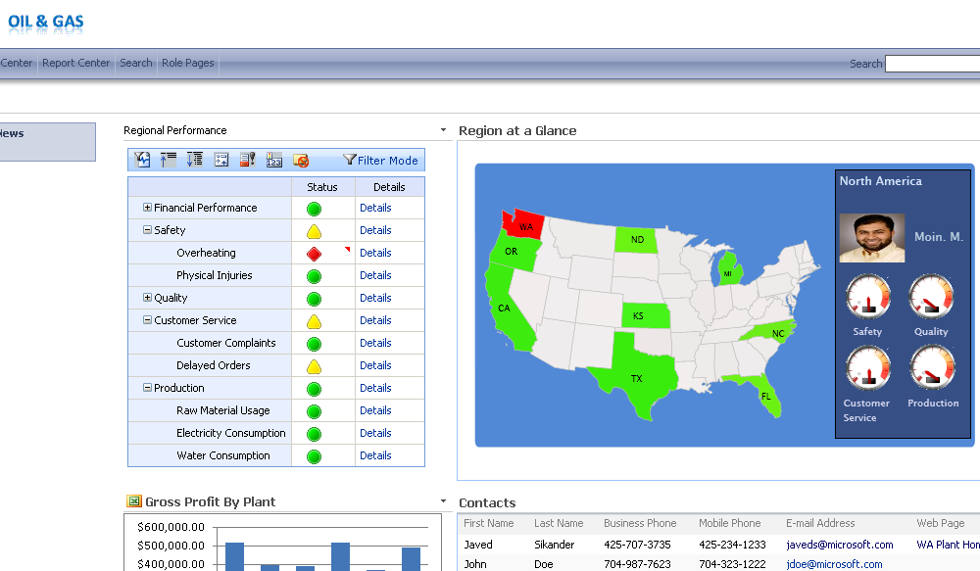
What is an OBA?
- A new breed of application that makes line-of-business systems and processes more accessible and actionable by information workers
- Combines the familiar, powerful and ubiquitous Microsoft Office system with line-of-business applications and processes including ERP, CRM and SCM
- Takes advantage of the Microsoft Office system as an extensible platform for application development

Benefits of OBAs
- Let users work the way they want to
- Provide a compelling user experience for your business application or process
- Formalize ad hoc processes using workflow

Customer and Partner Opportunity
The emergence of Microsoft Office as a true developer platform combined with the new capabilities of the 2007 Microsoft Office system will continue to escalate customer and partner interest in OBAs. Over 200 OBAs are in market today, and there are hundreds more under development.

Technical Resources for the Development of OBAs
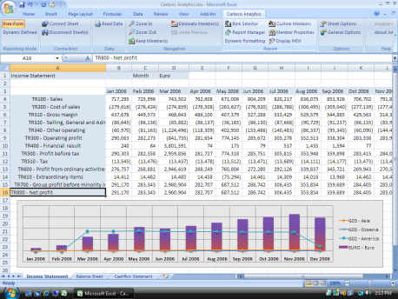
Microsoft is committed to supporting customer and partner development and deployment of OBAs with technical guidance and resources through the OBA OnRamp program, OBACentral and the periodic release of Reference Application Packs (RAPs).

- OBA OnRamp Program
  - Announced at the Worldwide Partner Conference in July 2007
  - Multi-million dollar Microsoft investment
  - Program includes technical resources, marketing assistance and sales acceleration for partners
  - OBA Quickstart Kit distributed to 10,000 attendees

- OBACentral
  - Intended as a vibrant and active community that brings together Microsoft, Microsoft OBA ISV, services partners and customers, and makes it easy to connect, and find solutions and services that address their business and technical needs
  - Can help you locate OBA solutions and services that meet your needs and can:
    - improve your organization’s productivity
    - realize the full potential of your LOB investments
    - Improve data management
    - Achieve better workflow or compliance
    - Support better decision making
  - As an ISV or SI, you can use OBACentral to get the word out about your solution or services to a broad audience interested in the key capabilities that make OBAs so powerful

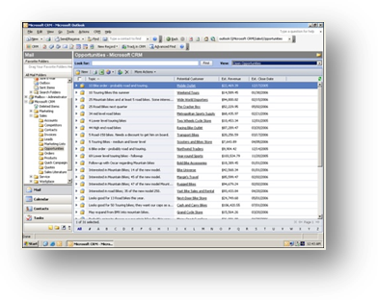
- Reference Application Packs (RAPs)
  - The OBA RAP is designed to help developers create applications that allow people to collect and analyze information using powerful tools they’re already familiar with to facilitate more rapid decision-making and quicker action
  - There are currently 6 OBA RAPs:
    - Plant Analytics
    - E-Forms Processing
    - Health Plans
    - Price Management
    - Loan Origination
    - SCM (Supply-Chain Management???)

- Tools
  - Visual Studio Tools for Office (VSTO)
    - VSTO is the premiere toolset for building OBAs based on Office 2007 and Office 2003. Using VSTO to build OBAs helps to reduce development costs and ultimately contributes to increasing the return on investments in Office. VSTO enables developers to build and deliver their OBAs easily and quickly, making their users even more productive than ever before.
    - VSTO is now available as part of every installation of Visual Studio 2008 Professional Edition which means the premier tool set for OBA development is right at the fingertips of most developers.

For More Information
To learn more about Office Business Applications, visit www.microsoft.com/oba or www.obacentral.com.

This document is for informational purposes only. MICROSOFT MAKES NO WARRANTIES, EXPRESS OR IMPLIED, IN THIS SUMMARY.
The example companies, organizations, products, domain names, e-mail addresses, logos, people, places, and events depicted herein are fictitious. No association with any real company, organization, product, domain name, e-mail address, logo, person, place, or event is intended or should be inferred.
© 2006 Microsoft Corporation. All rights reserved. Microsoft, Excel, the Office logo, PerformancePoint, SharePoint, SQL Server, Windows, and Windows Server are either registered trademarks or trademarks of Microsoft Corporation in the United States and/or other countries. All other trademarks are property of their respective owners.

