

Microsoft SQL Server 2008 R2

Reviewers Guide
Published: March 2010
Updated: March 2010

Summary: This guide provides key materials for evaluating Microsoft SQL Server 2008 R2, including product details, installation instructions and a guided tour.

The information contained in this document represents the current view of Microsoft Corp. on the issues discussed as of the date of publication. Because Microsoft must respond to changing market conditions, it should not be interpreted to be a commitment on the part of Microsoft, and Microsoft cannot guarantee the accuracy of any information presented after the date of publication.

This document may be changed substantially prior to final commercial release of the software described herein.

This document is for informational purposes only. MICROSOFT MAKES NO WARRANTIES, EXPRESS, IMPLIED OR STATUTORY, AS TO THE INFORMATION IN THIS DOCUMENT.

Complying with all applicable copyright laws is the responsibility of the user. Without limiting the rights under copyright, no part of this document may be reproduced, stored in or introduced into a retrieval system, or transmitted in any form or by any means (electronic, mechanical, photocopied, recorded or otherwise), or for any purpose, without the express written permission of Microsoft.

Microsoft may have patents, patent applications, trademarks, copyrights or other intellectual property rights covering subject matter in this document. Except as expressly provided in any written license agreement from Microsoft, the furnishing of this document does not give you any license to these patents, trademarks, copyrights or other intellectual property.

Unless otherwise noted, the example companies, organizations, products, domain names, e-mail addresses, logos, people, places and events depicted herein are fictitious, and no association with any real company, organization, product, domain name, e-mail address, logo, person, place or event is intended or should be inferred.

Contents

Welcome 5
What’s New in SQL Server 2008 R2? 7
SQL Server 2008 R2 Feature Review 15
Key Features at a Glance 15
Trusted, Scalable Platform 23
Managed Self-Service BI 34
IT and Developer Efficiency 49
SQL Azure 58
Conclusion 71

Welcome
Welcome to the Microsoft SQL Server 2008 R2 Reviewers Guide.
This document is designed to help you understand the features and capabilities of the new version of SQL Server 2008 R2 and take a tour of its capabilities.
Organizations are looking to compete and grow by reducing costs, reducing time to market and identifying the highest value opportunities for their business. We’re moving forward to rapidly address these challenges with new capabilities in development, manageability, business intelligence and data warehousing and by delivering the first relational database cloud offering with Microsoft SQL Azure. We have a vision for an information platform that goes beyond storing and managing your data to help you deliver greater value from your data across your business in the applications your people use every day.
A key element of this vision is to focus on the people at the center, the users of SQL Server:
- IT and database professionals who support expanding information needs through IT services
- Business intelligence (BI) practitioners and end users who are looking to quickly mine data for business insights to increase customer satisfaction and drive business results
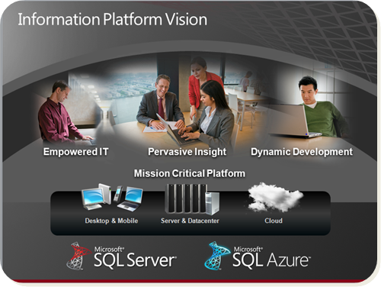
- Developers who build solutions to quickly capture business opportunities in an increasingly competitive market

Microsoft is committed to deliver an information platform that provides you with a complete set of enterprise-ready technologies and tools to help you realize more value from your information at the lowest total cost of ownership.
- SQL Server 2008 R2 delivers enterprise-class reliability, scalability and security, which is why it is already seeing rapid adoption among organizations that need to support mission-critical scenarios.
- Customers can now achieve “private cloud” operations capabilities in their own datacenter — by consolidating and virtualizing their datacenter, managing by policy and helping drive IT costs down while ensuring business uptime and agility.
- Microsoft, along with its global partners, can now deliver highly scalable data warehouse appliances based on standard reference architectures for guaranteed performance, while giving customers choice in which partners and configurations best suit their needs.

The key challenges we prioritized addressing with SQL Server 2008 R2 are broken down into three main categories:
Data Scale, Quality and Compliance. Data volumes especially for decision support systems are growing exponentially and the ability for the hardware and software to support this growth is essential. As information becomes more readily available to the rank and file of organizations, the ability to apply authorization rules and automate access also becomes critical.
Administrator Efficiency. If you look at the trend of technology over time you’ll see that we’re graduating more and more database administrators, and that’s great but the problem is that the proliferation of software and database applications is increasing at a greater rate than the number of database administrators on staff so what you get are these overburdened administrators. On top of that, the increase in the hardware computing capacity tends to leave a lot of underutilized hardware. So IT admins not only need to become more efficient in managing a large number of applications, they also need to ensure that resources are optimally utilized.
End-User Empowerment. This is essentially about enabling end users to do more with less dependency on their IT departments. IT was cited by end users as being a major bottleneck to reporting and analysis projects and from an IT perspective, they simply could not keep up with every change an end user demands. Providing end users with intuitive tools that enable them to build their own reports and models for analysis was a major challenge for IT.
This guide will walk you through the major upgrades, new features and changes that address these challenges. In addition, the second part of the guide will help you get started in the installation and testing of the Microsoft SQL Server 2008 R2 Beta.
There are five sections in the guide:
What’s NewA summary of what’s in the release
Features at a GlanceOverview of all features
Feature Review Product details and screenshots
Getting StartedStep-by-step installation instructions
Guided TourA hands-on tour of the product

What’s New in SQL Server 2008 R2?
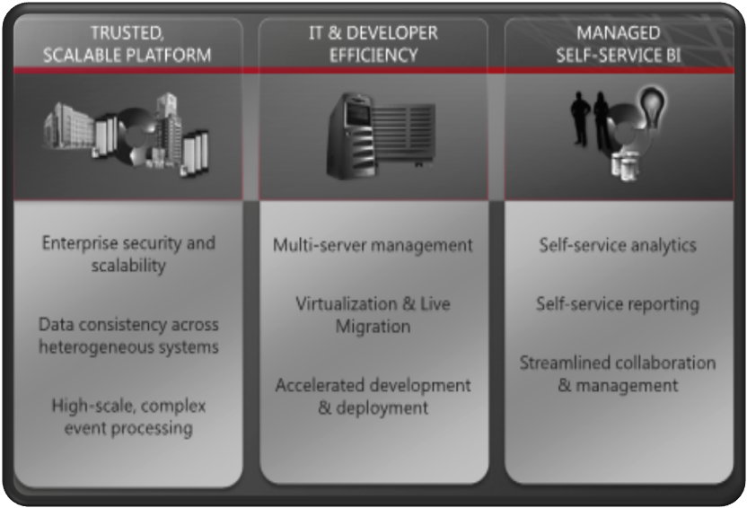
We have been listening to the challenges that businesses face today. The upcoming Microsoft SQL Server 2008 R2 is designed to meet these challenges and represents a significant evolution in scalability, manageability, data compression, application deployment and self-service business intelligence.

In response to the needs of our customers and partners, we have concentrated our efforts on three investment areas with SQL Server 2008 R2:

Figure 1: SQL Server 2008 R2 Investment Themes
Trusted, Scalable Platform. Supporting data consistency across heterogeneous systems through SQL Server Master Data Services (MDS), enabling high-scale complex event-stream processing through SQL Server StreamInsight, and supporting scale-up scenarios for the largest available x64 and Itanium hardware (up to 256 logical processors)
IT and Developer Efficiency. Enabling administrators to centrally monitor and manage multiple database applications, instances or servers, accelerating the development and deployment of applications and providing improved support for virtualization through Hyper-V with Live Migration in Windows Server 2008 R2
Managed Self-Service BI. Expanding powerful BI tools to all users with SQL Server PowerPivot for Excel and empowering a new class of business users to build and share powerful BI solutions independently, while still enabling IT to monitor and manage user-generated BI solutions

Trusted, Scalable Platform
SQL Server 2008 R2 provides a comprehensive information platform delivering high levels of performance, scalability, availability and security for mission-critical applications at a low cost of ownership.
In this release, examples of some of the new investments we made include delivering high scalability on a single system, enabling even more efficient data storage, and delivering real-time insights to the business.
The Trusted, Scalable Platform investment area is broken down into three parts:

Enterprise-Level Security and Scale. SQL Server 2008 R2 provides scalability, reliability, and security while allowing customers to take advantage of the latest hardware innovations and computing technologies — making it capable of handling enormous amounts of data fast, efficiently, and at a low cost. SQL Server provides the following:
- Database redundancy in case of disaster enabling companies to quickly recover damaged data the security companies need, such as data encryption, access control and simplified compliance and auditing
- Predictable performance across workloads by defining resource limits and priorities for workloads with Resource Governor
- Built-in compression features to enable companies to reduce hardware costs, optimize storage, improve performance and reduce backup times

New capabilities delivered in SQL Server 2008 R2 provide the following benefits:
- The ability to compress Unicode data is a significant benefit for organizations with international customer bases and for those who must store Unicode data for other reasons.
- The capabilities help companies take advantage of the latest hardware technology advancements and enables high scalability building on top of industry-standard hardware for great total cost of ownership.
Data Consistency Across Heterogeneous Systems. SQL Server 2008 R2 helps enterprises standardize the data people rely on to make critical business decisions. Using Master Data Services, organizations can align operational and analytical data across the enterprise and across their line of business systems and ensure the integrity of information over time. To enable organizations to deliver trusted data assets, SQL Server 2008 R2 includes the following:
- It includes a master data hub to provide an authoritative source for all master data used by an enterprise, regardless of data system. Organizations can easily align data from merged systems, new domains and even unique domains.
- It includes the reporting, auditing and versioning features help to protect master data and ensure compliance by maintaining change histories.
- It includes role-based security so administrators can enable anyone in an organization to access and update master data directly with minimal impact on IT. Administrators can lock down data and have granular control over what data a given user (or group or role) may access across models, applications and systems, even down to individual rows and columns in data sets.
- It includes powerful and agile hierarchy and attribute management capabilities, Master Data Services supports a wide variety of hierarchy styles. It can accommodate unique requirements and rectifies conflicts among systems. In addition, it provides the flexibility to modify hierarchies and attributes to meet changing needs, with built-in safeguards to insure the integrity of alterations.
High-Scale, Complex Event Processing. Gain rapid insight from streaming information using SQL Server 2008 R2 StreamInsight. StreamInsight is a powerful platform for developing and deploying complex event processing (CEP) applications. Its high-throughput stream processing architecture and .NET-based development platform enable developers to quickly implement robust and highly efficient event processing applications. A highly optimized engine built on a lightweight streaming architecture allows queries to be rapidly executed on high-speed data with low latency.
- Developers can write StreamInsight applications using .NET in their language of choice. With a large community of developers working with familiar tools, businesses can maximize the time to value of StreamInsight solutions and reduce the time and cost required to create them.
- Flexible deployment scenarios and a central management interface help IT deploy and manage CEP solutions efficiently while accurately tracking resource usage.

Managed Self-Service BI
SQL Server 2008 R2 unveils groundbreaking new technologies and tools, specifically targeted at empowering users, assisting in seamless, highly secure sharing and collaboration, and increasing IT and BI developer efficiency.
SQL Server 2008 R2 delivers a complete data infrastructure and BI platform, works with Microsoft SharePoint Server 2010 to supply a reliable and highly secure collaboration platform, and extends Microsoft Office 2010 to provide an intuitive and familiar user platform with powerful analytics capabilities. The Microsoft BI solution stack is a cornerstone in the Microsoft BI vision to provide business insight to all employees, leading to better, faster, more relevant decisions.
Figure 2: The Microsoft BI Solution Stack

SQL Server 2008 R2 capitalizes on the key business benefits that the Microsoft BI solution stack provides to the organization, business users, and the IT department and enables Managed Self-Service BI through the following areas of investments:

Empower End Users. End users will see the greatest impact from the uniform way they now have of working with BI solutions. Using familiar Microsoft Office applications, anyone can process vast amounts of data and obtain actionable insights without having to rely on developers or IT:
- Maximize utilization of familiar Excel features, such as the Microsoft Office Fluent user interface, PivotTables, PivotCharts and the new Slicers feature for interactive analysis
- Improve accuracy in decisions by combining and analyzing massive amounts of data from a multitude of sources, including relational databases, multidimensional sources, cloud services, data feeds, Excel files, and text files, in the corporate network and on the Internet; and sort, filter and scroll through millions of rows of data with about the same performance as a few thousand rows.
- Intuitive authoring and publishing of business reports with rich visualizations, flexible layouts, re-use of insights and pixel-perfect rendering with Report Builder 3.0
Share and Collaborate. The BI capabilities of SQL Server 2008 R2 help you quickly create, share and automatically refresh powerful analytical applications using SharePoint 2010 as a familiar collaboration platform. All employees can realize benefits:
- Capitalize on standard SharePoint features; benefit from all the available SharePoint features, such as role-based security, workflows and versioning
- Provide a simplified way for users can upload and find analyses, work seamlessly via Web browser, and enjoy an attractive user interface in SharePoint — browsing at its best — and the same performance and features as in the Excel client
- Make decisions based on most-recent data; schedule automatic data refresh for workbooks in SharePoint to ensure the data remains current automatically
- Maximize business insight; reuse available shared applications as data sources and use SharePoint permissions and workflows to coordinate how users share and collaborate on their own solutions

Improve IT Efficiency. Administrators benefit from interoperability with SharePoint Managed Services to provide comprehensive management and monitoring of self-service BI activities:
- Fewer dependencies on IT for quick and easy reporting and analysis and to compress decision cycles
- Centralized managed of BI assets using familiar tools within SharePoint with a management dashboard to centrally monitor user-generated applications and ensure that BI solutions are continuously available, up to date and highly secure
- Track usage patterns over time, drill down to obtain more details, discover mission-critical solutions and make sure appropriate server resources are provisioned to ensure high availability and performance
- Security enhanced, seamless delivery of data to business users through report-based data feeds to encapsulate enterprise systems that are notoriously hard to get to

IT and Developer Efficiency
SQL Server 2008 R2 provides new tools for managing large multidatabase environments along with improved capabilities to help maximize the value of consolidation efforts, and ensure the streamlined development and deployment of data-driven applications.
Investments in multiserver management will help organizations proactively manage database environments more efficiently at scale through centralized visibility into resource utilization and streamlined consolidation and upgrade initiatives across the application lifecycle — all with tools that make it fast and easy. SQL Server 2008 R2 delivers the following:

Centralized Visibility and Control. SQL Server 2008 R2 delivers enhancements to enable management of database instances and applications from a single location:
- Quickly identify potential issues or exceeded threshold via a unified dashboard view of the overall health of applications and instances
- Gain insights into utilization and capacity to allow administrators to quickly identify consolidation opportunities with detailed application and database views
Resource Optimization. Use new enhancements to gain insights for improved consolidation management to reduce server sprawl:
- Streamline consolidation efforts with insight into resource utilization through policy evaluation and historical analysis
- Make the best use of your server hardware investments through virtualization
- Maintain high availability targets when moving virtual machines from one host to another with Windows Server 2008 R2 Hyper-V Live Migration — without any disruption or perceived loss of service.
Administrative Efficiencies. SQL Server 2008 R2 simplifies the development, deployment, and upgrades of data-driven applications:
- Eliminate the guesswork in deploying new applications by packaging the application components and deployment requirements into a single “container” for more efficient, low-risk deployment
- Streamline the process of updating or upgrading database applications or moving changes from test to production
- Rapidly deploy and configure SQL Server with SQL Server 2008 R2 Sysprep

SQL Azure
Microsoft SQL Azure Database is a cloud-based relational database service built for Windows Azure platform. It provides a highly available, scalable, multitenant database service hosted by Microsoft in the cloud. SQL Azure Database enables easy provisioning and deployment of multiple databases. Developers do not have to install, setup, patch or manage any software. High Availability and fault tolerance is built-in and no physical administration is required. SQL Azure supports Transact-SQL (T-SQL). Customers can leverage existing tools and knowledge in T-SQL-based familiar relational database and Windows Server technologies. It provides the following benefits:

- It helps developers to quickly build or extend applications to run in the cloud environment.
- It helps maintain low-cost management with a highly scalable infrastructure.
- It helps maintain business continuity with reliability, security and availability.

Self-Managing. SQL Azure Database offers the high availability and functionality of an enterprise datacenter without the administrative overhead that is associated with an on-premises solution. This self-managing capability enables organizations to provision data services for applications throughout the enterprise without adding to the support burden of the central IT department or distracting technology-savvy employees from their core tasks to maintain a departmental database application.

- By using a cloud-based solution such as SQL Azure, you can provision your data-storage needs in minutes and respond rapidly to changes in demand. This reduces the initial costs of data services by enabling you to provision only what you need, secure in the knowledge that you can easily extend your cloud-based data storage if required at a future time.
- The service replicates multiple redundant copies of your data to multiple physical servers to ensure data availability and business continuity. In the case of a disaster, SQL Azure provides automatic failover to ensure maximum availability for your application.
- Published service level agreements (SLAs) guarantee a business-ready service. When you move to SQL Azure, you no longer need to back up, store, and protect data yourself.
Highly Scalable. A key advantage of the cloud computing model is the ease with which you can scale your solution. Using SQL Azure, you can create solutions that meet your scalability requirements, whether your application is a small departmental application or the next global Web success story.
- A pay-as-you-grow pricing model allows you to quickly provision new databases as needed or scale down the services without the financial costs associated with unused capacity.
- With a database scale out strategy your application can utilize the processing power of hundreds of servers and store terabytes of data.
- You can harness this global scalability to build the next generation of Internet-scale applications that have worldwide reach, but without the infrastructure costs and management overhead.
- SQL Azure provides the flexibility that ISVs need to segregate customer data and implement multitenant billing, which enables you to build a global software plus services solution quickly and easily.
Developer Empowerment. SQL Azure is built on top of the T-SQL language and is designed to be compatible with SQL Server with a few changes, so developers can use their existing knowledge and skills. This helps reduce the cost and time that is usually associated with creating a cloud-based application.
- SQL Azure provides the same Tabular Data Stream (TDS) interface as SQL Server, so developers can use the same tools and libraries to build client applications for data that is in the cloud.
- SQL Azure data is stored in a way that is very familiar to developers and administrators who use SQL Server. Within each server, you can create multiple databases that have tables, views, stored procedures, indices and other familiar database objects.
- The familiar data model ensures that your database developers can use their existing relational database design and T-SQL programming skills to easily migrate existing on-premises database applications to the cloud.
- SQL Azure is part of the rich Microsoft data platform which is interoperable with the Microsoft Sync Framework to support occasionally connected synchronization scenarios.

SQL Server 2008 R2 Feature Review

Key Features at a Glance
- Existing = SQL Server 2008
- Improved/New = SQL Server 2008 R2

Trusted, Scalable Platform
Feature | New, Improved or Existing | Description | Page
Enterprise-Level Security and Scalability
Transparent Data Encryption | Existing | Reduce the complexity of developing applications that require encrypted data by performing all encryption transparently at the database level through a security enhanced database encryption key. Enable application developers to access encrypted data without changing existing applications.
Resource Governor | Existing | The Resource Governor provides enterprise customers the ability to both monitor and control the way different workloads use CPU and memory resources on their SQL Server instances.
Support for >64 Cores | New | Achieve greater single system scale with support for up to 256 logical processors when deploying SQL Server 2008 R2 on Windows Server 2008 R2. | 24
Data Compression | Existing | The data compression feature released in SQL Server 2008 helps compress the data inside a database, and it can help reduce the size of the database. Apart from the space savings, data compression provides another benefit: Because compressed data is stored in fewer pages, queries need to read fewer pages from the disk, thereby improving the performance of input/output intensive workloads. SQL Server 2008 provides two levels of data compression — row compression and page compression.
Unicode Compression | New | Unicode compression in SQL Server 2008 R2 uses an implementation of the Standard Compression Scheme for Unicode (SCSU) algorithm to compress Unicode values that are stored in row or page compressed objects. For these compressed objects, Unicode compression is automatic for nchar(n) and nvarchar(n) columns. The SQL Server Database Engine stores Unicode data as 2 bytes, regardless of locale. This is known as UCS-2 encoding. For some locales, the implementation of SCSU compression in SQL Server 2008 R2 can save up to 50 percent in storage space. | 24
Data consistency across heterogeneous systems
Master Data Services
Microsoft SQL Server 2008 R2 Master Data Services helps an organization manage master data. Source systems import business data, such as data from transactions, into the Master Data Services system, where it can be standardized, streamlined, and organized into relationships for analysis and preparation to send to subscribing systems.
MDS Management Hub | New | Master data hub that provides central management of master data entities and hierarchies. A master data hub provides an authoritative source for all master data used by an enterprise, regardless of data system. Organizations can easily align data from merged systems, new domains, and even unique domains. In addition, Master Data Services can serve both as a System of Entry or System of Record. | 25
Master Data Manager | New | Master Data Manager is a Web application that serves as a stewardship portal for business users and a management interface for administrators. | 26
MDS Business Rules | New | In MDS, you can create business rules to describe the conditions to ensure the validity and integrity of the data. | 27
MDS Version Management | New | The reporting, auditing and versioning features help to protect master data and ensure compliance by maintaining change histories and logging user, date, and time for each master data update as well as pertinent audit details, such as type of change, member code and prior versus new value. | 27
MDS Role-based Security | New | With role-based security administrators can lock down data and have granular control over what data a given user (or group or role) may access across models, applications, and systems, even down to individual rows and columns in data sets. | 28
MDS Hierarchy Management | New | With powerful and agile hierarchy and attribute management capabilities, Master Data Services provides the flexibility to modify hierarchies and attributes to meet changing needs, with built-in safeguards to insure the integrity of alterations. It maintains consistency by automatically propagating approved updates across operational systems (e.g., DW, ERP, BI, CRM, analytics).
MDS Web Services API | New | The Web services API is an option for creating custom applications that integrate MDS with an organization’s existing applications and processes. This API provides access to the master data model definitions as well as to the master data itself. | 26
Complex Event Processing
StreamInsight
Microsoft StreamInsight is a powerful platform for developing and deploying complex event processing (CEP) applications. Its high-throughput stream processing architecture and .NET-based development platform enable developers to quickly implement robust and highly efficient event processing applications.
Lightweight architecture | New | StreamInsight implements a lightweight streaming architecture that supports highly parallel execution of continuous queries over high-speed data. The use of in-memory caches and incremental result computation provide excellent performance with high data throughout and low latency. | 31
.NET development environment | New | Developers can write their CEP applications using Microsoft’s .NET language such as Visual C#, leveraging the advanced language platform LINQ (Language Integrated Query) as an embedded query language. | 31
Input Adapters | New | The input adapter reads the incoming events in the format in which they are supplied and translates this data into the event format that is consumable by the CEP server. | 32
Output Adapters | New | You create an output adapter template to receive the events processed by the CEP server, translate the events into a format expected by the event target, and emit the data to that device. | 32
Event Processing | New | With StreamInsight, event processing is organized into queries based on query logic that you define. These queries take a potentially infinite feed of time-sensitive input data (either logged or real time), perform some computation on the data, and output the result in an appropriate manner. | 32
Event Aggregation | New | The StreamInsight server provides built-in aggregations for sum, count and average that typically operate on time windows. | 32
Event Matching | New | The StreamInsight server provides a powerful join operation that matches events from two sources if their times overlap. | 33
Manageability | New | The management interface and diagnostic views that are provided in the CEP server allow the administrator to monitor and manage the CEP application. The manageability framework also allows for ISVs and system integrators to remotely monitor and support CEP-deployed systems at manufacturing and other scale-out installations. | 33

Managed Self-Service BI
Feature | New, Improved or Existing | Description | Page
Empower End Users
PowerPivot Add-in for Excel
Assemble and analyze large scale, heterogeneous PowerPivot data in Excel 2010 workbooks. Create relationships between tables to join data from a variety of sources into a new composite data source. Use a rich expression language to create relational queries for custom aggregations, calculations, and filters. Add data visualization and interaction through PivotTables, PivotCharts, Slicers and filters in Excel reports.
Excel worksheet integration | New | Excel worksheets provide all data visualization and interaction. PivotTables, PivotCharts, filters and Slicers provide the presentation of PowerPivot data you create in the PowerPivot window. | 35
Data Analysis Expression Language (DAX) | New | A new formula language that extends the data manipulation capabilities of Excel to enable more sophisticated and complex grouping, calculation and analysis. | 37
Data Compression and VertiPaq mode | New | VertiPaq is fast, column oriented processing for published PowerPivot datasets in a SharePoint farm and for offline access while building or modifying large-scale PowerPivot data in an Excel workbook. | 36
Relationship Definition Tool | New | You can create relationships between data sources by matching columns that contain similar or identical data. Column-to-column mapping across the full set of tables allows you to build a multidimensional data source between tables that are from different data sources.
Data Feeds | New | PowerPivot for Excel includes built-in support for consuming data feeds as a source of data. Data feeds can be one-time or repeatable data imports from URL addressable data sources that return XML tabular data. | 32
Table Import Wizard | New | You can use the Table Import Wizard to add business data from your corporate network, your local computer, or ad hoc data sources on the Web. You can connect to external data sources directly, or use predefined connection objects such as Office Data Connection (ODC) to get the data. You can also enter or copy in data from other worksheets, documents or text files.
Report Builder 3.0
Report Builder 3.0 is an intuitive, Office-optimized report authoring environment for business users who prefer to work in the familiar Microsoft Office environment. You can use Report Builder to work with data, define a layout, preview a report, and publish a report to a report server or SharePoint site.
Report Parts | New | Report parts are report items that you store on a report server, or on a SharePoint site that is integrated with a report server. You can reuse report parts in multiple reports, and you can update them on the server. | 51
Report Part Gallery | New | The Report Part Gallery enables users to search and access pre-built report parts and re-uses them to create or enhance reports. | 52
Mapping & Geospatial Visualization | New | Report Builder 3.0 provides a Map Wizard and Map Layer Wizard to add maps and map layers to your report to help visualize data against a geographic background.
Sparklines, Databars | New | Sparklines and databars are simple charts that convey a lot of information in a little space, often in line with text. Sparklines and data bars are often used in tables and matrices and have the same basic chart elements of categories, series, and values, but they have no legend, axis lines, labels or tick marks. | 39
Indicators | New | Indicators are minimal gauges that convey the state of a single data value at a glance. The icons that represent indicators and their states are visually effective, even when they are used in small sizes. | 41
Calculating Aggregates of Aggregates | New | You can create expressions that calculate an aggregate of an aggregate. By using this feature for charts and gauges that are nested in a table, you can align horizontal and vertical axes for charts and scales for gauges. You do this by calculating the maximum and minimum of aggregated values so the nested items use the same ranges. | 42
PowerPivot Excel Workbooks as data source for Report Builder | New | When you publish a PowerPivot workbook to the PowerPivot Gallery library, you can use the New Report option to launch Report Builder and start a new report that uses the PowerPivot workbook as a data source.
Share and Collaborate
PowerPivot for SharePoint 2010
PowerPivot for SharePoint 2010 adds analysis services to a SharePoint 2010 farm, providing server-side query processing and collaboration features for PowerPivot workbooks that you publish to a farm.
PowerPivot Gallery | New | Rich preview and document access is provided through a new PowerPivot Gallery library that includes accurate thumbnails of the full range of sheets in a published PowerPivot workbook. Users can preview a workbook before opening it. | 46
PowerPivot Data Refresh | New | PowerPivot workbook owners can schedule data refresh to get updated data from any connected data sources that provided original data to the workbook. Users can view PowerPivot data refresh status and history for each PowerPivot workbook. | 47
Authentication and Access Control | New | The authentication methods and authorization model in SharePoint extends to PowerPivot workbooks. There is no separate authentication or authorization model to implement. Permissions in your SharePoint deployment determine access to the document, and flows back to the data source connections managed by the PowerPivot service application.
Reporting Services Add-in for SharePoint
Reporting Services with SharePoint integration has several new features. These include support for multiple SharePoint zones, support for the SharePoint Universal Logging service, and a query designer for SharePoint Lists as a data source.
Supports Multiple SharePoint Zones | New | S  You can use the alternate access mapping functionality in your SharePoint environment to access report server items from one or more of the following SharePoint zones: default, Internet, intranet, extranet or custom. | 49
Supports SharePoint Universal Logging Services | New |  | 49
SharePoint List Data Extension | New | The SharePoint list data extension lets you specify a SharePoint list as a data source. The associated SharePoint list query designer provides a graphical interface that lets you select the data you want from a hierarchical view of lists and their fields. | 50
Shared Datasets | New | Shared datasets are a new type of report server item that can retrieve data from shared data sources that connect to external data sources. A shared dataset provides a way to share a query to help provide a consistent set of data for multiple reports. | 53
Increase IT Efficiency
PowerPivot Content Storage and Document Management in the Farm | New | Centralized data access and document management is enabled through SharePoint sites and libraries.  You can use content types and workflows to enforce retention policies or processes. | 46
Excel Services Integration | New | Because embedded PowerPivot data is an integral part of an Excel workbook, all queries for data and all subsequent rendering of that data is through Excel Services.
PowerPivot Management Dashboard | New | In Central Administration, farm and service administrators can view consolidated reporting data about PowerPivot processing in the farm. Usage reports can reveal data consumption patterns that show how PowerPivot data is being used. | 55
Reporting Services ATOM Feed | New | SQL Server 2008 R2 Reporting Services includes a new rendering extension to support exporting report data to an Atom service document. An Atom service document can be used by any application that consumes data feeds, such as PowerPivot. | 56

IT and Developer Efficiency
Feature |  | New, Improved or Existing | Description | Page
Centralized Visibility and Control
SQL Server Utility | New |  | A SQL Server Utility groups multiple SQL servers as a pool of resources. | 59
Utility Control Point (UCP) | New |  | The UCP provides the central reasoning point for the SQL Server Utility using SQL Server Management Studio to organize and monitor SQL Server resource health. The UCP collects configuration and performance information from managed instances of SQL Server every 15 minutes. | 59
Utility Explorer | New |  | Utility Explorer, a component of SQL Server Management Studio, connects to Database Engine instances to provide a tree view of all the objects in the SQL Server Utility. The Utility Explorer content pane provides several ways to view summary and detailed data, and a user interface to view and manage policy definitions. | 59
Utility Dashboard | New |  | The dashboard includes summary and detail data from all managed instances of SQL Server and all data-tier applications in the SQL Server Utility. It allows you to view the health of your resources from a single dashboard. | 62
Optimize Resources
Consolidation Management | New |  | Administrators can bolster their consolidation efforts through their use of SQL Server Utility dashboards and viewpoints, which easily identify underutilized and over utilized SQL Server resources across the SQL Server Utility. | 65
Virtualization | Improved |  | SQL Server 2008 R2 is part of Microsoft’s virtualization stack. It is tightly interoperable and complements other tools, servers, solutions to provide a comprehensive and compatible virtualization experience. | 65
Hyper-V Live Migration | New |  | With Hyper-V Live Migration, you can move running virtual machines from one Hyper-V physical host to another without any disruption of service or perceived downtime. Live Migration is integrated with Windows Server 2008 R2 Hyper-V and Microsoft Hyper-V Server 2008 R2. | 65
Administrative Efficiencies
Define Global Policies | New |  | Resource utilization policies can be defined globally for all data-tier applications and managed instances of SQL Server in the SQL Server Utility, or they can be defined individually for each data-tier application and for each managed instance of SQL Server in the SQL Server Utility. | 67
Policy-Based Management | Existing |  | Policy-Based Management is a system for managing one or more instances of SQL Server 2008. When SQL Server policy administrators use Policy-Based Management, they use SQL Server Management Studio to create policies to manage entities on the server, such as the instance of SQL Server, databases, or other SQL Server objects.
Central Management Server | Existing |  | Allows you to administer multiple servers by designating Central Management Servers and creating server groups. Transact-SQL statements and Policy-Based Management policies can be executed at the same time against server groups.
Data-Tier Application Component (DAC) | New |  | Interoperability with the Microsoft Visual Studio development system introduces a new project template called Data-Tier Application Component (DAC). This project template captures the database application schema (tables, stored procedures, and so forth) and packages it with application deployment requirements, enabling a single unit of deployment. | 64
Data-Tier Application | New |  | Data-tier application — the data-tier application is an unpacked DAC file deployed on an enrolled SQL Server instance within a managed server group. The deployed data-tier application is connected with the SQL Server Utility Control Point enabling utilization data to be collected and capacity policies evaluated. | 64
SQL Server Sysprep | New |  | The SQL Server Sysprep functionality allows you to install files and then configure at a later point. SQL Server Sysprep can be used with Windows Sysprep to create an operating system image that includes an unconfigured SQL Server installation. | 66

Trusted, Scalable Platform
Over the years companies have faced tough decisions on how to store and help secure increasing amounts of structured and unstructured data. They have made it a priority to take the necessary steps to protect their data assets — especially customer details, human resources data, and financial information. With the growing number of users accessing the data, they also must make sure that the database performs reliably and quickly with little or no downtime.
SQL Server 2008 R2 provides scalability, reliability and security all in one comprehensive information platform. It allows customers to take advantage of the latest hardware innovations and computing technologies and is capable of handling enormous amounts of data fast, efficiently, and at a low cost. SQL Server provides database redundancy in case of disaster enabling companies to quickly recover damaged data. It also provides the security companies need like data encryption, access control, and simplified compliance and auditing.
With SQL Server 2008 R2, companies can achieve 99.999 percent availability — increasing competitiveness and confidence of their customers.

Enterprise-Level Security and Scale

The database platform is intimately related to the operating system. Because of this relationship, Microsoft has designed Windows Server 2008 R2 to provide a solid IT foundation for business-critical applications such as SQL Server 2008 R2. With these two products, an organization can achieve maximum performance, scalability, reliability, and availability, while at the same time helping reduce the total cost of ownership associated with its database platform.

Maximum Scalability on Industry-Standard Hardware

Windows Server 2008 R2 supports up to 256 logical processors and 2 terabytes of memory in a single operating system instance. When SQL Server 2008 R2 runs on Windows Server 2008 R2, the two products together can support more intensive database and business intelligence workloads than ever before.

Unicode Compression

Unicode compression in SQL Server 2008 R2 uses an implementation of the Standard Compression Scheme for Unicode (SCSU) algorithm to compress Unicode values that are stored in row or page compressed objects. For these compressed objects, Unicode compression is automatic for nchar(n) and nvarchar(n) columns. The SQL Server Database Engine stores Unicode data as 2 bytes, regardless of locale. This is known as UCS-2 encoding. For some locales, the implementation of SCSU compression in SQL Server 2008 R2 can save up to 50 percent in storage space.

The storage space that compression saves depends on the characteristics of the data that is being compressed and the locale of the data. The following table lists the space savings that can be achieved for several locales.

Locale | Compression percent
English | 50%
German | 50%
Hindi | 50%
Turkish | 48%
Vietnamese | 39%
Japanese | 15%

Data Consistency Across Heterogeneous Systems

As an organization grows, the number of line of business applications tends to increase. Furthermore, data from these systems flow into reporting and analytical solutions. Often, the net result of this proliferation of data is duplication of data related to key business entities, although each system may maintain only a subset of all possible data that an organization might have available for any particular entity type. Master Data Services is an extensible master data management platform that includes applications for developing, managing and deploying master data models.

Master Data Services

Master Data Services helps enterprises standardize the data people rely on to make critical business decisions. With MDS, IT organizations can centrally manage critical data assets companywide and across diverse systems, enable more people to securely manage master data directly, and ensure the integrity of information over time. Top features in MDS include:

Master Data Hub
The goal of MDS is to address the challenges of both operational and analytical master data management by providing a master data hub to centrally organize, maintain and manage your master data. By centralizing the master data in an external system, you can more easily align all business applications to this single authoritative source.

Because the master data hub is not specific to any domain, you can organize your master data as you see fit, rather than force your data to conform to a predefined format. You can easily add new subject areas as necessary or make changes to your existing master data to meet unique requirements as they arise. The master data hub is completely metadata-driven, so you have the flexibility you need to organize your master data.

Master Data Manager

Master Data Manager is a Web application that serves as a stewardship portal for business users and a management interface for administrators. Master Data Manager includes the following five functional areas:

Explorer. Use this area to edit the master data model objects and master data details, apply business rules to validate master data, review and correct data quality issues, annotate master data, monitor changes, and reverse transactions.

Version Management. Use this area to create a new version of your master data model and underlying data, uncover all validation issues in a model, prevent users from making changes, assign a flag to indicate the current version for subscribing systems, review changes, and reverse transactions.

Integration Management. Use this area to create and process batches for importing data from staging tables into the MDS database, view errors arising from the import process, and create subscription views for consumption of master data by operational and analytic applications.

System Administration. Use this area to create a new model and model objects, define business rules, configure notifications for failed data validation and deploy a model to another system.
- User and Group Permissions. Use this area to configure security for users and groups to access functional areas in Master Data Manager, to perform specific functions, or to restrict or deny access to specific model objects.

Web Services

MDS includes a Web services API as an option for creating custom applications that combine MDS with an organization’s existing applications and processes. This API provides access to the master data model definitions as well as to the master data itself. As an example, using this API, you can completely replace the Master Data Manager Web application.

Business Rules

One of the goals of a master data management system is to set up data correctly once and to propagate only valid changes to downstream systems. To achieve this goal, the system must be able to recognize valid data and to alert you when it detects invalid data. In MDS, you create business rules to describe the conditions which render data invalid. For example, you can create a business rule that specifies the required attributes (also known as fields) for an entity. A business entity is likely to have multiple business rules which you can sequence in order of priority, as in Figure 3.
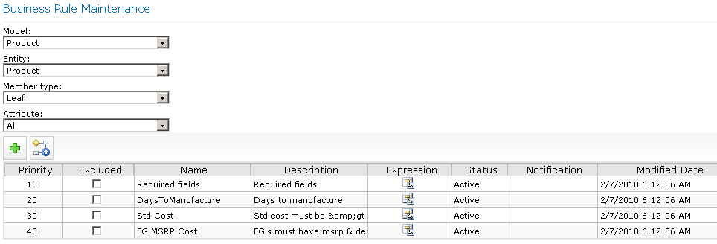
Figure 3. Product entity’s business rules

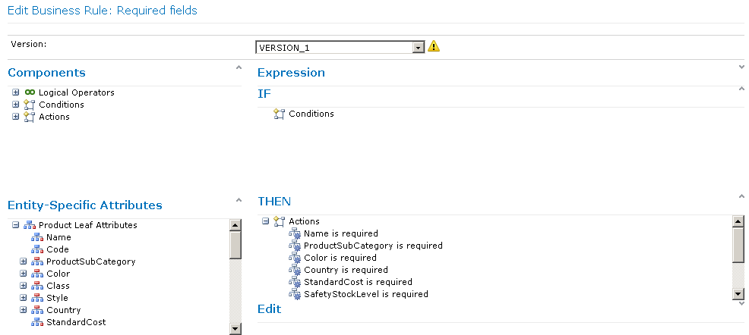
Figure 4 is an example of a simple condition which simply identifies the required fields for the Product entity. If you omit any of these fields when you edit a product member, MDS notes a validation issue for that member and prevents you from using the master data model until you supply the missing values.
Figure 4. Required fields business rule

Versioning Management
MDS uses a versioning management process to support multiple copies of a model and the data it contains. With versioning, you can maintain an official working copy of master data which no one can change alongside historical copies of master data for reference and a copy for work-in-progress copy as you prepare the master data for changing business requirements.

MDS creates the initial version when you create a model. Anyone with the appropriate permissions can populate the model with master data and make changes to the model objects in this initial version until you lock the version. At that point, only users with Update permissions can continue to modify the data in the locked version to add missing information, fix any business rules validation, or revert changes made to the model. If necessary, you can temporarily unlock the version to allow other users to correct the data.

When all data validates successfully, you can commit the version. Committing a version prevents any further changes to the model and allows you to make the version available to downstream systems through subscriptions. You can use a flag, as shown in Figure 5, to identify the version to use so that subscribing systems do not need to track the current version number themselves. If you require any subsequent changes to the model, you create a new version by copying a previously committed version and allow users to make their changes to the new version.

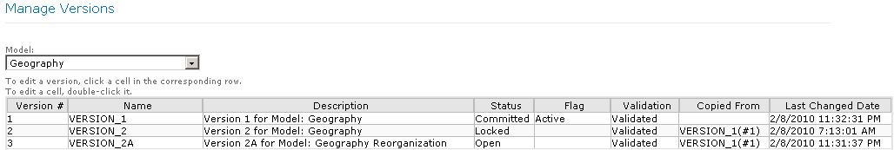
Figure 5. Model versions

Role-Based Security
MDS uses a role-based security model that allows you to configure security both by functional area and by object. For example, you can restrict one user exclusively to the Explorer area of Master Data Manager, as shown in Figure 6, while granting access to another user only to the Version Management and Integration Management areas. Then, within the functional area, you must grant a user access to one or more models to control which data the user can see and which data the user can edit. You must assign a user permission to access at least one functional area and one model in order for the user to open Master Data Manager.
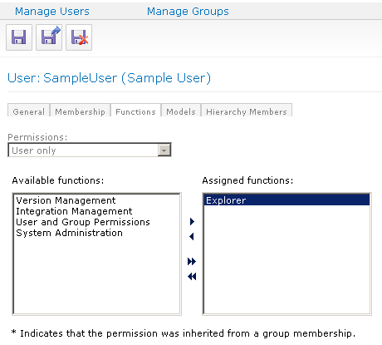
Figure 6. Functional area permissions
You can grant a user either Read-Only or Update permissions on a model. That permission level applies to all objects in the model unless you specifically override the permissions for a particular object, and then the new permission cascades downward to lower level objects. Similarly, you can grant permissions on specific members of a hierarchy and allow the permissions to cascade to members at lower levels of the hierarchy.

Complex Event Processing

While typical relational database applications are query-driven, event-driven applications have become increasingly important. Event-driven applications are characterized by high event data rates, continuous queries, and millisecond latency requirements that make it impractical to persist the data in a relational database for processing. They use complex event processing (CEP) technology with the goal of identifying meaningful patterns, relationships and data abstractions from among seemingly unrelated events and trigger immediate response actions.
Microsoft StreamInsight is a powerful platform for developing and deploying CEP applications. Its high-throughput stream processing architecture and .NET-based development platform enable developers to quickly implement robust and highly efficient event processing applications.
You can achieve the following tactical and strategic goals for your enterprise by developing your CEP applications using StreamInsight.
- Monitor your data from multiple sources for meaningful patterns, trends, exceptions and opportunities.
- Analyze and correlate data incrementally while the data is in flight — that is, without first storing it — yielding very low latency. Aggregate seemingly unrelated events from multiple sources and perform highly complex analyses over time.
- Manage your business by performing low-latency analytics on the events and triggering response actions that are defined on your business key performance indicators (KPIs).
- Respond quickly to areas of opportunity or threat by incorporating your KPI definitions into the logic of the CEP application, thereby improving operational efficiency and your ability to respond quickly to business opportunities.
- Mine events for new KPIs.
- Move toward a predictive business model by mining historical data to continuously refine and improve your KPI definitions.

Lightweight Architecture

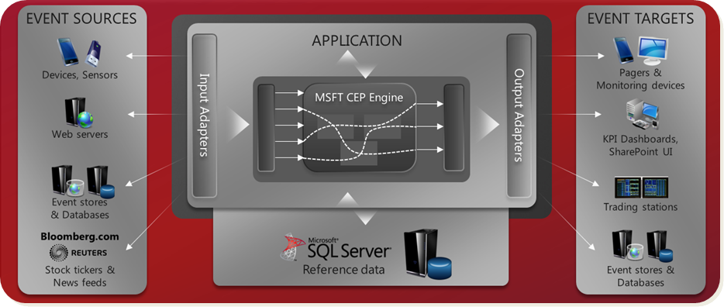
The StreamInsight runtime is the CEP server. It consists of the core engine and the adapter framework. The adapter framework allows developers to create interfaces to event stores such as Web servers, devices or sensors, and stock tickers or news feeds and event sinks such as pagers, monitoring devices, KPI dashboards, trading stations, or databases. Incoming events are continuously streamed into standing queries in the CEP server, which processes and transforms the data according to the logic defined in each query. The query result at the output can then be used to trigger specific actions.

Figure 7: StreamInsight Architecture

Development Models

StreamInsight provides three development models that support CEP application development. While the tasks defined above remain the same, actual implementation of the tasks varies with the development model . Sample applications demonstrating each of these models is available in the StreamInsight Samples Software Development Kit (SDK) available at http://go.microsoft.com/fwlink/?LinkId=160598.
- The explicit server development model provides a full-service CEP application environment by allowing the application developer to explicitly create and register all of the objects required to transform and process events coming into and going out of the CEP server. This gives the developer complete control of his or her CEP application and development environment by using the client-side object model API.
- The implicit server development model provides an easy-to-use environment that hides much of the complexity associated with the explicit server development model . It does this by allowing the CEP server to act as the implicit host creating and registering most of the objects required to transform and process events coming into and going out of the CEP server. This allows the developer to focus his or her efforts on developing the query logic needed to process and analyze the events within the CEP server. The server object itself is "anonymous" and cannot be accessed directly through the object model.
- The IObservable/IObserver development model provides an alternative method of implementing input and output adapters as the producers and consumers of event sources and sinks. This model is based on the IObservable/IObserver design pattern in which an observer is any object that wishes to be notified when the state of another object changes, and an observable is any object whose state may be of interest, and in whom another object may register an interest. For example, in a publication-subscription application, the observable is the publisher, and the observer is the subscriber object. More information is available on MSDN at http://msdn.microsoft.com/en-us/library/Ee817669(pandp.10).aspx.

Input Adapters
An input adapter instance accepts incoming event streams from external sources such as databases, files, ticker feeds, network ports and so on. The input adapter reads the incoming events in the format in which they are supplied and translates this data into the event format that is consumable by the CEP server.

Output Adapters

You create an output adapter template to receive the events processed by the CEP server, translate the events into a format expected by the event target, and emit the data to that device. Designing and creating an output adapter is similar to designing and creating an input adapter.

The Actions pane helps management actions to be discovered without the need for extensive right mouse clicks.

Event Processing

With StreamInsight, event processing is organized into queries based on query logic that you define. These queries take a potentially infinite feed of time-sensitive input data (either logged or real time), perform some computation on the data, and output the result in an appropriate manner. Developing the query logic you need to process and analyze incoming events is the core task in developing your CEP application.

Aggregation

When you do not care about each single event, you might want to look into aggregate values such as averages, sums or counts instead. The CEP server provides built-in aggregations for sum, count, and average that typically operate on time windows.

Matching Events From Different Streams

A common use case is the need to reason about events received from multiple streams. For example, because event sources provide timestamps in their event data, you may want to make sure that you only match events in one stream with an event in the second stream if they are closely related in time.
In addition, you may have additional constraints on which events to match, and when to match them. The CEP server provides a powerful join operation that performs both tasks: first, it matches events from the two sources if their times overlap and second, it executes the join predicate specified on the payload fields.
The result of such a match contains both the payloads from the first and the second event. In the following example, events in stream stream1 are compared with events in stream stream2. Events in the stream that meet the equality criteria defined in the on clause are joined and output into a new event that contains the payload fields i and j from event e1 and field j from event e2.
var equiJoin = from e1 in stream1
join e2 in stream2
on e1.i equals e2.i
select new { e1.i, e1.j, e2.j };

StreamInsight Manageability

The management interface and diagnostic views that are provided in the CEP server allow the administrator to monitor and manage the CEP application. The manageability framework also allows for ISVs and system integrators to remotely monitor and support CEP-deployed systems at manufacturing and other scale-out installations.

Monitoring the state of a CEP server involves tracking the overall health of the system and query performance. The state of a CEP server is captured by monitoring the CEP queries running on the server; evaluating how the entities that compose a CEP query are utilizing system resources.
Monitoring information can be obtained by creating diagnostic views using the ManagementService API. You can create diagnostics views that return attributes at the server level and at the query level. Query-level diagnostics are available for the query template definition and the query instance itself. Server-level diagnostics are available for two server components by using the Event Manager and Plan Manager.

Managed Self-Service BI
Microsoft SQL Server 2008 R2 expands on the value delivered in SQL Server 2008 to make actionable business intelligence accessible to all employees, leading to better, faster, more relevant decisions. More than ever, organizations can empower individuals to gain deeper insight into all aspects of their business and to share their findings effortlessly and more securely.
SQL Server 2008 R2 unveils groundbreaking new technologies and tools, specifically targeted at empowering users, assisting in seamless, more secure sharing and collaboration, and increasing IT and BI developer efficiency. Innovations, such as PowerPivot for Excel 2010 and SharePoint 2010, don’t just tackle typical enterprise BI challenges — they change the game.

Empower End Users
SQL Server 2008 R2 helps organizations empower their users by means of the following tools: Office applications and add-ins, PowerPivot for Excel 2010, and Report Builder 3.0. Standard Office applications, specifically Excel, have long been the preferred data analysis tools of business users. Excel includes a formidable formula engine, a familiar user interface, and extensive data manipulation, analytics, and data mining capabilities, including PivotTables, PivotCharts, and SQL Server Data Mining Add-ins.

PowerPivot for Excel 2010

PowerPivot for Excel 2010 is a data analysis tool that delivers unmatched computational power directly within the application users already know and love — Microsoft Office Excel. It provides users with the ability to analyze mass quantities of data and IT departments with the capability to monitor and manage how users collaborate by working seamlessly with Microsoft SharePoint Server 2010 and Microsoft SQL Server 2008 R2.

This innovative Excel add-in enables Excel power users to easily create powerful BI solutions by streamlining the integration of data from multiple sources enabling interactive modeling and analysis of massive amount of data and by supporting the seamless sharing of data models and reports through Microsoft SharePoint 2010.

PowerPivot for Excel supports self-service business intelligence in the following ways.
- Current row-and-column limitations in Excel are removed so that you can import much more data.
- A data relationship layer lets you integrate data from different sources and work with all of the data holistically. You can enter data, copy data from other worksheets, or import data from corporate databases. You can build relationships among the data to analyze it as if it all originated from a single source.
- Create portable, reusable data. Data stays inside the workbook. You do not need manage external data connections. If you publish, move, copy, or share a workbook, all the data goes with it.
- PowerPivot data is fully and immediately available to the rest of the workbook. You can switch between Excel and PowerPivot windows to work on the data and its presentation in PivotTables or charts in an interactive fashion. Working on data or on its presentation are not separate tasks. You work on both together in the same Excel environment.

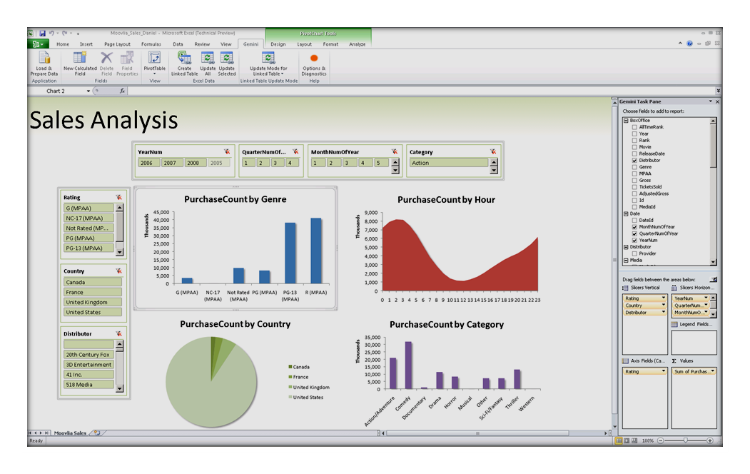Figure 8. Sample PowerPivot for Excel Application

User Interface Customizations

PowerPivot implements its own assembly to enhance the Excel user experience through ribbon customizations and spreadsheet templates, and overrides the default PivotTable field list to implement its own task pane.
VertiPaq Engine for Advanced Data Analysis
VertiPaq makes the most of multicore processors and gigabytes of memory to process enormous quantities of data with incredible speed. Processing millions of rows takes about the same time as thousands.
Column-Based Compression

VertiPaq compresses the data users import into a PowerPivot workbook with efficient column-based compression algorithms and maintains its database in a custom XML part directly in the Excel workbook.
In-memory data compression and processing describes VertiPaq mode, a new class of Analysis Services processing capability for PowerPivot data that is embedded in Excel workbooks. Processing metrics for VertiPaq can vary considerably depending on the degree of redundancy in the original data sources: the higher the redundancy in the data, the faster the processing. On average, you can expect to see 10-fold compression of the original data.
Data can be processed in three ways: on demand from the client computer, on demand in a SharePoint farm, or on a schedule via data refresh.

Broad Support for Data Sources

PowerPivot users can enjoy broad support of data sources to load and combine a great variety of data for massive analysis on the desktop, including relational databases, multidimensional sources, cloud services, data feeds, Excel files, text files and data from the Web.
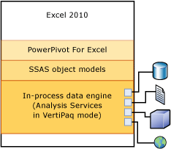

Data Analysis Expressions

Data Analysis Expressions (DAX) is a new formula language that extends the data manipulation capabilities of Excel to enable more sophisticated and complex grouping, calculation, and analysis.

By using DAX in addition to standard Excel features, PowerPivot users can quickly create advanced workbook applications. These applications can rely on data relationships between tables as in a database, include calculated columns and measures, and aggregate over billions of rows. In many cases, PowerPivot for Excel 2010 can establish the table relationships automatically.

DAX formulas are very similar to the formulas you type in Excel tables, but there are some key differences.
- In Microsoft Excel you can reference individual cells or arrays; in PowerPivot you can reference only complete tables or columns of data.
- DAX formulas do not support the same data types as Microsoft Office Excel, and perform implicit type conversions on some data, depending on the operation. More information is available at http://msdn.microsoft.com/en-us/library/ee634969(SQL.105).aspx.
A DAX formula always starts with an equal sign (=). After the equals sign, you provide any or all of the following:

- References to columns or tables. The DAX language always uses tables and columns as inputs to functions, never an array or arbitrary set of values.
- Operators, constants, and values provided as part of an expression.
- A function and any required arguments:
Most PowerPivot functions require one or more arguments, which can include table, columns, expressions, and values. However, some functions, such as PI, do not require any arguments, but always require parentheses to indicate the null argument. For example, you must always type PI(), not PI. You can also nest functions within other functions.
- Expressions. An expression can contain any or all of the following:
Operators
Constants
References to columns
For example, the following are all valid formulas:
Formula | Results
=3 | 3
="Sales" | Sales
='Sales'[Column 1] | The value of Column 1 in the Sales table.  If there is a relationship between the current table and the sales table, the value will depend on the relationship.
=(0.03 *[Amount])  =0.03 * [Amount] | Three percent of the value in the amount column of the current table.  Although this formula can be used to calculate a percentage, the result is not shown as percentage unless you apply formatting in the table.
=PI() | The value of the constant pi.
='FALSE' = 0  =(FALSE = 0)  =('FALSE' = 0) | TRUE  Because 0 and FALSE are different data types, DAX converts the values to a common type and compares the results.

Report Builder 3.0

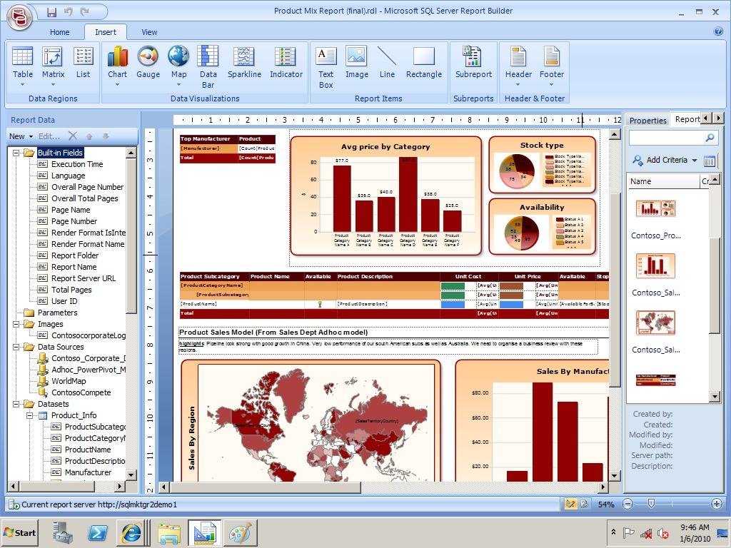
Report Builder 2.0 was released with SQL Server 2008 and gave the user expanded capabilities for importing queries from other report definition files or for writing a query on any data source supported by Reporting Services. In addition, Report Builder 2.0 included support for all layout options of Report Definitional Language (RDL). Report Builder 3.0 is the third iteration of this tool. It supports the new capabilities of SQL Server 2008 R2 RDL including map, sparklines and databars. Report Builder 3.0 also supports two improvements intended to speed up the report development process — edit sessions and the Report Part Gallery.

Figure 9. Report Builder 3.0 Interface

Data Bars

A data bar is a special type of chart that you add to your report from the Toolbox window. A data bar shows a single data point as a horizontal bar or as a vertical column. Usually you embed a data bar inside of a TABLIX to provide a small data visualization for each group or detail group that the TABLIX contains. After adding the data bar to the TABLIX, you configure the value you want to display, and you can fine-tune other properties as needed if you want to achieve a certain look.
By placing data bars in a TABLIX, you can compare each group’s value to the minimum and maximum values within the range of values across all groups, as shown in Figure 9-1. In this example, Accessories 2005 is the minimum sales amount, and Bikes 2007 is the maximum sales amount. The length of each bar allows you to visually assess whether a group is closer to the minimum or the maximum or some ratio in between, such as the Bikes 2008 group, which is about half of the maximum sales.
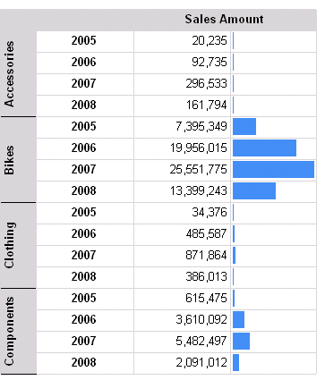
Figure 9-1: Data bars

Sparklines

Like data bars, sparklines can be used to include data visualization alongside the detailed data. Whereas a data bar usually shows a single point, a sparkline shows multiple data points over time, making it easier to spot trends.
You can choose from a variety of sparkline types such as columns, area charts, pie charts, or range charts, but most often sparklines are represented by line charts. As you can see in Figure 9-2, sparklines are pretty bare compared to a chart. You do not see axis labels, tick marks, or a legend to help you interpret what you see. Instead, a sparkline is intended to provide a sense of direction by showing upward or downward trends and varying degrees of fluctuation over the represented time period.
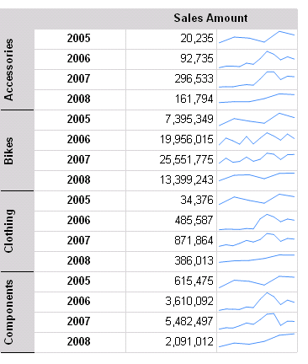
Figure 9-2: Sparklines

Indicators

Another way to display data in a report is to use indicators. In previous versions of Reporting Services, you could produce a scorecard of key performance indicators by uploading your own images and then using expressions to determine which image to display. Now you can choose indicators from built-in sets, as shown in Figure 9-3, or you can customize these sets to change properties such as the color or size of an indicator icon, or even by using your own icons.
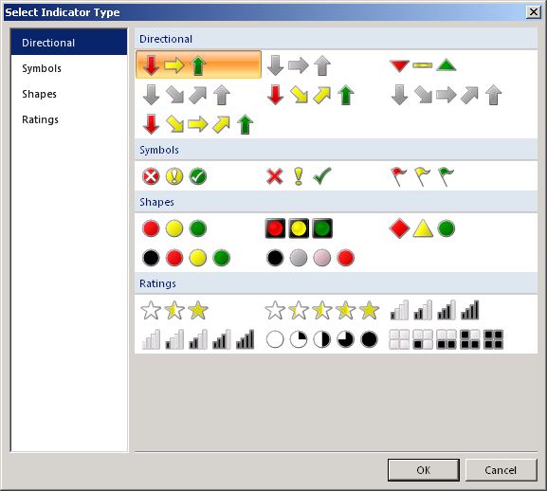
Figure 9-3: Indicator types

Maps
A map element is a special type of data visualization that combines geospatial data with other types of data to be analyzed. You can use the built-in Map Gallery as a background for your data, or you can use Environmental Systems Research Institute (ESRI) shapefile, and the map in Reporting Services also supports SQL Server spatial data types and functions so you can store your polygons, points, and routes in the database for use in your reports. In addition, you can even add Bing Maps tile layers as a backdrop for your data. For more advanced customization, you can create your own polygons to represent geographical areas or points on a map.
Figure 9-4: Map using colors to show population distribution

Aggregation
The aggregate functions available in Reporting Services since its first release with the SQL Server 2000 platform provided all the functionality most people needed most of the time. However, if you needed to use the result of an aggregate function as input for another aggregate function and weren’t willing or able to put the data into a SQL Server Analysis Services cube first, you had no choice but to preprocess the results in the dataset query.
In other words, you were required to do the first level of aggregation in the dataset query, and then you could perform the second level of aggregation by using an expression in the report. Now, with SQL Server 2008 R2 Reporting Services, you can nest an aggregate function inside another aggregate function. Put another way, you can aggregate an aggregation. The example table in Figure 9-5 shows the calculation of average monthly sales for a selected year. The dataset contains one row for each product, which the report groups by year and by month while hiding the detail rows.
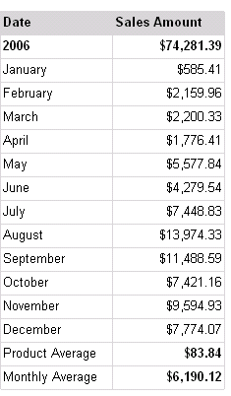
Figure 9-5: Aggregation of an aggregation
Here is the expression for the value displayed in the Monthly Average row:
=Avg(Sum(Fields!SalesAmount.Value,"EnglishMonthName"))

Share and Collaborate
There are at least three compelling reasons to use SharePoint 2010 in an enterprise BI environment to establish a business collaboration platform: Seamless sharing and collaboration with flexible security down to the individual item level; centralization of farm and infrastructure administration; and automated server-based processing through Windows services and SharePoint Timer jobs.

Power users play an important role as producers of insights at the team and personal BI level. Complementing BI developers who create organizational solutions, power users create and share workbook applications and reports by using PowerPivot for Excel 2010 and Report Builder 3.0.

Ultimately, power users decide whether to publish self-service BI solutions to a SharePoint environment. To ensure they do, the managed BI collaboration environment must enable them to publish their solutions effortlessly and highly securely. They must also be able determine security roles indicating who can access uploaded self-service BI solutions and who can modify these solutions with minimal dependency on IT. SharePoint 2010 fulfills these requirements by means of a flexible role-based security model that supports delegation of administrative control to groups and individual user accounts, as well as permission inheritance and explicit permission assignments.

PowerPivot for SharePoint 2010

PowerPivot for SharePoint 2010 takes advantage of Excel Services to render PowerPivot workbooks directly on the application server. BI consumers can seamlessly access shared workbook applications directly in the browser without having to download all the data to their workstations.

PowerPivot Gallery

PowerPivot Gallery is a special type of SharePoint document library that is available when you install Microsoft SQL Server PowerPivot for SharePoint in a Microsoft SharePoint Server 2010 farm or on standalone server. The PowerPivot Gallery combines an accurate preview of the file contents with facts about document origin. You can see immediately who created the document and when it was last modified.
PowerPivot Gallery uses a snapshot service to create thumbnails of a larger, multipage document. It can read PowerPivot workbooks and Reporting Services report definition (.rdl) files. The snapshot is based on how the workbook is rendered by Excel Services. The representation in PowerPivot Gallery should be identical to what you see when you view a PowerPivot workbook in a browser.

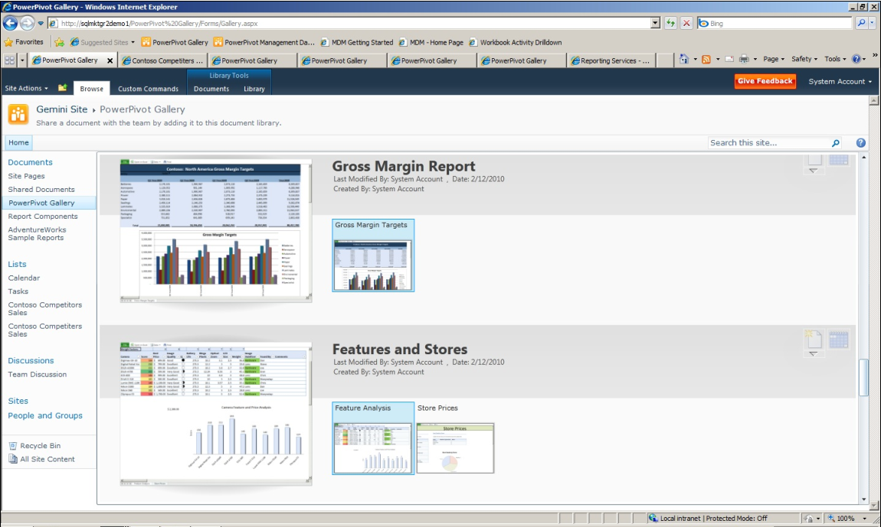
Data Requests and Excel Services and PowerPivot Processing

When you view a PowerPivot workbook from a SharePoint library, the PowerPivot data that is inside the workbook is detected, extracted, and processed separately on Analysis Services server instances within the farm, while Excel Services renders the presentation layer. You can view the fully-processed workbook in a browser window or in an Excel 2010 desktop application that has the PowerPivot for Excel add-in installed.
Because PowerPivot data is part of an Excel 2010 workbook, a request for query processing occurs when a user opens an Excel workbook from a SharePoint library and interacts with a PivotTable or PivotChart that contains PowerPivot data.

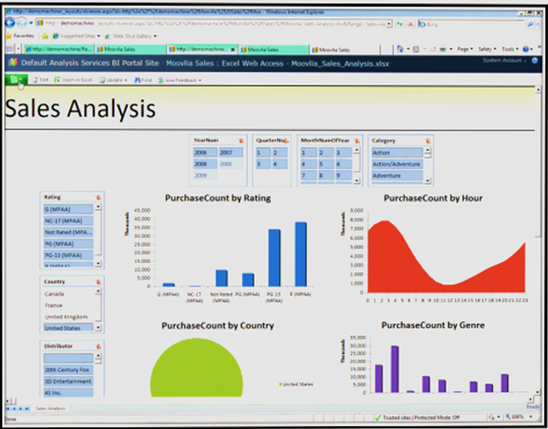

Excel Services and PowerPivot for SharePoint components process different parts of the same workbook (.xlsx) file. Excel Services detects PowerPivot data and requests processing from a PowerPivot server in the farm. The PowerPivot server allocates the request to an Analysis Services service instance, which retrieve the workbook from the content library and saves it to disk. The Analysis Services service extracts the PowerPivot data from the workbook and loads it into memory. Data that is stored in memory is merged back into the rendered workbook, and passed back to Excel Web Access for presentation in a browser window.
Not all data or objects in a PowerPivot workbook are handled by PowerPivot for SharePoint. Excel Services processes tables and cell data in a worksheet. Only PivotTables, PivotCharts, and slicers that go against PowerPivot data are handled by the PowerPivot service.

Data Refresh

Scheduled data refreshes ensure the data in managed self-service BI solutions remains current automatically, even when accessed over the Internet.
Power users can also manage the data refresh settings for uploaded self-service BI solutions, including refresh schedule, user credentials for the update process, and the portions of the datasets that should be updated to ensure accurate analysis and decision-making. SharePoint 2010 then performs the data refresh automatically.
SharePoint accomplishes this task based on a PowerPivot Data Refresh timer job, which the SQL Server 2008 R2 Setup program adds to the SharePoint configuration when installing PowerPivot for SharePoint 2010. This timer job runs every minute on the SharePoint server to determine if a data refresh job needs to be scheduled and executed.

Reporting Services in SharePoint-Integrated Mode
Report Builder 3.0 fully exploits the advantages of Reporting Services in SharePoint-integrated mode to store, manage, and render reports directly within the SharePoint collaboration environment. Uploaded report definitions automatically open in the Report Viewer Web Part, which supports page navigation, search, print, and export features. You can also connect the Report Viewer Web Part to a Filter Web Part or a Library Web Part in dashboards or site pages.

SQL Server 2008 R2 Reporting Services continues to improve interoperability with SharePoint. In this release, you will find better options for configuring SharePoint 2010 for use with Reporting Services, working with scripts to automate administrative tasks, using SharePoint lists as data sources, and integrating Reporting Services log events with the SharePoint Unified Logging Service.

Improved Configuration
The first improvement affects the initial implementation of Reporting Services in SharePoint integrated mode. After you have all components installed and configured on both the report server and the SharePoint server, you need to use SharePoint 2010 Central Administration to configure the General Application settings for Reporting Services. As part of this process, you can choose to apply settings to all site collections or to specific sites, which is a much more streamlined approach to enabling Reporting Services integration than was possible in earlier versions.

Support for Multiple SharePoint Zones
In previous releases of Reporting Services, report server items were available from only the default SharePoint zone, which restricted the ability to access such items from other SharePoint zones. In this latest release of Reporting Services, you can use the alternate access mapping functionality in your SharePoint environment to access report server items from one or more of the following SharePoint zones: default, Internet, intranet, extranet, or custom.

This is useful when you have a SharePoint environment that can be accessed by users from multiple zones. For example, your SharePoint site might be available to users from the Internet and an intranet. By using alternate access mapping, you can ensure that users from the Internet and intranet zones can access the same report server items from your SharePoint site.

You can configure up to five different URLs to access a single Web application that provides access to Reporting Services content, with each URL using a different authentication provider. This functionality is important when you want to use Windows authentication for intranet users and Forms authentication for Internet users.

RS Utility Scripting
Report server administrators frequently use the rs.exe utility to perform repetitive administrative tasks, such as bulk deployment of reports to the server and bulk configuration of report properties. Lack of support for this utility in integrated mode had been a significant problem for many administrators, so having this capability added to integrated mode is great news.

SharePoint Lists as Data Sources
More and more companies use SharePoint lists to store information that needs to be shared with a broader audience or in a standard report format. Although there are some creative ways you could employ to get that data into Reporting Services, custom code was always part of the solution.

SQL Server 2008 R2 Reporting Services has a new data extension provider that allows you to access SharePoint 2007 or SharePoint 2010 lists. After you create the data source using the Microsoft SharePoint List connection type and provide credentials for authentication, you must supply a connection string to the site or subsite in the form of a URL that references the site or subsite.

That is, use a connection string such as http://MySharePointWeb/MySharePointSite or http://MySharePointWeb/MySharePointSite/Subsite. A query designer is available with this connection provider, as shown in Figure 10-1, allowing you to select fields from the list to include in your report.
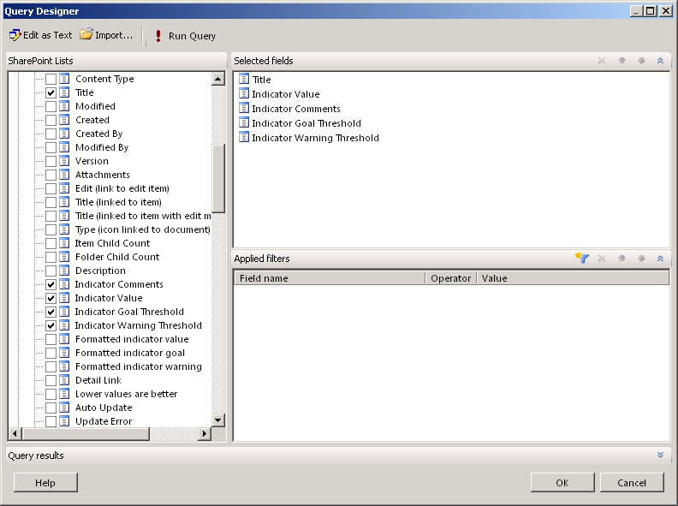
Figure 10-1: SharePoint list Query Designer

Reusability in Reporting
SQL Server 2008 R2 Reporting Services has several new features to support reusability of components. Report developers with advanced skills can build shared datasets and report parts that can be used by others. Then, for example, a business user can quickly and easily pull together these pre-constructed components into a personalized report without knowing how to build a query or design a matrix.

To help the shared datasets run faster, you can configure a cache refresh schedule to keep a copy of the shared dataset in cache. Last, the ability to share report data as an Atom data feed for PowerPivot extends the usefulness of data beyond a single source report.

Report Parts
After developing a report, you can choose which report items to publish to the report server as individual components that can be used again later by other report developers who have permissions to access the published report parts. You can publish any of the following report items as report parts: tables, matrices, rectangles, lists, images, charts, gauges, maps and parameters.
You can publish report parts both from Report Designer in Business Intelligence Development Studio and from SQL Server 2008 R2 Report Builder 3.0. In Report Designer, the Report menu contains the Publish Report Parts command. In the Publish Report Parts dialog box, shown in Figure 10-2, you select the report items that you want to publish. You can replace the report item name and provide a description before publishing. You can also choose which parts to publish.
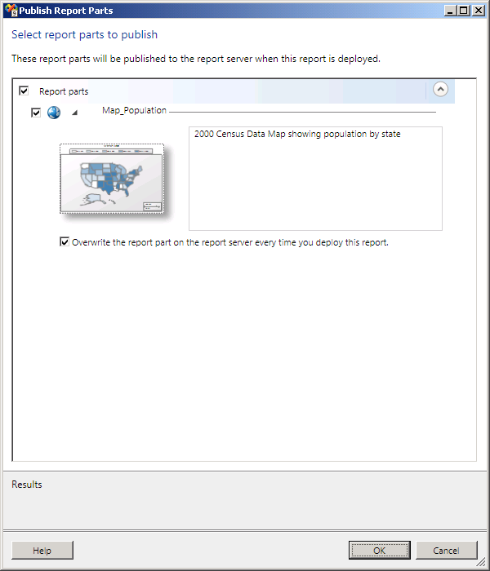
Figure 10-2: The Publish Report Parts dialog box
When you first publish the report part, Reporting Services assigns it a unique identifier that persists across all reports to which it will be added. Note the option in the Publish Report Parts dialog box in Report Designer (Figure 10-2) to overwrite the report part on the report server every time you deploy the report.

In Report Builder, you have a different option that allows you to choose whether to publish the report item as a new copy of the report. If you later modify the report part and publish the revised version, Reporting Services can use the report part’s unique identifier to recognize it in another report when another report developer opens that report for editing. At that time, the developer receives a notification of the revision and can decide whether to accept the change.
Be aware that you can only publish report parts in Report Designer. To find and use those report parts, you must use Report Builder 3.0. More information about Report Builder 3.0 can be found in the Report Builder 3.0 section.

The Report Part Gallery
Report Builder 3.0 includes a new window, the Report Part Gallery that you can enable from the View tab on the ribbon. Use the Report Part Gallery to collaborate and reuse report items. At the top of this window is a search box in which you can type a string value, as shown in Figure 10-3, and search for report parts published to the report server where the name or the description of the report part contains the search string. You can also search by additional criteria, such as the name of the creator or the date created. To use the report part, simply drag the item from the list onto the report body. The ability to find and use report parts is available only within Report Builder 3.0. You can use Report Designer to create and publish report parts, but not to reuse them in other reports.
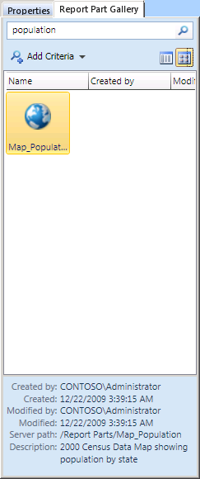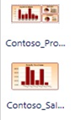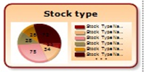
Figure 10-3: The Report Part Gallery

Shared Datasets
A shared dataset allows you to define a query once for reuse in many reports, much like you can create a shared datasource to define a reusable connection string. This reduces the need for the average user to know how to write queries to pull common data. The main requirement when creating a shared dataset is to use a shared data source. In all other respects the configuration of the shared dataset is just like the traditional embedded dataset used in earlier versions of Reporting Services.

You can check the server to see which reports use the shared dataset when you need to evaluate the impact of a change to the shared dataset definition. Simply navigate to the folder containing the shared dataset, click the arrow to the right of the shared dataset name, and select View Dependent Items, as shown in Figure 10-4.
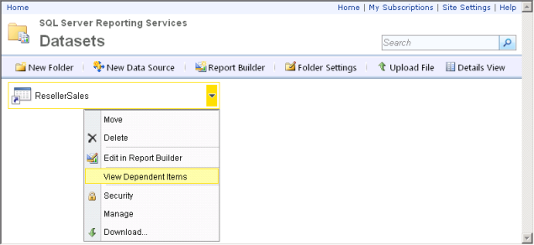
Figure 10-4: The shared dataset menu

Combining Data From More Than One Dataset
To display data from more than one source in a table (or in any data region, for that matter), you must create a dataset that somehow combines the data, because a data region binds to one and only one dataset. You could create a query for the dataset that joins the data if both sources are relational and accessible with the same authentication. But what if the data comes from different relational platforms? Or what if some of the data comes from SQL Server and other data comes from a Microsoft Office SharePoint Server list? And even if the sources are relational, what if you can access only stored procedures and are unable to create a query to join the sources? These are just a few examples of situations in which the new Lookup functions in the Reporting Services expression language can help.
In general, the three new functions, Lookup, MultiLookup, and LookupSet, work similarly by using a value from the dataset bound to the data region (the source) and matching it to a value in a second dataset (the destination). The difference between the functions reflects whether the input or output is a single value or multiple values.
You use the Lookup function when there is a one-to-one relationship between the source and destination. The Lookup function matches one source value to one destination value at a time, as shown in Figure 10-5.
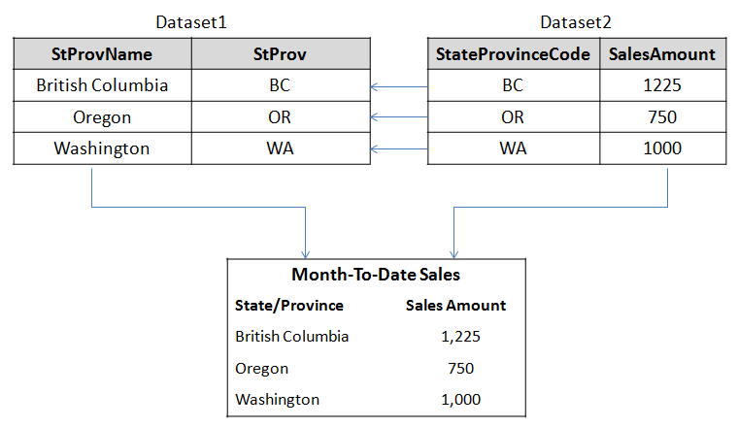
Figure 10-5: Lookup function results
In the example, the resulting report displays a table for the sales data returned for Dataset2, but rather than displaying the StateProvinceCode field from the same dataset, the Lookup function in the first column of the table instructs Reporting Services to match each value in that field from Dataset2 with the StProv field in Dataset1 and then to display the corresponding StProvName. The expression in the first column of the table is shown here:
=Lookup(Fields!StateProvinceCode.Value, Fields!StProv.Value,
Fields!StProvName.Value, "Dataset1")
The MultiLookup function also requires a one-to-one relationship between the source and destination, but it accepts a set of source values as input. Reporting Services matches each source value to a destination value one by one, and then returns the matching values as an array. You can then use an expression to transform the array into a comma-separated list, as shown in Figure 10-6.
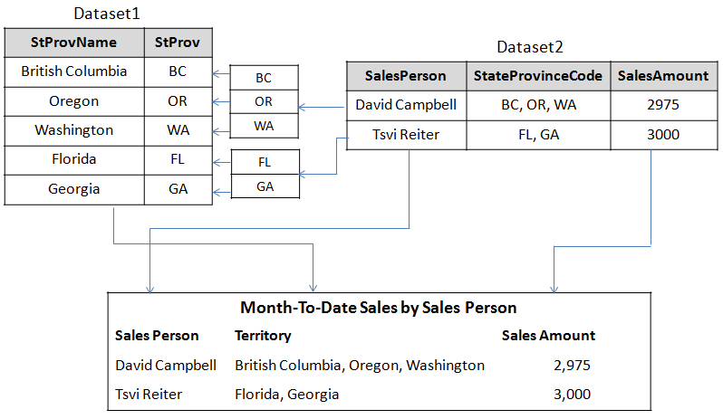
Figure 10-6: MultiLookup function results
The MultiLookup function in the second column of the table requires an array of values from the dataset bound to the table, which in this case is the StateProvinceCode field in Dataset2. You must first use the Split function to convert the comma-separated list of values in the StateProvinceCode field into an array. Reporting Services operates on each element of the array, matching it to the StProv field in Dataset1, and then combining the results into an array that you can then transform into a comma-separated list by using the Join function. Here is the expression in the Territory column:
=Join(MultiLookup(Split(Fields!StateProvinceCode.Value, ","), Fields!StProv.Value, Fields!StProvName.Value, "Dataset1 "), ", ")
When there is a one-to-many relationship between the source and destination values, you use the LookupSet function. This function accepts a single value from the source dataset as input and returns an array of matching values from the destination dataset. You could then use the Join function to convert the result into a delimited string, as in the example for the MultiLookup function, or you could use other functions that operate on arrays, such as the Count function, as shown in Figure 10-7.
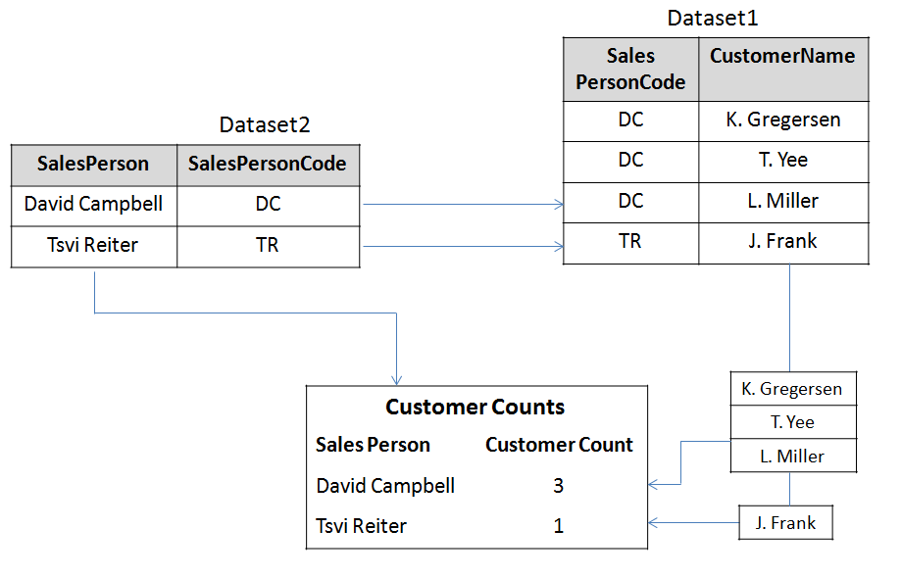
Figure 10-7: LookupSet function results

Increase IT Efficiency
IT administrators primarily care about usage statistics for published workbook applications, as well as statistics regarding the availability and performance of their Web applications, service applications, and databases hosted on front-end servers, application servers, and database servers in the SharePoint farm.
To provide this information, SQL Server 2008 R2 includes a customizable PowerPivot Management Dashboard that visualizes server and usage statistics with animated charts. The dashboard information helps IT administrators oversee their BI environments with operational efficiency, and it provides the basis to help ensure that user-generated BI solutions are continuously available, up to date and highly secure.

PowerPivot Management Dashboard
The PowerPivot Management Dashboard enables IT administrators to monitor activities and performance of shared workbook applications, track usage patterns over time, drill down to reveal hidden details, and detect solutions that have become mission-critical.

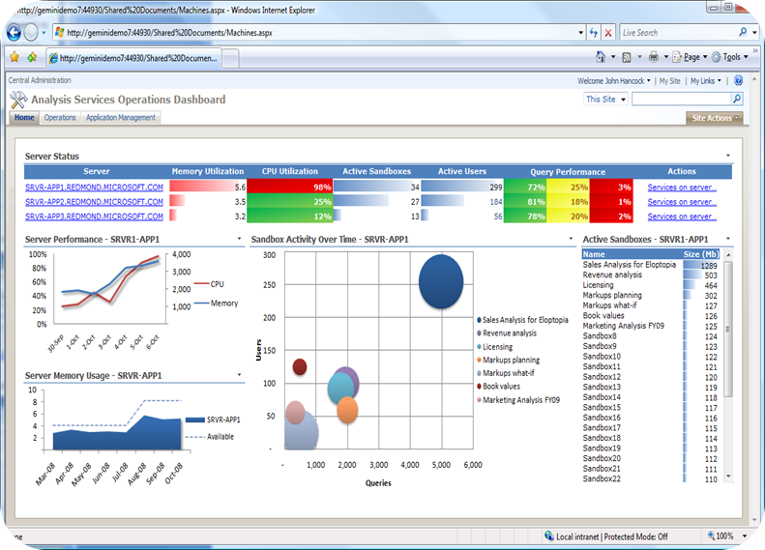

The dashboard reveals the largest and most popular solutions, their data sources, top users, and query-performance per workbook, and helps in this way to ensure high availability, scalability, and reliability for mission-critical applications. In addition, server administrators can keep an eye on CPU and memory utilization, system capacity and performance per server, response times, and current server state to provision appropriate server resources to ensure high availability and performance according to QoS requirements.
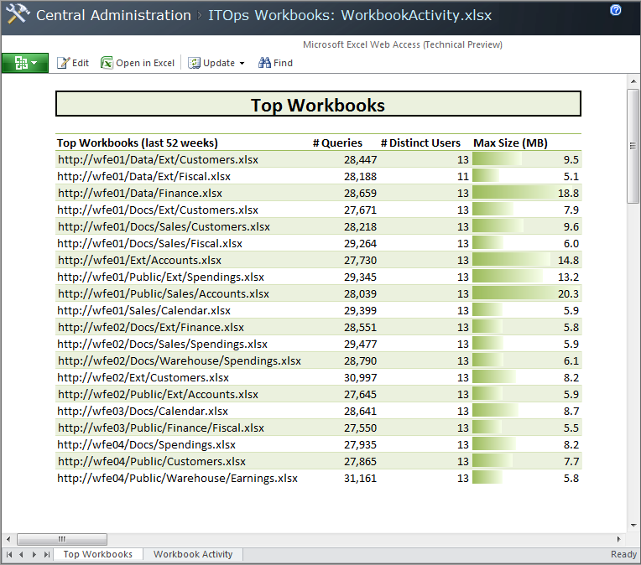
Most Popular Workloads Published in SharePoint
Leverage the PowerPivot Management Dashboard to monitor your shared applications. Track usage patterns over time, drill down to reveal hidden details, discover mission-critical solutions and make sure appropriate server resources are provisioned to ensure high availability and performance.

Reporting Services Atom Data Feed
SQL Server 2008 R2 Reporting Services includes a new rendering extension to support exporting report data to an Atom service document. An Atom service document can be used by any application that consumes data feeds, such as PowerPivot. You can use this feature for situations in which the client tools that users have available cannot access data directly or when the query structures are too complex for users to build on their own. Although you could use other techniques for delivering a data feeds to users, Reporting Services provides the flexibility to use a common security mechanism for reports and data feeds, to schedule delivery of data feeds, and to store report snapshots on a periodic basis.
To export a report to the Atom data feed, you click the last button on the toolbar in the Report Viewer, as shown in Figure 11-1.
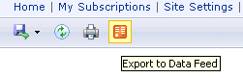
Figure 11-1: Atom Data Feed
The Atom service document is an XML document containing a connection to each data feed that is defined as a URL, as shown in the following XML code:
<?xml version="1.0" encoding="utf-8" standalone="yes" ?>
<service xmlns:atom="http://www.w3.org/2005/Atom"
xmlns:app="http://www.w3.org/2007/app" xmlns="http://www.w3.org/2007/app">
<workspace>
<atom:title>Reseller Sales</atom:title>
<collection
href="http://yourserver/ReportServer?%2fExploring+Features%2fReseller+Sales
&rs%3aCommand=Render&rs%3aFormat=ATOM&rc%3aDataFeed=xAx0x0">
<atom:title>TABLIX1</atom:title>
</collection>
</workspace>
</service>
SQL Server 2008 R2 Reporting Services-based data feeds provide the following advantages:

- Virtually unlimited data access. Users can get highly secure access to mission-critical information systems via server-based reports that access the source systems using a system account.
- Consolidated heterogeneous data sources. Reporting Services supports a wide range of data sources in reports that can serve as data feeds for analysis. Consolidating and preparing data helps to decrease analysis complexity, increases consistency, helps to compress decision cycles, and contributes to more accurate business insights.
- Increased power user productivity. With data-encapsulating and -consolidating reports readily available in the managed BI collaboration environment, users do not waste time importing data from a variety of internal and external sources.

IT and Developer Efficiency

There has never been greater demand for IT to provide more value with existing budgets and resources. SQL Server 2008 R2 provides new tools for managing large multidatabase environments along with improved capabilities to help maximize the value of consolidation efforts, and ensure the streamlined development and deployment of data-driven applications.

This section will focus on how SQL Server 2008 R2 helps the IT professional and developers become more efficient with enhancements to provide greater visibility and control, enable resource optimization and further drive deployment and administrative efficiencies.

Visibility and Control

The proliferation of software and database applications is increasing at a greater rate than the number of database administrators on staff so what you get is these overburdened administrators. On top of that, the increase in the hardware computing capacity tends to leave a lot of underutilized hardware. So IT admins not only need to become more efficient in managing a large number of applications, they also need to ensure that resources are optimally utilized.

Investments in application and multiserver management will help organizations proactively manage database environments efficiently at scale through centralized visibility into resource utilization and streamlined consolidation and upgrade initiatives across the application lifecycle — all with tools that make it fast and easy.

SQL Server Utility

This is a new manageability feature used to centrally monitor and manage database applications and SQL Server instances from a single management interface known as a Utility Control Point (UCP). Instances of SQL Server, Data-Tier Applications, database files, and volumes are managed and viewed within the SQL Server Utility.

Utility Control Point
As the central reasoning point for the SQL Server Utility, the UCP collects configuration and performance information from managed instances of SQL Server every 15 minutes.
After data has been collected from the managed instances, the SQL Server Utility dashboard and viewpoints in SQL Server Management Studio provide database administrators with a health summary of SQL Server resources through policy evaluation and historical analysis.

Utility Explorer
The Utility Explorer within the SQL Server Management Studio user interface provides a hierarchical tree view for navigating through and managing the entities in the SQL Server managed server group. This contrasts with SQL Server Management Studio Object Explorer as Object Explorer displays each instance as a completely independent object at the top of the hierarchy.

Utility Explorer Dashboards
The dashboards in the SQL Server Utility offer database administrators tremendous insight into resource utilization and health state for managed instances of SQL Server and deployed Data-Tier Applications across the enterprise.
Before the introduction of the SQL Server Utility, database administrators did not have a powerful tool included with SQL Server to assist them to monitor resource utilization and health state. Most organizations purchased third-party tools, which resulted in additional costs associated with the total cost of ownership of their database environment. The new SQL Server Utility dashboards also assist with consolidation efforts. Figure 1-2 illustrates SQL Server Utility dashboard viewpoints for providing superior insight into resource utilization and policy violations.
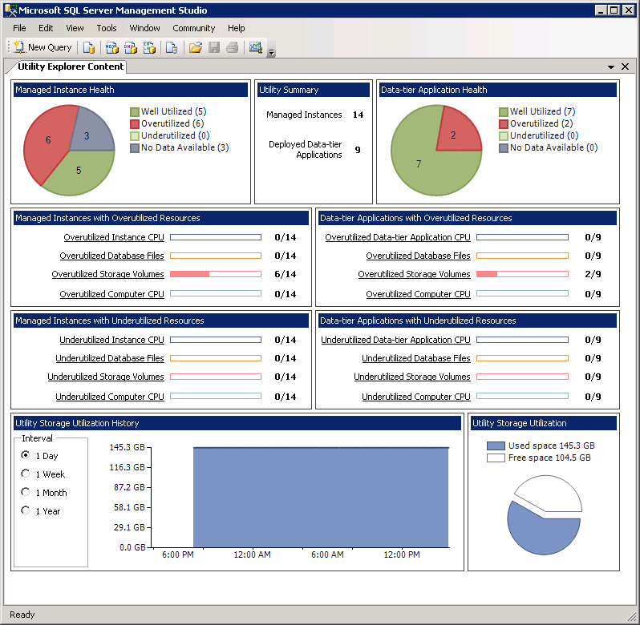

Optimize Resources
The widespread practice of running one major application and operating system per server has caused many server resources to be severely underutilized.
It has also resulted in server sprawl with many servers running at only 20 percent to 30 percent of their total system capacity. Companies have quickly realized that consolidating applications onto a fewer number of servers can provide tremendous economic benefits.
The database platform is intimately related to the operating system. Because of this relationship, Microsoft has designed Windows Server 2008 R2 to provide a solid IT foundation for business-critical applications such as SQL Server 2008 R2.
The combination of the two products produces an impressive package. With these two products, an organization can achieve maximum performance, scalability, reliability, and availability, while at the same time helping reduce the total cost of ownership associated with its database platform.

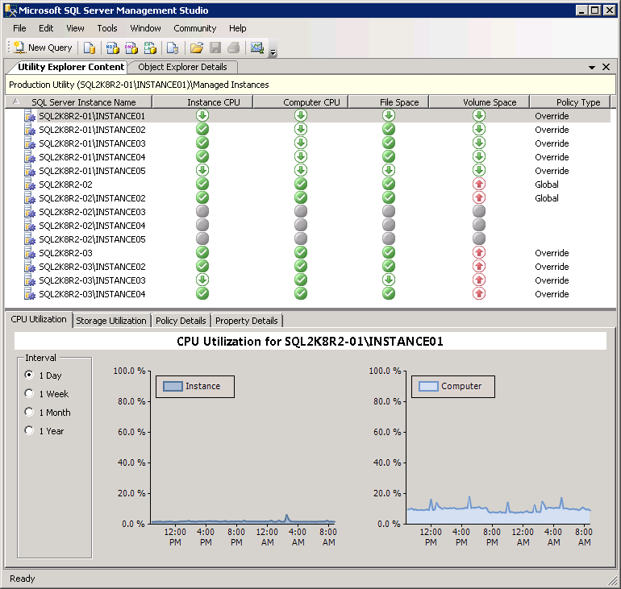
Consolidation Management
Organizations can maximize their investments by consolidating SQL Server resources onto fewer systems. Database administrators, in turn, can bolster their consolidation efforts through their use of SQL Server Utility dashboards and viewpoints, which easily identify underutilized and over utilized SQL Server resources across the SQL Server Utility. As illustrated in Figure 12-3, dashboards and viewpoints make it simple for database administrators to realize consolidation opportunities, start the process toward eliminating underutilization, and resolve overutilization issues to create healthier, pristine environments.

Figure 12-3: Identifying consolidation opportunities with the SQL Server Utility dashboard viewpoints

Hyper-V Virtualization

The Hyper-V virtualization technology improvements in Windows Server 2008 R2 were the most sought-after and anticipated enhancements for Windows Server 2008 R2. It is now possible to virtualize heavy SQL Server workloads, as Windows Server 2008 R2 scales far beyond its predecessors.

Hyper-V Virtualization Live Migration

By leveraging Live Migration and comma separated values (CSVs) — two new technologies included with Hyper-V and failover clustering on Windows Server 2008 R2 — it is possible to move virtual machines between Hyper-V hosts within a failover cluster without downtime.
This is achieved via an intricate process. First, all VM memory pages are transferred from the source Hyper-V physical host to the destination Hyper-V physical host. Second, any VM modifications to the VMs memory pages on the source Hyper-V physical host are tracked. These tracked and modified pages are transferred to the physical Hyper-V target computer. Third, the storage handles for the VMs’ virtual hard disk files are moved to the Hyper-V target computer. Finally, the destination VM is brought online.
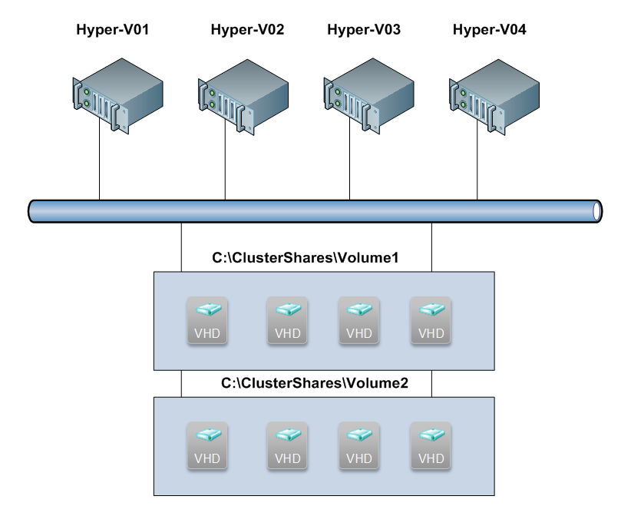
Figure 12-4 below illustrates a four-node Hyper-V failover cluster with two CSVs and eight SQL Server guest operating systems. With Live Migration, running SQL Server VMs can be seamlessly moved between Hyper-V hosts.

Figure 12-4: A Hyper-V cluster and Live Migration

Administrative Efficiencies
For centralized SQL Server management to provide incremental value, database administrators and developers need a single unit of deployment for their database applications to accelerate changes, upgrades, and deployments. Having the ability to more easily package and move database applications is especially important for streamlining the tasks associated with consolidation initiatives.
Data-Tier Application

To simplify the development and deployment of the data-tier, Microsoft has introduced the concept of a data-tier application (DAC). A DAC is a single unit of deployment that captures data objects and data-tier application artifacts. In other words, it is a container that includes server and database schema objects that are used by an application (for example., tables, views, logins and users), as well as deployment prerequisites that set the requirements on the instances of SQL Server where DACs can be deployed. The output file for a DAC is a Data-tier Application Component (.dacpac), this file is unpacked and deployed to a managed instance.
Database administrators can create a DAC package file from within an existing database. The DAC package can then be opened and edited by Visual Studio developers in Visual Studio 2010 to make changes to the data-tier. They can then build an updated DAC package file and send the changes to database administrators, who in turn deploy the updates using SQL Server Management Studio.
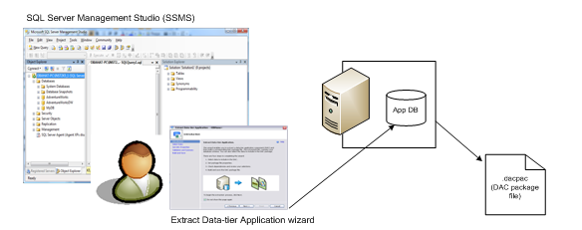
Figure 12-5: Extracting a DAC from an existing database.

DAC extraction and deployment are also extremely useful for upgrading databases to the SQL Server 2008 platform. Users can move databases by extracting a DAC from an instance of SQL Server 2000, SQL Server 2005, or SQL Server 2008, and then deploy the extracted DAC to an instance of SQL Server 2008 R2, through either SQL Server Management Studio or the Windows PowerShell command-line interface. Because the DAC contains server objects that the database depends upon, this process is extremely straightforward.

Global Monitoring Policies
Control Point health policies can be configured for data-tier applications and managed instances of SQL Server. Health policies can be defined globally for all data-tier applications and managed instances of SQL Server in the Utility Administration from within Utility Explorer, or they can be defined individually for each data-tier application and for each managed instance of the managed server group.
Using the Policy tab within Utility Administration, you can define global policies. For example, you could set the maximum and minimum values for managed instance processor utilization. This defines the levels at which instances are reported as over or under-utilized. These settings are defaults and each individual instance can have a specific setting. Furthermore, you can set global and individual policies for data-tier applications.

Advantages of Registering a Data-Tier Application to the Control Point Utility
The key benefit of using DACs is that they are designed to offer data-tier automation, including:
- Collecting large numbers of entities into one DAC that can be managed as a single unit through the full lifecycle of an application, including versioning.
- Automating the lifecycle of the data-tier by enabling developers to make changes to a data-tier application component, package it, and then pass it to database administrators for final deployment.
- Including policies that capture the intent of the developers, as well as deployment requirements on the instances of SQL Server where DACs can be deployed.

DAC Upgrade Efficiencies
DACs enable database administrators to upgrade the schema of SQL Server databases and instances from SQL Server 2000, SQL Server 2005, and SQL Server 2008 to SQL Server 2008 R2. Furthermore, the DAC contains any server level objects that the database depends upon such as logins.
To upgrade, users can point to a SQL Server 2000, SQL Server 2005, or SQL Server 2008 database, extract a DAC and create the corresponding DAC package file, and then deploy the DAC to a target instance of SQL Server 2008 R2. Then, data can be transferred from the source database to the target database by using SQL Server Integration Services, the bulk copy utility, or many other data migration techniques.

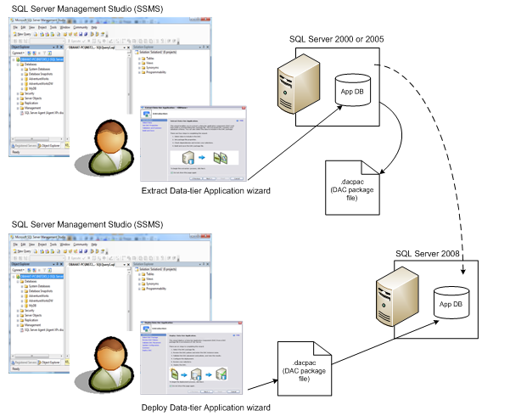

Figure 12-6: Upgrading to SQL Server 2008 R2 by extracting a DAC

SQL Server Sysprep
Organizations have been using the System Preparation tool (Sysprep) for many years now to automate the deployment of operating systems. SQL Server 2008 R2 introduces this technology to SQL Server.
Installing SQL Server with Sysprep involves a two-step procedure that is typically conducted by using wizards on the advanced page of the Installation Center. In the first step, a stand-alone instance of SQL Server is prepared. This step prepares the image; however, it stops the installation process after the binaries of SQL Server are installed. To initiate this step, select the Image Preparation of a stand-alone instance for Sysprep Deployment option on the advanced page of the installation center.
The second step completes the configuration of a prepared instance of SQL Server by providing the machine, network, and account-specific information for the SQL Server instance. This task can be carried out by selecting the Image Completion of a prepared stand-alone instance step on the advanced page of the installation center. SQL Server 2008 R2 Sysprep is recommended for database administrators seeking to automate the deployment of SQL Server while investing the least amount of their time.

SQL Azure
Microsoft SQL Azure Database is a cloud database service from Microsoft. SQL Azure provides Web-facing database functionality as a utility service. Cloud-based database solutions such as SQL Azure can provide many benefits, including rapid provisioning, cost-effective scalability, high availability, and reduced management overhead. This paper provides an architectural overview of SQL Azure Database, and describes how you can use SQL Azure to augment your existing on-premises data infrastructure or as your complete database solution.
Introduction
Companies that provide Internet-based applications are facing many challenges today. Users expect access to ever-increasing amounts of data from anywhere, at any time, and from any device. The size, scale of use, and variety of forms of data are expanding rapidly. Developers must build and deploy applications quickly to keep up with these growing demands. Using the traditional on-premises data management model, meeting these needs demands constant investment in and management of servers, operating systems, storage, and networking. IT and operational staff must constantly monitor the infrastructure to ensure that capacity, performance, and availability are maintained as data volumes and user loads increase.

Cloud database services, such as Microsoft SQL Azure Database, provide an improved way to respond to these challenges. SQL Azure is built on three key tenets: manageability, scalability and developer agility.

From a developer's perspective, SQL Azure offers the well-known rich relational programming model, and uses a familiar data access protocol and simple deployment options. SQL Azure simplifies the process of creating, prototyping, and deploying applications that integrate data across the enterprise. SQL Azure removes infrastructure obstacles, thereby giving developers more freedom to innovate and experiment with new ways of sharing data.

From the IT management perspective, SQL Azure offers a systematic and highly secure cloud-deployed solution that works with your on-premises assets and gives the IT organization oversight and control of distributed data assets. SQL Azure is built on the same Microsoft SQL Server technologies that have already been used and proven in on-premises deployments to provide high availability, reliability, and security.

From the business perspective, SQL Azure offers a cost-effective approach for managing data, with a flexible consumption-based pricing plan, near-zero capital and operational expenditures, and the ability to quickly and easily scale up or down as your needs change.

If you are planning to build applications on large or shared data sets, provide on-demand scalable data storage, or augment your on-premises data infrastructure with low-cost, rapidly provisioned cloud-based storage, SQL Azure can provide a robust and cost-effective solution.

Manageability

SQL Azure Database offers the high availability and functionality of an enterprise datacenter without the administrative overhead that is associated with an on-premises solution. This self-managing capability enables organizations to provision data services for applications throughout the enterprise without adding to the support burden of the central IT department or distracting technology-savvy employees from their core tasks to maintain a departmental database application.

Low-Friction Provisioning. When you use the traditional on-premises data infrastructure, the time that it takes to deploy and secure servers, network components, and software can slow your ability to prototype or roll out new data-driven solutions.

However, by using a cloud-based solution such as SQL Azure, you can provision your data storage needs in minutes and respond rapidly to changes in demand. This reduces the initial costs of data services by enabling you to provision only what you need, secure in the knowledge that you can easily extend your cloud-based data storage if required at a future time.

High Availability. SQL Azure is built on robust and proven Windows Server and SQL Server technologies, and is flexible enough to cope with any variations in usage and load. The service replicates multiple redundant copies of your data to multiple physical servers to ensure data availability and business continuity. In the case of a disaster, SQL Azure provides automatic failover to ensure maximum availability for your application.
Published service level agreements help to ensure a business-ready service. When you move to SQL Azure, you no longer need to back up, store and protect data yourself.
Scalability

A key advantage of the cloud computing model is the ease with which you can scale your solution. Using SQL Azure, you can create solutions that meet your scalability requirements, whether your application is a small departmental application or the next global Web success story.

Global Scalability. A pay-as-you-grow pricing model allows you to quickly provision new databases as needed or scale down the services without the financial costs associated with unused capacity. With a database scale out strategy your application can utilize the processing power of hundreds of servers and store terabytes of data.

SQL Azure runs in worldwide datacenters, so you can reach new markets immediately.

If you want to target a specific region, you can deploy your database at the closest datacenter. You can harness this global scalability to build the next generation of Internet-scale applications that have worldwide reach, but without the infrastructure costs and management overhead.

Multitenant Support. ISVs who develop software plus services offerings must provide adequate isolation for individual customers’ data. ISVs must be able to charge each customer the right price for the data storage services that they have consumed. SQL Azure provides the flexibility that ISVs need to segregate customer data and implement multitenant billing, which enables you to build a global software plus services solution quickly and easily.
Developer Empowerment

One of the potential obstacles to building great cloud-based applications is the requirement for developers to learn new tools, programming platforms, and data models. However, SQL Azure is built on top of the T-SQL language and is designed to be compatible with SQL Server with a few changes, so developers can use their existing knowledge and skills. This reduces the cost and time that is usually associated with creating a cloud-based application.

Familiar Client Development Model. When developers create on-premises applications that use SQL Server as a data store, they employ client libraries that use the Tabular Data Stream protocol to communicate between client and server. There is a large global community of developers who are familiar with SQL Server and have experience of using one of the many client access libraries that are available for SQL Server, such as Microsoft ADO.NET, Open Database Connectivity (ODBC), Java Database Connectivity and the SQL Server driver for PHP. SQL Azure provides the same TDS interface as SQL Server, so developers can use the same tools and libraries to build client applications for data that is in the cloud.

Proven Relational Data Model. SQL Azure data is stored in a way that is very familiar to developers and administrators who use SQL Server. You can create a SQL Azure Server which is a group of databases that are spread across multiple physical machines. This SQL Azure Server is in some ways conceptually analogous to a SQL Server instance and acts as an authorization boundary just as in SQL Server. You can also set geo-location at this level. Windows Azure and SQL Azure data centers are located worldwide; if your application is relevant to a specific region, you can increase performance by geo-locating it there.
Within each server, you can create multiple databases that have tables, views, stored procedures, indices, and other familiar database objects. This data model ensures that your database developers can use their existing relational database design and T-SQL programming skills, and easily migrate existing on-premises database applications to the cloud.
SQL Azure servers and databases are logical concepts that do not correspond to physical servers and databases. This abstraction enables the flexible provisioning that was described earlier in this paper. Administrators and developers can concentrate on data model design because SQL Data Services insulates them from the physical implementation and management.
Synchronization and Support for Offline Scenarios. SQL Azure is part of the rich Microsoft data platform that works with the Microsoft Sync Framework to support occasionally connected synchronization scenarios. For example, by using SQL Azure and the Sync Framework, on-premises applications and client devices can synchronize with each other via a common data hub in the cloud.

Conclusion

The groundbreaking new tools and technologies included in SQL Server 2008 R2 enable organizations to empower their users, facilitate seamless and highly secure sharing and collaboration on user-generated BI solutions, and help to increase IT and BI developer efficiencies. Tools such as PowerPivot for Excel 2010 and Report Builder 3.0, and innovative technologies such as PowerPivot for SharePoint 2010, Analysis Services in SharePoint on VertiPaq or traditional storage modes, Reporting Services, and Master Data Services, not only tackle all typical BI challenges in the enterprise, they truly change the game of BI. The focus shifts from IT delivering organizational BI solutions to a managed BI collaboration environment that gives users the power to get timely and reliable information to make more relevant decisions.
Thanks to SQL Server 2008 R2 technology, it is becoming easier for business users to get accurate answers in seconds and to ask even more questions, drill down into details, discover new information, and new questions, and new answers.

