Find Your Contacts Quickly and Easily
Microsoft® Outlook® 2010 integrates with the Office Communicator 2007 R2 to deliver great new contact features: Contact Cards and Quick Contacts. These “at-your-fingertips” features make it simple to communicate with colleagues using instant messaging, e-mail, or phone calls.
Contact Cards  Get instant access to your contacts through IM, e-mail, or phone with Contact Cards. Plus, photos of your contacts in Outlook 2010 help you put a face to the name.  Step by Step:  - Place your mouse cursor so it hovers over a name in Outlook to bring up the Contact Card. The color of the Presence status icon  alerts you to your contact’s current availability. (In this example, green means the contact is online and available.)  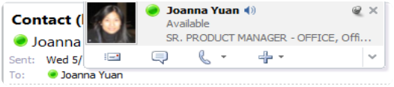  - Click the e-mail message icon to open a new e-mail to that person, or…  - Click the balloon  icon to start an instant messaging session, or the phone  icon to make a phone call.  - If you are not sure how to pronounce a person’s name, click the speaker icon to hear the contact’s recorded name.²  - Click the thumbtack icon to pin the Contact Card in place. | Quick Contacts  Quick Contacts uses Outlook 2010 integration with Office Communicator to provide access to your Communicator contacts directly from Outlook, under the Tasks bar.  Step by Step:  - Make sure you are signed in to Communicator in order to view Quick Contacts.  - Expand the to-do bar to the right of your message pane to show your Communicator contacts.  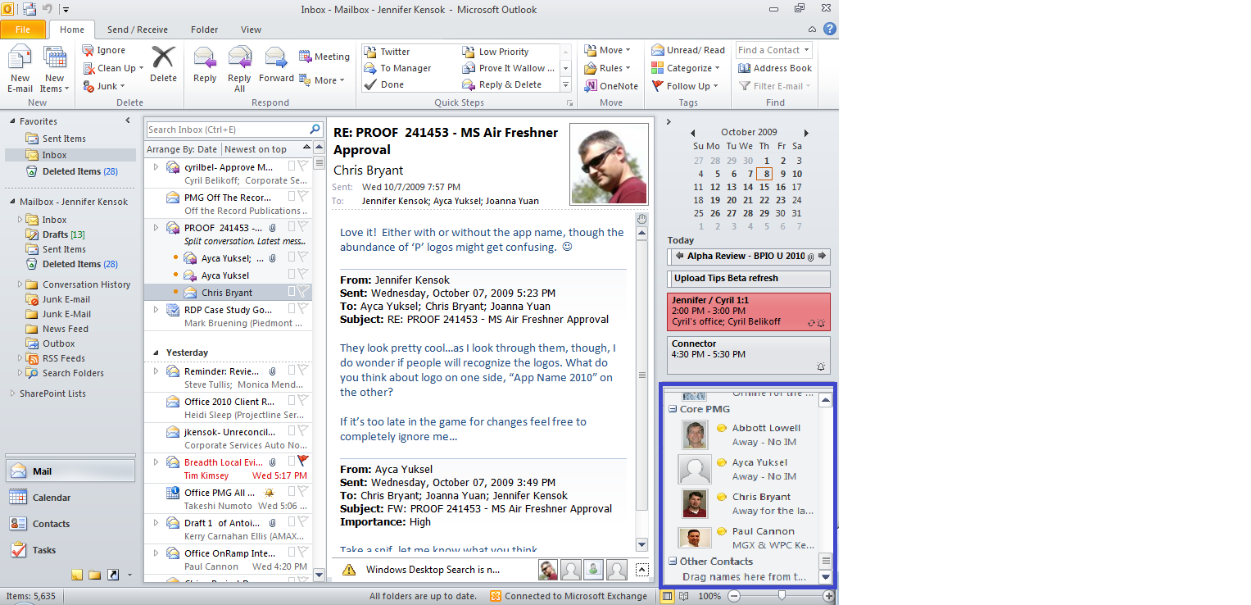  - With Quick Contacts at the bottom of the bar, you can see your recent contacts in Outlook. Hover over a name to display the Contact Card and initiate a conversation directly.

