Country or Region
 | Zensar Technologies  Employees Use Portal to Route Performance Reviews and Reduce Cycle Time by 50 Percent
Zensar Technologies of Pune, India, provides offshore software development services to Fortune 500 companies around the world. With staff members in 18 countries and growth topping 40 percent annually, Zensar wanted to streamline its employee review process, which took up to two months per employee and impaired the company’s ability to retain talent. Zensar used Microsoft® software to create a Web-based assessment portal with built-in workflow and document storage. Employees and managers now have greater control over their reviews and have shortened the review process by up to 50 percent.
overview

“The HR Assessment Portal is a great example of using innovative software to reduce business costs.”

Kumar Gaurav, Practice Head, Enterprise Collaboration and Content Management, Zensar Technologies

India

Industry
Professional services--IT Services

Customer Profile
Zensar Technologies of Pune, India, provides software development and management services for companies worldwide. Zensar has approximately 3,500 employees in 23 locations around the world.

Business Situation
As Zensar expanded internationally, its manual, paper-based employee-review process became more time-consuming and frustrating. Employees couldn’t access previous assessments or track their reviews.

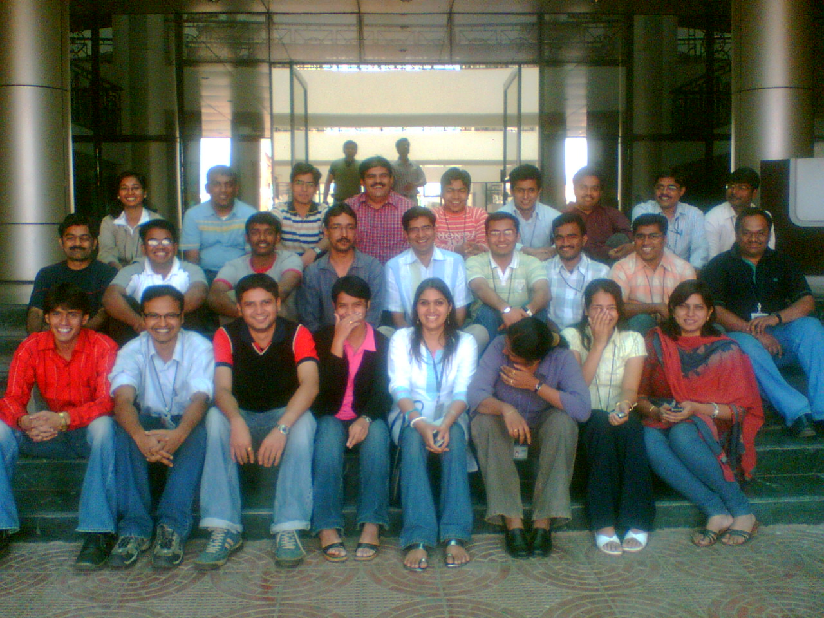
Solution
In just 16 days, Zensar used Microsoft® software to create a Web-based portal that employees use to create and track annual performance reviews.

Benefits
- Employee-friendly assessment process
- Up to 50 percent reduction in review process
- Better employee retention

Situation
When a company is growing rapidly and employees are located all over the world, routine administrative tasks can become tedious and time-consuming, which bogs down productivity and undermines morale. That’s what employee performance reviews were like at Zensar Technologies, a software developer headquartered in Pune, Maharashtra, India.

The company has development centers in 23 locations around the world, with approximately 3,500 employees in places as far-flung as China, Poland, South Africa, Singapore, and Latin America. With rapid growth in so many locations, annual employee performance reviews had become a tangled and burdensome ordeal. “We had a paper-based, manual process that involved sending documents around as e-mail attachments,” explains Kumar Gaurav, Practice Head, Enterprise Collaboration and Content Management, at Zensar Technologies. “Employees could not track their assessments-in-progress or save assessments from previous years, and HR [Human Resources] was responsible for keeping the whole process moving for thousands of employees.”

The HR staff commenced the process by sending employees an e-mail message containing an assessment document. Employees would complete the form, evaluating themselves on their completion of annual goals, and then send it back to HR. The HR staff would then send the form serially to the employee’s managers, who, if the employee worked on multiple projects that year, were sometimes located all over the world. When all the assessments were in, the HR staff obtained the employee’s consent to the final appraisal and calculated a score that was used to set the employee’s annual raise and bonus. The whole process took between one and two months for each employee.

Besides taking a long time, the old system made it impossible for employees to access their past reviews and made it difficult for managers to communicate about employee performance or share information. “Our managers and employees are all over the world and move constantly from project to project,” Gaurav says. “We had to reinvent the wheel every time an employee was reviewed, because paper forms were inaccessible to anyone outside of HR.” Often, employees worked at client sites and had client e-mail addresses, which made it awkward to conduct evaluation-related phone calls and to send confidential assessment documents.

“As a manager, I had no idea how many assessments I had done or had left to do unless I tracked it myself. This hurt my ability to plan my workload,” Gaurav says. “As an employee, I had no ability to access previous years’ assessments or to track the progress of my appraisal. Our hiring market is quite heated, and our appraisal system was hurting our ability to retain talent.”

Solution
Zensar wanted to solve this internal process problem quickly and cost effectively and focus on its primary business of creating great software for clients. When Zensar heard about Microsoft® Office SharePoint® Server 2007—portal software with built-in electronic forms and workflow capabilities—it decided that it had found its solution foundation.

“Now [employees] can follow their appraisal on the portal and see when it’s through management review and with HR. The system is completely transparent.”
Kumar Gaurav, Practice Head, Enterprise Collaboration and Content Management, Zensar Technologies

“Microsoft software is very easy to use, and it’s a very flexible development environment,” Gaurav says. “We didn’t want to spend a lot of time on development. We liked the built-in workflows in the new Microsoft collaboration software and the ability to easily connect the solution to other business software we had; namely, our PeopleSoft employee data and our network-credential data.”

In just 16 person-days, Zensar developers used Microsoft software to create an electronic performance appraisal system called the HR Assessment Portal. With the new system, the HR staff still sends an e-mail message to each employee when it is time for his or her performance review. But instead of sending a document, HR embeds a link to a Web site. With one click, the employee can access an electronic form that contains his or her previous-year’s assessment for reference to begin the process.

When employees complete their online self-assessments, they exit the system, which automatically generates an e-mail message to the employee’s supervisor. That e-mail message also contains a link to the portal. Each time a manager completes his or her review of an employee, the system automatically triggers a review by the next appropriate person. From the portal, managers can search a database for past reviews and other documents related to that employee’s performance. They can even initiate online conversations with other managers, which shortens the time spent tracking down documents and people.

When the assessment is complete, the HR Assessment Portal automatically calculates a recommended raise and bonus for the employee, relieving the HR staff and managers of a task that used to take two weeks per review.

Benefits
Zensar now has a Web-based shared-workspace and collaboration environment that employees can use to more easily create and track annual performance reviews. The company has been able to reduce employee review times by up to 50 percent and has improved employee satisfaction, which helps retain talent.

Employee-Friendly Assessment Process

Using the new HR Assessment Portal, employees can record their accomplishments online throughout the year rather than having to wait until the HR staff initiates their review. They can also access their previous years’ assessments, for easy reference in completing current assessments. The electronic forms are easy to complete, with many fields that fill automatically and others that have clear prompts.

Executive Biography
Kumar Gaurav heads Zensar’s enterprise collaboration and content management practice, where he is responsible for building a business from the ground up and developing skills across multiple competency centers. Gaurav specializes in business transformation consulting and has worked with Fortune 500 companies to improve their IT strategy, knowledge management, and collaboration.

“All employee achievements are now in one place, which makes it far easier for employees and managers to record information, and encourages them to do so,” Gaurav says. “Employees and managers don’t have to track down their achievement data once a year; they can enter accomplishments as they occur, in one central place.”

Employees can also track the status of their reviews online instead of sending e-mail queries to the HR staff. “Employees are anxious to know when they will receive their manager’s comments,” Gaurav says. “Now they can follow their appraisal on the portal and see when it’s through management review and with HR. The system is completely transparent.”

Managers, too, can centrally track how many appraisals are headed their way and where their staff members are on their appraisals. “As a manager, the new system makes my communication with HR and with my own staff much easier. As soon as I agree on a score for an employee, the compensation is automatically calculated,” Gaurav says. “The system even shows me a complete view of all my employees’ scores so I can see how my team is doing in meeting their annual objectives.”

Up to 50 Percent Reduction in Review Process
As a result of the automated efficiencies it has achieved, Zensar has been able to reduce the length of the employee review process by up to 50 percent—from as long as two months to one month or less per employee. The reduction in time reduces costs; Zensar has been able to redeploy one full-time staff member in its HR department to a higher-level and more satisfying management position.

“We are growing rapidly, but we want our hiring to be focused on profit-generating positions, not in operational areas such as HR,” Gaurav says. “The HR Assessment Portal is a great example of using innovative software to reduce business costs.”

Better Employee Retention
Creating the online assessment system has also helped Zensar create a positive image with its employees, which helps it retain talent. Gaurav and staff have been able to transform the onerous annual review process into a more transparent, objective, and supportive process.

“The more we smooth out administrative tasks such as performance reviews, the more employees like their jobs,” Gaurav says. “Making the effort to improve this particular process lets employees know that Zensar cares about their accomplishments and appreciates their work. Any way that we can remove frustration from our employees’ work lives makes them more productive, happier employees.”

This case study is for informational purposes only. MICROSOFT MAKES NO WARRANTIES, EXPRESS OR IMPLIED, IN THIS SUMMARY.
Document published December 2007

Customer Details:
Zensar Technologies
Phone: 91-20-66057500
Web site: www.zensar.com

The People-Ready Business.
A people-ready business is one where people can apply their unique skills, insights and experience to create new products and services, work responsively with customers and partners, and drive operational excellence in every aspect of the business. People-ready businesses support people with knowledge, practices and tools so that they can add the extra value that helps differentiate successful organizations in a competitive, fast-moving global economy.
www.microsoft.com/peopleready

Software & Services
Windows Server® 2003
Microsoft® SQL Server™ 2005
Microsoft Office InfoPath® 2007
Microsoft Office Outlook® 2007
Microsoft Office SharePoint® Server 2007

