

Internet Explorer 8
Technology Overview
for Enterprise and IT Professionals
January 2009
Table of Contents
Executive Overview 1
Internet Explorer 8 is the Business-Ready Browser 1
About Internet Explorer 8 2
Enterprise Ready 4
Compatibility View 4
Using the Compatibility View 5
. Configuring Compatibility View 6
Application Compatibility Tools 7
Ready to Deploy 8
Standalone Installation 8
Slipstream Installation 9
Internet Explorer Administration Kit Enhancements 9
Management Enhancements 10
Group Policy Enhancements 10
Managing User Settings Post-Deployment with the Internet Explorer Administration Kit 10
Reduces Security Risks 11
Enhanced Delete Browsing History 11
InPrivateTM Browsing 12
InPrivateTM Filtering 14
SmartScreen® Filter 15
Safer ActiveX® Controls and Management 19
Cross-Site Scripting Filter 20
Data Execution Prevention 22
Other Security Features 22
Tab Isolation 24
Crash Recovery 27
Enhanced Add-on Management 27
Diagnose Connection Problems Button 30
Improved Support for Accessibility Standards 31
Adaptive Page Zoom 32
Enables New Business Scenarios 33
Accelerators 33
Web Slices 34
Improved Productivity 35
Enhanced Favorites Bar 36
Enhanced Find on Page 36
Enhanced Instant Search 37
Redesigned “New Tab” Page 38
Smart Address Bar 39
Enhanced Tabbed Browsing 40
A Better Back Button 41
Customizing the User Interface 41
Interoperability Saves Developers Time 41
Integrated Developer Tools 42
New Features Make it Easy to Build Rich Applications 43
Extended Support Lifecycle 44
Summary 45

© 2009 Microsoft Corp. All rights reserved.
This is a preliminary document and may be changed substantially prior to final commercial release of the software described herein.
The information contained in this document represents the current view of Microsoft Corp. on the issues discussed as of the date of publication. Because Microsoft must respond to changing market conditions, it should not be interpreted to be a commitment on the part of Microsoft, and Microsoft cannot guarantee the accuracy of any information presented after the date of publication.
This white paper is for informational purposes only. MICROSOFT MAKES NO WARRANTIES, EXPRESS OR IMPLIED, AS TO THE INFORMATION IN THIS DOCUMENT.
Complying with all applicable copyright laws is the responsibility of the user. Without limiting the rights under copyright, no part of this document may be reproduced, stored in or introduced into a retrieval system, or transmitted in any form or by any means (electronic, mechanical, photocopying, recording or otherwise), or for any purpose, without the express written permission of Microsoft.
Microsoft may have patents, patent applications, trademarks, copyrights or other intellectual property rights covering subject matter in these documents. Except as expressly provided in any written license agreement from Microsoft, the furnishing of this document does not give any license to these patents, trademarks, copyrights or other intellectual property.
Microsoft, ActiveX, Active Directory, InPrivate, Internet Explorer, the Internet Explorer logo, Windows, the Windows logo, Windows Live, Windows Server, and Windows Vista are either registered trademarks or trademarks of Microsoft Corp. in the United States and/or other countries.
The names of actual companies and products mentioned herein may be the trademarks of their respective owners.
Microsoft Corp. • One Microsoft Way • Redmond, WA 98052-6399 • USA

Executive Overview
Welcome to the Windows® Internet Explorer® 8 Technology Overview for Enterprises and IT Professionals. Internet Explorer is currently the most widely used browser in business. While organizations often think of applications as one of the main areas that must be secured, the browser is an application portal which is a main link to many business applications living on the Web. In a typical work day, users spend 2 hours or more per day in the browser. Not only is the browser an application portal, but it is also the portal with access to the most uncontrolled applications users will interface with such as external Web sites, plug ins, and online applications. The browser needs to be thought of in the same terms as an operating system—it has to be rich, robust, interoperable, easy to use and secure. Internet Explorer 8 is a browser that meets the needs of users, enterprises, IT professionals and developers. Internet Explorer 8 is ready for deployment in the enterprise.

Internet Explorer 8 is the Business-Ready Browser
One of the main jobs of IT professionals is to make sure that information in the organization is secure and can be easily accessed. A few years ago, many applications were unmanaged, e-mail lacked filters, and firewalls were rarely used. Today, firewalls and filters are the first things that IT Professionals put into place on networks. A browser is like any other application—it can be well managed and secure, or poorly managed. If a browser is poorly managed, IT professionals and enterprises risk spending more time and dollars supporting users and dealing with security infiltrations, malware, and loss of productivity.
Organizations are doing an increasing amount of business on the Web. That business will continue to grow only if customers trust the Web as a safe place to do business. Unfortunately, customer’s trust in the Web as a place to do business is under attack from phishers and other criminals intent on using the Web as a place to expand their criminal activities. From the start, Internet Explorer 8 is built to help customers and users browse more safely, helping to maintain customer trust in the Internet and helping to protect the IT environment from the evolving threats presented by the Web. Internet Explorer 8 delivers new features and enhancements for enterprises, developers, users and IT professionals to meet their needs in the following main areas.
- Enterprise ready
- Reduces security risks
- Improves IT Productivity
- Enables new business scenarios
- More Reliable
The remainder of this document describes how Windows® Internet Explorer® 8 delivers improvements for the enterprise, and IT professionals as well as users and developers.

About Internet Explorer 8
We understand the need for IT professionals and developers to evaluate software products and define the business value before committing time and resources to deploying software updates. This document will help enterprise customers and IT professionals understand the value of upgrading and preparing their organization for Internet Explorer 8. Let’s look at why you will benefit by upgrading to Internet Explorer 8 as soon as possible; below are the primary benefits:
Internet Explorer 8 is enterprise ready: Internet Explorer 8 is the business-ready browser with Enterprise-class deployment, management, compatibility and security as a standard. It is designed to be compatible with applications written for Internet Explorer 7 and has a complete range of deployment tools including a deployment guide, Internet Explorer Administration Kit for customization, Slipstream, Systems Center Configuration Manager and Windows Server Update Services. More than 1,300 group policies are included in Internet Explorer 8 that allow IT professionals to customize Internet Explorer 8 to meet the needs of their enterprise. In addition, professional support is available by phone or email. For more information, see the Enterprise Ready section.
Internet Explorer 8 reduces security risks: Internet Explorer 8 reduces the risk of your IT environment being compromised by a wide range of evolving security and privacy threats on the Web. Internet Explorer 8 is specifically designed to help users maintain their privacy with features such as InPrivate™ Browsing and InPrivate™ Filtering. The new SmartScreen® Filter provides protection against social engineering attacks by identifying malicious Web sites trying to trick people into giving up personal information or installing malicious software, blocking the download of malicious software and providing enhanced anti-malware support. Internet Explorer 8 helps prevent the browser itself becoming an attack vector: it is built with the Secure Development Lifecycle (SDL) and provides more granular control over the installation of ActiveX® controls with per-site and per-user ActiveX features. The Cross Site Scripting Filter protects against attacks against Web sites themselves. For more information, see the Reduces Security Risks section.
Internet Explorer 8 provides speed and efficiency for the user: Many of the usability features in Internet Explorer 8 are designed to make the user experience better. Users can customize how the browser is used and work the way they want faster. Explorer 8
Accelerators, Web Slices, and AJAX enhancements provide the enterprise with a persistent connection with your users which keeps them closer to your site. Built-in developer tools in Internet Explorer 8 provide advanced code debugging and profiling. For more information, see the Enables New Business Scenarios section.

Enterprise Ready
The browser is becoming an increasingly central part of the enterprise and IT Environment—as an application platform and as a window to the potentially dangerous world of the Web. Built with security and application compatibility in mind, Internet Explorer 8 helps to keep customers, users and investment in Internet Explorer 7 applications safe.
Internet Explorer 8 is easy to deploy and manage in an enterprise. It supports a variety of deployment options, and configuration through the Internet Explorer Administration Kit and Group Policy. Internet Explorer 8 also provides better compatibility with applications written for Internet Explorer 7. It renders sites in the Intranet Zone using the Internet Explorer 7 engine by default. Developers can use a simple tag on their Web pages or Web server to tell Internet Explorer 8 to render like Internet Explorer 7. This provides the organization the benefits of Internet Explorer 8 without requiring application upgrades. In addition, new events are being added to the Application Compatibility Toolkit (ACT) to help IT professionals detect and resolve potential issues between Internet Explorer 8 and their internal applications and Web sites. Internet Explorer 8 also provides for greater administrator management of ActiveX controls through per-user ActiveX and per-site ActiveX.

Compatibility View
One of the major investments in Internet Explorer 8 is in a new rendering engine which is designed to more closely follow Web standards. Web standards aim to simplify Web site development by defining a set of rules that all browsers should follow to render Web pages. This consistent approach to rendering Web pages will save developers time in the long term allowing them to focus on innovation in their pages rather than spending time producing a version of a page for each browser. Internet Explorer 8 uses this standards based engine as the default rendering engine which can cause some sites to display differently than expected. Internet Explorer 8 also includes the Internet Explorer 7 rendering engine to provide a “Compatibility View” for Web pages designed for Internet Explorer 7.
Explorer 8The main features in Compatibility View are:
- Internet Web sites display in Internet Explorer 8 Standards Mode by default. Use the Compatibility View button to fix sites that render differently than expected, for example, misaligned text or overlapping graphics.
- Internet Explorer 8 remembers sites that have been set into Compatibility View so that the button only needs to be pressed once for a site and from then, that site is always rendered in Compatibility View unless removed from the list.
- Internet Explorer 8 ships with a list of sites provided by Microsoft known to require Compatibility View. This list will be periodically updated through Windows Update/Automatic Updates.
- Intranet Web sites display in Internet Explorer 7 Standards Mode by default. Compatibility View is “on” for the Local Intranet which means that internal Web sites should “just work”.
- IT Professionals can use Group Policy to set a list of Web sites that should be rendered in Compatibility View.
- Switching in and out of Compatibility View (between Internet Explorer 7 and Internet Explorer 8 modes) happens without restarting the browser.
The Compatibility View feature helps manage Web sites that don’t display correctly in Internet Explorer 8 and may result in fewer calls to the help desk with browser issues.

Using the Compatibility View
The Compatibility View button only displays when toggling into Internet Explorer 7 Compatibility View makes sense, such as when the developer hasn’t clearly stated in their code how they want their Web site to be rendered. In all other cases, such as viewing intranet sites (they’re already being displayed in Internet Explorer 7 Compatibility View), or viewing sites with a <META> tag / HTTP header indicating Internet Explorer 7 or Internet Explorer 8 Standards, the button is hidden.
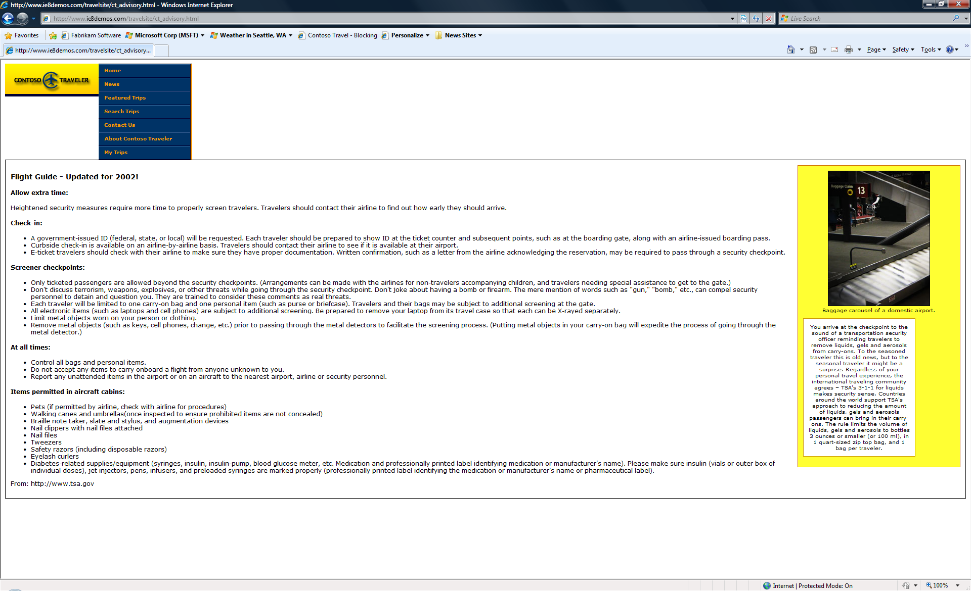
Depending on the speed of the machine, you may see the page refresh when the Compatibility View button is selected. A balloon tip indicates that the site is now running in Compatibility View. Additionally, the Compatibility View icon appears “pressed” showing what view you’re running in after the balloon tip disappears. The "scope" of Compatibility View is limited to the domain you are viewing when the button is pressed. And, Internet Explorer remembers your button press for the domain so that the next time you visit the site you don't have to press the button again. However when you visit other sites, Internet Explorer 8 will render in Internet Explorer 8 Standards mode.

. Configuring Compatibility View
A new entry in the ‘Tools’ menu allows for advanced configuration of the feature.
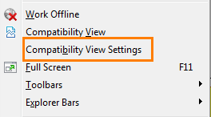
IT professionals can customize Compatibility View to meet the needs of the enterprise. Options allow IT professionals to make it so that all Intranet sites display in Internet Explorer 8 mode instead of the default Internet Explorer 7 mode. A policy can also be configured so that every site is viewed in Compatibility View, in which case, no button would appear. Finally, it is possible to pre-populate a list of sites that should always be viewed in Compatibility View.
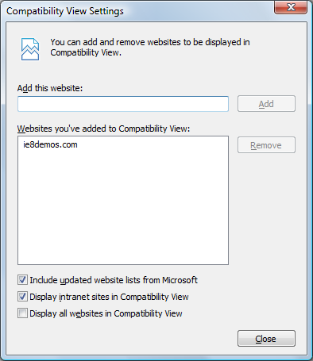

Application Compatibility Tools
The Application Compatibility Toolkit (ACT) is a set of tools to help IT Professionals identify potential application compatibility issues with the Windows Vista® operating system. The Internet Explorer Compatibility Evaluator component of ACT is designed to help IT Professionals track down potential compatibility issues with Web sites. For Internet Explorer 8, new events have been added to the Application Compatibility Toolkit (ACT) to help IT professionals detect and resolve potential issues between Internet Explorer 8 and their internal applications and Web sites. In addition, Group Policy settings are provided to help IT administrators control settings that most impact compatibility with a high degree of granularity.
For example, an IT professional notices that after installing Internet Explorer 8, some of the corporate Web pages and applications are not loading correctly. He wants to turn on logging and find out what is causing the problem so that he may debug and fix the issue. Events that are now logged include those for the Cross-Site Scripting Filter, Standards Mode, Windows Reuse Navigation Restriction, MIME restrictions, file name restriction, Control Block, DEP/NX, ActiveX control blocking, Intranet integrity, Codepage sniffing, Web Proxy handling changes and AJAX navigation. When Application Compatibility Tools are run, a log is created of compatibility events. In Internet Explorer 8, an error message is displayed when there is a compatibility event and a link provided to a white paper that describes in detail all of the compatibility issues, mitigations and fixes. The IT professional would use the information from the whitepaper to help resolve compatibility issues.
The new Application Compatibility Toolkit (ACT) with support for Internet Explorer 8 is available from MSDN (http://msdn.microsoft.com/en-us/library/cc994321(VS.85).aspx). It is accompanied by a white paper explain the compatibility issues identified by the tool (http://msdn.microsoft.com/en-us/library/cc994321(VS.85).aspx).
In addition, granular Group Policy settings help IT administrators manage compatibility issues. For example, using Group Policy, IT professionals can control the behavior of Internet Explorer 8 features such as Compatibility View, Loosely-Coupled Internet Explorer (LCIE), InPrivate™, Connection Scaling, and Data Execution Prevention.

Ready to Deploy
Internet Explorer 8 improves on the enterprise-readiness of Internet Explorer 7 and is the only browser that meets many of IT professionals’ needs out-of-the-box. Internet Explorer 8 comes ready for enterprise deployment. A variety of installation options let systems administrators install Internet Explorer 8 in a standalone manner or as part of the operating system, and offers improved customization and management capabilities through the use of Group Policy and the Internet Explorer Administration Kit. Internet Explorer 8 can be deployed standalone using a distribution service such as Active Directory® directory service, Microsoft® System Center Configuration Manager and Windows Server® Update Services or as part of the operating system by slipstreaming it into the OS image. An enhanced Internet Explorer Administration Kit helps IT professionals easily configure deployment settings for Internet Explorer. See the following sections for more information on deployment options.

Standalone Installation
Internet Explorer 8 is designed to provide IT professionals with flexibility over what is deployed and how it is deployed. IT professionals can use the package that is publicly available for download, or can use the Internet Explorer Administration Kit (discussed below) to create a custom Internet Explorer 8 package that includes an MSI installer. In the Internet Explorer Administration Kit, system administrators can choose to create:
- A full package (Internet Explorer 8 + customizations + MSI installer)
- A configuration-only package (customizations + MSI installer)
- A CD package (CD Auto-run + Internet Explorer 8 + customizations)

Slipstream Installation
Many IT professionals who manage desktop images for their organizations want their desktop operating system images to contain the latest version of Internet Explorer by default, so that the browser is installed along with the operating system. Currently, IT staff can build Internet Explorer 7 into a Windows® XP image but it’s time consuming – taking several hours to prepare in many cases. It requires setting up a machine with the OS image, installing Internet Explorer 7 on top, installing updates and recapturing the image. Slipstreaming Internet Explorer 8 saves IT professionals time because adding Internet Explorer 8 into an OS image takes just a few simple commands. System administrators can now create a Windows installation image that includes Internet Explorer 8, eliminating the need to install the browser separately and recapture the OS image. IT professionals also can slipstream Internet Explorer 8 cumulative updates and language packages, so that they can deploy the most up to date and secure image. Customizations to Favorites, Feeds, Accelerators, search provider, and home page also can be specified through the Unattend.xml file. When Internet Explorer 8 is deployed in this way, it will behave as part of Windows and individual users will not be able to uninstall it, improving desktop consistency and manageability.
The Windows Automated Installation Kit (WAIK) has all the tools and documentation for slipstream installation and unattended operating system installation. Such installation uses the Windows Vista/Windows Server 2008 CBS install method, meaning that Internet Explorer 8 slipstream installation is supported on both versions of the operating system.

Internet Explorer Administration Kit Enhancements
An enhanced Internet Explorer Administration Kit helps IT professionals easily configure user settings for Internet Explorer. Companies can use the Internet Explorer Administration Kit to create customized, branded versions of Internet Explorer 8 that are delivered as stand-alone packages to upgrade their users to a desired version of Internet Explorer. Lightweight, ‘branding-only’ update packages can be created to manage user settings post-installation, without having to reinstall the browser. Users can still change the customizations pre-set by administrators via Internet Explorer Administration Kit. Examples include changing default search providers, adding home pages, and installing additional components such as toolbars and ActiveX controls. Compared to the previous version, the Internet Explorer Administration Kit for Internet Explorer 8 is more intuitive and delivers better performance, making it easier than ever to create, deploy, and manage customized versions of Internet Explorer.
There are three licensing modes for the Internet Explorer Administration Kit —Independent Content Provider (ICP), Independent Service Provider (ISP), and Corporate—to give IT professionals a version that aligns with their needs. All licensing modes include improvements in the Internet Explorer Administration Kit customization workflow, including the ability to customize a single setting independent of a group of settings.

Management Enhancements
Internet Explorer contains a number of enhancements that make it easier to manage Internet Explorer 8 in the enterprise. Internet Explorer 8 enables the centralized management of user settings, allowing system administrators to change machine and user policies for existing deployments. New Group Policy feature settings give administrators more control and give users more visibility into the options that may or may not be available to them.

Group Policy Enhancements
Group policy settings can be used with many of the new features to customize how users are allowed to use the feature within the enterprise. Internet Explorer 8 installs an ADMX/ADM file as part of the full installation package, enabling system administrators to use Group Policy to ease deployment, configuration, and customization. For example:
- Group Policy can be used to change compatibility view settings.
- New Internet Explorer 8 features like Accelerators and search providers can be configured using Group Policy, allowing corporate IT departments to customize providers for those features or to disable them entirely.
- System administrators can use Group Policy to configure behavior of the SmartScreen Filter, for example, removing the user-override option to fully block access to known unsafe sites.
- Access to features such as the Developer Tools are configurable with Group Policy.
More than 100 new Group Policy settings were added for Internet Explorer 8, bringing the total to more than 1,300.

Managing User Settings Post-Deployment with the Internet Explorer Administration Kit
As an alternative to Group Policy, administrators can use the Internet Explorer Administration Kit to create a configuration-only package, through which system administrators can update security settings, apply custom branding, and change other user and browser settings. Unlike Group Policy which locks user settings and users are unable to modify them, the user would have an option to change the settings customized via Internet Explorer Administration Kit configuration-only package.

Reduces Security Risks
One of the biggest concerns for both users and businesses is the issue of security and privacy when using the Internet. Internet Explorer 8 is specifically designed to help users maintain their security and privacy. SmartScreen® Filter identifies malicious Web sites trying to trick people into giving up personal information or installing malicious software. SmartScreen Filter also blocks the download of malicious software. For enterprises that need users to be able to browse without collecting browsing history, Internet Explorer 8 has a privacy mode that allows users to surf the Web without leaving a trail. There is also a privacy mode that helps prevent third-party sites from tracking user actions. Finally, Delete Browsing History has been improved to allow users to delete browsing history without losing site functionality.
Web developers and IT professionals can increase security and trust through improvements in ActiveX controls so that technical staff can control how and where an ActiveX control loads as well as which users can load them. It also has Data Execution Prevention (DEP) enabled by default to help prevent system attacks where malicious data can exploit memory-related vulnerabilities to execute code. To help prevent threats introduced by add-ons and other applications accessed through the browser, Internet Explorer 8 restricts ActiveX controls on a per-site basis and prompts before launching application protocols. The XSS Filter in Internet Explorer 8 helps block Cross-Site Scripting (XSS) attacks, one of the most common Web site vulnerabilities today.
Specific Group Policy support allows technical staff to enable or disable the SmartScreen Filter using Group Policies. Other features improve management, reliability and accessibility for the Web Developer and IT professional. This section introduces the features added to Internet Explorer 8 to enhance security, privacy and reliability.

Enhanced Delete Browsing History
Privacy is a complex topic that more often than not puts one party in conflict with another. If security boils down to “the user is in control of what code runs on the machine,” then privacy boils down to “the user is in control of what information the browser makes available to Web sites." Cookies and cookie protection are definitely one aspect of the online privacy discussion. Some organizations write scripts to clean up cookies and browsing history at the end of a browsing session. This type of environment might be needed for very sensitive data (for example, defense, security, or law enforcement environments), for regulatory or compliance reasons, or for very private data in the healthcare industry. Enhanced Delete Browsing History enables users and organizations to delete browsing history for all Web sites except those in the user’s Favorites. Internet Explorer 8 builds on the robust Delete Browsing History functionality in Internet Explorer 8, providing the flexibility to delete information for certain sites while preserving it for other sites, such as frequently visited Web sites for which users wanted their personal preferences to be retained. This feature can be switched on and off in the Delete Browsing History dialog and is called “Preserve Favorite Website Data”.
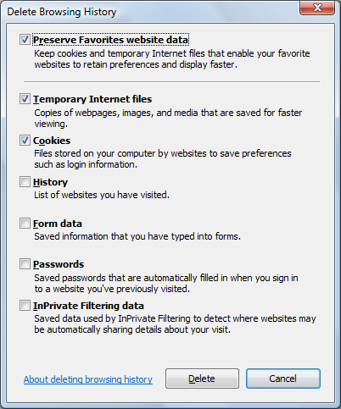
Administrators can configure Delete Browsing History options via Group Policy or through the Internet Explorer Administration Kit. Administrators can also configure which sites are automatically included in favorites allowing them to create policies that ensure security by aggressively scrubbing Internet files, and without impacting day-to-day interactions with preferred and favorite Web sites. The “Delete Browser History on Exit” checkbox on the Tools / Internet Options / General tab allows IT professionals to automatically delete the browsing history on exit.

InPrivateTM Browsing
Internet Explorer 8 takes privacy control to the next logical step with InPrivate™ Browsing. It adds to the standard privacy protections by addressing the larger challenge, allowing users to start a browsing session that will not store session data at all, notifying users clearly about what sites they’re disclosing information to and enabling them to control that disclosure if they choose. Two features in Internet Explorer 8 are specifically designed to enhance privacy in this way, InPrivate Browsing, and InPrivate Filtering.
From the enterprise and IT professional perspective, InPrivate Browsing is inherently more secure that using Delete Browsing History to maintain privacy because there are no logs kept, or tracks made during browsing. InPrivate Browsing is a proactive feature because it lets users or IT professionals control what is tracked during a browsing session. However, InPrivate Browsing could also be used by users to cover up their tracks when browsing to prohibited or non-work Web sites. The corporate administrator has full manageability and control and can use Group Policies to control how InPrivate Browsing is used in their enterprise.
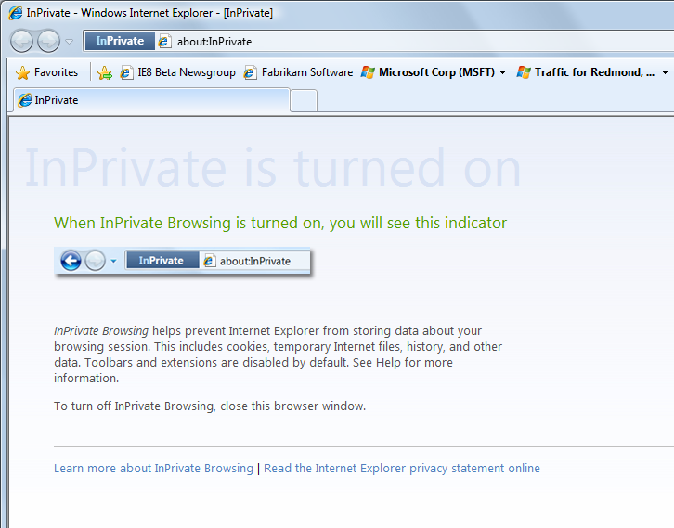
Once InPrivate Browsing is started, the user’s browsing history, temporary Internet files, form data, cookies and usernames/passwords are not stored or retained by the browser, or on the system. Specifications for disabling InPrivate Browsing also will be provided to third-parties for safety-related tools. InPrivate Browsing configuration may be controlled via Group Policy, and default configuration settings can be specified in the Internet Explorer Administration Kit for Internet Explorer 8.

InPrivateTM Filtering
InPrivate Filtering helps prevent third-parties that serve content on a Web page from tracking the user’s Web surfing activities. InPrivate Filtering in Internet Explorer 8 enhances privacy, control and security by providing users with greater choice and control over the third-parties for which content is displayed—and thus how third-parties can potentially track and aggregate users’ Web browsing activities. The corporate administrator can choose to completely disable InPrivate in their enterprise through group policy.
Most Web sites today are mash-ups of content from several different sites. When the user visits an intended “first-party” site, the Web page returned by that site often includes links to content on other, “third-party” sites. Depending on the user’s browser settings, the browser may also retrieve and display this third party information—often with little or no indication to the user. For example, if a user browses to the New York Times Web site, a number of third-party sites would also display ads or content such as articles and graphics.
While this approach allows Web sites to deliver richer content and experiences and is the business model on which a lot of Web content is delivered, it has potential privacy implications. Every piece of content that a browser requests from a Web site discloses information to that site—even in cases where the user has blocked all cookies. Users are not often fully aware that their Web browsing activities can be tracked by Web sites other than those they have consciously chosen to visit.
InPrivate Filtering in Internet Explorer 8 enhances privacy and security by providing users with greater choice and control over which third party content is downloaded and displayed—and thus how third-parties can potentially track and aggregate users’ Web browsing activities. InPrivate Filtering monitors the frequency with which all third-party content appears across all Web sites visited by the user. It does not discriminate between different types of third-party content, but rather blocks content from a specific third-party only if it appears on more than a predetermined number of sites the user has visited. This number can be configured by the user and is initially set at 3.
Because InPrivate Filtering is designed to watch for and block only third-party content that appears with a high frequency across sites the user visits; no content is blocked until such frequency levels are reached. Users can control what is downloaded and displayed by each third-party site by using the Block and Allow list settings.
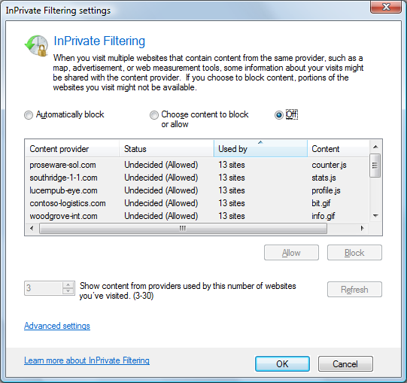

SmartScreen® Filter
Businesses put a lot of effort into protecting computer assets and resources. Phishing attacks, otherwise known as social engineering attacks, can evade those protections and result in users giving up personal information. While it’s true that the majority of phishing scams target individuals in an attempt to extort money or perform identity theft, businesses can’t let their guard down. A Phishing attack on Booz Allen Hamilton, a company with Defense contracts, targeted a single individual through a sophisticated e-Mail that appeared as though it was a list of parts requested by a customer. The whole point was to get the recipient to click a link which contained a keystroke logger. This is an example of a malware attack.
. Internet Explorer 8 builds on the Phishing Filter technology introduced in Internet Explorer 7 which was designed to warn users when they attempt to visit known-phishing sites, and replaces it in Internet Explorer 8 with the SmartScreen Filter that helps protect against phishing Web sites, other deceptive sites, and sites known to distribute malware. The SmartScreen Filter improves upon the Phishing Filter in many ways by providing:
- Improved user interface
- Faster performance
- New heuristics & enhanced telemetry
- Anti-Malware support
- Improved Group Policy support

SmartScreen Filter provides another layer of security and makes it less likely something will compromise the network or systems on the network—reducing the likelihood IT will have to take drastic action. It makes it hard for users to miss the indicator that a site is dangerous and allows the IT department, through Group Policy, to restrict access if a site is determined to be unsafe. It also blocks malware which will save IT personnel time by not having to clean-up desktop systems.
With SmartScreen enabled, Internet Explorer 8 performs a detailed examination of the entire URL string, and compares the string to a database of sites known to distributed malware. The following example shows how an “unsafe” site might be displayed in SmartScreen.
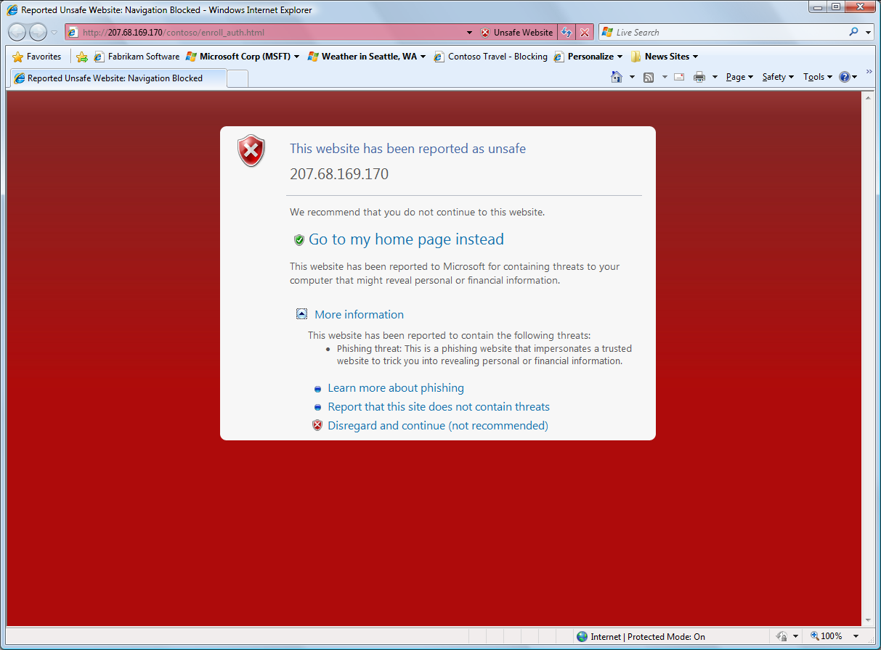
SmartScreen relies upon a Web service backed by a Microsoft-hosted URL reputation database. If SmartScreen is active and the user attempts to visit a Web site that isn’t listed in a local “known-non-malicious” database, the browser checks with the Web service. If the Web site is known to be unsafe, it is blocked and the user is notified with a bold SmartScreen blocking page that offers clear language and guidance to help avoid known-unsafe Web sites. By default, the SmartScreen Filter is enabled in the Internet, Trusted, and Restricted Zones, and disabled in the Intranet Zone.
The “Go to my homepage” link lets users easily navigate away from the unsafe Web site to start browsing from a trusted location. If a user instead chose to ignore the SmartScreen warning by clicking the “Disregard and continue” link, the address bar remains red as a persistent warning that the site is unsafe. The “Disregard and Continue” link can be disabled via Group Policy.
Users can use the “Report Unsafe Website” option on the Tools menu to report new unsafe site, and submit it for analysis. In the unlikely event of a false-positive, users can provide feedback using the “Report that this is not an unsafe Web site” link on the blocking page or by clicking the “Unsafe Website” flyout in the address bar.
New heuristics & telemetry
As attackers have evolved their phishing sites in an attempt to avoid being recognized and blocked, the SmartScreen Filter has also evolved. New heuristics, developed with help from security research teams across Microsoft, are able to evaluate more aspects of Web pages to detect suspicious behavior. These new heuristics, combined with enhanced telemetry, allow the URL Reputation Service to identify and block phishing sites faster than ever.
In rare cases, SmartScreen will request feedback on sites of unknown reputation (as shown below):
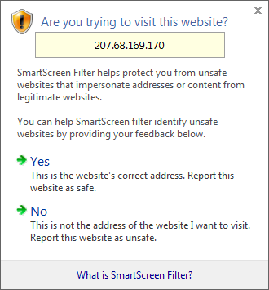
User feedback about unknown sites is collected by the SmartScreen Web service and quickly evaluated to block new phish as they are discovered in the wild.
Anti-Malware Support
The SmartScreen Filter goes beyond anti-phishing to help block sites that are known to distribute malware as well. There are many types of malware, but most types can impact your privacy and security. The SmartScreen anti-malware feature is URL-reputation-based, which means that it evaluates the servers hosting downloads to determine if those servers are known to distribute unsafe content. SmartScreen’s reputation-based analysis works alongside other signature-based anti-malware technologies like the Malicious Software Removal Tool, Windows Defender, and Windows Live™ OneCare™, in order to provide comprehensive protection against malicious software. If users attempt to access a site that is known to distribute malware, the SmartScreen blocking page is displayed. If users attempt to click on a direct link to a download (from an instant message, or e-mail for instance) hosted by a known-malicious site, the Internet Explorer download dialog will interrupt the download to warn of the threat:
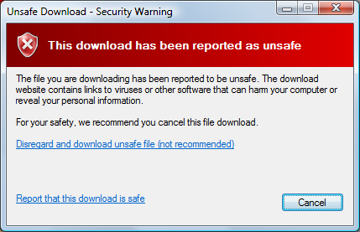
SmartScreen’s anti-malware feature complemented by the Internet Explorer 8 features that combat malicious repurposing or exploit of browser add-ons, helps to protect users from a full range of malicious Web sites.
Group Policy Support
Group Policy can be used to enable or disable the SmartScreen Filter for Internet Explorer users across an entire Windows domain. A new Group Policy option is available that allows domain administrators to block users from overriding SmartScreen Filter warnings. When Group Policy restrictions are enabled, the option to override the SmartScreen warning screen is removed from the blocking pages and download dialog.

Safer ActiveX® Controls and Management
Many Line-of-Business (LOB) applications use ActiveX controls. ActiveX controls are easy to create and deploy, and provide extra functionality beyond regular Web pages. An example might be a line of business application that uses a Website rich with ActiveX controls, the software has a single Web page that is made up of many ActiveX controls. Businesses can’t control which partners or vendors use ActiveX controls, or how they’re written. Therefore, businesses need a browser that provides the most flexibility and control in dealing with ActiveX controls so that they are usable, yet highly secure, and pose as small a threat as possible.
ActiveX controls can be a potential attack vector. IT Professionals now have more granular management and control of both the ActiveX controls themselves–they can set specific controls for sites or require signed files–but can also control what options are available to users.
Internet Explorer 8 allows for greater management of ActiveX controls, such as where and how they can load, as well as which users can load them. Internet Explorer 8 also allows the administrator to help set up the ActiveX control installation process for future ActiveX controls. This section covers ActiveX control safety features in detail.
Per-User ActiveX
In Internet Explorer 8, per-user ActiveX makes it possible for standard users running on Windows Vista to install ActiveX controls in their own user profile, without requiring administrative privileges. This makes it easier for an organization to realize the full benefit of User Account Control by enabling standard users to install ActiveX controls that are used in their day-to-day browsing. In this way, if a user happens to install a malicious ActiveX control, the overall system will be unaffected, as the control was installed only under the user’s account. Since installations can be restricted to a user profile, the risk and cost of compromise (and, in turn, the total cost of administering users on a machine) are lowered significantly.
As in Internet Explorer 7, when a Web page attempts to install a control, an Information Bar is displayed to the user. By clicking on the information bar, users can choose to either install the control machine-wide, or install it only for their own user account. The options in this menu will vary depending on the rights of the user (as managed with Group Policy settings for per-user ActiveX installations) and whether or not the control has been packaged to allow per-user installation. While this feature offers the possibility of lowering total cost of ownership, IT Administrators running managed environments also can elect to disable this feature via Group Policy.

Per-Site ActiveX
When a user navigates to a Web site containing an ActiveX control, Internet Explorer 8 performs a number of checks, including a determination of where a control is permitted to run—a defense mechanism intended to help prevent malicious repurposing of controls. If a control is installed but is not permitted to run on a specific site, an Information Bar appears asking the user whether or not the control should be permitted to run on the current Web site or on all Web sites. IT administrators can use Group Policy to preset allowed controls and their associated domains.
ActiveX Opt-In
Like Internet Explorer 7, Internet Explorer 8 by default employs ActiveX Opt-In, which disables most controls on a user's machine. When the user encounters a Web page with a disabled ActiveX control, they will see an Information bar with the following text: "This website wants to run the following add-on "ABC Control" from "XYZ Publisher". If you trust the website and the add-on and want to allow it to run, click here …" The user can then choose to enable the ActiveX control from this Information bar. ActiveX Opt-In allows some controls to run by default:
- A small list of common controls intended for use in the browser.
- Controls which were used in Internet Explorer on a user’s machine before upgrading to Internet Explorer 8.
- Controls which are installed through Internet Explorer.

Cross-Site Scripting Filter
Mashups are becoming more common on the Web, most sites today have a combination of content from local site servers and content obtained from other sites or partnering organizations. Customers, users and partners are coming to expect this type of integration—from something as simple as an embedded map from a mapping site, to richer integration of ads, or multi-media elements. Organizations are striving to offer more of these rich experiences because it drives customers to their site. This is a great capability that’s making the Web a richer place, but it’s also provides an opportunity for malicious users to create and exploit vulnerabilities. Mashups may pose security risks because Web administrators may not know who provided the code being run, relying on techniques that simply merge scripting from a third-party directly into the mashup page can cause a security vulnerability. Internet Explorer 8 employs many technologies to make mashups safer. In fact, Cross Site Scripting (XSS) attacks are one of the most common vulnerabilities in Web sites. XSS Attacks exploit vulnerabilities in Web applications and enable an attacker to control the relationship between a user and a Web site or Web application that they trust. Cross-site scripting can enable attacks such as:
- Cookie theft, including the theft of sessions cookies that can lead to account hijacking.
- Monitoring keystrokes input to the victim Web site / application.
- Performing actions on the victim Web site on behalf of the victim user. For example, an XSS attack on Windows Live Mail might enable an attacker to read and forward e-mail messages, set new calendar appointments, etc.
- Cross-site scripting can use a victim’s Web site to subvert a legitimate Web site.
This is a new type of problem, businesses must protect themselves from vulnerabilities in Web sites they don’t own or control! Typical security options that harden the browser such as Per User and Per Site ActiveX don’t address this threat. Features like the SmartScreen Filter that help protect from Social Engineering attacks won’t address this threat either. While many great tools exist for developers to mitigate XSS in their sites / applications, these tools do not satisfy the need for average users to protect themselves from XSS attacks as they browse the Web. Internet Explorer 8 includes a filter that helps protect against XSS attacks using a XSS Filter.
The XSS Filter operates as an Internet Explorer 8 component with visibility into all requests and responses flowing through the browser. When the filter discovers likely XSS in a request, it identifies and neuters the attack if it is replayed in the server’s response. The XSS filter is able to better protect users from Web site vulnerabilities without asking questions they are unable to answer or harming functionality on the Web site.
Domain Name Highlighting
Domain Name highlighting aids users to more accurately and quickly ascertain that the site they are visiting is the intended site. Because the domain name is the most security-relevant identifier in a URL, it is shown in black text, while site-controlled URL text like the query string and path are shown in grey text. This is particularly useful as many deceptive sites embed a domain name within the URL as an attempt to deceive users into believing they are visiting legitimate Web sites. The following are three examples of domain name highlighting:
Standard Web site:

There is Domain highlighting for a secured site with an Extended Validation (EV) SSL Certificate. Note that HTTPS and the domain name are highlighted:
Unsafe Web site as determined by the SmartScreen Filter:
Domain spoofing attacks are simple and fairly unsophisticated, but they aren’t always about banking scams; a sophisticated spoofing attack may spoof a B2B partner portal. If, for example, an attacker successfully spoofed a document sharing site, workers may inadvertently share confidential or sensitive documents exposing this information. Domain Name highlighting helps block attacks to increase security and productivity.

Data Execution Prevention
Internet Explorer 7 on Windows Vista introduced an off-by-default Internet Control Panel option to “Enable memory protection to help mitigate online attacks.” This option is also referred to as Data Execution Prevention (DEP) or No-Execute (NX).
DEP/NX helps to foil attacks by preventing code from running in memory that is marked non-executable, such as a virus disguised as a picture or video. DEP/NX, combined with other technologies like Address Space Layout Randomization (ASLR), make it harder for attackers to exploit certain types of memory-related vulnerabilities like buffer overruns. Best of all, the protection applies to both Internet Explorer and the add-ons it loads. No additional user interaction is required to provide this protection, and no new prompts are introduced.
DEP/NX feature is enabled by default for Internet Explorer 8 on Windows Server 2008 and Windows Vista SP1 and later.
Enforcing Per-Site with ATL SiteLock Technology
Developers in your Enterprise can create ActiveX controls using SiteLock Technology. If your ActiveX control is designed for use only on your Web site, then locking it to the domain of that Web site will make it harder for other sites to repurpose the control in a malicious manner.
For more information on ATL SiteLock technology see: http://www.microsoft.com/downloads/details.aspx?FamilyID=43cd7e1e-5719-45c0-88d9-ec9ea7fefbcb&DisplayLang=en

Other Security Features
Application Protocol Prompt
Application Protocol handlers enable third-party applications (such as streaming media players and internet telephony applications) to directly launch from within the browser or other programs in Windows. Unfortunately, while this functionality is quite powerful, it presents an attack surface, because some applications registered as protocol handlers may contain vulnerabilities that could be triggered from untrusted content from the Internet.
Data that gets out can compromise security and provide a back door into the system. A common business practice is to have firewalls block all ports that aren’t in use, you lock the doors so unwanted guests can’t come in. Web applications can leave doors open – and provide too much data – data that can be used to gain entry. Security professionals tell businesses to minimize any and all data exposed or let out into the public, why should the browser behave differently? Internet Explorer 8 provides only minimal data and provides users and IT departments with more control allowing them to choose if a protocol is appropriate, and whether to allow it, and controlling information exposed during file upload. To provide even more protection, Internet Explorer 8 provides IT both Application Protocol Prompts and File Upload Control to further protect information and access to files.
To help ensure that the user remains in control of their browsing experience and that businesses are protected, Internet Explorer 8 will now prompt before launching application protocols.
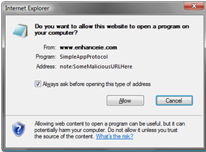
To provide defense-in-depth, Application Protocol developers should ensure that they follow the Best Practices described on MSDN.
File Upload Control
Historically, the HTML File Upload Control (<input type=file>) has been a source of information disclosure vulnerabilities. To resolve these issues, two changes were made to the behavior of the control. Internet Explorer 8 controls information exposed during file upload with its expanded file upload control and file locking on the Internet zone.
To block attacks that rely on “stealing” keystrokes to surreptitiously trick the user into typing a local file path into the control, the File Path edit box is now read-only. The user must explicitly select a file for upload using the File Browse dialog.
Additionally, the “Include local directory path when uploading files” URLAction has been set to "Disable" for the Internet Zone. This change prevents leakage of potentially sensitive local file-system information to the Internet. For instance, rather than submitting the full path such as:
C:\users\ericlaw\documents\secret\image.png
Internet Explorer 8 will now submit only the filename:
image.png
The Application Protocol Prompt and File Upload Control features make it a little more difficult for users to make a mistake, and harder for damaging data, information, and content to get into attackers hands. For businesses that require more control over these types of features, Internet Explorer 8 offers it through Group Policy allowing the IT department more granular control over these features.

Tab Isolation
Business users are spending an increasing amount of time in the browser—accessing line of business applications, performing work related research and personal browsing. It is important to reduce the risk of a crash in the browser because crashes mean lost productivity, which translates into time and money. When a crash occurs, IT professionals must stop their work to focus on user calls, help users recover lost data, or locate and roll back transaction data. It is easy for IT professionals to disable toolbars in Internet Explorer 8 which helps save time and can help increase security. Tab isolation and better reliability in Internet Explorer can help prevent that. If the browser is more stable, there is less lost productivity, and both workers and IT professionals can complete tasks more reliably.
Internet Explorer 8 is the most stable version of Internet Explorer—ever. While this reduces the likelihood that users will experience a crash, the Web still has many poorly-behaved Web sites, script errors, and unstable add-ons. In Internet Explorer 7, if one tab crashed, it would crash or hang the entire browser—including other tabs the user may have had open. In Internet Explorer 8, the browser’s frame and tabs run as separate, isolated processes—an approach called Loosely-Coupled Internet Explorer (LCIE). LCIE is a collection of internal architecture changes to Internet Explorer that improve the reliability, performance, and scalability of the browser. It also paves the way for future improvements in other areas, including security and usability. LCIE isolates the browser frame and its tabs and uses asynchronous communication between components. In this way, if a Web site or add-on causes a tab to crash or hang, only that tab is affected. The browser itself remains stable and other tabs remain unaffected, thereby minimizing any disruption or inconvenience for the user.

The Internet Explorer Process Model
Part of the goal with LCIE is to split the frame from the tabs, and allow them to function more autonomously. For reference, review this somewhat simplified view of the Internet Explorer 7 process model:
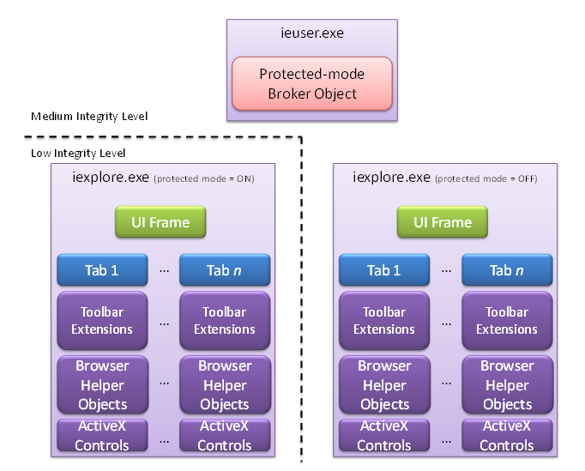
In the Internet Explorer 7 model, each browser window (UI Frame) usually has its own process. There are a few exceptions. For example, if you press CTRL-N to open a new window, Internet Explorer creates a new UI frame in the same process. The tabs, toolbar extensions, browser helper objects, and ActiveX controls all reside in the same process as the browser window. The problem with this model is that a single access violation, stack overflow, or any other type of failure will cause your entire browser, and all its tabs, to crash.
The following diagram shows how we’ve changed the process model in Internet Explorer 8:
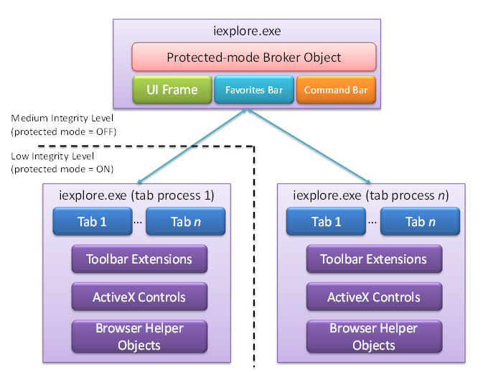
The notable changes in this process model are:
- Tabs are isolated from the frame, and are located in separate processes. This gives Internet Explorer the opportunity to isolate many failures to the tab process, thereby reducing the amount of damage done to the rest of your browsing session.
- The frame and the broker object are located in the same process. This improves startup performance. The broker object is responsible for examining a URL, and determining if it should be loaded under Protected Mode or not, and launching Internet Explorer at the appropriate integrity level. There is no longer a wait for the protected mode broker object’s process to startup before loading the rest of the browser.
- Low and Medium integrity tabs can reside in the same UI frame. The Windows Integrity Mechanism operates on a per-process basis. Now that we can place tabs into their own processes, we can turn Protected Mode on or off on a per-tab basis. This is a big usability improvement. You no longer need separate browser windows to view sites in and out of protected mode. For example, if a user browsed to Web sites on the Internet and then browsed to open files from their local hard drive, in nter users would have been required to open the local files in a new window. With Internet Explorer 8 and LCIE, the files will simply open in another tab because LCIE will create two tab processes: one with Protected Mode on for your Internet files, and one with Protected Mode off for your local files.

Crash Recovery
With the advent of tabbed browsers, users typically have multiple browser windows active within a single instance of the browser. In Internet Explorer 8, due to the LCIE architecture, a crash in one browser tab does not cause the entire browser to crash, thereby helping to prevent the user from losing the list of pages they are browsing. In addition to saving users time, crash recovery in Internet Explorer 8 will also mean that IT professionals spend less time helping users with lost data or rolling back database data. Preventing crashes saves time and money and can help increase user and IT staff productivity due to fewer interruptions.
In addition, Internet Explorer 8 has Automatic Crash Recovery. A tab that crashes will be restored automatically to its former state including data entered into most Web forms. And in the unlikely event that the browser crashed or closes unexpectedly, the entire session (all tabs) will be restored.

Enhanced Add-on Management
Add-ons, specifically custom toolbars that users install, are a common cause of browser crashes. Crashes due to add-ons result in lost productivity and often require IT staff time to resolve the issue. Internet Explorer 8 provides easier management of add-ons and allows users to manage it more effectively.
Being able to manage add-ons running in the browser is a key component of keeping the browser and personally identifiable information protected. The ability to easily manage and remove slow-performing or suspicious add-ons is critical to building confidence in users who are concerned about add-ons. A new feature in Internet Explorer 8 allows users to close toolbars using an “X” that has been added to the toolbar. Automated functions associated with the close toolbar feature also determine associated components and disables them too. This feature saves time and provides the user with greater control.
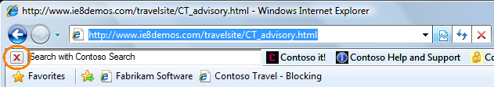
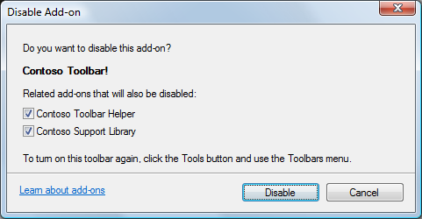
Improved Manage Add-ons Interface
Managing add-ons in Internet Explorer 8 is a much simpler, more straight-forward process. Help desks can do it faster and they can walk users through it over the phone, or over IM without having to visit. Add-on Management is also available through Group Policy; if IT professionals find a toolbar that they feel causes problems in their environment, they can disallow its installation and use—simply and easily through Group Policy. It’s easier to make toolbar and add-on problems go away or never happen in the first place.
The new Manage Add-ons UI is familiar and is modeled after Windows File Explorer and the Control Panel in Windows Vista. Users choose a category of object types from the left to view that list on the right. Users select any item in the list and the details pane at the bottom will display information about the selected add-on.
Most changes made in Manage Add-ons take effect immediately, although some (like disabling a toolbar or explorer bar) might still require a restart of Internet Explorer.
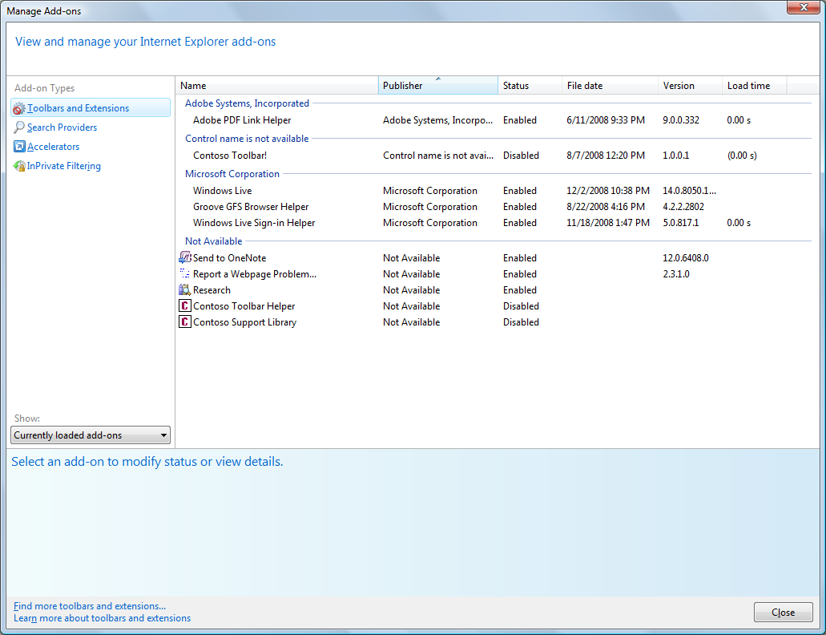
The Manage Add-ons window can be resized for different resolutions and users can choose custom columns, grouping, and sorting order. In addition, the Manage Add-ons UI has these capabilities:
- Select multiple Add-ons from the list (CTRL+click or drag to multi-select)
- Support for right-click context menu actions
- Visibility into add-on load times to identify poorly performing add-ons
- Details about add-ons can be copied to the Windows clipboard and into email, a document editor, or a spreadsheet so that information can be shared with administrators, technical support or developers.
Easier to Find Add-on Information
More detailed information about installed add-ons is available at a glance with Internet Explorer 8. Links to make it easy to accomplish the following common tasks:
- Find more add-ons with a single click. Just click “Find more add-ons…”
- Search online for information about a particular add-on by clicking “Search for this add-on via default search provider”
- Clicking “More information” displays more detailed technical information about installed add-ons, including file names, versions, and other properties. You can even view or clear the list of Web sites that ActiveX controls are allowed to run on for per-site installed ActiveX controls
- Right-click any add-on to access to common actions like enable or disable
New types of Add-ons to Manage
In Internet Explorer 8, the list of add-ons you can manage has been expanded to include Explorer Bars, Search Providers, and Activities.
- Explorer Bars: In Internet Explorer 8, Explorer Bars are available in Manage Add-ons so users have more control over what’s running in the browser.
- Search Providers: In Internet Explorer 8, management of Search Providers has been moved to Manage Add-ins. Internet Explorer 8 allows users to see at a glance what Search Providers are installed, which is the default, and where it is sending information when a search is submitted. Additionally, users can change the order that Search Providers are listed.
- Accelerators: Accelerators are new to Internet Explorer 8 and are also managed from the Manage Add-ons window. Businesses and IT professionals can use Accelerators to build business interactivity features into their Web site providing better functionality and making sites easier to use.
- Managing Add-ons in No Add-ons Mode: Internet Explorer 7 and Internet Explorer 8 support “No Add-ons Mode,” a troubleshooting mode. When Internet Explorer is run this way, no 3rd party code runs, which allows you to do to things like disable troublesome controls or repair Windows via Windows Update.

Diagnose Connection Problems Button
The faster a user’s problem can be solved, the less money it costs because less IT time is consumed resolving the issue. The Diagnose Connections Problems button helps users find and resolve issues potentially without involving the Helpdesk.
When Internet Explorer 8 is unable to connect to a Web site, it shows a Diagnose Connection Problem button. Clicking the button helps the user resolve the problem. Users, or Helpdesk personnel, can find the information provided to troubleshoot the problem. This option was available in Internet Explorer 7 but is now easier to find which will help the user diagnose the problem. This can save time for the user and may mean that IT staff is not needed to resolve the issue. The next figure shows options that may display to help the user determine why the connection failed.
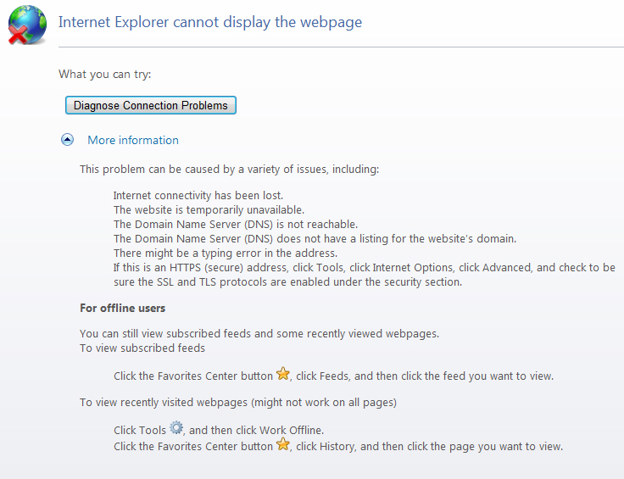

Improved Support for Accessibility Standards
In the United States, you can’t do business with the U.S. government unless your site supports accessibility options for users with disabilities. Internet Explorer 8 has improved support for accessibility standards to help support this requirement.
ARIA is a syntax for defining how Web developers can mark up content with roles, states, and properties that browsers use when communicating with assistive technology. Thanks to ARIA, end users with impairments can access Web sites with a rich interaction comparable to the original UI experience. Internet Explorer 8 supports ARIA through Microsoft Active Accessibility (MSAA) which uses APIs to expose information about the UI, and allow for creation of rich content that is highly accessible.

Adaptive Page Zoom
Page zoom enables users to enlarge or reduce the view of a Web page in order to improve readability. This feature is particularly useful on really large and really small displays because it allows for scaling of content while maintaining the intended layout of the page. While the initial Internet Explorer 7 version of zoom was a “digital” page zoom, the second iteration of the zoom feature improves the existing experience by providing a higher quality, more predictable zooming experience known as an “adaptive” page zoom. While zooming, Internet Explorer 8 will size the text and images and reflow the page to make it easier to read. This will eliminate horizontal scroll bars for the majority of mainstream scenarios and the introduction of persistent zoom states.
For example, zooming the Internet Explorer Blog to 150% in Internet Explorer 7 looked like the following image. Note that text moves off the screen and a horizontal scrollbar appears at the bottom of the screen:

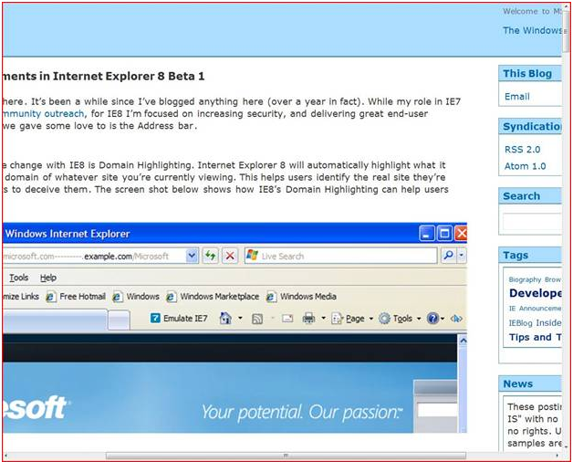
The following image shows the same page zoomed to 150% in Internet Explorer 8, the text is now being wrapped, and no horizontal scrollbar is needed.
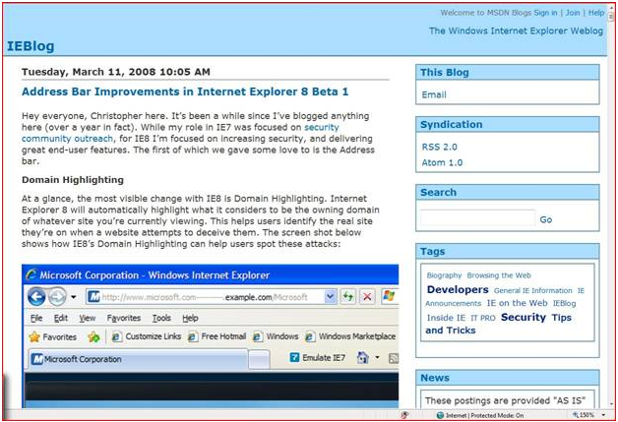

Enables New Business Scenarios
The new Accelerators and Web Slices features in Internet Explorer 8 lets enterprises build rich applications and makes delivering advanced Web experiences easier. Enterprises can use Accelerators, Web Slices and AJAX enhancements to build business interactivity features into their Web site providing better functionality and making sites easier to use. Built-in developer tools provide advanced code debugging and profiling. This section explores these new and enhanced features.

Accelerators
Whether finding directions, posting blog entries, or performing other common actions, today’s Web users often find themselves copying and pasting information from one Web page to another. While the experience has been “good enough” so far, Internet Explorer 8 brings these powerful Web services one step closer through a new feature called Accelerators. Enterprises could increase productivity by using Accelerators.
Accelerators are contextual services that provide quick access to external site services from any Web page. They typically involve one of two types of actions:
- “Look up” information related to data in the current Web page.
- “Send” content from the current Web page to another application.
For example, a user may be interested in using information about the Perseids meteor displayed on the current page. In the past, the user would need to copy the name of the meteor, open a new tab, navigate to their favorite search engine and paste the name into it. By using a Accelerators the user would get an in-place way to access blogs, live maps, email or Encarta for information on the meteor.

Web Slices
Users commonly visit many Web sites several times a day to check for updates. The introduction of RSS feeds can make this experience easier for users, although this requires a nontrivial amount of work on behalf of the developer.
Web Slices is a new feature for Web sites that enable users to subscribe to content directly within a Web page. Businesses can use Web Slices to help their line-of-business applications interface more easily with customers. Web Slices can help improve productivity and can also be used to help Developers build rich client application experiences.
Web Slices behave just like feeds in that users can subscribe to them and receive update notifications when the content changes. Sites are polled at user-defined intervals, similar to the way RSS feeds are polled. Site operators may also define a minimum wait time between polls to minimize requests.
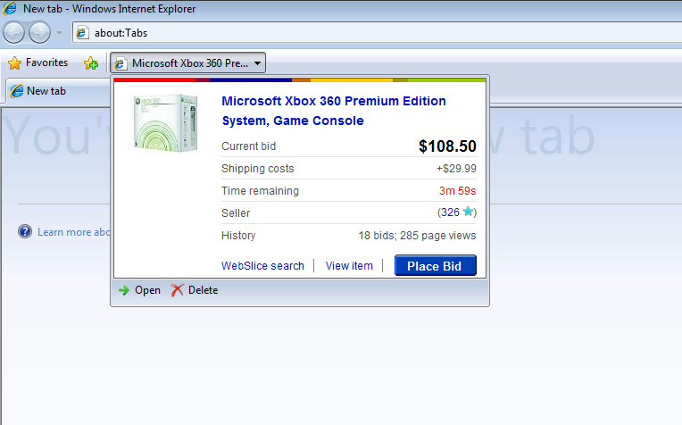
A Web Slice is a section within a Web page that is treated like a subscribable item, just like a feed.
Users of Windows Internet Explorer 8 can discover Web Slices within a Web page and add them to the Favorites bar, a dedicated row below the Address Bar for easy access to links. Internet Explorer 8 subscribes to the Web page, detects changes in the Web Slice, and notifies the user when updates occur. Users can preview these updates directly from the Favorites bar and click through to the Web site to get more information if they want to.

Improved Productivity
Many of the usability features in Internet Explorer 8 are designed to make the user experience better, and enable users to both browse the way they want, and work the way they want faster. Internet Explorer 8 includes a number of enhanced features like “Find on this Page”, redesigned tabs and an enhanced address bar features that will make the user browsing experience easier and help save time. For the IT professional, this could result in reduced Helpdesk calls. However, Internet Explorer 8 also enables businesses, IT professionals and developers to have a richer, yet more controlled, better managed browser. These features are described in the following section.

Enhanced Favorites Bar
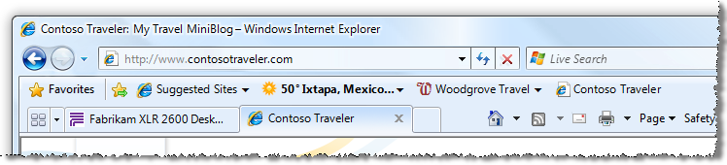
In Internet Explorer 8, the Enhanced Favorites Bar, (formerly called the Links Bar), is turned on by default and can be used to save Favorites, RSS Feeds, and Web Slices. It has been renamed to the Favorites Bar, which more accurately reflects its intended purpose. Being on by default, and with clearly labeled tabs, the Enhanced Favorites Bar provides a useful Dashboard for users.

Enhanced Find on Page
Internet Explorer 8 includes a completely redesigned “Find on this Page” tool. The “Find” dialog box in Internet Explorer 7 often floated over and often obscured the page. The new tool is an integrated bar below the tab row, so it does not block any of the page. And instead of waiting for users to type the entire search term and hit Enter, Internet Explorer 8 searches on a character-by-character basis as users type, similar to the Microsoft Office Outlook and Windows Vista search boxes. The total number of matches is shown on the bar along with buttons to navigate to the next or previous match, and matches are highlighted in yellow and are easy to see.
“Find on Page” which is activated by pressing Ctrl-F or choosing Find On Page from the Edit menu or Instant Search Box.

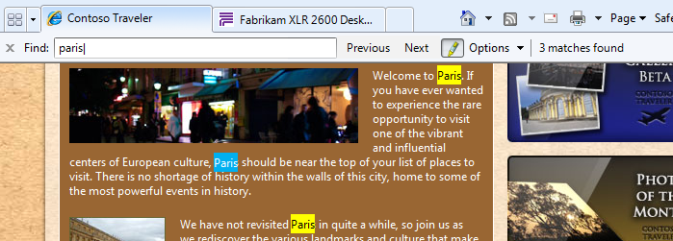
The new “Find on this Page” tool is also linked to the Search Box in Internet Explorer 8. A common activity is to enter a term in the Search Box, look at the search results, and click on one that looks promising, and then try to find the original search term on that page. So when users open the “Find on this Page” tool in Internet Explorer 8, the last term you entered in the Search Box is automatically copied in there and those hits are highlighted, streamlining searches.

Enhanced Instant Search
Internet Explorer 7 has a built-in Search Box to the right of the Address Bar. When the user enter a search term, that term is passed from the Search Box to the user’s preferred search engine and the user is taken to search results page from that provider. The enhanced Search features will save users time to help increase productivity.
The Search Box in Internet Explorer 8 looks similar, but it’s more helpful. As users type a search term, they will see real-time search suggestions from their chosen search provider, recommending common searches related to the text that is typed. Users can click on a suggestion at any time to immediately execute the search without having to type the entire word or phrase. Not only does this save time, but it increases the odds that the search results will be relevant.

Internet Explorer 8 also enables search providers to deliver direct results and “visual search” images (see the above diagram for an example) that provide users with immediate answers. For example, if you enter a stock ticker symbol, the search provider could provide a stock quote and a corresponding chart directly in the Search Box drop-down. Internet Explorer 8 provides the enabling technology, but the choice of what to show is made by the search provider.

Redesigned “New Tab” Page
When users open a new tab, the next step is often to navigate to a page. In Internet Explorer 8, the New Tab page enhances usability and makes new features more readily available by quick navigation links to:
Use an Accelerator. Users frequently copy text from one page, open a new tab, and then navigate to a new site, with the intention of doing something with the copied text. The new tab page in Internet Explorer 8 includes links that enable users to initiate an Accelerator on any text they have copied to the clipboard (Accelerators are covered in more detail in the Accelerators section of this document).
Start InPrivate Browsing. Clicking on this link starts an InPrivate session (described earlier), in which browsing activities are not recorded.
Reopen Closed Tabs. The user can reopen a tab that they’ve closed in their current browsing session, which can be helpful when a tab is accidentally or prematurely closed.
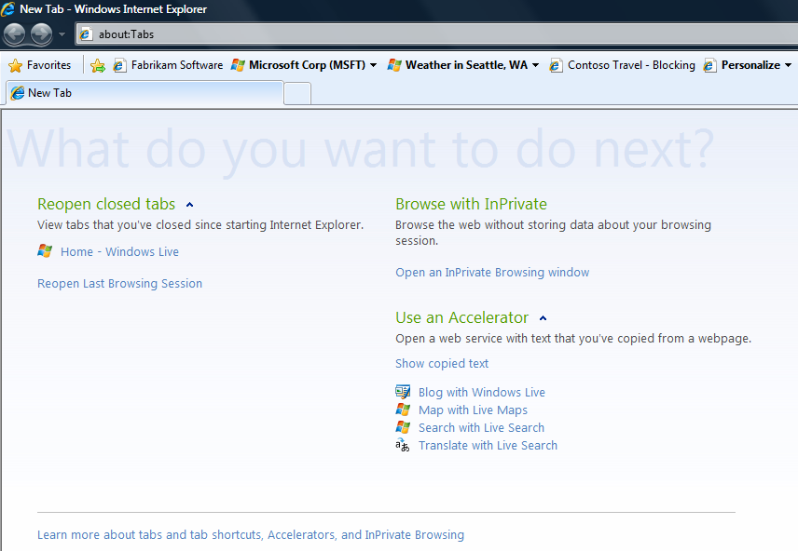

Smart Address Bar
At its core, the Address bar in Internet Explorer 8 works as it did in Internet Explorer 7. Users enter a Web address (URL), hit Enter, and the page loads. The Address bar in Internet Explorer 8 has been improved to make navigation easier and to minimize the need for users to enter full Web addresses to get to their destination. The Internet Explorer 8 Address bar drop-down searches across Favorites and RSS Feeds in addition to History. It displays matches from the Web site title or any part of the URL, not just the beginning of the URL. As the user types, matched characters are highlighted in blue so that they can be identified at a glance.
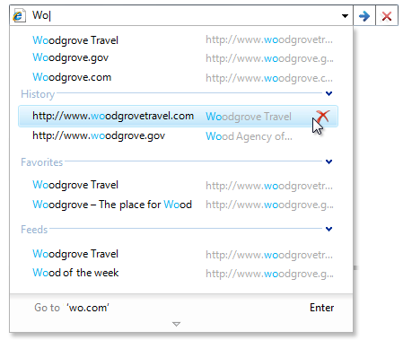

Enhanced Tabbed Browsing

Internet Explorer introduces Tab Groups, which make tabbed browsing easier. When one tab is opened from another, the new tab is placed next to the originating tab, and both are marked with a colored tab, so that users can quickly discern which tabs have related content. If the user closes a tab that’s part of a group, another tab from the same group is displayed, enabling the user to remain within the context of the current browsing task rather than suddenly looking at a potentially unrelated site. For example, if a user is researching computer peripherals, links opened off of the primary search page will all be part of the same tab group, and as tabs in the group are opened and closes, the user’s browsing experience will remain “in context” of the browsing task.

By right-clicking on any tab, users can close the tab, close the tab group, or remove the tab from a group. From the same menu, they can refresh one or all tabs, open a new tab, reopen the last tab they closed, or see a list of all recently closed tabs and reopen any or all of them.

A Better Back Button
Users browsing the Web are experiencing more and more AJAX sites. AJAX sites use JavaScript and XML (the J and X in AJAX) to make Web sites more interactive and dynamic so that they function more like full-blown applications rather than static Web pages. Older browsers don’t have the ability to read the individual navigation events within an AJAX application, and instead, just consider the AJAX site to be static. This meant the Back button did not work as expected after panning across a map or zooming in and out a few times. Rather than take the user back to the last view of the map, the Back button takes users off the map completely and back to the previous Web site they were looking at.
The Internet Explorer 8 Back button fixes this issue and can read individual AJAX events. If sites comply with the HTML5 standard that Internet Explorer 8 has implemented, the Back button will bring you back to your last action, just as you’d expect. Using the Forward button would return to the starting point on the map rather than the place where browsing left off.

Customizing the User Interface
Internet Explorer 8 also allows users to customize the User Interface so that enterprise users can make changes to the browser to fit the way they like to work. Users can resize the search box and address bar, move stop and refresh buttons, and also move toolbars and the command bar.

Interoperability Saves Developers Time
There are a number of new features in Internet Explorer 8 that help developers more easily create Web sites. These features benefit the enterprise because more interactive and mashup Web sites can be created—yet security is enhanced for both the user and the enterprise. Features in Internet Explorer 8 include:

- CSS 2.1 Compliance: Internet Explorer 8 supports Cascading Style Sheets (CSS) 2.1. This is a simple mechanism for adding style (e.g. fonts, colors, spacing, positioning) to Web documents. In compliance with WC3 Web standards, Internet Explorer 8 is designed so Web pages can be written once and displayed correctly across multiple browsers. DOM improvements have been made in Internet Explorer 8 to help resolve cross-browser inconsistencies.
- DOM Improvements: Some functionality in Internet Explorer has not been supported by other browsers, creating inconsistencies when Web pages are viewed. Internet Explorer 8 fixes many of the cross-browser inconsistencies, such as separate URL handling for attributes and properties, and enhanced functionality around handling elements and attributes.
- Data URI Support: Data URIs offer Web developers the opportunity to embed small external resources (like CSS files or images) directly into a URL on a Web page.
- Improved Namespace Support: In Internet Explorer 8, Web developers have the ability to apply “behaviors” to those elements through special HTML markup known as HTCs (HTML Components).
- HTML Improvements: To assist developers in taking full advantage of the elements offered by HTML 4, Internet Explorer 8 provides upgraded support for several presentational elements. Through improved support for these and other HTML elements, Web developers can deliver more expressive and accessible HTML markup.
- Acid2 Test Compliance: Compliance with accepted standards in Internet Explorer 8 is evidenced by the fact that Microsoft successfully renders the ACID 2 test and can handle a number of edge cases outside the specification.

Integrated Developer Tools
Internet Explorer 7 supported a Developer Toolbar, which developers could download separately and run as an extension to the browser. Although many developers found it to be highly useful for testing, debugging, profiling, or rapidly prototyping a Web page, because it ran as an extension, its performance was limited and it resulted in a larger memory footprint. Internet Explorer 8 replaces the Developer Toolbar for Internet Explorer 7 with an integrated set of integrated developer tools that can be accessed by pressing F12 or clicking the Developer Tools icon in the Command Bar. Because the Developer Tools are an integral component of the browser, performance is improved and no memory is used when the tools are not running. The integrated Developer Tools make it faster and easier for Developers to develop and troubleshoot rich content sites.
Developers can use the Developer Tools to edit and debug CSS and HTML, test and debug script, profile script performance, view or change the document object model (DOM), examine applied rules, and trace the origin of style values—all within a rich, visual environment that exposes the browser’s internal representation of a Web page as it runs, instead of just its source code. In such a way, developers can rapidly iterate within Internet Explorer 8—for example, changing an attribute or a style rule and immediately viewing the results—and then save the HTML tree and CSS files to disk as text files for integration back into the original application. The Developer Tools also makes it easy to toggle between the different layout engines included in Internet Explorer 8, enabling developers to quickly and easily identify changes that must be made for sites to work well with older versions of Internet Explorer.
By eliminating the need to tweak source code in one program, save it, and then refresh the browser to view the results, the Developer Tools enables Web developers to rapidly prototype and test a new page, debug a problem, or just learn more about Web development. While these capabilities won’t be used by most mainstream users of Internet Explorer 8, they will benefit everyone by making it easier to create, test, and fine-tune the Web sites that we all use.

New Features Make it Easy to Build Rich Applications
Internet Explorer 8 provides a variety of new ways to connect with end users and to improve their browsing experience through new features such as Accelerators and Web Slices. Internet Explorer 8 also enables search providers to deliver direct results and “visual search” images that provide users with immediate answers. Other features in Internet Explorer 8 that enhance the ability to build rich applications, incorporate Web 2.0 features and provide advanced code debugging and profiling include:
- AJAX Navigation: Websites that use AJAX navigation have the ability to update page content without traditional page navigations. This can be problematic in some scenarios because components like the address bar, back and forward buttons only update after page navigation. Internet Explorer 8 solves this issue by letting Web sites handle navigations within their AJAX applications and update back history and the address bar by interacting with the window.location.hash event.
- Internet Explorer 8 DOM Storage: Today, Web page Cookies are limited in capability by the fact that only 50 key/value pairs can be stored per domain. Internet Explorer 8 uses W3C’s HTML 5 Draft DOM Storage objects to provide a much simpler persistent and session storage model so that each domain is allotted 10MB of local storage space and each browser tab maintains its own store.
- Connection Events: In Internet Explorer 8, connection events allow Web sites to check when the user is connected to the network. These events can be useful to the developers of dynamic applications because they enable the seamless handling of network connection changes.
- Selectors API: Selectors are a query language for searching and “selecting” tags (elements) within a Web page. In Internet Explorer 7 there is no way of “executing” the selector independently of CSS. In Internet Explorer 8, the Selectors API puts the power, high-performance and flexibility of CSS selectors into the hands of the Web developer for rapid element lookups.
- Improved Printing: Internet Explorer 8 provides improved functionality and control over print functions, allowing developers to specify the margin area, portions of content that must be kept together, and much more, enabling them to greatly improve the readability of printed Web pages.
- Cross Domain Requests (XDR): Internet Explorer 8 introduces support for Cross Domain Request objects, which can be used to request public resources from another domain’s server. Resource data is shared between domains through an explicit acknowledgement of sharing cross domain and anonymously. As a result, users can be better protected while site operators can decide what data they share.
- Cross Document Messaging (XDM): In the Web 2.0 world, Web applications are increasingly built using clientside mashup techniques, yet many mashups are built using unsafe development techniques. To help developers build more secure mashups, Internet Explorer 8 introduces support for the HTML5 cross-document messaging feature that enables IFRAMEs to communicate more securely while maintaining DOM isolation.
- Safer Mashups-HTML and JavaScript Object Notation (JSON) Sanitization: Internet Explorer 8 exposes a new HTML sanitization method so that when a string of HTML is passed to the toStaticHTML function, any potentially executable script constructs are removed before the string is returned. Internet Explorer 8 also implements a method for using JavaScipt (JSON) objects to ensure that the JSON object does not contain executable script (but there’s a performance penalty for this.)

Extended Support Lifecycle
IT professionals don’t want to be put in a position where they’re forced to update the Web browser on hundreds or thousands of user desktops just because a new version is being released and support for the old version soon discontinued. Microsoft’s support commitment for Internet Explorer 8 is designed to deliver this peace-of-mind, enabling IT professionals to upgrade on their own schedules. Internet Explorer 8 is supported for the life of the operating systems on which it runs, including scheduled updates (Patch Tuesday) and dedicated enterprise-level updates and security response.

Summary
The browser is becoming an increasingly central part of the enterprise and IT environment—as an application platform and as a window to the potentially dangerous world of the Web. Organizations are doing an increasing amount of business on the Web. That business will continue to grow only if customers trust the Web as a safe place to do business. Unfortunately, customer’s trust in the Web as a place to do business is under attack from phishers and other criminals intent on using the Web as a place to expand their criminal activities. From the start, Internet Explorer 8 is built to help customers and users browse more safely helping to maintain customer trust in the Internet.
Internet Explorer 8 helps enable new business scenarios and makes it easier to build rich, intelligent Web applications. In addition, Internet Explorer 8 reduces the risk of your IT environment being compromised by a wide range of evolving security and privacy threats. When using Internet Explorer 8, IT professionals will find it provides a better user online experience and that it is easier to deploy and manage Web content which can help reduce costs and provide a better return-on-investment.

The Trustworthy Computing Security Development Lifecycle (or SDL) is a process that Microsoft has adopted for the development of software that needs to withstand malicious attack. The process encompasses the addition of a series of security-focused activities and deliverables to each of the phases of Microsoft's software development process.

