Brief

Software Assurance Coverage Consolidation Options

Corporate and Academic ▪ Select License ▪ Enterprise Agreement ▪ Open License
▪ Open License Value

Summary
Microsoft® Volume Licensing customers who have more than one volume license program agreement may now consolidate their Software Assurance (SA) coverage from an expiring program agreement into an existing active program agreement.

Some benefits of consolidating Software Assurance coverage include:

- Continuous coverage with fewer agreements
- Improved licensing management (fewer agreements to manage with varying terms and expiration dates)
- Greater pricing predictability and increased flexibility by eliminating the need for multiple program agreements at varying price levels
The consolidation options for renewing an expiring program agreement into an existing active program agreement vary based on two factors:

- The Microsoft Volume Licensing program agreement that is expiring
- The existing active Microsoft Volume Licensing program agreement into which the current Software Assurance coverage consolidates

Details
You can consolidate an expiring program agreement’s Software Assurance coverage into an existing active program agreement within 90 days of the expiration date. To do so, you must acquire the remaining years of Software Assurance coverage in the existing program agreement.

For example, the following diagram represents a customer with two expiring program agreements (Agreement X and Agreement Y). The customer wants to consolidate Software Assurance coverage from these agreements on expiration into an existing program agreement (Agreement Z).

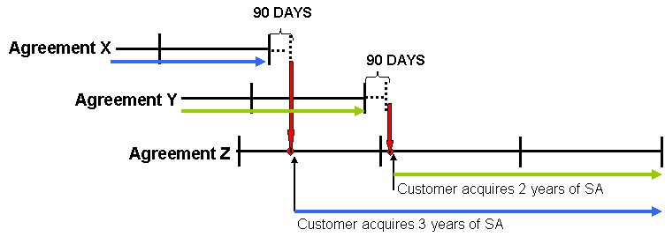

To consolidate Software Assurance coverage from the expiring Agreement X and Agreement Y into Agreement Z, the customer needs to:

- Acquire three years of Software Assurance coverage on Agreement Z when Agreement X expires.
- Acquire two years of Software Assurance coverage on Agreement Z when Agreement Y expires. This is because the 90-day purchase window following the expiration of Agreement Y places the customer into the second year of Agreement Z. The timing of its order determines how many years of coverage the customer will need to order. Because the 90-day purchase window extends into the second year of Agreement Z, the customer has the option to postpone ordering until the second year begins.

Allowable Software Assurance Consolidation Options
 |  | Consolidating To
 |  | Open License | Open License Value (Non-Company-wide) | Open License Value (Company-wide) | Select License | Enterprise Agreement Additional Products | Enterprise Agreement Enterprise Products
Consolidating From | Open License | Not recommended  (*1) | Yes | No  (*2) | Yes | Yes | No  (*2)
Consolidating From | Open License Value (Non Company-wide) | Yes  (*1) | Yes | No  (*2) | Yes | Yes | No  (*2)
Consolidating From | Open License Value (Company-wide) | Yes  (*1) | Yes | Yes | Yes | No  (*3) | Yes
Consolidating From | Select License | Yes  (*1) | Yes | No  (*2) | Yes | Yes | No  (*2)
Consolidating From | Enterprise Agreement Additional Products | Yes  (*1) | Yes | No  (*2) | Yes | Yes | No  (*2)
Consolidating From | Enterprise Agreement Enterprise Products | Yes  (*1) | Yes | Yes | Yes | No  (*3) | Yes
Note: For those consolidation options indicated as allowable, you can consolidate expiring Software Assurance coverage into an existing program agreement within 90 days of the expiration date.

*1: Consolidation into a mid-term Open License program is not recommended as you may not enjoy the full two years of Software Assurance. It is encouraged that you open up a new Open Authorization number when you consolidate into Open License.
*2: You cannot consolidate expiring Software Assurance coverage into a company-wide offering such as Open License Value (Company-wide) or Enterprise Agreement Enterprise Products.
*3: This scenario is not available as products offered on a company-wide basis are not available as additional products.

For more information
For more information regarding the Software Assurance consolidation options that are available, please contact your Microsoft account representative or preferred reseller.

Frequently Asked Questions

Can I consolidate my SA coverage under an agreement that has not yet expired into another agreement?
No. You will need to wait until your existing program agreement expires.

Does it matter if one of the program agreements is a different version than the other? For example, if the expiring agreement is a 5.x version and the existing current agreement is a 6.x version?
No. The version of the program agreements does not affect your ability to consolidate your SA coverage.

Can I consolidate my SA coverage from several expiring agreements into one existing agreement simultaneously?
Yes. You may choose the consolidation option to move SA coverage from multiple agreements into a single existing current agreement. You can also choose to consolidate SA coverage from more than one expiring program agreement into more than one existing current agreement.

