Microsoft Office Communications Server 2007 R2
Planning Workbook

Published
September 2009
Version 2.4

Prepared by
OneTAP Unified Communications COE
Information in this document, including URL and other Internet Web site references, is subject to change without notice. Unless otherwise noted, the companies, organizations, products, domain names, e-mail addresses, logos, people, places, and events depicted in examples herein are fictitious. No association with any real company, organization, product, domain name, e-mail address, logo, person, place, or event is intended or should be inferred. Complying with all applicable copyright laws is the responsibility of the user. Without limiting the rights under copyright, no part of this document may be reproduced, stored in or introduced into a retrieval system, or transmitted in any form or by any means (electronic, mechanical, photocopying, recording, or otherwise), or for any purpose, without the express written permission of Microsoft Corporation.

Microsoft may have patents, patent applications, trademarks, copyrights, or other intellectual property rights covering subject matter in this document. Except as expressly provided in any written license agreement from Microsoft, the furnishing of this document does not give you any license to these patents, trademarks, copyrights, or other intellectual property.

© 2009 Microsoft Corporation. All rights reserved.

Microsoft, Active Directory, Excel, Outlook, PowerPoint, RoundTable, SQL Server, Windows, Windows Mobile, and Windows Server are either registered trademarks or trademarks of Microsoft Corporation in the United States and/or other countries.
All other trademarks are property of their respective owners.

Table of Contents
1 Objectives 1
1.1 Document Structure 1
1.2 Audience 1
2 Deployment Scenarios 2
2.1 Key Changes from Office Communications Server 2007 2
2.2 New Roles and Capabilities in Office Communications Server 2007 R2 2
2.3 Office Communications Server 2007 R2 Server Roles 3
2.4 Basic Office Communications Server 2007 R2 infrastructure 5
2.5 Voice Scenario Options 6
2.5.1 SIP Trunking and Direct SIP 7
2.5.2 Gateway Connectivity Options 8
2.5.3 Recommendation for Pilot user selection 10
2.5.4 Connecting to Existing Telephony Systems 11
2.6 Advanced Scenario Options 13
2.7 Supported Server Role Collocation 18
2.8 Supported Migration Paths and Coexistence Scenarios 20
3 Questionnaire 22
4 Detailed Questions for Basic Deployment 24
4.1 Environmental Dependencies 24
4.1.1 Assumptions 24
4.1.2 Infrastructure 24
4.1.3 Administration 25
4.1.4 Pilot Users 25
4.1.5 Security 26
4.1.6 Change Management and Monitoring 27
4.1.7 Disaster Recovery 27
4.2 Core 1: Standard Edition Server or Enterprise Edition Consolidated Pool Deployment 27
4.2.1 New Installation 27
4.3 Core 2: Mediation Server Deployment 29
4.3.1 Mediation Server Questions 29
4.3.2 General Telephony Questions 30
4.4 Voice 3A: Direct PSTN Connection 31
4.5 Voice 3B: Tie-Line Off Existing Time-Division Multiplexing (TDM) PBX 32
4.6 Voice 3C: PRI Off Existing IP/PSTN Gateway 34
4.7 Voice 3D: Greenfield 35
4.8 Voice 3E: SIP Trunking 35
4.9 Voice 3F: Direct SIP 36
5 Detailed Questions for Advanced Deployment 38
5.1 Option 4A: Edge Server for Remote User access for IM, Presence, Conferencing, and Voice 38
5.1.1 New Installation 38
5.1.2 Upgrade from Office Communications Server 2007 39
5.2 Option 4B: Voice Mail and Auto-Attendant with Exchange 2007 SP1 Unified Messaging 40
5.2.1 New Installation of Unified Messaging 40
5.2.2 Integrating Existing Installation of Unified Messaging 42
5.3 Option 4C: Communicator Web Access for IM, Presence, Conferencing and Dial-in 43
5.3.1 New Installation of Communicator Web Access 43
5.3.2 Upgrade from Office Communications Server 2007 43
5.4 Option 4D: Communicator Mobile 3.0 44
5.4.1 New Installation 44
5.4.2 Upgrade from Office Communications Server 2007 44
5.5 Option 4E: Archiving Server 45
5.5.1 New Installation 45
5.5.2 Upgrade from Office Communications Server 2007 45
5.6 Option 4F: Updating Communicator Clients 46
5.6.1 New Installation 46
5.6.2 Upgrade from Office Communications Server 2007 Update Server 46
5.7 Option 4G: Monitoring Server 47
5.7.1 New Installation 47
5.7.2 Upgrade from Office Communications Server 2007 47
5.8 Option 4H: Group Chat Server 47
5.8.1 New Installation 48
6 Definitions 49
7 Appendix A: Port Requirements 50

- Objectives
This Planning Workbook is intended to document the recommended roll-out of Microsoft® Office Communications Server 2007 R2 in an enterprise-level lab or production environment. This document’s purpose is to provide enterprise customers and deployment partners a method to begin planning for their Office Communications Server 2007 R2 deployment. This document does not replace communications with Microsoft Consulting Services or a Microsoft unified communications (UC) deployment partner. This is a living document that will be continually updated throughout the product lifecycle.
  - Document Structure
This document focuses on the deployment of Office Communications Server 2007 R2, with an emphasis on enterprise voice scenarios (the bulleted list includes links to each section).
- Section 1 provides a description of the document’s objectives and structure.
- Section 2 provides an overview of the common deployment scenarios for Office Communications Server 2007 R2.
- Section 3 allows you to select installation options from the deployment portfolio listed in section 2.
- Section 4 provides a set of scenario-specific questions derived from the responses to the questions in section 3.
- Section 5 provides a set of scenario-specific questions for the additional roles available for deploying an advanced topology.
- Section 6 provides definitions for terminology used in this document.
- Section 7 provides the port requirements as focused on the Edge server role(s).
  - Audience
The target audiences for this document are:
- Internal Microsoft employees, customer IT staff, and/or Microsoft deployment partners during the planning phase of an Office Communications Server 2007 R2 customer deployment.
- Deployment partners during the planning phase of their internal Office Communications Server 2007 R2 production deployment.

- Deployment Scenarios
The following sections describe the different deployment options available with Office Communications Server 2007 R2. Section 2.1 highlights new and changed roles as well as new capabilities. Section 2.2 presents the recommended step-by-step approach for establishing basic functionality. Sections 2.3 through 2.6 add increasingly complex components and functionality, based on customer requirements.
  - Key Changes from Office Communications Server 2007
Change | Roles impacted | Comments
The Update Server no longer requires Windows® SharePoint Services. | Front End, Web Components, Reverse Proxy | A file share is used instead to store image updates that are published through a virtual directory on the Web Components server and through the Firewall via the HTTP Reverse Proxy. Integration with Microsoft Software Update Services is no longer provided. For details, see Option 4F: Updating Communicator Clients.
QoE Server becomes Monitoring Server and includes call detail recording (CDR) functionality that was in the Archiving role | Quality of Experience (QoE) Monitoring Server | For details, see Option 4G: Monitoring Server.
Archiving Server no longer collects CDRs. | Archiving Server | For details, see Option 4E: Archiving Server.
Enterprise Edition Expanded Topology is no longer a preferred deployment scenario. | Expanded Edition roles | Consolidated configuration should be deployed for Enterprise pools. The Expanded configuration is no longer offered in the setup wizard.
The consolidated Edge role is now the only supported edge topology. | Edge | Multiple consolidated edge servers can be deployed behind a load balancer for scale and high availability.
A publicly routable IP address is no longer needed in a site with only a single Edge Server. | Edge | If multiple edge servers are deployed with a load balancer, a publicly routable IP address is still required.
Edge Server port requirements have been changed. | Edge | For details, see Appendix A: Port Requirements.

  - New Roles and Capabilities in Office Communications Server 2007 R2
Office Communications Server 2007 R2 introduces the Unified Communications Application Server (UCAS), which is installed on each front end server. This UCAS component enables many of the new capabilities in Office Communications Server 2007 R2 that are implemented as UCAS applications. The following table shows new Office Communications Server 2007 R2 roles and associated capabilities.
Office Communications Server 2007 R2 New Roles and Capabilities
Role(s) | Component | Capabilities
Conferencing Auto Attendant (CAA) | UCAS Application | Public switched telephone network (PSTN) dial-in conferencing
Conferencing Announcement Service (CAS) | UCAS Application | PSTN dial-in conferencing, music on hold
Call Control Server (CCS) | UCAS Application | Single number dialing for mobile phones
Automatic Call Distribution (ACD) | UCAS Application | Response group
Interactive Voice Response (IVR) | Web Component | Workflows for response groups
Application Sharing | Application Sharing Server | Desktop sharing via Remote Data Protocol (RDP)
Mobile Communicator Express (MCX) | Communicator Web Access | Single number dialing for non-Microsoft phones
Channel Service, Lookup Service, Web Service and Group Chat Console | Office Communications Server 2007 R2 Group Chat Server | Group Chat
Attendant Console | Client | Delegation, console

In addition to new features, a number of capabilities have been added or enhanced in Office Communications Server 2007 R2, as shown in the following table.
Office Communications Server 2007 R2 New Capabilities for Existing Roles
Role | New capabilities
Communicator Web Access | Desktop sharing, audio conferencing dial-out
Mediation Server | Session Initiation Protocol (SIP) trunking
Monitoring Server | Combines prior CDR and QoE Monitoring Server functionality, enhances reporting capabilities
Update Server | Dedicated server role is included in Office Communications Server Front End services and extends to Microsoft Office Communicator software updates as well as Office Communicator Phone Edition and the Microsoft RoundTable™ conferencing device
Voice Mail Routing | Call directly into voice mail; change greeting directly from Office Communicator

  - Office Communications Server 2007 R2 Server Roles
The following table shows Office Communications Server 2007 R2 server roles.
Office Communications Server 2007 R2 Server Roles
Role | Scenario | Purpose
Front-End Server (Standard Edition) | Instant messaging (IM)/presence, conferencing, voice | A registration, presence, IM, and conferencing server that hosts the user database, IM Conferencing service, Address Book service, Telephony Conferencing service, and Unified Communications Application Server.
Enterprise Edition Front End: Consolidated | IM/presence, conferencing, voice | High availability: Typical enterprise deployment; all core server functions except storage.
Enterprise Edition Back End | IM/presence, Conferencing, Voice | Hosts the Microsoft SQL Server® back-end database, which provides user information and conference state, including persistent user data, transient user data, and persistent Office Communications Server settings to the Front End Server.
Edge Server | IM/presence, conferencing, voice | Resides in the perimeter network and provides connectivity for external users and public IM connections.
Mediation Server | Voice | Mediates signaling and media between Office Communications Server Directors or Front End Servers and a media gateway.
Archiving Server | IM/Presence, Conferencing | Within the internal network, captures all IM conversations and group conferences and stores them in a SQL Server database. With Office Communications Server 2007 R2, the Archiving Server role is separated from CDR collection, which is included in the new Monitoring server role.
Communicator Web Access | IM/presence, conferencing | Extends real-time presence and instant messaging to Web-based clients, insufficiently privileged Windows operating system platforms, and non-Windows platforms that use Asynchronous JavaScript and XML (AJAX). In Office Communications Server 2007 R2, conference calling and desktop sharing are available through Communicator Web Access.
Monitoring Server | Conferencing, voice | Within the internal network, collects CDR and quality of QoE information.
Director | IM/presence, conferencing, voice | Within the internal network, authenticates external users and routes traffic between Edge Servers and the internal Office Communications Server deployment.
Group Chat Server | Persistent Group Chat | Instantiates, manages permissions for, and maintains the state of chat rooms.

Depending on the selected scenarios, the additional Microsoft or third-party components shown in the following table might be necessary.
Microsoft or Third-party Components
Component | Scenario | Purpose
Active Directory® Domain Services (AD DS) | IM/presence, conferencing, voice | Enterprise directory – users and configuration
Load balancer | IM/presence, conferencing, voice | Third-party hardware for high availability
HTTP reverse proxy | IM/presence, conferencing | Reverse proxy in the perimeter network for access to Communicator Web Access, Web conferencing, distribution group expansion, slide content for external meeting attendees, and address book download functions
IP-PSTN gateway | Voice | Third party gateway to connect enterprise IP network with PSTN or existing IP-PBX
RCC gateway | Voice: remote call control | Third party SIP/CSTA gateway for remote call control
Session border Controller | Voice: SIP trunking | Service providers can choose to deploy a Session Border Controller or a similar device for SIP or SRTP interoperation.
File share | Conferencing: Web | Standard Windows file share for storing Web content
Microsoft Exchange Server 2007 with Service Pack 1 (SP1) | Voice mail | Voice mail for Enterprise Voice users
  - Basic Office Communications Server 2007 R2 infrastructure
The Office Communications Server pool is the building block of your implementation. You can build your initial pool as a single Standard Edition server or using Enterprise Edition as a more scalable and available pool with multiple Enterprise Edition consolidated front ends and a SQL Server Backend, which can be clustered for high availability.

Note
If you immediately require high availability, we recommend that you start by installing an Enterprise Edition consolidated pool with a single Office Communications Server 2007 R2 front end. After you establish functionality and test features, you can introduce a hardware load balancer and second Office Communications Server 2007 R2 front-end to the pool for failover and optionally cluster SQL Server.

The core deployment steps to deploy Office Communications Server 2007 R2 are shown in the following figure.
Core 1: Standard Edition server or Enterprise Edition consolidated pool | Core 2: Mediation Server
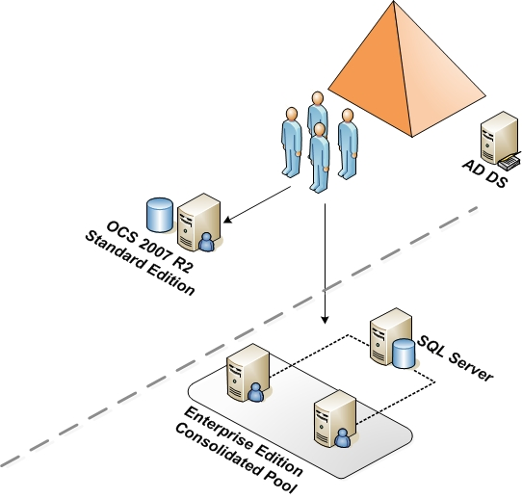 | 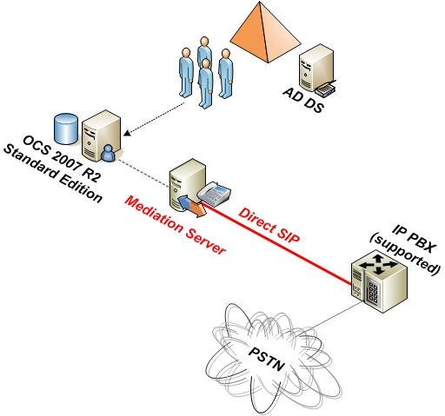
Prerequisites  - Active Directory Domain Services (AD DS)  - Domain controllers and global catalog servers are running the Windows Server® 2003 operating system with SP2, Windows Server 2003 R2 with SP2, or Windows Server 2008.  - All domains in which you deploy Office Communications Server 2007 R2 must be raised to a domain functional level of Windows Server 2003 or Windows Server 2008. Note: Office Communications Server 2007 R2 cannot be deployed in a Windows 2000 Server mixed or Windows 2000 Server native domain.  - Schema extended for Office Communications Server 2007 R2  - One server running Windows Server 2003 R2 with SP2 or Windows Server 2008  - Certificates  Functionality  - Internal usage of IM, presence, conferencing ,and voice for Office Communicator 2007 R2 and Office Communicator Phone Edition IP phone  Scale  - One server (one role)  - Few thousand users (goal)  Personas Involved  - Active Directory Schema Admin  - Office Communications Server Admins  - Desktop Admins  - Network Admins  Notes  - No high availability, unless an Enterprise Edition consolidated pool is deployed  - Limited scale  - No external, federated, or anonymous users for IM, presence, conferencing, and voice  - Hardware load balancer is required if two or more servers are deployed in Enterprise pool | Prerequisites  - AD DS as in Core 1  - One server running Windows Server 2003 with SP2 or Windows Server 2003 R2 with SP2 or Windows Server 2008.  - PSTN connection (see step 3)  - Certificates  Functionality  - Internal usage of IM, presence, and Conferencing for Office Communicator 2007 R2 and Office Communicator Phone Edition IP phone  - Voice access to existing telephony environment and PSTN for Office Communicator 2007 R2 and Office Communicator Phone Edition IP phone  Scale  - Basic: two servers (two roles)  - Basic hybrid: one server  - Few thousand users (goal)  Personas involved  - PBX/Telephony Admins  - Network Admins  Notes  - No high availability  - If not doing direct-SIP, Mediation Server must be paired and collocated with an IP/PSTN gateway  - No external, anonymous, or federated users for IM, presence, conferencing, or voice
  - Voice Scenario Options
Office Communications Server 2007 R2 introduces two new voice connectivity options that do not require the use of IP/PSTN gateways:
- SIP Trunking for direct IP connectivity to qualified carriers. (Voice 3E: SIP Trunking (New))
- Direct SIP for direct IP connectivity to qualified IP PBXs. (Voice 3F: Direct SIP (New))

Note
Direct SIP was available with Office Communications Server 2007 as well but is a recommended topology for the Office Communications Server 2007 R2 TAP.

The prior gateway-centric options for connection to existing corporate telephony system continue to be valid options for Office Communications Server 2007 R2, and if applicable, they can be used in conjunction with SIP trunking. These options are:
- Direct PSTN connection (Voice 3A: Direct PSTN connection)
- Tie-line off existing TDM PBX (Voice 3B: Tie-line off existing TDM PBX)
- PRI off existing IP/PSTN gateway (Voice 3C: PRI off existing IP/PSTN gateway)
- Greenfield (Voice 3D: Greenfield)

    - SIP Trunking and Direct SIP

Voice 3E: SIP Trunking (New) | Voice 3F: Direct SIP (New)
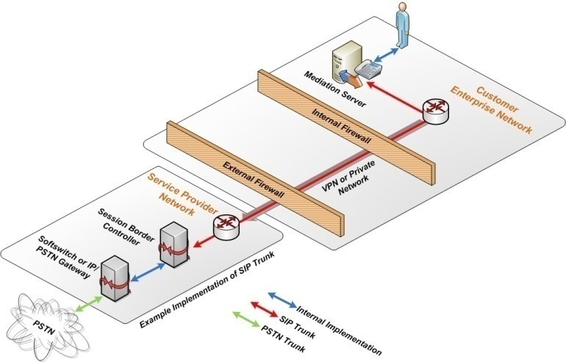 | 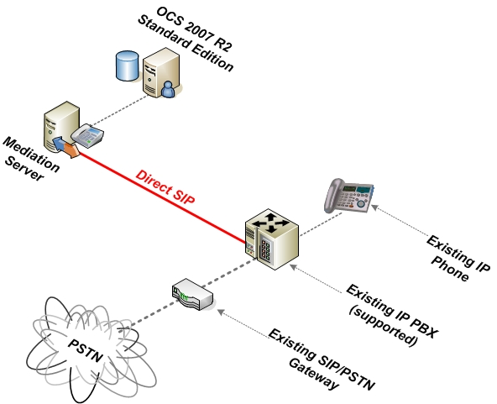
Mediation Server is directly connected to an approved IP trunk from a telephony service provider. This is similar to 3A and 3D, except the PSTN connection is made directly via IP (SIP trunk) and does not require an IP/PSTN gateway.  Note This configuration can potentially be combined with 3E or 3B/C for PBX connectivity.  Recommended for  - Companies (or branches) with a single IP trunk for their data and voice networks  Personas involved  - PBX/Telephony Admins  - Office Communications Server Admins  Pros  - No integration necessary with existing voice infrastructure.  - No requirement to deploy, maintain, and operate IP-PSTN gateways on-premises either regionally or at remote offices.  - Consolidation of data/voice networks (recurring costs)  Cons  - Pilot users may need new phone numbers.  - Service providers must certify interoperability of their infrastructure via the Microsoft SIP Trunking spec . | Mediation Server is directly connected to a qualified IP PBX, eliminating the need for an IP/PSTN Gateway. This is similar to 3C, except without the gateways.  Note Only qualified PBXs listed on the OIP Web site can be used in this configuration.  Recommended for  - Enterprise environments that have an direct-SIP qualified IP-PBX  Personas involved  - PBX/Telephony Admins  - Office Communications Server Admins  Pros  - No IP/PSTN gateway is required.  - Pilot users do not need a new phone number.  Cons  - Supplementary services (such as Call completion on busy subscriber and Team calls) cannot be used between Office Communicator or Office Communicator Phone Edition and existing IP PBX users.  - Routing to pilot users must be configured in IP-PBX.  - PBX attendant console will not have information on phone presence states (busy lamp field) of those users (Office Communicator can be used instead).

    - Gateway Connectivity Options
Voice 3A: Direct PSTN connection | Voice 3B: Tie-line off existing TDM PBX
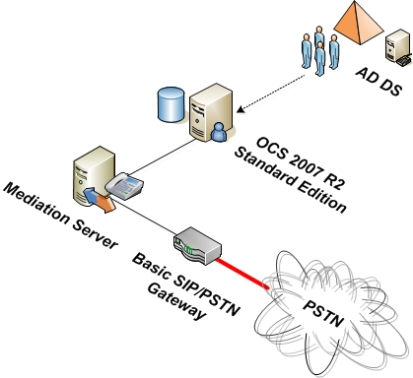 | 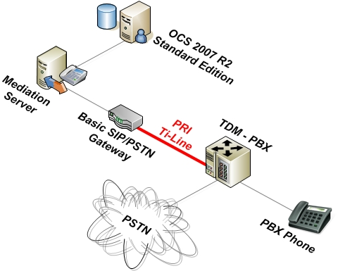
Gateway is directly connected to the PSTN  Recommended for  - Companies with an outdated PBX infrastructure  - Companies that do not want to interfere with their existing voice infrastructure  Pros  - No integration necessary with existing voice infrastructure.  - Easy to set up.  Cons  - Pilot users typically need new phone numbers.  - External call forwarding must be configured for pilot users through PSTN in existing voice solution. | Gateway is connected to a tie-line of the existing TDM PBX  Recommended for  - All large enterprise environments that still have a TDM-based PBX  - Companies that have an unused tie line PRI port available or can configure that easily (with assistance from Microsoft)  Pros  - Core features are transparent to all other PBX users.  - Allows using the existing PBX network for all cross-site call routing.  - Pilot users do not need a new phone number.  Cons  - Supplementary services (such as Call completion on busy subscriber and Team calls) cannot be used between Office Communicator or Office Communicator Phone Edition and existing PBX users.  - Routing to pilot users must be configured in PBX.  - PBX attendant console will not have information on phone presence states (busy lamp field) of those users (Office Communicator can be used instead).

Voice 3C: PRI off existing IP/PSTN gateway | Voice 3D: Greenfield
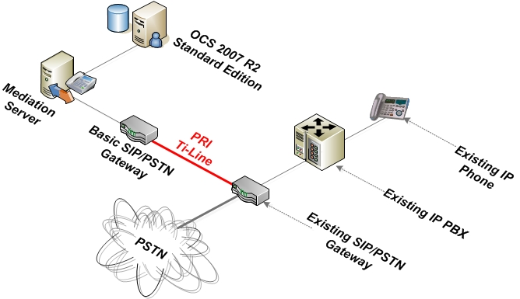 | 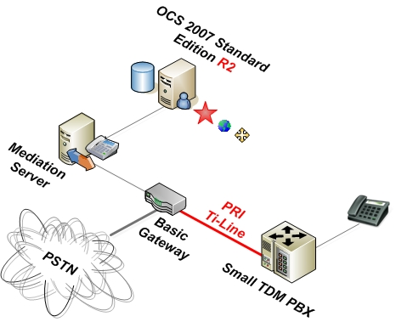
Gateway is connected to a TDM PRI off the existing IP/PSTN gateway  Recommended for  - All large enterprise environments that already have an IP-PBX  Pros  - No SIP-to-SIP connection needs to be established between the two VoIP systems.  - All cross-system traffic will be “normalized” by the SIP/PSTN gateways.  - Pilot users do not need a new phone number.  Cons  - Supplementary services (such as Call completion on busy subscriber and Team calls) cannot be used between Office Communicator or Office Communicator Phone Edition and existing IP-PBX users.  - Routing to pilot users must be configured in IP-PBX and on the existing IP-PBX gateway.  - PBX attendant console will not have information on phone presence states (busy lamp field) of those users (Office Communicator can be used instead). | (Small) PBX is connected to a TDM PRI off the IP/PSTN gateway  Recommended for  - Organization without an existing PBX  - Progressive customers with minimal telephony requirements  Pros  - Easy to configure from Office Communications Server perspective.  - Small PBX for legacy devices is inexpensive and may already be available at customer site.  Cons  - Small PBX can only provide missing connectivity but not additional features for the Office Communicator or Office Communicator Phone Edition clients.  - Small PBX must be configured  - Current Office Communicator or Office Communicator Phone Edition feature set must match customer requirements.

    - Recommendation for Pilot user selection
When selecting pilot users for the voice functionality provided by Office Communicator 2007 and the Office Communications Server 2007 R2 server infrastructure, Microsoft recommends the following:
- Collocate pilot users in clusters and select users who have a computer and use Microsoft Office, specifically the Microsoft Office Outlook® messaging and collaboration client, on a daily basis.
- Ensure that pilot users update to Microsoft Office 2007 to obtain the highest level of integration in conjunction with Microsoft Office Communicator 2007 R2.
- Ensure that pilot users are equipped with a webcam and a USB audio device (handset or headset with microphone). For details, including a list of devices optimized for Office Communicator, see the Phones and Devices Optimized for Microsoft Office Communicator Web site at http://technet.microsoft.com/en-us/bb970310.aspx.
- Recommend the use of USB audio devices, because they provide the ability to separate operating system sounds from your audio call. USB audio devices also ensure best audio quality.
- Pilot users should have a mailbox on Exchange 2007 with SP1 for Unified Messaging.
Given the current voice feature set of Office Communicator 2007 R2 and the Office Communicator Phone Edition IP phone, we recommend avoiding voice installations in special call-routing environments, such as call centers and trading.
    - Connecting to Existing Telephony Systems
The new voice connectivity options in Office Communications Server 2007 R2 - SIP trunking (Voice 3E) and Direct SIP (Voice 3F) do not require an IP/PSTN gateway. However, scenarios 3A-3D continue to require a certified IP/PSTN gateway. This section provides guidance on gateway types and selection criteria for these scenarios.
For details about Office Communications Server 2007 R2, including a list of available and supported IP/PSTN gateways, see the Microsoft Unified Communications Open Interoperability Program Web site at http://technet.microsoft.com/en-us/office/bb735838.aspx.
The following gateway types are available:
- Basic gateway Gateway is a separate device, independent but located close to the Mediation Server (connected at LAN speed).
- Basic hybrid gateway Gateway combines a basic gateway and a mediation server in single rack mounted server.
- Advanced gateway Gateway combines the functionality of a basic gateway and the functionality of a Mediation Server into a single device (currently, none of the manufacturers provide an advanced gateway).
A gateway with 1 PRI (T1=23 B channels, E1 with 30 channels) is usually sufficient to supply PSTN access to approximately 100 heavy PSTN users (three or more calls per hour). When sizing your gateways, take into consideration that only calls going from an Office Communicator client or Office Communicator Phone Edition IP phone to a user of the existing telephony world (and the reverse) will consume a gateway channel; calls that stay within the IP world will not.
In the majority of cases, the same IP/PSTN gateway can be used for both Office Communications Server 2007 R2 voice deployments and Exchange 2007 SP1 Unified Messaging. If you have a Unified Messaging gateway currently installed, confirm the correct gateway selection (such as the one that will work with both Unified Messaging and Office Communications Server 2007 R2).
To select the appropriate gateway, depending on the designated voice scenario as listed here, we recommend verifying the following gateway specifications or checking with the gateway vendor support team to ensure that the scenario will work in your particular environment:
- Scenario Voice 3A:
  - Does the gateway provide the right number and type of connections to the PSTN?
  - Does the gateway provide the right PSTN protocol?
  - Does the gateway have the relevant country permissions to connect to the PSTN?
  - Does the gateway provide the necessary number (called or calling party number) manipulation capabilities in the admin program?
  - Do I need to prepare a special connection cable or does it come with the gateway?
  - Do I need an adapter for the power supply?
- Scenario Voice 3B:
  - Does the gateway provide the right number and type of connections to my PBX?
  - Does the gateway provide a protocol that is also supported by my existing PBX?
  - Does the gateway provide the necessary number (called or calling party number) manipulation capabilities in the admin program?
  - Do I need to prepare a special connection cable or does it come with the gateway?
  - Do I need an adapter for the power supply?
- Scenario Voice 3C:
  - Does the gateway provide the right number and type of connections to my existing IP gateway?
  - Does the gateway provide a protocol that is also supported by my existing IP gateway?
  - Does the gateway provide the necessary number (called or calling party number) manipulation capabilities in the admin program?
  - Do I need to prepare a special connection cable or does it come with the gateway?
  - Do I need an adapter for the power supply?
- Scenario Voice 3D:
  - Include questions from Scenario Voice 3A.
  - Can I configure a PRI tie line of the gateway to the PBX in the admin program and how?
  - Which protocols will be available for this PRI tie line to the PBX?
  - Advanced Scenario Options
When the basic infrastructure is in place, your Office Communications Server 2007 R2 deployment can be enhanced with the following features. Each of these scenarios require additional server roles, the deployment of additional components, or both, as shown in the following figure.

Option 4A: Edge Server for remote user access for IM, presence, conferencing, and voice | Option 4B: Voice mail and auto-attendant with Exchange 2007 SP1 Unified Messaging
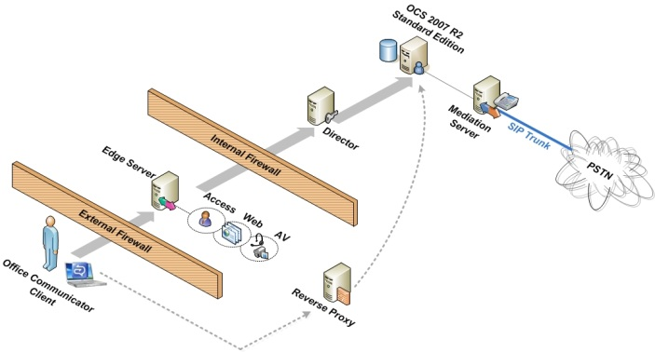 | 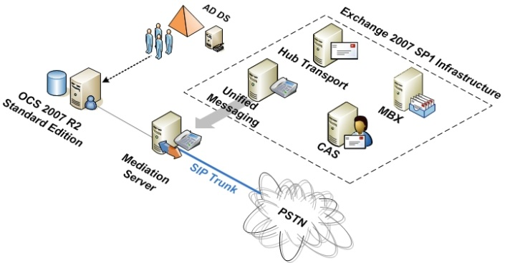
Prerequisites  - Active Directory Domain Services as in Core 1  - HTTP reverse proxy (for example, Internet Security Accelerator (ISA))  - PSTN connection or SIP trunk  - One server running Windows Server 2003 SP1 or Windows Server 2003 R2 SP1 or Windows Server 2008  - Certificates.  Note For federation with Microsoft or anonymous access, a certificate from a public trusted certification authority (CA)is required.  Functionality  - All IM, presence, and conferencing (including A/V, Web, and IM conferencing)  - External, federated presence, and IM (including PIC/Anonymous usage)  - External and federated voice usage  Scale  - Plus one additional server (plus one additional role)  - Few thousand users (goal)  Personas involved  - Firewall Administrators  - Office Communications Server Admins  - Network Admins  Notes  - A Director is recommended in Office Communications Server 2007 R2 remote access scenarios.  - High availability and capacity can be added with multiple load-balanced edge servers.  - Consolidated Edge Server in perimeter network. | Prerequisites  - Active Directory Domain Services  - The domain controller that is the schema master must have Windows Server 2003 withSP1 installed.  - You must have at least one global catalog server in every Active Directory site where you plan to install Exchange 2007 SP1. This global catalog server must be running Windows Server 2003 with SP1.  - In each domain where you will run Setup / PrepareLegacyExchangePermissions, setup must contact a Windows Server 2003 with SP1 domain controller.  - For all domains in the Active Directory forest where you will install Exchange 2007 SP1 or that will host Exchange 2007 recipients, the Active Directory domain functional level must be Windows 2000 Server native or higher.  - The Exchange organization must be in Native Mode.  - All Exchange 2000 servers must be running the latest SP3 Update Rollup.  - All Exchange 2003 servers must be running SP2.  - At least 1 server running Windows Server 2003 with SP1 or Windows Server 2003 R2 as the operating system and the following Exchange 2007 server roles: Mailbox, Client Access, Hub Transport, Unified Messaging.  - PSTN connection from Voice 3.  - For small-scale deployments, all Exchange server roles can be combined on one physical 64 bit server.  - Certificates.  Functionality  - Voice mail for Office Communicator and Office Communicator Phone Edition IP Phone users.  - Auto-attendant functionality.  Scale  - No additional server role for Office Communications Server 2007 R2.  Personas involved  - Active Directory Schema Admins.  - Exchange Admins.  - Office Communications Server Admins.  - PBX/Telephony Admins.  Note  - For details about requirements, see the Exchange documentation.

Option 4C: Communicator Web Access for IM, Presence and Application Sharing | Option 4D: Communicator Mobile
 | 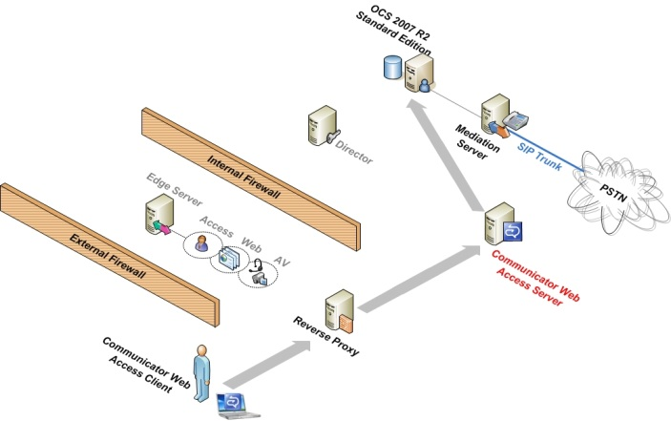
Prerequisites  - Active Directory Domain Services from Core 1  - HTTP reverse proxy (for example, ISA)  - A server running Windows Server 2003 with SP1, Windows Server 2003 R2 with SP1, or Windows Server 2008  - Certificates  Functionality  - Browser-based IM and presence  - Dial-in conferencing PIN provisioning  Scale  - Plus one additional server (plus one additional role)  - Few thousand users (goal)  Personas involved  - Firewall Admins  - Office Communications Server Admins  - Network Admins  Notes  - No high availability  - Consider a second Communicator Web Access server to support remote users to isolate external traffic | Prerequisites  - Active Directory Domain Services from Core 1  - HTTP reverse proxy (for example, ISA)  - A server running Windows Server 2003 with SP1, Windows Server 2003 R2 with SP1, or Windows Server 2008  - Certificates  Functionality  - IM/presence, voice (via mobile network) using client on Windows-Mobile based devices  - Single number dialing  Scale  - Plus one additional server (plus one additional role)  - Few thousand users (goal)  Personas involved  - Firewall Admins  - Network Admins  - Office Communications Server Administrator  Note  - No high availability

Option 4E: Archiving Server | Option 4F: Updating Communicator Clients
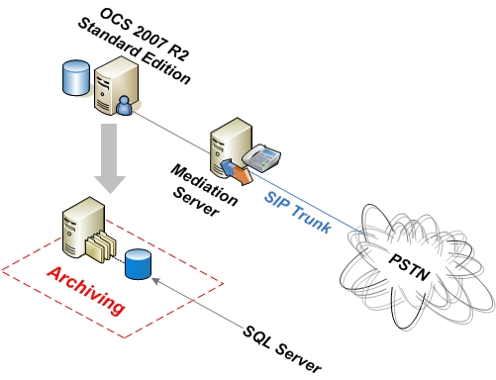 | 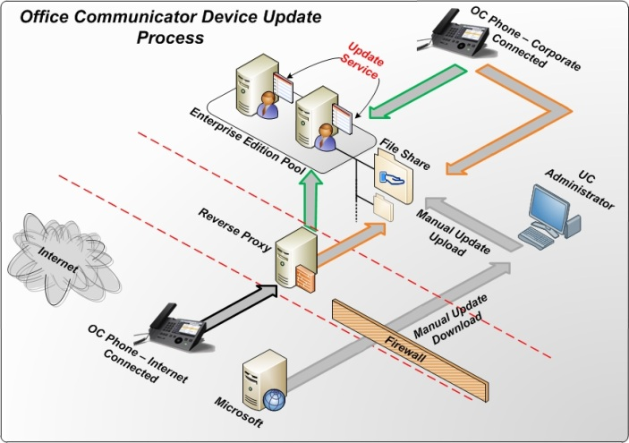  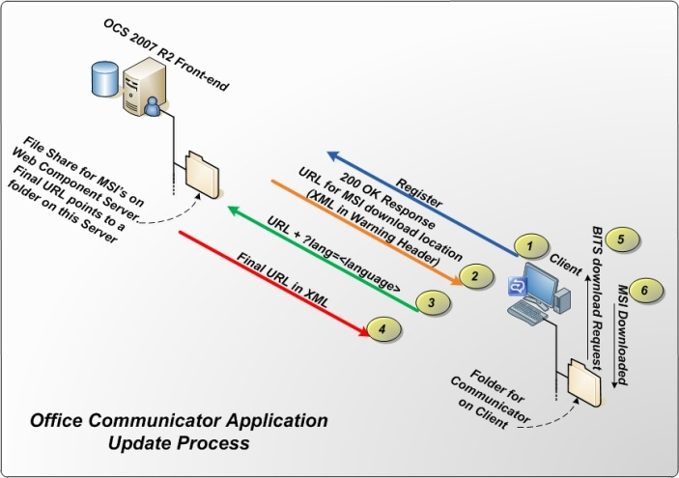
Prerequisites  - Active Directory Domain Services from Core 1  - A server running Windows Server 2003 with SP1, Windows Server 2003 R2 with SP1, or Windows Server 2008  - SQL Server 2008 (32-bit or 64-bit) or SQL Server 2005 with Service Pack 2 (32-bit or 64-bit)  - Certificates  Functionality  - Archiving service for IM and group conferences  Scale  - Plus one additional server (plus one additional role)  - Few thousand users (goal)  Personas involved  - Network Admins  - Office Communications Server Administrator  Notes  - No high availability.  - Archiving Server is shown here with collocated SQL Server; SQL Server can also reside on a separate server. | Prerequisites  - Active Directory Domain Services from Core 1  - Certificates  - Web Service running on the Office Communications Server 2007 Web Component server  Functionality  - Remote updating of Office Communicator soft clients  Scale  - No additional Office Communications Server computers required  - Few thousand users (goal)  Personas involved  - Office Communications Server Admins  - Network Admins  Notes  - Soft client update configured via the client version check  - Device updates configured via new Microsoft Management Console (MMC) application  - Internal and external downloads supported  - Windows Server Update Services (WSUS) and SharePoint are no longer supported

Option 4G: Monitoring Server | Option 4H: Chat Room Server
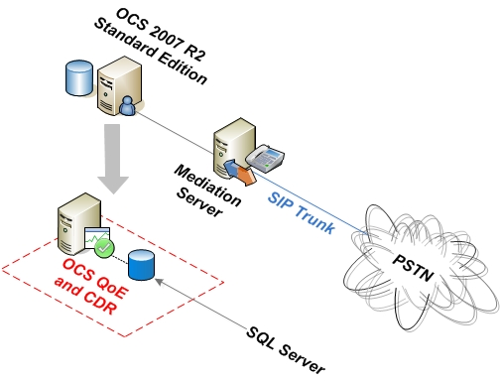 | 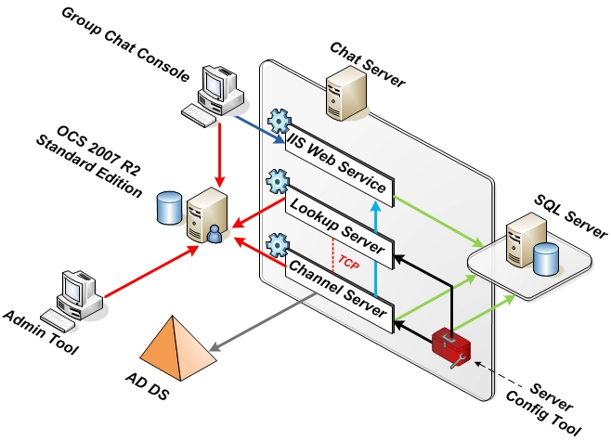
Prerequisites  - Active Directory Domain Services from Core 1  - A server running Windows Server 2003 with SP1, Windows Server 2003 R2 with SP1, or Windows Server 2008  - SQL Server 2008 (32-bit or 64-bit) or SQL Server 2005 with SP2 (32-bit or 64-bit)  - Certificates  Functionality  - Gathers both CDR and QoE data  Scale  - Plus one additional server (plus one additional role)  - Few thousand users (goal)  Personas involved  - Network Admins  - Office Communications Server Administrator  Notes  - No high availability  - Monitoring Server are shown here with collocated SQL Server running separate instances. SQL Server can also reside on a separate server. | Prerequisites  - Active Directory Domain Services from Core 1  - A server running Windows Server 2003 with SP1, Windows Server 2003 R2 with SP1, or Windows Server 2008  - SQL Server 2008 (32-bit or 64-bit) or SQL Server 2005 with SP2 (32-bit or 64-bit)  - Certificates  Functionality  - Persistent IM conversations  Scale  - Plus one additional server (plus one additional role)  - Few thousand users (goal)  Personas involved  - Network Admins  - Office Communications Server Admins  Notes  - No high availability
  - Supported Server Role Collocation
The following table identifies the Office Communications Server 2007 R2 components that can be collocated on the same computer. Any combination that is not identified has not been tested and is not supported.
Collocation Guide for Office Communications Server 2007 R2 Components
This server role/configuration | Can collocate with this server role
Standard Edition server | Communicator Web Access  Archiving Server (Note: this topology is not recommended)  Monitoring Server
Enterprise Edition consolidated server | Communicator Web Access
Back-End Database Server | Archiving Database  Monitoring Database
Enterprise Edition expanded server Front-End | Web Conferencing Server  Application Sharing Conferencing Server  Communicator Web Access
Enterprise Edition expanded server Web Conferencing | Front-End Server  Application Sharing Conferencing Server  A/V Conferencing Server  Web components  Communicator Web access
Enterprise Edition expanded server Application Sharing | Front-End Server  Web Conferencing Server  A/V Conferencing Server  Web components  Communicator Web access
Enterprise Edition expanded server A/V Conferencing | Web Conferencing Server  Application Sharing Conferencing Server  Web components  Communicator Web Access
Web components | Web Conferencing Server  Application Sharing Conferencing Server  A/V Conferencing Server  Communicator Web Access  Archiving Server  Monitoring Server
Director | Communicator Web Access
Communicator Web Access | Front-End Server  Web Conferencing Server  Application Sharing Conferencing Server  A/V Conferencing Server  Web components  Director  Archiving Server  Monitoring Server
Edge Server | Never collocated
Mediation Server | Never collocated
Archiving Server | Web components  Communicator Web Access  Monitoring Server
Monitoring Server | Web components  Communicator Web Access  Archiving Server
Group Chat Server | Never collocated

The following collocation scenarios are explicitly not supported for Office Communications Server 2007 R2:
- Any server role on an Active Directory domain controller
- Any server role on an Active Directory global catalog server
- Exchange UM and Office Communications Server
- Edge servers and any other Office Communications Server role
- Edge servers and Microsoft Internet Security and Acceleration Server (ISA)
- Mediation Server with any other Office Communications Server 2007 R2 role
- Group Chat Server with any other Office Communications Server role.
- Virtualization of any role in Office Communications Server 2007 R2
  - Supported Migration Paths and Coexistence Scenarios
Migration of Office Communications Server 2007 Standard Edition, Enterprise Edition in a consolidated configuration, and Enterprise Edition in an expanded configuration, either with or without Edge Servers, is supported. Migrations can be approached in a phased fashion, starting with the internal network and moving to the perimeter network. These migrations must be completed starting with internal servers and moving out to the Edge Server.
The following two migration methods are supported:
- Side-by-side migration In side-by-side migration, a new Office Communications Server 2007 R2 configuration is built alongside the Office Communications Server 2007 configuration. After the new configuration is fully validated, users are moved from the original configuration to the new configuration. This method requires additional servers during the migration, and system names and pool names are different in the new configuration. During this type of migration, service outage is brief or nonexistent.
- Uninstall/reinstall This type of migration is similar to a disaster recovery. All user and configuration data is exported and stored in a backup location. Office Communications Server 2007 is uninstalled, Office Communications Server 2007 R2 is installed on the same computer, and then all user and configuration data is restored. This migration method does not require additional servers, and the system name and pool name remain the same. During this type of migration, service outage is expected to be longer. This method requires an operating system upgrade from 32-bit to 64-bit.

Supported Migration Scenarios
Starting topology | Target topology | Migration method
Enterprise Edition, expanded | Enterprise Edition, consolidated | Side-by-side migration, from internal network to perimeter network  Uninstall/reinstall
Enterprise Edition, consolidated | Enterprise Edition, consolidated | Side-by-side migration, from internal network to perimeter network  Uninstall/reinstall
Enterprise Edition, expanded | Enterprise Edition, expanded | Side-by-side migration, from internal network to perimeter network  Uninstall/reinstall
Enterprise Edition, consolidated | Enterprise Edition, expanded | Side-by-side migration, from internal network to perimeter network
Standard Edition | Standard Edition | Side-by-side migration, from internal network to perimeter network
Standard Edition | Enterprise Edition, consolidated | Side-by-side migration, from internal network to perimeter network
The coexistence scenarios described in this section support phased side-by-side migrations. Any coexistence scenario not included in this section is not supported.
Coexistence Scenarios
This Office Communications Server 2007 R2 component | Can communicate with this Office Communications Server 2007 or Live Communications Server 2005 component
Enterprise pool or Standard Edition server | Director Server  Edge Server  Communicator Web Access  Mediation Server  Office Communicator 2007  Office Communicator 2005  Office Live Meeting 2007
Mediation Server | Enterprise pool or Standard Edition server
Monitoring Server | Mediation Server  Clients homed on Enterprise pool or Standard Edition server
Director Server | Edge Server
Enterprise Edition or Standard Edition pool server | A/V Edge Server
Office Communicator 2007 R2 | A/V Edge Server  (only for conferences initiated by an A/V Conferencing Server)
Enterprise Edition or Standard Edition pool server | Microsoft Office Communicator Web Access (2007 Release)
Enterprise Edition or Standard Edition pool server | Mediation Server
Exchange UM | Enterprise pool or Standard Edition server
Enterprise Edition or Standard Edition pool server | Office Communicator 2007

Following are coexistence restrictions:
- Office Communications Server 2007 R2 Edge Servers cannot communicate with Office Communications Server 2007 servers.
- The back-end database schema has changed with Office Communications Server 2007 R2, so a new SQL Server instance is required for an Office Communications Server 2007 R2 Enterprise pool. An existing back-end server with the required level of SQL Server 2005 can host an Office Communications Server 2007 R2 Back-End database, but there might be performance limitations for a collocated back-end.
- Call Control Server (CCS) requires Office Communications Server 2007 R2 Mediation Server. In side-by-side phased migrations, CCS is disabled until Mediation Server is upgraded to Office Communications Server 2007 R2.
- The following Office Communications Server 2007 R2 components must be upgraded when the pool is upgraded.
- Archiving and CDR Server must be upgraded to Archiving Server
- Quality of Experience Monitoring Server (QoE) must be upgraded to Monitoring Server
- Administrative Tools
- Questionnaire
In the table below, indicate your current or selected deployment, referencing the deployment variations presented earlier in section 2. Check the appropriate boxes with an X and indicate in the fourth column the number of instances you want to deploy in this scenario. After that, go to section 4.1 and answer the questions there. References to supplemental documentation, which provide answers to detailed questions, are provided in section 4, later in this document.
Answers to the detailed questions below provide information to assist you in your communications with Microsoft support and consulting staff or deployment partners in the design and deployment of your Office Communications Server 2007 R2 environment.
When you answer the questions, focus on providing information relevant to your Office Communications Server 2007 R2 deployment and associated pilot users, as shown in the following table.

Selected Deployment Roles/Scenarios
Scenario | New  install | Update | Number of instances | Detailed  questions
Core 1: Standard Edition Server or Enterprise Edition consolidated pool (section 2.4) |  |  |  | Go to 4.2.1
Core 2: Mediation Server (section 2.4) |  |  |  | Go to 4.3.1
Voice 3A: Direct PSTN connection (section 2.5) |  |  |  | Go to 4.4
Voice 3B: Tie-line off existing TDM PBX (section 2.5) |  |  |  | Go to 4.5
Voice 3C: PRI off existing IP/PSTN gateway (section 2.5) |  |  |  | Go to 4.6
Voice 3D: Greenfield (section 2.5) |  |  |  | Go to 4.7
Voice 3E: SIP Trunking (section ) |  |  |  | Go to 4.8
Voice 3F: Direct SIP (section ) |  |  |  | Go to 4.9
Option 4A: Edge Server for remote user access for IM, presence, conferencing, and voice (section 2.6) |  |  |  | Go to 5.1
Option 4B: Voice mail and auto-attendant  with Exchange 2007 with SP1 Unified Messaging (section 2.6) |  |  |  | Go to 5.2
Option 4C: Communicator Web Access for IM, presence, conferencing, and dial-in (section 2.6) |  |  |  | Go to 5.3
Option 4D: Communicator Mobile 3.0 |  |  |  | Go to 5.4
Option 4E: Archiving Server |  |  |  | Go to 5.5
Option 4F: Updating Office Communicator clients |  |  |  | Go to 5.6
Option 4G: Monitoring Server |  |  |  | Go to 5.7
Option 4H: Group Chat Server |  |  |  | Go to 5.8
Feature 5A: Audio conferencing |  |  |  | N/A
Feature 5B: Call delegation |  |  |  | N/A
Feature 5C: Voice mail enhancements |  |  |  | N/A
Feature 5D: Video enhancements |  |  |  | N/A
Feature 5E: Team calling |  |  |  | N/A
Feature 5F: Response group (Astana) |  |  |  | N/A
Feature 5G: Office Communicator application and desktop sharing |  |  |  | N/A
Feature 5H: Communicator Attendant (Samara) |  |  |  | N/A
Feature 5I: Office Communicator Phone Edition (Tanjay) |  |  |  | N/A

- Detailed Questions for Basic Deployment
This section covers detailed questions pertaining to deployment scenarios involving basic Office Communications Server 2007 R2 functionality. You can skip those questions that are unrelated to the specific deployment scenarios you chose earlier in section 3.
  - Environmental Dependencies
    - Assumptions
The following assumptions are made for customers deploying Office Communications Server 2007 R2:
- WAN links are capable of supporting 57Kbps (audio) and 320Kbps (video) per stream.
- A voice conversation between two users uses two streams
- A video conversation between two users uses two streams
- WAN link latency is less than150 ms round trip
    - Infrastructure
Answer the questions shown in the following table.
Infrastructure Questions
Question | Answer | Comment
Have you run the Office Communications Server 2007 Best Practices Analyzer and submitted the data? |  | The Office Communications Server 2007 Best Practices Analyzer produces a report with information about your current Office Communications Server environment. For details, see the Office Communications Server 2007 Best Practices Analyzer on the Download Center Web site at http://www.microsoft.com/downloads/details.aspx?FamilyID=1b90993c-072a-4c84-b385-b76d23b2f27c&DisplayLang=en.
Provide an executive view of your LAN and WAN topology. Include details of any internal firewalls or router/switch access control lists (ACLs) between subnets, port restrictions. |  | Only describe the relevant links for Office Communications Server 2007 R2 usage.
Is a publicly routable IP address available in the perimeter network? |  | Only required for A/V federation with Office Communications Server 2007 and load-balanced scaled consolidated Edge Server deployments
How do external users connect to the corporate network (such as VPN or dial-up)? |  | Specify hardware and software details of your VPN solution. Also describe whether your users will be connected through VPN when performing voice calls.
Can computer and other devices look up SRV and A records in your SIP URI domain, both internally and externally to your corporate network? |  | For Office Communicator Phone Edition and RoundTable configuration.
Do you have a Network Time Protocol (NTP) Server available on your corporate network? |  | For Office Communicator Phone Edition.
Is it possible to use HTTP requests to access certificates through the virtual directory on the CA? |  | For Office Communicator Phone Edition.
Do you have an A record for autodiscover.<SIP URI>? |  | For Office Communicator Phone Edition.

    - Administration
Answer the questions shown in the following table.
General Administration Questions
Question | Answer | Comment
Do you have the necessary information and permissions to extend the Active Directory schema? |  | If you don’t have permissions, will there be any issues in getting them or working with the teams that do?
What is the estimated lead time for obtaining approval for schema changes? |  | Are there any policies or conditions that would delay extending the schema for more than a week or two?
What is the estimated lead time for firewall changes?
Does your Office Communications Server 2007 R2 administrator have access to telecom equipment or to someone who does?
Does your Office Communications Server 2007 R2 administrator have access to network equipment or to someone who does?
Does your Office Communications Server 2007 R2 administrator have Exchange administrator privileges or access to someone who does?
Does your Office Communications Server administrator have full administrator privileges to Live Communications Server/Office Communications Server or access to someone who does?
Do you have an automated provisioning system for users? If yes, do you anticipate using it for Office Communications Server 2007 R2?

    - Pilot Users
Answer the questions in the following table.
Pilot User Questions
Question | Answer | Comment
How many pilot users do you expect to roll out and when?
What are the versions of Office in use by pilot users (such as Office 2000, Office 2003, or Office 2007)? |  | Please provide an approximate percentage of each client type in use
Which client operating system will pilot users be running?
Are pilot users using Microsoft Office Communicator 2005? |  | This configuration is not supported with Office Communications Server 2007 R2.
Do pilot users have audio equipment? |  | One audio device required per Office Communicator user
Do pilot users have webcams installed?

    - Security
Answer the questions in the following table.
Security Questions
Question | Answer | Comment
Do you have an internal CA or do you use a third party CA to issue X509 certificates for internal servers?
Do all your internal Office Communications Server 2007 R2 clients and Office Communications Server 2007 R2 servers trust the issuing CA?
Do you need assistance providing X509 certificates for external servers?
Do you require client-to-client encryption for audio and video?
Do you require client-to-server encryption?
Is there an organization-wide security policy that prevents the internal use of IM, VoIP, or both?
Are all the necessary ports open and in the proper direction? |  | For details, see the following:  Appendix A of this document  Ports and Protocols in the Office Communications Server 2007 R2 Planning and Architecture documentation at http://go.microsoft.com/fwlink/?LinkID=154083.
Describe server hardening requirements for servers in the perimeter network.
Are there any specific antivirus and antispam requirements for the Office Communications Server 2007 R2 servers? |  | For details about Microsoft Forefront Security for Office Communications Server, see http://www.microsoft.com/forefront/serversecurity/ocs/features.mspx.

    - Change Management and Monitoring
Answer the questions in the following table.
Change Management and Monitoring Questions
Question | Answer | Comment
Do you have a change management process which could be applied to Office Communications Server 2007 R2 and its components and patches? |  | For details about Microsoft Operations Framework, see http://www.microsoft.com/technet/solutionaccelerators/cits/mo/mof/default.mspx.
Do you have a patch management process that could be applied to Office Communications Server 2007 R2 and its components? |  | Consider using the Best Practice Analyzer to determine needed updates and patches. It is available at http://www.microsoft.com/downloads/details.aspx?FamilyId=1B90993C-072A-4C84-B385-B76D23B2F27C&displaylang=en.
Do you have any tools which that be used to monitor Office Communications Server 2007 R2 and its components (for example, Microsoft System Center Operations Manager)?

    - Disaster Recovery
Answer the questions in the following table.
Disaster Recovery Questions
Question | Answer | Comment
Do you have a backup policy in place for Windows Server, Active Directory Domain Services, and SQL Server?
Do you have a disaster recovery plan for the current Office Communications Server 2007 environment? If yes, can it be extended to cover Office Communications Server 2007 R2? |  | It is important to have a fall-back plan for the pilot users. Remember it is not possible to just move them back to Office Communications Server 2007.

  - Core 1: Standard Edition Server or Enterprise Edition Consolidated Pool Deployment
    - New Installation
Answer the questions in the following table.
Questions for New Installations
Question | Answer | Comment
Do you plan to deploy Standard Edition server or Enterprise Edition consolidated pool?
If deploying a consolidated pool, do you have a hardware load balancer? Is it operating in source network address translation (SNAT) or destination network address translation (DNAT) mode? |  | Only SNAT mode is supported.
Do you need assistance from Microsoft with your deployment?
Is this a pilot in which you might deploy more users than originally stated and if so, how many more?
  - Core 2: Mediation Server Deployment

Note
The Mediation Server must be located geographically close to the PSTN gateway (as in at LAN speed) due to latency limitations on the connection between the two devices.
    - Mediation Server Questions
Answer the questions in the following table.
Mediation Server Questions
Question | Answer | Comment
Will the Mediation Server connect using direct SIP, SIP trunking, or a media gateway?
Which media gateway or IP/PSTN gateway will you deploy? |  | Such as Dialogic TIMG 600DTI supports 2E1 PRIs. For details, see the Microsoft Unified Communications Open Interoperability Program Web site at http://technet.microsoft.com/en-us/office/bb735838.aspx.
How many media gateways will you deploy?
How many PRI connections will you connect to the gateway?
Where (physical location) will you deploy the gateways?
What kind of telephony solution is your organization currently using at the location(s) where you will deploy the media gateways? |  | Equipment vendor make, model, software versions for PBX, IP-PBX, IP/PSTN gateways, gateways, and telephones
Can the media gateways be located physically close to the PRI termination point?
What kind of device is your user’s primary phone? |  | Desktop device (such as PBX phone, IP phone, computer, and so on)  Mobile device  Computer plus Softphone
Is the telephony solution integrated into a voice mail solution? If yes, how?
Do you provide Direct Inward Dialing (DID)?
Which Active Directory user attributes are used for storing phone numbers and how are they formatted?
How are telephone numbers stored in Outlook Contacts for your users? |  | To ensure dialing from Outlook contacts, configure Outlook to store phone numbers as RFC 3966 (such as +1 [503] 123-4567) for the US and +45 12345678 for EMEA
Do you currently have the telephony solution integrated with Office Communications Server 2007? If yes, are you using RCC or IP/PSTN? Which software are you using?

    - General Telephony Questions
The current topologies supported with Office Communications Server 2007 R2 include connections to a Time-Division Multiplexing (TDM) PBX, a hybrid PBX, an IP PBX, and environments with no PBX (leveraging the use of cellular phones).
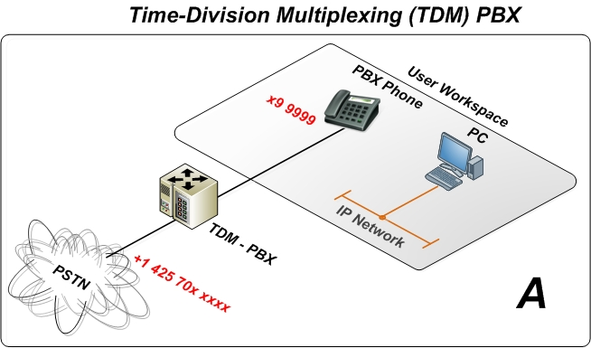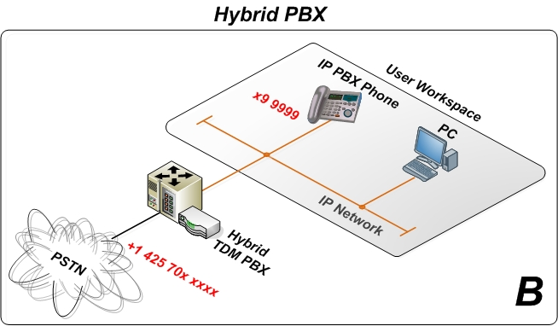
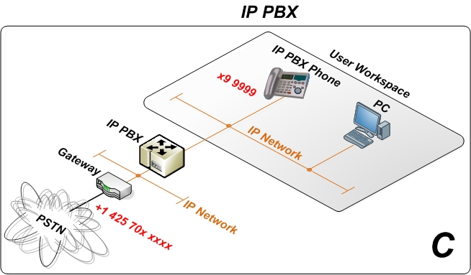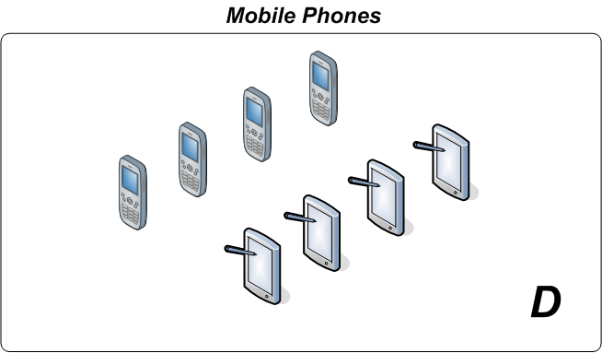
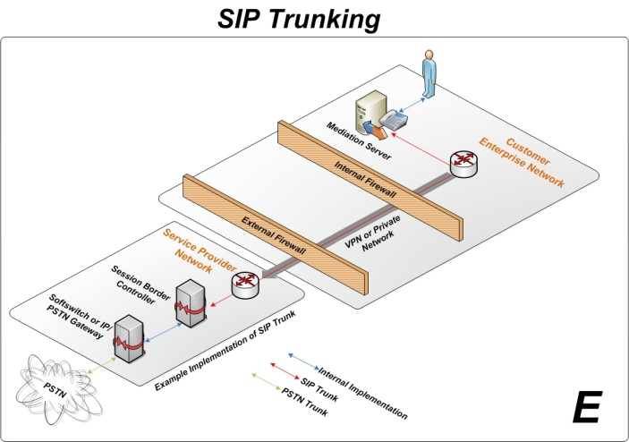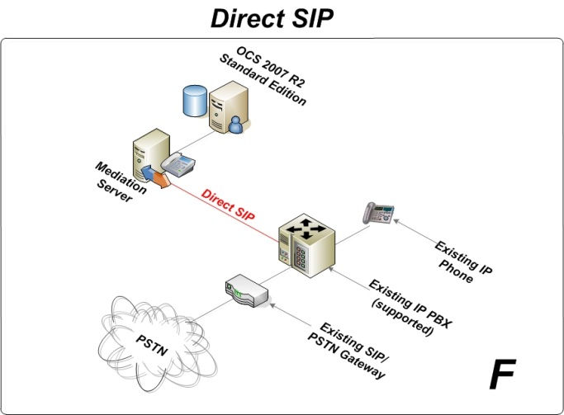
Existing telephony topology options
Answer the questions in the following table.
General Telephony Questions
Question | Answer | Comment
If you have already deployed Office Communications Server 2007 integrated with your telephony system, which deployment options are you currently using - Voice 3A, 3B, 3C, or 3D? |  | Describe your configuration or include a diagram.
Which one of the telephony architectures presented above describes your current infrastructure best? (A-F) |  | Based on the site where you want to integrate Office Communications Server 2007 R2 with the existing telephony environment.
Describe the common dialing patterns used by your pilot users. |  | As in 5-digit extension dialing (12345), local calls (9-555-1223), national calls (9-1-425-555-1234), international calls (9-011-41-1-11111111) or similar for your country. Describe on a per calling site basis where users are deployed.
Will pilot users be grouped into different classes of service? |  | For example, x users get just local and national calls, y users get unrestricted access. Describe on a per calling site basis where users are deployed.
Do you have special telephony legal requirements, such as E911, special PSTN routing, and so forth?
  - Voice 3A: Direct PSTN Connection
The questions pertaining to voice options 3A through 3F must be answered on a per site basis because it is possible to mix and match these options, depending on the existing PBX environment and the physical location of the IP/PSTN gateways.
Use the following diagrams to describe the approach you plan to use for deploying the PRI and gateway with a new IP/PSTN gateway.

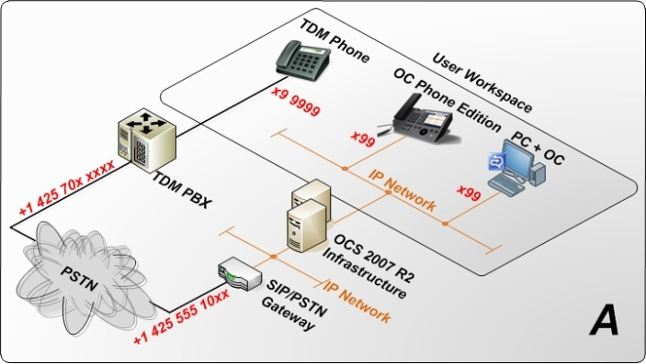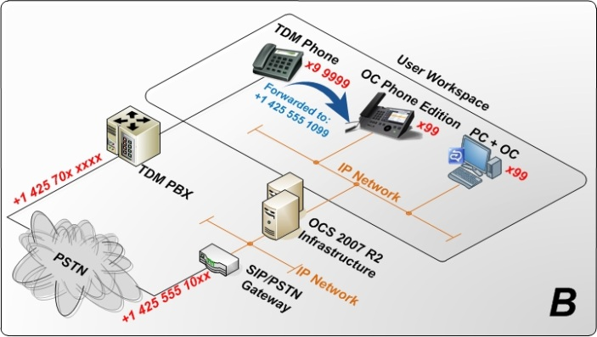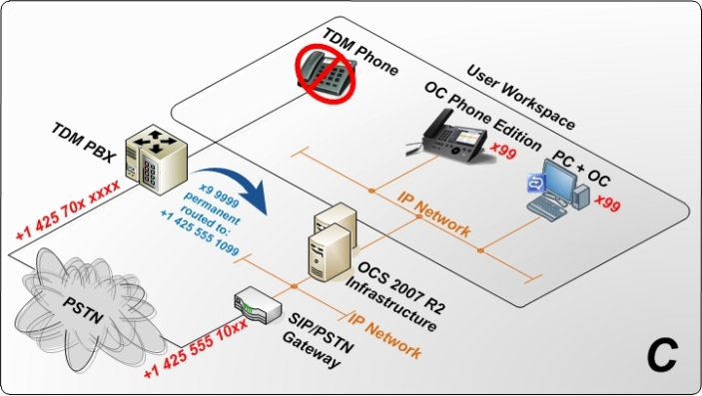
Direct PSTN configurations

Answer the questions in the following table.
Direct PSTN Questions
Question | Answer | Comment
Which one of the configuration options (A, B, or C) best describes your planned Office Communications Server 2007 R2 voice deployment architecture?
Will you order a new primary rate interface (PRI) link or use an existing one for pilot users?
If you require a new PRI link, what is the estimated lead time for ordering and installing this?
What is the DID number range for the PRI link?
Are you aware that pilot users will receive new phone numbers and that outbound calls will display it?
What are the telephone numbers of your pilot users?
What is your numbering scheme?
Do you use any special dial-plans (configuration, permission)?
Do you have an Attendance Console or main switchboard for pilot users to use?

  - Voice 3B: Tie-Line Off Existing Time-Division Multiplexing (TDM) PBX
Use the following diagrams to describe the approach you plan to use for deploying the PRI and gateway with an existing TDM PBX.
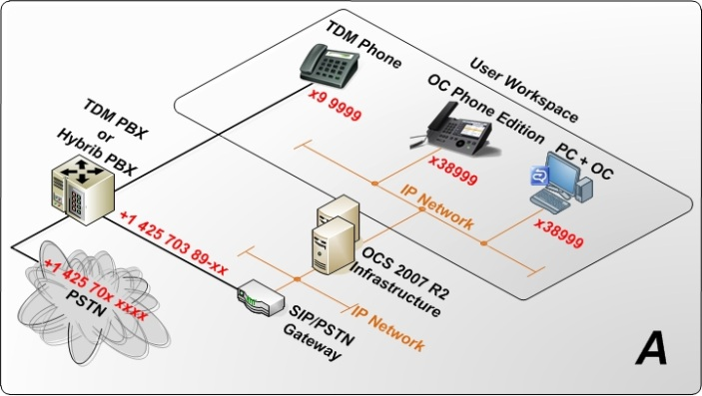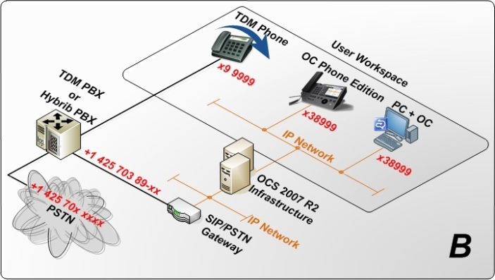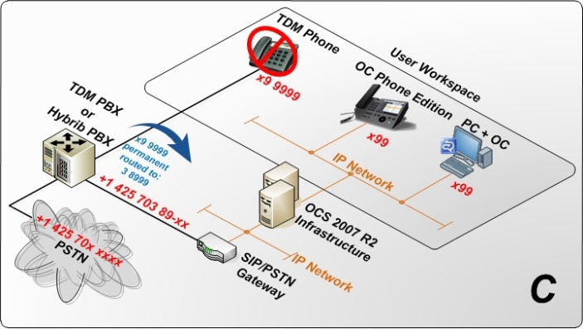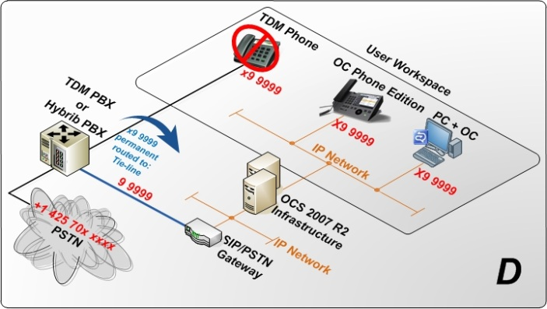
Tie-line off existing TDM PBX options
Answer the questions in the following table.
Tie-Line Off Existing TDM PBX Questions
Question | Answer | Comment
Which one of the configuration options (A, B, C, or D) best describes your planned Office Communications Server 2007 R2 voice deployment architecture best?
Do you have tie-lines that you can use that offer you a free PRI line?
Do you need help getting the tie-lines prepared and configured?
Will you reroute the users’ existing numbers to the PRI line?
What type of cabling will be used for your PRI link? Does it require a cross over cable or other special configuration?
What are the telephone numbers of your pilot users?
What is your numbering scheme?
Do you use any special dial-plans (configuration, permission)?
Do you have an Attendance Console or main switchboard for pilot users to use?

  - Voice 3C: PRI Off Existing IP/PSTN Gateway
Use the following diagrams to describe the approach you plan to use for deploying the PRI and gateway with an existing IP/PSTN gateway connected to an existing IP-PBX.
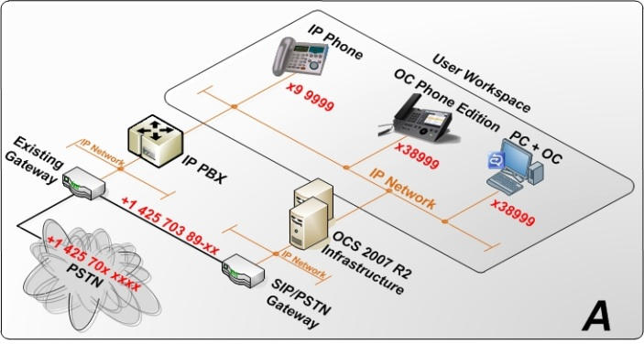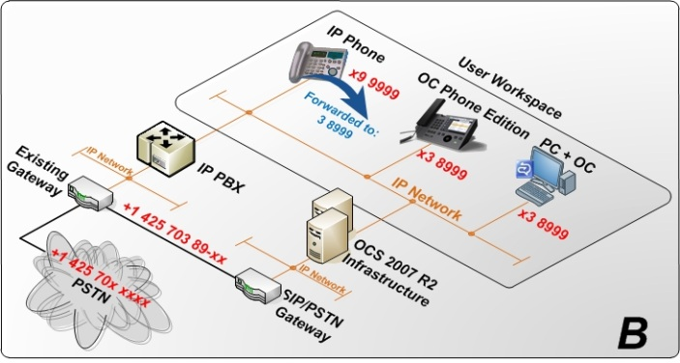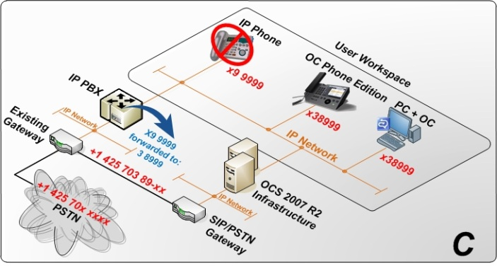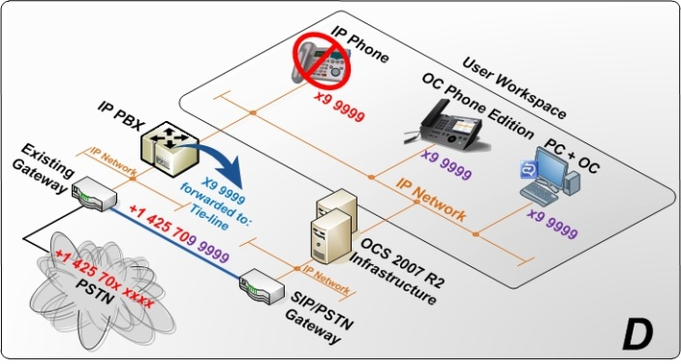
PRI off existing IP/PSTN gateway
Answer the questions in the following table.
PRI Off Existing IP/PSTN Gateway Questions
Question | Answer | Comment
Which one of the configuration options (A, B, C, or D) best describes your planned Office Communications Server 2007 R2 voice deployment architecture best?
Do you have a spare port on your existing SIP/PSTN gateway to provide a PRI line to the SIP/PSTN gateway?
Have you configured your IP-PBX to route pilot numbers to the existing PRI line?
Have you configured your IP-PBX to route pilot numbers to the existing IP/PSTN gateway?
What are the telephone numbers of your pilot users?
What is your numbering scheme?
Do you use any special dial-plans (configuration, permission)?
Do you have an Attendance Console or main switchboard for pilot users to use?

  - Voice 3D: Greenfield
The following diagrams should be useful when you deploy in a new or branch office without an existing PBX. Careful analysis of the location’s needs for handling fax, emergency phones, and lobby phones should be conducted —because Office Communications Server 2007 R2 does not provide a solution for these needs.
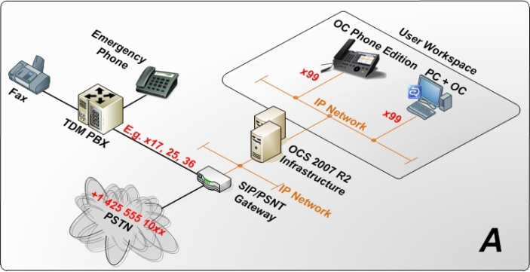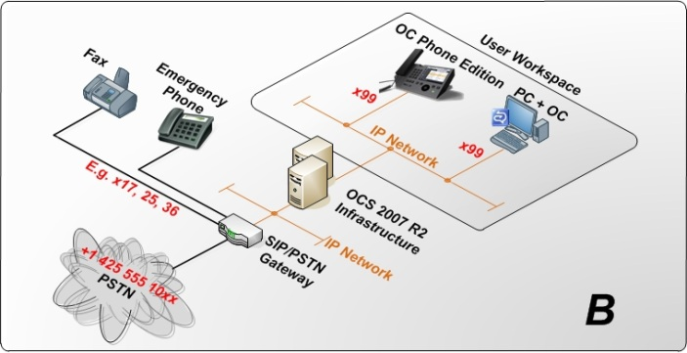
Greenfield deployment configurations
Answer the questions in the following table.
Greenfield Deployment Questions
Question | Answer | Comment
Which one of the configuration options (A or B) best describes your planned Office Communications Server 2007 R2 voice deployment architecture best?
Do you have a spare PBX that can be used to set up this scenario?
What other devices will you connect to the PBX? |  | Such as FAX machines, ISDN modem, and so on
If replacing an existing PBX, what devices were previously connected?
What are the telephone numbers of your pilot users?

  - Voice 3E: SIP Trunking
SIP trunking

Answer the questions in the following table.
SIP Trunking Deployment Questions
Question | Answer | Comment
Who would be your preferred carrier for SIP trunk? |  | This can be any carrier, regardless of whether they offer the service today
Which carrier will you connect to via a SIP trunk?
Will you move existing numbers over to the new trunk or will you get new numbers?
What is the anticipated provisioning time from the carrier?
How will you connect Office Communications Server to your PBX – via a gateway (Voice option 3A, 3B, 3C, or 3D) or via a direct SIP connection (Voice option 3F)?

  - Voice 3F: Direct SIP
Use the following diagrams to describe the approach you plan to use for deploying direct SIP with a certified IP PBX.
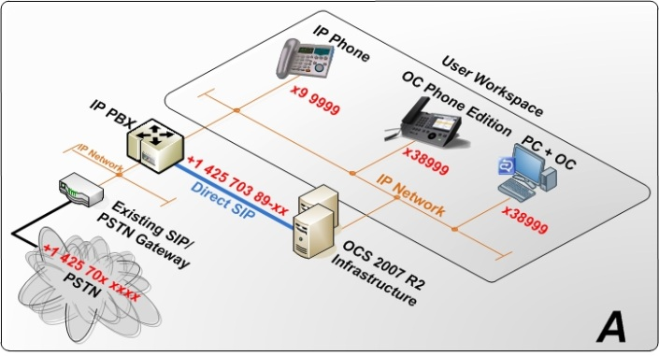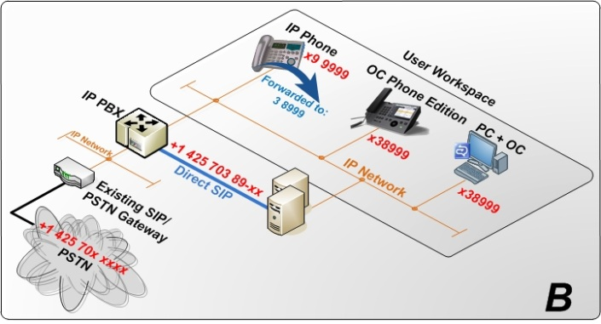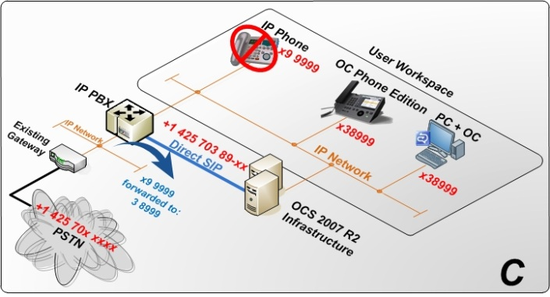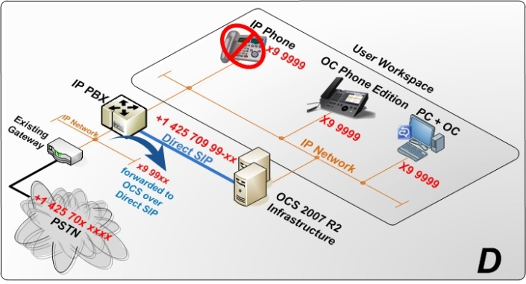
Direct SIP

Answer the questions in the following table.
Direct SIP Questions
Question | Answer | Comment
Which one of the configuration options (A, B, C, or D) best describes your planned Office Communications Server 2007 R2 voice deployment architecture best?
What is the make and model of your IP-PBX?
Is your IP-PBX certified for Direct SIP on the UC OIP Web site?
Have you configured your IP PBX to route pilot numbers to a new SIP trunk to Office Communications Server?
What are the telephone numbers of your pilot users?
What is your numbering scheme?
Do you use any special dial-plans (configuration, permission)?
Do you have an Attendance Console or main switchboard for pilot users to use?
- Detailed Questions for Advanced Deployment
This section covers the additional Office Communications Server 2007 R2 roles, services, and tools available to extend the usage beyond a basic internal deployment.
  - Option 4A: Edge Server for Remote User access for IM, Presence, Conferencing, and Voice
Providing remote user access for instant messaging, presence, conferencing, and voice allows an enterprise to extend these features to their mobile, nomadic, or remote staff, which increase their productivity when away from the main office.
For details about supported CA for external access features, see Knowledge Base article 929395, “Unified Communications Certificate Partners for Exchange 2007 and for Communications Server 2007,” at http://support.microsoft.com/kb/929395/EN-US/.
    - New Installation
Answer the questions in the following table.
Remote User Access Questions
Question | Answer | Comment
Which Edge roles or remote user access features do you want to deploy? |  | For example, federation, audio/video conferencing, and Office Communicator with audio/video.
Do you already have a Director in place? |  | A Director is recommended for all remote access scenarios in Office Communications Server 2007 R2
Are you planning on deploying a consolidated or expanded Edge configuration?
Are you planning on deploying an array of Edge servers?
How many concurrent external users do you expect to have for Microsoft Office Live Meeting 2007?
How many concurrent external users do you expect to have for Office Communicator?
Do you already have an HTTP reverse proxy implemented? |  | An HTTP reverse proxy (for example, ISA 2004 or ISA 2006) is required to provide:  Communicator Web Access for external users  Address book download URL  Distribution group expansion  Microsoft Office Live Meeting content

    - Upgrade from Office Communications Server 2007
For details, see sections 2.5 and 2.6 in this document.
Answer the questions in the following table.
Upgrade Questions
Question | Answer | Comment
Do you have a consolidated or expanded Edge configuration?
  - Option 4B: Voice Mail and Auto-Attendant with Exchange 2007 SP1 Unified Messaging
The deployment of Office Communications Server 2007 R2 enterprise voice requires the provision of voice mail in order to adequately replace an end user’s current experience with the PBX phone. Exchange 2007 SP1 Unified Messaging is the supported voice mail solution for Office Communications Server 2007 R2.

Note
Office Communications Server 2007 R2 requires Exchange 2007 SP1 for a supported Exchange 2007 SP1 Unified Messaging topology.

For details about downloading Exchange 2007 SP2, see http://go.microsoft.com/fwlink/?LinkId=104387.
Exchange 2007 SP1 Unified Messaging language packs are available at http://www.microsoft.com/downloads/details.aspx?FamilyID=18426838-7733-4712-8b98-d6d1fd8c2310.
    - New Installation of Unified Messaging
The questions in the following table will help administrators deploying the product for the first time evaluate some high-level requirements and considerations, enabling them for success.
Answer the questions in the following table.
Questions for New Unified Messaging Deployments
Question | Answer | Comment
Have you run AdMAP and submitted the data? |  | AdMAP produces a report with information about your Active Directory and Exchange environments. Based on the report data, the team might ask more questions, especially around the requirements for implementing Exchange 2007 (if you have not yet implemented Exchange 2007).
What languages or locales do your Domain Controller/Global Catalog Servers DC/GC’s support?
What is the default locale used when installing servers?
Which languages or locales will the pilot users be using? |  | To understand the requirements for Outlook Web Access and the Unified Messaging Language Packs for Exchange Server 2007 SP1
Which of the Active Directory domains will host Exchange users and Exchange administrators?
Do you have the necessary information and permission to extend the Active Directory schema? |  | Exchange 2007 SP1 requires extending the Active Directory schema.  If you do not have permissions, will there be any issues in getting them or working with teams that have them?
Are you also responsible for Exchange deployment in your company? If yes, do you have an understanding of the new features in Exchange 2007 SP1 and experience with managing Exchange 2007 SP1? |  | If you are not responsible for Exchange in your company, is it possible for you to work closely together with the team that is responsible?
Do you have 64-bit hardware available for Exchange 2007 SP1? |  | If you have not yet implemented Exchange 2007 SP1, you need at least one 64-bit server. For a limited number of pilot users, it is possible to use one server with all necessary Exchange 2007 SP1 server roles.
    - Integrating Existing Installation of Unified Messaging
If Unified Messaging is already deployed, review the options for deploying Office Communications Server 2007 R2, because there is a known issue with unsecured gateway connections (they are allowed for Unified Messaging but not Office Communications Server 2007 R2).
Answer the questions in the following table.
Questions for Integrating Office Communications Server with Exchange Unified Messaging
Question | Answer | Comment
How many users are enabled for Unified Messaging?
Will the Unified-Messaging-enabled users also be part of the pilot group for Office Communications Server 2007 R2? |  | If not, can the Office Communications Server 2007 R2 users become enabled for Unified Messaging?
List the full configuration of Exchange Server 2007 SP1 Unified Messaging. |  | Unified Messaging Server, Unified Messaging Dial Plans, Unified Messaging IP Gateways, Unified Messaging Hut Groups, Unified Messaging Mailbox Policies, and Unified Messaging Auto Attendants.
Where is the Exchange Server 2007 SP1 Unified Messaging server role or roles installed? |  | Physical location and network location. It is necessary to evaluate this due to the network bandwidth requirements between Office Communications Server 2007 R2 servers and the Exchange Server 2007 SP1 Unified Messaging role.
Which Unified Messaging language packs are you using? |  | Microsoft Exchange Server 2007 Service Pack 1 Unified Messaging Language Packs at http://www.microsoft.com/downloads/details.aspx?FamilyID=18426838-7733-4712-8b98-d6d1fd8c2310&displaylang=en.
Which media gateways have you implemented? How many and in which locations? |  | Vendor, software versions.

For details, see Exchange Server 2007 Unified Messaging at http://technet.microsoft.com/en-us/library/bb123911.aspx.
  - Option 4C: Communicator Web Access for IM, Presence, Conferencing and Dial-in
By using Microsoft Office Communicator Web Access, users can access the instant messaging, presence, and conferencing features in Office Communications Server 2007 R2 through a Web browser without installing a software desktop client or connecting through a VPN. Users can sign in to Communicator Web Access either from within the corporate network or over the Internet simply by entering a uniform resource identifier (URI) in a supported Web browser.
Users of Communicator Web Access have access to many of the same features that are available in the Office Communicator 2007 desktop client. For example, users can manage contacts, create and edit a personal note that is displayed to contacts, search for users, communicate with federated partners, set call forwarding on their desktop phone, and redirect incoming VoIP calls. Desktop sharing and conference calling is now available in the Office Communications Server 2007 R2 release.
    - New Installation of Communicator Web Access
Answer the questions in the following table.
Communicator Web Access Questions
Question | Answer | Comment
Do you have an HTTP reverse proxy in place? |  | An HTTP reverse proxy (for example, ISA 2004 or ISA 2006) is required to provide:  Communicator Web Access for external users
Do you have the correct ports open for IM and presence? |  | Appendix A of this document.  Ports and Protocols in the Office Communications Server 2007 R2 Planning and Architecture documentation at http://go.microsoft.com/fwlink/?LinkID=154083.

    - Upgrade from Office Communications Server 2007
See sections 2.5 and 2.6 in this document.
  - Option 4D: Communicator Mobile 3.0
Microsoft Office Communicator Mobile is an enterprise messaging client for mobile devices that integrates instant messaging (IM), presence, and telephony. It offers a familiar experience for users of Microsoft Office Communicator, and it can be accessed anywhere that information workers can connect to their wireless service provider or network service provider.
    - New Installation
Answer the questions in the following table.
Communicator Mobile 3.0 Installation Questions
Question | Answer | Comment
For your Windows devices, what operating system do your devices currently run? |  | Microsoft Windows Mobile® 2003 Second Edition devices must be upgraded or a coexistence scenario must be considered.
For non-Windows phones, what make and model will you be using |  | Nokia S Series and Motorola RAZR 3xx are supported for the Office Communications Server 2007 R2 TAP. Refer to UCTAPRDP Tech Session 8-13-2008 for details.
Do you currently use the Client Version Filter? |  | The Client Version Filter may need to be modified to allow Microsoft Office Communicator Mobile clients to connect.  This Client Version Filter must be updated on both Standard Edition Front End and Enterprise pools, as well as Edge Server deployments.  For example, enter the following rule to block clients with versions less than 358:  CPE “<=” 2.0.358.* Block
Are you aware of the Device Emulator software? |  | Microsoft Device Emulator 3.0 -- Standalone Release at http://www.microsoft.com/downloads/details.aspx?familyid=A6F6ADAF-12E3-4B2F-A394-356E2C2FB114  Running Communicator Mobile on a Virtual Machine on the Office Communications Server Web site at http://communicationsserverteam.com/archive/2008/09/04/260.aspx.  Recognize that you may need to download additional images depending on the devices you want to test.
Are you planning to test Communicator Mobile on Java?

    - Upgrade from Office Communications Server 2007
See sections 2.5 and 2.6 in this document.
Communicator Mobile 3.0 Installation Questions
Question | Answer | Comment
Are you planning to test Communicator Mobile on Java?
  - Option 4E: Archiving Server
Microsoft Office Communications Server 2007 R2 Archiving Server provides a solution for archiving instant messaging (IM) conversations and group conferences.
    - New Installation
Answer the questions in the following table.
Archiving Questions
Question | Answer | Comment
Do you have a separate instance of SQL Server for Office Communications Server 2007 R2 Archiving Server?
Do you want to archive traffic from all pilot users or only some?
Have you considered how to consume the archived data?
Are there any special legal requirements? A requirement to Inform pilot users, or requirements regarding storage, and protection of the archived data?
Will there be any requirement for content filtering?

    - Upgrade from Office Communications Server 2007
See sections 2.5 and 2.6 in this document.

  - Option 4F: Updating Communicator Clients
Unified communications endpoints, such as Microsoft Office Communicator, Microsoft Communicator Phone Edition, and Microsoft RoundTable, enable rich communication within an organization. Deploying these endpoints requires regular maintenance by the IT department, which includes providing available software updates to these unified communications endpoints. These devices rely on an automatic mechanism to obtain software update required on a regular basis.
Microsoft Office Communications Server 2007 R2 Update Service provides an automated way to update all unified communications devices and soft clients deployed in an organization. These software updates can be the latest enhancements or fixes to known issues in the current version already deployed.
    - New Installation
Answer the questions in the following table.
Updating Communicator Clients Questions
Question | Answer | Comment
Are you planning to use the update feature of Office Communications Server 2007 R2? |  | This will be done via the Client Version Filter.
Are you planning to deploy Microsoft Office Communicator Phone Edition or Microsoft RoundTable? |  | This will be done via the Web service running on the Office Communications Server 2007 Web Components Server.

    - Upgrade from Office Communications Server 2007 Update Server
See sections 2.5 and 2.6 in this document.
Answer the questions in the following table.
Upgrading from Office Communications Server 2007 Update Server Questions
Question | Answer | Comment
Do you currently use the Client Version Filter? |  | This will be done via the Client Version Check.
Have you created the file share that will contain the updates? |  | The SharePoint site has been replaced by a file share for the CAB updates and logs; administrators must manually upload files.
  - Option 4G: Monitoring Server
Office Communications Server 2007 R2 Monitoring Server provides near real-time monitoring, service assessment, and reporting of unified communications media, and for capturing usage information related to file transfers, audio/video (A/V) conversations, application sharing, remote assistance, meetings, and conferencing servers in call detail records.
    - New Installation
Answer the questions in the following table.
Monitoring Server Questions
Question | Answer | Comment
Do you have a separate instance of SQL Server for Office Communications Server 2007 R2 Monitoring Server?
Do you have tools to read the SQL Server data? |  | SQL Server 2005 Reporting Services SP2 is recommended.
Will you deploy the Monitoring Server Operations Server 2007 management pack?

    - Upgrade from Office Communications Server 2007
See sections 2.5 and 2.6 in this document.
Answer the questions in the Table below.
Monitoring Server Update Questions
Question | Answer | Comment
Did you deploy the Office Communications Server 2007 QoE Server Operations Server 2007 management pack?

  - Option 4H: Group Chat Server
Office Communications Server 2007 R2 Group Chat Server adds Group Chat capabilities to Office Communications Server in conjunction with the Group Chat Console client. Group Chat services are implemented as highly-scalable SIP endpoints and include Channel, Lookup, and Web services. The Chat Room Server connects directly to an Office Communications Server 2007 R2 Standard Edition or Enterprise pool VIP. The Group Chat client coexists with Office Communicator, with Office Communicator remaining the preferred client for IM-only conversations.

    - New Installation
Answer the questions in the following table.
Group Chat Server Questions
Question | Answer | Comment
Where will you house the SQL Server databases to support the Group Chat Server? |  | Group Chat requires a separate installation and instance of SQL Server as an Office Communications Server Enterprise pool.
Will your users use both Office Communicator and the Group Chat Console? |  | Both clients are recommended for the best user experience.
Have you planned the categories and chat rooms you will deploy? |  | An administrator needs to set up categories, chat rooms, and permissions prior to use via the Group Chat Administration Tool.
Which user groups will have access to chat rooms? |  | An understanding of the organizational structure of chat users will help in planning for the implementation of initial chat rooms and categories. Typically, each team will have a private leadership room, an announcements room, and a team chat room.
How are Group Chat users grouped within Active Directory Domain Services? |  | Management of membership and manager permissions should leverage Active Directory objects with which users are affiliated, rather than user objects directly; this best-practice approach provides for simplified management in the long term.

- Definitions
The following table lists the acronyms and abbreviations used in this document.
Common Acronyms and Abbreviations
Acronym | Description
AD DS | Active Directory Domain Services
ACD | Automatic Call Distribution
MAP | Exchange Discovery and Documentation Tool
BRI | Basic Rate Interface
CAA | Conferencing Auto Attendant
CAS | Conferencing Announcement Service
CCS | Cal Control Server
CDR | Call detail recording
ExBPA | Best Practice Analyzer for Exchange
GCC | Group Chat Console
IVR | Interactive Voice Response
MCX | Mobile Communicator Express
PBX | Private Branch Exchange
PRI | Primary Rate Interface
PSTN | Public switched telephony network
RDP | Remote Desktop Protocol
RCC | Remote Call Control
RTCArt | Office Communications Server 2007 Automated Reporting Tool
RTCBPA | Office Communications Server 2007 Best Practices Analyzer
SBC | Session Border Controller
TDM | Time-Division Multiplexing
UCAS | Unified Communications Application Server
VoIP | Voice over IP
- Appendix A: Port Requirements
The A/V Edge service requires the port range from 50,000 through 59,999 to be opened inbound only if you are federating with organizations running previous versions of Office Communications Server 2007.
If you will be federating with companies that run Office Communications Server 2007 and earlier, you must open this port range for both RTP/TCP and RTP/UDP, and for both inbound and outbound connections.
Otherwise, you can close these inbound ports, and leave the port range open only for outbound connections over RTP/TCP.
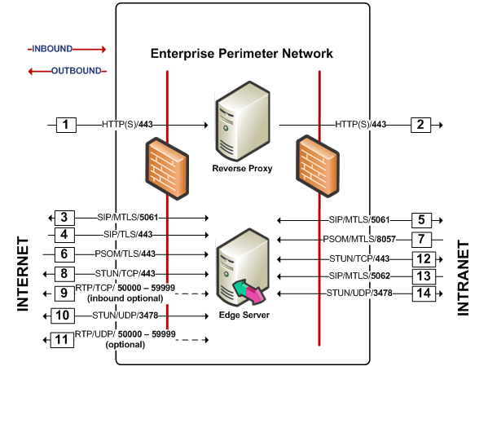
Edge Server port requirements

