Summer school for Innovative Teachers 2008 in Slovakia

From august 10th to 16th 66 teachers from all around Slovakia gathered at the Summer school for Innovative Teachers. Summer school took place in a nice place in Slovak mountains and was organized by NGO P-Mat with Partners in Learning and other NGO’s.

Summer school had many goals. From strengthening the community around Slovak ITN, giving active teachers on the ITN an opportunity to meet face to face, up to great rest in beautiful nature.

Program of the Summer school was very busy. Teachers met with professor Zelina - an advisor for the minister for the reform in pedagogy in Slovak schools and had a chance to listen to his lecture. The most popular activity was an Ideas Exchange where teachers presented what innovative they have done during the school year. Other activities included seminars and workshops on topics like “How to manage stress”, “Critical thinking”, “Anywhere, anytime learning with notebooks for every pupil”, “How to cooperate with non innovative colleagues” and many, many more.

One of the most popular was seminar about Windows Live services and how they can use them in their work. We have started a large Windows Live community with all the teachers participating. You can check this community at <http://modernyucitel.spaces.live.com>.

All participants agreed that Summer school was a wonderful week they will remember. Also the community they have created will help them to overstake all the obstacles of Innovative Teacher they will face during the following school year.

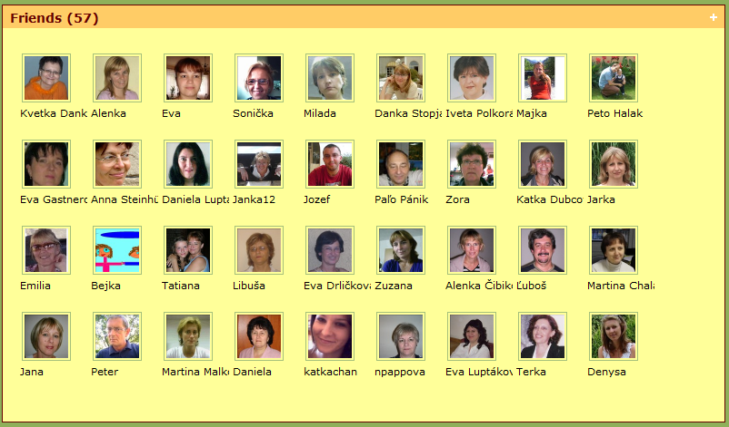

Innovative Teachers - friends of the Innovative Teacher community at Windows Live Spaces

