

Microsoft® Dynamics™ CRM 3.0
Unlocking the Power of Extensibility

Hands-On Lab

Table of Contents

Lab: Power of Extensibility 1
Lab Objective 1
Exercise 1: Create a New Entity 2
Task: Extend Microsoft Dynamics CRM to add a new entity 2
Exercise 2: Create System Views 17
Task: Create a new System View called Washington Leads 17
Exercise 3: Create a new marketing e-mail template 24
Task: Create a new marketing e-mail template for leads 24
Lab Summary 34

Lab: Power of Extensibility

Lab Objective

Microsoft® Dynamics™ CRM is a very powerful product when used out-of-the-box. But the key to every successful CRM implementation is the ability for the CRM application to fully compliment the business processes of the unique organization. Microsoft Dynamics CRM gives you the ability to extend the application to meet your very specific business needs. These customizations, while powerful, are very easy to implement. This lab will introduce you to a few of the Microsoft Dynamics CRM extensibility features. At the end of this lab you will have a vision for how Microsoft Dynamics CRM can support and accelerate your business objectives.

In this lab, you will perform the following exercises:
- You will create new Microsoft Dynamics CRM entities
- You will create new system views
- You will create a new marketing e-mail template

This lab will take approximately 60 minutes to complete.

This lab will require that you use the Virtual PC Images called CRM Client – TechEd 2006

Exercise 1: Create a New Entity

You are the manager at a large bicycle manufacturer. You are using Microsoft Dynamics CRM and have been very satisfied with the ability to track information against your account and contact records. Recently, your business model changed so that part of your customer channel has broken off and you now sell product to suppliers in addition to the retail stores you sold to before. You need to configure Microsoft Dynamics CRM to support this new business model. You could choose to modify the account form to add a pick list field that contains the type of customer but you realize this will minimize your ability to create relationships between suppliers and your retail stores. You decide the best course of action is to create a whole new entity called Suppliers and create a relationship between suppliers and your account records.

Task: Extend Microsoft Dynamics CRM to add a new entity

- Press Right + ALT + Delete to display the logon screen. Logon as gailwrsm1 with a password of P@ssw0rd.
- Open up Internet Explorer and type in the URL http://crm. In order to create new entities you will need to access Microsoft Dynamics CRM using your web browser (Figure 1.1).

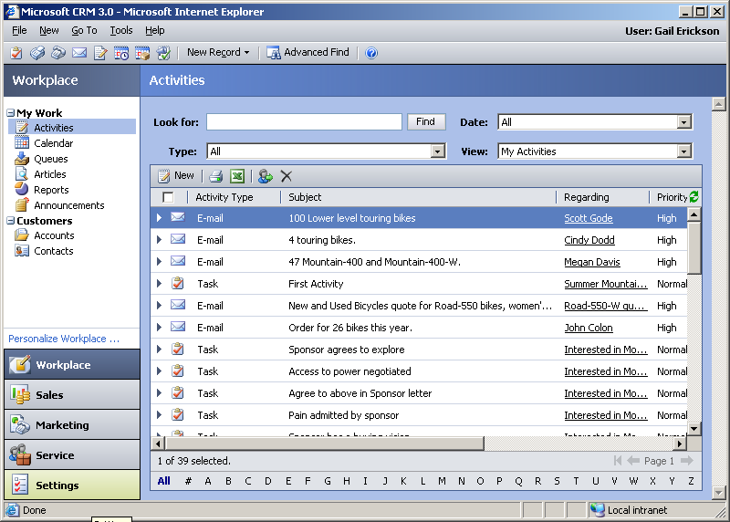
Figure 1.1 – Maintaining Microsoft Dynamics CRM entities is handled through
Internet Explorer.

- Click on the settings button on the lower left-hand corner of the browser (Figure 1.2).

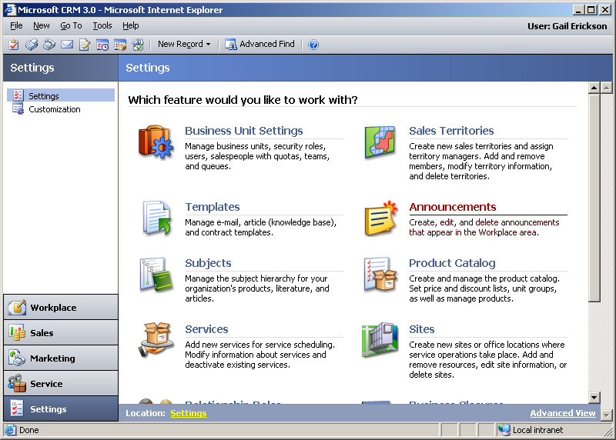
Figure 1.2 – Settings is where you administer your CRM application.

- You want to create a new entity in CRM so you need to click on the link called Customization in the upper left-hand corner (Figure 1.3).

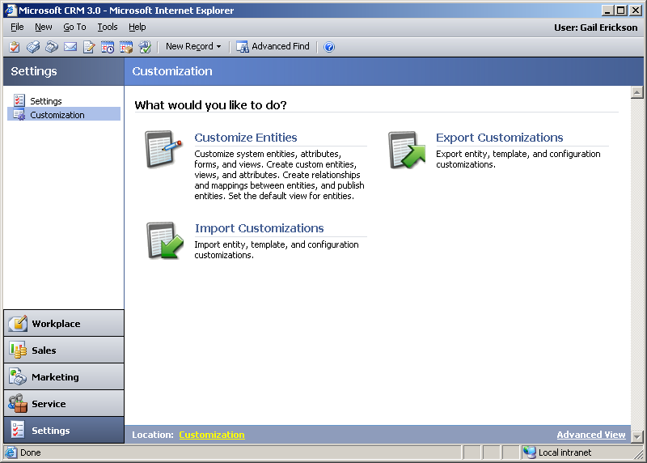
Figure 1.3 – Customization allows you to maintain entities, export customizations, and import customizations.
- Click on Customize Entities to begin adding the new entity called Suppliers (Figure 1.4).

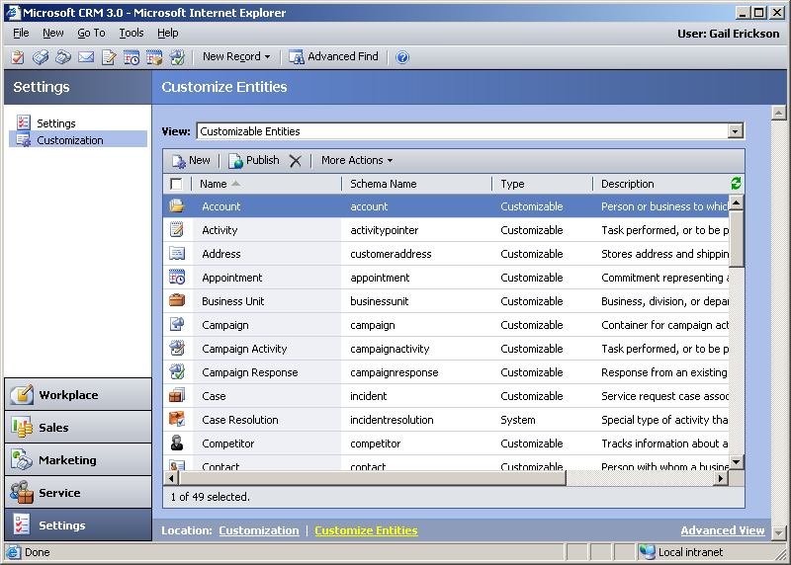
Figure 1.4 – This will display the master list of all entities in your Microsoft Dynamics
CRM installation.

- Click on the New button on the toolbar to create a brand new CRM entity (Figure 1.5).

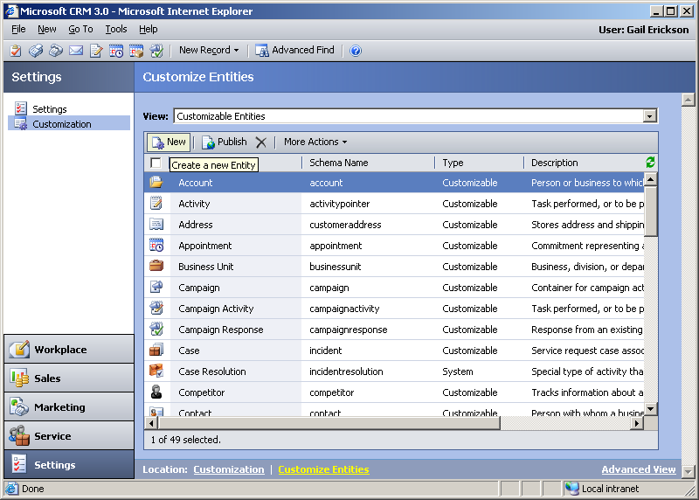
Figure 1.5 – Microsoft Dynamics CRM allows you the ability to create you own business specific entities.
- You are now ready to create your own custom CRM entity. Remember, your business has just recently changed its business model so that you are now selling your products to both retailers and suppliers and you want to associate suppliers with retailers for ongoing reporting purposes.

- Name the new entity Supplier and carefully fill out the information on the new entity form (Figure 1.6). The Plural Name should be Suppliers. The Schema Name should default to New_Supplier.
You want to make sure that your remote sales staff has access to supplier information so check Show in Microsoft CRM client for Outlook when offline to make the new entity available for offline usage.
You will be capturing notes and activities regarding this entity so check the Notes and Activities Associated Entities.
Check the Sales, Marketing and Service checkboxes to display this new entity in the sales, marketing, and services modules of CRM. Think of suppliers as accounts so wherever an account appears suppliers should also appear. Click the save button on the toolbar when you are finished (saving the form will take a minute as the new data structure is created in Microsoft SQL Server™).

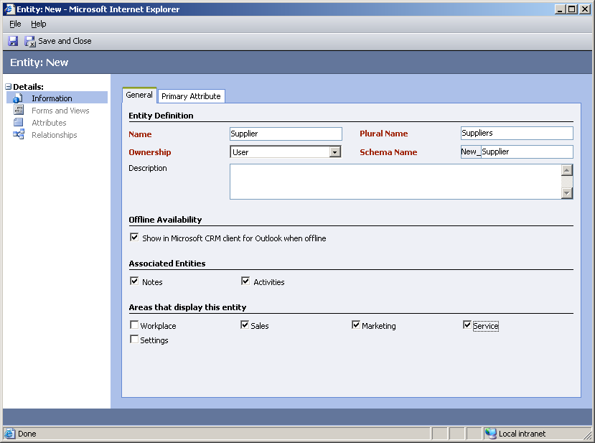
Figure 1.6 – Carefully profile your new supplier entity.

- Once you have saved the new supplier entity you will want to add attributes to the form. Consider adding similar attributes that are contained on the account form as the record types are very similar. In this lab we will only add a few attributes to help you understand how entities are created (Figure 1.7).

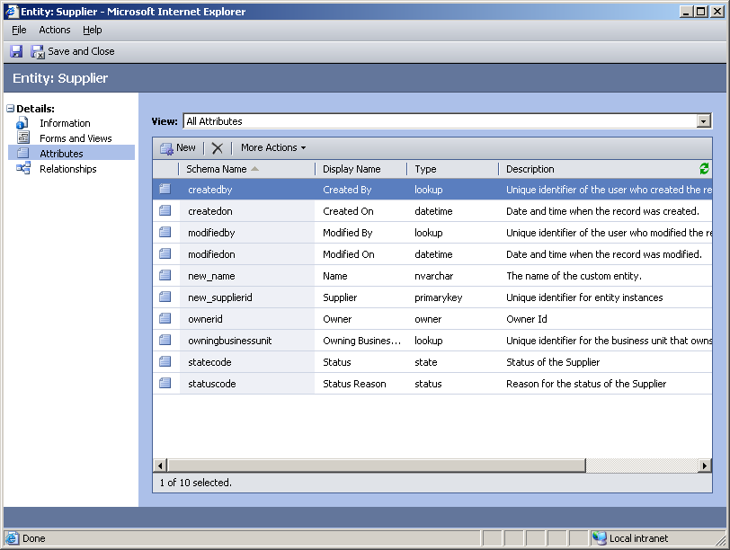
Figure 1.7 – After you save the new entity you can work on adding attributes, forms, views, and relationships.

- For this exercise we will add two attributes to the Supplier form. We will add city and state so we can quickly identify where the Supplier is located. Keep in mind, your organization will probably want to create a complete profile of your supplier. You can add as many attributes as you wish and then add them to the Supplier form.

- Make sure you have clicked on the Attributes link and then click on the New Attribute button. Create a new attribute called City (Figure 1.8).

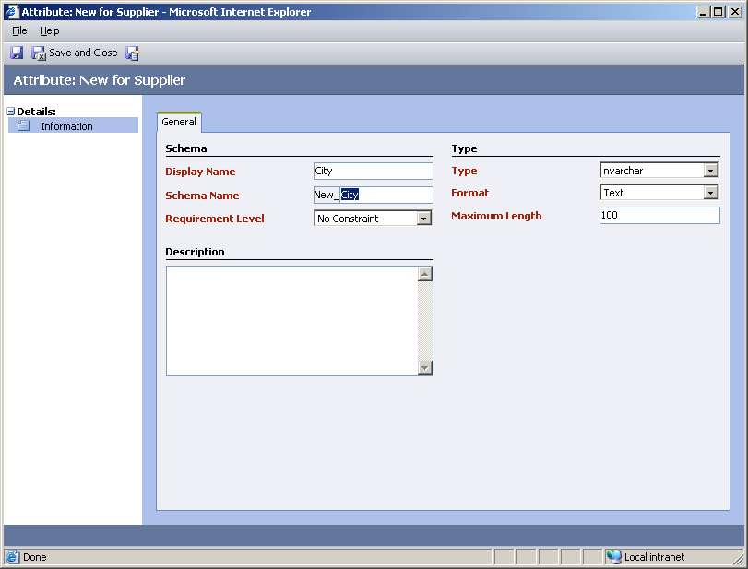
Figure 1.8 – Configure the attribute by selecting Type and Format.

- Save and close the City attribute and then repeat this step to create an attribute called State. When you are finished you should see your new attributes on the attributes list (Figure 1.9).

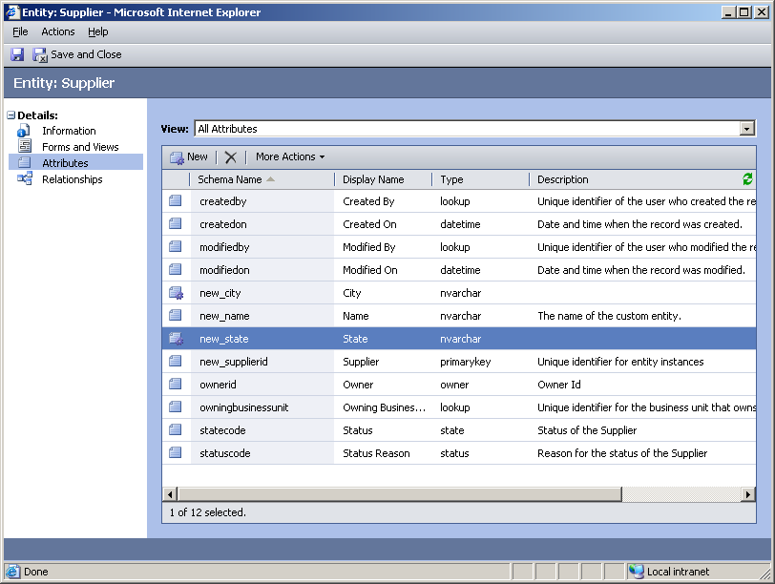
Figure 1.9 – Master list of all available attributes for this entity.

- After you have created your attributes we need to add them to the form. This will allow your users to profile the supplier when they create a new supplier record. Click on the Forms and Views link (Figure 1.10).

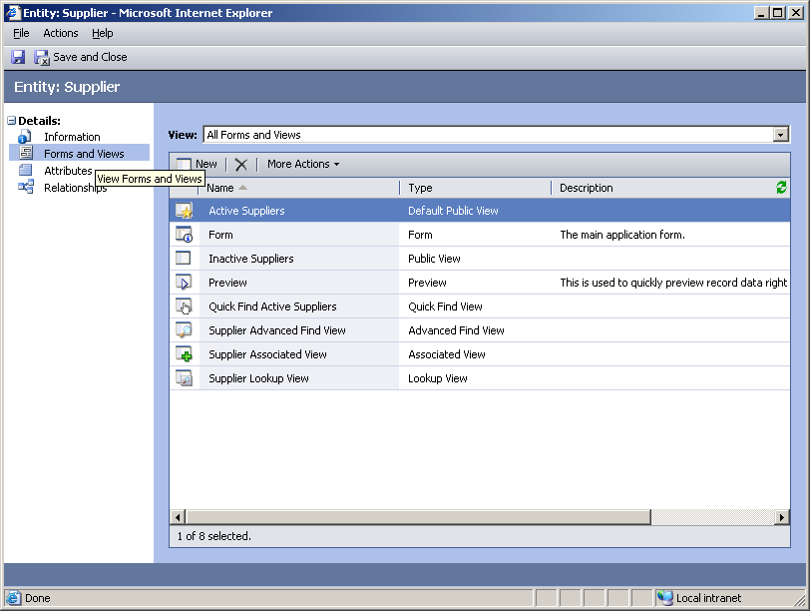
Figure 1.10 – Master list of all available forms and views.

- Double-click Form to open the main form used when creating and modifying supplier information (Figure 1.11). You can use the view on the screen to filter your list to display only forms or only views.

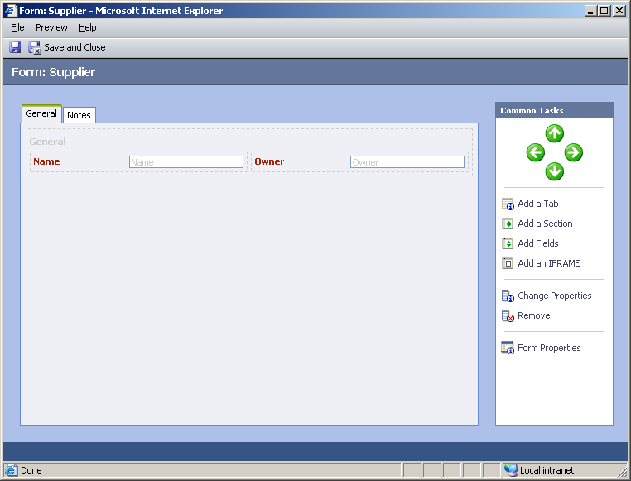
Figure 1.11 – This is the form editor. You make changes to all forms using this feature.
- Add the new attributes you created to the form. Click on the Add Fields link to get a list of available attributes to add to the form. Select the fields from the list you want to add to the form and click OK (Figure 1.12).

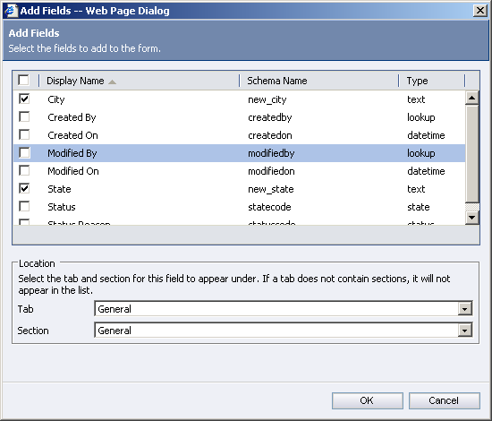
Figure 1.12 – You can define where on the form you want to add fields by using the Tab and Section pick list.

- Once the fields are added to the form you may need to move them around. Click once on the field and then use the green arrows to move the field around on the form (Figure 1.13). Save and Close the form when you are finished.

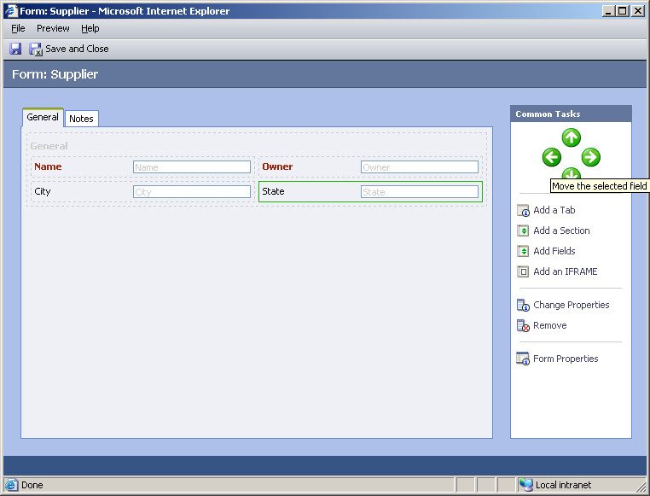
Figure 1.13 – Review the form and create a layout that will be easy to use.
- Remember why we are creating this new Supplier form. Your company has just decided to change business models to sell your product to suppliers in addition to selling direct to retailers. You want to be able to track suppliers as they are related to accounts. Microsoft Dynamics CRM gives you the ability to create relationships between your new entities and other CRM entities. Click on the Relationships on the entity form to create a relationship between suppliers and accounts (Figure 1.14).

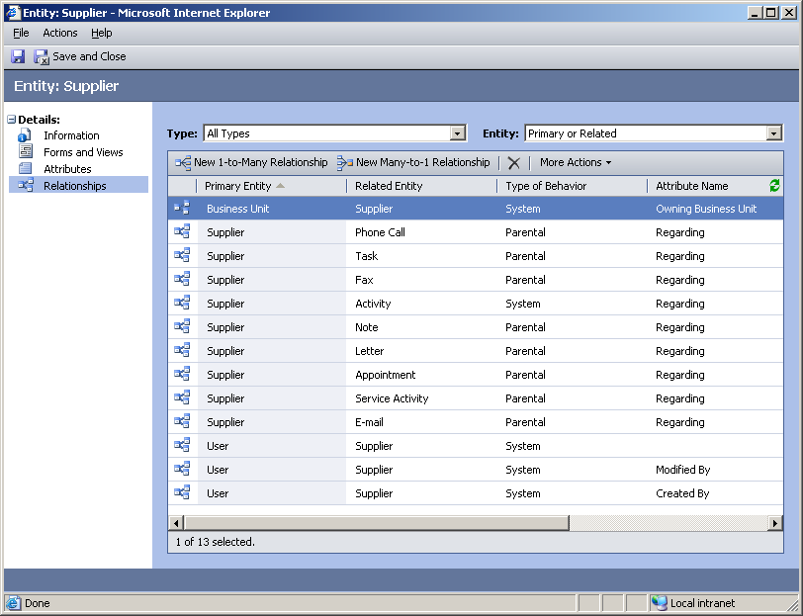
Figure 1.14 – You can create 1-to-many and many-to-1 relationships.

- In your new business model there might be 5 suppliers servicing 1 of your accounts. We will need to create a many-to-1 relationship between suppliers and accounts (many suppliers servicing 1 account). Click on the New Many-to-1 relationship button to create a new relationship (Figure 1.15).

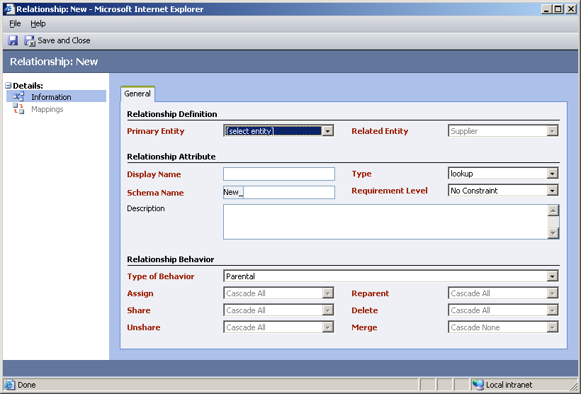
Figure 1.15 – Configure your relationship between the entities.
- While this screen gives you a lot of different options you will only need to fill out two fields to create the relationship. Choose the entity called Account for the Primary Entity field. Create a Display Name called Suppliers (make sure to include the “s” in Suppliers). Save and Close the form when you are done (Figure 1.16).

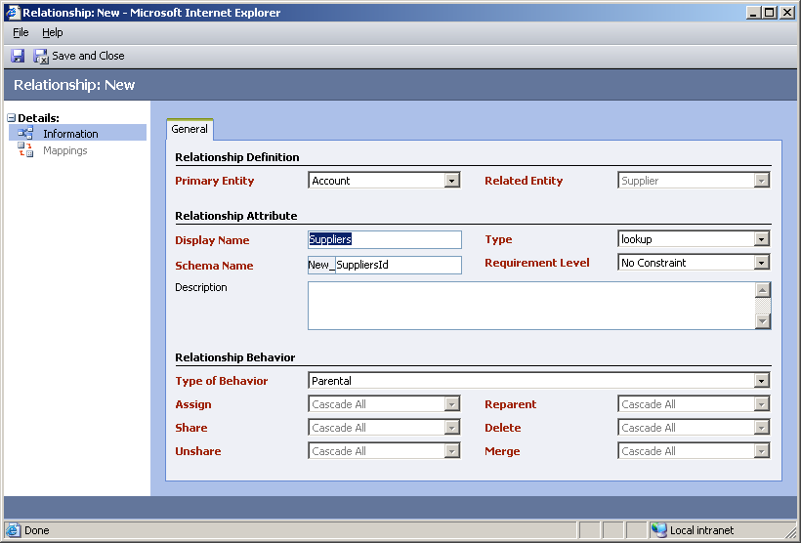
Figure 1.16 – Customize your relationship by selecting options on the relationship screen.

- You are now ready to publish this new entity for general usage. Click on the Actions menu and select Publish (Figure 1.17). Once you publish the entity it will be available for your CRM users.

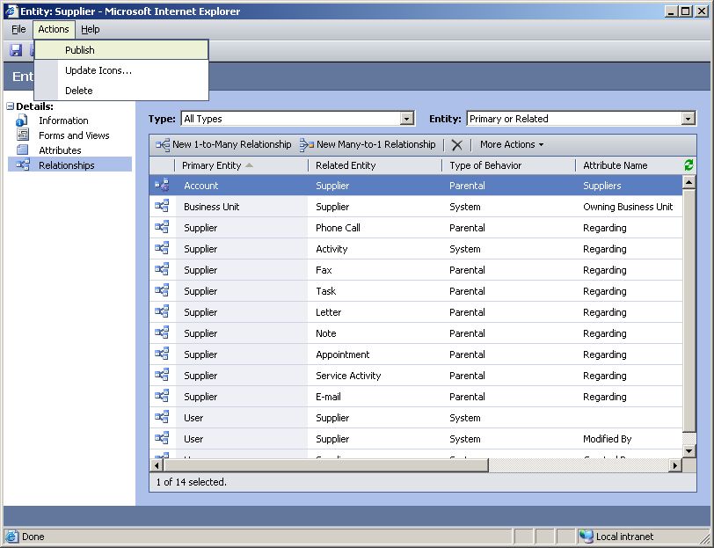
Figure 1.17 – Publishing changes will make the new entity available for CRM users.
- You are now ready to view this new entity using Microsoft Dynamics CRM. Close your web browser and all other windows. Open a new Internet Explorer browser session and type in http://crm for the web address. Click on the Sales module and look for the new Suppliers entity link (Figure 1.18).

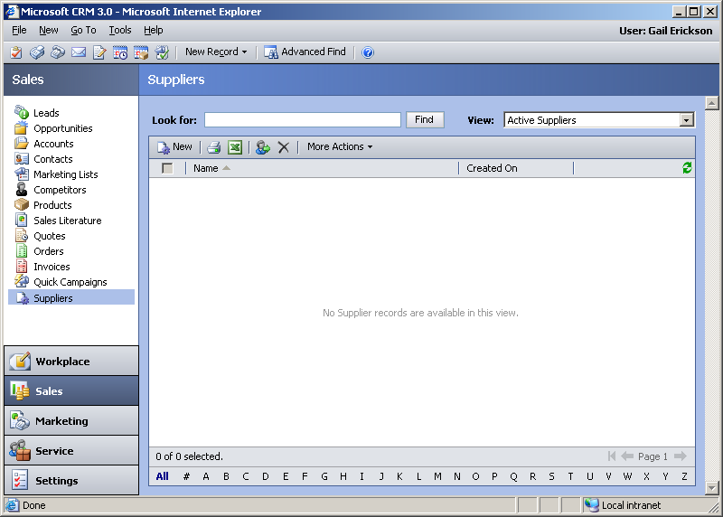
Figure 1.18 – The suppliers entity will appear under Sales, Marketing, and Service.

- The reason we created the supplier entity was to create a relationship between your suppliers and your accounts. Click on Accounts and open up Bike Universe.
Click New Supplier to add a new supplier to the account. Type Supplier 1 as the Name. Click Save and Close. (Figure 1.19).

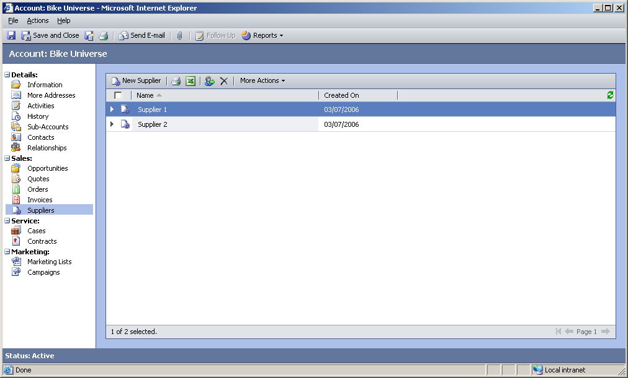
Figure 1.19 – Add suppliers to an existing account.
- Click Save and Close to return to the main screen.

- After creating this new supplier entity you realize that this is a field that you want to restrict access to within your organization. You want to make sure that your customer service desk can read the information for suppliers but they can’t make any modifications to the data. In order to restrict access you will need to modify the customer service roles in CRM to restrict access to the new entity. Click on the Settings button and Business Unit Settings to modify security roles (Figure 1.20).

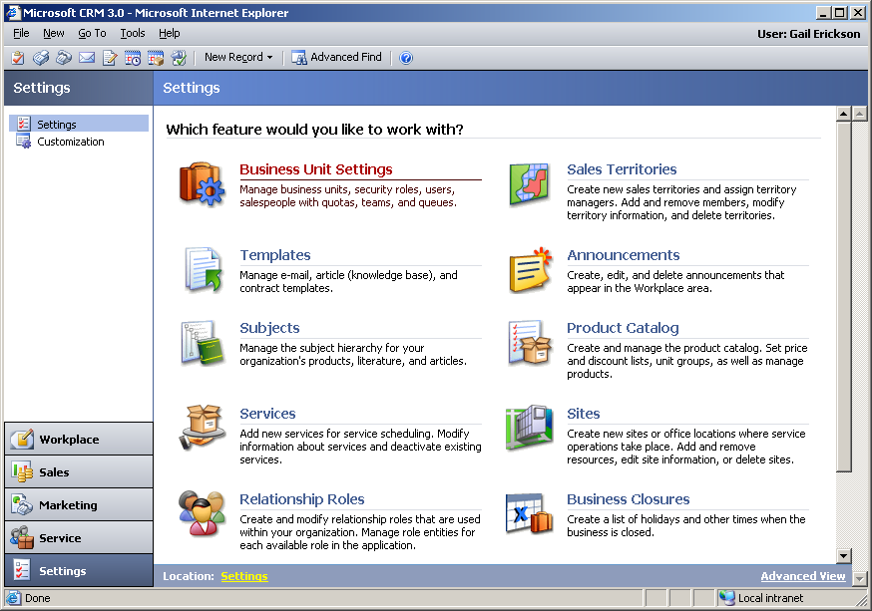
Figure 1.20 – Manage security roles under Business Unit Settings.

- Click on Security Roles (Figure 1.21).

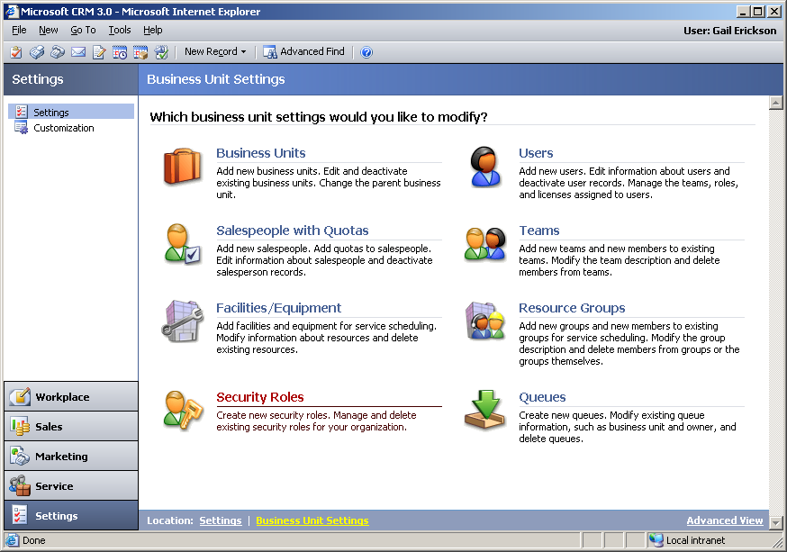
Figure 1.21 – Note the different settings that are configurable.
- Change the Business Unit to Adventure Works Cycle. Locate the security role called Customer Service Representative (Figure 1.22). This is the role that is assigned to all of your customer service representatives. Open up the role to maintain entity security.

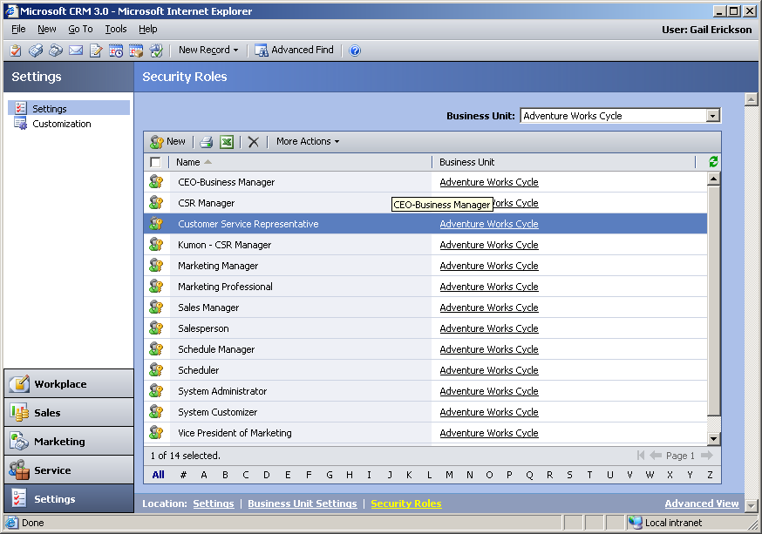
Figure 1.22 – List of security roles that you have defined for your company.

- Click on the Custom Entities tab. We want to provide our customer service representatives the ability to read supplier information and have no other access. Click Read to grant this right to all records within the organization (Figure 1.23). Save and close to accept these changes.

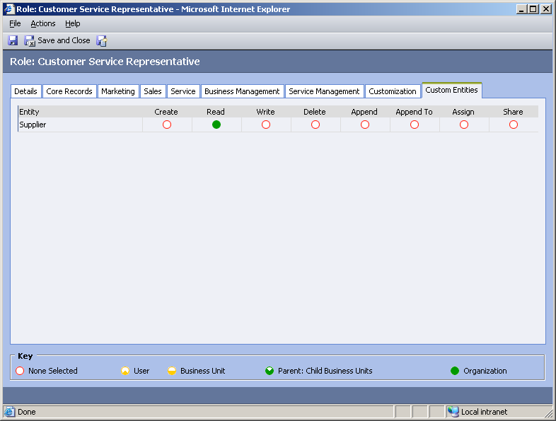
Figure 1.23 – Click on the red circle for Read until it turns solid GREEN.
- You are now finished. You have successfully created a new entity called Suppliers that are linked to Accounts on a many-to-1 relationship. You have modified your security roles to allow customer service representatives access to read the data but make no modifications to supplier information.

Exercise 2: Create System Views

As your company decides to incorporate suppliers as a main selling channel your marketing department has come to you asking for ways to configure CRM to make finding target markets easier to find. The marketing team has identified the state of Washington as a key market to start building relationships with bicycle suppliers. You decide the best way to give them visibility into the leads in Washington is to create a system view that displays all open leads in Washington.

Task: Create a new System View called Washington Leads

- Open up Internet Explorer and type in the URL http://crm. In order to create new views you will need to access Microsoft Dynamics CRM using your web browser (Figure 2.1).

Figure 2.1 – Maintaining Microsoft Dynamics CRM system views is handled through
Internet Explorer.

- Click on the settings link to gain access to system customizations. Click on the Customization link. Click on Customize Entities (Figure 2.2).

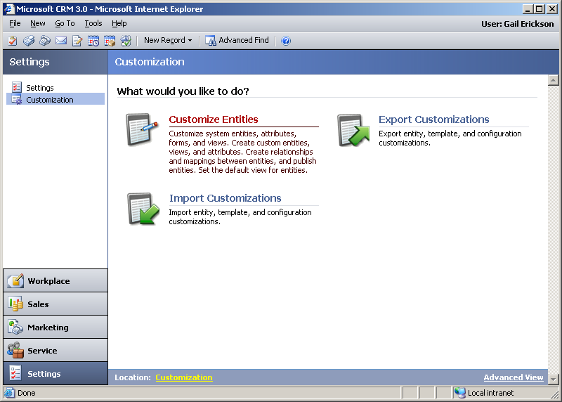
Figure 2.2 – Customize entities will allow you to maintain system views.

- Locate the entity called Lead. You will need to create a new system view for leads that displays all active leads in the state of Washington. Open the lead entity (Figure 2.3).

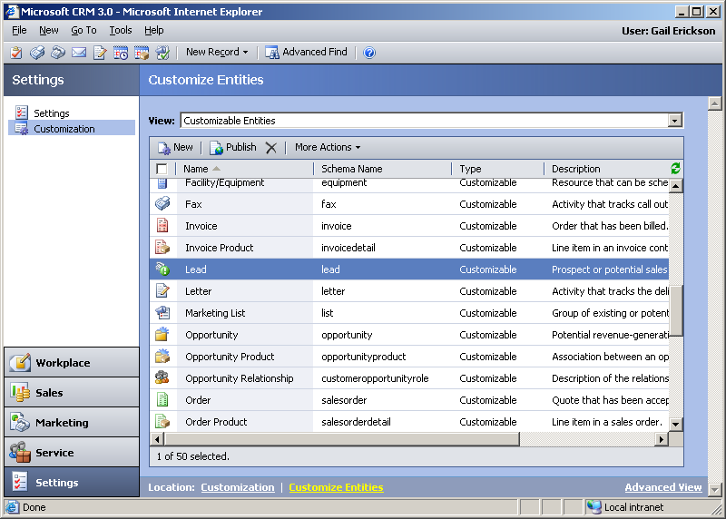
Figure 2.3 – System views are tied to their respective entities.
- Click Forms and Views.

- Click on the New view button on the toolbar (Figure 2.4). Create a new view called Open Washington Leads (Figure 2.5).

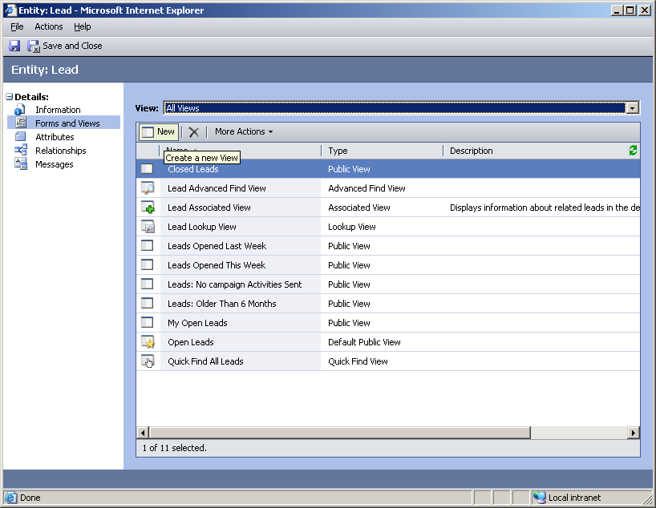
Figure 2.4 – You can filter the forms and views by clicking on All Views.

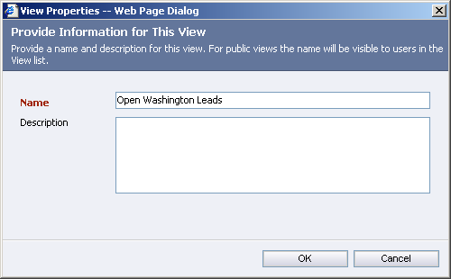
Figure 2.5 – Name your new view.

- This new view should return leads in the state of Washington where the status of the lead is open. Click on the Edit Filter Criteria link (Figure 2.6).

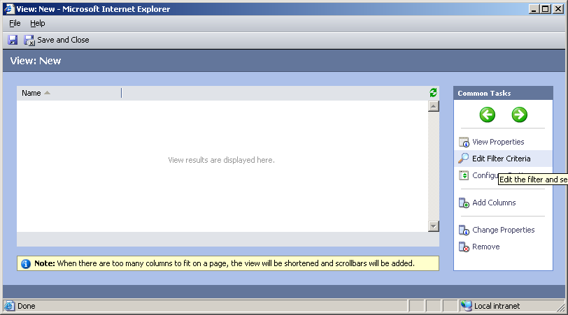
Figure 2.6 – The filter criteria will determine the records returned when this view is selected by your users.

- Hover the mouse over the Select link. Look for State/Province in the drop down box and set it equal to WA. Look for Status and set it equal to Open (Figure 2.7). When you are finished with your filter criteria click OK.

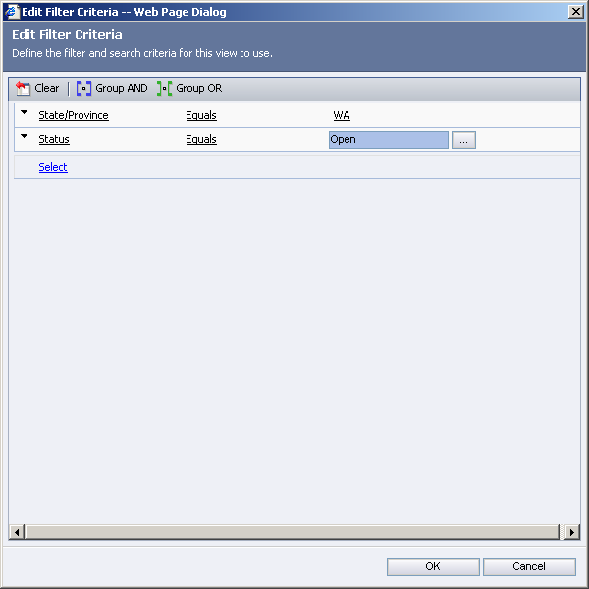
Figure 2.7 – Create your custom filter criteria.
- Now you will need to add a couple of additional columns to the view. These columns will display information about the leads to help identify information regarding the leads when viewing the Washington leads view. Click on the Add Columns link to add new columns (Figure 2.8).

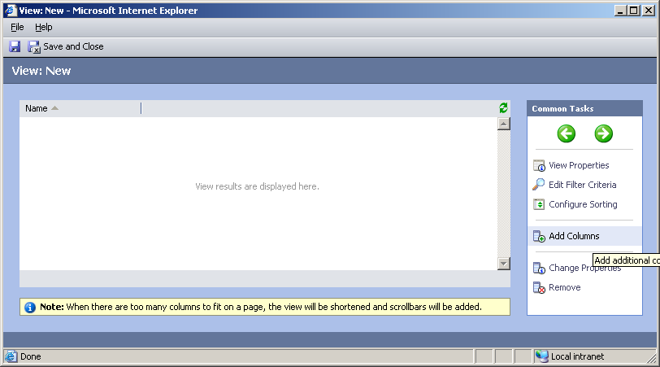
Figure 2.8 – You can add columns based on your business need.

- Select Company Name, City, and Owner for this exercise (Figure 2.9).

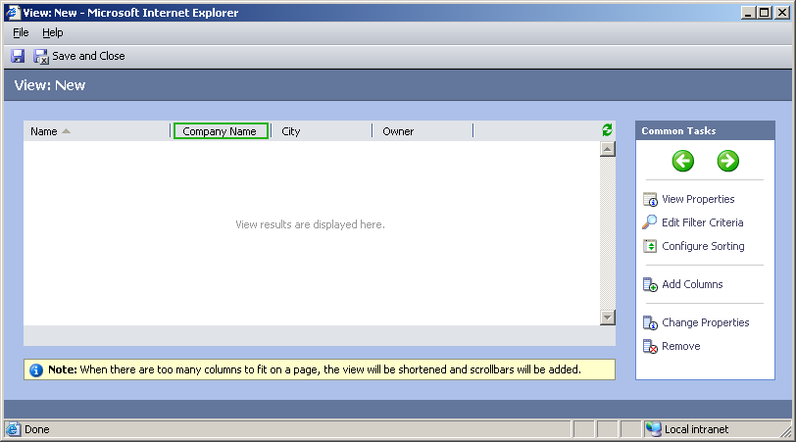
Figure 2.9 – You can move the columns around by clicking on the column and using the green arrow keys to move them left and right.

- You are now done creating your new view. Click Save and Close to save the view
(Figure 2.10).

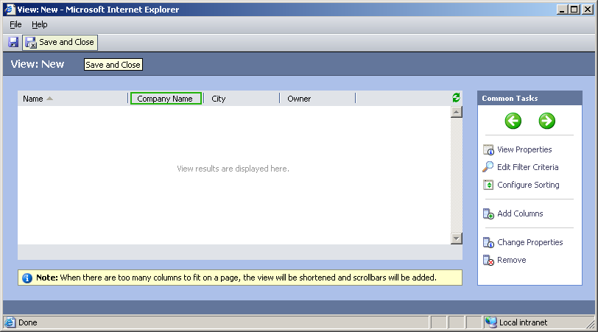
Figure 2.10 – You can go back anytime and modify views once they have been saved.

- Before the view can be properly viewed by your CRM users you will need to publish the entity. Click on the Actions menu and select Publish (Figure 2.11).

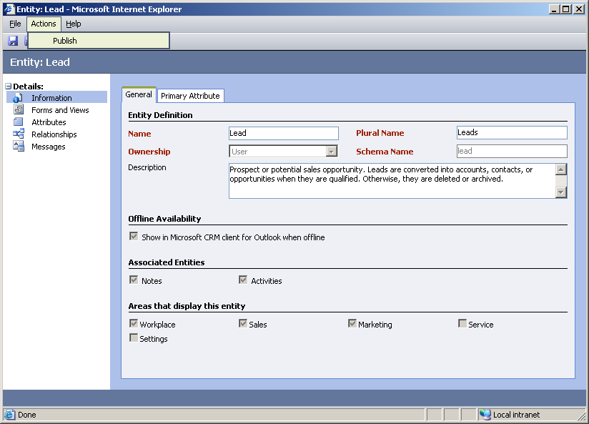
Figure 2.11 – Publish the entity to release the new system view.

- You are now ready to use the view. Close all Internet Explorer browser windows. Open a new Internet Explorer browser session. Type in the address http://crm. Click on the Sales module and click on the Leads link. Select the system view called Open Washington Leads (Figure 2.12).

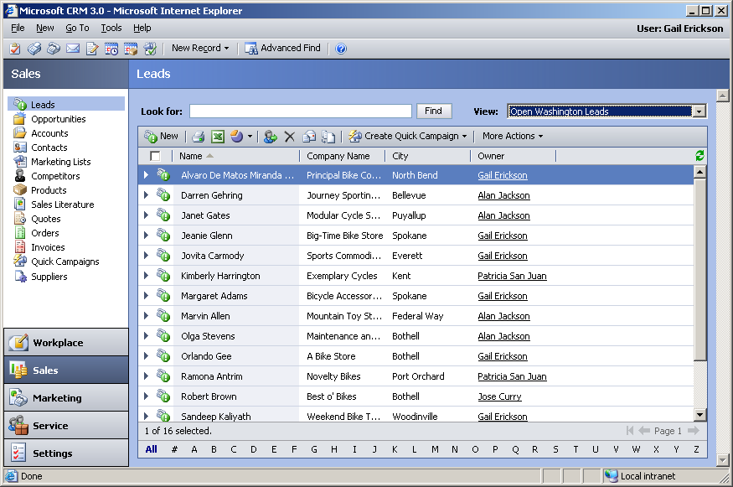
Figure 2.12 – System views can be shared out to the entire user base or assigned to individuals.

Exercise 3: Create a new marketing e-mail template

As your marketing department prepares to signup suppliers in Washington you discover the audience of potential suppliers is quite large. You want to optimize efficiencies in communicating with potential suppliers so you decide you want to communicate your new product offerings by sending out a mass e-mail message. You want to make sure that the e-mail message is a personalized message and the message is tracked in CRM.

Task: Create a new marketing e-mail template for leads

- Open up Internet Explorer and type in the URL http://crm. In order to create new e-mail templates you will need to access Microsoft Dynamics CRM using your web browser
(Figure 3.1).

Figure 3.1 – You can manage e-mail templates using your Internet Explorer web browser.

- Navigate to the setting page and select Templates (Figure 3.2).

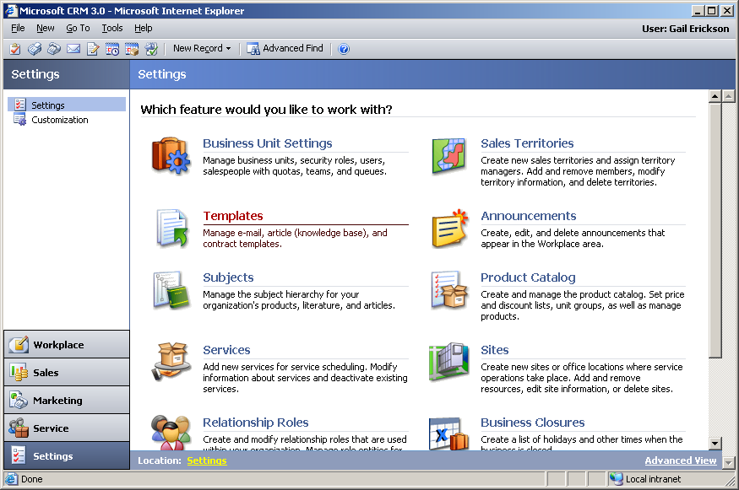
Figure 3.2 – Templates will allow you to manage e-mails, contracts, and articles.

- Select E-Mail Templates (Figure 3.3).

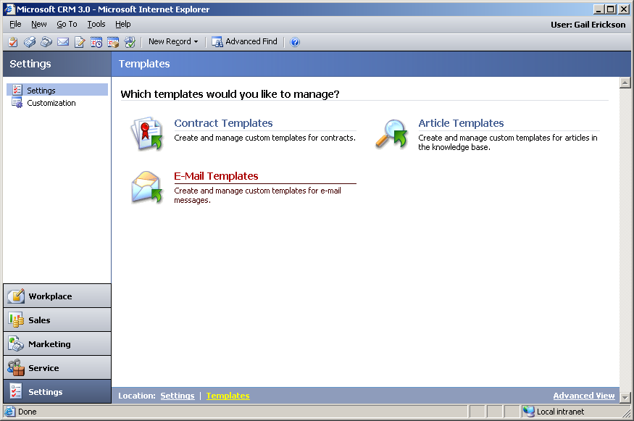
Figure 3.3 – Creating e-mail templates will allow you to communicate on a 1-to-many basis with your customers.
- Click on the New template button (Figure 3.4). You will need to create a template for your marketing department that is tied to leads (Figure 3.5). This will allow you to add fields to the e-mail template that are captured on the lead form.

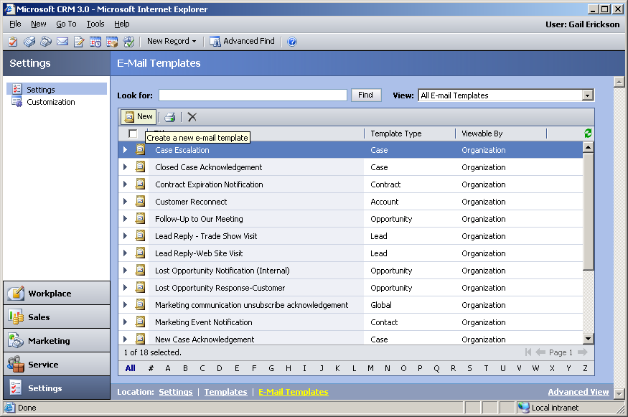
Figure 3.4 – Create new e-mail templates.

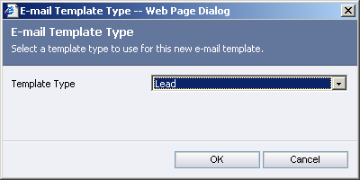
Figure 3.5 – Choose lead for the template type.

- Begin by profiling the e-mail template so that your marketing users can easily locate the proper e-mail template (Figure 3.6).

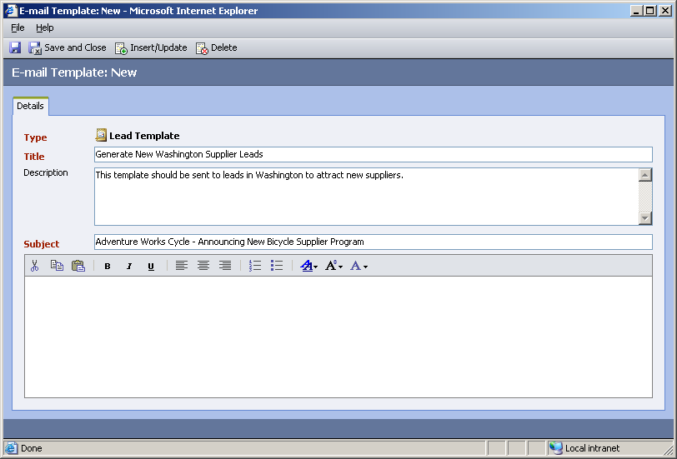
Figure 3.6 – Create a Subject and Title that is appropriate for this e-mail template.

- This e-mail should be a customized e-mail so the person receiving it feels like you are speaking directly to them. Use Microsoft Dynamics CRM Insert Field functionality to include CRM data fields in the body of your e-mail message. Begin by adding some text to your e-mail message (Figure 3.7). When you want to add a data field from CRM click on the Insert/Update button on the toolbar (Figure 3.7). Click on the Add button (Figure 3.8) to add specific CRM fields. Change the Record Type to Lead (Figure 3.9). In this example we will use First Name to insert into the body of our message (Figure 3.10). Click OK (Figure 3.11) to select this field. Make sure you have inserted the field into the proper place in your e-mail message (Figure 3.12). Continue adding text to your e-mail message to complete the message (Figure 3.13). Save and Close the template when you are finished.
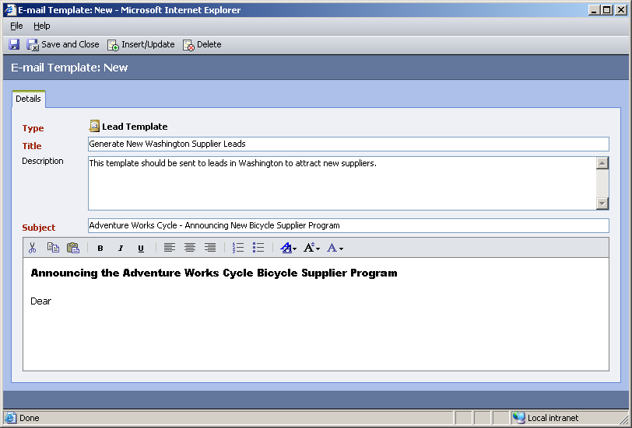
Figure 3.7 – Create the body of you e-mail message.

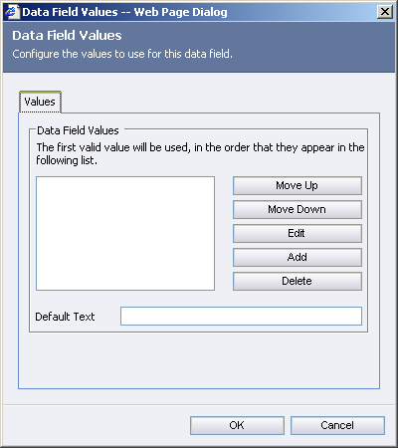
Figure 3.8 – Select the fields you want to add to the form.

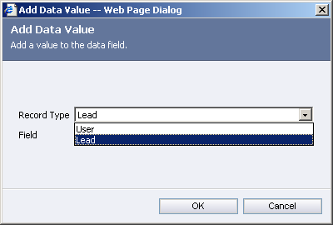
Figure 3.9 – Change the record type to Lead. This will allow you to choose fields from the lead entity.

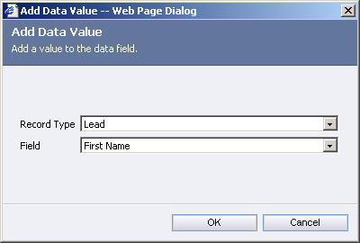
Figure 3.10 – Select the field called First Name.

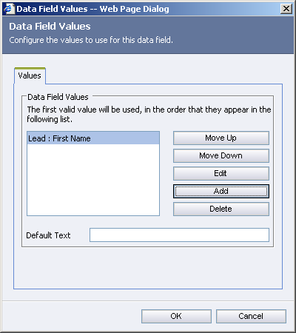
Figure 3.11 – Click OK to add First Name to your e-mail template.

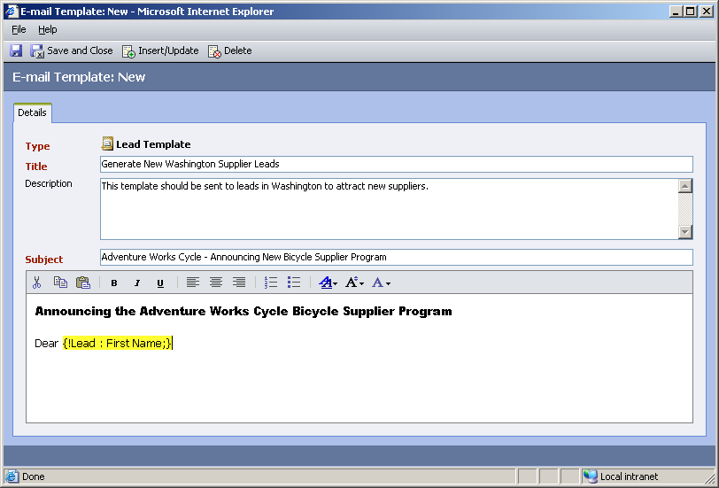
Figure 3.12 – Validate you have inserted the CRM field in the proper position.
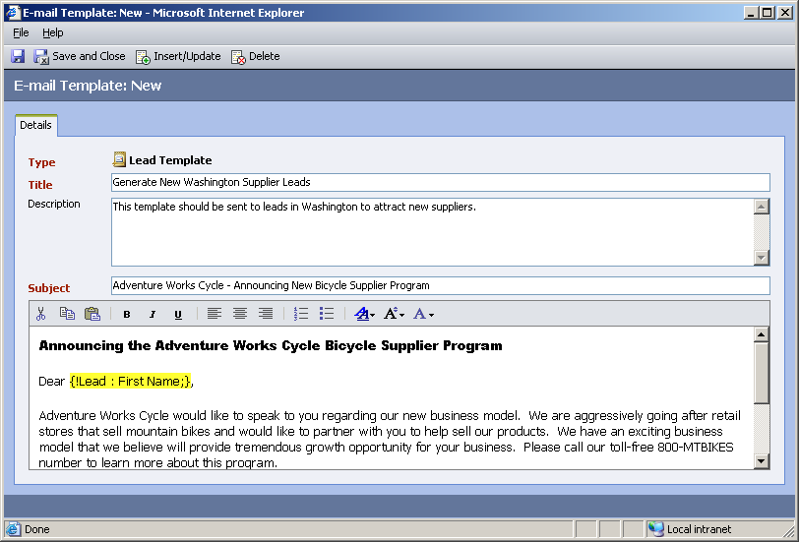
Figure 3.13 – Continue to write the e-mail template.

- Once you have finished the message you are ready to save the e-mail template. Click Save and Close. Review the list of templates to see your new e-mail template (Figure 3.14).

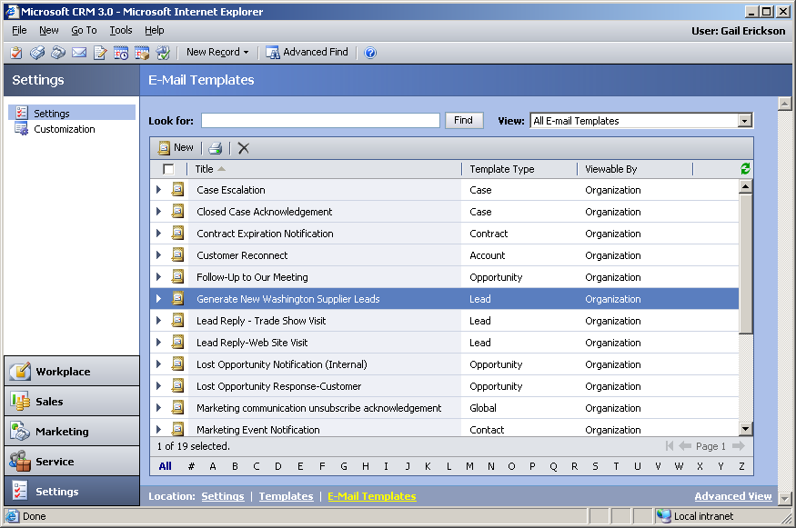
Figure 3.14 – You can sort the list of templates by Template Type to help navigate the list of available templates.

- Because you profiled the e-mail template as type “lead” this template will only be available when sending direct e-mail messages from the lead entity within Microsoft Dynamics CRM.
- You are now ready to use this template in production. You want to start generating opportunities in Washington so you want to send the e-mail message out right away. Simply click on the Marketing button and click on the Leads link. Click on the system View called Open Washington Leads (Figure 3.15).

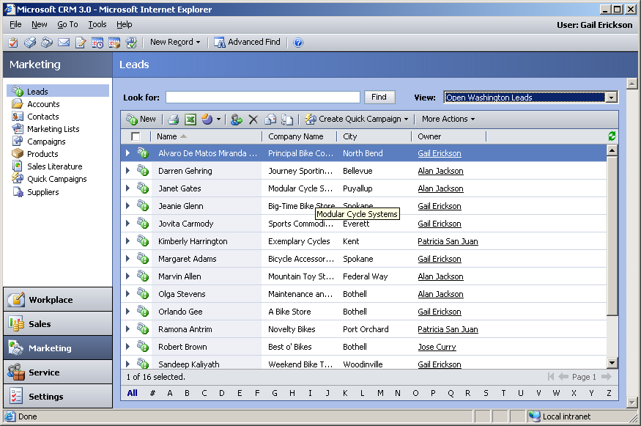
Figure 3.15 – Find the set of leads you want to send your e-mail message to. You can either use system views or create your own view using the Advanced Find functionality.

- Click on the Send Direct E-Mail button on the toolbar (Figure 3.16).

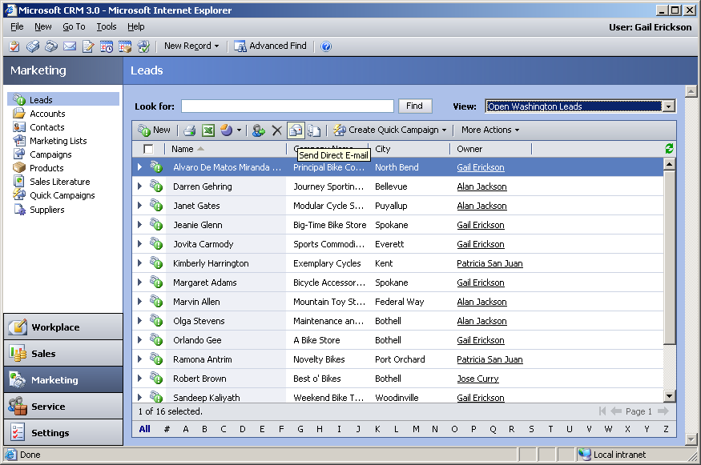
Figure 3.16 – Click on the icon that looks like a letter and an envelope.
- Find the e-mail template called Generate New Washington Supplier Leads (Figure 3.17).

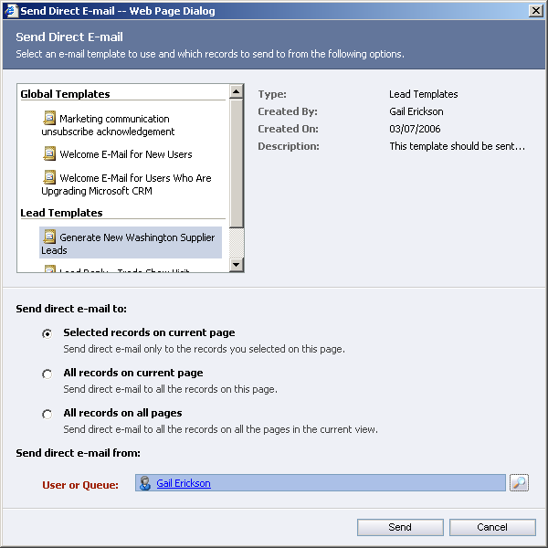
Figure 3.17 – Select the appropriate template and confirm to whom the e-mail message will be sent.

- You have discussed with your Marketing manager that these e-mail messages should come from your sales and marketing department. Before sending the message you will want to change the User or Queue option to be your Sales and Marketing Queue. Click on the magnifying glass lookup button and change the pick list to Queue. Select the Sales and Marketing queue and click OK (Figure 3.18).

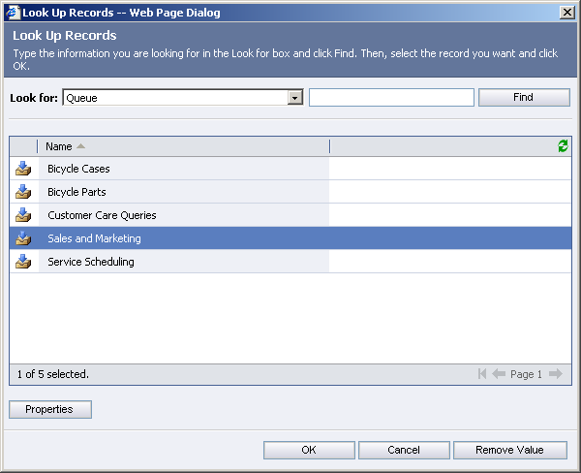
Figure 3.18 – Configure the “From:” field for your e-mail template.
- You are now ready to send your e-mail message (Figure 3.19).

NOTE: Disregard sending the message as these Virtual PC Images are not connected to an external e-mail gateway.

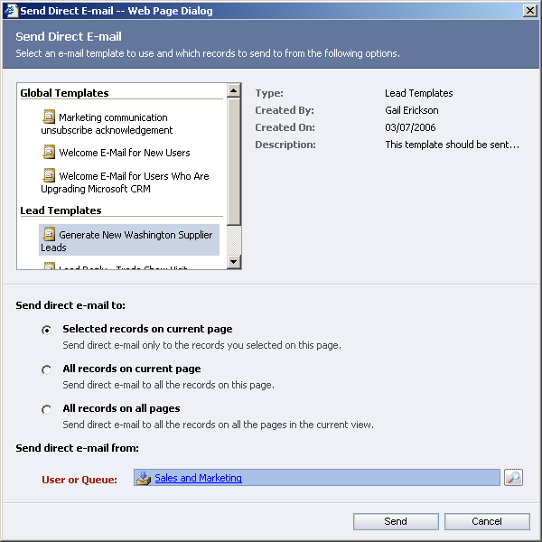
Figure 3.19 – Clicking send will initiate the process to send the e-mail template to all appropriate recipients.

Lab Summary

In this lab, you performed the following exercises:
- You created new Microsoft Dynamics CRM entities
- You created new system views
- You created a new marketing e-mail template

You learned how creating some simple customizations of Microsoft Dynamics CRM you were able to configure the application to support your business needs. You discovered how easy it is to create new CRM entities. You learned that as your business changes Microsoft Dynamics CRM can be easily modified to support your needs. Most importantly, you validated that Microsoft Dynamics CRM works the way your business works.

Additional information can be found at www.microsoft.com/crm.

