A Guide to MSN®
Premium Broadband Software
And Services

November 2003

For more information, press only:
Rapid Response Team
Waggener Edstrom
(503) 443-7070
rrt@wagged.com

The information contained in this guide relates to prerelease software product that may be substantially modified before its first commercial release. Accordingly, the information may not accurately describe or reflect the software product when first commercially released. The data sheet is provided for informational purposes only, and Microsoft makes no warranties, express or implied, with respect to the data sheet or the information contained on it.

This document is for informational purposes only. MICROSOFT MAKES NO WARRANTIES, EXPRESS OR IMPLIED, IN THIS DOCUMENT.
© 2003 Microsoft Corp. All rights reserved.

Microsoft, MSN, the MSN logo, Encarta, Outlook, Hotmail, Windows, Picture It! and Windows Media are either registered trademarks or trademarks of Microsoft Corp. in the United States and/or other countries.
The names of actual companies and products mentioned herein may be the trademarks of their respective owners. Intellisync is a registered trademark of Pumatech Inc. that may be registered in certain jurisdictions.

Welcome to MSN Premium Broadband Software and Services Overview
With the launch of MSN® Premium this winter, MSN is focusing on delivering advanced software and services designed to make people’s broadband experience more useful and to ensure that their connected time is spent as efficiently as possible.

Consumers are adopting broadband at an accelerating pace, and as they do so, they are requiring practical software solutions that help protect them from ongoing annoyances such as spam and computer viruses; let them communicate with others in a more simple, seamless and personally expressive way; and optimize their time online. By leveraging Microsoft Corp.’s core strength in developing industry-leading software, MSN Premium delivers these types of services, which consumers demand, while allowing the organizations that are best suited to deliver the actual broadband connection — such as the cable and telecommunication companies — to do so.

MSN Premium delivers a comprehensive suite of tools and features that give customers the assurance of knowing they’ll always be up to date and will receive ongoing value in their subscriptions. While customers can acquire various Web tools separately, such as anti-virus and firewall software, junk e-mail blocking tools, pop-up blocking or parental control offerings, MSN has attempted to bring together all these features for a complete online experience, compiling them in a total package at a very reasonable price. Customer feedback plays an important role in deciding what is included in MSN offerings, and MSN Premium is no exception.

The comprehensive selection of services delivered in MSN Premium spans areas central to everyone’s daily needs:
- Persistent protection. MSN helps provide broadband users with the protection from junk
e-mail, unwanted pop-ups, and desktop and e-mail viruses they need, which is particularly important now with consumers’ increased time online and “always-on” connection.
- Advanced communication. Communicating with others is the No. 1 activity online and MSN has developed flexible e-mail solutions that let people access e-mail when, where and however they need it, as well as share digital media with advanced e-mail and instant messaging software.
- Digital life management. MSN helps people optimize their time online with easy sharing of digital content including photos and calendars, as well as with shared browsing of Web sites with family and friends.

MSN Premium, MSN’s premier online experience, is designed for the multiperson household and delivers security services and additional communication services designed for groups with expanded requirements. Customers will receive the benefit of up to 11 accounts with a total of 125 MB of e-mail account storage, as well as powerful features such as parental controls, software for creating online photo stories, and advanced information management tools including MSN Photo Plus, Money Plus and Encarta® Premium.

As people seek to enhance their lives using the resources available to them over high-speed connections, comprehensive, innovative, personalized software will become more and more vital. MSN Premium communication software and services are well positioned to help them get far more from their high-speed Internet service and benefit from more-powerful, integrated and customized offerings.

This reviewers guide is designed to help you explore the features and capabilities of MSN Premium broadband software and services. As you read through this guide, look for the information icon ( Feature Highlight), which highlights important features and details in MSN Premium.
Contents

Persistent Protection 6
Virus Guard Powered by McAfee® Security — PCwide Anti-Virus Service 6
Firewall Powered by McAfee® Security — Internet Firewall 6
Multilevel Junk E-Mail Protection 7
Pop-Up Guard 10
MSN Parental Controls 12
New Online Activity Report 14
Kids Summary Page 14
MSN Advanced Communications 15
Multiple Accounts 16
Extensive E-Mail Storage and Large Attachment Sizes 16
Roaming and Offline Access to Communications Information 16
MSN Inbox, Calendar and Address Book 17
Multiple MSN and Hotmail Account Access 18
Microsoft Office Outlook Connector for MSN 18
MSN Designer E-Mail and Photo E-Mail
MSN Messenger Photo Swap 22
Shared Calendar 22
Digital Life Management 24
Toolbar Customization 24
Dashboard Customization 25
MSN Video 26
MSN Home Page 26
My MSN 27
MSN Photos Plus — Viewing, Organizing, Editing, Creating and Sharing 28
Picture It! Library 9 28
Viewing and Organizing Photos 28
Microsoft Picture It! Express 9 — Photo-Editing Tools 29
Sharing Pictures Using Plus! Photo Story Lite (available only in MSN Premium) 30
MSN Encarta Premium................................................................................................ 31
MSN Money Plus......................................................................................................... 33
Feature Matrix Overview

Persistent Protection
MSN Premium delivers powerful features to help protect customers when they are online and offline from some of the most common Web dangers and irritations, such as viruses, junk e-mail and unwanted pop-up advertising. In addition, MSN Premium incorporates strong and flexible Parental Controls for helping parents manage their kids’ online experience and provides extensive tools to help them understand whom their kids are communicating with online and the types of content they’re accessing.

Feature Highlight: MSN delivers exciting features to help protect customers when they are online and offline:
- Virus Guard® Powered by McAfee® Security. This helps put virus concerns about e-mail and the entire local computer to rest with automatic virus protection.
- Firewall Powered by McAfee Security. This helps protect customers from computer and personal data hacker attacks.
- McAfee Security e-mail scanning. Technology, powered by McAfee, scans for viruses and cleans incoming e-mail messages and e-mail attachments if viruses are detected at the incoming server level.
- Multilevel junk e-mail filtering including the advanced MSN Junk E-mail Guard Microsoft® patented technology. This helps return e-mail to a useful communications tool by working to ease the burden and often offensive responsibility of dealing with junk e-mail.
- Pop-up Guard. This lets customers decide which pop-ups they see and which ones they don’t.
- Parental Controls. These help keep kids safe from online dangers when parents can’t be there.

Virus Guard Powered by McAfee Security — PCwide Anti-Virus Service
MSN Premium customers receive, as part of their subscription, Virus Guard Powered by McAfee Security, which helps protect them and their computers from viruses that can arrive in e-mail or through other file transfer methods (e.g., floppy disk, CD, instant messaging). When installed, Virus Guard automatically detects and cleans viruses from e-mail, files and downloads, and includes automatic updates, so customers’ protection is updated when they are connected.

For complete details regarding the Virus Guard offering, please refer to the full overview included as a secondary document.

Firewall Powered by McAfee Security — Internet Firewall
As part of their subscription, MSN Premium customers receiveFirewall Powered by McAfee Security, which helps them stay safe from hackers and unwanted computer attacks by preventing unauthorized access to their computer and personal data while alerting them to immediate threats and tracking the source of attacks.

The following are key features of Firewall Powered by McAfee Security:
- Automatic Database Updates, which provide updates for trusted applications on an ongoing basis. Customers do not have to manually update the list as they install new applications.
- Visual Trace, which allows customers to track an event back to its source and report that IP address to HackerWatch.org.

For complete details regarding the Firewall Powered by McAfee Security offering, please refer to the full overview included as a secondary document.

McAfee Technology Automatically Scans and Cleans E-Mail Messages at Incoming Servers
When MSN subscribers access their e-mail using the MSN software or a Web browser, it is automatically scanned at the incoming e-mail server for known viruses, using McAfee technology. If a virus is detected, the message and attachment are cleansed automatically before they reach the customer’s inbox or machine.

Multilevel Junk E-Mail Protection
Most people who use e-mail are tired of being affected by junk e-mail, whether by the time required to sort through it or by needing to deal with offensive and unwanted content and images that are presented to them. MSN delivers multilevel junk e-mail protection technology, which helps return e-mail to a useful communications tool and works to get wanted e-mail to customers and stop unwanted e-mail from receiving them. When customers first go into MSN Mail, they will receive the following dialog box providing them with information about the trainable junk e-mail filter technology in MSN and asking them if they would like to adjust their settings or simply begin training the filter:

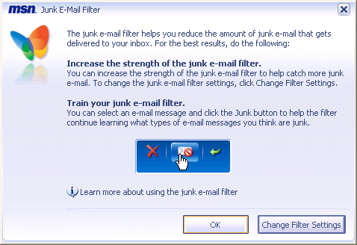
MSN junk e-mail filter first-run dialog box

MSN works to first identify known junk e-mail at the incoming e-mail server level and stop it from appearing in a customer’s inbox. It then employs advanced junk e-mail filtering techniques in the MSN client to further help customers minimize their exposure to it. MSN also works to help customers identify mail from unknown senders (addresses not in their address book) through descriptive icons in the inbox and by blocking images in e-mail messages from unknown senders. MSN includes the ability to have e-mail messages that are flagged as junk seamlessly reported to MSN to help identify originators of spam. When customers first click on the junk e-mail button in MSN, they will see the following dialog box asking whether they would like to report all junk e-mail to MSN or if they would like to report messages individually by right-clicking on the junk e-mail message and then clicking on Report This Junk E-Mail to MSN in the context menu.

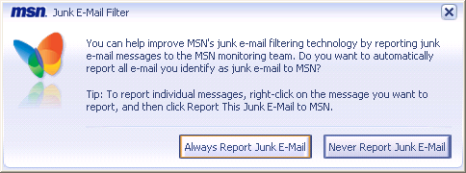
Junk e-mail filter optional reporting dialog box

Feature Highlight: With MSN, customers can not only classify e-mail as junk, they can choose to have all junk e-mail seamlessly and unobtrusively reported to MSN or report it individually by simply right-clicking on the junk e-mail message, and then clicking on the Report This Junk E-Mail to MSN option in the context menu.

MSN puts customers in control of deciding the level of filtering applied to their account. The following exercise details one of the methods available for customers to use to adjust the filtering level and settings for their MSN junk e-mail.
- From MSN Explorer, select the Safety icon from the toolbar, and then Junk E-Mail Guard, and then Settings from the fly-out menu. This will take you to the Junk E-mail Guard settings page.
- The Junk e-mail settings page provides options for putting customers in control of how their e-mail is filtered. Options on the Junk e-mail settings page include these:
  - Junk e-mail filter
  - Junk e-mail preferences
  - Safe list
  - Mailing list
  - Blocked senders list
  - Custom filters
Review the options and descriptions for each item on this page. Two important settings we’ll explore are the Junk e-mail filter options and the Junk e-mail preferences. First, select Junk
e-mail filter from the listed options on this page, and this will take you to the Set up your junk
e-mail filter settings page.
- On the Set up your junk e-mail filter page you’ll notice that there is a scalable list of settings ranging from Minimal to Exclusive, with Exclusive being the strongest of the settings. From this list click on the different options (Minimal, Light, Moderate, Strong and Exclusive) and note how the description to the right of the settings changes to reflect how the settings differ.
Feature Highlight: Changing the settings on the Set up your junk e-mail filter page helps move more or less e-mail to customers’ Junk e-mail folder automatically. If junk
e-mail (often referred to as spam or unsolicited e-mail) appears in customers’ inboxes, they can simply select the e-mail message by clicking on it, and then click on the Junk button on the MSN Mail toolbar to move the message to their Junk e-mail folder. This action also trains the MSN Mail Junk E-mail Guard so similar messages will be moved automatically to the Junk e-mail folder. Although the Junk E-mail Guard has a high degree of accuracy built into it, it will become more effective as customers use it and train it to their personal preferences. Typically, after two to three weeks of persistent use the filter will become highly effective. If e-mail that customers want is inadvertently moved to the Junk e-mail folder, they can simply select that message, and then click the Not Junk button from the MSN Mail toolbar.
- If the Moderate setting is not already selected, select it and then click on the Save Changes button at the bottom right of the page. This will return you to the Junk e-mail settings page.
- Now we’ll look at the options available for fully customizing how e-mail is presented to you. From the Junk e-mail settings page, select Junk e-mail preferences from the list of options. This will take you to the Choose your junk e-mail filter preferences page.
- The Choose your junk e-mail filter preferences page delivers an extensive list of options that will allow you to tailor how your e-mail is managed in MSN. The options include these:
  - Don’t show unfiltered e-mail
  - Don’t display potentially offensive content in the preview pane
  - Block images
  - Prompt to add senders to safe list
  - Prompt to add senders to blocked senders list
  - Automatically report junk e-mail messages to MSN
Review the options and descriptions for each of them on this page, and then select the Cancel button to return to the Junk e-mail settings page.
Feature Highlight: MSN delivers visual cues to help protect customers when they are navigating their e-mail. For example, if customers attempt to reply to a suspected junk
e-mail message, the following dialog box will appear warning them of the potential hazards:
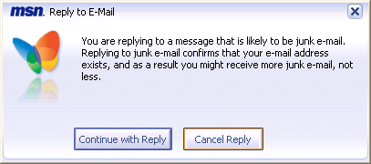
Potential junk e-mail reply warning dialog box

In addition, the following list of icons is used in the inbox and applied to unopened e-mail to help customers understand the significance of specific e-mail messages. Notice that there are designations for e-mail messages from unknown senders or messages from MSN staff, designated with the butterfly icon:

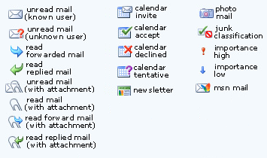
Inbox status icon definitions

These visual cues help customers determine if they should be more cautious with an
e-mail message or if it is a message that appears to be from MSN but is not.

Pop-up Guard
The Pop-up Guard, integrated directly into MSN, enables customers to decide which pop-ups they see and which ones they don’t, and uses advanced technology to intelligently determine whether a pop-up being generated from a Web site should be presented to a customer. This is accomplished using technology similar to that found in the MSN Advanced Junk E-Mail filter, which looks at the context of information being presented to determine whether the pop-up contains beneficial information or should be blocked.

The first time customers receive a pop-up after installing MSN Premium they will receive the following dialog box:

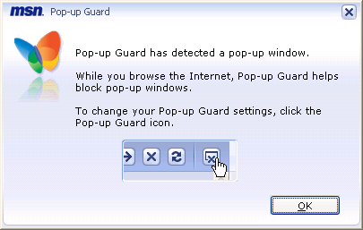
Pop-up Guard dialog box

The customer can then choose whether to receive future pop-ups by clicking on the Pop-up Guard icon and adjusting the settings.

After selecting the initial settings for the Pop-Up Guard, customers will have the following settings set for them by default:
- Filter Settings
  - Filter and show useful pop-up windows and pop-up windows added to the allow list
- Notifications
  - Animate the Pop-up Guard icon
  - Show a thumbnail of the pop-up windows below the Pop-up Guard icon

These settings can be adjusted easily by the customer and accessed through the Safety & Security toolbar button or through the Help & Settings menu. Below are the Pop-up Guard main settings options available to customers:

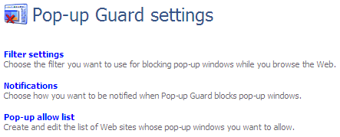
Pop-up Guard settings page

After the default settings have been enabled, customers will see indicators when a pop-up is received and blocked. First the Pop-up Guard icon will animate, and then a thumbnail of the pop-up will appear so that customers can determine if they would like to see the full pop-up. Below is an example of the Pop-up Guard icon highlighted and a pop-up thumbnail showing. The other graphic demonstrates the options that are available by clicking on the Pop-up Guard icon.

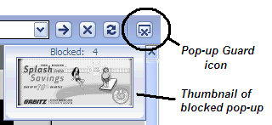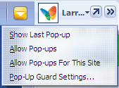
Pop-up Guard icon and pop-up thumbnail Pop-up Guard settings from icon

The following exercise explores the extensive Pop-up Guard customization options available to MSN customers:
- To access the Pop-up Guard settings, use one of the following three options:
- Left-click on the Help & Settings menu, and then Settings,and then select Pop-up Guard from the left-hand column.
- Left-click on the Safety icon on the MSN toolbar, and then Pop-up Guard, and then Pop-up Guard Settings….
- Left-click on the Pop-up Guard icon when in the browser view (note that the Pop-up Guard icon only appears while in the browser view within MSN), and then Pop-up Guard Settings….
- Now you’re in the Pop-up Guard settings screen. Select the Filter settings option.
- In the Filter settings screen, the customer can select one of three options:
- Exclusive allows only pop-ups from sites on the Pop-up allow list to be presented to the customer.
- Filter uses machine-based intelligence to determine whether the pop-up should be presented to the customer.
- Off turns off all filtering of pop-ups.
- After you’ve had a chance to explore the various filter setting options, select Notifications under the Related settings in the left-hand column.
- In the Choose Pop-up Guard notifications settings screen, customers can select how they want to be notified when a pop-up occurs by choosing one or a combination of the following three notification methods:
- Play a sound
- Animate the Pop-up Guard icon
- Show a thumbnail of the pop-up window below the Pop-up Guard icon
- After you’ve had a chance to review the notification options, select Pop-up allow list under the Related settings in the left-hand column.
- The Pop-up allow list is similar to an allowed e-mail recipient feature in which you receive e-mail only from individuals on a preapproved list such as your address book. With the combination of the Exclusive setting in the Filter settings and list of URLs in the Pop-up allow list, a customer will only receive pop-ups from sites listed in the allow list. URLs can be added to the allow list as follows:
- Manually adding them in the Pop-up allow list window
- Left-clicking on the Pop-up Guard icon, and then selecting Allow Pop-ups For This Site

Feature Highlights: The MSN Pop-Up Guard, which helps intelligently protect MSN customers from unwanted pop-ups while enabling them to decide if they would like to view blocked pop-ups, provides extensive flexibility and customization options. Customers can choose levels of pop-up blocking and designate how they would like to be notified when a pop-up is blocked, whether through a thumbnail image, animated icon and/or audio notification.

MSN Parental Controls

MSN Parental Controls are designed to help keep kids safe from online dangers when parents can’t be there.

MSN Premium Parental Controls continue to build on the foundation previous versions delivered by including features such as Ask Now and Instant Block that help parents interactively manage their kids’ online experience while they are near the family computer running MSN Premium. Of course, MSN Premium also delivers extensive features for remotely managing kids’ experience and includes features such as the easy-to-read-and-understand weekly Online Activity Report, which provides detailed information regarding how kids are spending time online, and the ability to review pending requests remotely. These are great features for helping manage a child’s online activities even when the parent is not nearby.

MSN Premium Parental Controls are built on advanced, patented Microsoft technology and incorporate new content-filtering technology. The Parental Controls provide broad coverage of areas in MSN such as e-mail, instant messaging and Web browsing, perform page-by-page evaluations of sites, and provide the flexibility to view appropriate pages within a site while preventing the viewing of pages that may not be appropriate for children.
In MSN Explorer, the Safety icon on the toolbar provides quick and easy access to the Parental Controls options, including Set Parental Controls and Review Pending Requests or settings for accounts that have already had Parental Controls applied to them.

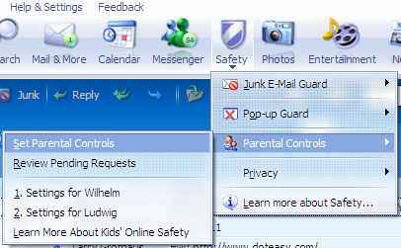
Parental Controls settings

Feature Highlight: From the MSN Explorer and the Safety toolbar icon, customers can easily access each account that has Parental Controls applied to it and set Parental Controls on other accounts, review pending requests, or learn more about kids’ online safety.
From the Set Parental Controls page, customers have quick access to all the task items they need to establish or modify Parental Controls settings. The Set Parental controls page enables parents to add member accounts, change Parental Controls settings, set the Parental Controls to control other Internet browsers and Web-based programs, and adjust other settings.
The settings for Parental Controls in MSN Premium cover a broad variety of areas. When parents first apply Parental Controls to an account, they are taken through a wizard that helps them set a baseline level of Parental Controls for an account based on age of the child. These age groupings and general initial settings are specified below:
- General. In this level, no Parental Controls are set by default, but customers can customize the settings themselves.
- Teen (recommended for 13- to 17-year-olds). This level allows access to most of the Web; use of e-mail, calendar and MSN Messenger instant messaging service; and file downloads of all music lyrics. This level reports back to the parents using the Online Activity Report. Settings can be further customized by parents to meet the specific needs of their children.
- Preteen (recommended for 9- to 12-year-olds). This level limits access to the Web, restricts use of e-mail and MSN Messenger, and blocks calendar and explicit music lyrics. This level reports back to the parents using the Online Activity Report. Settings can be further customized by parents to meet the specific needs of their children.
- Young child (recommended for 8-year-olds and younger). This level provides the most limited access to the Web, restricts the use of e-mail, calendar and MSN Messenger, and blocks file downloads and explicit music. This level reports back to the parents using the Online Activity Report. Settings can be further customized by parents to meet the specific needs of their children.

Customizing for each kid’s specific needs once the Parental Controls have been set up is easy. Parents can simply click on the Safety icon on the MSN Explorer toolbar or go to the Help & Settings menu items to access specific accounts or all Parental Controls settings.

Parents can personalize their child's online experience by modifying the age group and setting restrictions on Web browsing items (by blocking Web content categories and certain Web sites, and limiting access to explicit language in MSN Music and MSN Encarta Premium), communication items (MSN Mail, MSN Messenger and MSN Calendar) and supervision options (by choosing to receive an Online Activity Report).

Once the Parental Controls are set up and adjusted, they will be applied seamlessly to kids’ Web usage when they are logged into the MSN software. As kids visit Web sites or try to add e-mail or Messenger contacts, those requests can either be approved “over-the-shoulder” by using the Ask Now button, via the Pending Requests option or via the Online Activity Report.

Over the Shoulder is a Parental Controls management method that allows parents to refine the Parental Controls settings that they change most often at the point at which the child is blocked. These include the following situations:
- Approve Web page permanently
- Preview Web pages
- Instant Block Web pages
- Approve e-mail contacts
- Approve downloads
- Integrate with Kids Request Line (KRL)

In addition, parents can use Instant Block to add the current Web site to the child’s block list. Parents can now instantly block a page their child is viewing if they do not approve of it.

New Online Activity Report
The new weekly Online Activity Report is sent via e-mail and now includes more information. With it, a child’s online activity is much easier to review with easy-to-read and complete summaries.

Kids Summary Page
A single page, accessible from MSN software at any time, provides easy access to a complete summary of Parental Controls settings and makes it easy change settings.
MSN Advanced Communications
MSN includes advanced functionality that delivers a richer communications experience and lets customers access their information where, when and how they want to from any Internet connected location through a variety of client choices.

Feature Highlight: MSN delivers exciting advanced communication options to provide customers with the highest level of availability and usefulness of their information. Some of the exciting features include these:
- Multiple accounts. One primary account and up to 10 subaccounts provide the flexibility that multiperson households and families require.
- Large storage and attachment sizes. Customers have a 25MB inbox with 10MB attachments for primary account and a 10MB inbox and 3MB attachments for the 10 secondary accounts.
- Roaming access. Customers can get e-mail, calendar and address book access virtually anywhere.
- Offline Access. Customers can get access to and work in e-mail, the calendar and address book, from MSN or Outlook®, while offline.
- Advanced e-mail management. Customers have a choice of clients, including MSN software, Outlook, Outlook Express or any Web-connected browser.
- Access to multiple MSN or Hotmail accounts at once. MSN Mail lets customers access multiple MSN and Hotmail® accounts at once in the Mail client.
- Easy POP3 account integration and access. Customers can easily access and manage multiple POP3 accounts in the MSN Inbox and receive the full benefits of the advanced junk e-mail filtering technology and other powerful MSN e-mail features.
- MSN Designer E-mail. Customers can create rich and vibrant e-mail messages that they can easily share with others.
- Photo E-mail. Customers can share their digital photos via e-mail by converting the high-resolution images into smaller pictures for easy sharing via e-mail, and then uploading the high-resolution images to the Web for recipients to access if they choose.
- MSN Photo Swap. Customers can share their digital photo collection with other subscribers in real time using MSN Messenger.
- Shared calendar. Customers can easily provide other subscribers with access to their calendar and determine the level of access that each of them has.

The options for accessing full communications information (e-mail, calendar, address book and tasks) include these:
- The MSN Premium broadband software using the integrated MSN Mail features
- Microsoft Outlook (Outlook XP and Outlook 2003) via the Office Outlook Connector for MSN, which delivers the full Microsoft Outlook experience using MSN as the server infrastructure
- Any Internet-connected Web browser, including those on cell phones and PDA devices, by simply going to http://www.hotmail.com/ and logging in using the subscriber’s MSN account name and password

In addition, Outlook (Outlook XP and Outlook 2003), without the Outlook Connector, and Outlook Express can be used to retrieve e-mail from an MSN account from any Internet-connected location using the HTTP protocol.

Multiple Accounts
MSN Premium now delivers a total of 11 accounts for subscribers, one primary account and 10 subaccounts. The secondary accounts can be used to effectively manage multiperson households and families or to establish multiple e-mail identities for the primary subscriber. Each of the accounts is easily accessible through the MSN sign-on screen and has its own user title to help personalize the experience, similar to the sign-on screen in Microsoft Windows® XP. When customers sign into MSN, their preferences are automatically loaded, including things such as their personal startup page, favorites, dashboard settings and other areas that they have personalized. In addition, MSN can be set to welcome the individual audibly at sign-on or the audio can be disabled.
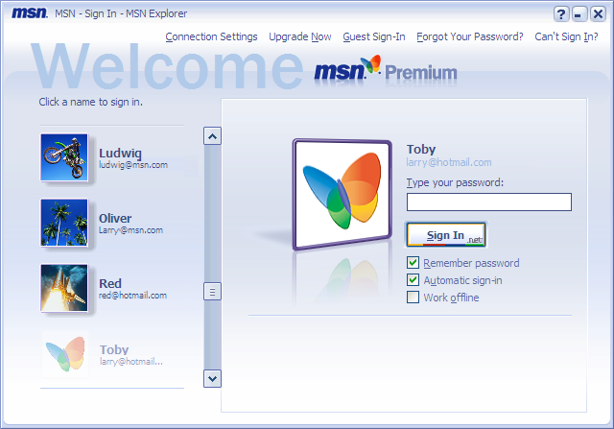
MSN Sign-on screen with multiple accounts

Extensive E-Mail Storage and Large Attachment Sizes
MSN Premium delivers powerful e-mail features to help customers communicate the way they want to while connected and take advantage of exciting new advances in digital technology such as the exchange of digital photos, video and audio, which are often large files. MSN Premium provides a primary e-mail inbox that delivers 25 MB of storage and attachment sizes up to 10 MB. In addition, each of the 10 subaccounts under the primary account includes 10 MB of e-mail inbox storage and allows attachments up to 3 MB. Using the MSN Mail Inbox and Microsoft Outlook, customers can easily manage their inbox and move content to local storage as well as more effectively utilize their online storage.

Roaming and Offline Access to Communications Information
MSN enables you to get to your communications information from virtually anywhere, using a standard browser from any Internet-connected location. From any Internet-connected browser on any device, MSN customers can go to http://www.hotmail.com/ and log in using their MSN subscriber account information. This provides them with full access to their online e-mail, calendar and contact information and allows them to manage their MSN communications information even while away from their computer or MSN software.
In addition, customers using the MSN Premium broadband software or Microsoft Outlook can work offline and access all their communications information. When they reconnect, the information that was changed or updated offline is automatically synchronized with the MSN service and then made available from any roaming location where the customer accesses it.

MSN Inbox, Calendar and Address Book
The MSN Premium software delivers easy-to-use-and-manage mail, calendar and address book features that empower customers with the tools they need to manage their communications experience unhampered.
The MSN software not only lets customers easily manage their folders and information on MSN, it also lets them create folders for offline storage to more efficiently manage and organize their
e-mail. Accessing e-mail, calendar and address book is easy with the MSN toolbar, which provides buttons for quick access to each of those. These buttons can be added, removed or relocated on the toolbar through the customization options.

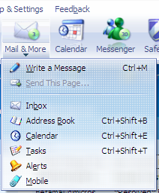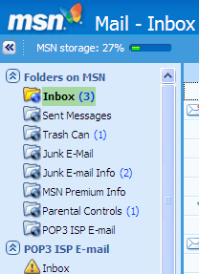
Mail and calendar toolbar buttons Folders on MSN view in the MSN software
Feature Highlight: E-mail stored in the folders on MSN is accessible anywhere a customer logs onto MSN, whether through the MSN software, Microsoft Outlook or a standard Internet-connected Web browser accessing http://www.hotmail.com/. Subfolders can also be created within the folders on MSN to help manage and organize information and are also accessible while roaming.

Multiple MSN and Hotmail Account Access
MSN Mail lets customers send from, receive and manage multiple MSN and Hotmail accounts within the Mail interface without requiring them to log out and log in individually to each account. By providing a single interface to manage multiple e-mail accounts, MSN helps customers stay more productive and in sync with all their MSN, Hotmail and POP3 e-mail communications simultaneously. The multiple accounts being accessed within MSN Mail receive the same benefits that the primary account does, including Junk E-mail Guard filtering and Designer E-Mail.

Additional MSN or Hotmail accounts can be easily added by selecting Help & Settings from the MSN menu, and then Settings, and then E-mail from the settings options. In the E-mail settings there is an option for Additional e-mail accounts, which allows customers to add accounts.

Multiple POP3 Accounts
MSN Premium’s advanced e-mail inbox lets customers easily manage and incorporate their POP3 accounts. Each POP3 account is provided with a folder in which e-mail messages are delivered and can be managed with the other MSN account in the inbox and the local e-mail folders. Customers can send and receive their POP3 e-mail within MSN, and when they create a new e-mail message in MSN, the From line provides a drop-down list of their MSN accounts and all their POP3 accounts from which they can choose the originating account of the message. In addition, there is virtually no limit to the number of POP3 accounts that can be added in MSN.
There are two ways to set up POP3 accounts in MSN: The first is to simply click on Add e-mail account in the left-hand pane of the MSN Mail client, shown below.
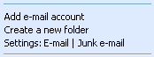
Add e-mail account option in MSN Inbox left pane
Another option for setting up POP3 accounts or modifying settings while in the MSN Inbox is to select Help & Settings from the MSN menu, and then E-mail Settings from the options available on the menu. This will bring you to the E-mail Settings page, and you’ll see an option for setting up additional e-mail accounts. Clicking on this option will bring up a list that includes POP3
e-mail and the option for adding them or copying POP3 e-mail settings, as well as adding MSN and Hotmail e-mail accounts. This settings page is shown below:
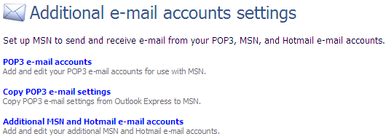
Additional e-mail account settings page
Customers can either enter the settings for their POP3 accounts, or if they have already set them up in Outlook Express, they can import them into MSN. Once the account settings are entered, they will appear in the MSN Mail Inbox even if customers log in at another computer running the MSN software using their account.
Feature Highlight: The multiple MSN, Hotmail and POP3 accounts managed in MSN also receive the benefits of the MSN Junk E-mail Guard, which helps protect those accounts from unsolicited e-mail. In addition, all the rich e-mail creation tools from MSN e-mail are available to each of those accounts in the MSN software, allowing customers to create photo e-mail and apply features such as stationery and WordArt.

Microsoft Office Outlook Connector for MSN
Providing customers with flexibility and choices is a key goal of MSN, whether that means providing them with access to their communications information from any browser connected to the Internet or delivering the experience of Microsoft Outlook access to all their information. MSN Premium customer subscriptions receive the benefit and flexibility of the Microsoft Office Outlook Connector for MSN, which allows customers to use Microsoft Outlook XP or Outlook 2003 to access all the communications information in their MSN account including e-mail messages, calendar items and address book entries as well as create task items and notes that can be stored in their MSN online accounts.
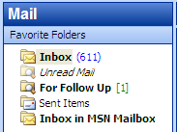
Microsoft Outlook 2003 accessing MSN Inbox
Business customers that use Microsoft Outlook connected to Exchange Server benefit by being able to stay connected to that environment and simultaneously access their MSN account in the same software — Microsoft Outlook. In Outlook and using the Outlook Connector, customers can view multiple calendars side by side, meaning that if customers are connected to an Exchange Server for their corporate use and also MSN, they can move or copy events among those calendars. This allows them to stay productive while managing their work and personal lives. With the Outlook Connector customers can drag and drop e-mail, calendar items and contacts among the stores they access in Outlook, whether Microsoft Exchange, MSN or local folders.

MSN Designer E-Mail and Photo E-Mail: Easy Sharing of Photos in E-Mail
MSN includes several ways in which customers can easily share their digital pictures with friends and family, including MSN Mail, MSN Groups and MSN Messenger.

Photo-sharing options can be accessed in several ways, including through the Microsoft Picture It!® Library, the Photos button on the MSN explorer toolbar, or MSN Mail. The graphics below show various sharing options available through the MSN Explorer toolbar and also the easy access to photo-sharing in the MSN Mail inbox.

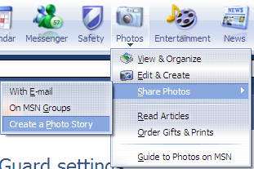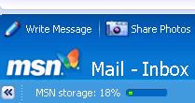
Sharing photos using the Photo toolbar button Sharing Photos in the MSN Mail inbox

In addition, within MSN Mail customers can use MSN Designer E-Mail to create visually rich photo albums that include their photos, captions for those photos, stationery and titles using Word Art. Although these e-mail messages can contain many pictures and other content elements, their size when sent will typically remain relatively small. The messages are sent using HTML standard formatting, so they can be read in any e-mail client capable of reading HTML.

Feature Highlight: Customers can use MSN Mail Designer E-mail to create content-rich e-mail messages and photo albums that can include photos, stationery and titles, but which are sent using efficient techniques to minimize their size.

With the additional benefit of Photo E-mail when used with Designer E-mail, customers can also automatically have the high-resolution images associated with any of the compressed photos included in the e-mail uploaded to the Web for 30-day storage. When the customer sends the e-mail message to the recipients, each of them can view a complete slide show of the photos included in the e-mail and can also choose to download the high-resolution images. This functionality is easily accessible through links for Play slideshow or Download images, found in the Photo E-Mail toolbar at the top of the message.

Feature Highlight: When a customer creates new Photo E-Mail using pictures that have already been uploaded from their machine using this feature, MSN uses software intelligence to determine this so it does not reupload the pictures, which helps intelligently conserve the customer’s bandwidth.

Recipients of Photo E-mail can view the photos that have been shared using the integrated slide show feature by clicking on Play slideshow in the Photo E-Mail toolbar. The photo slide show viewer includes options for controlling the slide show experience, such as adjusting the speed or clicking on a picture thumbnail to go directly to it. In addition, recipients can choose to download the high-resolution images and print them on their home printer, purchase prints, or order other fun photo-related items.

The following two exercises explore ways in which customers can easily share photos using e-mail. MSN has made it easy to create rich e-mail messages containing photos and then easily share them with others in exciting new ways.
- From the MSN explorer toolbar, select the Photos button, Share Photos option, and then With E-mail. This will create a new e-mail message into which you can insert photos and automatically launch the File Browser in the Picture It! Library. Note: In the MSN Mail inbox, customers can also simply click on the Share Photos icon to create a Photo E-mail.
- Next, select multiple photos from one of the directories shown in the folders window. You can select multiple pictures by holding the CTRL key and then clicking on the images, or simply by dragging your mouse across photos to select several at once. Click on OK to complete your photo selection.

Feature Highlight: The MSN Photos E-Mail toolbar is automatically added to the e-mail message. With MSN customers can now easily share high-quality copies of their photos online when they send e-mail. Recipients will see the MSN Photos E-Mail toolbar in the e-mail message, and can choose to view a slide show and/or download the high-quality images associated with the embedded pictures in the message. Photos shared using the MSN Photos E-mail feature are available online to recipients for 30 days.

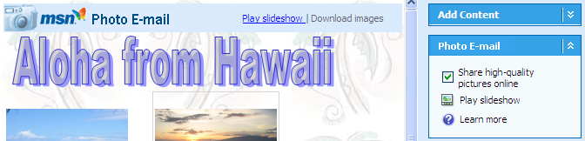
MSN Photo E-Mail toolbar and Share option

- Now you will see your new e-mail message window with the photos you just selected embedded in the message. You have several options at this point to enhance the message:
  - Add Content enables you to add more pictures or apply stationery to the layout.
  - Photos Plus enables you to automatically share your high-quality pictures online when you send e-mail or preview a slide show of the photos in your e-mail message.
  - Picture Layout Tasks enables you to change your picture layout, delete pictures or clear captions.
  - Modify Picture enables you to make changes to your pictures, such as touching them up, rotating them or adding borders, while they are embedded in the e-mail message.
- Click on the Add Content pane to expand it if it is not already expanded. Then select the Apply Stationery option.
- From the drop-down list, you can choose from several stationery themes such as Artistic, Popular or Sports. Select Popular, and then select Blue tiles. The stationery is applied to your e-mail message.
- Now click on the Close button at the bottom of the Apply Stationery pane to view the other customization options.
- Next, change the layout of the pictures in your e-mail message. In the Picture Layout Tasks pane, select one of the other thumbnail examples under Click a picture layout. You’ll notice that your pictures are dynamically rearranged in your message as you select various layout options.
- The majority of the layout options allow you to apply captions to each of the pictures in your layout. Try it yourself by clicking on one of your pictures, and then on Click Here to Add Text next to or below the picture. Type in your personalized description for the picture.
- Now you’re ready to send your e-mail message. In the To: line, address the message to yourself at the MSN account that you’re currently using and to another e-mail user with whom you’d like to share the pictures; then click on the Send Message button at the top of the e-mail message. You’ll notice that as the message is sent, the high-quality images are uploaded at the same time.
- When the e-mail message arrives in your inbox, double-click on it to open it.
- You’ll see that the Photos Plus toolbar is embedded in the e-mail message. The toolbar will be available to any recipient using an e-mail client capable of reading standard HTML.
- Click on the View Slideshow option. A browser occurrence will begin and a slide show of the embedded photos will start playing. You’ll notice that in addition to choices embedded in the slide show viewer for adjusting the playback speed, you have options that allow you to show titles, print and download pictures, and order prints or gifts.
- Close the slide show by selecting the Close and return to email button in the slide-show viewer.
- Finally, still in the e-mail message that you sent to yourself, click on the Download images link. This launches a window for MSN Photos E-Mail and takes you to thumbnail views of all the photos you chose to share online. You can choose to download high-quality images of all photos or selected photos.
- Choose a few photos by clicking on them, and then select Continue.
- Choose a folder to put them in, using the Browse for Folder window that appears, and then select OK.

It’s easy to select photos from the Picture It! Library and share them in e-mail with the help of great features such as the ability to change the layout, add captions and apply stationery.

MSN Messenger With MSN Photo Swap
MSN Messenger delivers exciting features such as webcam integration; broad customization options including custom emoticons, backgrounds and user tiles; and peer-to-peer applications and games. Customers who subscribe to MSN can now also initiate real-time photo sharing using MSN Photo Swap in MSN Messenger. During an instant message conversation, Photo Swap gives customers the ability to launch a rich photo-sharing application that becomes part of the MSN Messenger instant messaging experience. Customers participating in the Photo Swap session can also choose to save photos that were part of the exchange.

Shared Calendar
Shared calendars are an exciting new feature of MSN that let customers easily share their calendar with other subscribers or broadly publish their calendar information to the Internet. In addition, customers can view others’ calendars alongside their own, including MSN Group calendars.

Let’s first look at sharing calendars with others. Customers can share them with one or more people.

- To access the MSN Calendar, click on the Calendar button on the MSN explorer toolbar.
- In the left-hand column you’ll see the Shared calendars pane. Click on Sharing options, and then Share your calendar on the fly-out menu. This will begin the Settings Wizard for sharing your calendar and take you to Step 1: Choose a person.
- On the Choose a person page you can either type in the e-mail name of a person you would like to share your calendar with or select a name from your address book. Note: The person you want to share your calendar with must either be an MSN subscriber or have a Microsoft .NET Passport. Enter or select the name of someone to share your calendar with in the e-mail address box of this page, and then select Next to advance to the Step 2: Choose permissions page.
- On the Choose permissions page you have the option to show only free and busy blocks of time or show all appointment details. Choose the option you would like to apply to the person you are sharing your calendar with,and then select Next to advance to the Step 3: Send a personal note page.
- On the Send a personal note page you can create a personalized, nongeneric note that will be sent to the person with whom you’re planning to share your calendar. Type a personalized note, and then select Next to advance to the completion page, where you should see a message stating “You’re done!” if you have specified a valid account with a Microsoft .NET Passport.
Feature Highlight: To share their calendar with another person, customers must send an invitation to that person, who, in turn, must accept the invitation before sharing is enabled.

- At this point you can choose to Share Your Calendar, View Permissions, Go to Calendar or Close the Calendar Sharing Wizard page. Select Close and you will be taken to the Calendar sharing settings page.
- From the Calendar sharing settings page, select Permissions from the listed options, which will take you to the Change who can view your calendar page.
- On this page select an account for which to modify the viewing permissions, and then select the Edit button, which will take you to the Choose permissions page.
- The Choose permissions page has options for showing only free or busy information, showing all appointment details or removing access to your calendar entirely. Select Show all your appointment details, and then Save Changes. This will return you to the Change who can view your calendar page.
- In the left-hand column of this page you’ll see the Calendaring sharing preferences setting. Select that setting to go to the Choose calendar sharing preferences page.
- On this page select one of the listed names, and then select the Edit button. This will bring you to the Change calendar sharing preferences page for the name you selected.
- On this page you can change the name that describes that person, the viewing status and the color used to represent that person’s schedule information in the Shared calendar view. Change the color used to represent this account in the Calendar color option, and then click on Save changes. This will return you to the Choose calendar sharing preferences page.

Accessing a calendar that has been shared with you is easy with MSN. Below is an example of what a shared calendar view looks like. In this example there is an individual calendar (Joe Jr.) shared with the MSN subscriber, but also two MSN Groups calendars in the Shared calendars box on the lower left of the graphic. To choose to view or not view calendars that are shared with you, simply choose the appropriate name from those listed under Shared calendars, and you will have a view similar to the one below.

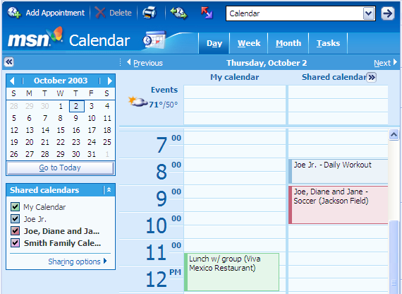
Shared calendar view

Digital Life Management
MSN delivers features that help customers manage and customize their digital lives and provide them with the information they want, how they want it and where they want it.
Feature Highlight: MSN delivers exciting features to help customers manage their digital life:
- Customizable Toolbar. The MSN Explorer toolbar delivers customization options for resizing the entire toolbar and adding or removing buttons.
- Customizable Dashboard. While MSN is connected to the Web, the dashboard delivers constant updates on a customized selection of features that most interest the customer.
- Customizable My MSN. Advanced customization features include click and drag-and-drop movement of more than 100 content modules.
- New MSN.com and Home Page. This feature offers easier navigation and access to searching as well as broadband-specific content and selections.
- MSN Video. This new broadband video service delivers instant-on and always-on streaming content from leading content providers including MSNBC and ESPN, with others to be announced later.
- MSN Photos Plus. Customers can get the most out of their digital photo collections by using advanced photo-organizing and -editing tools to help manage, update and share them.
- MSN Encarta Premium with online math help. This learning and research resource makes the Internet more useful for families every day.
- MSN Money Plus. This feature helps customers manage their budgets, investments and other financial tasks online and all in one place.

Toolbar Customization
The ability to customize allows customers to tailor their environment and be as productive as possible when online. In previous versions of MSN, customers could simply customize the toolbar by dragging it with the mouse to resize it. The newest versions of MSN now include the ability to not only easily resize the toolbar but also to quickly add or remove icons from the toolbar.

To customize the MSN toolbar by changing the button configuration, do the following:
- Right-click anywhere on the toolbar.
- Select Customize… from the context menu that appears.
- In the Choose Buttons for Toolbar dialog box, shown below, simply double-click on a description to move it to the other box (Available buttons to Displayed buttons or vice versa) or select the Add >> or << Remove buttons to change whether a button is displayed on the toolbar. You always have the option to reset the toolbar to its original state by clicking on the Reset button in this dialog box.
- After customizing the toolbar with your preferences, click on OK to complete the update.

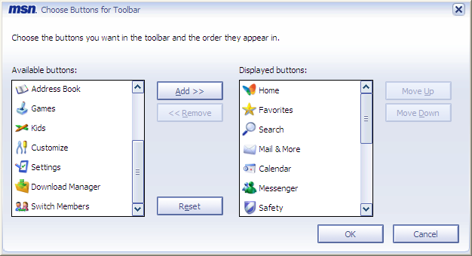
Choose buttons for toolbar dialog box

Dashboard Customization
The dashboard provides updates while customers are connected to the Internet, which means that the optimal dashboard experience is achieved while in an “always-connected” broadband environment. The dashboard can be viewed in several ways, including being docked directly to MSN Explorer or shown as part of the desktop environment so it is always visible and providing easy access to information, regardless of what application is being used. The dashboard can also be easily collapsed and expanded. Both of these customization options are available by left-clicking the mouse at the top of the dashboard or by selecting the buttons for these options as shown in the graphic below.

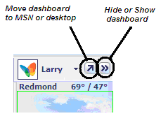
Dashboard button options

Several enhancements have been made to the dashboard in this version of MSN:
- Photo show. Customers can display a photo slide show of photos from their MSN Groups storage or their local hard drive.
- E-mail. Customers can view unread e-mail messages, with sender and subject line information, in the MSN Inbox.
- Calendar. Customers can view calendar events and shared calendar items.
- Traffic reports. Customers can view traffic incidents for a customized region.
- Alerts. Customers can display and easily access the history of incoming alerts.

Let’s explore how to customize the dashboard and include photos:
- To access the menu to customize the dashboard, left-click on the header area of the dashboard near the dashboard buttons. An extensive menu of options appears and allows you to choose the information on which you would like to receive updates.
- Select Photos from the list of available options by clicking on it with your mouse.
- You will now see the Photos section in the dashboard. To add photos, click on Photos in the dashboard, and then Show a Slide Show from the fly-out menu.
- The MSN Photo Show Options dialog box appears and provides you with options for determining what photos will appear in the dashboard. You may choose from either photos hosted on MSN Groups or photos stored in folders anywhere on your local machine. Select the My Pictures directory by selecting the My Pictures tab in the dialog box, and then the My Pictures option listed.
- Select the OK button, and you’ll see pictures located in the My Pictures folder begin cycling in the dashboard.

MSN Video
MSN Video is a new broadband video service available free to all visitors to MSN. MSN Video can deliver high-quality news from its joint venture with NBC, which includes “NBC Nightly News With Tom Brokaw,” the “Today” show, “Dateline NBC,” “Meet the Press,” MSNBC and CNBC. Additional entertainment and sports video content will become available over time as well. Using MSN Video, viewers can create customized play lists of favorite video segments or watch entire shows on demand at their convenience.

Built on Windows Media® 9 Series technology, MSN Video can deliver an instant-on, always-on streaming experience for broadband users, effectively eliminating any buffering delays and offering 300Kbps playback speeds. For those who are set up for surround sound, MSN Video can deliver Web-based 5.1-channel surround sound with full-spectrum, full-resolution audio.

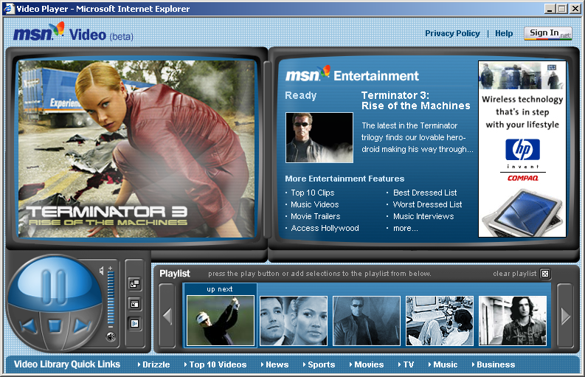
MSN Video service example

MSN Home Page
The MSN home page has been redesigned to be more useful with features that are best experienced with a broadband connection. A Flash-enabled, lead-story section will present broadband-only content with links to video and text. Content will be presented in an editorial tone that broadband users expect from their trusted news and information sources. These content areas will be refreshed frequently to highlight the latest news and information. In addition, a new Broadband module will highlight even more broadband content, while the Entertainment module will feature links to Internet radio, music downloads, movies, gaming and more.

Overall, the new MSN home page will be easier for visitors to navigate. Popular MSN channels and destinations, such as Going Places, Hot Deals, Living, and News & Opinion, are now consolidated on one left-hand pane and grouped according to interest. Links to My MSN, Hotmail and Messenger now appear as three icons in the upper-right corner. A fourth icon will change according to the season (e.g., Halloween, Thanksgiving, Fourth of July), linking visitors to timely information and services. Content for Sports and News has been moved into the lead story section so visitors will only have to scan one area for top news stories. MSN Search remains in a top page position within a clean and uncluttered header. The rest of the content on the new home page is reorganized into two easy-to-read columns.

My MSN
My MSN has a new look, improved customization and a greater choice of content including broadband-specific content. Customers can design a personal Web page using advanced customization features. Creating and customizing a page has never been easier. Customers move modules around the page with a simple click, drag and drop of the mouse. Adjusting column widths is just as easy. My MSN customers can create more space by adding more columns and new pages. My MSN also provides creative themes and colors to complete the customization experience.

There are more than 100 content module choices from news and information and video and music to personalized traffic and weather reports. Hotmail users can even select a module to preview inbox and mail status. A My Video page will provide rich content and high-quality video from Microsoft’s joint venture with NBC. With the new My MSN, customers can truly access whatever they want on the Internet, arranged to their customization preferences.

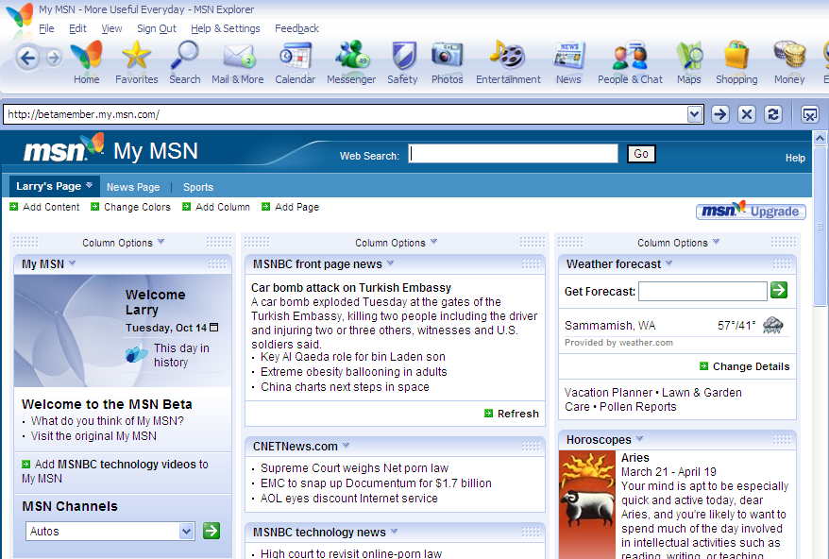
My MSN example

MSN Photos Plus — Viewing, Organizing, Editing, Creating and Sharing
MSN Premium delivers advanced photo capabilities in MSN Photo Plus, which let customers get the most out of their digital photo collection and easily share photos with friends and family. With easy access to a variety of photo tools in MSN Explorer, customers can easily do the following:
- View, organize and easily find their photo collections using Picture It! Library 9
- Edit and create photo collections using Picture It! Express 9
- Share photo collections through e-mail, MSN Groups, a Photo Story or MSN Messenger

Picture It! Library 9
MSN delivers powerful tools for helping customers organize, view and easily find photos in their collections using Picture It! Library 9. When initially started, Picture It! Library finds photos on customers’ local drive and categorizes any photos located into groups based on date, which is one of the most requested organizational methods for photos. After locating photos and displaying them, customers can arrange and/or rearrange their photos into categories and add keywords, captions and comments to their photos. This enables customers to create virtual views of their photos, allowing them to find what they are looking for later. The Picture It! Library is a hub or launch point for many photo activities including sharing, editing, printing and archiving.

Now you can try these exciting features for yourself. The following exercises assume that you have photos or images located in the My Pictures directory of the machine you’re using. If you do not have photos in the My Pictures directory, please add some at this time.

Let’s begin by viewing and organizing photos located on your machine.

Viewing and Organizing Photos
- In MSN Explorer, select the Photos button from the toolbar, and then the View & Organize option. This will launch the Picture It! Library. Picture It! Library delivers powerful digital image viewing and organizing tools including features such as easy photo importing, batch editing, CD archiving, keyword indexing, and creation of rich multimedia photo presentations using Photo Story.
- If it is not already selected, click on the My Pictures folder in the left folder view. You will see photos that you have located in that directory appear in the main Group By: window.
- The button next to Group By: provides you with options for viewing your photos. Select the button and you’ll see viewing options such as Auto, Date Taken, Keyword and Rating. These selections let you quickly and easily change the way you view your photos.
- Let’s next apply keywords to your photos. First, click on the Keywords button on the Picture It! Library toolbar. The Keyword Painter dialog box will appear.
- In the Keyword Painter dialog box, click on <Click here to add keyword>.
- Type a keyword that you would like to use to describe a set of your pictures, such as “Vacation 03,” and then hit Enter.
- You’ll see that the keyword you entered is now part of the Keyword Painter list and is selected. You can also select multiple keywords to apply to your photos by simply selecting additional terms in the keyword list.
- Now move your cursor over the photos in the Group By: window, and you’ll notice that the icon has a paintbrush attached to it with the keyword(s) that you’ve selected in the Keyword Painter. Select all the photos that you would like to apply the keyword to by simply clicking on them with the paintbrush cursor.
- When you’re done applying keywords to your photos, click on the X in the Keyword Painter box to close the box.
- Select Keyword on the Group By: button to sort your photos by keyword. You’ll now see the photos you selected grouped under the appropriate keyword.
- In addition, you can also use the area at the bottom of the Group By: box to apply keywords, captions and ratings to your photos individually or as groups. Select multiple photos by holding the CTRL key on your keyboard while clicking on multiple, similar photos. You will now see something similar to the graphic below:

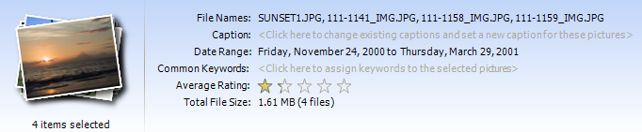
Applying keywords, captions and ratings to photos

- You can type directly into the area next to the Caption: Common Keywords: or click on the stars for the Average Rating: to change them. Try it yourself.

Microsoft Picture It! Express 9 — Photo-Editing Tools
MSN includes powerful and easy-to-use editing tools that enable subscribers to perform often- requested touch-up tasks such as fixing red-eye, adjusting brightness and contrast, rotating, and cropping. Picture It! Express contains simple editing features and a sample of creative tools that allow customers to easily add frames, mats and fancy edges, which provide personalized touches to customers’ photos. Microsoft Picture It! Express 9 can be used to edit individual photos or batches of photos. Picture It! Express is available inPicture It! Library by selecting the Edit button on the toolbar, by right-clicking with the mouse on photos, or by selecting the Photos icon on the MSN Explorer toolbar and then Edit & Create from the menu.
Perform the following steps to access and use Picture It! Express:
- In Picture It! Library, select any single picture and right-click on it. This will bring up a menu with options to edit, rotate, find similar pictures, convert file formats and other options.
- Select Edit Picture… from the menu to start Picture It! Express in Picture It! Library. Picture It! Express opens and displays common picture-editing tasks such as touchup, format, effects, edges and adding text.
- From the Touchup task, select Levels Auto Fix and watch to see if any changes are made to the picture in real time. Note that various adjustments such as red-eye, brightness and tint as well as hue and saturation can be made from the Touchup task menu.
- From the Format task, select Crop Canvas… and the Crop task options will appear.
- The first option is to select a proportion. For this exercise select 5x7 from the Custom drop-down list.
- Next, simply drag your mouse across the picture while holding down the left mouse and you’ll see a rectangular box selecting the area to be cropped. Once the rectangular selection box is the correct size, you can reposition it by dragging it with your mouse.
- When you have the selection box sized and positioned as you want it, click on the Done button at the bottom of the crop task column. You will now see your cropped picture.
- To save the changes to your picture, select File>Save As from the menu.
- To exit Picture It! Express, choose either File/Exit from the menu or click on the X in the upper right-hand corner of the window. This will return you to the Picture It! Library.

Sharing Pictures Using Plus! Photo Story Lite
Plus! Photo Story Lite is an exciting tool included with MSN Premium that allows customers to take pictures from their photo collection and weave them with voice annotations and audio tracks to create rich multimedia stories that they can easily share with their friends by e-mail or host on their MSN Groups site. Customers can simply select photos and apply a short audio clip to each to create a rich slide show that can be shared. The Photo Story feature is launched from the Photo Library, and only through the Photo Library. Within Photo Story, customers can do the following tasks:
- Choose photos they want to include from the Photo Library
- Arrange and rearrange the photos
- Add a voice narration to the photo
- Select background music
- Create a title page for the project

Once the project is complete, customers can preview the Photo Story, save it and even burn a video CD. Photo Story is a great feature for bringing photo collections to life.

Let’s take a look at how easy it is to create a Photo Story.
- To begin sharing your pictures using Plus! Photo Story Lite, go to the MSN Explorer toolbar and select the Photos button, and then Share Photos, and then Create a Photo Story. This will launch the Photo Story Creation Wizard. If you have a microphone and you have not configured it, please do so now using the wizard option titled Configure Microphone.
- To begin creating your Photo Story presentation, click on the Begin a Story button on the wizard.
- You are now at the Add and arrange your pictures screen of the wizard. Select the Add Pictures button; this will take you into the File Browser and the Picture It! Library tab.
- If you are in a folder that does not contain pictures, navigate to a folder that does, such as My Pictures.
- Once you’re in a folder with pictures, select multiple pictures from thoseshown in the right pane of the File Browser by clicking and dragging across them using your mouse or holding down the CTRL key on your keyboard and clicking on multiple pictures. Once you have multiple pictures selected, click on the OK button in the File Browser to select the photos and insert them into the wizard.
- You can drag photos in the film strip or use the move buttons at the right end of the film strip to reorganize the photos that you have selected to include in the Photo Story. After all the photos you’d like to include are selected and organized, select the Next button to proceed to the Record your story page.
- The Record your story page enables you to voice annotate pictures in your story and zoom in on important things you’d like to highlight while doing so. If you have a microphone on your computer, select the record button (blue circle with red inner circle) to start recording and move your mouse over the picture while recording to emphasize certain aspects. Click on stop (blue square with white inner square) after you’ve recorded your annotation. Continue to narrate your other pictures if you’d like by selecting each of them, and then repeating the previous steps. When you’ve recorded all the annotations you’d like, click on the Next button in the wizard to proceed to the Add a title page.
- The Add a title page of the wizard lets you choose to easily add information such as a title, description and number of seconds to display the title page for your Photo Story. Select the Add a title page to your story checkbox on this page.
- Next, type a Title and Description for your Photo Story in the input boxes. You can also choose to change the font and alignment for these items now. When you’re done, click on the Next button in the wizard to proceed to the Add music and preview your story page of the wizard.
- You may now add music to the background of your Photo Story. You can choose a Windows Media Audio, WAV or MP3 formatted track. Ensure that the Add background music to your story box is checked, and then click on the Browse… button to select a music file from your local hard drive and then on the Open button to include it in the Photo Story.
- You’re now ready to preview your completed Photo Story. Simply click on the Preview Final Story on this page of the wizard. After you’ve previewed the Photo Story and are satisfied with it, click on the X in the preview window to close it and return to the wizard.
- Click on the Next button in the wizard to proceed to the Select audio quality and save your story page of the wizard.
- The Select audio quality and save your story page of the wizard allows you to choose the audio quality of the music file and provide a name for your Photo Story file. Select High quality for the audio and name your Photo Story by typing an appropriate name for the file in the File name box.
- Click on the Next button, and you’ll see the Building your Story box appear while your story is created; then the wizard will advance to the Completing Plus! Photo Story page.
- On the Completing Plus! Photo Story page the name, location and size of your completed Photo Story will be displayed. You have several options on this page of the wizard:
  - View Your Story
  - Create a Video CD of Your Story
  - Create Another Story
- After you’ve made your selection and completed any necessary steps, close the wizard by selecting Exit from the wizard page.

Feature Highlight: There are several ways customers can distribute their completed Photo Story. They can e-mail or send it via MSN Messenger to a friend, or they can create a video CD of their story. Video CDs are created using standard PC-based CD writers and media (CD-R) and will play in the majority of consumer DVD players. This is a convenient way to share a Photo Story with friends and relatives who may not have a computer or would like to watch it on their televisions instead.

MSN Encarta Premium
MSN Encarta Premium is a comprehensive online encyclopedia of content that could fill a 30-volume print encyclopedia. Included are an interactive world atlas, the Encarta dictionary and thesaurus, a multimedia center, statistics and tables, and facts and figures. Encarta Premium delivers extensive resources to help provide kids with valuable learning tools and premium content that enhance learning productivity and educational outcomes. For adults, it provides a one-stop source of premium reference content.

Going beyond usual references to meet customer’s learning and research needs, Encarta Premium includes a searchable magazine collection featuring the archives of 100 leading magazines, as well as literature guides that contain summaries, background and insight on the great works of literature most commonly studied in grades 6–12.

MSN Encarta Premium also provides the Homework Center, a collection of powerful tools to help customers and their children overcome daily frustrations with math, English, foreign language homework and projects of all types. Exciting areas within the Homework Center include these:

- Homework starters. Step-by-step guides to writing essays, research papers, book reports and more
- Math. Step-by-step explanations of math problems that are correlated to math textbooks
- Web directory. A list of the best online sources carefully selected by the expert staff at Encarta
- Translation. Bilingual dictionaries to help customers translate words

Now let’s take a look at some of the ways Encarta Premium can help make learning a fun and exciting lifelong pursuit.

Homework Starters
Sometimes the hardest part of homework is getting started. Encarta Homework starters can give your kids a gentle nudge with step-by-step instructions for essays, book reports and other assignments. They just follow the tasks to get going. Let’s see how these Homework starters work.
- Start by clicking the Homework link on the Encarta Premium icon in the MSN Explorer toolbar to display the Homework Center home page.
- Under the Study Tools option, select the Homework Starters link. This displays a list of Homework Starters, including Starters for Essays, Research Papers, Book Reports, Oral Presentations, Creative Projects, Creative Writing Projects and Science Projects.
- Select the Essay link. This displays the Essay options in the right pane.
- Select the General Essay link and notice the outline of tasks required to complete a General Essay such as requirements, topic, etc.

Encarta Math Help
Encarta Math Help offers step-by-step explanations to math problems in commonly used math textbooks. Using Encarta Math Help, children can pick a problem from their textbook, and Encarta guides the child to the solution. The following exercise details one of the ways in which Encarta Math Help can be used to provide explanations for exercises in a textbook.
- From MSN Explorer, select the Encarta icon from the toolbar, and then the Homework link on the Encarta Premium home page, which displays the Homework Center page.
- Select the Math Homework Help link from under the Study Tools option to display the Math Homework Help page.
- Select the Find an Algebra Book button and click on Algebra 1: Integrated Approach.
- Go to Chapter 7, Page 372, Problem 15, and display the online problem for this textbook.
- The Math Homework Help walks through a four-step process to answering a similar problem that can be found in the textbook. There are lots of hints accompanying each step to help along the way.

Dictionaries and Thesaurus
Dictionaries from Encarta contain approximately 400,000 dictionary entries. In addition to definitions, dictionary entries may include some or all of the following:
- Pronunciation keys
- Word histories
- Word usage notes
- Thesaurus entries

Let’s take a look at how to use the pronunciation key in the Encarta Dictionary.
- Select the Encarta Premium icon from the MSN Explorer toolbar, and then click on the Dictionary & Thesaurus button in the drop-down menu
- In the Find field, type in the word “plenitude.”
- Click on the Dictionaries button to see the results page.
- To hear the entire word pronounced, if using Windows, click on the WAV button next to the speaker image icon or if using Mac OS, click the AIFF.

MSN Money Plus
A useful, automated online personal finance service, MSN Money Plus includes all the tools, content and services available on the MSN Money Web site, plus easy online tools for virtually effortless financial management. The service puts a consumer’s bank, brokerage and credit card accounts at his or her fingertips, providing automated financial management tools and services, including spending and budgeting tools, and free bill pay — all in one place.

MSN Money Plus features an expanded array of tools and resources that are easy to use and navigate, including simpler accounts setup, convenient roaming with Microsoft Money 2004 personal financial management software and more consistency with MSN Premium. The online personal finance service delivers a financial management experience that couples the offline power of software with the timeliness and speed of the Web. Now consumers can view and then analyze their data with little effort, making it easier for them to review, understand and improve their finances. Following are some of the key features available in MSN Money Plus:

- Dynamic Home Pages. To keep consumers informed of the ever-changing economic landscape, MSN Money Plus features redesigned home pages that deliver the latest financial news and key developments. Automatically updated, pertinent information from Briefing.com, CNBC, Forbes, Kiplinger, MSNBC, MSN Money and Reuters keeps consumers abreast of the current issues and events that may affect their finances.
- 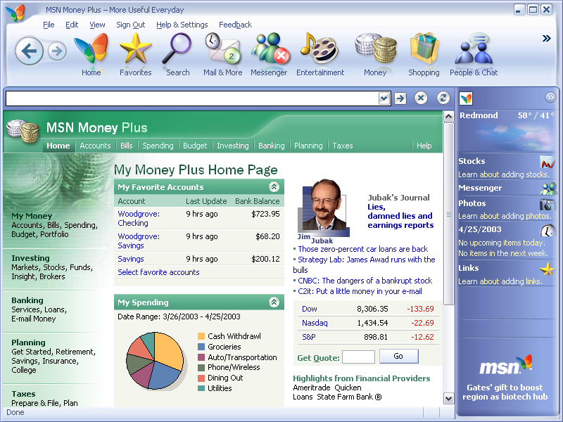
Dynamic Home Page in MSN Money Plus

- Online Bill Pay Integration with Shared Calendar. MSN Money Plus makes it convenient to receive and pay bills online, any time, any place. Now consumers can view their online bills in the Shared Calendar in MSN Premium, making it easier for them to manage their financial lives in one place. Also, MSN Bill Pay is included with the MSN Premium subscription, which enables unlimited bill payments to a list of 900 national billers.

- Connections to Financial Institutions. Via Open Financial Exchange connections and through an alliance with Yodlee, MSN Money Plus provides account information from nearly 3,000 financial institutions. With automatic account updates and analysis capabilities, consumers can more easily monitor where their money goes across multiple accounts and institutions.

- Spending Analysis. This tool helps consumers improve cash flow and reduce debt, enabling them to classify spending transactions for 30 categories, including up to five of their own personal categories. This powerful feature automatically generates a detailed pie chart of customizable expense categories over multiple time frames, and shows dollar amounts and percentage breakouts for each category. In addition, consumers can click on a category to see where they are spending the most.
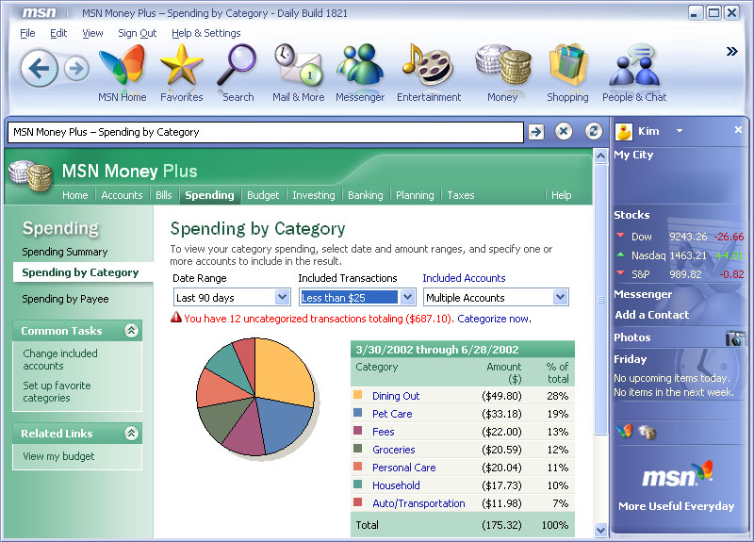
Spending Analysis tool in MSN Money Plus

- Budget Tracker. With automated data from My Accounts, the Budget Tracker establishes a plan relevant to each consumer’s situation, enabling him or her to monitor monthly spending versus budget — overall and in each spending category — and to identify and monitor key areas that often account for overspending.

Requires separate installation

