
MSN Direct — For the Information People Want, Just by Flicking Their Wrist
MSN® Direct allows people to customize the content received on their Smart Watch based on their likes and needs.

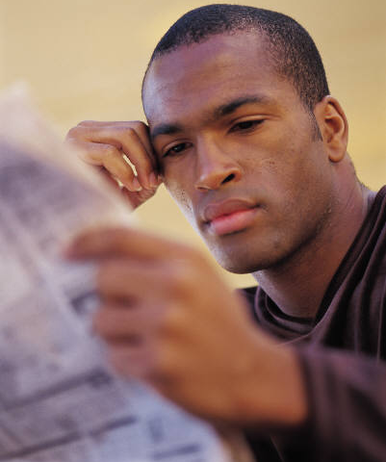
For those who need to be in the know. News updates from around the world are delivered directly to the watch. People get current news, local event notifications and the information that matters most to them, in their own back yard and in their country. Customized sports news and current financial figures are sent directly to the watch, so people only get the information they care about. There is no need to search through massive stock tables or weed through sports scores.


For the executive. Business executives can have current business news and market trends at their wrist. The Smart Watch’s glanceable format allows for the unobtrusive receipt of messages and information during meetings and at places where a cell phone would be distracting or inappropriate. Syncing with Microsoft® Outlook® calendar allows executives to be reminded of important meetings and engagements.

For the road warrior. For travelers and commuters, MSN Direct is a natural lifeline. When a traveler changes time zones, the watch doesn’t need to be reset, because the time is automatically updated based on the location.

For the sports fan. Sports updates from around the nation are delivered directly to a Smart Watch, so subscribers get the game times, standings and information that matters most to them. MSN Direct delivers post-game recaps and statistics straight to the wrist. So even if a spouse insists on attending that family reunion or business dinner, a sports fan will be in the know.


For the movie buff. For the person who jets out to see the latest showings, Smart Watches let people view show times and movie listings for up to 10 local theaters all at a glance. This information makes it easy to find the next show time and place without having to call theaters or check the newspaper.


For the active lifestyle. Whether outdoors enthusiasts are heading to the beach, the mountains or the open road, they can get current weather updates, temperature readings, UV index, sunset times and more.


For the busy parent. With personalized calendar syncing options, parents never have to miss a soccer game, a recital or a carpool appointment. Calendar reminders will help ensure that parents are where they need to be, and personal messaging allows them to receive those inevitable schedule changes from the kids.

For a trendsetter. For those who set trends, not follow them, the Smart Watch offers formal, funky or retro watch faces to match one’s individual style. Personalized messaging allows people to discreetly receive notes whether they’re at a club or in a business meeting.

For the gadget guru. For the person who was the first to get a plasma screen, has the latest cell phone and never leaves the house without his PDA, a Smart Watch is the ideal must-have. He can wow his friends by receiving personal messages, calendar appointments and more directly on his Smart Watch.
#########
Microsoft, the MSN logo, MSN and Outlook are either registered trademarks or trademarks of Microsoft Corp. in the United States and/or other countries.
The names of actual companies and products mentioned herein may be the trademarks of their respective owners.

For more information, press only:
Dave Hanon, Waggener Edstrom, (425) 638-7000, daveh@wagged.com
Linda Mills, Waggener Edstrom, (425) 638-7000, lindam@wagged.com
Rapid Response Team, Waggener Edstrom, (503) 443-7070, rrt@wagged.com

For more information about MSN Direct:
http://www.msndirect.com

