Brief

Microsoft® Desktop Operating Systems - Licensing in blade PC Environments November 2004
Corporate & Academic Open License◻Open Value License◻Select License◻Enterprise Agreement ◻
Academic Select License

Background
Many computer manufacturers (OEMs) have introduced a new desktop environment using blade hardware technology and Microsoft® Windows® XP Professional. This technology solution enables end users to access Windows XP Professional running on these blade PCs that are stacked securely in a data center rather than sitting under or on an end user’s desk. In this solution, end users connect to the blade PC using a small connection port and one of many different types of access devices, ranging from a desktop PC to a thin client. Blade PCs offer business customers centralized management of their desktop hardware and software and may reduce maintenance and support costs as well through elimination of rigorous “desk-side” support processes such as applying updates, patches and security fixes. This infrastructure can also help with security maintenance since it is much easier and quicker to apply patches to PCs in a centralized, managed infrastructure.

Windows XP Professional is a key enabler of this new infrastructure. It provides the operating system that enables the blade PCs to run in the data center and connect to the rest of the infrastructure. It also provides additional benefit by provisioning a Windows XP Professional experience, through the Remote Desktop Protocol Feature (RDP), to the remote users of accessing devices.

Businesses can employ a variety of devices for access: desktop PCs or thin client devices running an embedded operating system. RDP (or a similar technology) is used to access Windows XP Professional running on the PC. Unlike server models which provide simultaneous access of multiple users to a single piece of server hardware, each blade PC can have only one user accessing it at a time.

As new technology comes to market, Microsoft is working to ensure that our licensing models continue to support customers’ business needs. Blade PC solutions are currently being evaluated by our customers, partners and analysts in the marketplace. In parallel, Microsoft has reviewed its current product licensing models in order to better enable these solutions. The result of this effort is our introduction of a new licensing model for Microsoft desktop operating system software that is appropriate for this emerging technology.

Licensing Desktop Operating Systems for blade Infrastructures
The Microsoft® Remote Desktop License for Microsoft® Windows® XP Professional has been added to the Volume License programs as of November 1, 2004. RDLs are procured in the form of a license; there is no software provided with them. The RDL permits a remote device (laptop, PDA, cell phone) to access any other device that is running Windows XP Professional without the need for the remote device to be licensed separately for Windows XP Professional. An RDL does not provide you the right to access any desktop application running on the blade PC. It permits access to the Windows XP Professional software experience and to files and other data on the PC. Customers must refer to the use rights for any other application that resides on the blade PC to determine if this kind of access is permitted under the use rights for that application.

The accessing devices use RDP or similar technologies to access the Windows XP Professional software. Like some server Client Access Licenses (CALs), the customer has the flexibility to choose to license the accessing devices in their infrastructure in one of two ways —by device or by user:
- Device-based RDLs allow customers to license the access by devices (device can be used by any user, although each device will need to be licensed with an RDL)
- User-based RDLs allow customers to license the access by named user (each user can use any number of devices to access Windows XP Professional).
Each business can decide whether they want user-based or device-based licensing of RDLs, or a mix of the two. This will depend on what makes the most sense economically, technically, and operationally for each customer.

When a customer acquires blade PCs from their OEM partners, Microsoft Windows XP Professional Blade PC Edition is preinstalled. Each preinstalled license of Windows XP Professional Blade PC Edition includes one RDL license. Only blade PCs acquired from OEMs will include one RDL license with Windows XP Professional Blade PC Edition. Additional RDLs will be available from OEMs and through all volume license programs.

Basic Licensing Model

The following cases compare the RDL model to the licensing model that existed prior to November 1, 2004.

Case 1: Pre-RDL solution Case 2: New solution (device-based)

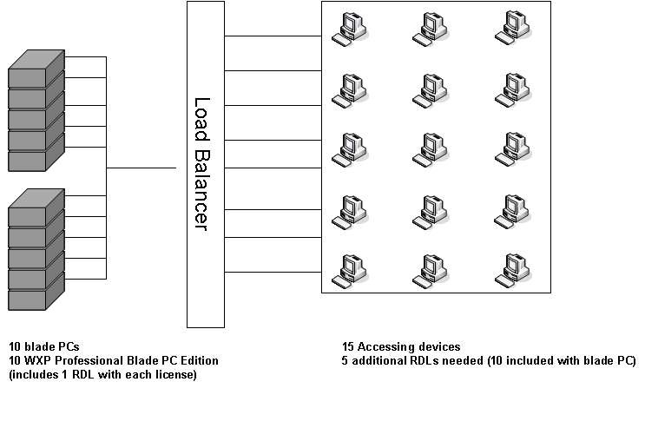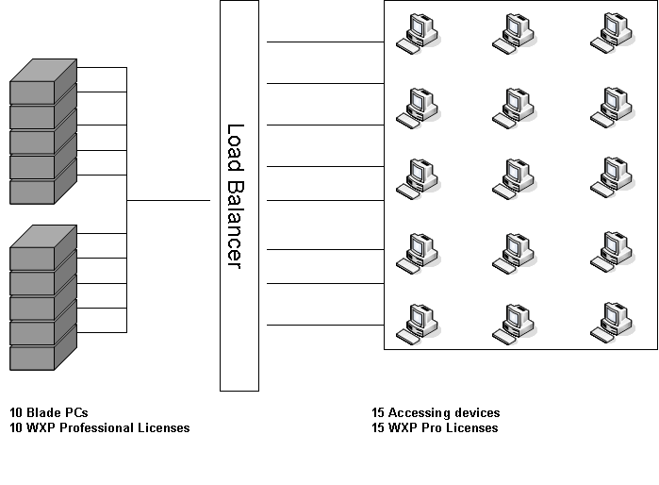
In both cases, the customer needs a total of 25 licenses. However, with the pre-RDL solution, the customer would need to acquire a total of 25 licenses (all Windows XP Professional). In the new RDL solution, the customer only needs to acquire 15 licenses (10 Windows XP Professional Blade PC Edition and 5 RDLs). Because 10 RDLs are included with each license of Windows XP Professional Blade PC Edition preinstalled on the blade PCs, they only need to acquire an additional five RDLs for Windows XP Professional.

In Case 2, we assumed the customer has decided on a device-based solution. The following section explores the options a customer has for choosing the environment (device-based, user-based, or mixed) that best suits their business needs.

LICENSING OPTION SCENARIOS
Scenario 1: Mixing user-based and device-based RDLs for Windows XP Professional
Assume we have the same scenario as in Case 2 above, but with 15 users instead of 15 accessing devices. Nine of these fifteen users are shift workers in three shifts of three and never overlap. Each shift has three devices available, one for each user on the shift. The other six users are sales staff each of whom has 3 devices they use to access a blade PC. In this scenario, the customer would elect three device-based RDLs for the shift workers and six user-based RDLs for the sales staff. With a mixed RDL approach, the customer needs to have nine RDLs. Since they are licensed for to up to 10 RDLs that were included with Windows XP Professional installed on the blade PCs, there is no need for additional license purchases. In fact, they have one RDL for Windows XP Professional that is unused and available for future growth.

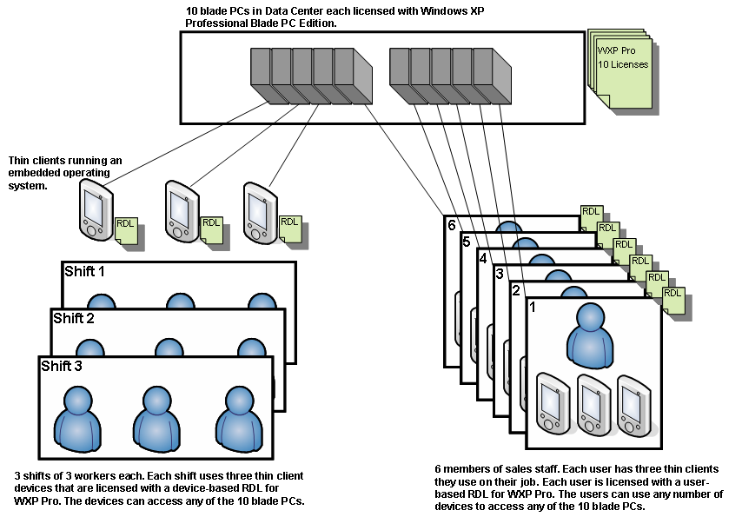

Two months from now, the customer adds two more workers per shift and two more thin client devices to support the new workers on each shift. Also, assume the customer hires three more sales staff each requiring the use of three devices. The table below shows the additional licenses they will need to acquire from their OEM or volume licensing reseller.

Scenario 2: Using desktops already licensed for Windows XP Professional
Let’s go back to our Case 2 example above. Assume 10 of the 15 accessing devices are thin clients running an embedded operating system, and five are desktop PCs running Windows XP Professional. How many RDLs for Windows XP Professional do you need? Per Volume Licensing Product Use Rights, devices already licensed with Windows XP Professional do not need RDLs to access other workstations running Windows XP Professional. You will only need 10 RDLs for the ten thin clients. The 5 accessing devices (in this case desktop PCs) which are already licensed for Windows XP Professional do not need RDLs. And, in this case, the 10 RDLs for Windows XP Professional were included with your Windows XP Professional Blade PC desktop operating system license from the OEM, so you do not need to acquire additional RDLs.

FREQUENTLY ASKED QUESTIONS:
When do I need to acquire a Remote Desktop License (RDL) for Windows XP Professional?
If you need remote access to PCs running Windows XP Professional, you will need an RDL unless you meet the criteria in the Windows XP Professional EULA or Volume Licensing Product Use Rights for Windows XP Professional: you are the primary user of the PC, or the device you are using to access the PC is already licensed for Windows XP Professional. If you set up your blade PC infrastructure so that each blade has a single, primary user, then the primary user will not require an RDL to access their blade PC. They will need an RDL if they access another person’s blade PC.

Can I use RDLs to access PCs that aren’t blades – for example, regular desktop PCs?
Yes, RDLs for Windows XP Professional permit an accessing device to access any workstation running a licensed copy of Windows XP Professional. Please note that in the OEM channel, one RDL is included with each blade PC preinstalled and licensed with Windows XP Professional Blade PC Edition.

Are RDLs included with all licenses of Windows XP Professional?
No. Only blade PCs licensed with Windows XP Professional Blade PC Edition from an OEM include the RDL. However, RDLs can be acquired through the OEM and reseller channel and can be used to access any copy of Windows XP Professional.

Do RDLs for Windows XP Professional permit me to access and use applications running on a workstation or PC that has Windows XP Professional installed?
RDLs for Windows XP Professional are licenses that permit you to access Windows XP Professional. They do not grant rights to access the applications running on the desktop PC.

Where can I acquire RDLs for Windows XP Professional?
RDLs for Windows XP Professional are available via your OEM or Volume Licensing reseller.

What product pool do RDLs for Windows XP Professional reside in?
RDLs for Windows XP Professional fall within the Systems Pool, just like Windows XP Professional.

With regards to Microsoft Volume Licensing, with the RDL, am I acquiring a full license or an upgrade license like Windows XP Professional? What about Software Assurance?
RDLs for Windows XP Professional are full licenses like most other licenses within volume licensing. They are sold in the volume licensing channel as a License, License & Software Assurance, and Software Assurance. RDLs, like CALs, are version specific. Software Assurance will ensure your ability to upgrade them for any later version of Windows XP Professional made available during your term of coverage.

Is an RDL just a license for Windows XP Professional?
No, RDLs are not Windows XP Professional licenses. They do permit access to a licensed copy of Windows XP Professional on another device without the need for a Windows XP Professional license on the accessing device.

What other licenses permit me to remotely access a workstation running Windows XP Professional without the need for an RDL?
Per the Product Use Rights for Windows XP Professional, devices separately licensed for Windows XP Professional may access a workstation running Windows XP Professional without an RDL. The only other time you don’t need an RDL is if a workstation or blade PC is assigned to a primary user, and the primary user is remotely accessing Windows XP Professional on that workstation or blade PC.

What is Windows XP Professional Blade PC Edition? Is it different than Windows XP Professional?
Windows XP Professional Blade PC Edition is the version of Windows XP Professional preinstalled on blade PCs by OEMs. It includes one RDL with each licensed copy. RDLs enable access to any version of Windows XP Professional.

The Remote Desktop Protocol feature in Windows® XP Professional allows you to remotely control your computer from another office, from home, or while traveling. This allows you to use the data, applications, and network resources that are on your office computer, without being in your office. There are third-party technologies available that provide similar technology.
The primary user is the individual who uses the computer most of the time it is in use.

