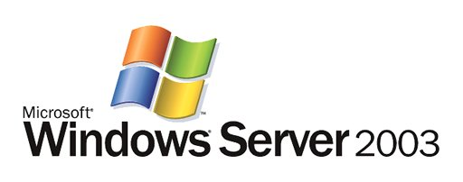

Automated Deployment Services Technical Overview

Microsoft Corporation
Published: March 2003

Abstract
With Windows® Server 2003, Microsoft® extends the platform to make it easier for administrators to build and administer very large, scaled out deployments of Windows servers. Automated Deployment Services (ADS) includes a new set of imaging tools developed by Microsoft and a more secure, remote-able infrastructure for rapidly deploying both Windows 2000 Server and Windows Server 2003 onto bare metal servers. In addition, ADS offers a more secure, reliable script execution framework that lets administrators perform script-based administration on 1,000 servers as easily as they once did on a single server.
This is a preliminary document and may be changed substantially prior to final commercial release of the software described herein.
The information contained in this document represents the current view of Microsoft Corporation on the issues discussed as of the date of publication. Because Microsoft must respond to changing market conditions, it should not be interpreted to be a commitment on the part of Microsoft, and Microsoft cannot guarantee the accuracy of any information presented after the date of publication.
This document is for informational purposes only. MICROSOFT MAKES NO WARRANTIES, EXPRESS OR IMPLIED, AS TO THE INFORMATION IN THIS DOCUMENT.
Complying with all applicable copyright laws is the responsibility of the user. Without limiting the rights under copyright, no part of this document may be reproduced, stored in or introduced into a retrieval system, or transmitted in any form or by any means (electronic, mechanical, photocopying, recording, or otherwise), or for any purpose, without the express written permission of Microsoft Corporation.
Microsoft may have patents, patent applications, trademarks, copyrights, or other intellectual property rights covering subject matter in this document. Except as expressly provided in any written license agreement from Microsoft, the furnishing of this document does not give you any license to these patents, trademarks, copyrights, or other intellectual property.
© 2003. Microsoft Corporation. All rights reserved.
Microsoft, Active Directory, MS-DOS, Windows and the Windows logo are either registered trademarks or trademarks of Microsoft Corporation in the United States and/or other countries.
The names of actual companies and products mentioned herein may be the trademarks of their respective owners.

Contents
Introduction 1
Table 1: Key features and benefits of ADS 1
Architectural Overview 2
Figure: ADS Architecture 2
ADS Services and Tools 2
Controller Service 2
Figure: ADS Controller 3
Network Boot Service 3
Figure: ADS Network Boot Service 4
Image Distribution Service 4
Figure: ADS Image Distribution Service 5
Volume Imaging Tools 6
Figure: Imaging Process 6
ADS Agents 7
Figure: ADS Agents 7
ADS Task Sequences and Task Sequence Editor 8
Figure: Task Sequence Editor 9
ADS Administration Tools and Programmatic Interfaces 9
WMI Object Model 9
Figure: WMI Object Model 9
Table 2: Available object areas 10
Administration Tools 10
Table 3: Administration tools 11
Figure: ADS devices 12
ADS Network Environment 12
ADS Security Model 12
Using ADS: Examples 14
Image Deployment and Maintenance 14
Bare Metal Server Deployment and Configuration 14
Preparing and Capturing an Image 14
Hardware Configuration 15
Deploying and Personalizing Images 16
Post Operating System Deployment Configuration 17
Mass Server Administration 18
Supported Jobs and Scripts 18
Running Jobs and Scripts 18
Capturing and Logging Results 19
Example Task Sequences 21
PXE Based Bare Metal Purposing 21
Script/Job Remote Execution 23
Summary 24
Links 25
Glossary 26

Introduction
As both the rate of growth and the installed base of Windows Server operating systems increases, managing the deployment and administration of these systems has become a significant driver of the overall cost of ownership.
Today, automated operating system and application deployment technologies are typically script based or rely on traditional imaging and deployment tools from third-party vendors. Script-based installation solutions provide flexibility across a wide range of hardware configurations but tend to be very slow, and fewer standard methodologies exist for them. Traditional imaging technologies, although much faster, are inflexible and require considerable effort to adapt and maintain an image collection over both hardware variations and time.
Script-based administration of a large number of Windows servers has traditionally not been easy. Unlike in the UNIX environment, in which operators can use tools such as rsh, ssh, and rdist to perform remote administration on groups of servers, script-based administration in the Windows Server environment has required operators to deal with each server individually.
With Windows Server 2003, Microsoft extends the platform to enable rapid, flexible deployment and seamless, script-based administration of a large number of Windows servers. Table 1 shows the key features and benefits of Automated Deployment Services (ADS).
Table 1: Key features and benefits of ADS
Feature | Benefit
More secure, scalable, remote deployment architecture | An intelligent Preboot Execution Environment (PXE) server and dynamically built deployment agent enable “zero touch” server builds of PXE-compliant bare metal boxes, drastically reducing the cost to deploy servers.
Powerful task sequence-driven automation | Sample task sequences can be extended to automate hardware configuration, operating system deployment, and application installation, enabling customers to encode their operational practices and eliminate human error.
Flexible new imaging tools | Powerful new tools built by Microsoft use knowledge of the NTFS file system structure to create smaller images that can be updated and edited without first being deployed to a server. Combines the speed of traditional imaging with the flexibility of script based installations.
Reliable remote execution framework | ADS enhances existing scripting investments and extends your ability to administer hundreds of servers.
Virtual Floppy | ADS incorporates standard server vendor MS-DOS tools into the deployment process to automate hardware configuration.
Diverse choice of user interfaces | ADS offers a simple-to-use GUI, a set of command-line tools, and a rich Windows Management Instrumentation (WMI) program interface. ADS enables point-and-click operation or integration with other solutions in your deployment process.
Centralized data store | You can maintain a complete history of all administrative tasks carried out using the ADS infrastructure.

Architectural Overview
Figure 1 summarizes the ADS architecture.
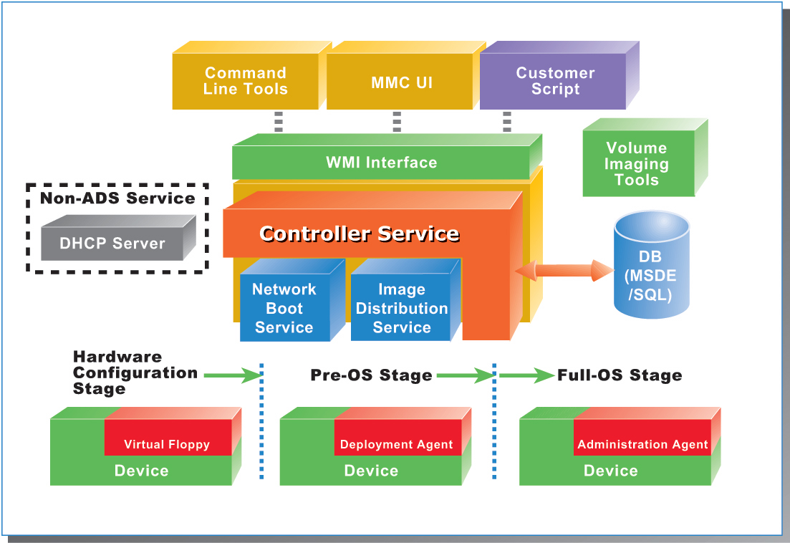
Figure 1: ADS architecture

ADS Services and Tools
ADS is composed of the following:
- An integrated set of services, including:
- Controller Service
- Network Boot Service
- Image Distribution Service
- Volume Imaging Tools
- A set of agents
These features work together to greatly enhance the ability of administrators to deploy and administer large numbers of Windows servers.

Controller Service
The Controller Service is the operational heart of ADS. The Controller orchestrates all ADS activity by providing configuration information to the other ADS services and allowing administrator inputs through the WMI interface, ADS command line tools, and a GUI MMC snap-in component. It maintains the master records that detail each device known to the ADS system along with the actions associated with those devices.
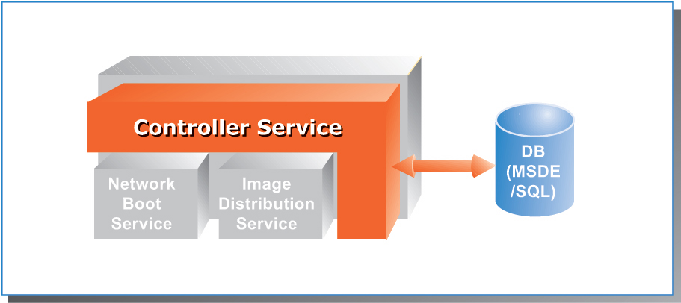
Figure 2: Controller Service
Controller Service functionality includes:
- Coordination and sequencing of tasks. The Controller coordinates administrative activity throughout deployment and administration. For example, it provides the PXE service within the Network Boot Service the appropriate boot commands for each device. In the deployment phase, the Controller coordinates the task sequence designed to configure the server and install the images locally on the system. When rebooting after the initial image deployment, devices check with the Controller for any waiting boot commands, which enables you to completely repurpose a device on its next boot, as though it were a bare metal server.
- Secure communication with devices. The Controller communicates securely with the ADS Deployment and Administration agents that reside on devices to run task sequences.
- Centralized recording of device data and administrative activity. The Controller Service uses either Microsoft SQL Server 2000 Desktop Engine (MSDE) or Microsoft SQL Server 2000 to store all device and configuration data and to log information for all the tasks performed on the devices. A complete audit trail for each task run at the device is available through the Controller.
- Logical grouping of devices assets. The Controller Service can manage each device individually if needed, but in general you work with sets. Sets are groups of managed devices that can be addresses as a single entity. When deploying operating systems or performing post-deployment administration, you need to reference only the set name belonging to the group of devices you want to affect. A set can also contain references to other sets, allowing a hierarchical model in which everyday management commands can be executed on all devices with a single command and smaller groups can be used to provide more detailed control over your devices. ADS is such a powerful tool that a single command from the command line or MMC snap-in can initiate actions to hundreds of devices at one time.

Network Boot Service
The Network Boot Service (NBS) works in conjunction with a network Dynamic Host Configuration Protocol (DHCP) server to give ADS boot command capability, as Figure 3 shows. A PXE-enabled device discovers the PXE service using DHCP and then begins a communication session with ADS via the NBS.
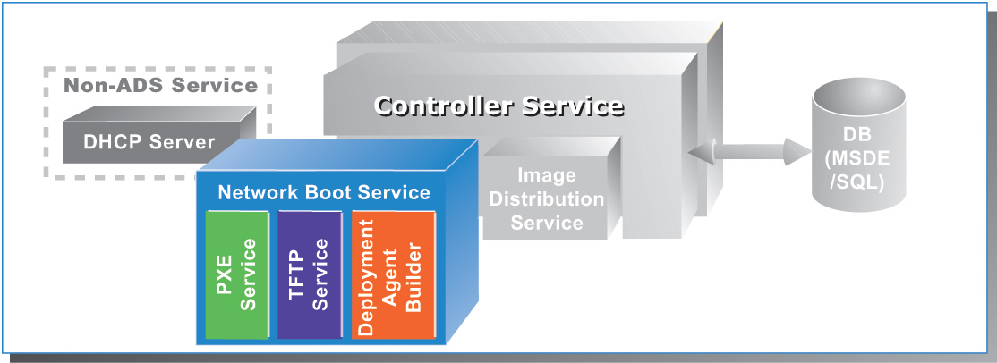
Figure 3: Network Boot Service
NBS includes two services:
- ADS PXE Service—Sends PXE boot commands to the device. The PXE service can instruct the destination device to:
- Download and boot an ADS deployment agent that is created for it by the agent builder service
- Download and boot a Virtual Floppy image
- Ignore the PXE boot request
- Abort PXE operations and boot to hard disk
- ADS Deployment Agent Builder—Creates a device-specific agent at boot time. After the PXE boot occurs and the Deployment Agent option is chosen, the builder service:
- Performs a local hardware discovery on the device and sends that data to the controller
- Builds a customized agent based on the device’s hardware configuration
- Downloads that agent to the device on which it executes in local memory
In addition to enabling Deployment Agent downloading, the NBS also provides a way to download and execute an MS-DOS-based Virtual Floppy image that also executes in memory. Utilities are usually provided by your server vendor and can perform hardware configuration tasks such as RAID drive configuration and BIOS flashing in the Virtual Floppy environment.
The NBS uses the Windows Server 2003 Trivial File Transfer Protocol (TFTP) service to download both Deployment Agents and Virtual Floppy images.
Either on the Controller or elsewhere in the network, ADS requires a Dynamic Host Configuration Protocol (DHCP) server to be present to provide IP addresses to configurable devices.

Image Distribution Service
The Image Distribution Service (IDS) provides storage and communications capabilities for ADS to manage device images, and it allows administrators to deploy device operating system images created using the ADS imaging tools.
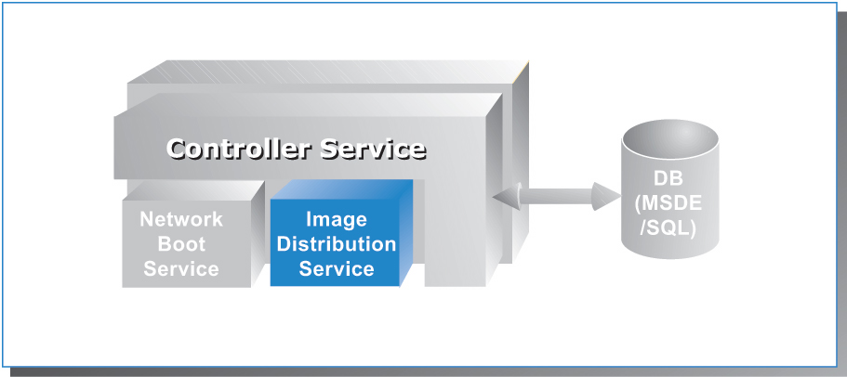
Figure 4: Image Distribution Service
To quickly and efficiently deploy an operating system and applications to devices, ADS uses powerful new Microsoft imaging technology. Imaging is a straightforward process that enables users to capture and rapidly deploy complete operating system and application bundles to one or many devices simultaneously.
After the images are captured, as described in the Imaging Process box below, they are added to the IDS image store, where they are kept on the file system of the IDS server. While the images are downloading to the device, the communications channel is encrypted to prevent eavesdropping on the image data. The Controller Service orchestrates the imaging operation, communicating with the device through a secure connection using an SSL-based protocol. IDS can deploy images to multiple devices over unicast-enabled and multicast-enabled networks. In addition, the IDS provides users the ability to adjust the amount of network bandwidth that is used during the multicast imaging transmissions.
The Imaging Process
The imaging process is comprised of several discrete tasks:
- Install a reference device. Using a hardware configuration similar to that of the devices you will deploy with this image, install the base operating system and any other applications and device drivers that this image will need in production. Also add the ADS Administration Agent, discussed later in this paper under "ADS Agents."
- Prepare the reference device for imaging. Use SYSPREP to prepare the system for imaging. SYSPREP removes unique system information and prepares the system to run a miniature version of Windows Setup the next time it boots. This allows every device that is created from this image to generate the information that makes it unique to the Windows environment.
- Capture the boot disk partition using image tools. ADS includes tools to manually capture the image of a device by running a command-line tool on the reference system. Alternatively, you can use ADS to remotely capture the image when the system reboots.
- Deploy the image to new or existing devices. ADS deploys the operating system image to a new or existing device, which can then join the production environment. From a single image hundreds of devices can be deployed easily, quickly, and in a completely reproducible manner.

Volume Imaging Tools
Figure 5 summarizes the volume imaging tools in ADS.
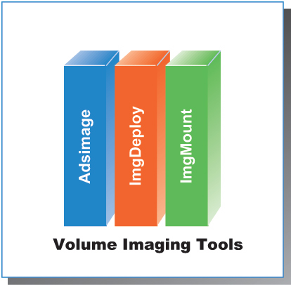
Figure 5: Volume imaging tools
ADS has a powerful, flexible set of imaging tools. Any FAT or NTFS file system volume can be captured and deployed when used in conjunction with SYSPREP, but users realize enhanced capture and editing benefits when working with NTFS based file systems. The ADS imaging tools are:
- Imgdeploy—The actual image capture and restoration tool. It features:
- Image compression—imgdeploy can compress images to reduce storage requirements.
- Image encryption—Images can be encrypted for transport or alternative storage.
- Defragmented restoration—Images can be captured in file order so that files are automatically defragmented when restored to a device.
- Windows Server 2003 Volume Shadow Copy Service integration—imgdeploy can capture a live system image while Windows Server 2003 is running if Volume Shadow Copy service is enabled and supported by the applications running on that server. Images captured in this manner cannot be used for device deployment.
- imgmount—Introduces the ability to perform true editing of captured images. Images captured with imgdeploy can be mounted and accessed exactly like a file system. After an image is mounted in this fashion, it can be read from and written to by any standard Windows tool or application. The saving in administration time is considerable: the image can be maintained without modifying the reference system from which it was captured and then recapturing the image.
- adsimage— Accessed from the command line or the MMC UI, this tool lists images available for deployment and adds images, deletes images, or updates image properties,

ADS Agents
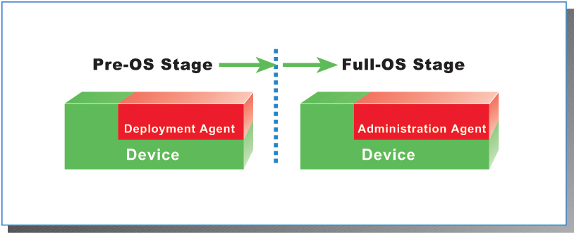
Figure 6: ADS agents
As shown in Figure 6, ADS provides two control agents that correspond to the pre-deployment and post-deployment stages:
- The Deployment Agent—A highly optimized, reduced-functionality version of Windows Server 2003 that loads into a RAM disk on the device and handles deployment operations such as disk partitioning and image downloading. This agent is available only for environments using PXE boot control and is the key facilitator of a pure network-based operating system deployment.
- The Administration Agent—Used after the device has been deployed with an operating system for post-deployment task execution. Using the Administration Agent, you can initiate operations on the device that can perform any scriptable command and run local applications or any application reachable on the network. With the Administration Agent, you can also restart the entire deployment to completely repurpose a given device.

ADS Task Sequences and Task Sequence Editor
At boot time or after deployment, the ADS controller issues jobs to devices that consist of individual tasks sequenced together. These sequences can be run against one or more devices and are stored as Extensible Markup Language (XML) files on the controller. A typical task sequence used to deploy a new device with PXE is:
- Execute a Virtual Floppy to update system BIOS or configure a RAID controller.
- Request and boot the Deployment Agent.
- Partition the hard disk.
- Download an operating system image to the hard disk.
- Modify the Sysprep.inf that was downloaded in the deployed image to give this device a unique host name, product identifier, and so on.
- Configure the ADS Administration Agent in the downloaded image to communicate with the controller when this operating system first boots.
- Reboot.
- Instruct the device to boot to the local hard disk on the next boot.
When the device boots from the newly downloaded image for the first time, an abbreviated setup runs in an unattended mode to perform final configuration of the operating system.
Task sequences can consist of the following:
- PXE boot commands
- Deployment Agent internal commands
- Any Windows application or script available to the destination device or on a network share accessible by the destination device
- A script available on the controller to be downloaded to the destination device and run there
- A script available on the controller to be run directly on the controller
When using ADS tasks, the controller logs all commands run and their output to the controller’s database, providing a complete audit log as well as an error log for debugging commands. Some sample task sequences are provided later in this document.
These XML task sequences can be created with any XML authoring tool, but ADS also includes the simple Sequence Editor for administrators who prefer not to work directly with XML. It provides an easy-to-use Windows-based user interface for creating ADS sequences. The Sequence Editor provides templates for the most common tasks that administrators want to carry out, including deployment steps such as partitioning the disk, downloading an image, and personalizing the image. It can be used to create a new task sequence or to edit existing sequences simply by opening the Sequence Editor, manipulating parameters, and saving the result as a new sequence.
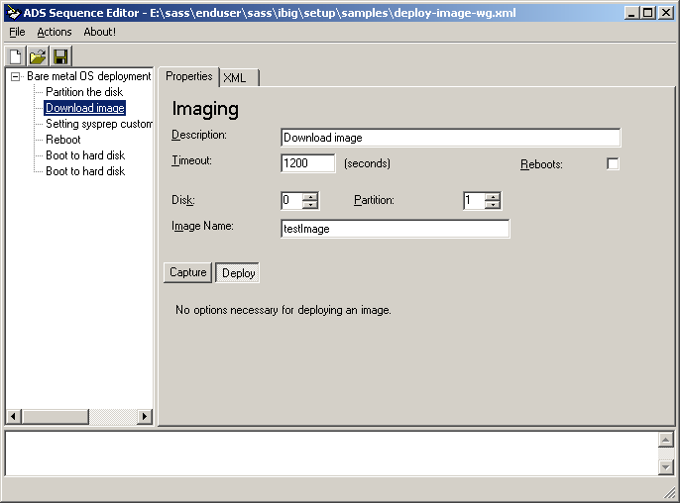
Figure 7: Task Sequence Editor

ADS Administration Tools and Programmatic Interfaces
ADS provides a series of command-line tools and an MMC snap-in to manage ADS services. The true beauty of ADS though, is the programmatic interface exposed through the WMI interface. All ADS features are available via the WMI interface. If your organization already has in-house talent to develop management applications, you can easily tailor and manage ADS in your environment.

WMI Object Model
Figure 8 illustrates the range of WMI object areas under ADS.
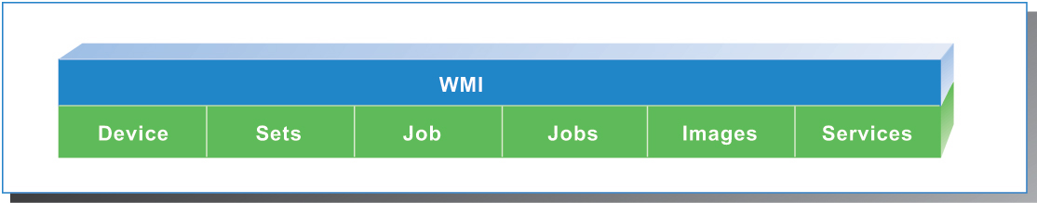
Figure 8: WMI Object Model
Using WMI, you can address all the individual aspects of ADS. Using Microsoft Component Object Model (COM) communication, all aspects of the ADS system are available for scripting or application development. Table 2 identifies the primary object areas available for use by a scripting administrator or a developer as well as examples of the properties and methods available.
Table 2: Available object areas
Object | Description | WMI Classes
Devices | Devices represent physical devices within the data center. Several classes combine to represent the information available for one device. | Devices  DeviceVariables  DeviceHWAddrs
Sets | Sets represent collections of devices. Each set has a unique name and can contain from zero to multiple devices or other sets. A given device may be in multiple sets. | Sets
Job templates | Job templates are job definitions available to be run. A job template may be a simple job (such as a script or program to run) or a task sequence. Each template has a unique name. | JobTemplates
Jobs | Jobs are representations of jobs in progress or jobs that have already completed. The Jobs object stores basic information, such as the description, job type, target, command, and parameters. | Jobs  JobLogs
Images | Images represent captured volumes that are available to be deployed. They might be operating system volumes captured after Sysprep that can be deployed to multiple servers, operating system volumes captured without Sysprep that can be deployed to a single server, or data volumes. | Images  ImageVariables
Services | Services represent each of the ADS services—the Controller Service, Network Boot Services and Image Distribution Service. These are used to configure the controller so that it knows which physical system hosts each of these services and to configure global properties for each service. | Services  ServiceVariables

Administration Tools
ADS provides both a flexible, easy to use MMC user interface and a set of command-line tools for administration. Several command-line tools are available to manage and operate ADS. It is important to note that the tools that operate the Controller Service are built directly on the WMI interface. Other command-line tools that provide imaging or certificate management neither depend on nor require WMI functionality to operate.
Table 3: Administration tools
Tool | Description
adsarchive | Archives previous jobs by removing them from the database and storing them in an XML file
adsdevice | Manages device records and allows you to list, add, delete, control, or modify device records
Adsimage | Lists images available for deployment and adds images, deletes images, or updates image properties
adsjob | Provides job management to run, stop, list, read logging information, or view the history of jobs run on the controller
adsjobtemplate | Lists the templates available to execute as jobs and installs and deletes templates
adsservice | Manages the ADS services
adsset | Provides set management to add devices to a set, remove devices from a set, create or delete sets, list set members, or modify set properties
dskimage | Creates a virtual floppy image from a floppy disk. This allows you to download flash BIOS configuration or other tools to the device during deployment
imgdeploy | Read or write file system images from or to disk. After running SYSPREP on the system providing the deployment image, this tool creates the image file that is downloadable by the device
imgmount | Allows you to mount captured images to view, add or remove files within the image
adskey | Generates, signs, and registers controller certificates
regcert | Registers agent certificates

GUI access to the ADS services is provided via an MMC snap-in, as shown in Figure 9. This provides administrators the flexibility of either scripting directly to the command-line interface or walking through tasks and procedures using a GUI.
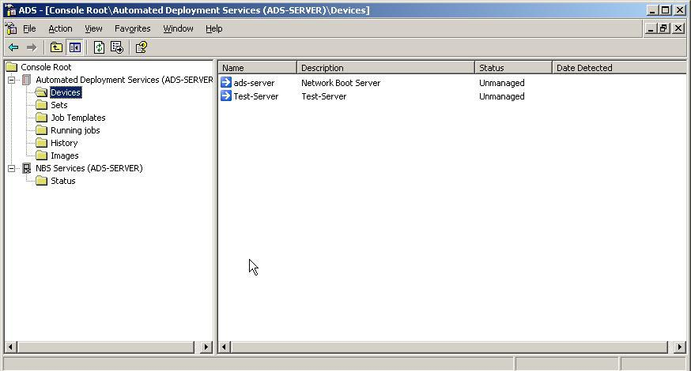
Figure 9: ADS devices

ADS Network Environment
ADS assumes a well-connected networking environment—10 MB or more connectivity among the controller, IDS, NBS, and managed devices. No provisions are made for general retries when tasking devices or downloading images; the operations either complete successfully or don’t. That makes ADS impractical for usage over low-speed wide-area network (WAN) links.
Deployment of ADS consists of:
- Controller Service
- IDS
- NBS
In a subnetted or a virtual local area network (VLAN) environment, the DHCP broadcast scope is usually constrained to the IP subnet or VLAN of the attached network. This is the same for PXE broadcasts. In these environments, you must configure DHCP forwarding at your routing points to bring all the devices back to one DHCP and NBS server. In Cisco environments, this means simply configuring an “IP helper” at the router or layer three switch. In environments that cannot provide DHCP forwarding in the routers, Microsoft provides a DHCP forwarding service in the server operating systems that perform this function.
For large device deployments, ADS provides multicast support, which can reduce the overall bandwidth used when deploying disk images. In a switched or routed environment, your equipment must be configured and capable of supporting this feature.

ADS Security Model
The ADS security model is divided into three distinct realms.
The first security realm encompasses the initial stages of the bare metal deployment in which DHCP and PXE are being used initially. The DHCP and PXE phases are not authenticated and because of the design of those protocols, Microsoft recommends that the deployment network interface reside on a dedicated management network.
The second security realm is the communication between the various ADS services and the device agents communicating with the ADS Controller. ADS uses a public key infrastructure (PKI) and Secure Sockets Layer (SSL) server authentication to create private out-of-band management communication channels.
The third security realm is the security context in which the ADS services and agents operate. The ADS Controller Service runs under the context of the system service, the equivalent of local administrator. This is necessary because of the configuration control delegated to the ADS Controller. On managed devices, however, the agent is installed by default using the local machine Administrator account. This account can be changed to any user that has the appropriate authority to run the applications and scripts that will be used as ADS jobs. Also, whatever account is chosen will require access to network resources if you execute scripts or applications from network share points.

Using ADS: Examples
ADS provides a powerful tool set with which to manage deployment and administration of large numbers of Windows Servers. The brief examples below illustrate the power and capability of ADS in a number of common procedures.

Image Deployment and Maintenance
Central to ADS functionality is the ability to deploy prepared images to managed devices. ADS can deploy Windows Server 2003 or Windows 2000 Server operating system images without your input.

Bare Metal Server Deployment and Configuration
Initial device deployment showcases one of the two major features of ADS. Here we will walk through the procedures needed to install a new device into your environment without help from the system administrator. We provide the commands necessary to carry out these tasks and indicate how a user can accomplish the same tasks using the MMC user interface.
Preparing and Capturing an Image
The first step in the process is to capture a working device operating system image that can be deployed to the new hardware. Microsoft provides excellent preparation and imaging tools with which to complete this process.
To capture an image, prepare a working server system that can provide the “gold” image:
- Install the Windows Server operating system according to your site policy.
- Install the ADS Administrative agent, which provides post-deployment control capability.
- Install other SYSPREP-compatible applications needed for the image.
- You will need another bootable operating system partition or a Microsoft Windows Preinstallation Environment (Windows PE) CD from which to run the imaging tools.
2. Run SYSPREP on the partition to be imaged.
Below is an example SYSPREP.inf file for Windows Server 2003. Notice the circumflex (^) characters in this script. These allow for multiple images to be configured after deployment with individual settings.
;SetupMgrTag
[Unattended]
OemSkipEula=Yes

[GuiUnattended]
AdminPassword="^PASSWORD^"
EncryptedAdminPassword=NO
OEMSkipRegional=1
OEMDuplicatorstring=sysprep-id
TimeZone=85
OemSkipWelcome=1

[UserData]
ProductKey=^PID^
FullName="ADS"
OrgName="ADS"
ComputerName=^COMPUTERNAME^

[LicenseFilePrintData]
AutoMode=PerSeat

[TapiLocation]
CountryCode=1
AreaCode=206

[SetupMgr]
DistFolder=C:\sysprep\i386
DistShare=windist

[Identification]
JoinWorkgroup=^WORKGROUP^

[Networking]
InstallDefaultComponents=Yes
  - Use the ADS image capture utility to create the gold image.
“Imgdeploy /c <volume> <image file> <description>”
  - Add the prepared image to the ADS Image Distribution Service to make it available for future deployment
From the server running the IDS add the image:
“adsimage /add imagename /ipath imagepath “
Hardware Configuration
As part of the deployment task sequence, specific hardware configuration tasks can be accomplished using a Virtual Floppy. Using the tools supplied with ADS, an administrator creates a floppy disk containing a subset of MS-DOS version 6.22 and adds the MS-DOS utilities needed to configure the specific hardware items. The floppy contents are then captured into a single file—the virtual floppy image That image is then used in the deployment task sequence, in which it is downloaded to the device during the PXE boot sequence. The MS-DOS utilities must be scriptable from the command line, they must automatically execute when the virtual floppy is booted into memory, and they must complete the cycle by rebooting the device so that the deployment can continue with the next task sequence. Using this method, the administrator can configure RAID controllers, flash BIOS items, or perform any other hardware-specific feature for which the manufacturer provides utilities that can be run from this Virtual Floppy.
Deploying and Personalizing Images
After preparing the gold image for deployment, you can prepare ADS to manage the new device.
To prepare ADS to manage the new device:
- Prepare and install the job template that the Controller Service will use to deploy the image to the new device. Also prepare and install job templates to boot the device into the deployment agent and hard disk. For an example of a deployment sequence, see “PXE Based Bare Metal Purposing,” below.
- From the command line:
adsjobtemplate /create newtemplate /description "template desc." /sequence c:/path/filename.xml
- From the MMC user interface:
Go to Job Templates off of the Console Root, right-click and choose Add Job for each of the three templates.
- Add the new device to the ADS database, and mark it as a device to control from this controller.
- From the command line:
adsdevice /add devicename /description "text" /mac macaddress /jobtemplate boot-to-da
adsdevice /tc devicename
- From the MMC user interface:
Go to Devices off of the Console Root, right-click and choose Add Device.
After the device is added, right-click the device name and select Control.
- Provide values for the SYSPREP substitutions that will be used during deployment.
- From the command line:
adsdevice /edit devicename /setvar PASSWORD password \
/setvar PID pid /setvar COMPUTERNAME computername \
/setvar WORKGROUP workgroup
(The \ symbol means to you should place all these commands on a single line.)
- From the MMC user interface:
Right click and the added device and choose Properties.
Select the User tab and add the four variables and their values
- After ensuring that PXE is first in the BIOS boot order, boot the device(s). This will cause the default job template (boot-to-da) to be run, which makes the devices boot into the Deployment Agent.
- If there is more than one device to deploy to, create a set comprising the devices, and then run the deployment sequence with the following.
- From the command line:
Adsjob /run /set newset /sequence newtemplate
The image downloads using multicast.
If there is only one device to deploy to, run the deployment sequence with:
Adsjob /run /device devicename /sequence newtemplate
The image downloads using unicast.
- From the MMC user interface:
Right-click Sets, and add all members to the set
- Modify the ADS device record so that subsequent system boots are to the internal hard disk. An example sequence is listed here.
- From the command line:
adsdevice /edit devicename /jobtemplate boot-to-hd
- From the MMC user interface:
Right-click Properties, and select boot-to-hd from the Default Job Template drop-down menu.
Post Operating System Deployment Configuration
Simply getting an operational server image onto new devices is a great accomplishment, but with ADS, an administrator can remotely and securely configure new or existing devices via the ADS Administration Agent. Obviously, any device deployment fulfills a purpose within the production environment. After that device is given an image, the next task for the administrator is to configure the device for the specific tasks for which it is intended. Here, again, ADS provides a manageable, scalable, and secure solution to provide for those post deployments tasks.
For example, to perform an unattended Microsoft SQL Server 2000 installation on a newly deployed device:
- Prepare and install the job template that the Controller Services will use to implement the post-deployment configuration. (For an example script, see “Script/Job Remote Execution,” below.)
- From the command line:
adsjobtemplate /create newtemplate /description "template desc." /sequence c:\path\filename.xml
- From the MMC user interface:
Go to the Job Template Wizard to help create your new job.
- Start running the sequence:
- From the command line:
adsjob /run /device devicename /template newtemplate
- From the MMC user interface:
Go to Job Templates, right-click and select Run.

Mass Server Administration
Sets and jobs are the true administration powerhouses in the ADS arsenal. Using sets, an administrator can issue the same job to one or to thousands of managed devices with the same commands. Today, with a standard Windows environment, the administrator generally provides device-by-device command execution via the console, Terminal Services, or a third-party remote control interface. There is no system-generated audit trail with this method, and command consistency is not guaranteed.

Supported Jobs and Scripts
An ADS job can be either an internal command or external programs available to the managed device. Internal commands are those that ADS provides during task sequence execution. Operations that can be performed using internal commands include the following, in the Administration Agent:
- Reboot the device.
- Shutdown the device.
In the Deployment Agent, operations that can be performed using internal commands include:
- Partition the disk or list partition information.
- Set a registry key on a newly downloaded image.
- Transfer a file to a newly downloaded image.
- Replace strings in a file on the device.
A job can also be any Windows application or script that is valid for the target device. The job could be a script sent from the Controller, a script or application that is already present on the device, or a script or application that is available to the ADS Administration Agent via a network share. In our post-deployment example, we used a script loaded from an admin share.

Running Jobs and Scripts
Below is a typical administrative task that is performed as a job. In this example, our device executes the ipconfig command and returns the results:
C:\>adsjob /run /device ADS-Device /devicepath c:\windows\system32\ipconfig.exe /all
Microsoft (R) Windows Script Host Version 5.6
Copyright (C) Microsoft Corporation 1996-2001. All rights reserved.
Job started with job id 14
C:\>
This command sequence was issued to one device, the job requiring it to execute the ipconfig command. By modifying one item on the command line, we could easily have hundreds or thousands of devices all execute the same command sequence.
C:\>adsjob /run /set DATACENTER /devicepath c:\windows\system32\ipconfig.exe /all
Microsoft (R) Windows Script Host Version 5.6
Copyright (C) Microsoft Corporation 1996-2001. All rights reserved.
Job started with job id 15
With the preceding command, each device in the set executes the same task sequence and reports its results to the ADS Controller, which logs every action into the database. ADS provides a complete audit trail for every action that is performed on each device. Because ADS also provides SSL security, every command issued and the results returned are also encrypted between the managed device and Controller.
Job commands may also use device variables that are stored in the ADS Controller service. When running the same job against many devices, you often need a replaceable parameter to individualize each device correctly. You can create job variables initially with the device record or later using the command-line tools, GUI, or WMI interface.

Capturing and Logging Results
As each job is sent to the Controller Service for execution, it is issued a job ID that uniquely identifies it. When a job is sent to a set rather than to an individual device, a hierarchical structure is created. The initial job ID returned when the command is run is referred to as the parent job ID. At the Controller, each device within the set has a separate job created for it, and a distinct job ID is assigned for each device. The administrator can track both the initial set job ID and each job ID. The adsjob command-line utility and the GUI and WMI interface provide job status and results. The results from the preceding examples are as follows.
C:\>adsjob /result 14 /full /verbose
Microsoft (R) Windows Script Host Version 5.6
Copyright (C) Microsoft Corporation 1996-2001. All rights reserved.
Device: ADS-Device
Status: Succeeded
Output:
Windows IP Configuration
Host Name . . . . . . . . . . . . : ads-device
Primary Dns Suffix . . . . . . . :
Node Type . . . . . . . . . . . . : Unknown
IP Routing Enabled. . . . . . . . : No
WINS Proxy Enabled. . . . . . . . : No
Ethernet adapter Local Area Connection:
Connection-specific DNS Suffix . :
Description . . . . . . . . . . . : AMD PCNET Family PCI Ethernet Adapter
Physical Address. . . . . . . . . : 00-50-56-7F-99-1B
DHCP Enabled. . . . . . . . . . . : No
IP Address. . . . . . . . . . . . : 192.168.100.2
Subnet Mask . . . . . . . . . . . : 255.255.255.0
Default Gateway . . . . . . . . . :
Error:
Exit Code: 0
C:\>
The results from the job run against the set are as follows.
C:\>adsjob /result 15 /full
Microsoft (R) Windows Script Host Version 5.6
Copyright (C) Microsoft Corporation 1996-2001. All rights reserved.
Device Status Output Error Exit Code
------------------- ------------- --------------- --------------- -----------
ADS-Device Succeeded \n\nWindows IP 0
ADS-Device1 Succeeded \n\nWindows IP 0
C:\>

Example Task Sequences
The examples below are described earlier in this article. After installing ADS, you can find these and additional sample task sequences in the C:\Program Files\Microsoft ADS\Samples directory (assuming that C:\ is your system drive).

PXE Based Bare Metal Purposing
<?xml version="1.0" encoding="utf-8" ?>
<sequence command="deploy.xml" description="Deploy image to device after next PXE boot"
xmlns="http://schemas.microsoft.com/ads/2003/sequence" version="1">
<task description="Boot to deployment agent">
<command>/pxe/boot-da</command>
</task>
<task description="Download image">
<command>/imaging/imgbmdeploy.exe</command>
<parameters>
<parameter>Image1</parameter>
<parameter>\device\harddisk0\partition1</parameter>
<parameter>-r</parameter>
<parameter>-client</parameter>
</parameters>
</task>
<task description="Personalize sysprep.inf file">
<command>/BMONITOR/bmstrrep.exe</command>
<parameters>
<parameter>\device\harddisk0\partition1\sysprep\sysprep.inf</parameter>
<parameter>^ADS_WINDOWS_PRODUCT_KEY^</parameter>
<parameter>$ProductKey$</parameter>
<parameter>^ADS_COMPUTER_NAME^</parameter>
<parameter>$Device.System.Name$</parameter>
<parameter>^ADS_JOIN_WORKGROUP^</parameter>
<parameter>WORKGROUP</parameter>
</parameters>
</task>
<task description="Set controller IP address">
<command>/bmonitor/bmsetreg.exe</command>
<parameters>
<parameter>-h:\device\harddisk0\partition1\windows\system32\config\system</parameter>
<parameter>controlset001\control\bmss</parameter>
<parameter>controlleripaddress</parameter>
<parameter>reg_multi_sz</parameter>
<parameter>$controller.system.adminipaddr$</parameter>
</parameters>
</task>
<task description="Set BMDP port number">
<command>/bmonitor/bmsetreg.exe</command>
<parameters>
<parameter>-h:\device\harddisk0\partition1\windows\system32\config\system</parameter>
<parameter>controlset001\control\bmss</parameter>
<parameter>bmdpipport</parameter>
<parameter>reg_dword</parameter>
<parameter>$controller.system.bmdpport$</parameter>
</parameters>
</task>
<task description="Set BMCP port number">
<command>/bmonitor/bmsetreg.exe</command>
<parameters>
<parameter>-h:\device\harddisk0\partition1\windows\system32\config\system</parameter>
<parameter>controlset001\control\bmss</parameter>
<parameter>bmcpipport</parameter>
<parameter>reg_dword</parameter>
<parameter>$controller.system.bmcpport$</parameter>
</parameters>
</task>
<task description="Set management MAC address">
<command>/bmonitor/bmsetreg.exe</command>
<parameters>
<parameter>-h:\device\harddisk0\partition1\windows\system32\config\system</parameter>
<parameter>controlset001\control\bmss</parameter>
<parameter>bindexcept</parameter>
<parameter>reg_multi_sz</parameter>
<parameter>$controller.system.adminmac$</parameter>
</parameters>
</task>
<task description="Copy public key file to target">
<command>/bmonitor/bmfilexfer.exe</command>
<parameters>
<parameter>-d</parameter>
<parameter>c:\program files\Microsoft ADS\certificate\adsroot.cer</parameter>
<parameter>\device\harddisk0\partition1\windows\temp\adsroot.cer</parameter>
</parameters>
</task>
<task description="Set the certificate public key">
<command>/bmonitor/bmsetreg.exe</command>
<parameters>
<parameter>-h:\device\harddisk0\partition1\windows\system32\config\system</parameter>
<parameter>-f</parameter>
<parameter>-r</parameter>
<parameter>controlset001\control\bmss\bmcpcertificates</parameter>
<parameter>adsroot</parameter>
<parameter>reg_binary</parameter>
<parameter>\device\harddisk0\partition1\windows\temp\adsroot.cer</parameter>
</parameters>
</task>
<task doesReboot="true" description="Reboot">
<command>/BMONITOR/reboot</command>
</task>
<task doesReboot="true" description="Boot to hard disk">
<command>/pxe/boot-hd</command>
</task>
<task description="Boot to hard disk">
<command>/pxe/boot-hd</command>
</task>
</sequence>

Script/Job Remote Execution
<?xml version="1.0" encoding="utf-8" ?>

<!--
ADS Sample code

Copyright (c) 2003 Microsoft Corporation

Download and run script
-->

<sequence command="sample1.xml" version="1"
xmlns="http://schemas.microsoft.com/ads/2003/sequence">
<task timeout="600" description="Install SQL Server 2000">
<command delivery="bmcp">\\AdminServer\MS-SQL2000-CD\Sqlins.bat</command>
</task>
</sequence>

Summary
Enterprise data center administrators face significant challenges as they scale their infrastructures and deploy larger numbers of Windows servers in their environments. Automated Deployment Services is a new component of Windows Server 2003 that helps customers address those challenges using the following features.
- The ADS Controller and NBS deployment automation permits operating system and application installation to dozens or even hundreds of bare metal systems in a secure and auditable manner without administrator input.
- Task sequence jobs issued to individual devices or sets of devices provide a level of automation previously unattainable. Organizations can now embody their operational best practices in discrete software modules and reliably issue the same commands over and over with consistent execution.
- New imaging tools delivered with ADS can quickly create gold-standard system image libraries and allow individual images to be updated without having to be recaptured on the target system.
- Through command-line operations, MMC user interface snap-ins, or a complete WMI interface, administrators can use familiar and comfortable management styles to control vast numbers of servers securely and with a complete audit trail.
ADS enables you to build a rock-solid foundation for deploying and administering Windows-based applications and services.

Links
See the following resources for further information:
- Windows Server 2003—http://www.microsoft.com/windowsserver2003/
- WMI resources—http://msdn.microsoft.com/downloads/default.asp?URL=/code/sample.asp?url=/msdn-files/027/001/566/msdncompositedoc.xml
- Microsoft SQL Server 2000 Desktop Engine (MSDE)—http://msdn.microsoft.com/library/default.asp?url=/library/en-us/architec/8_ar_sa2_9gz4.asp?frame=true
- SSL communication—http://www.microsoft.com/technet/treeview/default.asp?url=/technet/prodtechnol/windowsnetserver/proddocs/server/sec_ssl_aboutssl.asp
- IP multicast—http://support.microsoft.com/default.aspx?scid=kb;en-us;165011
- Differences between multicast and unicast—http://support.microsoft.com/default.aspx?scid=kb;en-us;291786
- Microsoft XML resources—http://msdn.microsoft.com/library/default.asp?url=/nhp/Default.asp?contentid=28000438
- Windows scripting resources—http://msdn.microsoft.com/library/default.asp?url=/nhp/Default.asp?contentid=28001169
- Using SYSPREP—http://support.microsoft.com/?kbid=325554
- Microsoft X.509 certificate resources—http://www.microsoft.com/technet/treeview/default.asp?url=/technet/security/prodtech/certauth/default.asp
- Microsoft SQL Server 2000 unattended installations—http://msdn.microsoft.com/library/default.asp?url=/library/en-us/instsql/in_runsetup_8ege.asp
- Microsoft Windows Preinstallation Environment— http://www.microsoft.com/LICENSING/programs/sa/sam/winPe.asp

Glossary

PXE stands for Preboot Execution Environment. This is a standard from Intel that allows the network adapter to act before the server loads an operating system from the load hard disk.
The Microsoft SQL Server 2000 Desktop Engine (MSDE) is a Microsoft SQL 2000-compatible database engine to a local client system. For a link to more information, see "Links," earlier in this paper.
TFTP stands for Trivial File Transfer Protocol. A TFTP server is a very weak file-transfer mechanism that is typically used to transfer small amounts of data to devices that either are not very powerful or are not meant to run extensive applications.
DHCP stands for Dynamic Host Configuration Protocol. It is primarily a way to dynamically assign IP addresses to machines that do not require fixed addresses.
Unicast transmission is a single data stream from the Controller Service to one device. When you deploy images to more than one device, each device has an individual data stream from the Controller, which creates more demand on network bandwidth. For more information, read the Microsoft Knowledge Base article “Differences Between Multicast and Unicast” at http://support.microsoft.com/default.aspx?scid=kb;en-us;291786.
Multicast transmission employs a single data stream that is read by multiple servers. Network use is minimized when using multicast. For more information, see the Microsoft Knowledge Base articles “What Is IP Multicast?” (http://support.microsoft.com/default.aspx?scid=kb;en-us;165011) and “Differences Between Multicast and Unicast” (http://support.microsoft.com/default.aspx?scid=kb;en-us;291786).
A RAM disk is an area of computer memory that appears to be a physical disk drive. It is accessed by a drive letter like any other system drive. RAM disks are used in situations in which an application needs maximum performance or when a system needs temporary storage that can be easily accessed. ADS uses a RAM disk in the second capacity.
XML stands for Extensible Markup Language. XML is becoming the de facto standard for information storage on the Internet. The XML standard enforces specific formats on information so that applications can easily use and exchange data. For a link to more information, see "Links," earlier in this paper.
BIOS stands for Basic Input/Output System—software that provides the basic instructions needed to control the system hardware. The operating system directly accesses BIOS routines to provide better compatibility for such functions as screen display. Some accessory boards, such as RAID controllers, provide their own BIOS modules that work in conjunction with the system BIOS.
RAID stands for Redundant Array of Inexpensive Disks. RAID provides data redundancy or performance enhancement by spreading system data across multiple disk drives.
COM stands for Microsoft Component Object Model. COM is a standard method for applications to interact with each other and the operating system. For a link to more information, see "Links," earlier in this paper.
VLAN stands for Virtual Local Area Network. VLANs allow network administrators to divide a large network infrastructure into smaller, more manageable sections.
Microsoft® Windows® Preinstallation Environment (WinPE) is a minimal operating system based on the Windows XP kernel. WinPE functionally replaces DOS and contains the minimum functionality needed to run Windows Setup, scripts, or custom installation and imaging applications. For a link to more information, see "Links," earlier in this paper.
For a link for help performing unattended installations, see "Links," earlier in this paper.

