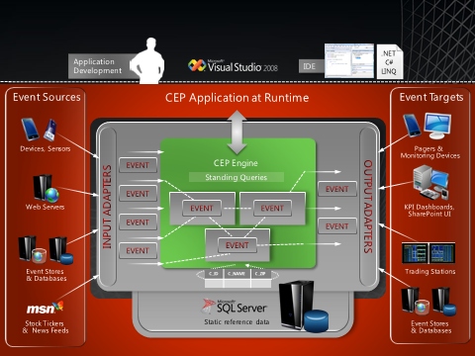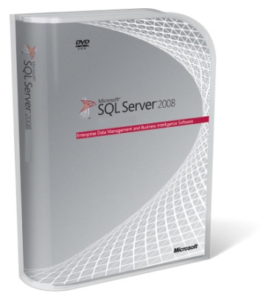

## *Enabling organizations to derive insights from streaming information in near real-time*

Key Features

* Process large volume of events across multiple data streams in less than a second
* Better manage your business through historical data mining and continuous insights
* Provides built-in support for different types of event handling and rich query semantics
* Reduce development costs by utilizing existing skill sets and investments in Microsoft development platform

## Reduce cost and complexity of management with a platform that is easy to manage and support

* Extend the benefit of near real-time event processing to Microsoft® SQL Server® data platform
* Tailor to needs of the business with flexible deployment options

Data volumes are exploding with event data streaming from sources such as RFID, sensors, and Web logs, across industries such as manufacturing, financial services, and utilities. The size and frequency of the data make it challenging to store for data mining and analysis. With the complex event processing technology from Microsoft, the ability to monitor, analyze, and act on the data in motion provides significant opportunity to make more informed business decisions in near real-time.

**Process large volume of events across multiple data streams in less than a second**

Process events with low latency so that action can be taken immediately based on the insights derived. Process high volumes of data and scale the processing of events and the number of queries to process these streams. Derive insights by correlating multiple event streams from multiple sources with near-zero latency for improved business decisions.

Combine real-time event streams with historical data seamlessly using the same queries for better insights. Gain better insights by enriching “standing queries” with static reference data. Generate new event streams from large data warehouses for more focused data analysis and mining.

**Better manage your business through historical data mining and continuous insights**

Mine KPIs from historical data to gain greater insight into your business. Monitor effectiveness of these KPIs using the data from event streams.

Create new KPIs and continuously refine your existing KPIs by mining historical and current data streams using the same query.

**Provides built-in support for out-of-order event handling and rich query semantics**

A rich, extensible query language is provided with built-in support for point-in-time and interval event types, including intervals of unknown duration; and temporal operators, including the correct handling of missing events and events that arrive out of order. For example, events are processed correctly even when the order of event arrival is different from the order of event generation.

Queries are composable, enabling complex queries to be quickly and easily assembled from multiple simple queries. The ability to derive meaningful and relevant information depends on the ability to identify complex patterns in the data/events streams. These complex patterns can be defined using query languages such as Language Integrated Query (LINQ) and other operators provided. The language facilitates complexities while providing a very easy way to define these queries in a manner consistent with the domain needs.

**Reduce development costs by utilizing existing skill sets and investments in Microsoft development platform**

Benefit from increased productivity, ease of development and faster time to market with LINQ, C#®, and Microsoft Visual Studio®. Use extensions to Microsoft .NET Framework to express queries in native C# syntax. Events are expressed in the .NET data types and can be extended to create new domain specific types and operators.

Reduce development time and cost by utilizing existing .NET skills and Visual Studio as the integrated development environment. Easy availability of Microsoft developer platform skills will allow customers, solution developers and adapter developers to take advantage of the platform faster and in a more cost effective way.

Third-party adapters will help you improve the time-to-market, and enable easier and quicker integration. Realize value from existing investments in Microsoft platforms and gain better insights from integration with existing data stores and enterprise event sources and targets.

Use the adapter development kit to develop your own custom adapters or third-party adapters from one of the many Microsoft partners with specialized industry solutions. Take advantage of an open and active collaborative environment to drive the adapter ecosystem

## Easy to manage and support

Use the query debugger to identify, fix, and test problems quickly and easily. The replay capabilities can help troubleshoot and tune queries for optimum resource utilization and predictable performance.

Have confidence in reliable access to worldwide Microsoft support and an extensive ecosystem of Microsoft partners with specialized knowledge and solution offerings.

## Flexible deployment options

## Take advantage of flexible deployment options to scale your processing needs and use the deployment option that best suits the diverse processing needs of your business.

## Use the embedded options to pre-process on the edge, e.g., in sensors and other devices. Use a regional hub for local processing of event streams from embedded engine, e.g., aggregation and correlation. Run complex analytics and mine insights with centralized processing, using feeds from regional hubs to create a unified view.