Overview  Country or Region: Israel  Industry: Manufacturing—High tech and electronics  Customer Profile  Gizmox, a development tools company, has 14 employees and is based in Tel Aviv, Israel.  Business Situation  Gizmox saw the need for a set of enterprise-ready tools that married the developer experience of desktop application development with the reach and accessibility of Web applications.  Solution  Visual WebGui Professional Studio integrates with the Microsoft® Visual Studio® 2008 Professional Edition development system to enable developers to use familiar, Windows® Forms–based development techniques to deliver applications that are based on Microsoft ASP.NET.  Benefits  - Faster development of ASP.NET-based applications  - No learning curve  - Increased security |  |  | “Because we integrate with Visual Studio, developers can do everything from binding to data to accessing any .NET resources and services or exploring servers in the same way they always have.”  Itzik Spitzen, Vice President of Research and Development, Gizmox
 |  |  | In 2007, Microsoft® Visual Studio® Industry Partner Gizmox set out to combine the desktop application development experience with the reach and accessibility of Web applications. Visual WebGui Professional Studio, the company’s flagship product, enables developers to use Windows® Forms–based development techniques to build applications that are based on Microsoft ASP.NET. Benefits for developers include a 50 to 90 percent increase in productivity, no learning curve, and strong security. For Gizmox, building a solution that integrates with the Visual Studio development system provides access to a large community of Visual Studio developers and, because the company is a Visual Studio Industry Partner, several ways to reach those potential customers.
 |  |  | 

Situation
For many years, Gizmox cofounder Guy Peled worked as a consultant to large companies, helping them overcome the complexities of Web development and move existing desktop applications to the Web. However, he often found that, after he left the company, the client found it hard to continue building on the work he had done. Because Web development was so different from traditional development for the Windows® operating system, clients still faced lengthy development cycles, significant learning curves, and security issues unique to Web-based solutions.

In 2007, after sharing his work with the open source community for some years, Peled set out to market the technologies he had developed for streamlining Web development. Specifically, he saw the need for a set of enterprise-ready tools that married the developer experience of desktop application development with the reach and accessibility of Web applications, all without requiring developers to learn yet another new set of tools and skills.
“Customers using Visual WebGui have reported 50 to 90 percent decreases in development time.”
Roy Goffer, Online Marketing Manager, Gizmox

Solution
Visual WebGui Professional Studio, the flagship product of Gizmox, integrates with the Microsoft ® Visual Studio® 2008 Professional Edition development system to provide a unique new approach to Web development—namely, enabling developers to use familiar, Windows Forms–based development techniques to deliver applications that are based on Microsoft ASP.NET. As a result, developers who already know Windows Forms can use Visual WebGui to build Web applications faster, without having to learn new skills, and can avoid many of the security issues presented by traditional Web development.

“Extending Visual Studio provided an ideal way to simplify the bridge between client and Web development through a highly integrated set of tools,” says Roy Goffer, Online Marketing Manager at Gizmox. “Visual WebGui is more than just another Asynchronous JavaScript and XML [AJAX] framework. Rather, it combines a unique set of design-time and run-time technologies that, as extensions to Visual Studio, provide a comprehensive platform for the rapid development and deployment of new Web-based applications—or the migration of existing desktop applications to the Web.”

Here’s how it works: Visual WebGui adds its own wizards, menu options, and project type to Visual Studio. It also adds a toolkit of 50 to 60 Visual WebGui controls, which are identical to the Windows Forms controls included with Visual Studio but are designed to run within the Microsoft ASP.NET environment. “When developers create a Visual WebGui project, they get an ASP.NET project type that’s encapsulated within a Windows Forms design-time experience,” says Itzik Spitzen, Vice President of Research and Development at Gizmox. “They can use the Windows Forms designer in Visual Studio to drag Visual WebGui controls onto the screen, and can then double-click those controls to program them—with access to all of the same APIs and behaviors as the corresponding Windows Forms controls.”

Full integration with the Visual Studio project system makes managing Visual WebGui applications as easy as managing other types of Visual Studio projects. Visual WebGui applications are deployed using XCOPY, executed on the Web server alongside other ASP.NET applications, and rendered in the user’s Web browser using dynamic HTML.

“Visual WebGui executes the business logic on the server and virtualizes the user interface to the Web browser, downloading only a very small kernel to the Web browser the first time an application is run,” says Goffer. “This separation between the application and user interface enables simultaneous support for multiple presentation layers with the same source code, including plain DHTML, Microsoft Silverlight™, or a Windows Forms–based desktop client. We’ll soon support Windows Mobile®, Windows Presentation Foundation, and Adobe Flash as well.”
Figure 1. Visual WebGui enables developers to use familiar Windows Forms–based development techniques to deliver applications that are based on Microsoft ASP.NET.

Benefits
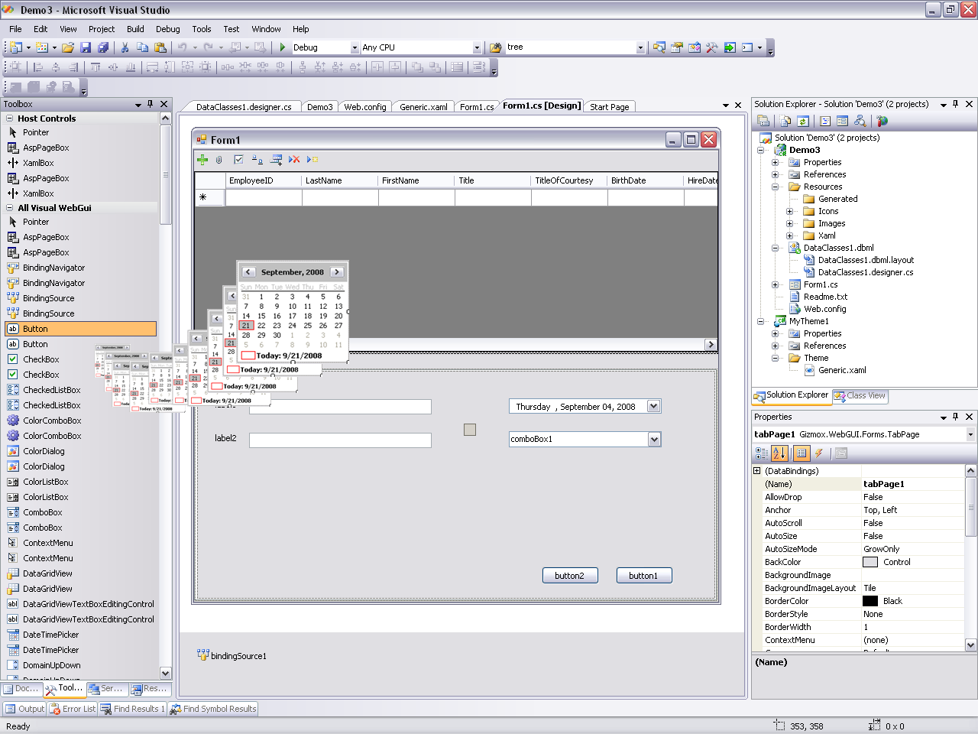
With Visual WebGui, Gizmox is providing an innovative new way to develop rich Internet applications. Benefits of the company’s approach for developers include:

- Faster development of ASP.NET-based applications. Visual WebGui “flattens” AJAX-based and Silverlight-based UI development into a single layer, making the developers of those applications far more productive. “Customers using Visual WebGui have reported 50 to 90 percent decreases in development time,” says Goffer. “In many cases, developers can redeploy an existing Windows Forms–based application to the Web by simply copying the existing Windows Forms code and changing the namespaces.”

- No learning curve. Because Visual WebGui uses the Windows Forms designer included with Visual Studio, developers who are already familiar with Windows-based development can start building Web applications without a learning curve. “Because we integrate with Visual Studio, developers can do everything from binding to data to accessing any .NET resources and services or exploring servers in the same way they always have,” says Spitzen. “We didn’t really develop anything new—we simply took something that was already proven and familiar to many, and encapsulated it for a different audience.”
“Being a Visual Studio Industry Partner gives us many ways to reach potential customers, including the Visual Studio Gallery, the Microsoft Developer Network, and other advertising and promotion opportunities.”
Roy Goffer, Online Marketing Manager, Gizmox

- Increased security. Because of the way in which Visual WebGui separates the execution of an application from its rendering of the UI, nothing is retained on the client other than what is currently being displayed on the screen. “Only UI commands and a static kernel are transmitted to the client,” says Spitzen. “The client simply renders the UI and send events to the server; which exclusively handles all interaction with data and other services.”

Offering a solution that integrates with Visual Studio is benefiting Gizmox as well. “By building on Visual Studio, we have access to a huge potential developer base—including Windows Forms developers who want to build Web applications and Web developers who want a faster and easier way to build ASP.NET applications,” says Goffer. “Although we just released Visual WebGui Professional Studio in February 2009, we’ve already had tens of thousands of downloads of our 30-day free trial, not to mention a few hundred sales. Being a Visual Studio Industry Partner gives us many ways to reach potential customers, including the Visual Studio Gallery, the Microsoft Developer Network, and other advertising and promotion opportunities.”

Microsoft Visual Studio 2008
For More Information
For more information about Microsoft products and services, call the Microsoft Sales Information Center at (800) 426-9400. In Canada, call the Microsoft Canada Information Centre at (877) 568-2495. Customers who are deaf or hard-of-hearing can reach Microsoft text telephone (TTY/TDD) services at (800) 892-5234 in the United States or (905) 568-9641 in Canada. Outside the 50 United States and Canada, please contact your local Microsoft subsidiary. To access information using the World Wide Web, go to:
www.microsoft.com

For more information about Gizmox, visit the Web site at:
www.gizmox.com

This case study is for informational purposes only. MICROSOFT MAKES NO WARRANTIES, EXPRESS OR IMPLIED, IN THIS SUMMARY.

Document published August 2009

Software and Services  - Microsoft Visual Studio  - Microsoft Visual Studio 2008 Professional Edition | - Technologies  - Microsoft ASP.NET

Microsoft Visual Studio 2008 is the world’s most popular development environment for designing, developing, and testing next-generation Windows-based solutions and Web applications and services. By improving the development experience for Windows, the Web, mobile devices, and Microsoft Office, Visual Studio 2008 helps organizations deliver a variety of solutions more productively than ever before. Visual Studio Team System expands the product line with new software tools that enable greater communication and collaboration throughout the development life cycle. Interaction between developers and designers is enhanced through the use of Visual Studio 2008 and Microsoft Expression® Studio. With Visual Studio 2008, businesses can deliver modern service-oriented solutions more efficiently.

For more information about Visual Studio 2008, go to:
msdn.microsoft.com/vstudio

