Customer: Voith IT Solutions
Web Site: www.voith-it-solutions.com
Customer Size: 380 employees
Country or Region: Germany
Industry: Professional services—IT services

Customer Profile
As a senior system engineer for Voith IT Solutions, Rainer Gold manages an IT team that provides services for both the Voith Group of companies and external customers.

Software and Services
- Microsoft Office
- Microsoft Office Communications Server 2007 R2
- Microsoft Office Communicator Mobile
- Microsoft Server Product Portfolio
- Microsoft Exchange Server 2003
- Exchange Server 2007
- Windows
- Windows Mobile 6.5
- Technologies
- Active Directory
- Direct Push Technology
- Internet Explorer Mobile 6
- Microsoft ActiveSync

Hardware
- HTC HD2 mobile phone
- HTC Snap mobile phone
- HTC Touch2 mobile phone
- HTC Touch Pro2 mobile phone
For more information about other Microsoft customer successes, please visit: www.microsoft.com/casestudies
“Windows® phones are easier to use than most other mobile phones, they will reduce our costs, and they work much better with our existing infrastructure.”
Windows® Phone
Customer Solution Case Study
 |  |  | IT Group Gains Mobile Solution Estimated to Save up to 20 Percent in Operating Costs
Rainer Gold, Senior System Engineer, Voith IT Solutions
Rainer Gold, a senior system engineer at Voith IT Solutions, and two IT colleagues pilot-tested Windows® phones with Windows Mobile® 6.5. Based on the successful pilot, Voith IT will begin deploying the mobile phones to 2,000 users worldwide. Gold expects to save money with easy-to-use phones that help them work faster, are up to 20 percent less expensive to operate, and work efficiently with the company’s existing Microsoft® software.

Business Needs
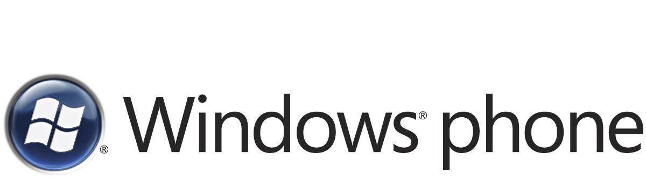

Senior System Engineer Rainer Gold manages a global IT team at Voith IT Solutions, which is based in Heidenheim, Germany. Voith IT Solutions provides services to the Voith Group of companies. Voith AG, the parent company, is a global leader in paper production, power transmission, hydro power, and industrial services with 43,000 employees at 300 locations worldwide. To help ensure that the group’s supporting IT infrastructure is operating efficiently, Gold must travel frequently. So staying in touch with his colleagues and family is important.

“If I’m in South America and need to consult with someone back in Germany about a problem, I can’t wait hours for a response,” he says. “I have a critical need for both voice communications and easy, mobile access to my e-mail and instant messaging.”

The Voith Group uses a variety of mobile phones and adopted the Windows Mobile® operating system as its standard several years ago. For e-mail, the group relies on 95 server computers running Microsoft® Exchange Server 2003 or Exchange Server 2007. It uses those server computers to support its 43,000 employees worldwide, and did not want to add unnecessary middleware servers to support its 2,000 mobile users.

Voith had also deployed Microsoft Office Communications Server 2007 R2 and the Microsoft Office Communicator Mobile client, which provide presence awareness for mobile users, so they can see at a glance when contacts are available to communicate.

Although the group’s mobile e-mail communications were working well, help-desk calls had been mounting because many employees needed help operating their non-Windows phones. Costs were also rising in Germany, because the Voith Group had to pay a monthly radio-transmission fee of €6 (about U.S.$9) for each of the approximately 1,800 mobile phones with integrated FM radios—something the group did not need.

Mobile communications are used by the group’s IT team, salespeople, executives, and service workers who construct machines for paper production throughout the world. “Because the ability to work from anywhere is vital in our business, we want to have the most advanced mobile technology,” Gold says.

Gold relies on his smartphone in his personal life for e-mail and instant messaging, too. He also participates in activities that require Global Positioning System (GPS) receivers, such as geocaching, a high-tech “treasure hunt” that uses GPS coordinates to locate items.

Solution
To satisfy both business needs and his personal interest, Gold and his IT colleagues began pilot-testing several models of Windows® phones with Windows Mobile 6.5 in April 2009.

The IT team tested phones with specific users in mind, including the HTC Snap mobile phone for workers who require both a phone and personal information manager. For workers who need to use e-mail or create Office documents from the field, the team reviewed the HTC Touch2. The HTC Touch Pro2 mobile phone—which converts instantly to a speakerphone when placed screen-down on a table—was considered for managers and salespeople. And for executives who want a powerful phone with customizable shortcuts to the applications that they use most, the team tested the HTC HD2 model. All the HTC smartphones feature the Windows Mobile 6.5 touch-sensitive interface, and all include an integrated GPS receiver.

With the new Windows® phones, Gold and his colleagues take advantage of Direct Push Technology, which uses Microsoft ActiveSync® technology to send their e-mail messages directly to their phones, without to the need to initiate a connection. They also use Internet Explorer® Mobile 6 for Web browsing.

Testing was completed in December 2009.

Benefits
Based on the successful pilot, Voith IT will gradually deploy the HTC Windows® phones with Windows Mobile 6.5 throughout the Voith Group. “Windows® phones are easier to use than most other mobile phones, they will reduce our costs, and they work much better with our existing infrastructure,” says Gold. They also complement the HP phones that the Voith Group uses in countries where HTC phones are currently unavailable.

- Ease of use. Gold and his colleagues enjoyed their testing experience. “The ability to tap and slide on the screen to perform tasks, the simplicity of the icon display, and the easy navigation make Windows® phones with Windows Mobile 6.5 easier to use,” he says. He also likes the new Lock Screen feature, which makes it harder to accidentally initiate calls and displays new messages without the need to unlock the screen. Web browsing is quicker, too. “With Internet Explorer Mobile 6, pages load about 15–20 percent faster than with our previous system,” he says. “It’s great to have my e-mail and GPS on one phone, so I can stay in touch even when I’m geocaching.”

- Lower costs. Gold expects the Voith Group will save money by switching to Windows® phones with Windows Mobile 6.5. “The Windows® phones appear to be about 20 percent cheaper to operate than any of the smartphones we used previously. Management should be easier, because we expect fewer help-desk calls with the ease of use, which directly affects our support costs.” Also, in Germany, Voith can save the €6 fee per phone for FM radio support. And administrators can use the Active Directory® service and Group Policy to deactivate the FM receivers on phones equipped with them.

- Efficient operation with Microsoft infrastructure. Gold appreciates how well the Windows® phones work with the existing Microsoft infrastructure. “In the past, employees have asked to use iPhones,” he says. “But with our Windows® phones, we can use Direct Push e-mail and ActiveSync. We can manage all of our e-mail in one place with Microsoft tools. We can also use Office Communicator Mobile to see when colleagues are available and contact them at once through Single Number Reach wherever they are.”

