# Role-Based Template for SharePoint My Sites: Marketing Manager

***Functional Overview for***

***Business Decision Makers***

### With personalization becoming an increasingly important business need and the key to effective collaboration, Microsoft® Office SharePoint® Server 2007 offers My Site, a personal site that pulls together summary views of personal information and provides full control over information "for me, by me, and about me." Role-Based Templates for SharePoint My Sites are custom templates designed for Office SharePoint Server 2007 and tailored to address the unique needs and requirements of specific roles. They are envisioned as extensions to the standard My Site functionality, providing a personal portal and dashboard data relevant to your role.

### Role-Based Templates for SharePoint My Sites can provide enhanced business insight and help drive company-wide productivity through a common interface to access priority information from varied sources and systems related to job roles, individual responsibilities, and surrounding processes. The templates display information in a way that is familiar and easy, and is built around the way people in the company work, enabling business decision-making with greater confidence.

### Description of Template

Marketing Managers are mainly responsible for developing the firm’s marketing strategy. They estimate the demand for products and services offered by the firm and its competitors and support various business units by managing campaigns and implementing marketing strategies for various initiatives. They handle media communications and plan the budget for marketing activities. Marketing Managers also work with advertising and promotion teams to promote the firm’s products and services.

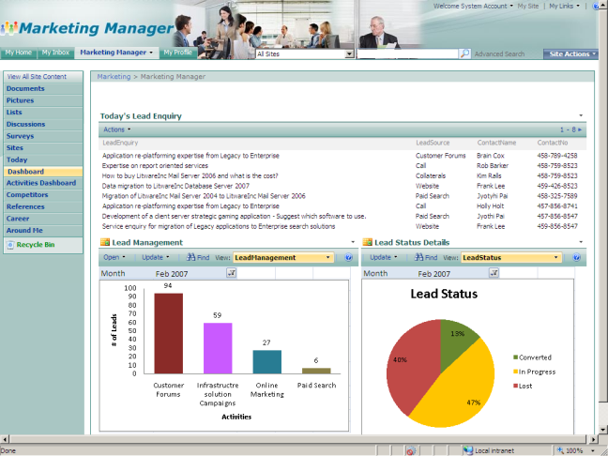

The Marketing Manager role-based template for SharePoint My Sites helps streamline the process of lead inquiries and conversions. The template assists with activities such as budget planning for marketing activities, planning activities for certain initiatives, planning for collateral, and implementing a wide range of promotions for products. This template also displays metrics related to the number of activities conducted and provides assistance in managing competitor information. The overall design of this Role-Based My Site template is to help the Marketing Managers attain their goals developing and implementing marketing communications focused on brand development, customer acquisition and engagement.

**Sample Activities Performed in this Role-Based My Site Template**

Role-based My Site templates aim to provide a “one-stop shop” experience that enables users to view and access information relevant to their jobs by unlocking data buried in various business systems. These templates come with sample data. The following example shows how this template might be used in a typical organization.

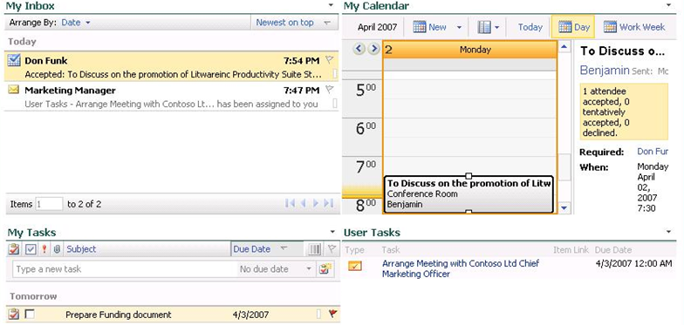Benjamin is a Marketing Manager in Litware Inc’s Sales and Marketing department. Like many information workers, he starts his day by accessing his personal productivity tool, Microsoft Office Outlook**®** 2007. Since his company has deployed Microsoft Office SharePoint Server 2007 and Role-Based My Site templates, he also logs into his personal My Site page. He checks emails and replies using the My Inbox section of his Today page.

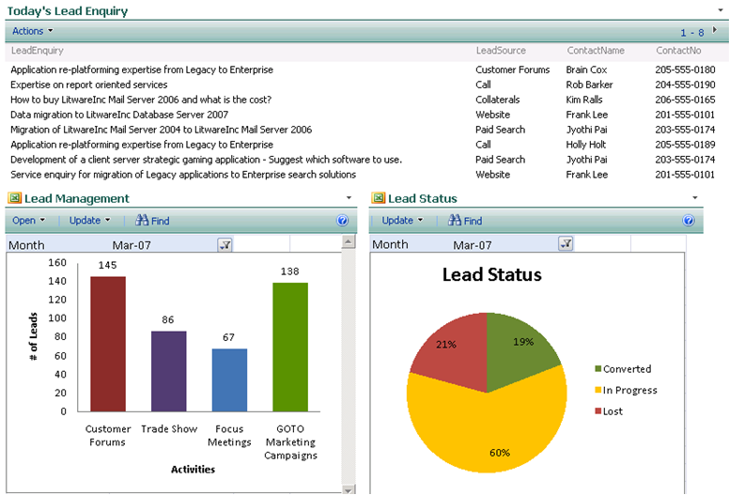As a part of his routine work, Benjamin checks out the previous day’s lead inquiries. He looks at the lead management graph to check the effectiveness of various events in generating leads. He realizes that customer forums have generated the highest number of leads in the month of March, as well as the previous month, and decides to plan more customer forums in the coming months. Also, he notes that the lead conversions for the current month are better than that of the previous month.

He visits the Activities Dashboard page to check on the money spent on the various marketing activities and to plan for future events. He ensures that sufficient funds are allocated for customer forums. He also ensures that they are included in the activities planned for the initiative “Generating Leads”. He looks at the activity indicator to see how he is doing in terms of organizational goals. He’s reminded early in his day of a meeting with Don Funk, the Regional Business Manager, to discuss an upcoming promotion of the recently launched Litware Inc Productivity Suite and brainstorm ideas for working with retailers. He downloads the InfoPath**®** form from the Meeting Outcomes section on the References page.

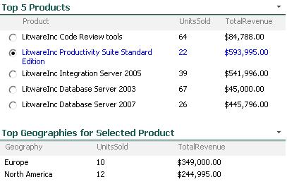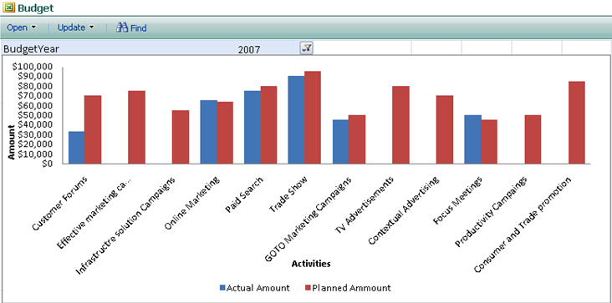

In order to devise strategies for different geographies, Benjamin checks out the units sold and revenue earned for “Litware Inc Productivity Suite Standard Edition**”** by selecting it in the Top 5 Products web part to view its top geographies by revenue. He also checks out the current and forthcoming promotions for the product in the current month by filtering the promotions list.

In order to devise the competition strategy for the product, he goes to the Competitors page to check the product price list of one of his competitors, Fabrikam Inc, who have been doing well in the productivity tools space. He prepares himself for the meeting. Once done with the meeting, he uploads the notes to the References page to keep a tab on the meetings attended.

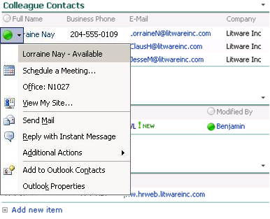

Later in the day, Benjamin is contacted by Lorraine Nay, a Sales Manager, to assist her with documents for converting a lead. Benjamin pulls out the relevant case studies, white papers and presentations from the References page and sends an instant message to the sales manager to go ahead with the meeting with the customer. At the end of the day, Lorraine Nay, who was assisted by Benjamin to convert a lead, calls him and says that the customer is extremely convinced with the presentation and that the lead has been converted.

Benjamin visits the Around Me page to catch up on organizational news and info. He checks his Career page and updates his Goals and Objectives. Benjamin is happy with achieving the target for the quarter and heads for home, hoping for more business prospects tomorrow.

**About Microsoft Office SharePoint Server 2007**

Microsoft Office SharePoint Server 2007 is an integrated suite of server capabilities that can help improve organizational effectiveness by providing comprehensive content management and enterprise search, accelerating shared business processes, and facilitating information-sharing across boundaries for better business insight. Office SharePoint Server 2007 supports all intranet, extranet, and Web applications across an enterprise within one integrated platform, instead of relying on separate fragmented systems. Additionally, this collaboration and content management server provides IT professionals and developers with the platform and tools they need for server administration, application extensibility, and interoperability.

**More Information**

For more information on the technologies described in this article, please visit:

Microsoft Office SharePoint Server 2007:

<http://www.microsoft.com/sharepoint>

Role-Based Templates for SharePoint My Sites:

<http://go.microsoft.com/?linkid=6060804>