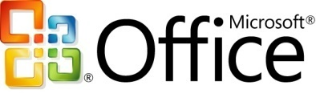Microsoft Office Enterprise 2007

**Microsoft® Office Enterprise 2007, a new suite for collaborative work, adds Microsoft Office Groove® 2007 and Microsoft Office OneNote® 2007 to Microsoft Office Professional Plus 2007.**

**With Office Enterprise 2007, you get a complete set of tools that help your employees work efficiently and productively both with each other and in collaboration with customers and partners.**

Easily Organize Information

Building on the strengths of Office Professional Plus 2007, Office Enterprise 2007 provides two additional tools that help teams gather, store, organize, find, and easily share virtually any type of information, so they can work more efficiently:

* Office Groove 2007 is a collaborative environment where teams can work together effectively.
* Office OneNote 2007 gives people one place to find, gather, and share their notes and information, from meeting notes to Web research to audio recordings.

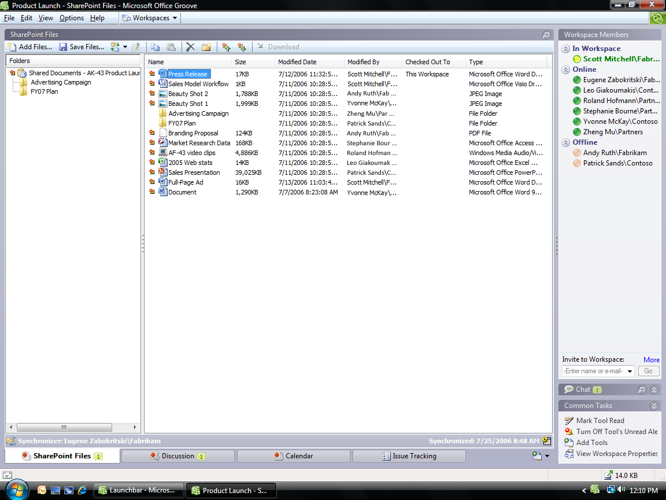

Simplify Working Together

Make it easier for information workers to share information and work collaboratively.

Organize content in one location. Use Office OneNote 2007 to easily gather, find, and organize many different types of content—all in one place.

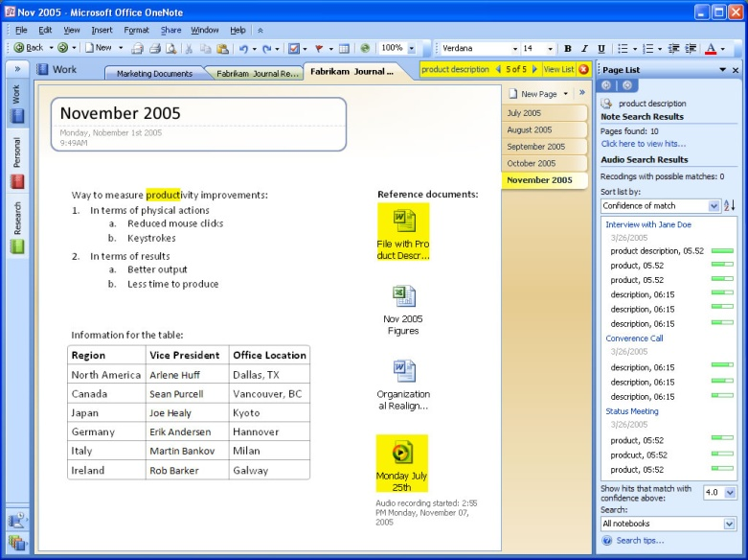

Gather disparate pieces of information in one place.

Work dynamically with teams. With the Office Groove 2007 rich client experience, you can work in teams dynamically from any location, independent of a network connection. Quickly set up and invite colleagues into a security-enhanced online Groove workspace, where all team members can share information without the need for designated IT staff.

Know when information has been updated. Create customized alerts and notifications in Groove workspaces so you can know when others have created and are sharing new information.

Keep your information in sync. Before going offline, you don’t have to download information from Groove workspaces or OneNote notebooks, or upload changes when you reconnect. Offline work is automatically synchronized to all team members as soon as an Internet connection is obtained.

Create, Control, and Manage Content

Enhance your organization’s ability to manage all types of content more effectively.

Work more productively. Use Office OneNote 2007 to organize and consolidate disparate pieces of project-related information, including handwritten notes, audio and video recordings, formatted documents, and still images.

Remain in control of your information. You can choose which portions of your OneNote notebooks to share and which to keep private. Password protection on specific sections of users’ notebooks means only individuals who are granted access can view them.

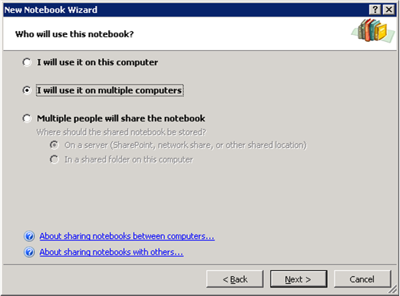

Choose the shared notebook option.

Help protect your data. Your information will be in a security-enhanced environment at all times, even on portable computers and wireless networks, with Office Groove 2007.

Take advantage of workspaces. Work effortlessly in Groove workspaces virtually anywhere, online or offline, without having to download, upload, or replicate documents and information.

Deliver Better Business Insight

Extend information workers’ ability to find, use, and manage information.

Manage information in one place. Use Office OneNote 2007 to gather, store, and search information about projects that can be used as examples of best practices or as a way to avoid duplicating work. Collect all the research for a project in one place.

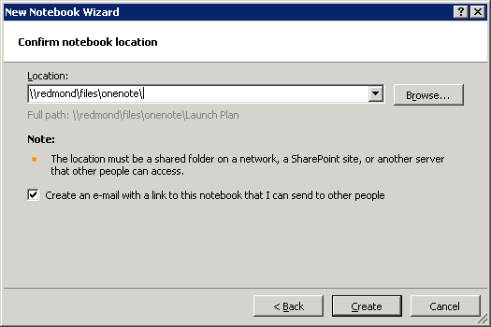

Confirm the shared notebook location.

Access relevant data, online or offline. With both Office OneNote 2007 and Office Groove 2007, you can access the most relevant project data continuously whether you are online or offline.

Monitor document changes. Gain greater visibility into the most up-to-date project information. Sound and text alerts notify you of specific changes, helping eliminate the need to check for updates.

**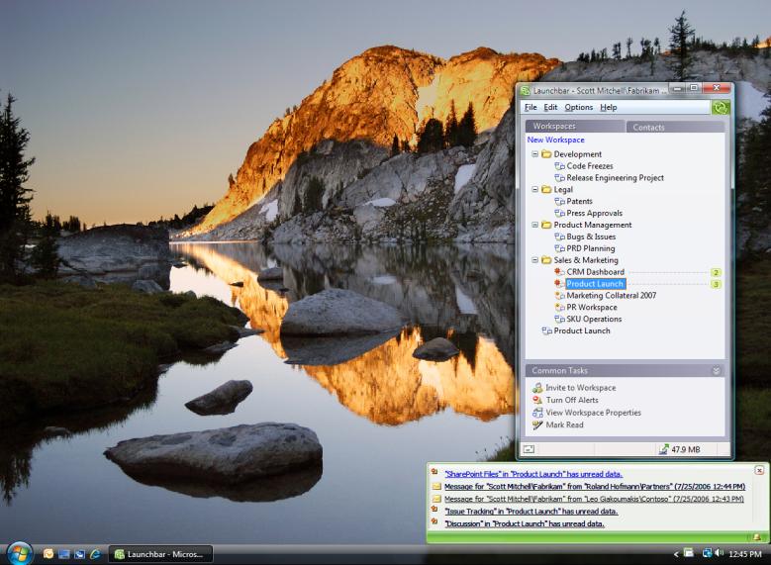**

* **See which team members are actively working online.** Through indicators of member presence in Groove workspaces, you always know who is online. You can exchange messages with online team members using the chat tool in Office Groove 2007.

Streamline Business Processes

Help organizations execute business processes more effectively and with greater efficiency.

Collaborate efficiently virtually anywhere, anytime. Use Office Groove 2007 to increase your productivity by working efficiently with others anywhere you can connect your portable computer to the Internet.

Work remotely. Be productive on the go with Office OneNote 2007 by collecting, viewing, and searching notes and other information on a mobile device and syncing it with the OneNote notebook on your computer. Create and customize Groove workspaces in minutes, and invite colleagues, partners, and customers to collaborate in a security-enhanced environment without having to worry about needing IT resources.

Keep track of action items. Two-way task syncing between Office OneNote 2007 and Microsoft Office Outlook® 2007 means you can easily keep track of action items and other important information. You can link notes in your OneNote notebooks to Office Outlook 2007 contacts or meetings, so you always have the proper context and are better prepared.

For More Information

Learn more about Office Enterprise 2007 and   
the Microsoft Office system at [www.microsoft.com/office/suites/enterprise](http://www.microsoft.com/office/suites/enterprise).

For complete system requirements, visit [www.microsoft.com/office/suites/enterprise](http://www.microsoft.com/office/suites/enterprise).

This document is for informational purposes only. MICROSOFT MAKES NO WARRANTIES, EXPRESS OR IMPLIED, IN THIS SUMMARY.

The example companies, organizations, products, domain names, e-mail addresses, logos, people, places, and events depicted herein are fictitious. No association with any real company, organization, product, domain name, e-mail address, logo, person, place, or event is intended or should be inferred.

MSlogo_k_1118© 2006 Microsoft Corporation. All rights reserved. Microsoft, Groove, the Office logo, OneNote, and Outlook are either registered trademarks or trademarks of Microsoft Corporation in the United States and/or other countries. All other trademarks are property of their respective owners.