

**Microsoft FAST Search Server 2010 for SharePoint**

**Evaluation Guide**



This is a preliminary document and may be changed substantially prior to final commercial release of the software described herein.

The information contained in this document represents the current view of Microsoft Corporation on the issues discussed as of the date of publication. Because Microsoft must respond to changing market conditions, it should not be interpreted to be a commitment on the part of Microsoft, and Microsoft cannot guarantee the accuracy of any information presented after the date of publication.

This white paper is for informational purposes only. MICROSOFT MAKES NO WARRANTIES, EXPRESS, IMPLIED, OR STATUTORY, AS TO THE INFORMATION IN THIS DOCUMENT.

Complying with all applicable copyright laws is the responsibility of the user. Without limiting the rights under copyright, no part of this document may be reproduced, stored in, or introduced into a retrieval system, or transmitted in any form or by any means (electronic, mechanical, photocopying, recording, or otherwise), or for any purpose, without the express written permission of Microsoft Corporation.

Microsoft may have patents, patent applications, trademarks, copyrights, or other intellectual property rights covering subject matter in this document. Except as expressly provided in any written license agreement from Microsoft, the furnishing of this document does not give you any license to these patents, trademarks, copyrights, or other intellectual property.

Unless otherwise noted, the example companies, organizations, products, domain names, e-mail addresses, logos, people, places, and events depicted herein are fictitious, and no association with any real company, organization, product, domain name, e-mail address, logo, person, place, or event is intended or should be inferred.

© 2009 Microsoft Corporation. All rights reserved.

Microsoft, Windows, SharePoint, FAST, Visual Studio, SQL Server, OneNote, PowerPoint, Outlook, and Excel are trademarks of the Microsoft group of companies. All other trademarks are property of their respective owners.

Contents

Abstract 1

How to Use This Document 2

Introduction 3

Technical Problems Solved by SharePoint Server 2010 Enterprise Search 3

Search Terminology 4

Microsoft Enterprise Search Products Overview 9

Microsoft Server-Side Search Products 9

Content Source Repositories 10

Indexing Scale 11

Developer Information 12

Enterprise Search Features in FAST Search Server 2010 for SharePoint 13

End-User Perspective 13

IT Professional Perspective 14

Developer Perspective 14

FAST Search Server 2010 for SharePoint 15

Enterprise Search Enhancements in FAST Search Server 2010 for SharePoint 15

Visual Search Capabilities 15

Document Thumbnails 15

Scrolling PowerPoint previews 15

Visual Best Bets 16

Conversational Search Capabilities 16

Sort Results on Managed Properties 16

Deep Results Refinement 16

Similar Results 17

Result collapsing 17

Contextual Search Capabilities 17

Relevancy Tuning by Document or Site Promotions 17

Synonyms 18

Managed Properties and Metadata creation 18

Property Extraction 18

Rank Profiles 19

Linguistics 20

FAST Search Server 2010 for SharePoint for End Users 21

End-User Search Experience 21

Social Search 25

Finding People 25

Mining and Discovering Expertise 26

Improving Search based on Social Behavior 26

FAST Search Server 2010 for SharePoint User Experience 27

Enhanced Search Results 29

FAST Search Server 2010 for SharePoint for IT Professionals 31

FAST Search Server 2010 Architecture Overview 31

Modular and Scalable Architecture 32

Integration with Search Center 32

IT Professional Experience 33

Windows PowerShell Support 33

Categories of cmdlets 34

Developer Experience 34

FAST Search Server 2010 for SharePoint —Services and Components 35

FAST Search Connector 35

Web Link Analysis (Web Analyzer) 36

Item Processing 36

Indexing 37

Query Matching 37

Query Processing 38

Connector Framework 38

New Connector Features 38

Creating Connectors 39

Search Administrator Walkthroughs 39

Search Administration at the Search Service Application Level for SharePoint Server 2010. 39

Crawler Settings 40

Queries and Results Settings 42

Search Reports 48

Administering FAST Search Server 2010 for SharePoint Managed Properties 50

Search Administration at the Site Collection Level 52

FAST Site Collection Settings 58

Appendix A: Resources Available for Evaluating SharePoint Server 2010 62

# Abstract

This evaluation guide is designed to give you an understanding of the design goals and the details of the enterprise search features provided by Microsoft® FAST™ Search Server 2010 for SharePoint®. This guide is also designed to give you a familiarity with how to implement enterprise search by using FAST Search Server 2010 for SharePoint.

This guide includes:

* Descriptions of the enterprise search features and technologies provided by FAST Search Server 2010 for SharePoint.
* Details of the additional features that FAST Search Server 2010 for SharePoint provides over and above SharePoint Server 2010.
* Details on the indexing and query architecture implemented by FAST Search Server 2010 for SharePoint.
* Tours and walkthroughs of the main search features provided by FAST Search Server 2010 for SharePoint.

This guide is designed for technical decision makers, IT professionals, and developers. The overall goal of this guide is to help you perform a thorough and effective evaluation of the search features provided by FAST Search Server 2010 for SharePoint.

For the latest information about SharePoint 2010 products, please visit [SharePoint Products and Technologies](http://www.microsoft.com/sharepoint).

# How to Use This Document

This document has been designed to enable you to learn about and evaluate the enterprise search features provided by FAST Search Server 2010 for SharePoint. The document provides comprehensive information that can be used to evaluate all of the enterprise search features and components provided by FAST Search Server 2010 for SharePoint, from the perspective of the following roles:

* **Technical Decision Makers**. You can use this guide to gain an understanding of the business requirements that are met by enterprise search solutions. You can also learn how specific aspects of the search technologies provided by FAST Search Server 2010 for SharePoint work together to fulfill business and technical requirements for a successful enterprise search solution.
* **IT Professionals**. You can use this guide to gain an understanding of how to configure, administer, and manage the enterprise search features of FAST Search Server 2010 for SharePoint. You should pay particular attention to the walkthroughs throughout this guide.
* **Developers**. You can use this guide to gain an understanding of the features of FAST Search Server 2010 for SharePoint. You should read all of the sections in this document so that you gain an insight into the platform on which you will develop solutions. You should also refer to the [SharePoint Server 2010 SDK](http://msdn.microsoft.com/en-us/library/ee557253(office.14).aspx) (which includes the FAST capabilities) for more detailed developer guidance, walkthroughs, and samples.

# Introduction

Welcome to this evaluation guide for Microsoft FAST Search Server 2010 for SharePoint. The goal of this guide is to help you gain sufficient knowledge and understanding of FAST Search Server 2010 for SharePoint to evaluate how it can fulfill your organization's business requirements.

**NOTE**: This guide describes the enterprise search features FAST Search Server 2010 for SharePoint. If you would like to find out more about the enterprise search features of SharePoint, review the [SharePoint Server 2010 Enterprise Search Evaluation Guide](http://www.microsoft.com/downloads/details.aspx?FamilyID=13fb5242-aa6f-467a-9d5e-1833f2b73e2f).

In this section, you will learn about typical business and technical requirements for enterprise search solutions, and how FAST Search Server 2010 for SharePoint fulfills those requirements.

## Technical Problems Solved by SharePoint Server 2010 Enterprise Search

The general aims of enterprise search solutions are to:

* Ensure that enterprise data from multiple systems can be indexed. This includes collaborative data stored in SharePoint sites, files in file shares, Web pages in other Web sites, third party repositories, and other line of business systems such as CRM databases, ERP solutions, and so on.
* Ensure that content from multiple enterprise repositories systems can be searched both independently and from within the context of your business applications. Ideally, users who perform searches with enterprise search user interfaces should be able to see results from SharePoint sites, files in file shares, pages from other Web sites, and data in custom business solutions. This also means that users do not need to know where the data is, before they start searching.
* Ensure that searches provide accurate ranking for relevant results, if you expect users to adopt and use those search capabilities. The major reason that a user continues to use a search engine is if it returns relevant information near the top of the search results. Similarly, the major reason that a user stops using a search engine is if it does not return relevant results, or if those relevant results are not immediately visible because of poor relevance ranking.
* Ensure that your enterprise search solution identifies people and expertise within your organization. At a minimum, users should be able to search for names of other members of their organization to obtain contact information and availability. Ideally, users should be able to express interest in topics or functional areas of your business and find experts who regularly contribute or provide thought leadership. Your search solution should automatically build out your users profile from interactions with your regular business systems, including e-mail and your content repositories.

FAST Search Server 2010 for SharePoint provides an enterprise search platform for fulfilling these aims. As a brief overview, FAST Search Server 2010 for SharePoint includes a connector framework that enables the crawler to index files and metadata from various types of content sources. It also provides an indexing engine that stores the crawled data in an efficient manner in index files, and it provides query servers, query object models, and user interfaces for performing searches on the indexed data.

You will learn more about each of these components later in this guide, but for now just be aware that these components all work together to fulfill the aims and meet the requirements of enterprise search solutions.

## Search Terminology

Before delving into the details of enterprise search features provided by FAST Search Server 2010 for SharePoint, it will be useful for you to ensure that you are familiar with search terms and definitions. You can use the following table to review brief descriptions of the terms used later in this guide.

|  |  |
| --- | --- |
| **Term** | **Definition** |
| **Best Bet** | Best Bets are URLs to documents that are associated with one or more keywords. Best Bets are returned by queries that include the associated keywords, regardless of whether the URL has been indexed. Site collection administrator can create keywords and associate Best Bets with them. |
| **Connector** | Connectors are components that communicate with specific types of system, and are used by the crawler to connect to and retrieve content to be indexed. Connectors communicate with the systems being indexed by using appropriate protocols. For example, the connector used to index shared folders communicate by using the FILE:// protocol, whereas connectors used to index Web sites use the HTTP:// or HTTPS:// protocols. |
| **Content Source** | Content sources are definitions of systems that will be crawled and indexed. For example, administrators can create content sources to represent shared network folders, SharePoint sites, other Web sites, Exchange public folders, third-party applications, databases, and so on. |
| **Crawl Rule** | Crawl rules specify how crawlers retrieve content to be indexed from content sources. For example, a crawl rule might specify that specific file types are to be excluded from a crawl, or might specify that a specific user account is to be used to crawl a given range of URLs. |
| **Crawl Schedule** | Crawl schedules specify the frequency and dates/times for crawling content sources. Administrators create crawl schedules so that they do not have to start all crawl processes manually. |
| **Crawled Property** | Crawled properties represent the metadata for content that is indexed. Typically, crawled properties include column data for SharePoint list items, document properties for Microsoft Office or other binary file types, and HTML metadata in Web pages. Administrators map crawled properties to managed properties, in order to provide useful search experiences. See Managed Properties for more details. |
| **Crawler** | The crawler is the component that uses connectors to retrieve content from content sources. |
| **Crawler Impact Rule** | A crawler impact rule governs the load that the crawler places on source systems when it crawls the content in those source systems. For example, one crawler impact rule might specify that a specific content source that is not used heavily by information workers should be crawled by requesting 64 documents simultaneously, while another crawler impact rule might specify less aggressive crawl characteristics for systems that are constantly in use by information workers. |
| **Federation** | Federation is the concept of retrieving search results from multiple search providers, based on a single query performed by an information worker. For example, your organization might include federation with Bing.com, so that results are returned by SharePoint and Bing.com for a given query. |
| **IFilter** | IFilters are used by connectors to read the content in specific file types. For example, the Word IFilter is used to read Word documents, while a PDF IFilter is used to read PDF files. |
| **Index** | An index is a physical file that contains indexed content, and which is used by query servers to satisfy a query. |
| **Indexer** | Indexers manage the content to be included in an index, and propagate that content to query servers where they are stored in index files. |
| **Indexing Engine** | See *Indexer* |
| **Index Partition** | See *Partitioned Indexes* |
| **Managed Property** | Administrators create managed properties by mapping them to one or more crawled property. For example, an administrator might create a managed property named *Client*that maps to various crawled properties called *Customer*, *Client*, and *Cust* from different content sources. Managed properties can then be used across enterprise search solutions, such as in defining search scopes and in applying query filters. |
| **OpenSearch** | OpenSearch is an industry standard that enables compliant search engines to be used in federated scenarios. See *Federation* for more details. |
| **Partitioned Index** | SharePoint Server 2010 includes a new concept that enables administrators to spread the load for queries across multiple query servers. This is achieved by creating subsets of an index, and propagating individual subsets to different query servers. The subsets are known as *partitions*, and SharePoint Server 2010 uses a hash of each documents ID to determine in which partition the index entries for a specific document should be stored. At query time, the query object model contacts each query server that can satisfy the search so that all results to be returned to the user are included. |
| **Properties Database** | Managed properties and security descriptors for search results are not stored in the physical index files. Instead, they are stored in an efficient database that is propagated to query servers. Query servers typically satisfy a query by retrieving information from both the index file and the properties database. |
| **Query Object Model** | The query object model is responsible for accepting inputs from search user interfaces, and for issuing appropriate queries to query servers. The search Web Parts provided by SharePoint Server 2010 use the query object model to run queries. Developers can also create custom user interfaces and solutions that run queries by using the query object model. |
| **Query Server** | Query servers query retrieve data from index files and property databases to satisfy queries. |
| **Ranking** | Ranking defines the sort order in which results are returned from queries. Typically, results are sorted in order of descending relevance, so that the most relevant documents are presented near the top of the results page. However, information workers might choose to apply a different sort order, such as by date modified. |
| **Relevance** | Relevance is a measure of how closely each item returned by a search matches the terms used in the query. Relevance is calculated for each item by a complex algorithm that includes multiple inputs, and has one numeric output that represents how relevant the item is in relation to other items in the result set. |
| **Search Center** | Search Center is a site based on the Search Center site template, and provides a focused user interface that enables information workers to run queries and work with search results. |
| **Search Document** | See *Search Item* |
| **Search Item** | A search item represents a document, list item, file, Web page, Exchange public folder post, or database row that has been indexed. Search items are sometimes referred to as *search documents*, but the key point is that these items are returned by search queries. |
| **Stemming** | Words in each language can have multiple forms, but essentially mean the same thing. For example, the verb '*To Write'* includes forms such as *writing, wrote, write,* and *writes*. Similarly, nouns normally include singular and plural versions, such as *book*and*books.* Stemmingis the process of analyzing words to be indexed by mapping the various forms back to a consistent root or stem. |
| **Stop Word** | Stop words (sometimes known as noise words) are those words for which there is no value in indexing them. Some stop words are part of the language (such as 'a', 'and', and 'the'). There is no value in indexing these words as they are likely to be contained in a high percentage of indexed items. Furthermore, information workers rarely search for just these types of terms. |
| **Synonym** | Synonyms are words that mean the same thing as other words. For example, you might consider *laptop* and *notebook* to mean the same thing. Administrators can create synonyms for keywords that information workers are likely to search for in your organization. |
| **Word Breaker** | Streams or words are retrieved from content sources, and those streams are broken down into discrete words for indexing. Word breakers are the components that break down streams into individual words. Streams to be indexed are normally broken down by identifying spaces and punctuation marks. Also, when a user enters multiple words into a search box, that query is broken into discrete terms by a word breaker (unless the terms are included inside quotation marks). |

# Microsoft Enterprise Search Products Overview

There are various search products available from Microsoft, so before delving into the details of enterprise search for FAST Search Server 2010 for SharePoint, it will be useful for you to become familiar with all of the products in the enterprise search portfolio.

## Microsoft Server-Side Search Products

The following products all provide varying degrees of indexing and search features.

* Microsoft SharePoint Foundation 2010 search
* Microsoft Search Server 2010 Express
* Microsoft Search Server 2010
* Microsoft SharePoint Server 2010
* FAST™ Search Server 2010 for SharePoint*

You can use the following table to make quick comparisons of the search features provided by each product:

|  |  |  |  |  |  |
| --- | --- | --- | --- | --- | --- |
| **Feature** | **SharePoint Foundation 2010** | **Search Server 2010 Express** | **Search Server 2010** | **SharePoint Server 2010** | **FAST Search Server 2010 for SharePoint** |
| Basic search | Y | Y | Y | Y | Y |
| Best Bets |  | Y | Y | Y | Y |
| Visual Best Bets |  |  |  |  | Y |
| Similar Results |  |  |  |  | Y |
| Duplicate Results |  |  |  |  | Y |
| Search Scopes |  | Y | Y | Y | Y |
| Search Enhancement based on user context |  |  |  |  | Y |
| Crawled and Managed Properties |  | Y | Y | Y | Y* |
| Query Federation |  | Y | Y | Y | Y |
| Query Suggestions |  | Y | Y | Y | Y |
| Sort Results on Managed Properties or Rank Profiles |  |  |  |  | Y |
| Relevancy Tuning by Document or Site Promotions |  | Y | Y | Y | Y* |
| Shallow Results Refinement |  | Y | Y | Y | Y |
| Deep Results Refinement |  |  |  |  | Y |
| Document Preview |  |  |  |  | Y |
| Windows 7 Federation |  | Y | Y | Y | Y |
| People Search |  |  |  | Y | Y |
| Social Search |  |  |  | Y | Y |
| Taxonomy Integration |  |  |  | Y | Y |
| Multi-Tenant Hosting |  |  |  | Y | Y |
| Rich Web Indexing Support |  |  |  |  | Y |

* - FAST Search Server 2010 for SharePoint provides enhanced capabilities in these areas.

This guide will delve into the features in the above table in later sections.

### Content Source Repositories

In addition to the feature comparisons, you should also consider the types of content sources that can be crawled by each product:

* SharePoint Foundation 2010 can only crawl SharePoint sites in the same farm.
* All the other products in the above table can crawl the following types of content source:
* SharePoint sites (in the same farm, or in external farms)
* Windows file shares
* Microsoft Exchange public folders
* Non-SharePoint Web Sites
* People Profiles
* External Line-of-Business applications
* Structured content in databases
* Content returned by Web services
* Third-party products and solutions including Lotus Notes and Documentum  
    
  **NOTE**: Microsoft SharePoint 2010 Indexing Connector for Documentum (Beta) can be downloaded separately from Microsoft Connect (<https://connect.microsoft.com/office/Downloads/DownloadDetails.aspx?DownloadID=23324>).

### Indexing Scale

Although there are no hard-coded limits for the number of items that can be indexed by any of the products in the table above, there are some practical guidelines based on feasibility and performance:

* SharePoint Foundation 2010 can index and search up to 10 million items per search server.
* Search Server 2010 Express can index and search up to 300,000 items if it is used with SQL Server® Express; otherwise it can index and search up to 10 million items.
* A scaled-out Search Server 2010 farm can index and search up to 100 million items.
* A scaled-out SharePoint Server 2010 farm can index and search up to 100 million items.
* A FAST Search Server 2010 for SharePoint installation can support extreme scale, and can index and search over a billion items.

One of the general aims of enterprise search with SharePoint Server 2010 is to implement sub-second query latencies for all searches. To achieve this, you must ensure that no query server deals with more than ten million items; you can achieve this by adding multiple query servers to your farm, and therefore by taking advantage of the new index partitioning features of SharePoint Server 2010. Index partitioning enables administrators to spread the load for queries across multiple query servers. This is achieved by creating subsets of an index, and propagating individual subsets to different query servers. SharePoint Server 2010 uses a hash of each document's ID to determine in which partition the index entries for a specific document should be stored. At query time, the query object model contacts each query server needed to satisfy the search so that all results to be returned to the user are included.

For more comparison data between the server-side search products from Microsoft, see   
[Search Technologies for SharePoint 2010 Products](http://www.microsoft.com/downloads/details.aspx?displaylang=en&FamilyID=d7c0091e-5766-496d-a5fe-94bea52c4b15).

### Developer Information

All of the products described above provide a unified [query object model](http://msdn.microsoft.com/en-us/library/ee557319(office.14).aspx). The result is that if you develop a custom solution that uses the query object model for SharePoint Foundation 2010, for example, then it will continue to work if you upgrade to SharePoint Server 2010, or if you migrate your code to FAST™ Search Server 2010 for SharePoint.

# Enterprise Search Features in FAST Search Server 2010 for SharePoint

FAST Search Server 2010 for SharePoint builds on SharePoint Server 2010, and provides significant enhancements to the Enterprise Search capabilities. Search in SharePoint Server 2010 is targeted at “general productivity search.” General productivity search solutions increase employee efficiency by connecting a broad set of people to a broad set of information. Intranet search is the most common example.

FAST Search Server 2010 for SharePoint can be used on a variety of search problems, providing enhanced “general productivity search” but also uniquely addressing “high value” search applications. High-value search applications drive measurable ROI by helping a specific set of people make the most of a specific set of information. Common examples include product support applications, research portals, and customer record locators.

The frameworks and tools used by IT pros and developers are common across the product line - as much as possible, given the additional capabilities in FAST Search Server 2010 for SharePoint. In understanding the benefits of FAST Search Server 2010 for SharePoint, it is useful to consider:

* Capabilities that are the **Same** as those in SharePoint Server 2010 search.
* Capabilities that are **Better** than those in SharePoint Server 2010 search.
* Capabilities that are **Unique** to FAST Search Server 2010 for SharePoint.

A high level summary of the capabilities are shown in the tables below.

## End-User Perspective

|  |  |
| --- | --- |
| **Capability** | **Difference** |
| One-stop search center to find answers quickly | Better |
| Refinement to explore information quickly | Better |
| Social search to connect with people and expertise | Same |
| Search gets better with use | Same |
| Visual cues for rapid recognition of information | Unique |
| Contextual search to meet the needs of diverse groups | Unique |

## IT Professional Perspective

|  |  |
| --- | --- |
| **Capability** | **Difference** |
| Industrial strength scale-out and performance | Better |
| Easy deployment | Same |
| Enterprise-class manageability | Better |
| Secure, broad connectivity | Better |
| Advanced content processing out-of-the-box | Unique |
| Easy to configure high-end user experiences | Unique |

## Developer Perspective

|  |  |
| --- | --- |
| **Capability** | **Difference** |
| Customize the out-of-the-box user experience by using Web Parts | Better |
| Extend connectivity using the Business Connectivity Services and Federation | Same |
| Combine search with other SharePoint capabilities | Better |
| Use familiar tools built for developer productivity | Same |
| Leverage advanced content processing | Unique |
| Customize relevance | Unique |
| Use advanced query capabilities to create powerful applications | Unique |

# FAST Search Server 2010 for SharePoint

FAST Search Server 2010 for SharePoint provides enhancements and new capabilities to the enterprise search features of SharePoint Server 2010. You can use this section to learn more about the enhanced enterprise search features provided by FAST Search Server 2010 for SharePoint. If you are not familiar with the new enterprise search capabilities in SharePoint Server 2010, refer to the [SharePoint Server 2010 Enterprise Search Evaluation Guide](http://www.microsoft.com/downloads/details.aspx?FamilyID=13fb5242-aa6f-467a-9d5e-1833f2b73e2f).

## Enterprise Search Enhancements in FAST Search Server 2010 for SharePoint

This section provides a summary of the new and enhanced capabilities that FAST Search Server 2010 for SharePoint provides compared to the other search products from Microsoft. You can use this section to gain an overview of the value of implementing enterprise search solutions based on FAST Search Server 2010 for SharePoint.

**NOTE:** Please refer to the following sections later in this guide for walkthroughs that show how to work with each of these capabilities.

## Visual Search Capabilities

The visual search capabilities provide an engaging, useful, and efficient way for information workers to interact with search results.

### Document Thumbnails

Word documents and PowerPoint presentations can be previewed directly in search results. A thumbnail image is displayed along with the search results to provide rapid recognition of information, thereby faster information finding. This feature is part of the Search Core Results Web Part for FAST Search Server 2010 for SharePoint, and can be configured in that Web Part.

### Scrolling PowerPoint previews

The PowerPoint document preview enables an information worker to browse the actual slides in the presentation. The PowerPoint document preview enables an information worker to browse the actual slides in the presentation by using Silverlight technology, and the Word document preview can be configured to display a thumbnail image of the document.

### Visual Best Bets

SharePoint Server 2010 Search keywords can have definitions, synonyms and Best Bets associated with them. FAST Search Server 2010 for SharePoint adds the ability for you to define Visual Best Bets for keywords.

These visual search elements are unique to FAST Search Server 2010 for SharePoint and are not provided in SharePoint Server 2010 search.

## Conversational Search Capabilities

The conversational search capabilities provide ways for information workers to interact with and refine their search results, so that they can quickly find the information they require.

### Sort Results on Managed Properties

With FAST Search Server 2010 for SharePoint, users can sort results on any managed properties, such as sorting by Author, Document Size, or Title. Relevance ranking profiles can also be surfaced as sorting criteria, allowing end users to pick different relevance ranking as desired.

This sorting is considerably more powerful than sorting in SharePoint Server 2010 search (By default, SharePoint Server 2010 sorts results on each document's relevance rank. Information workers can re-sort the results by date modified, but these are the only two sort options in SharePoint Server 2010.)

### Deep Results Refinement

Refinement with FAST Search Server 2010 for SharePoint is considerably more powerful than refinement in SharePoint Server 2010.

SharePoint Server 2010 automatically generates 'shallow' refinement for search results that enable a user to apply additional filters to their search results based on the values returned by the query. 'Shallow' refinement is based on the managed properties returned from the first 50 results by the original query.

FAST Search Server 2010 for SharePoint enables you to specify whether a managed property can be used in a 'shallow' or 'deep' refinement. 'Deep' refinement is based on statistical aggregation of managed property values within the entire result set; ‘shallow’ refinement is just based on, by default, the first 50 results returned by the query. Using 'deep' refinement you can find the 'needle in the haystack', such as a person who has written a document about a subject, even if this document would otherwise appear down the result list. 'Deep' refinement can also display counts, and lets the user see the number of results in each refinement category.

You can also use the statistical data returned for numeric refinements in other types of analysis.

### Similar Results

With FAST Search Server 2010 for SharePoint, results returned by a query include links to 'Similar Results'. When a user clicks on the link, the search is re-defined and re-run to include documents that are similar to the result in question.

### Result collapsing

FAST Search Server 2010 for SharePoint documents that have the same checksum stored in the index will be collapsed as one document in the search result. This means that documents stored in multiple locations in a source system would only be displayed once during search with usage of the collapse search parameter. Collapsed results include links to 'Duplicates'. When a user clicks on the link, the search result displays all versions of this document.

Similar results and result collapsing are unique to FAST Search Server 2010 for SharePoint and are not provided in SharePoint Server 2010 search.

## Contextual Search Capabilities

FAST Search Server 2010 for SharePoint allows you to associate Best Bets, Visual Best Bets, document promotions, document demotions, site promotions, and site demotions with defined user contexts in order to personalize the experience for information workers. You can use the FAST Search User Context link in the Site Collection Settings pages to define user contexts for these associations.

### Relevancy Tuning by Document or Site Promotions

SharePoint Server 2010 enables you to identify varying levels of authoritative pages that help you tune relevancy ranking by site. FAST Search Server 2010 for SharePoint adds the ability for you to specify individual documents within a site for promotion, and furthermore enables you to associate each promotion with user contexts.

### Synonyms

SharePoint Server 2010 keywords can have one-way synonyms associated with them. FAST Search Server 2010 for SharePoint extends this concept by enabling you to implement both two-way and one-way synonyms.

### Managed Properties and Metadata creation

SharePoint Server 2010 enables you to create metadata property mappings (known as Managed Properties). FAST Search Server 2010 for SharePoint adds the ability for you to:

* Enable stemming support and word forms for managed property values, when they are used by an information worker in a query.
* Choose between static and dynamic summaries for display in search results. A dynamic summary will only display a hit-highlighted summary of the specific managed property in the result.
* Define whether information workers can sort results on the managed property in question.
* Define whether information workers can use the managed property in query operators or filters.
* Define whether search results page can use the managed property as a query refiner or deep query refiner in results pages.
* Define the priority associated with the managed property. The priority is one of the inputs into the ranking algorithm, and defines how documents with the search term in this property should be ranked against other documents that may have the search term in other properties.
* Define how managed properties can be grouped into one or more full-text search-enabled indexes.

### Property Extraction

Property extraction identifies key information such as people, companies, and locations in documents. The properties can then be used to enhance the search experience, for instance by providing search result refinement based on the properties. You can improve the precision of the Property Extraction by editing the include lists and exclude lists for each property extractor. Excluded items are removed immediately, while included items take effect the next time the content is indexed. You can also create custom property extractors based on your organization's specific content using Windows PowerShell and SharePoint administration. Dictionary or Taxonomy based extractors, also called Verbatim Extractors, will allow you to extract managed properties based on a fixed list of known terms. Developers will also be able to create more dynamic extractors based on the FAST matcher framework and will be able to extend the document pipeline with specialized classifiers, entity extractors, or other processing can be used to support specialized scenarios. More details on creating custom property extraction will be available very soon.

### Rank Profiles

The index schema in FAST Search Server 2010 for SharePoint includes rank profiles, which control how relevancy ranking is calculated for each item in search results.

A rank profile defines how relevancy calculations are performed when you search a full text index. A rank profile consists of several components which are weighted when calculating an item's relevance. You can adjust the weights of a profile’s components to improve search result relevance. Rank profile components include the following:

* Freshness. This component manages how the age of an item affects rank.
* Proximity. This component manages how the distance between query terms affects rank.
* Authority. This component manages how links between Web documents affect rank.
* Query authority. This component manages how user selections in previous query results affect rank.
* Context. This component manages how different managed properties within the associated full text indexes contribute to the rank.
* Managed properties directly impacting the rank. You can specify that the value of a numeric managed property is added to the rank, or you can specify that certain values of a managed property impact the rank. In the latter case you can, for example, define that documents of a given type (as defined by a specific managed property) will get a relevancy boost in the results.
* You can tailor different rank profiles to different use cases, or you can enable advanced information workers to select different rank profiles for different queries.
* Custom Rank Profiles are created with Windows PowerShell cmdlets. Refer to the [FAST Search Server 2010 for SharePoint Windows PowerShell Cmdlet Overview (Beta)](http://go.microsoft.com/fwlink/?LinkId=169492) and the [FAST Search Server 2010 for SharePoint Windows PowerShell Cmdlet Help (Beta)](http://go.microsoft.com/fwlink/?LinkId=169494) guides for more details.

### Linguistics

In search, linguistics is defined as the use of information about the structure and variation of languages so that users can more easily find relevant information. The item’s relevancy with regard to a query is not necessarily decided based on words common to both query and document, but instead depends on the extent that its content satisfies the user’s need for information. Examples of linguistic processing in the item and query processing include character normalization, normalization of stemming variations and suggested spell corrections. FAST Search Server for SharePoint 2010 performs linguistic processing for items returned by the crawl process before those items are indexed, as well as for the queries before the actual matching occurs.

# FAST Search Server 2010 for SharePoint for End Users

This section provides information about how the search experience is blended with the SharePoint experience, and how it has been enhanced for end users when they use FAST Search Center.

## End-User Search Experience

End users typically start searches either from the Simple Search box or by browsing to a site based on a Search Center site template. Figure 1 shows the Simple Search box that is available by default on all site pages. By default, this search box issues queries that are scoped to the current site, because users often navigate to sites that they know contain the information they want before they perform a search.

Figure 1 also shows navigation to a search site based on the Enterprise Search Center template. Information workers use Search Center sites to search across all crawled and federated content.

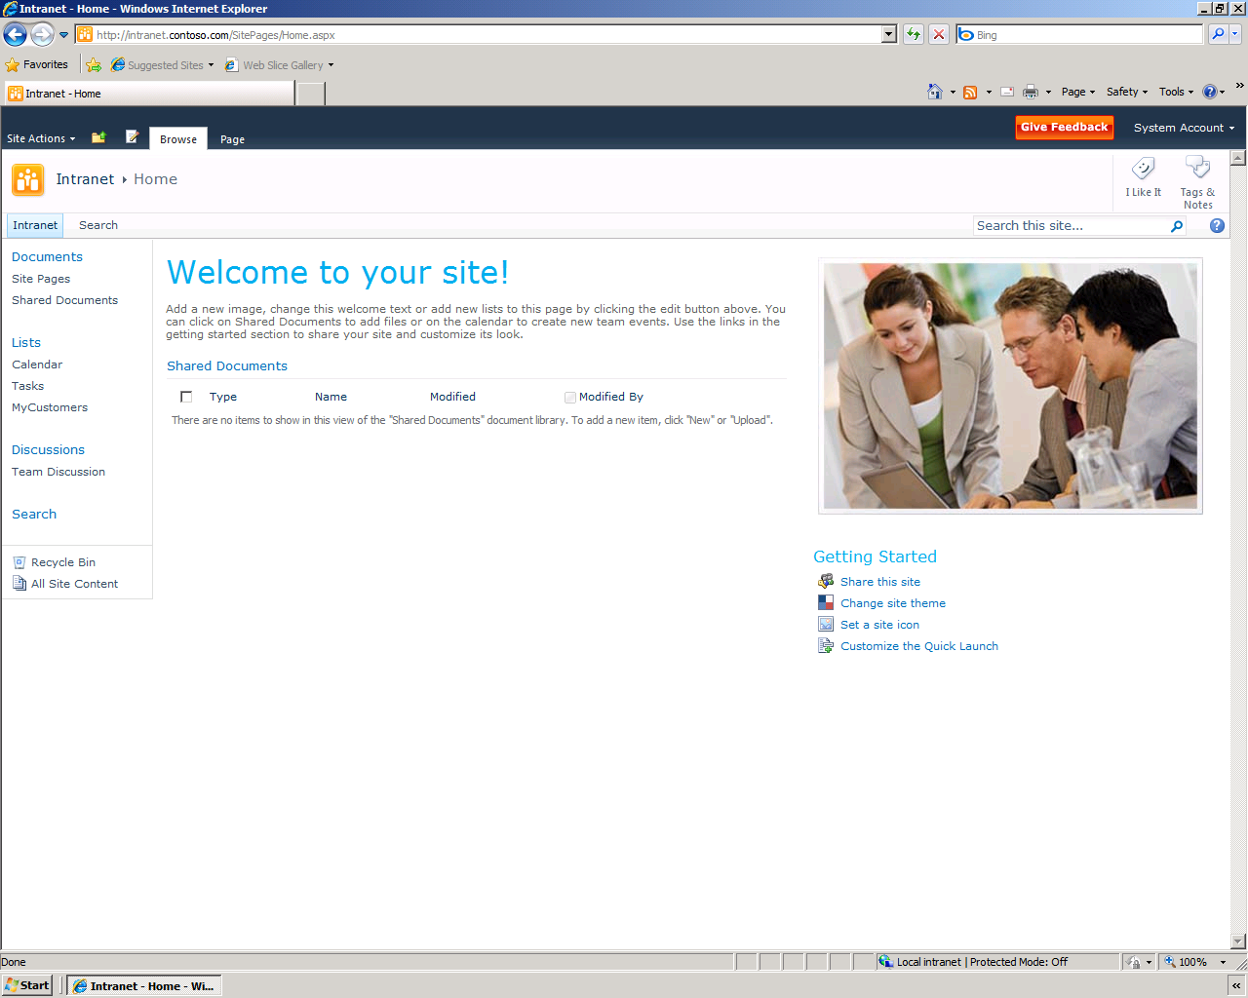

Simple Search Box

Navigation to Search Center

Figure . Search in a SharePoint Site

Figure 2 shows the search site based on the Enterprise Search Center template.

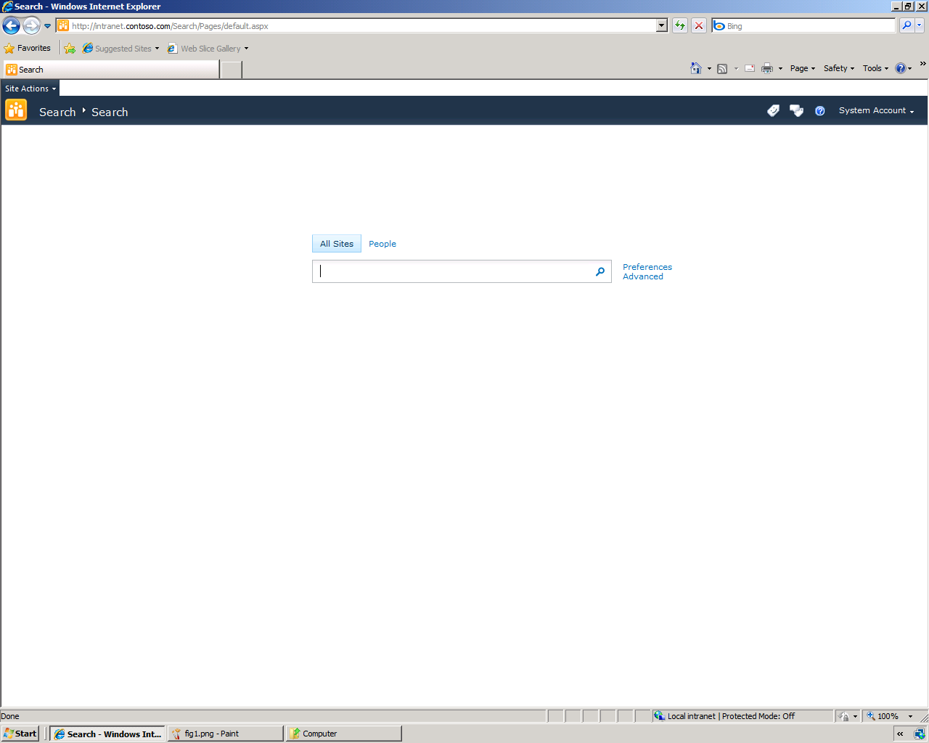

Figure 2. Search Center

Note how the Search Center includes an Advanced Search Box that provides links to the current user's search preferences and advanced search options. Also, by default, the Search Center includes search tabs: All Sites, and a dedicated People search. You will learn more about People search later in this section.

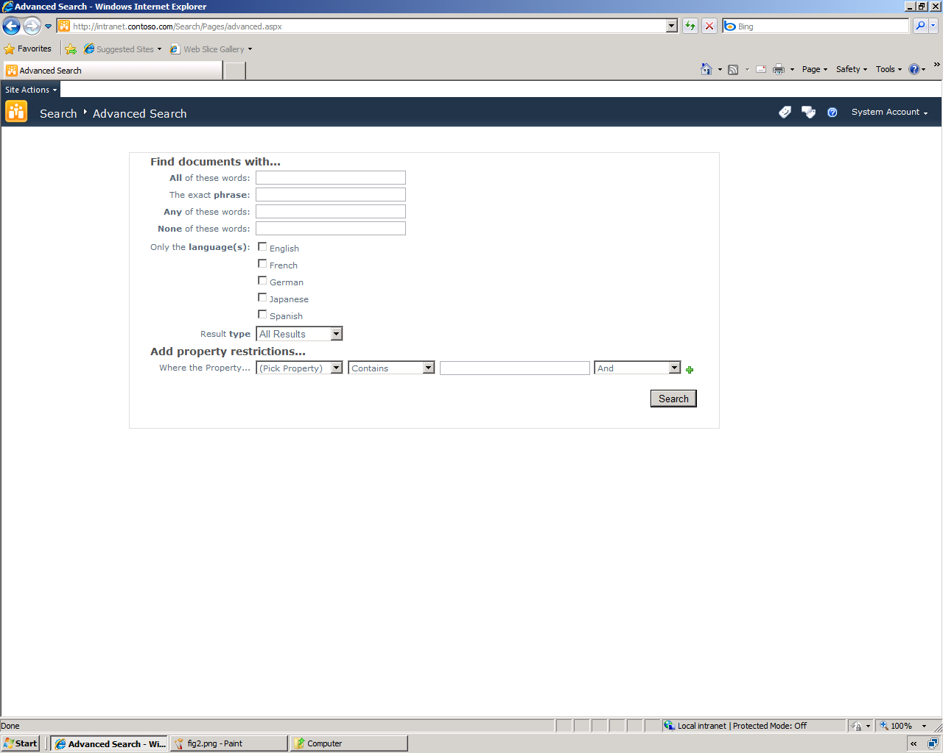

Figure 3. Advanced Search

Figure 3 shows the default view for performing an advanced search, with access to phrase management features, language filters, result type filters, and property filters.

All of the search user interfaces are intuitive and easy to use, so information workers can start searches in a very straightforward way. When an information worker performs a search, the results are displayed on a results page as shown in Figure 4. The SharePoint Sever 2010 search core results page offers a very user-friendly and intuitive user interface. People can use simple and familiar keyword queries, and get results in a rich and easy to navigate layout. A Search Center site template is provided as well as a simple search box that can be available on every page in a SharePoint Server 2010 site.

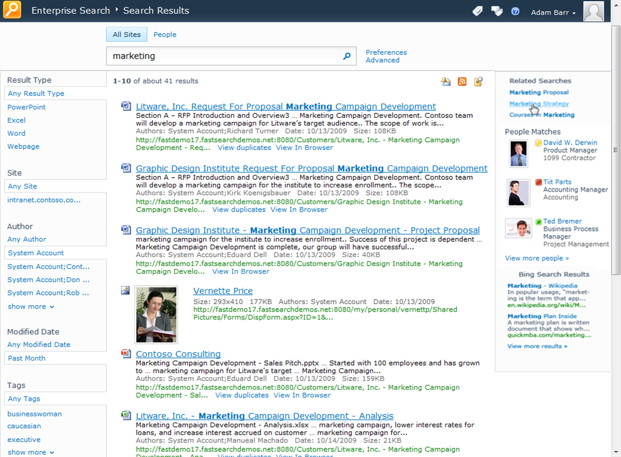

Figure 4. SharePoint Server 2010 Search Results Page

Search results are straightforward to browse and understand, and include several features to help information workers understand and explore the results. Snippets are included with each result, and definitions are provided at the bottom of the list (these are auto-generated based on the context in which the query words have been seen in the content). ‘Did you mean’ suggestions appear to help with misspelled and ambiguous queries, and acronyms are expanded in the related search sections. For example, searching for ECM will return results for Enterprise Content Management and *vice-versa*. Results are typically returned with sub-second response time.

Information workers can mark a search in several ways to save time in monitoring topics or repeating searches. They can subscribe to an RSS feed of the search results, and bookmark a search for later re-use. They can also quickly create an alert that will rerun the query at scheduled intervals and notify the user via an e-mail or text message of changes to the results.

SharePoint Server 2010 provides more relevant results. The query syntax has been enhanced to allow more expressive queries. Advanced search continues to be available for power users who want to express queries in more complex ways. Significant enhancements have also been made to the core relevance ranking – using additional text fields, taking advantage of the structure of content, click-throughs and optimizing ranking of the search engine. Linguistics have also been enhanced to provide improved language detection and recall in many languages.

|  |  |
| --- | --- |
| SharePoint Server 2010 also provides a new way to explore information - via search refinements, as shown in Figure 5. These refinements are displayed down the left-hand side of the page in the core search results. They provide self-service drill-down capabilities in filtering the search results returned. Refinements are automatically determined by SharePoint Server 2010 using tags and metadata in the search results. Such refinements include searching by the type of content (Web page, document, spreadsheet, presentation, and so on) location, author, last modified date, and metadata tags. Administrators can extend the refinement panel easily, to include refinements based on any managed property. | Figure 5. Search Result Refinements |

While the out-of-the-box user interface is very intuitive and useful for information workers, power users can create their own search experiences. SharePoint Server 2010 includes many search-related Web Parts that enable power users to create customized search experiences that implement Best Bets, a refinement panel, featured content, or pre-defined queries. Figure 6 shows the Search Web Parts.

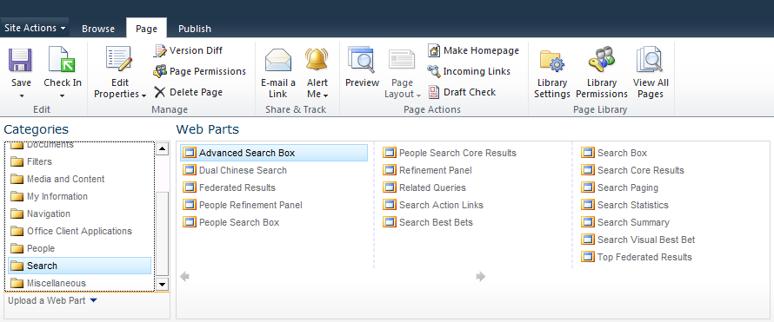

Figure 6. Search Web Parts

## Social Search

A significant aspect to people's work in an organization is interacting with other people and finding the right people to connect with who have specific skills and talents. This can be a daunting challenge in a large organization. SharePoint Server 2010 addresses this challenge through search, and connects this search to the social capabilities in SharePoint Server 2010. A people search center provides specific capabilities for connecting with people.

### Finding People

SharePoint Server 2010 provides an address book-style name lookup experience with better name matching, making it easier to find people by name, title and organizational structure. This includes phonetic name matching that will return names that sound similar to what the user has typed in a query. It will also return all variations of common names, including nicknames.

The refiners provided on the core search results are also provided with people search results—exploring results via name, title, and various fields in a user's profile enable quick browsing and selection of people. People search results also include real-time presence through Microsoft Office Communications Server, making it easy to immediately connect with people once they are found through search. Figure 7 shows a People Search results page.

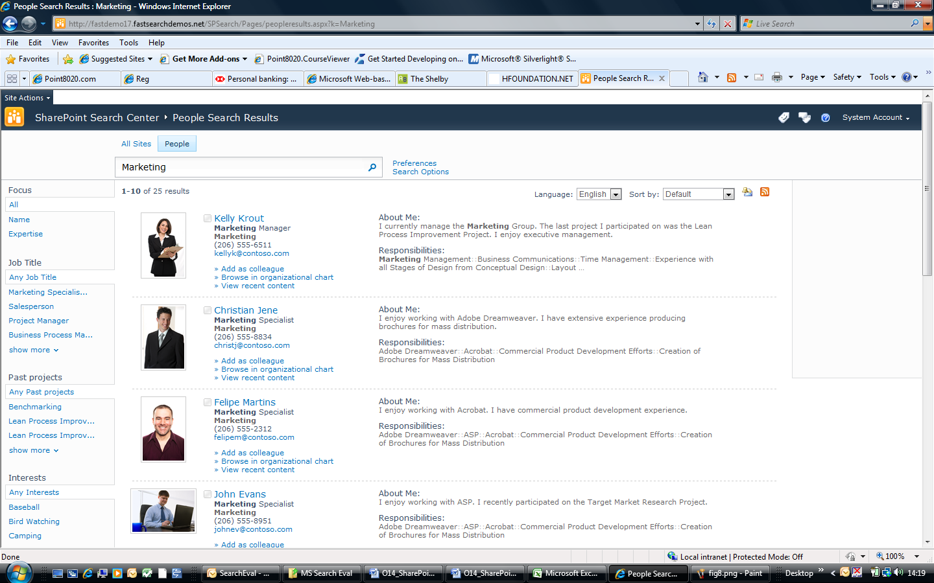

Figure 7. People Search Result Page

### Mining and Discovering Expertise

Users can manually submit or automatically generate a list of colleagues mined from Outlook®. Automatically generated lists of colleagues are a way of rapidly inferring social relationships throughout the organization, which speeds the adoption and usefulness of people search results. SharePoint Server 2010 also infers expertise by automatically suggesting topics mined from the user’s Outlook inbox and suggesting additions to their expertise profile in their My Site. This makes it easy to populate My Site profiles and means that more people have well-populated profiles and get the benefits of this in both search and communities.

### Improving Search based on Social Behavior

For many organizations, SharePoint sites have become gathering places where people create, share and interact with information. Social behavior is taken into account in order to provide high quality search results in several ways. The relevance ranking for people search takes social distance into account: a direct colleague will appear before someone 3 degrees removed. Second, SharePoint Server 2010 supports social tagging of content, and this feedback can influence the relevance of content in search results. People’s day-to-day usage of information in SharePoint Server 2010 and Microsoft Office can have a measurable impact on search relevance, thereby helping the organization harness the collective wisdom of its people.

## FAST Search Server 2010 for SharePoint User Experience

Figure 8 shows the search user interface provided by the FAST Search Center site template. Note that the user interface looks and feels very similar to Search Center sites in SharePoint Server 2010. This provides information workers with a consistent search experience.

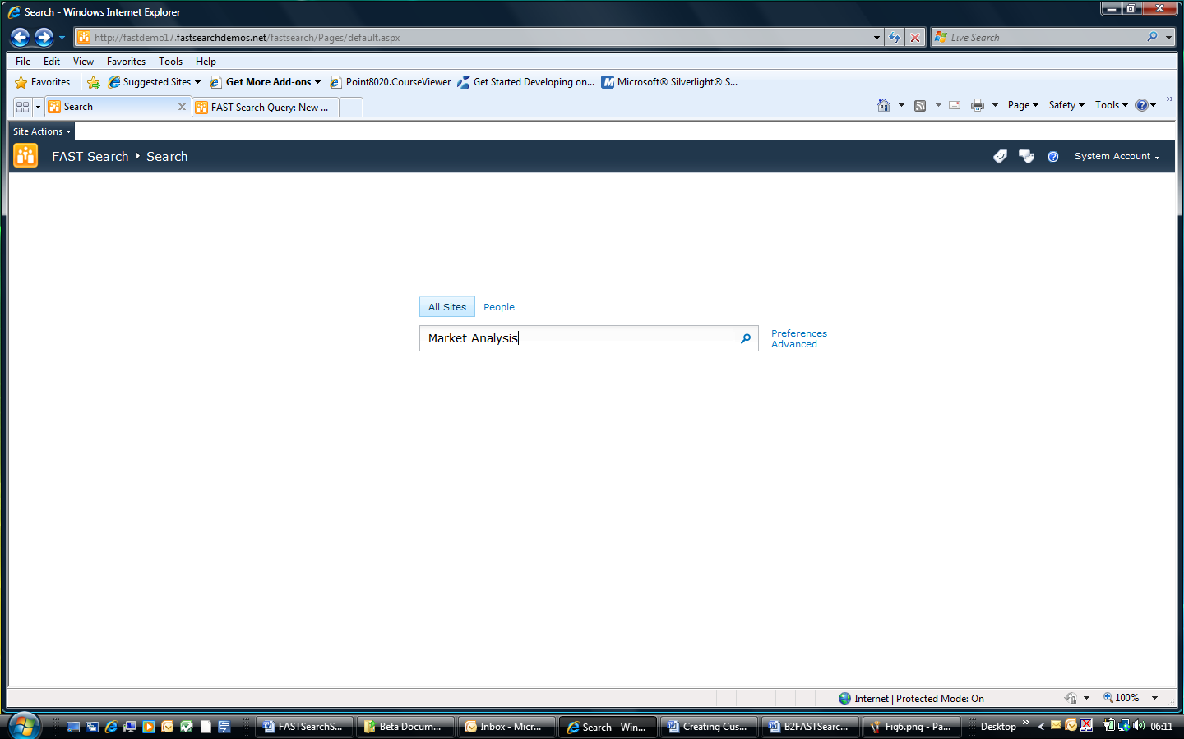

Figure . Consistent Search User Interface

Figure 9 shows the advanced search user interface provided by the FAST Search Center site template. Note that the advanced user interface also looks and feels similar to that provided by Search Center sites in SharePoint Server 2010.

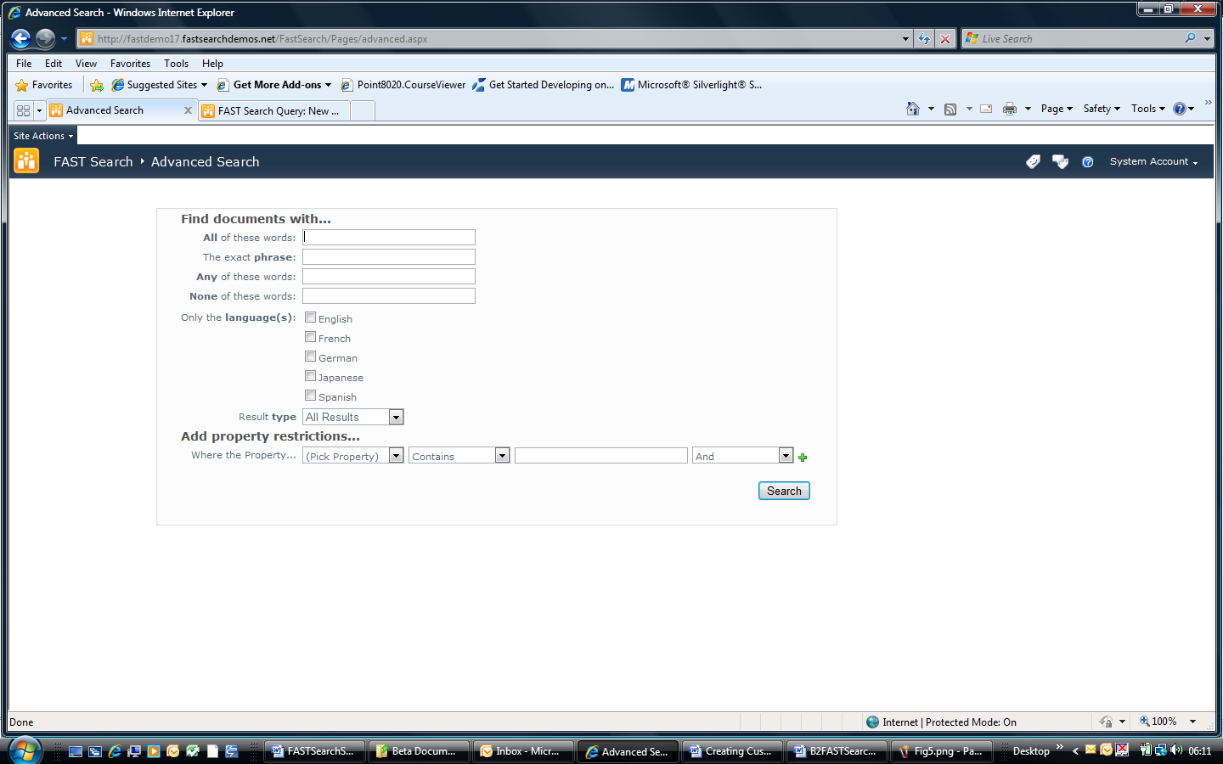

Figure . Consistent Advanced Search

Figure 10 shows the user preferences provided by the FAST Search Center site template. Note that the user preferences interface also looks and feels similar to that provided by Search Center sites in SharePoint Server 2010. This provides information workers with a consistent search experience.

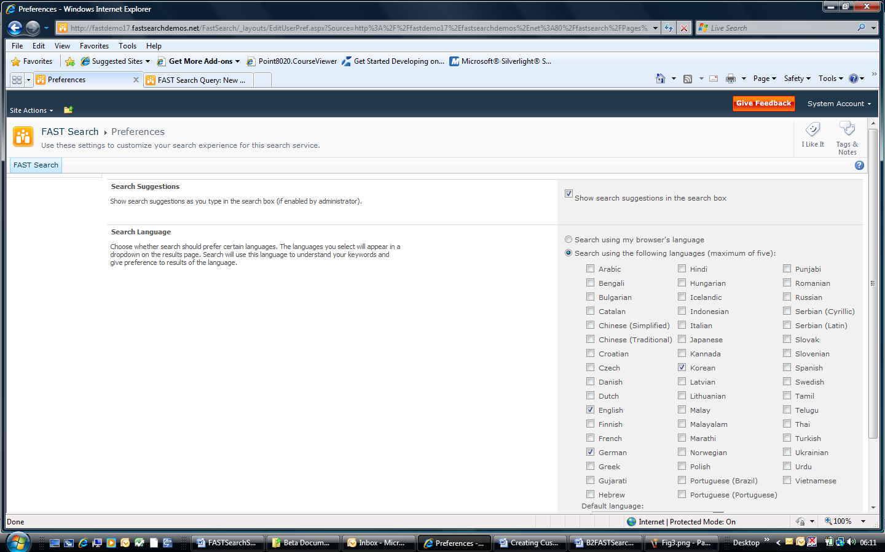

Figure . Consistent User Preferences

## Enhanced Search Results

Figure 11 shows a typical results page in a FAST Search Center.

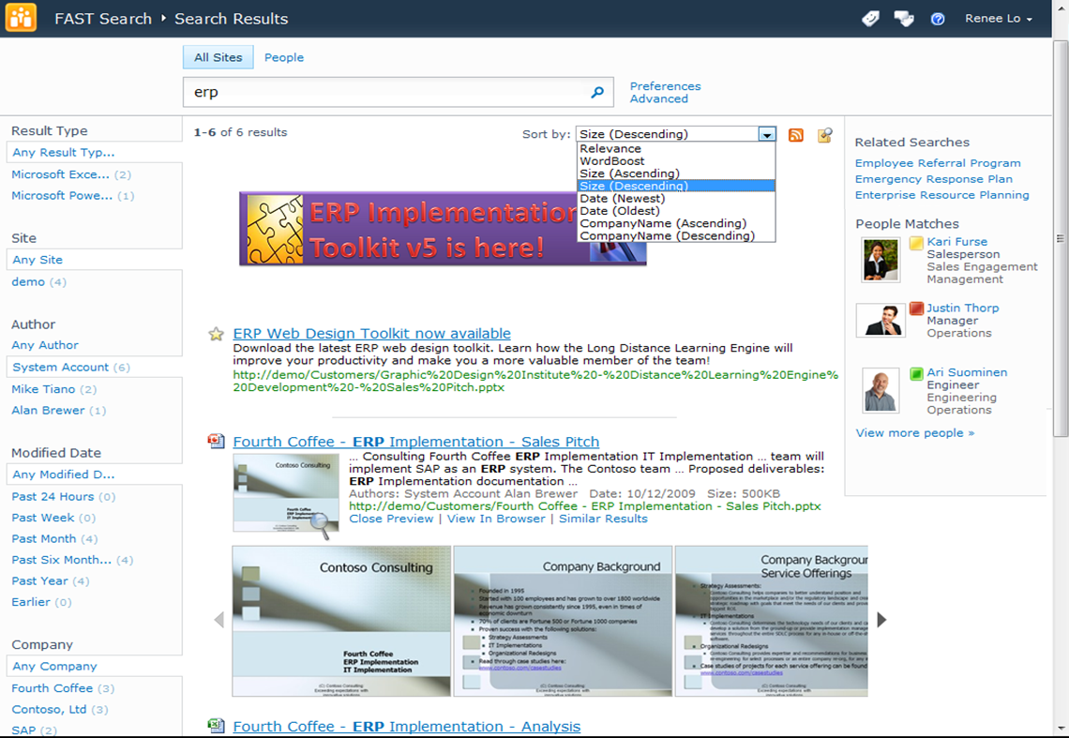

Figure . Enhanced Search Results Page

Notice how the overall results experience is very similar to the results provided by SharePoint Server 2010. The refiners are to the left, the search results are down the middle, and the federated results (from People Profiles and other sources) and query suggestions are on the right. However, there are some key capabilities that are only available with FAST Search Server 2010 for SharePoint. The most noticeable difference is the document previews and thumbnails for the search results, and the Visual Best Bet at the top of the results. Microsoft Word and PowerPoint documents have thumbnails, and PowerPoint documents can be previewed right in the browser. Along the left hand side, all of the refiners have exact counts. This reflects the total number of documents in the entire result set that contain this value. Additionally, you can see how results can be sorted by managed properties and ranking profiles.

FAST Search Server 2010 for SharePoint is also the ideal platform for developing search based applications and custom solutions. Figure 12 illustrates an example of a Customer Relationship Management application based on search. In this scenario, a sales executive can find related content from previous engagements with a customer or with a particular service offering that is very similar to something in her pipeline. This helps the organization secure new business by leveraging the organization's past successes.

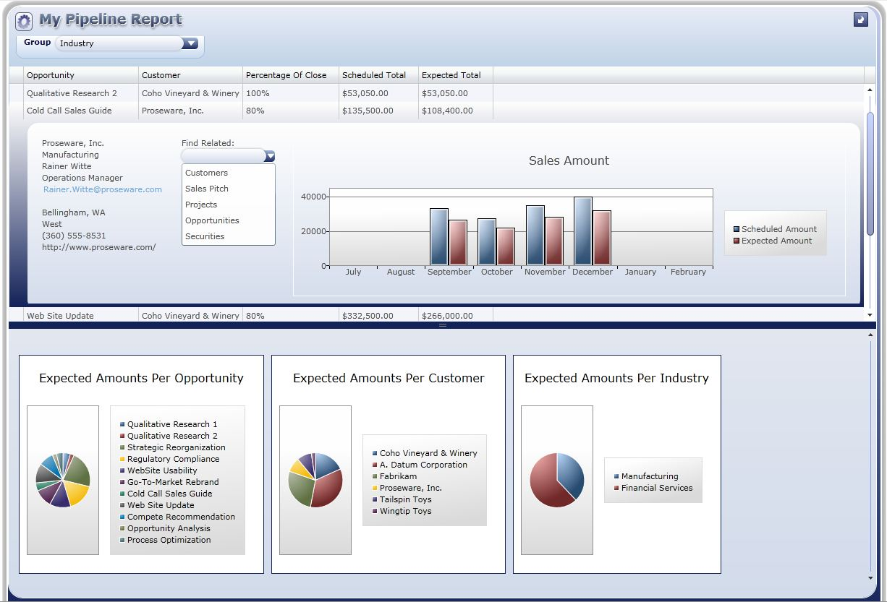

Figure . Search Based Applications

# FAST Search Server 2010 for SharePoint for IT Professionals

## FAST Search Server 2010 Architecture Overview

Figure 13 shows the FAST Search Server 2010 for SharePoint system as part of an overall SharePoint deployment.

Figure . FAST Search 2010 for SharePoint in an Overall SharePoint Farm Architecture

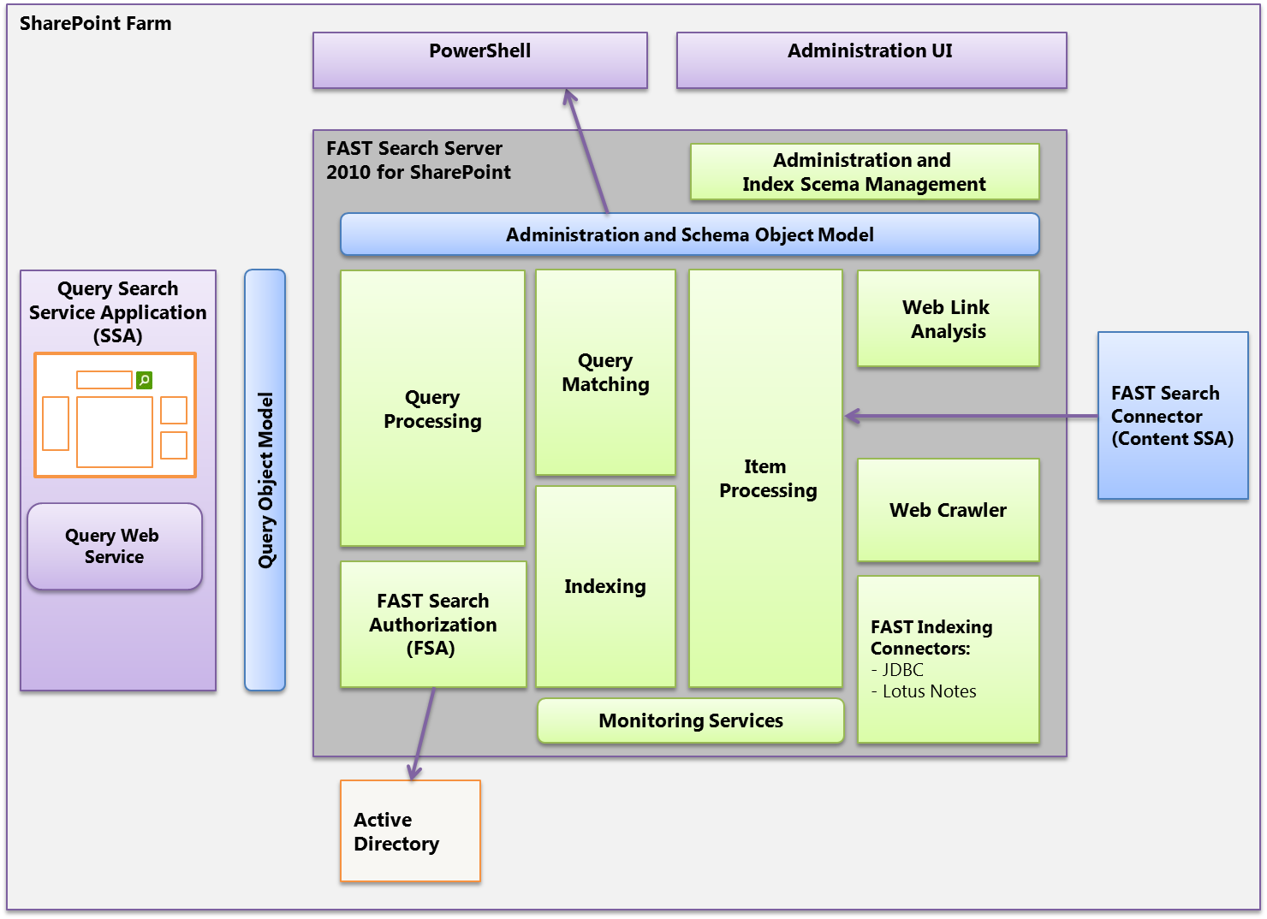

FAST Search Server 2010 for SharePoint search solutions consist of three main parts:

* **FAST Search Server 2010 for SharePoint**. The server infrastructure that provides processing, indexing and query capabilities, and the administration of these features.
* **FAST Query Search Service Application**. The Query Search Service Application provides the query Web front-end capabilities. You install and deploy this Search Service Application on SharePoint Web servers, and it hosts Search Web parts and the SDK query integration capabilities for your search solution.
* **FAST Search Connector Content Search Service Application**. The content Search Service Application retrieves content for indexing from SharePoint farms and other content repositories. You install and deploy this Search Service Application on a SharePoint application server. The content Search Service Application includes an indexing connector that can retrieve content from any external source including SharePoint farms, internal/external Web servers, Exchange public folders, line of business data and file shares. FAST Search Server 2010 for SharePoint also provides a set of additional indexing connectors for advanced content retrieval use cases. Configuration of the additional indexing connectors is performed via XML files and through Windows PowerShell cmdlets or command-line operations, as opposed to the other supported SharePoint indexing connectors, which are administered directly from Central Administration.

### Modular and Scalable Architecture

1. FAST Search Server 2010 for SharePoint is built on a highly modular architecture where the services can be scaled individually to achieve the desired performance with respect to:

* Amount of indexed content. By partitioning into multiple index columns you can index over a billion documents within a single installation.
* Query load. You can scale the query matching components in a row/column matrix where the columns reflect the index partitioning, and the rows add query performance and fault-tolerance for query evaluation.
* Freshness (indexing latency). FAST Search Server 2010 for SharePoint enables you to optimize for low latency from the moment a document is changed in the source repository to the moment it is searchable. This can be done by proper dimensioning of the crawling, item processing, and indexing to fulfill your requirements. These three parts of the system can be scaled independently through the modular architecture.

### Integration with Search Center

When you create a search site based on the FAST Search Center template, the resulting site will look and feel very similar to a SharePoint Server 2010 Search Center site. However, the Web Parts included are extended versions of the SharePoint Server 2010 Search Web Parts. They include the additional capabilities provided by FAST Search Server 2010 for SharePoint, such as sorting by managed properties, previewers, deep refiners, similar results links, and so on.

FAST Search Centers, like those of SharePoint Server 2010, also include People search capabilities. In fact, the People search is provided natively by SharePoint Server 2010, and FAST Search Server 2010 for SharePoint simply federates People search into the Search Center user interface. Refer to *Walkthroughs: Information Workers and FAST Search Center* later in this guide for procedures and screenshots that show how a user works with FAST Search Center.

### IT Professional Experience

IT professionals work with FAST Search Server 2010 for SharePoint in a similar way to how they administer the enterprise search features of SharePoint Server 2010. For example, you can use the Site Settings page to administer FAST Search keywords, FAST Search site promotion and demotion, and FAST Search user contexts, much like you would administer SharePoint Server 2010 keywords at the site collection level. Furthermore, you can use Central Administration to work with FAST managed properties much like you would administer SharePoint Server 2010 keywords at the Search Service Application level. Refer to the various walkthroughs later in this guide for step-by-step procedures.

### Windows PowerShell Support

Windows PowerShell is a powerful command-line shell and scripting language that helps you perform administrative tasks. Microsoft FAST Search Server 2010 for SharePoint includes over 80 Windows PowerShell cmdlets.

Windows PowerShell cmdlets for FAST Search Server 2010 for SharePoint are specialized .NET classes that implement specific system administration actions in the areas of search management, index schema management, security, and administration. Typical tasks include uploading a custom dictionary, mapping crawled properties to managed properties, and customizing the index schema.

FAST Search Server 2010 for SharePoint uses a master Windows PowerShell snap-in called Microsoft.FASTSearch.PowerShell.dll. This DLL includes all the code for over 80 cmdlets.

### Categories of cmdlets

FAST Search Server 2010 for SharePoint cmdlets cover four basic areas:

* Administration
* Security
* Index schema
* Spell tuning

For more information, refer to the overview page for [FAST Search Server 2010 for SharePoint](http://go.microsoft.com/fwlink/?LinkID=169498).

### Developer Experience

FAST Search Server 2010 for SharePoint Web Parts use the same unified object model as SharePoint Server 2010 and the other search platforms from Microsoft. The result is that if you develop a custom solution that uses the query object model for SharePoint Server 2010, for example, then it will continue to work if you migrate your code to FAST Search Server 2010 for SharePoint.

## FAST Search Server 2010 for SharePoint —Services and Components

1. Figure 14 shows the main services of FAST Search Server 2010 for SharePoint.

Figure . High-Level System Overview



The following subsections describe the functionality for each service in Figure 12.

### FAST Search Connector

The FAST Search Connector enables you to retrieve content for indexing from SharePoint farms, public Exchange folders, Web sites, databases and file shares.

You install and deploy the FAST Search Connector as a Search Service Application (SSA) on a SharePoint application server, and it shares the same crawler/connector framework as SharePoint Server 2010. This includes the Business Data Catalog functionality, which is substantially improved from Office SharePoint Server 2007.

FAST Search Server 2010 for SharePoint also includes additional indexing connectors for more targeted content retrieval needs. This includes connectors for database access (JDBC), Lotus Notes and a dedicated Web crawler. For the Beta release it is recommended to use the standard SharePoint connectors, which will solve most enterprise search needs.

### Web Link Analysis (Web Analyzer)

The Web Analyzer has two main functions: It analyzes search click**-**through logs and hyperlink structures. Both contribute to better ranked search results. Items that show many clicks in the search click**-**through log are popular and therefore receive better rank scores than less-viewed items. Items that are linked to from many other items are also perceived to be more relevant for the user and therefore receive better rank scores.

The Web Analyzer scales up to many nodes to reduce the total time that is needed for the analysis.

### Item Processing

The item processing service receives items to be indexed from indexing connectors. The item processing service extracts content from source documents in various formats, discovers and sets managed properties, and performs linguistic processing on the content. The item processing service then sends the processed items to the indexing service.

Key features of the item processing service are as follows:

* Mapping from crawled properties to managed properties. Managed properties contain the content that will be indexed including metadata associated with the items. You will first perform a crawled property discovery based on an initial set of crawled items. Based on this discovery you can change the mapping to managed properties.
* Parsing of document formats such as Office and PDF. This includes extracting searchable text and metadata from these formats.
* Extracting properties from the retrieved content. The property extraction can detect various properties such as names and dates from the documents, and maps them into managed properties. In this manner you can query these properties, and also change query refinement based on these properties. It is also possible to create custom property extractors using, for example, a dictionary of product names relevant to your organization.
* Linguistic processing of items before indexing. In search, linguistics is defined as the use of information about the structure and variation of languages so that users can more easily find relevant information. The item’s relevancy with regard to a query is not necessarily decided based on words common to both query and document, but instead the extent that its content satisfies the user’s need for information. Examples of linguistic processing in the item processing include character normalization and normalization of stemming variations.

### Indexing

The indexing service creates searchable indexes, based on the processed items. No external database is needed for the indexing or the generated indexes.

The indexing service supports a seamless content partitioning into index columns in order to handle large content volumes.

The indexing is controlled by an index schema object model, which defines the mapping of managed properties into the searchable index structures, and how relevancy ranking is to be performed.

### Query Matching

The query matching service uses the indexes created by the indexing service to retrieve the items that match a query and then return these items as a query result set.

A query usually contains several terms combined with query operators, such as AND and OR. The query matching service looks up each term in the index and retrieves a list of items in which that term appears. The order of the returned items is based on the requested sorting mechanism, which is usually the relevance ranking that is calculated from various item properties, or a sort based on one or more of the item properties.

The query matching service can also return a hit highlighted summary for each item in the query hit list. A hit highlighted summary consists of a fragment of the original item in which the matching query terms are highlighted.

The query matching service is responsible for the deep refinement that is associated with query results. Query refinement enables drilling down into a query result by using aggregated statistical data that was computed for the query result. The query matching service maintains aggregation data structures to enable deep refinement across large result sets.

### Query Processing

The query processing service performs the processing of queries and results that can be performed without access to the index. Query processing includes query-language parsing, linguistic processing, and item-level security processing. Result processing includes merging the results from multiple index columns, formatting the query hit list, formatting the query refinement data, and removing duplicates.

It is the responsibility of the query processing service to ensure that the user performing a query sees only the results that he or she is authorized to see. The query processing service therefore validates the user’s permissions and rewrites the incoming query with an access filter that corresponds to the current user and group membership.

## Connector Framework

SharePoint Server 2010 provides a new framework for connecting to and crawling content sources. Connectors for SharePoint sites, Web sites, file shares, custom databases and Web services (via Business Connectivity Services), Exchange public folders, and Lotus Notes databases are provided with the product.

### New Connector Features

The connector framework provides improvements over the protocol handlers in previous versions of SharePoint Server. For example, connectors can now crawl attachments as well as the content in e-mail messages. Also, item-level security descriptors can now be retrieved for external data exposed by Business Connectivity Services. Furthermore, when crawling a Business Connectivity Services entity, additional entities can be crawled via its entity relationships. Connectors also perform better than previous versions of protocol handlers, by implementing concepts such as inline caching and batching.

Connectors support richer crawl options than the protocol handlers in previous versions of SharePoint Server. For example, they support the full crawl mode that was implemented in previous versions, and they support timestamp-based incremental crawls. However, they also support change log crawls that can remove items which have been deleted since the last crawl.

### Creating Connectors

In previous versions of SharePoint Server, it was very difficult to create protocol handlers for new types of external systems. Protocol handlers were required to be coded in unmanaged C++ code, and typically took a long time to test and stabilize.

With SharePoint Server 2010, you have many more options for crawling external systems. You can choose to:

* Use SharePoint Designer 2010 to create external content types and entities for databases or Web Services, and then simply crawl those entities
* Use Visual Studio 2010 to create external content types and entities for databases or Web Services, and then simply crawl those entities
* Use Visual Studio 2010 to create .NET types for Business Connectivity Services (typically for back end systems that implement dynamic data models, such as document management systems). Then use either SharePoint Designer 2010 or Visual Studio 2010 to create external content types and entities for the .NET type.

**NOTE**: You can still create protocol handlers (as in previous versions of SharePoint Server) if you need to.

## Search Administrator Walkthroughs

The enterprise search features provided by SharePoint Server 2010 can be administered at the site collection level and at the Search Service Application level. The following sections provide step-by-step instructions for working with various aspects of enterprise search in SharePoint Server 2010.

### Search Administration at the Search Service Application Level for SharePoint Server 2010.

Administrators can use the Search Service administration pages to manage search settings that affect all Web applications that consume the search service. The main day-to-day operations include scenarios for working with crawler settings, working with queries and results settings, and working with search reports. The following step-lists provide instructions for performing common operations in all of these scenarios.

### Crawler Settings

The following step-by-step instructions will help you get started working with crawler settings.

#### Creating Content Sources

1. Click **Start>All Programs>Microsoft SharePoint 2010 Products>SharePoint 2010 Central Administration**.
2. In the **Application Management Section**, click **Manage service applications**.
3. Click **Search Service Application**.
4. In the **Quick Launch**, in the **Crawling** section, click **Content Sources**.
5. Click **New Content Source**.

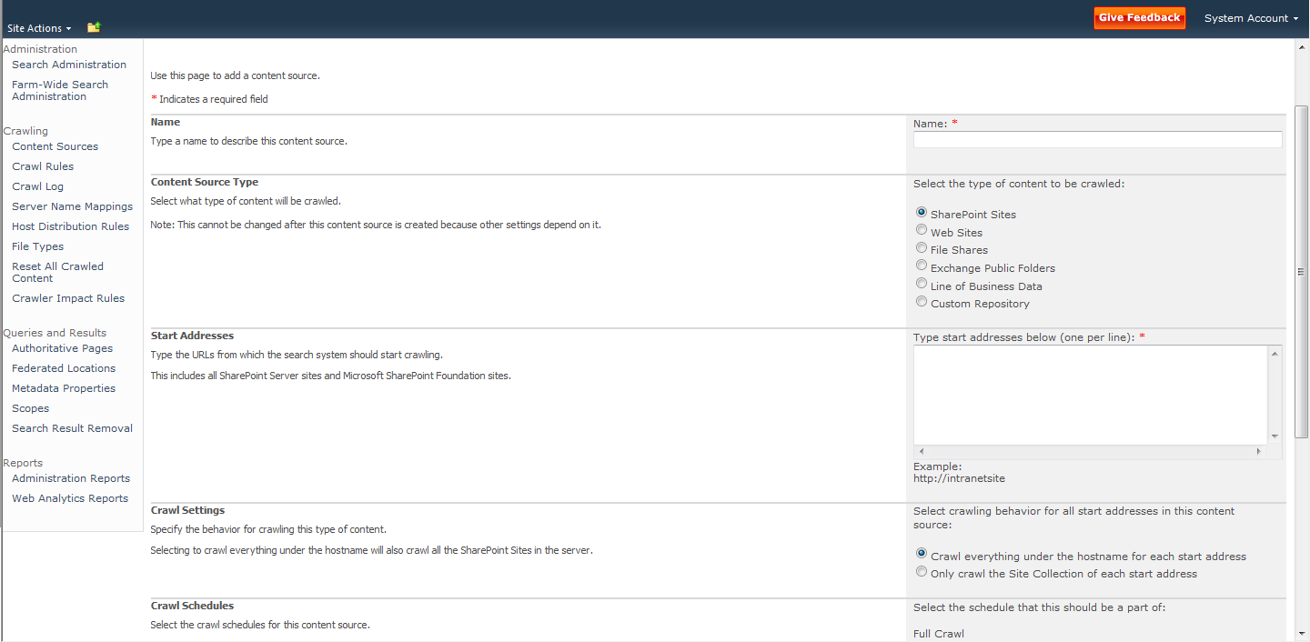

1. Review all of the settings on this page. Experiment with adding different types of content sources for your environment.

#### Configuring People Search

By default, SharePoint Server 2010 automatically includes user profile details when it crawls the Local SharePoint Sites content source. This indexed user profile data provides the basis for People search in SharePoint Server 2010. However, before people searches yield useful information, you will need to import or create user profiles. Refer to [Post-installation steps for search (SharePoint Server 2010)](http://technet.microsoft.com/en-us/library/ee808863(office.14).aspx) for guidance on working with user profiles, and making other post-installation configuration changes to SharePoint Server 2010.

#### Creating Crawl Rules

1. Click **Start>All Programs>Microsoft SharePoint 2010 Products>SharePoint 2010 Central Administration**.
2. In the **Application Management Section**, click **Manage service applications**.
3. Click **Search Service Application**.
4. In the **Quick Launch**, in the **Crawling** section, click **Crawl Rules**.
5. Click **New Crawl Rule**.

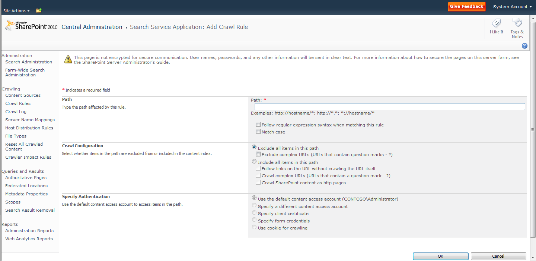

1. Review all of the settings on this page. Experiment with adding different crawl rules for your environment.

#### Creating Crawler Impact Rules

1. Click **Start>All Programs>Microsoft SharePoint 2010 Products>SharePoint 2010 Central Administration**.
2. In the **Application Management Section**, click **Manage service applications**.
3. Click **Search Service Application**.
4. In the **Quick Launch**, in the **Crawling** section, click **Crawler Impact Rules**.
5. Click **Add Rule**.

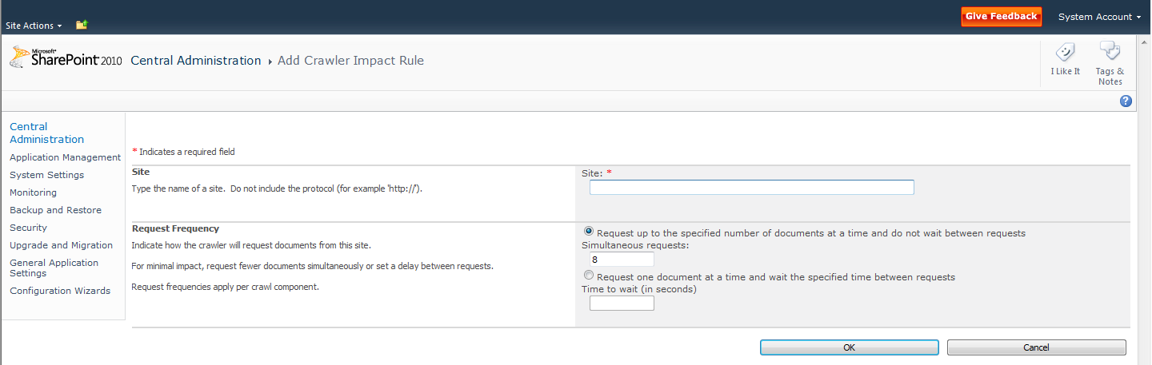

1. Review all of the settings on this page. Experiment with adding different crawler impact rules for your environment.

### Queries and Results Settings

The following step-by-step instructions will help you get started working with queries and results settings.

#### Creating Authoritative Pages

1. Click **Start>All Programs>Microsoft SharePoint 2010 Products>SharePoint 2010 Central Administration**.
2. In the **Application Management Section**, click **Manage service applications**.
3. Click **Search Service Application**.
4. In the **Quick Launch**, in the **Queries and Results** section, click **Authoritative Pages**
5. Add a new line and URL in the **Most authoritative pages** box.
6. Add a new line and URL in the **Sites to demote** box.

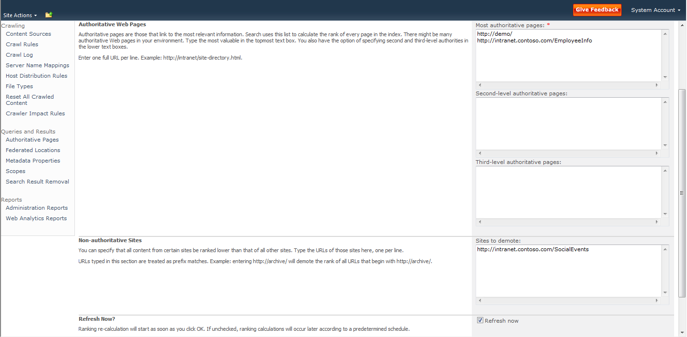

1. Click **OK**.

#### Creating Federated Locations

**Note:** This procedure depends on you having created a site based on the Enterprise Search Center site template in one of your site collections.

1. Click **Start>All Programs>Microsoft SharePoint 2010 Products>SharePoint 2010 Central Administration**.
2. In the **Application Management Section**, click **Manage service applications**.
3. Click **Search Service Application**.
4. In the **Quick Launch**, in the **Queries and Results** section, click **Federated Locations**.
5. Click **New Location**.
6. Click the **Online Gallery** link.  
   A web page opens in a new browser window.
7. Click **Federated Search Connectors**.
8. In the **Download Sample Connectors** section, expand the **News** section.
9. Click **Live.com News**.

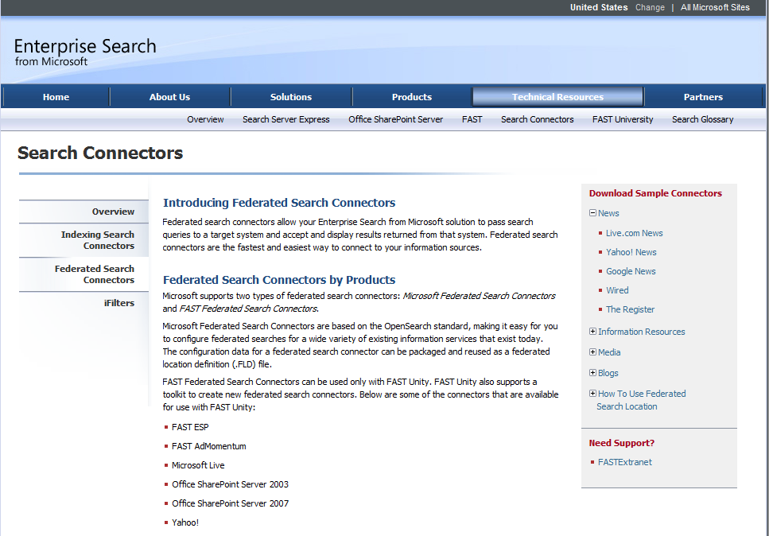

1. Click **Save** and save the **LiveNews.FLD** file to your desktop.
2. Switch back to Central Administration.
3. Click **Import Location**.
4. Click **Browse**.
5. Select the **LiveNews.FLD** file in your **Desktop** folder, and click **Open**.
6. Click **Done**.
7. Start Internet Explorer and browse to your SharePoint site collection. Then browse to your Search Center site.
8. In the search box, type **SharePoint** and press [ENTER].
9. On the **Site Actions** menu, click **Edit Page**.
10. In the **Bottom Zone**, click **Add a Web Part**.
11. In the **Categories** pane, click **Search**.
12. In the **Web Parts** pane, click **Federated Results**.
13. Click **Add**.
14. In the **Bottom Zone**, point to **Top Federated Results**, and then click the dropdown arrow on the Web Part.
15. Click **Edit Web Part**.

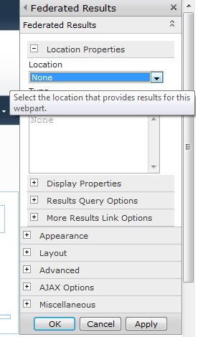

1. In the properties pane for the Web Part, in the **Location** section dropdown list, click **Live News**, and then click **OK**.
2. On the ribbon, click **Save**.

#### Creating Metadata Properties

**NOTE**: In this procedure you will create two lists with custom columns. You will then crawl the lists so that their columns are indexed, and then you will create a managed metadata property that maps to columns in the lists.

1. Use Internet Explorer to browse to your SharePoint site.
2. On the site actions menu, click **More Options**.
3. Click **Custom List**.
4. In the **Name** text box, type **Products** and then click **Create**.
5. On the ribbon. Click **List Settings**.
6. Click **Create Column**.
7. In the **Column name** text box, type **Product Name** and then click **OK**.
8. On the site actions menu, click **More Options**.
9. Click **Custom List**.
10. In the **Name** text box, type **SKUs** and then click **Create**.
11. On the ribbon. Click **List Settings**.
12. Click **Create Column**.
13. In the **Column name** text box, type **SKU Name** and then click **OK**.
14. In the **Quick Launch**, click **Products**.
15. Click **Add new item**.
16. In the **Title** text box, type **SharePoint**.
17. In the **Product Name** text box, type **SharePoint Foundation 2010**.
18. Click **Save**
19. In the **Quick Launch**, click **SKUs**.
20. Click **Add new item**.
21. In the **Title** text box, type **SharePoint**.
22. In the **Product Name** text box, type **SharePoint Server 2010**.
23. Click **Save**
24. Click **Start>All Programs>Microsoft SharePoint 2010 Products>SharePoint 2010 Central Administration**.
25. In the **Application Management Section**, click **Manage service applications**.
26. Click **Search Service Application**.
27. In the **Quick Launch**, in the **Crawling** section, click **Content Sources**.
28. Point to **Local SharePoint Sites** and then click the dropdown arrow that appears.
29. Click **Start Full Crawl**.
30. Click **Refresh** until the **Status** column reads **Idle**. This may take a few minutes, depending on the size of your SharePoint sites.
31. In the **Quick Launch**, in the **Queries and Results** section, click **Metadata Properties**.
32. Click **New Managed Property**.
33. In the **Property Name** text box, type **Product**.
34. Click **Add Mapping**.

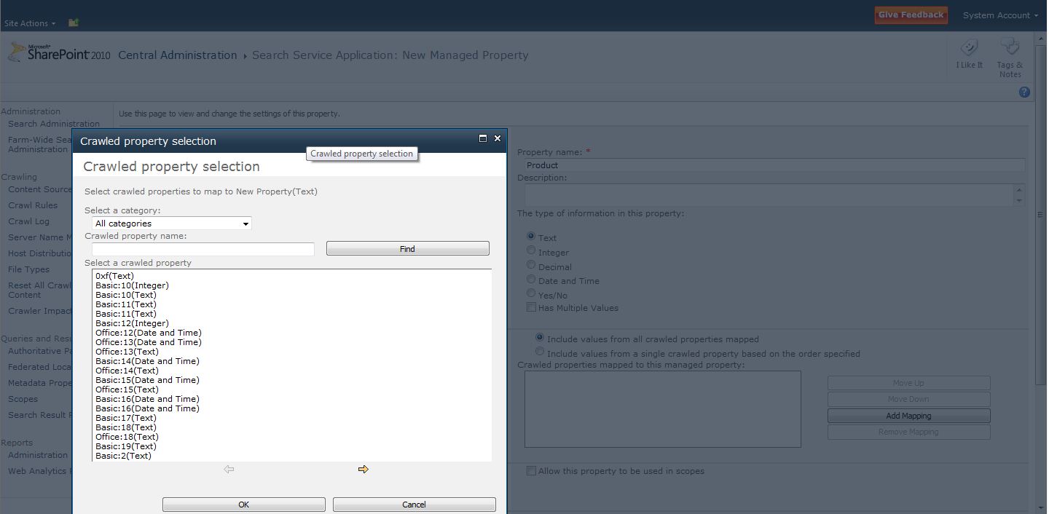

1. In the **Select a category** dropdown list, ensure that **All categories** is selected.
2. In the **Crawled property name** box, type **ows_Product** and then click **Find**.
3. Click the **ows_Product_x0020_Name(Text)** property, and then click **OK**.
4. Click **Add Mapping**.
5. In the **Select a category** dropdown list, ensure that **All categories** is selected.
6. In the **Crawled property name** box, type **ows_SKU** and then click **Find**.
7. Click the **ows_SKU_x0020_Name(Text)** property, and then click **OK**.
8. Check the **Allow this property to be used in scopes** check box.
9. Click **OK**.

### Search Reports

The following step-by-step instructions will help you get started working with search reports.

#### Running Administration Reports

1. Click **Start>All Programs>Microsoft SharePoint 2010 Products>SharePoint 2010 Central Administration**.
2. In the **Application Management Section**, click **Manage service applications**.
3. Click **Search Service Application**.
4. In the **Quick Launch** area, in the **Reports** section, click **Administration Reports**
5. Click **Search administration reports**.

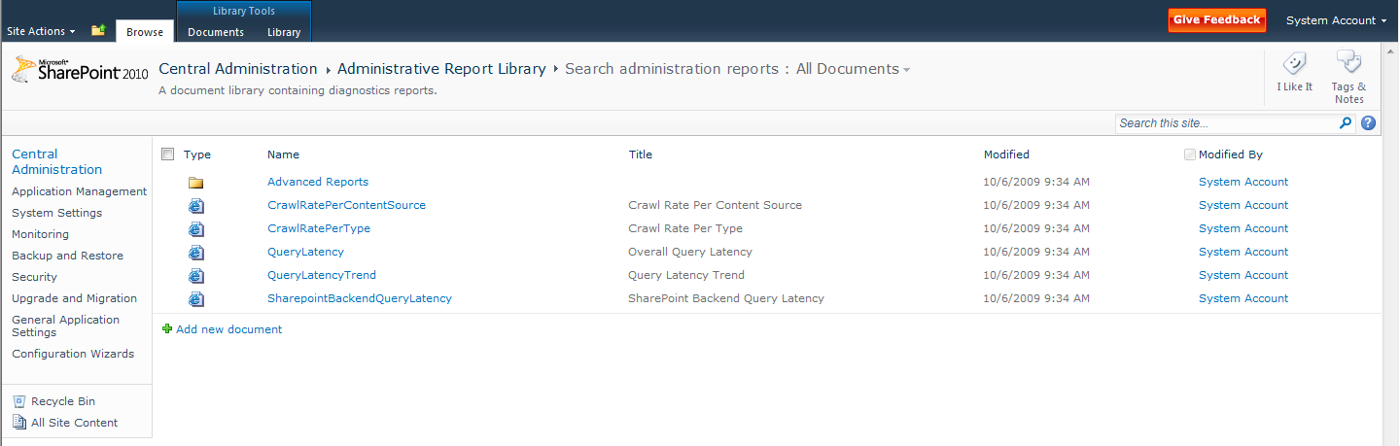

1. Click each of the reports to review the information contained. The following image shows an example of the **Query Latency** report:

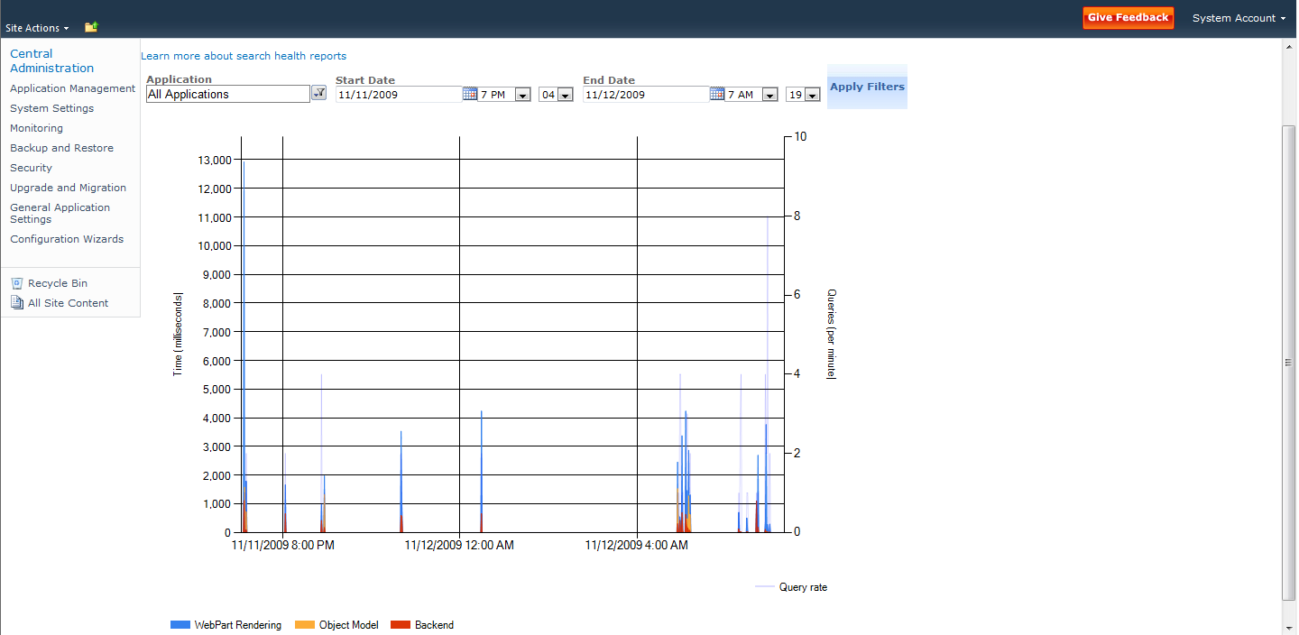

#### Running Web Analytics Reports

1. Click **Start>All Programs>Microsoft SharePoint 2010 Products>SharePoint 2010 Central Administration**.
2. In the **Application Management Section**, click **Manage service applications**.
3. Click **Search Service Application**.
4. In the **Quick Launch**, in the **Reports** section, click **Web Analytics Reports**.
5. Click each of the links in the **Quick Launch** area to view the different reports.

### Administering FAST Search Server 2010 for SharePoint Managed Properties

This section provides information for how administrators work with FAST Search Server 2010 for SharePoint settings at the Central Administration level. Use the following procedure to start administering managed properties for FAST Search Server 2010 for SharePoint.

#### Creating Managed Properties with FAST Search Server 2010 for SharePoint

1. Click **Start>All Programs>Microsoft SharePoint 2010 Products>SharePoint 2010 Central Administration**.
2. In the **Quick Launch** bar, click **General Application Settings**.
3. In the **Search** section, click **Farm-Wide Search Administration.**
4. In the **Search Service Applications** section, click **FAST Search Query**.
5. In the **Quick Launch** bar, in the **Administration** section, click **FAST Search Administration**.   
   The FAST Search Administration page appears.

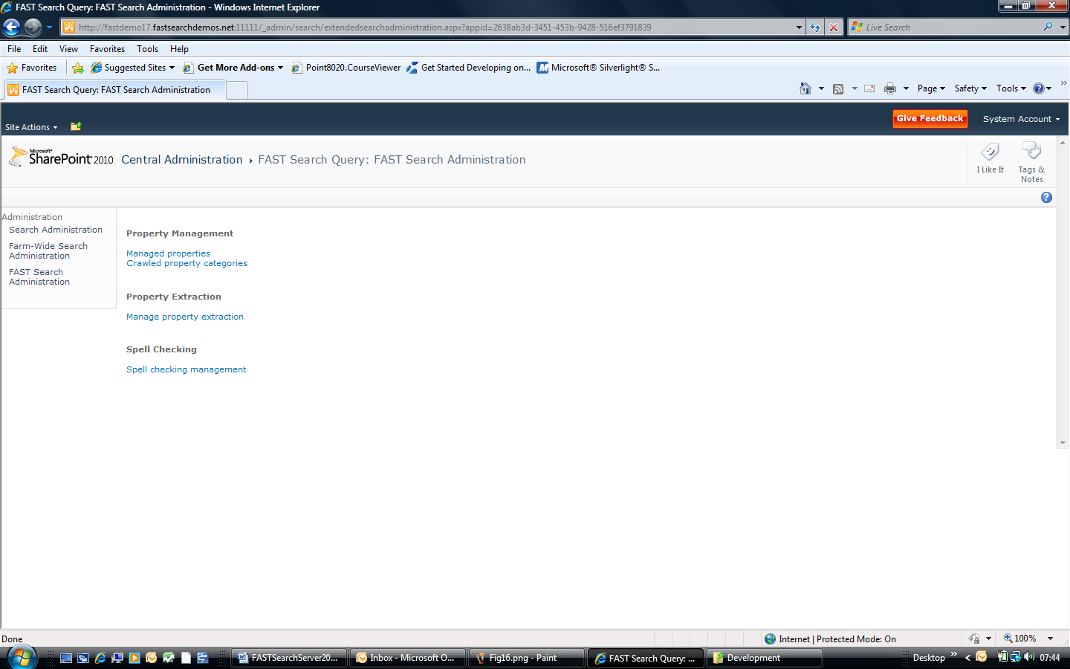

1. On the **Fast Search Administration** page, click **Managed properties**.
2. Click **Add Managed Property**.  
   The **New Managed Property** page appears.

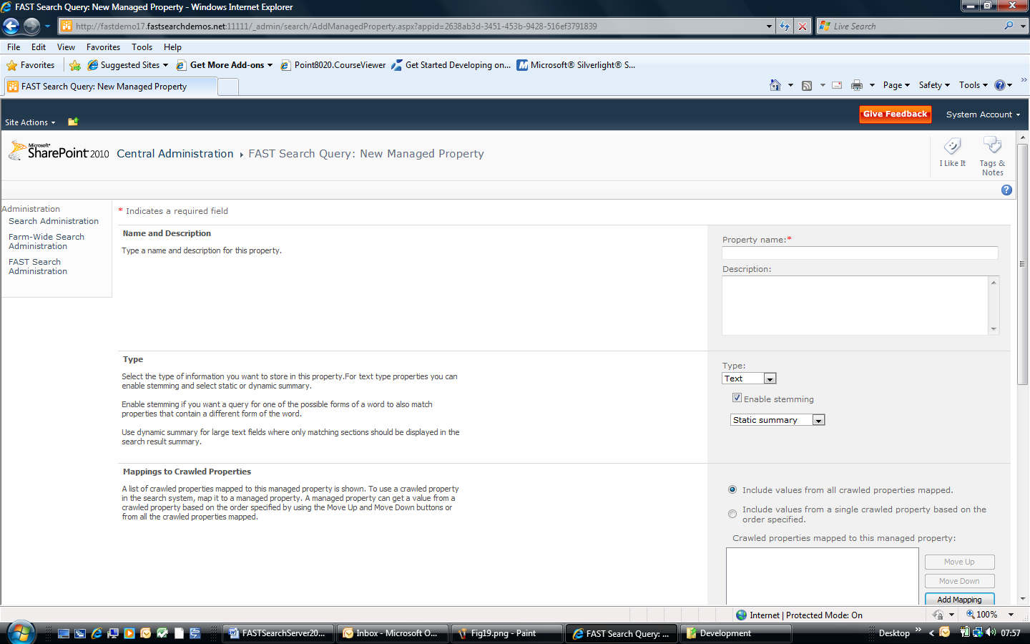

FAST managed properties include the stemming and summary behaviors that are not provided by SharePoint Server 2010 managed properties.

FAST managed properties include the ability for you to specify whether the managed property can be used as a sort by field and whether it can be used in as a filter term in search queries. You can also specify whether the managed property should be represented as refiner field. If so, you can also specify whether it is a deep refiner or just a shallow refiner. Furthermore, you can specify the priority level for the managed property. The priority is one of the inputs into the ranking algorithm, and defines how documents with the search term in this property should be ranked against other documents that may have the search term in other properties.

Figure 15 shows the user interface for working with all of these attributes

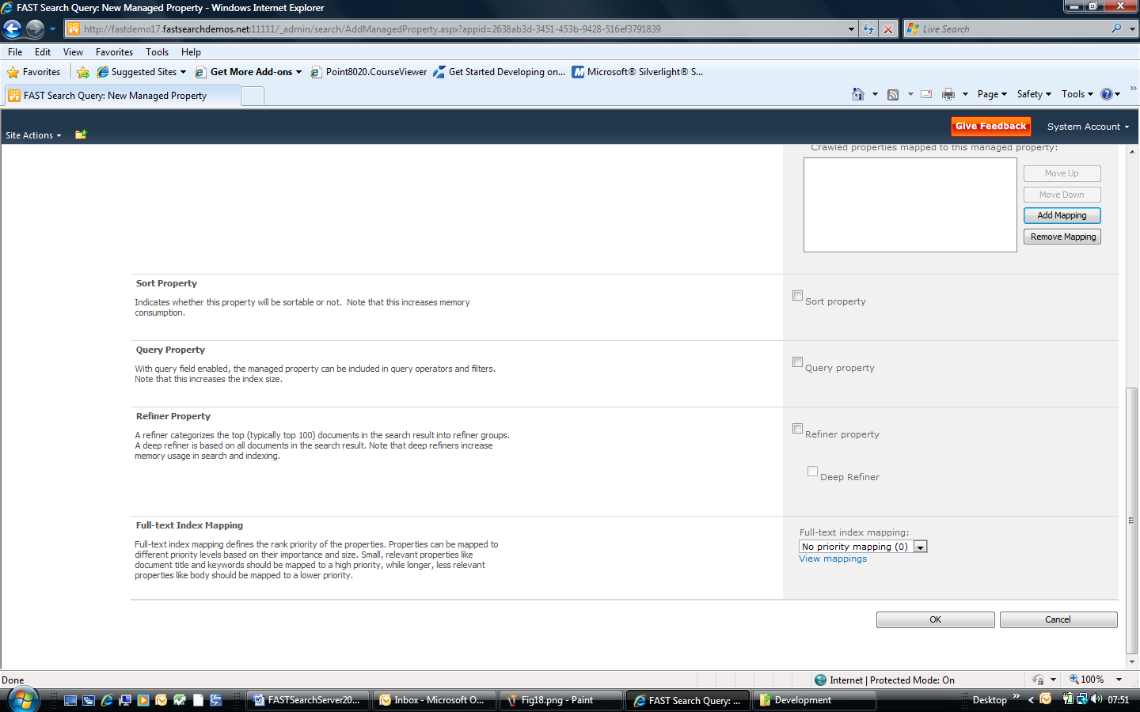

Figure . Sorting, Query Filters, and Refinement Attributes

### Search Administration at the Site Collection Level

Administrators can use the site collection administration pages to define keywords, Best Bets, synonyms, and definitions. Administrators can also use the site collection administration pages to define search scopes.

**NOTE**: Any settings created or modified at the site collection level affect only that Site Collection

#### Creating FAST Search Centers

**NOTE**: The following procedure creates a FAST Search Center at the root Web for a Site Collection. This is the generally recommended approach and architecture for creating Search Center sites with SharePoint Server 2010.

1. Click **Start>All Programs>Microsoft SharePoint 2010 Products>SharePoint 2010 Central Administration**.
2. In the **Application Management** section, click **Create site collections**.
3. In the **Web Application** section, use the Web Application changer to select the Web application where you want to create the Search Center.
4. In the **Title** text box, type **FAST Search Center**.
5. In the **Description** text box, type **FAST Search Center for SharePoint 2010**.
6. In the **Web Site Address** section, select **/sites/** in the drop-down list, and then type **fastsearch** in the text box.
7. In the **Template Selection** section, click the **Enterprise** tab.
8. Click **FAST Search Center**.   
   **Note**: Do not select *Basic Search Center*, because this template does not include tabs and people search features. Also, do not select **Enterprise Search Center**, because this is the SharePoint Server 2010 enterprise search center, rather than that of FAST Search Server 2010 for SharePoint.
9. In the **Primary Site Collection Administrator** section, type your name in the text box, and then click **Check Names**.
10. Click **OK**.  
    After a short period of time, the site collection is created and the **Top-Level Site Successfully Created** page appears.
11. Click the hyperlink to the new site collection to start exploring FAST Search Center.

#### Creating Keywords, Definitions, Best Bets, and Synonyms

1. Browse to the FAST Search Center site collection that you created previously.
2. On the **Site Actions** menu, click **Site Settings**.
3. In the **Site Collection Administration** section, click **Search keywords**.

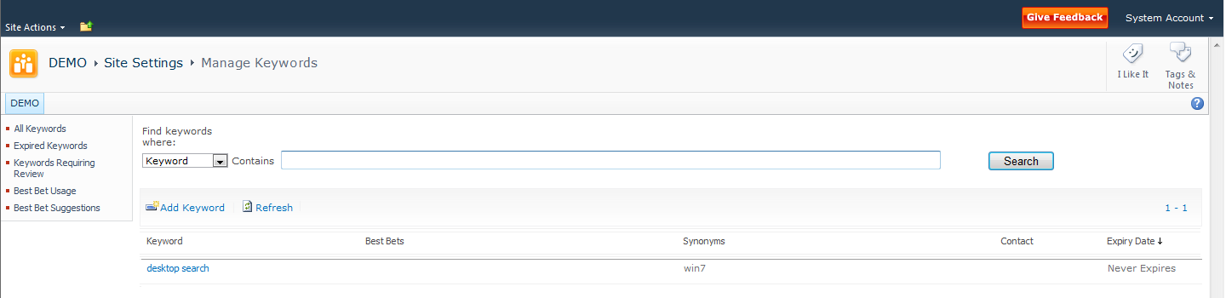

1. Click **Add Keyword**.
2. In the **Keyword Phrase** text box, type **SharePoint**.
3. In the **Synonyms** text box, type **SharePoint Foundation; SharePoint Server; Windows SharePoint Services**.
4. Click **Add Best Bet**.
5. In the **URL** text box, type **http://www.microsoft.com/sharepoint**.
6. In the **Title** text box, type **SharePoint on the Web**.
7. In the **Description** text box, type **SharePoint home page on www.microsoft.com**.
8. Click **OK**.
9. Click **Add Best Bet**.
10. In the **URL** text box, type **http://msdn.microsoft.com/sharepoint**.
11. In the **Title** text box, type **SharePoint Developer**.
12. In the **Description** text box, type **SharePoint home page on MSDN**
13. Click **OK**.
14. In the **Keyword Definition** text box, type **Collaboration and Search Platform**.

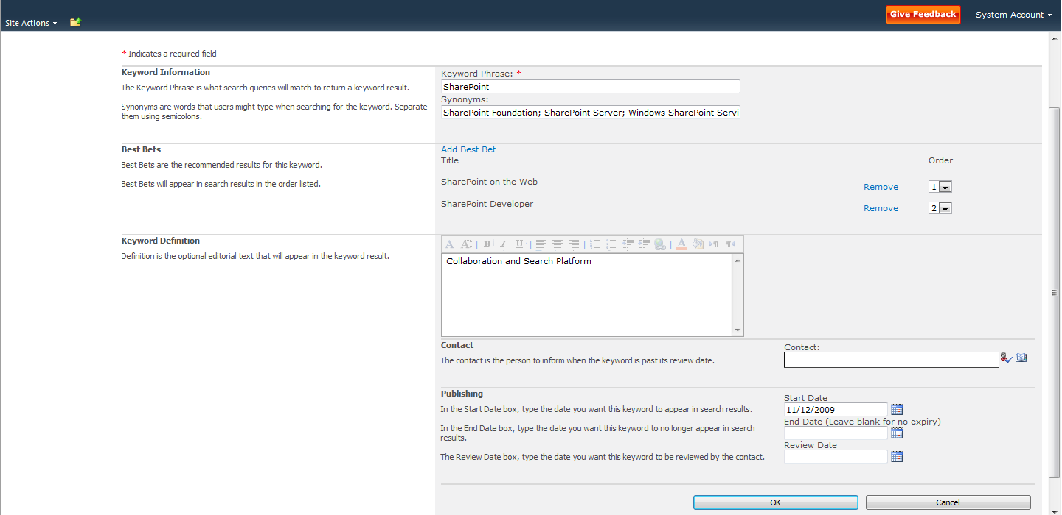

1. Click **OK**.

#### Creating Search Scopes

1. Browse to the FAST Search Center site collection that you created previously.
2. On the **Site Actions** menu, click **Site Settings**.
3. In the **Site Collection Administration** section, click **Search scopes**.

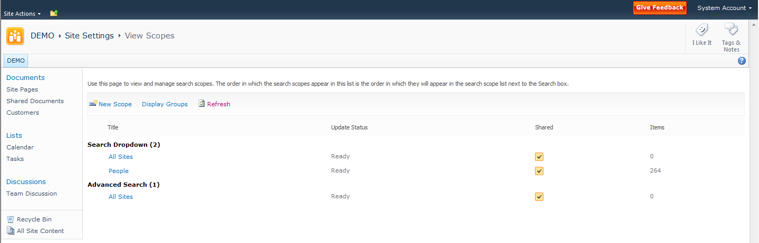

1. Click **New Scope**.
2. In the **Title** text box, type **Admin Docs**.
3. In the **Display Groups** section, check all check boxes.

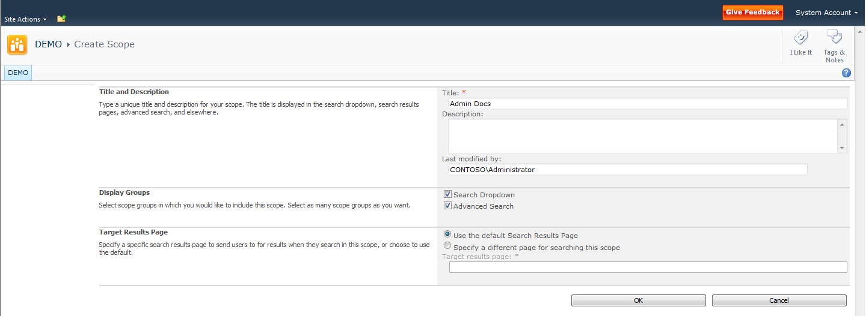

1. Click **OK**.
2. In the **Search** Dropdown section, next to **Admin Docs**, click **Add rules**.
3. In the **Scope Rule Type** section, click **Property Query**.
4. In the **Property Query** section, ensure that **Author** is selected in the dropdown box.
5. In the text box, type your name.

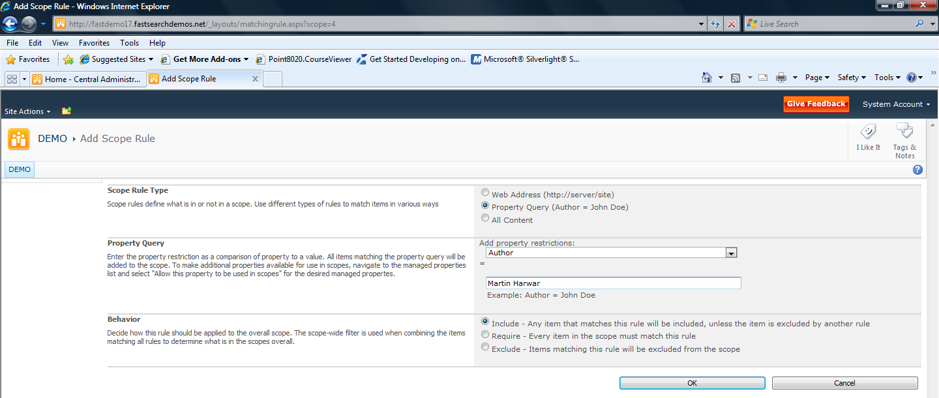

1. Click **OK**.  
   You may be notifies that the scope will be updated in a few minutes. If so, either wait the required number of minutes and then continue at step 18, or perform steps 13 through 17 and then continue at step 18.
2. Click **Start>All Programs>Microsoft SharePoint 2010 Products>SharePoint 2010 Central Administration**.
3. In the **Application Management Section**, click **Manage service applications**.
4. Click **Search Service Application**.
5. In the **System Status** section, next to **Scopes needing updating**, click **Start update now**.
6. Switch back to your SharePoint site collection.
7. Browse to the Search Center site in the site collection.
8. On the **Site Actions** menu, click **Edit Page**.
9. Point to the **Search Box** Web part, and then click the dropdown arrow that appears. Then click **Edit Web Part**.
10. In the properties of the Web Part, expand the **Scopes Dropdown** section.
11. In the **Dropdown mode** dropdown list, select **Show scopes dropdown**.

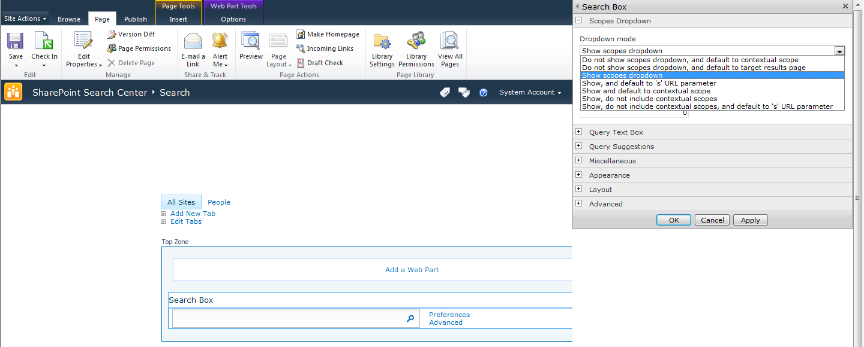

1. Click **OK**.
2. On the ribbon, click **Save**.  
   Note that the scopes dropdown list appears, and that your new **Admin Docs** scope is included in the list.

### FAST Site Collection Settings

This section provides information for how site collection administrators work with FAST Search Server 2010 for SharePoint settings.

**NOTE**: Any settings created or modified at the site collection level affect only that Site Collection

#### Exploring FAST Search Settings at the Site Collection Level

As a site collection administrator, you can use the site settings page to start creating FAST Search keywords, site promotions and demotions, and user contexts. Figure 16 shows links to the FAST Search settings in a site collection settings page.

FAST Search Settings

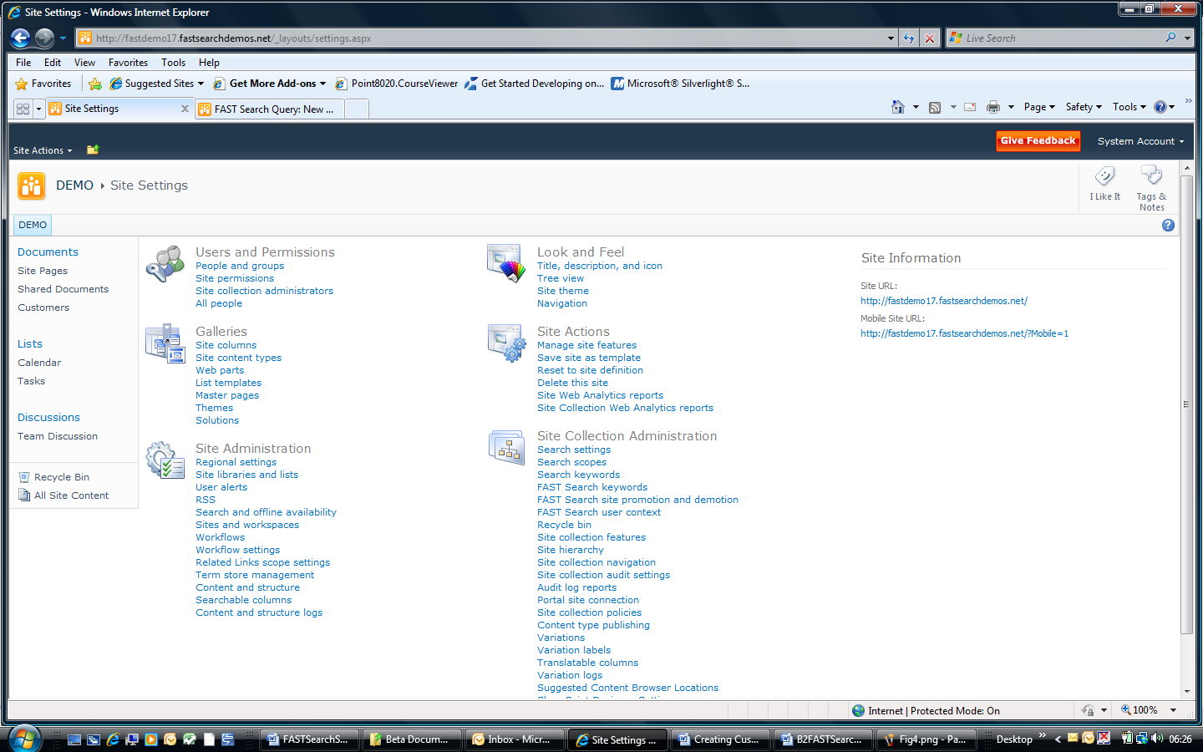

Figure . FAST Site Collection Settings

#### FAST Search Keywords

Figure 17 shows the main page for administering FAST Search keywords.

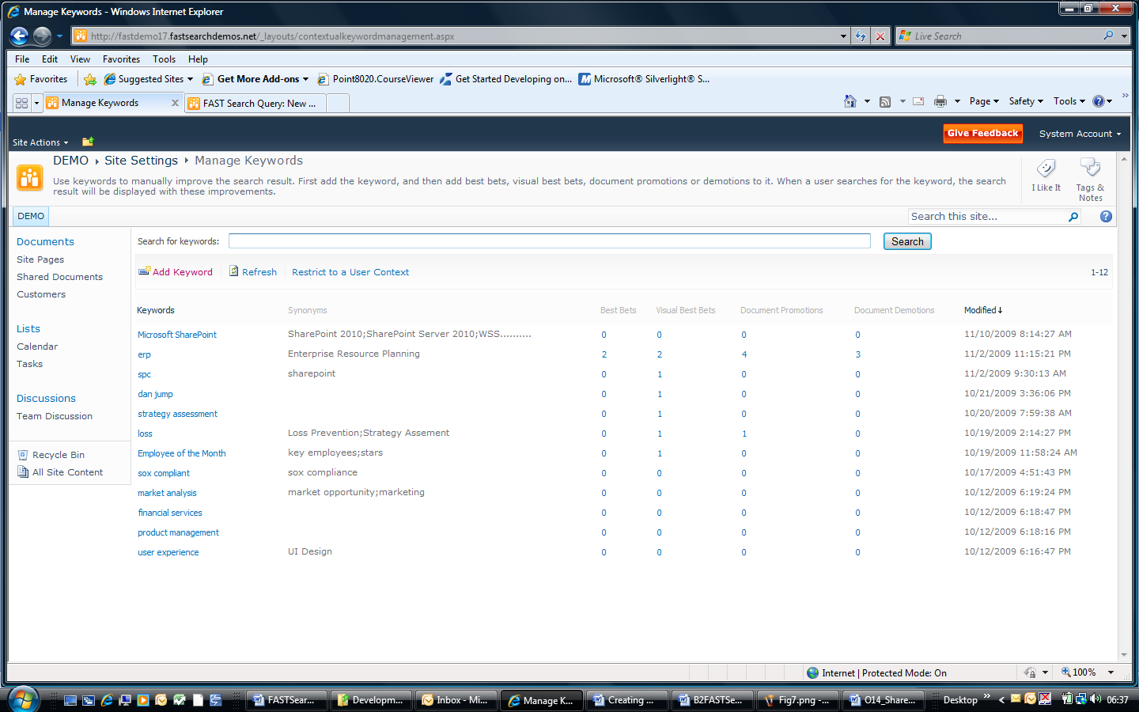

Figure . FAST Search Keywords

FAST Search keywords are more powerful than their SharePoint Server 2010 counterparts. You can create Best Bets, Visual Bets, Document Promotions, and Document Demotions for a keyword, and you can also restrict a keyword to a specific user context. Figure 18 shows the FAST Search keyword creation process, including one-way and two-way synonyms.

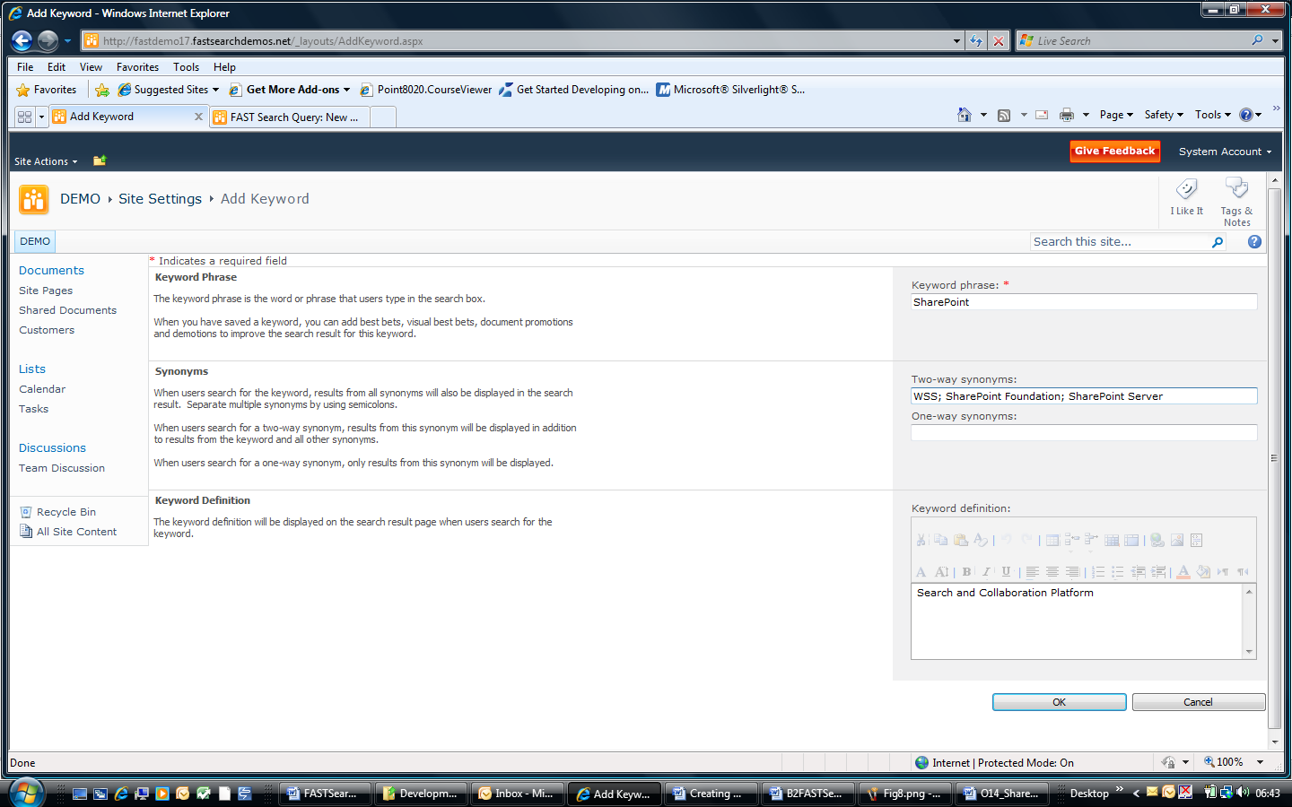

Figure . FAST Keyword Creation

#### FAST Search Site Promotions and Demotions

You can promote or demote sites, which affect the relevance ranking for documents in those locations. Figure 19 shows the promotion page.

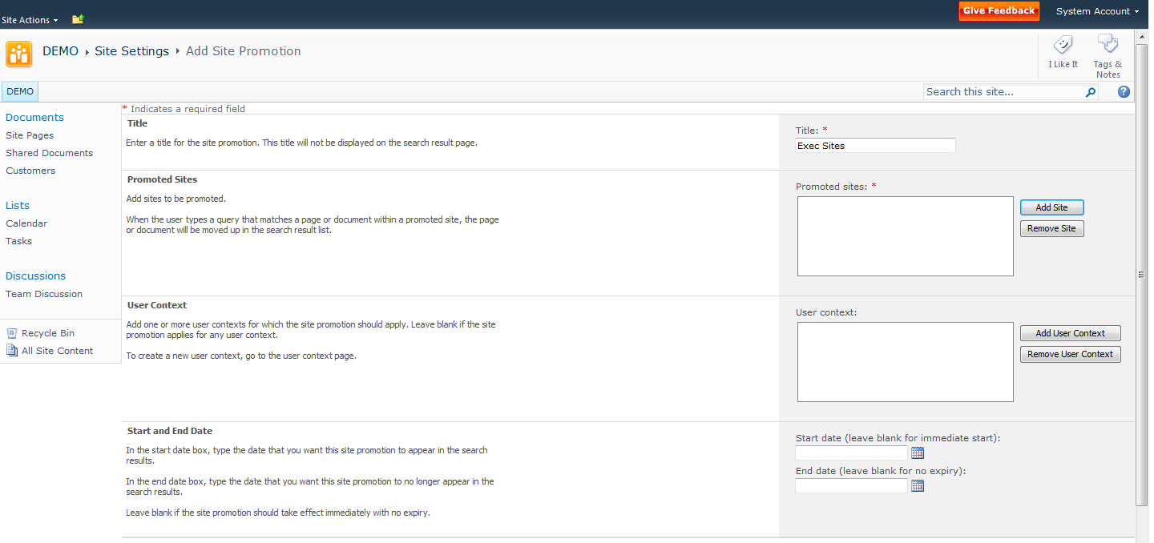

Figure . Site Promotion

#### FAST Search User Contexts

You can create FAST Search user contexts by using the site settings page in a site collection. When you have created a user context, you can associate it with Best Bets, Visual Best Bets, document promotions, document demotions, site promotions, and site demotions. Figure 20 shows how to start creating a FAST Search user context called *Marketing*. The new user context can apply to users with specific Office Locations or with specific knowledge

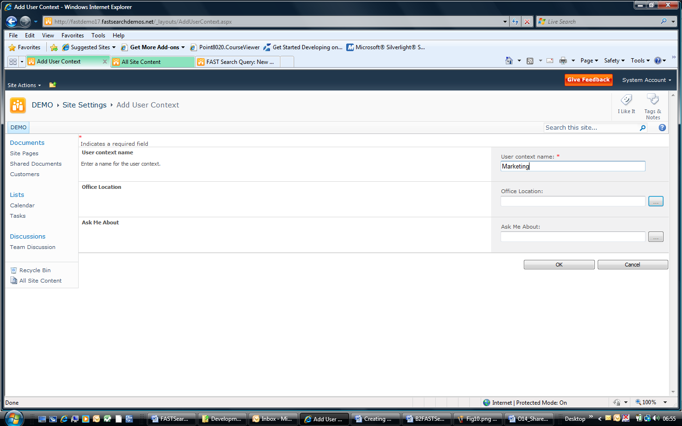

Figure . Adding a User Context

The table of keywords can be filtered to display only Best Bets, Visual Best Bets, Document Promotions and Document Promotions that apply to a specific user context. This is useful for a content manager who is responsible for a specific user context, such as employees based in Munich, for example. Use the *Restrict to a User Context* link, as illustrated in Figure 21, to see only Best Bets, Visual Best Bets, Document Promotions and Document Promotions that applies for this user context.

Filter Table by User Context



Figure . Filtering Best Bets, Visual Best Bets, Document Promotions and Document Demotions for a User Context

You can also associate promotions with a user context as shown in Figure 22.

Restricted to User Context

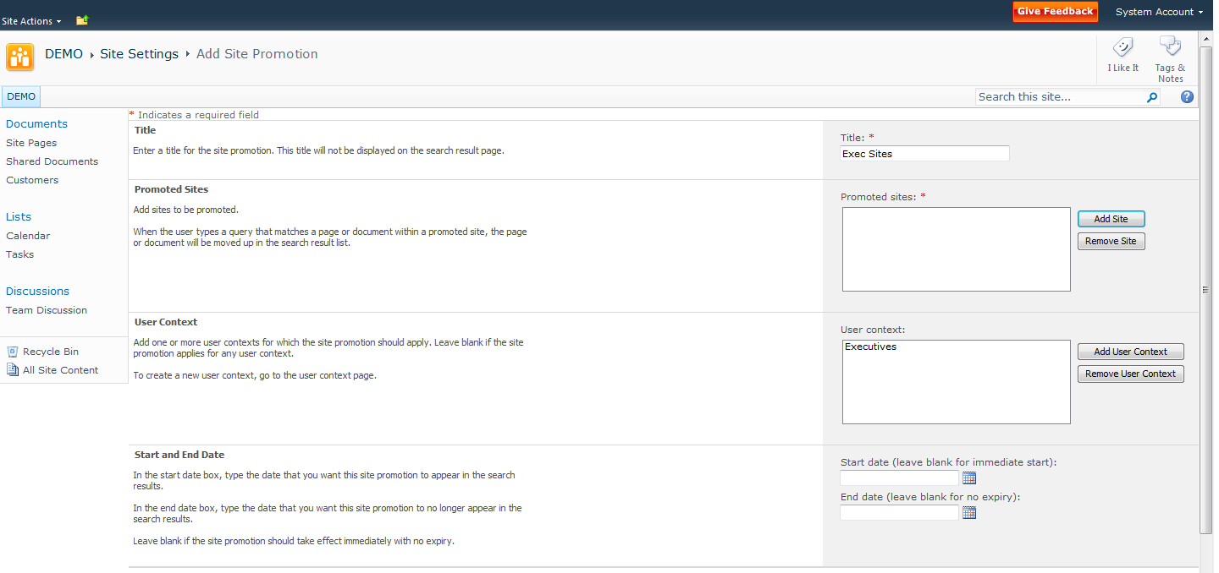

Figure . Promotions and User Contexts

# Appendix A: Resources Available for Evaluating SharePoint Server 2010

Microsoft encourages you to use the following resources as aids in installing and evaluating SharePoint Server 2010 in addition to this evaluation guide:

* The [product documentation](http://technet.microsoft.com/en-us/library/cc303422(office.14).aspx) on TechNet will help you install SharePoint Server 2010.
* [SharePoint.microsoft.com](http://sharepoint.microsoft.com/) offers a variety of white papers and other resources.
* [MSDN SharePoint Server Developer Center](http://msdn.microsoft.com/sharepoint) contains numerous technical resources from a developer's perspective about Microsoft SharePoint 2010 Products.
* [TechNet](http://technet.microsoft.com/en-us/sharepoint/ee263917.aspx) contains numerous resources on how to deploy, manage, maintain and support SharePoint Server 2010.
* The [Enterprise Search TechCenter](http://technet.microsoft.com/en-us/enterprisesearch/default.aspx) on TechNet has tabs with information about each of the enterprise search products.
* The [Microsoft SharePoint Team Blog](http://blogs.msdn.com/sharepoint/) is the official blog of the SharePoint Product Group.
* The [Microsoft SharePoint Server 2010 Evaluation Guide](http://www.microsoft.com/downloads/details.aspx?displaylang=en&FamilyID=110318ec-0238-4811-8fc7-ec4399d3c100) gives IT professionals an introduction and overview of the SharePoint Server 2010 features that are most pertinent to installing, managing, and configuring the SharePoint farm.
* The [SharePoint 2010 Developer Reviewers Guide](http://www.microsoft.com/downloads/details.aspx?FamilyID=cffb14e8-88a9-43bd-87aa-4792ab60d320&displaylang=en) contains an overview of the extensibility and customization points available for developers.