**Microsoft® Office SharePoint® Server 2007 Training**

**Install Guide**

**Table of contents**

Overview 2

System Requirements (32 bit or 64 bit) 2

Operating System 2

Additional Requirements 2

Supported Browsers 2

Download Instructions 2

Install Microsoft Office SharePoint Server 2007 Training 3

Run the Training Solution Batch File 3

Deploy the Training Solution 4

Configure Office SharePoint Training 7

Database access 10

Create Office SharePoint Server 2007 Training Site 13

Enable Office SharePoint Server Training Feature 16

User Accounts 20

Assign URLs and Accounts to Users 20

Upload Additional Training Content 20

Resources for administrators 21

Delete Training Sites 22

Retract and Remove Solution 24

Uninstall 27

Locating Central Administration in WSS 3.0 installations 28

Known issues 29

Troubleshooting 29

Resources for end users 29

Disclaimers 30

# Overview

The Microsoft® Office SharePoint® Server 2007 Training is designed to help end-users learn about the rich set of features in Microsoft Office SharePoint Server 2007.

The Office SharePoint Server Training includes interactive demos, articles, and videos.

**System Requirements (32 bit or 64 bit)**

* Computer and processor
* Server with processor speed of 2.5 gigahertz (GHz) or higher; dual processor, 3 GHz or higher recommended
* 1 gigabyte (GB) RAM; 2 GB RAM recommended
* 3 GB of available hard disk space
* CD ROM or DVD drive, local or network accessible
* Display 1024x768 or higher resolution monitor

**Operating System**

Microsoft Windows Server 2003 Standard Edition, Windows Server 2003 Enterprise Edition, Windows Server 2003 Datacenter Edition or Windows Server 2003 Web Edition or later, plus service packs.

**Additional Requirements**

* Microsoft Office SharePoint Server 2007 or WSS 3.0
* SQL Server 2005
* Microsoft .Net Framework 3.0.
* Over 100 megabits per second (Mbps) connection speed required for farm deployment, 56 kilobits per second (Kbps) required for client to server connection.

**Supported Browsers**

Internet Explorer 6.0 or later

**Note:** If you do not have Internet Explorer, you will need to download it to view the content correctly. Download [Internet Explorer](http://www.microsoft.com/windows/products/winfamily/ie/default.mspx) here.

# Download Instructions

1. Click the **Download** button to start the download
2. Do one of the following:
   1. To start the installation immediately, click the **Run** button.
   2. To save the download to your computer for installation later, click the **Save** button.
   3. To cancel the installation, click the **Cancel** button.

# Install Microsoft Office SharePoint Server 2007 Training

Run SharePointTraining.msi to install the program on your Office SharePoint server. If you have a farm installation, download the application on one of the Web front servers and proceed with the installation on the Web front.

1. Navigate to the folder where you have saved the **SharePointTraining.msi** file.
2. Double click the file to open.
3. Click the **Next** button to proceed.
4. Read the Software License Agreement and click the **I Agree** radio button if you agree.
5. Click the **Next** button.
6. If you want to install your application in a folder other than the default folder, click the **Browse** button and select the folder.
7. Click the **Next** button.
8. Click the **Next** button to confirm the installation.
9. Click the **Close** button.

Microsoft Office SharePoint Server 2007 Training is now installed. Proceed to **Run the Training Solution Batch File**.

# Run the Training Solution Batch File

You must install the Office SharePoint Server Training solution in your Office SharePoint environment.

1. Open a Command window: **Start** 🡪 **Run** and type **cmd** and press **Enter**.
2. 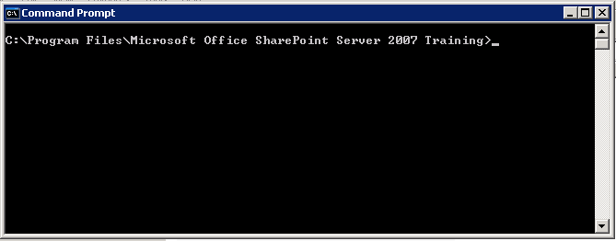Change the directory to the folder the application was installed in. The default directory is C:\Program Files\Microsoft Office SharePoint Server 2007 Training.
3. Type **InstallMossTraining.bat** and press **Enter**.

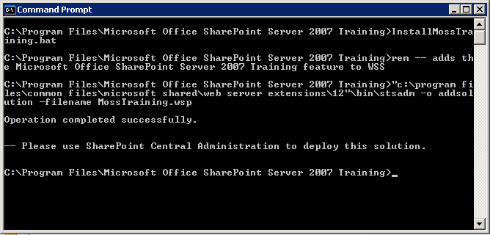

The Office SharePoint Server Training Solution is now installed.

For a farm installation, copy the **Catalog** folder found in [drive]:\Program Files\Common Files\Microsoft Shared\web server extensions\12\TEMPLATE\FEATURES\Moss Training\ Catalog from the web front where the installation occurred to the other web fronts. The **Catalog** folder contains the training content. The image below shows the training content installed under the **c:\Program Files\Common Files\Microsoft Shared\web server extensions\12\TEMPLATE\FEATURES\Moss Training\ Catalog**.  
  
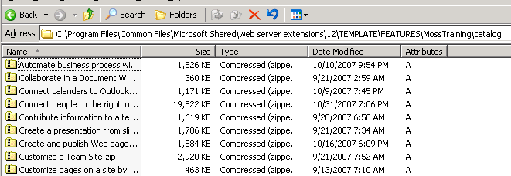

Proceed to the next section.

# Deploy the Training Solution

You must deploy the Office SharePoint Server Training Solution in your SharePoint environment through Central Administration.

1. Navigate to the **Central Administration** page in SharePoint Server. If you are on a web front server for a farm installation, you need to log on to the Central Administration server and navigate to the Central Administration page.

**Note:** For instructions on how to locate WSS 3.0 Central Administration page, see Locating Central Administration in WSS 3.0 installations below. Then continue with Step 2 below.

1. 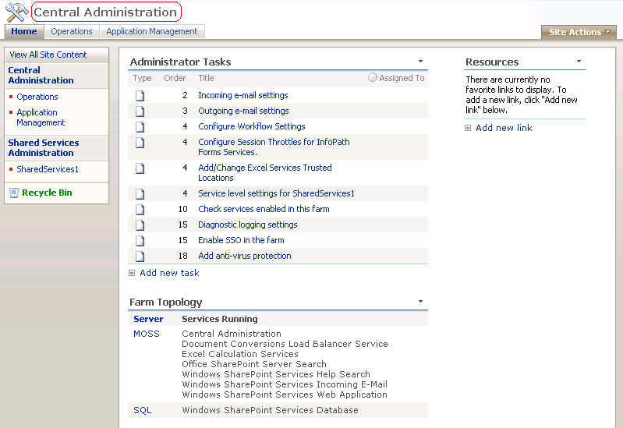Click the **Operations** tab.

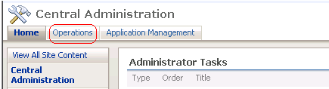

1. Click the **Solution management** link under Global Configuration.

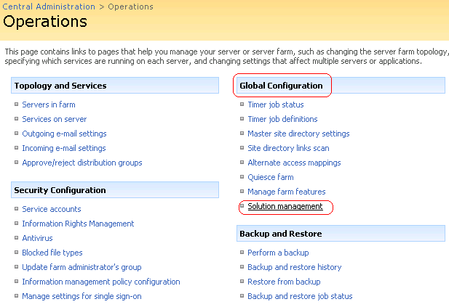

1. Click the **mosstraining.wsp** link.  
     
   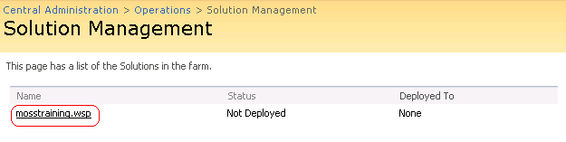
2. Click the **Deploy Solution** link.  
     
   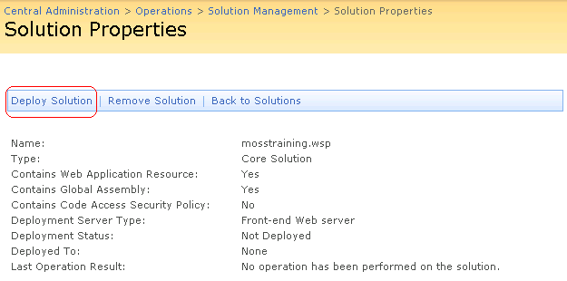
3. Click the **OK** button.

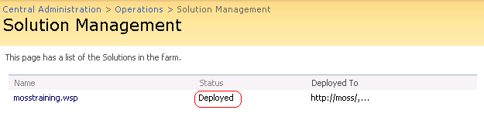

The Office SharePoint Server Training solution is now deployed. Proceed to the next section: Configure Office SharePoint Training.

# Configure Office SharePoint Training

To configure the Office SharePoint Server Training, you need to create a database and apply a specific site collection.

1. Click the **Application Management** tab.  
     
   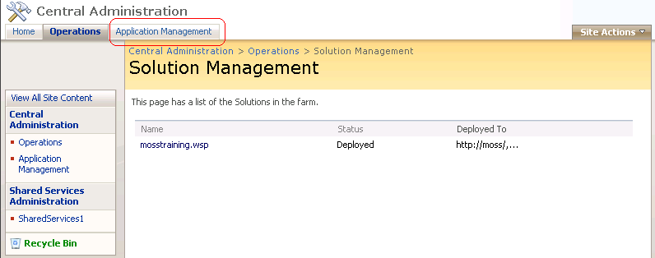
2. Scroll down to the bottom of the page under the **Office SharePoint Training Configuration** column and click the **Configure Office SharePoint Training** link.  
     
   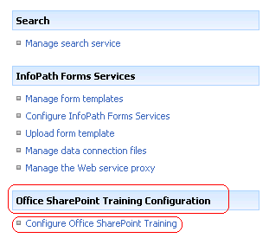
3. Select the specific **Site Collection** to configure Office SharePoint Training.

**Caution:** You must select the specific Site Collection to which you will be installing the Microsoft Office SharePoint Server 2007 Training.  
  
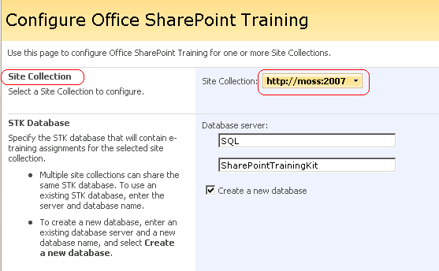

1. Specify the **Database server** and **database name**.

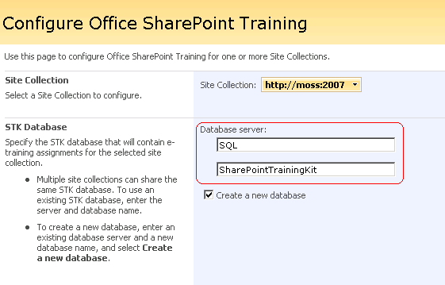

1. Check the **Create permissions** checkbox as shown below.

**Caution:** The default value for Instructor permission and Learner permission should not be changed.

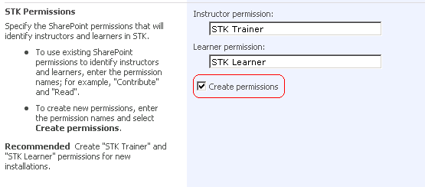

1. Click the **OK** button.

Configuration is complete.  
  
**Note:** To configure the Office SharePoint Training on multiple **site collections**, repeat the **Configure Office SharePoint Training** steps above, selecting a different site collection for step 3.

Proceed to the next section.

# Database access

**Note**: In the Configure Office SharePoint Training steps above, if you created a new database you will need to grant access to the database. The application pool account for the Site Collection will need the LearningStore role on the SharePointTrainingKit database.

1. Open **Microsoft SQL Server Management Studio** inSQL Server 2005**.**
2. Expand the **SQL** node.
3. Expand the **Security** node.
4. Click the **Logins** node.  
     
   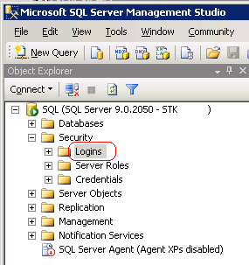
5. In the **Logins** pane on the right, double click the application pool account for the site collection. In this example, the account is STK\SharePointService.  
     
   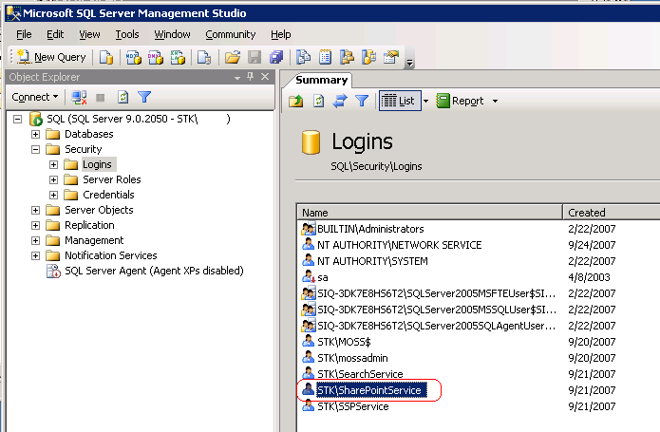
6. On the **Login Properties** dialog, click the **User Mapping** in the left pane.  
     
   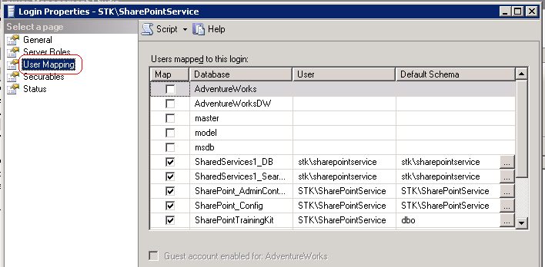
7. Check the **Map** checkbox for **SharePointTrainingKit** database.  
     
   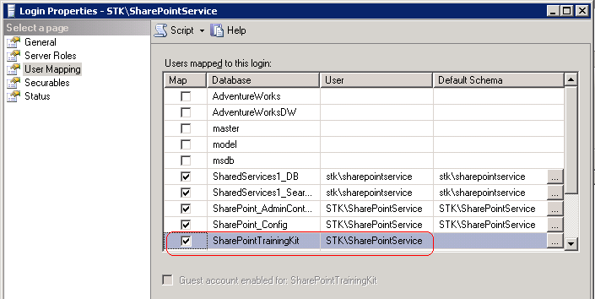
8. Check the checkbox for **LearningStore** role.  
     
   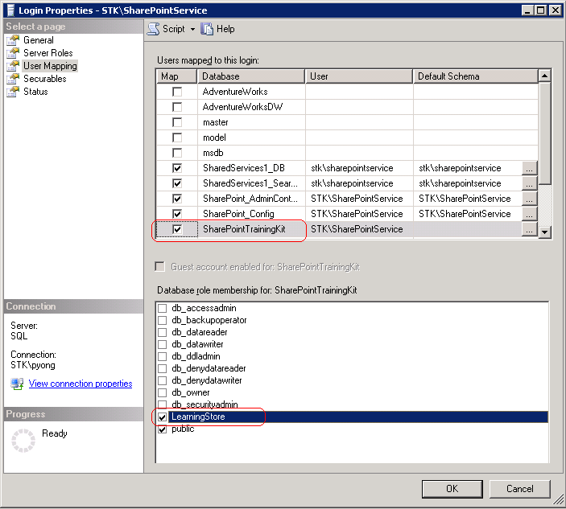
9. Click the **OK** button.

**Note:** If the application pool account is a db-owner, you will not be able to add roles to the database. In this case, you need to change the application pool account for the site collection to a non-db-owner account.

Proceed to the next section.

# Create Office SharePoint Server 2007 Training Site

You can create an Office SharePoint Server 2007 Training for any site collection that has the Office SharePoint Server 2007 Training configured.

1. Logon on to SharePoint with an account that has rights to create a site.  
   **Note:** You must use an account that has administrative rights.
2. Navigate to the Site Collection where you want to create the Office SharePoint Server Training.
3. Click **Site Actions** 🡪 **Create**.  
     
   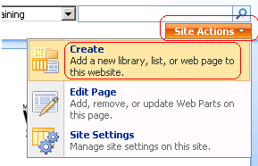
4. Under the **Web Pages** column, click the **Sites and Workspaces** link.  
     
   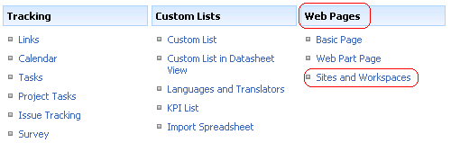
5. Enter the **Title**, **URL name**, and select the **SharePoint Training Home Site** template.

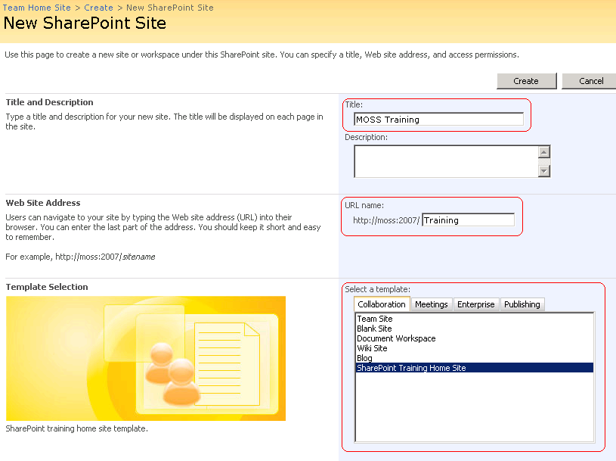

1. Click the **Create** button.  
     
   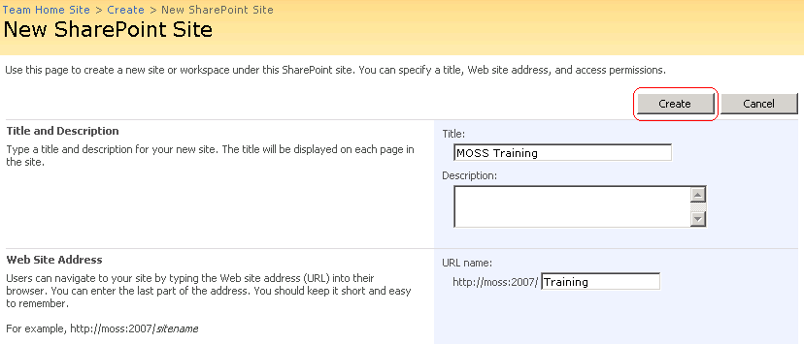

Your Office SharePoint Server Training site has been created. Proceed to the next section.

# Enable Office SharePoint Server Training Feature

Now you need to enable the Office SharePoint Server Training feature in the Office SharePoint Server site created in the step above.

1. Click **Site Actions** 🡪 **Site Settings**.
2. Under the **Site Administration** column, click the **Site features**.  
     
   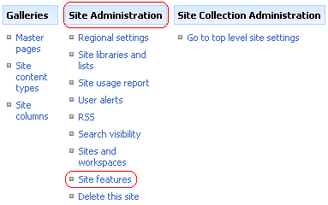
3. Click the **Activate** button for Office SharePoint Server Training Features.

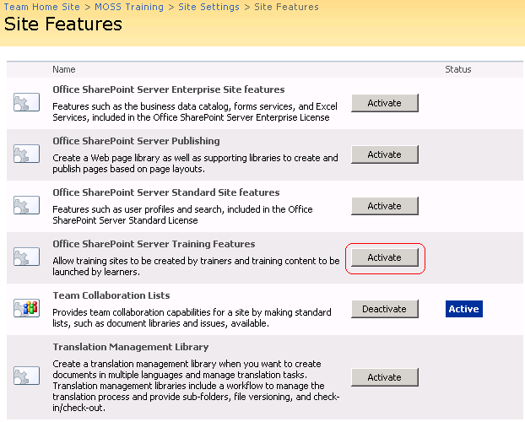

You will know that the features are activated when you see the Microsoft Office SharePoint Server 2007 Training look and feel.

1. Click the main site link in the top left hand corner. In this example, the main site link is MOSS Training.

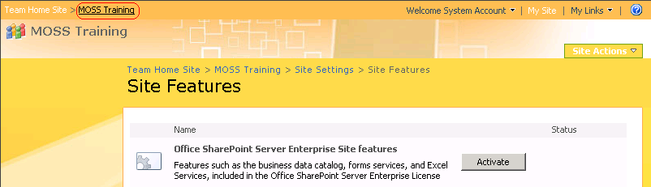

The Home page for Microsoft Office SharePoint Server 2007 Training will look like the screenshot below.  
  
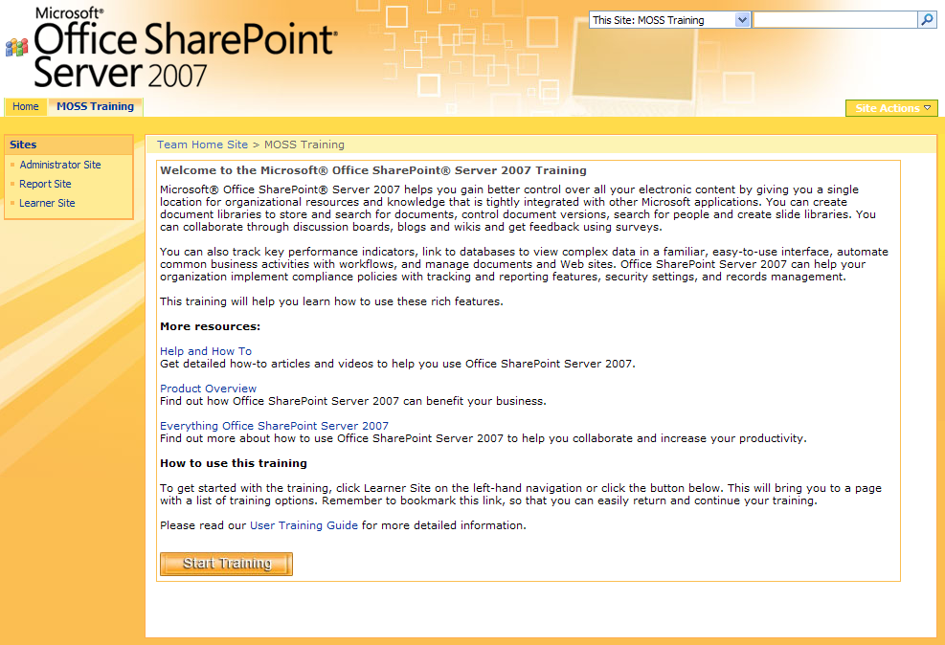

There are three additional pages, listed in the left pane.  
  
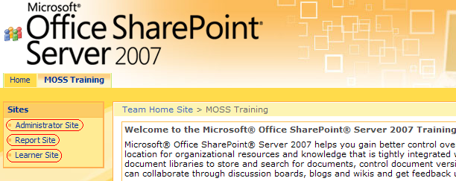

**Learner Site**.  
  
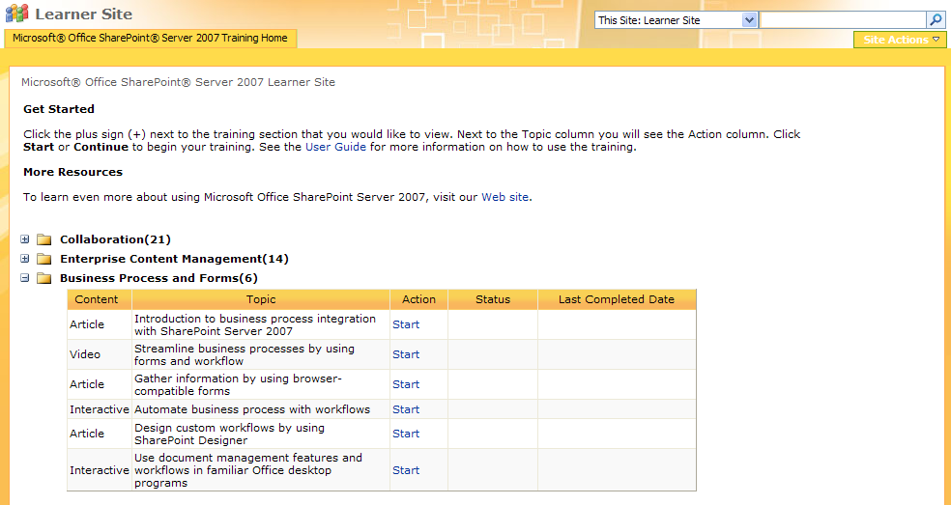  
**WARNING:** If you do not see the screen above, you have not deployed correctly. Please uninstall and follow the directions step-by-step.

**Report Site** (This screenshot does not contain any reporting, as it is a new installation. Report data will appear after users view the training content).  
  
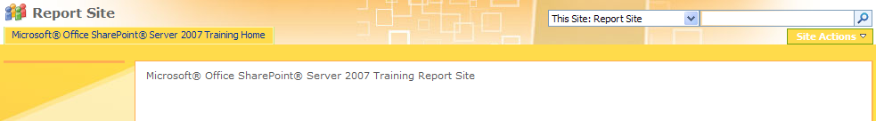

**Administration Site**  
  
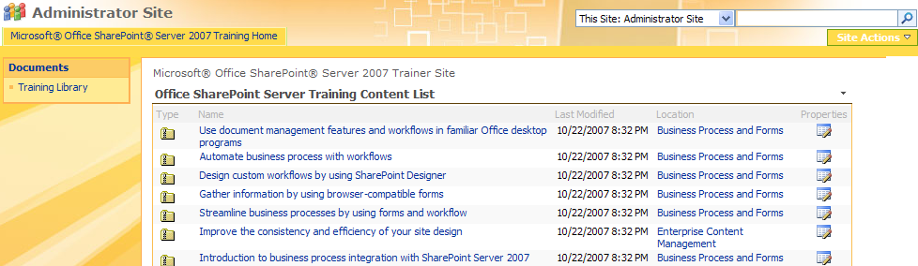

The creation of sites is now complete.

# User Accounts

The Learner site is available to all domain users.

# Assign URLs and Accounts to Users

You can now give users their account information and the Office SharePoint Server Training home site URL you created.

**Browser Settings**

Since there will be training content that is uploaded to your browser, you need to make sure that your portal site is a trusted site in your browser.

# Upload Additional Training Content

The Office SharePoint Training content is SCORM compliant. When creating new content, you will need to convert your content using a SCORM authoring tool before uploading the content. Non-SCORM compliant content is not supported in the Office SharePoint Server Training. If you upload non-SCORM files, the reporting and other features may not work correctly.

You can find a list of SCORM authoring tools on the CodePlex site blog at this URL:

<http://www.codeplex.com/SLK/Thread/View.aspx?ThreadId=16806>. Microsoft does not support any of these authoring tools.

To upload additional training content that has been created as a SCORM file:

1. Navigate to the Administrator site.
2. Click **Training Library**.
3. Create a new training topic if needed. To do so,
   * Click **Create** menu, then **Folder** submenu.
   * Enter the name of the topic for the folder name.
   * Click **OK**.

The new training topic will be created with content type ‘Topic’ and the next available sequence number.

**Caution:** You cannot adjust the automatically generated sequence number once it is created. You need to add your training topics in the exact sequence you plan to order them.

1. Click the training topic you want to add training content to.
2. Click the **Upload** menu.
3. Enter the name of the training content file path, or use the **Browse** button to browse to the training content file location.
4. Click **OK**.
5. Enter the custom properties as needed. Note that the properties with red ‘*’ next to them are required.
6. Click **Check In**.

**Note:** If you click **Cancel**, the training document will still be created, but without the required custom properties. These documents will be ignored and will not be available to the learners.

When adding additional training contents, please note the following behavior:

* This release supports only one level of training topic. You cannot add training topics to an existing training topic. If you do, the training topic will be removed without an error message.
* All training contents must belong to a training topic. Therefore you cannot add training content outside of a training topic folder. If you do, the training content will be removed without an error message.
* Uploading training content involves two steps: **Upload** followed by **Check-in**. If you cancel out the check-in after you have uploaded training content, the training content will be ignored and won’t be available to learners.
* You can use the standard **Edit Properties** menu on the dropdown menu list to edit existing training content custom properties. To do so, you need to switch to **All Documents** view.

# Resources for administrators

The Microsoft Office SharePoint Server 2007 Training allows customers to add their own branding to the training sites. The branding customization includes:

* Customer’s logo. The Microsoft Office SharePoint Server 2007 Training recognizes and uses the logo that is currently used by your Office SharePoint Server site.
* The name of sites for learners, administrators, and reports. The default names for training sites created are ‘Learner site’, ‘Administrator site’, and ‘Report site’. To change the names of these sites, please do the following AFTER the training home site is created and BEFORE the training feature is enabled,
  + Start from your SharePoint 12 hive folder. Usually it is C:\Program Files\Common Files\Microsoft Shared\web Server Extensions\12.
  + Navigate to the Templates\Features\MossTraining\Catalog folder.
  + Use a text editor, such as Notepad, to edit the StkTopics.xml file.
  + Locate this section of text in the xml file:

<siteNames>

<siteName site="**learner**" name="**Learner Site**" />

<siteName site="**trainer**" name="**Administrator Site**" />

<siteName site="**report**" name="**Report Site**" />

</siteNames>

* + Change the value of the ‘name’ attribute to your choice of site name. Do not change the value of the ‘site’ attribute because it is used as the ‘key’ to find the name of the site.
  + Save the xml file.

**Note**: Since the name you choose will appear on the left hand side vertical navigation bar, we recommend that you choose a concise name.

* You can apply themes available in Office SharePoint Server 2007 to the training sites to change the look-and-feel.

For more technical information about how to customize your Office SharePoint Server site, visit [Microsoft TechNet](http://technet2.microsoft.com/Office/en-us/library/3e3b8737-c6a3-4e2c-a35f-f0095d952b781033.mspx).

# Delete Training Sites

Microsoft Office SharePoint Server 2007 Training consists of four sites: Home, Administrator, Report, and Learner site.

**Caution**: The sites must be deleted in the following order: Learner Site, Report Site, Administrator Site, and finally the Home Site.

1. Open Internet Explorer and go to the Microsoft Office SharePoint Server 2007 Training Home site.
2. Click the **Site Actions** > **Site Settings**.  
     
   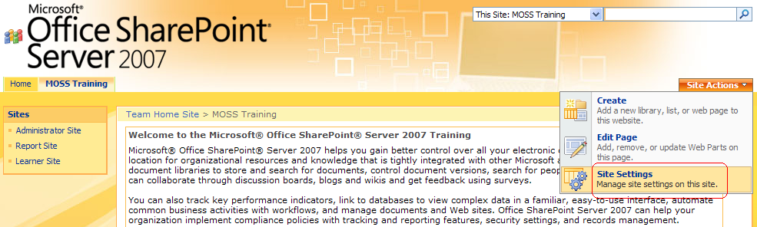
3. On the **Site Settings** page, under the **Site Administration** column, click the **Sites and workspaces** link.  
     
   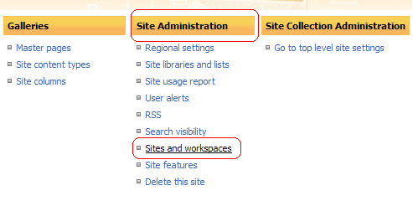

**Delete the Learner Site**

1. Delete the **Learner Site** by clicking the [Delete](http://10.10.4.99:2007/Training/_layouts/deleteweb.aspx?Subweb=repor) in the Delete column next to Learner Site.
2. Click the **Delete** button.
3. Click the **OK** button on the confirmation dialog.

**Delete the Report Site**

1. Delete the **Report Site** by clicking the [Delete](http://10.10.4.99:2007/Training/_layouts/deleteweb.aspx?Subweb=repor) in the Delete column next to Report Site.
2. Click the **Delete** button.
3. Click the **OK** button on the confirmation dialog.

**Delete Administrator Site**

1. Delete the **Administrator Site** by clicking the [Delete](http://10.10.4.99:2007/Training/_layouts/deleteweb.aspx?Subweb=repor) in the Delete column next to Administrator Site.
2. Click the **Delete** button.
3. Click the **OK** button on the confirmation dialog.

**Delete the Home Site**

1. Delete the **Home Site** by clicking the **Site Actions** > **Site Settings** link.
2. Under the **Site Administration** column, click the **Delete this site** link.  
     
   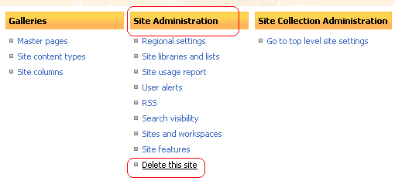
3. Click the **Delete** button to complete the Delete.
4. Click the **OK** button on the confirmation dialog.
5. All the sites have been deleted when you see the screenshot below:  
     
   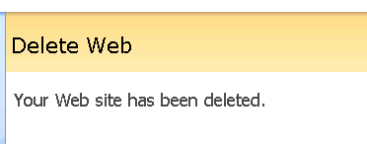

# Retract and Remove Solution

Follow the steps below to retract and remove The Microsoft Office SharePoint Server 2007 Training from your SharePoint environment.

1. Navigate to the **Central Administration** page.  
     
   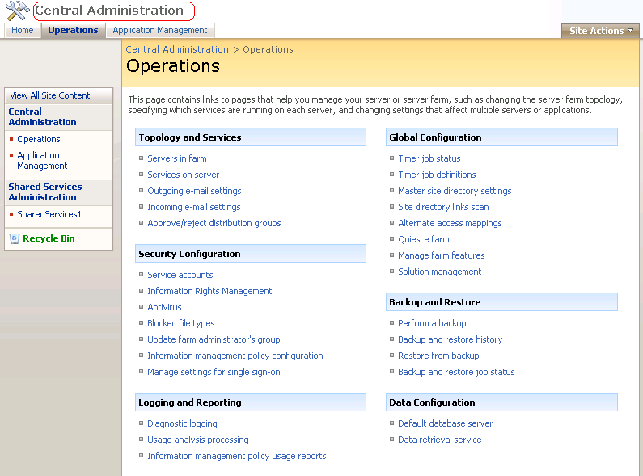

2. Under the **Global Configuration** column, click the **Solution management** link.  
  
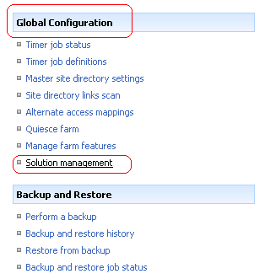

3. Click the **mosstraining.wsp** link.  
  
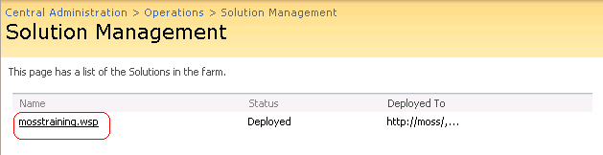

4. Click the **Retract Solution** link.  
  
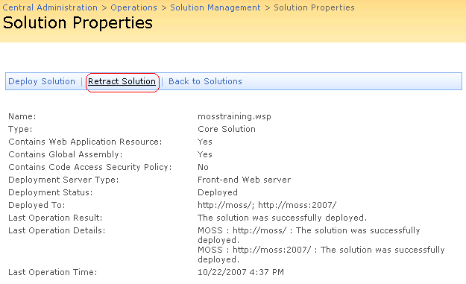

5. Click the **OK** button. Retracting takes a few minutes.  
  
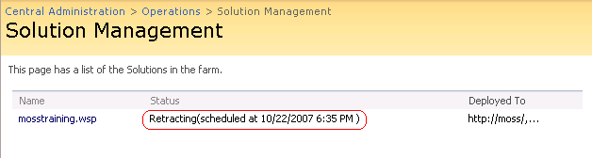

6. Refresh the page until **Status** is **Not Deployed**.  
  
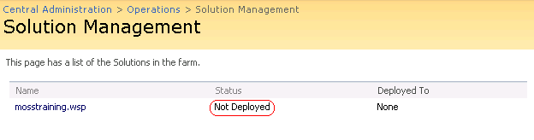

The Microsoft Office SharePoint Server 2007 Training is now retracted from your SharePoint environment.

**Remove the solution**

1. Click the **mosstraining.wsp** link.  
     
   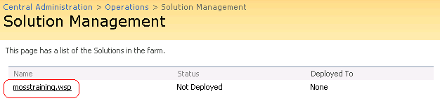
2. Click the **Remove Solution** link and click **OK** button on the confirmation dialog.  
     
   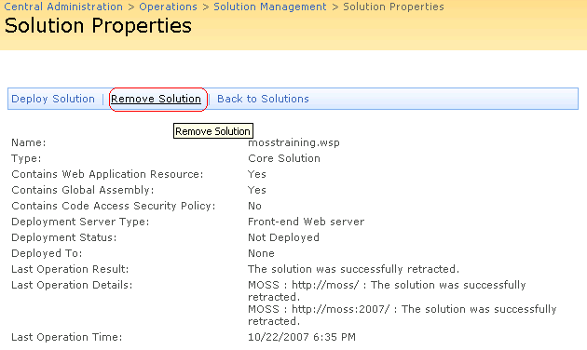

The Microsoft Office SharePoint Server 2007 Training is now removed from your SharePoint environment.

# Uninstall

Uninstalling Microsoft Office SharePoint Server 2007 Training will remove the program on the server.

1. Open the **Add/Remove Programs**, **Start** 🡪 **Control Panel** 🡪 **Add/Remove Programs.**
2. Click Microsoft Office SharePoint Server 2007 Training.
3. Click the **Remove** button, or if you are using a Windows Vista™ operating system, click **Uninstall** at the top of the screen.
4. Click the **Yes** button on the confirmation dialog.

The Microsoft Office SharePoint Server 2007 Training has been removed.

# Locating Central Administration in WSS 3.0 installations

For installation of Office SharePoint Server 2007 Training using WSS 3.0, please follow these steps to locate your Central Administration page:

1. From the server that has WSS 3.0 installed, open **IIS Manager**
2. In IIS Manager, find **SharePoint Central Administration v3**, right click **Properties**
3. In the Properties window copy the **TCP port** value
4. Open Internet Explorer and enter **http://<servername>:<port number>** to open the **Central Administration** page. The example in the screenshot below shows the server name=sql and the port number=3579. The corresponding Central Administration page would be located at <http://sql:3579/default.aspx>. Use the correct server name and port number for your application.

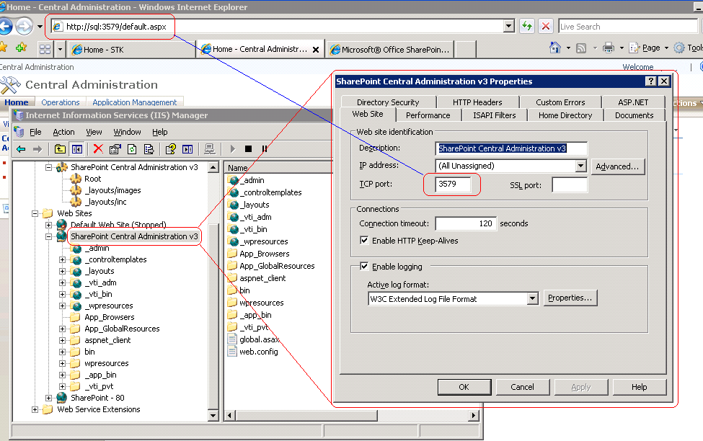

# 

# Known issues

* The training content was designed for a screen resolution of 1024 x 768.

Resizing the window to greater or lesser resolution may result in unreadable training materials.

* Office SharePoint Server 2007 Training will run best in the Internet Explorer (IE) browser. Please [download Internet Explorer](http://www.microsoft.com/windows/downloads/ie/getitnow.mspx) and view the Microsoft Office SharePoint Server 2007 Training with Internet Explorer.
* Language needs to be set to English (US). You may try installing the Training using the English (US) setting, and reverting back to your specific version of English after installation.
* The Microsoft Office SharePoint Server 2007 Training Application is not designed to be installed more than once without prior uninstalls. If you need to update your Microsoft Office SharePoint Server 2007 Training, please refer to the section **Obtaining Training Updates** above.
* Retracting the **mosstraining.wsp** solution before deleting the all Office SharePoint Server 2007 Training sites will break the functionality of those sites.
* Non-SCORM compliant content is not supported in the Office SharePoint Server Training. If you upload non-SCORM files, the reporting and other features may not work correctly.

# Troubleshooting

* “An unexpected error has occurred” on the Learner Site. You will see this error message if you have not configured the Office SharePoint Server 2007 Training for the specific site collection. Please repeat the steps in **Configure Office SharePoint Training** section.
* “Server Error in ‘/’ Application” – This is due to permissions not being applied during installation or permissions were deleted after installation. Please review the steps for **permissions** in **Configure Office SharePoint Training** section.

# Resources for end users

[Help and How To](http://go.microsoft.com/fwlink/?LinkId=100886)

Get detailed how-to articles and videos to help you use Office SharePoint Server 2007.

[Product Overview](http://go.microsoft.com/fwlink/?LinkId=100888)

Find out how Office SharePoint Server 2007 can benefit your business.

[Everything about Office SharePoint](http://go.microsoft.com/fwlink/?LinkId=100889) Server

Find out more about how to use Office SharePoint Server 2007 to help you collaborate and increase your productivity

# Disclaimers

1. Depending on the browser you use, there may be slight variations in the appearance of this training kit.
2. This training supports only Internet Explorer.
3. The tutorials in this training kit are based on Microsoft® Office SharePoint® 2007, and may demonstrate features and capabilities not present in earlier versions.
4. Depending on your permission level—which can be assigned to users, groups, or inherited from a parent site—you may experience different features, settings, or views on your computer.
5. Depending on the software programs installed locally on your hard drive—for example, for e-mail, word processing, or your calendar, etc.—the lists in Office SharePoint Server 2007 may present the option for views different from what are shown in the tutorial.
6. The example companies, organizations, products, domain names, e-mail addresses, logos, people, places, and events depicted herein are fictitious. No association with any real company, organization, product, domain name, e-mail address, logo, person, places, or events is intended or should be inferred.