Global Sales Experience Delivers Business Value with Microsoft Dynamics CRM and a Focus on the User Experience
Published: July 2009
Microsoft Information Technology (MSIT) manages the applications and systems that support a global sales force of more than 9,000. This document provides an overview of the program developed by MSIT and Microsoft Sales, Marketing, and Services Group (SMSG) to deploy a role-based Global Sales Experience (GSX) solution, powered by Microsoft Dynamics® CRM. GSX improves both the efficiency and effectiveness of the Microsoft sales force, while reducing total cost of ownership (TCO) of sales force automation.

Introduction
Intended Audience
Business and IT executives and managers responsible for continuous improvement in sales force automation and enablement.
Products & Technologies
- Microsoft Dynamics CRM
- Microsoft SQL Server
- Microsoft Outlook
- Microsoft Silverlight

This document illustrates the multiyear program strategy that MSIT developed to implement Microsoft Dynamics CRM as the foundation for a GSX platform. The primary objective of GSX is to improve the efficiency and effectiveness of the Microsoft sales force. In addition to significant increases in productivity, MSIT has identified substantial operational cost savings in replacing the existing Siebel-based platform for sales force automation with the new platform based on Microsoft Dynamics CRM.
This document also details the innovative strategy that MSIT employed. This strategy focuses on the end-user experience and ensures that the new solution meets both the needs of the corporate business owners and the needs of the sales professionals who serve as the user audience. This document also includes a high-level overview of the architecture, along with a description of the complementary Microsoft technologies integrated into the solution, MSIT’s approach to address data quality concerns, and the change management strategy employed to mitigate the risks associated with such an extensive program transition. Finally, this document illustrates the benefits that Microsoft has already begun to realize from the early GSX deployments and details the incremental benefits forecasted as each phase of the GSX program is completed.
MSIT supports more than 100,000 employees worldwide. It provides key infrastructure and line-of-business applications to users and business groups within Microsoft. As the primary connection point to the business customers of Microsoft, the SMSG organization is a crucial audience to the overall success of Microsoft. MSIT identified an opportunity to work with its partners in SMSG to improve processes, simplify user experiences, and apply innovative Microsoft technologies to create the new role-based platform. These changes will empower the worldwide sales force to spend more time on customer-focused activity and become more effective in driving revenue and customer/partner satisfaction.
Microsoft has made a strong business case for moving to the new platform by identifying more than $128 million US in productivity gains—in the first phase of the program alone—by giving time back to the sales force to focus on their customers and partners. In addition, Microsoft projects TCO savings of approximately $20 million annually in reduced operations and support costs after the existing Siebel platform is retired.
Situation
SMSG has more than 9,000 sales professionals in more than 100 countries around the world. While Microsoft has several hundred thousand partners and several million customers worldwide, its sales force manages relationships with more than 120,000 business customers and more than 25,000 partners to promote and deploy Microsoft technology-based solutions. Automating daily tasks and integrating valuable data and other key resources are crucial enablers to the efficiency and effectiveness of the sales force.
Customer relationship management (CRM) systems are intended to address many of the automation needs for sales professionals. However, numerous studies show that a significant percentage of CRM system implementations fail to deliver the promised productivity gains of sales force automation. Low user value proposition, a negative user experience, poor process design, and poor data quality are four of the top reasons why many CRM system implementations fail to deliver desired results. The previous Siebel CRM implementation at Microsoft suffered from many of these common industry issues.
Figure 1 illustrates the importance of focusing on the end-user experience in the GSX program, along with timely implementation of continuous user-driven improvements to GSX in order to sustain ongoing value. The gray boxes describe potential causes of value diminishment, and the GSX approaches to mitigate those risks are bulleted in red font.
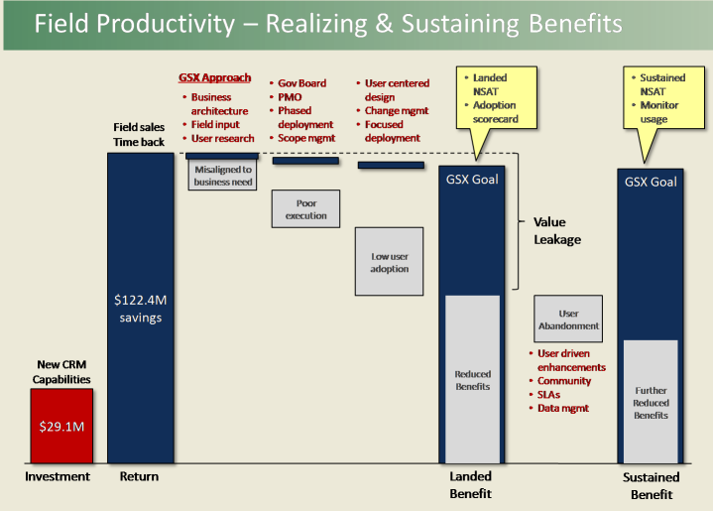
Figure 1. Realizing and sustaining benefits
Pain with Existing CRM System
For several years, SMSG has used an assortment of sales tools built on the Siebel CRM platform to perform its primary relationship management (planning), opportunity management (selling), and business management (measuring and review) sales processes. Users increasingly perceived this platform as a blocker of productivity, because it became overly complex and difficult to use for basic tasks such as extracting meaningful business intelligence or orchestrating key internal resources. In addition, the time required to add new features was not acceptable for many worldwide business owners, and the complexity of the technology architecture hindered the agility required to keep pace with the evolution of the business.
The most important activities for sales professionals are those that involve focus and interaction with their customers and partners. Most sales professionals say that high-value discussions with customers and partners are critical to a healthy business relationship. For Microsoft sales professionals, the administrative processes of the existing CRM platform had become overly time-consuming to the point that they significantly diminished the time that sales teams could dedicate to those important customer-focused activities. To identify productivity blockers such as these and to plan for continuous improvement, Microsoft regularly conducts in-depth sales field surveys that measure the value perception among the members of the sales force. These surveys attempt to target the efficiency and effectiveness of CRM systems by measuring the time spent in the following categories:
- Engaged time selling to customers
- Perceived productivity drivers
- Top productivity inhibitors
- Back-office administration and reporting time
- Key areas where top performers spend their time
In addition to the productivity survey, Microsoft regularly measures the user community’s net satisfaction (NSAT) with the CRM system. NSAT serves as a key value indicator of an application from the end-user perspective. The most recent NSAT score for the existing Siebel-based CRM system was a 60 on a scale of 0 to 200.
Note: At Microsoft, NSAT is measured both at the time of initial deployment (called “landed” NSAT) and then twice a year, beginning six months after initial deployment (called “sustained” NSAT). Whereas the field survey includes several questions designed to pinpoint areas for improvement, Microsoft bases the NSAT operational calculation on the answer to a single question:
Please rate your overall level of satisfaction with the solution:
1. Very Satisfied
2. Somewhat Satisfied
3. Neither Satisfied nor Dissatisfied
4. Somewhat Dissatisfied
5. Very Dissatisfied
Microsoft then calculates NSAT by using the following formula:
(Number of Very Satisfied Responses / Total Number of Survey Responses) – (Number of Somewhat Dissatisfied Responses + Number of Very Dissatisfied Responses)
Compounding the user perception issues with the existing CRM platform was the complexity of the overall CRM ecosystem that supported the platform. Over the years, the existing CRM platform had grown to consist of more than 170 applications with more than 330 additional downstream and shadow applications. This growth was due in large part to historical propagation on non-standardized business processes that resulted from an overly complex, global business model. Very strong partnership with the business leadership in driving worldwide business process standardization was a critical precursor to the success of the GSX program. Many of these applications had overlapping functionality and limited integration among them. This Siebel ecosystem became complex to a point where Microsoft lacked the agility to evolve its portfolio of sales applications to align with its worldwide sales strategies.
Lack of application integration and significant overall system complexity leads to IT operational complexity, which increases operational costs. Increasing TCO for sales force automation was a growing concern for Microsoft, especially in consideration of the diminishing value realized from the CRM platform. In addition, the existing platform architecture had reached scalability limitations in the ability to process system transactions or messages, limiting further growth and evolution of the platform.
The combination of low end-user NSAT, increasing platform TCO, and the lack of business agility and platform scalability led both MSIT and the worldwide sales leadership team to conclude that a major change had to occur. This realization set in motion the envisioning and business case justification for the new, role-based GSX solution.
Assumptions
Based on its own experience with the existing CRM platform and in-depth research into common pitfalls of CRM implementations, MSIT made two crucial assessments as a foundation for building the new GSX platform. First, it embraced the tremendous efforts made over the previous five years in driving well-defined, standardized sales processes worldwide. Refining and rationalizing these connected processes was a multiyear effort, performed well in advance of the design and implementation of the GSX platform. Without this, a significant amount of change management risk would have been added to the program and would have required a thorough and time-consuming process re-engineering and simplification effort.
Second, MSIT understood that designing and implementing GSX would require a multiyear program with two major phases that have separate but complementary success criteria. The initial activities would focus on re-platforming from the Siebel-based CRM solution and migrating all targeted sales users to the Microsoft Dynamics CRM–based solution. The primary business case for the first phase would be to:
- Provide efficiencies to these users in the form of time back to sales teams for increased customer and/or partner focus time.
- Reduce the TCO by deconstructing and ultimately eliminating the current Siebel platform without any disruption to the business.
The second phase will focus on effectiveness elements of productivity, such as faster closure of sales, higher win rates, and greater opportunity value, while optimizing customer and partner satisfaction. MSIT will achieve key performance indicators in phase 2 by delivering advanced sales capabilities that the Siebel user experience does not provide. These capabilities include streamlined account, services, and partner planning, in addition to higher-value role-based operational reporting capabilities.
Figure 2 illustrates the phases.
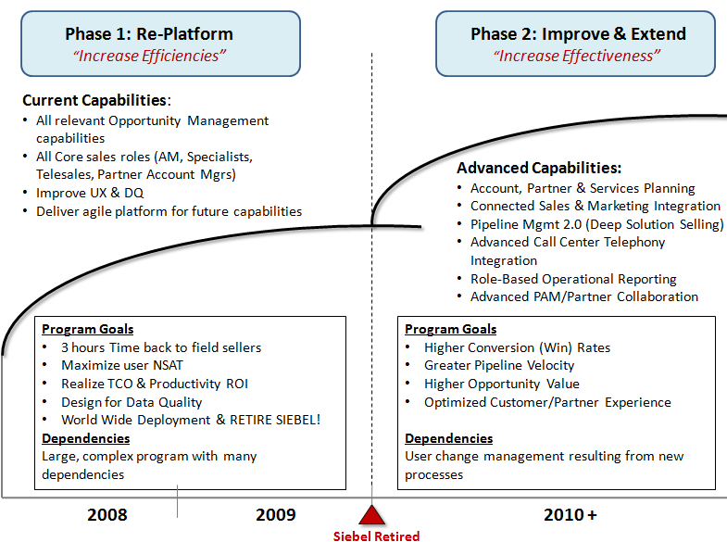
Figure 2. GSX phases
Solution
MSIT designed the new GSX platform to take advantage of innovative Microsoft technology to deliver phase 1 and phase 2 benefits. Both MSIT and its partners from the worldwide sales leaders knew that replacement of such a large, complex ecosystem would be a major undertaking. Because of the cost and potential business disruption of such an undertaking, the solution design and implementation needed to be well planned and flawlessly executed. As another outcome of its previous experience and extensive research, MSIT identified four primary pillars to the GSX program to ensure success:
- User-centered design: strong focus on end-user requirements, value, and acceptance.
- Technical agility: a solution architecture that enables agility and integration with lower operational complexity.
- Design for data quality: data that is accurate and readily available.
- Change management: a transition strategy and plan that minimizes frustration and maximizes adoption.
User-Centered Design
MSIT's guiding principle for the GSX program at Microsoft is “Putting the Field First.” This represented a significant shift in the way solutions had been developed. Historically, MSIT would gather business requirements from the corporate business and strategy owners without any direct contact with end users. MSIT would then create a business requirements document (BRD), which it then developed into a functional specification to ultimately deliver a solution that end users never actually saw until the system was launched.
MSIT and its corporate business partners committed a substantial amount of time and effort to ensuring that GSX would meet not only the requirements of the business group, but more importantly, the needs of the sales professionals. In January 2007, the GSX team embarked on a six-month research and design project to “live with the field” in order to gain an understanding of the various sales and roles, what they each do to perform their jobs, and how they do it. The primary objective of this part of the project was to define the vision for a future sales platform based on the design guidance learned from closely observing the sales professionals in action. Blending that guidance with a clear understanding of future business strategy ensures that end users are able to work the way they want to. A user-centered design approach keeps MSIT focused on people and delivers an innovative solution that improves user experiences, drives business results, and makes a difference in the lives of the sales force. This philosophy places the person (as opposed to the thing) at the center. It is a process that focuses on cognitive factors such as perception, memory, learning, and problem solving as they pertain to people’s interactions with software and products. User-centered design is integrated into solution development to capture feature requirements and interaction plans based upon the user's goals.
Key to determining the value to the users is a thorough understanding of the various roles and basing designs on those specific roles. For example, enterprise account sales teams, partner account managers, telesales representatives, and sales management roles each have a unique set of needs and require a different experience.
Microsoft used the following three-phase process to achieve its user-centered design goals:
- Discover
- Envision
- Design
Discover
Discovery entailed understanding the three-year business strategy (what SMSG wanted to enable as a worldwide business), and the understanding of the field users—who they are and what they do. This research helped identify their needs beyond a typical flat list of functional requirements. Rather than watching users run through workflow sequences in a lab, MSIT used a contextual inquiry approach: It observed a cross section of the sales force from around the world in their natural environment, going about their daily work routines, revealing their motivations, and discovering the pitfalls and the positive experiences as they pass through the day. Also in the discovery phase, MSIT used participatory design techniques with its sales professionals to gain further insight into their needs and how innovative product design could meet them.
To define the full problem statement, MSIT conducted research with Microsoft sales teams in four countries (United States, Norway, Switzerland, and New Zealand). This research included interviews and observations regarding the current CRM experience. In addition, MSIT collected more than 500 personal end-user video testimonials from sales people around the world to add to the research. These observations generated thousands of data points that MSIT clustered into groups and categorized by using an affinity diagram. These clusters allowed the team to process and make sense of a large volume of data, evolving into clear problem statements that led to effective solutions. These problem statements included:
- Finding the right data is hard. Better access and views on quality data is needed. Finding the right information was confusing. It was dispersed across multiple systems, making it difficult for users to know where to find the right details. Even when users found information, it was often out-of-date and sometimes incorrect.
- There are too many tools. Integration and consolidation of tools is needed. Sales representatives preferred to start and stay, as much as possible, within a single experience. In many locations, an account manager may rely on 12 or more disparate tools, many of them requiring duplication of data entry, to complete all of his or her sales responsibilities.
- It is difficult for me to share information with my team. Better team collaboration and communication is needed. The cornerstone tool of field sales is the Microsoft® Outlook® messaging and collaboration client. This is their collaboration and messaging solution of choice. Separate systems for storing, tracking, and retrieving customer and opportunity data made it difficult for team members to follow up on sales opportunities. Because of these disparate sources of customer information, sales people often found themselves unknowingly calling customers who had recently been contacted by someone else regarding the same topic.
- I spend too much time collecting data from various sources. Better relationships with customers and partners are needed. There was no holistic view of a customer. To appropriately prepare for a meeting with the customer, sales professionals had to do a great deal of work. There was also no easy way to share information with customers and partners. Sales representatives found that integrating partners into their workflow was often difficult and time-consuming.
- Fundamental functionality needs are not being met. The system needed a better user experience design. There were too many screens to click through, and the system was confusing. Entering a single opportunity could take up to 15 minutes—even longer in remote locations where network latency remains a challenge. Also, the system required people to be connected to the corporate network to enter data. Sales representatives were forced to stay at their desks to enter and retrieve information or chose to neglect to update the system entirely.
Envision
The most important part of the envisioning process was to develop design concepts that could be validated against key problem statements and defined personas. Microsoft used workshops to develop these design concepts, whereby multidisciplinary teams collaborated to deliver “what if” statements to address each business pain. Microsoft developed personas, or archetypal role-based user profiles, to help focus the solution design. Microsoft defined the personas based on data collected from the field during discovery. Each sales persona received a name, a role, key responsibilities, pain points, and a list of unmet needs to illustrate the unique requirements for each user type. Developing personas encouraged a common understanding of the users, in addition to a framework for discussing the finer points of ideas.
Microsoft used personas such as account managers, services executives, solution sales professionals, technical sales professionals, inside sales representatives, sales managers, and corporate program managers as the basis for envisioning activities.
Figure 3 illustrates the activities and artifacts of the user-centered design process.
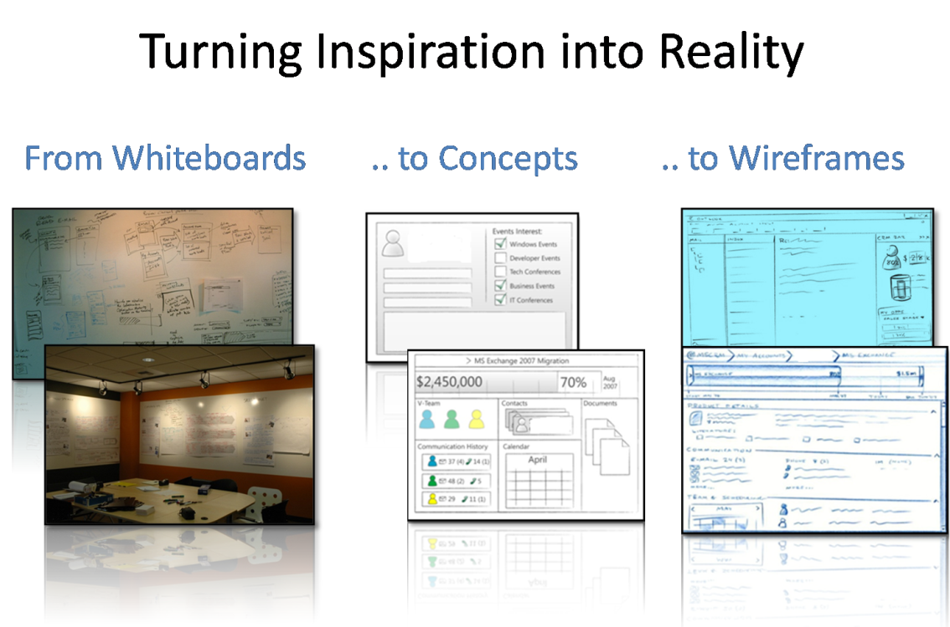
Figure 3. Activities and artifacts of the user-centered design process
Design
Extensive design brainstorming sessions based on multiple user roles and scenarios or use cases yielded 50 individual design concepts. These concepts were iterated on over time with the field sales force. This feedback helped the GSX team to prioritize the concepts for further development, with the highest-scoring concepts forming the basis for a prototype. In addition, the following design tenets guided the iterative design evolution from prototype to final design:
- Valuable. Provide a 360-degree view of customer status and the current workflow. Information is easily accessible in many ways.
- Simple. Provide the right amount of information when needed and where needed, with no distractions and no learning curve.
- Insightful. Provide views of information in new ways, giving insights into data that allows for better, faster decisions.
- Dynamic. Provide rich visualizations of data that the system renders in real time, along with the ability to dynamically share progress and information with peers and management.
- Flexible. Provide an experience that works the way users do. Information is available when needed, whether users are in the office or mobile.
- Integrated. Provide the ability to use Outlook as the communications center and hub. The new experience must live, as much as possible, inside Outlook.
- Collaborative. Provide the ability to share and discuss information with customers, peers, and management.
- Trustworthy. Provide one version of reliable data and an accurate representation of customers and workflow.
Engaging end users in the design process is an important factor in the change management strategy. End-user participation not only creates awareness; because the engaged users feel a sense of ownership of the solution, they also become credible evangelists during the change management process.
Technical Agility
MSIT approached the technical design of the GSX platform from two perspectives: the user experience application for the end users, and the server-side architecture that consists of the back-end systems responsible for managing the data, integration, and reporting. MSIT derived the guiding architecture principals for the user experience from the output of the user-centered design approach. The GSX team made extensive efforts to define detailed, comprehensive, and prioritized requirements for the functionality of the user experience application. To support those detailed functional requirements, the architecture needed an extensible user experience layer that would support multiple roles on multiple work surfaces, including mobile devices and desktop computers.
For the new platform, the primary motivation was to reduce the TCO of a system that had become overly complex and operationally burdensome. To that end, the primary design principles for the server-side technology architecture included:
- A scalable Microsoft .NET service-oriented architecture (SOA) based on MSIT enterprise architecture standards and products, including:
- Microsoft Dynamics CRM
- Microsoft SQL Server® database software
- Microsoft Outlook
- Microsoft Silverlight™ browser plug-in
- Ability to support an online or offline, role-based user experience
- Rationalization of the myriad supporting applications, including retirement of redundant applications and migration of key functionality to the new platform
- Standardized business intelligence and reporting through an enterprise data warehouse
- Data model and role-based business rules at all points of data entry to support data quality management based on SQL Server Service Broker (SSB)
- Single source of sales Entity Data Management (EDM) across integrated systems
EDM is critical to maintaining a single view of customers and partners. EDM is a set of processes and tools that consistently defines and manages the attributes of customer and partner entities that change infrequently and are consistent across various points of interactions with an entity. For example, some of the customer details that are relevant to a sales pursuit may be the same details relevant to a services contract for that customer. It is important that a single master source exists for all of those details about the customer to avoid data redundancy and inconsistencies.
The resulting architecture is a highly scalable .NET services-oriented platform primarily based on Microsoft Dynamics CRM and SQL Server. This platform fully supports the requirements of a user experience primarily based on Outlook, Microsoft Silverlight 2, and Microsoft SQL Server Compact.
Figure 4 shows the key solution architecture components.
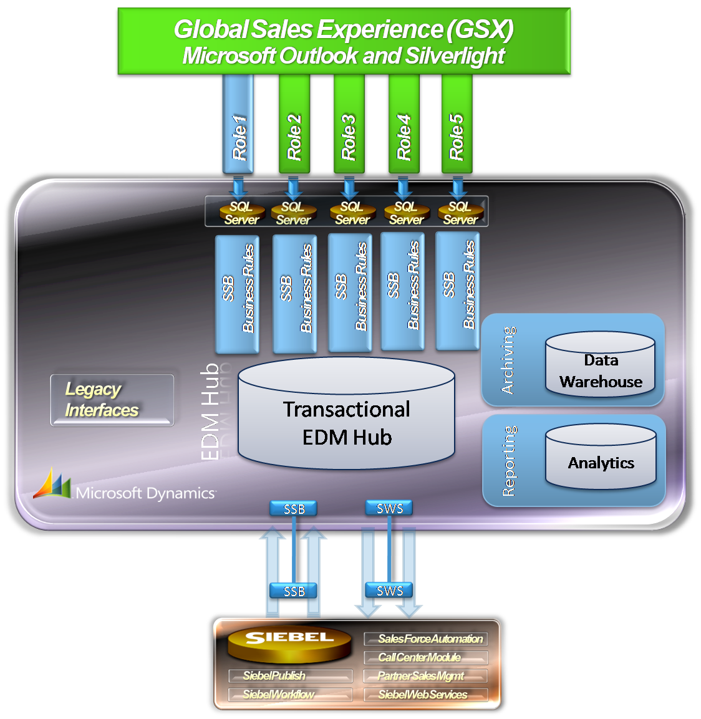
Figure 4. GSX solution architecture
The GSX user experience is fully integrated into Outlook and relies on role-based services accessed through standard Microsoft Dynamics CRM Web services and SQL Server Service Broker. Certain data objects, such as accounts, contacts, and opportunities, are rendered in Silverlight. Microsoft Dynamics CRM is the master transactional hub that communicates exclusively with the user experience application and the existing platform being migrated from using Siebel Web Services (SWS). With SQL Server Service Broker, the platform is designed to scale to up to 100 times greater data transaction volumes than the prior platform. This vastly increased capacity to scale data transactions provides ample room for system growth and evolution. With this improved performance and the offline client capability, the system virtually eliminates the performance challenges related to the previous Siebel solution.
Complementing the technical architecture of the GSX platform are guiding program principals that emphasize process automation and agile design and development, with quarterly release cycles and a phased implementation of technologies. The technology implementation milestones for GSX include:
- Develop and deploy the user experience application to completely replace the existing Siebel end-user experience. Microsoft Dynamics CRM becomes the integration hub to the old platform and provides the application platform services necessary to deliver the role-based productivity.
- Begin the process of migrating back-end processing functionality from the old platform to the new GSX platform.
- Complete the transition from the old platform to the GSX platform by migrating all users (sales professionals and non-sales professionals) and allow for the retirement of the old platform.
- Migrate remaining data, realign application programming interfaces (APIs), and decommission the Siebel ecosystem.
The first three milestones include the need to maintain coexistence and synchronization between the two platforms. Microsoft Dynamics CRM becomes the central hub for all GSX data and services. This single integration point with the existing system greatly simplifies the process.
Design for Data Quality
Confidence in data quality—including the completeness, accuracy, uniqueness, and validity of data—is paramount for successful adoption and reliable use of a sales automation tool. With data coming from and being updated by multiple sources, and widespread inconsistencies in business rules for data input and structure between various systems, users lacked confidence in the quality of data in the old system. Further, a major part of the continuing operational costs of the existing system is a staff dedicated to fixing data consistency issues.
For the new GSX platform, there is a strong emphasis on improving overall data quality by adhering to strict design guidelines, including:
- Focus on a single data-mastering strategy for all organizations, including customers and partners, with a robust policy for data usage, access, and retention.
- Enforcement of single set of data rules upon user input and migration, or upon bulk input of data.
- Comprehensive governance structure with strict policy enforcement.
Figure 5 shows the data quality management framework that MSIT used to detail the specific actions to help ensure data quality requirements of completeness, accuracy, uniqueness, and validity at points of integration, entry, and post-entry.
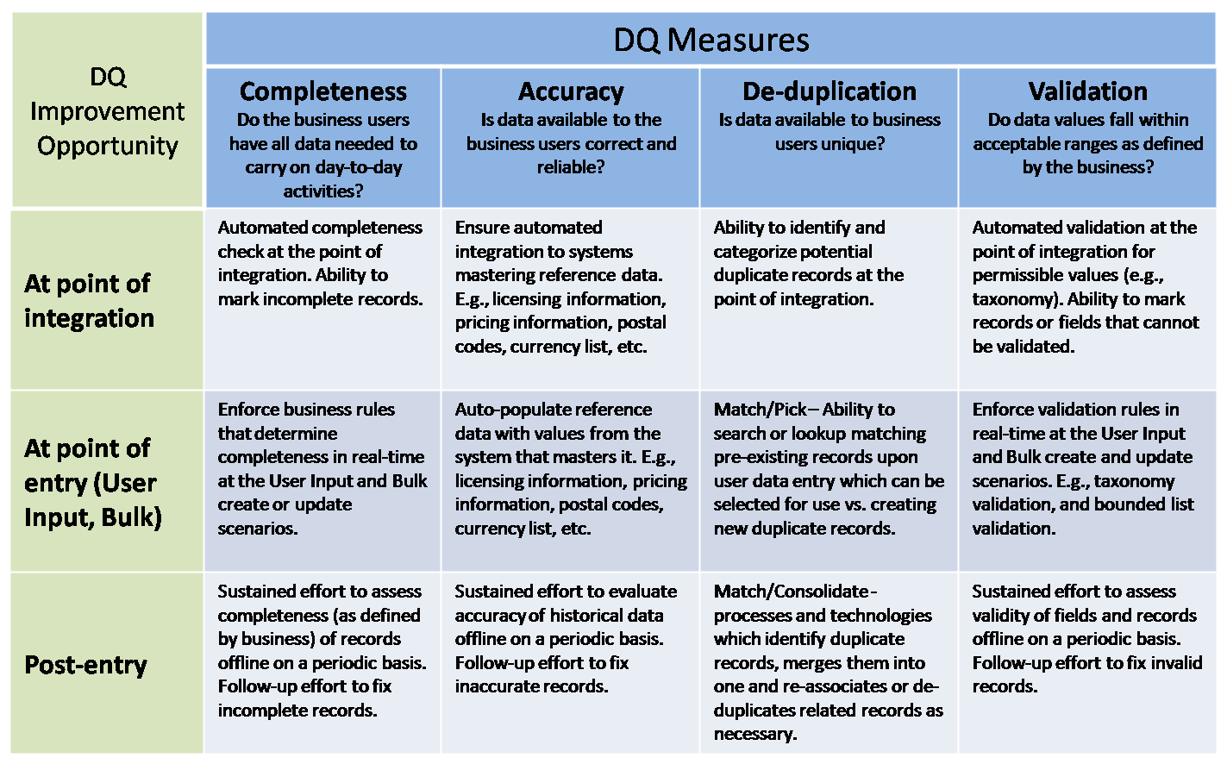
Figure 5. Data Quality Management Framework
Change Management
The final pillar in MSIT's approach to successfully deploying GSX to end users is a comprehensive change management strategy that emphasizes rapid adoption through careful planning, communication, and readiness preparation. It should also be noted that effective change management and engaging the target end-user community in the user-centered design activity should never be decoupled. As mentioned previously in this paper, MSIT's user-centered design efforts serve as a critical input to the team's change management strategy by engaging influential end users during the design phase. This enables better end-user awareness and credible evangelism. But it is equally important for MSIT to feed the key lessons from change management activities back into user-centered design activities for future releases. This helps to minimize the causes of value diminishment previously illustrated in Figure 1.
Strategic stakeholder identification, analysis, and involvement are also crucial to a successful deployment. Based on the stakeholder analysis, the change management team was able to identify ideal adoption candidates by their willingness to embrace change. The team segmented the deployment waves into three primary types:
- Early adopters. This included sales locations whose local leadership teams embraced the concept of leading through change and expressed a public desire to be part of the solution's development and post-deployment ongoing evolution.
- Fast followers. This included many forward-thinking leaders who expressed a desire to be a part of the GSX evolution, but felt there was too much risk associated with being a part of the initial deployment wave. This group wanted some proof of viability before engaging in an organization-wide deployment.
- Full-scale deployments. This included all remaining sales locations and any locations requiring non-English language localization.
The GSX program created a stakeholder matrix to support the following requirements of effective stakeholder engagement:
- Align leaders and engage the right people.
- Ensure that messages are timely, relevant, and effective.
- Improve collaboration and strengthen partnerships.
- Proactively assess, monitor, and mitigate risk.
- Provide information that can be found quickly and easily.
- Identify a local “stakeholder champion” to manage stakeholder groups.
After the stakeholders were identified and engaged, a local adoption team (LAT) formed at each location to provide adequate training and support for each stage of the rollout. The LAT and MSIT work collaboratively to help ensure that each local deployment experience goes smoothly and is successful. The LAT consists of both local business representatives and field-based MSIT personnel who provide the local expertise needed to complete important launch activities effectively. The LAT provides local insight to help guide all deployment activities and ensure local success.
Figure 6 describes roles in the LAT.
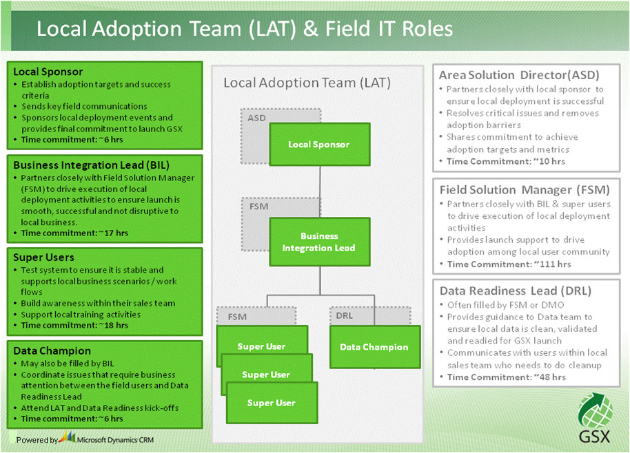
Figure 6. LAT roles
Using the LAT as the primary conduit, the GSX program uses four stages of user messaging throughout the deployment process. The messaging begins with building initial awareness and anticipation in the field, followed by specific preparedness communications in advance of the launch. Users are fully informed and prepared before they receive the formal launch communications sent at the time of deployment. The final stage of communication is to recognize and reward the efforts and results of the people responsible for a successful deployment.
Two additional key aspects of the GSX change management program are the use of a deployment toolkit and execution of a user impact assessment immediately upon rollout. The toolkit provides details for every deployment milestone, a collection of best practices, video summaries that provide an overview of the toolkit content, documents to help Field Solution Manager complete milestones, and an easy mechanism to provide feedback to the deployment team. The user impact assessment collects positive, neutral, and negative feedback from each deployment and is followed up by action plans created for all perceived negative impacts.
The ultimate goal of change management for the GSX program is to encourage rapid and comprehensive adoption of the GSX platform so that the field can realize immediate benefits from the new platform, and so that the old platform can be retired as quickly as possible. Retirement of the old platform is necessary to realize TCO savings between the two platforms. Rapid adoption by the field, coupled with a moratorium on further application development on Siebel, will help ensure a graceful degradation and eventual retirement of the Siebel platform.
Value Realization
MSIT’s number-one goal for improvements to the CRM system was to give time back to the sales field, and to greatly improve overall satisfaction with the sales force automation experience. For the initial phases of GSX, MSIT set a target of giving back three hours per week to each sales professional, and a minimum target for sustained NSAT of 130. As previously stated, MSIT is tracking NSAT of the GSX solution both at the time of implementation (landed NSAT), and every six-month interval post deployment (sustained NSAT). Continuous improvements to GSX enabled by an agile design and processes to allow for timely and predictable user-driven enhancements will be critical to maintaining high levels of sustained NSAT, thereby preventing value diminishment and ultimately, a loss of user adoption.
GSX Phase 1 (Results to Date)
Phase 1 of the GSX rollout to the Microsoft sales professionals includes immediate, measureable results that indicate a successful realization of the intended benefits.
Details of the GSX phase 1 rollout to date are:
- More than 2,700 users in various roles, including quota-carrying sales people, sales management, and sales/marketing support people (approximately 2,350 are users in which the ROI from productivity gains is calculated)
- 22 subsidiary locations throughout Europe and Asia
- 78 percent adoption in the first 15 business days and 90 percent adoption in the first 30 business days
- Landed NSAT score of 180 out of a possible 200 (50 points higher than the target NSAT and 120 points higher than the existing Siebel solution)
Anecdotal evidence suggests the goal of giving back a minimum of three hours a week on average to each user has been achieved. This result will be confirmed by a more formal survey six months after deployment (currently targeted for August 2009).
More than 800 post-deployment survey responses also show the following results:
- 95 percent agree that GSX reduces the complexity of their sales force automation tool.
- 92 percent agree that GSX simplifies their sales experience.
- Hundreds of positive anecdotal comments indicate that GSX is saving users ample amounts of time on activities related to sales opportunity management.
In addition to the preceding rollout metrics and survey responses, many data quality issues were addressed during the migration, including:
- 35,600 opportunities with data defects fixed.
- 107,228 records managed for taxonomy issues.
MSIT expects to realize another $58 million in savings in time back to the field between July 2009 and June 2010, when deployment increases to more than 9,000 users and retires other sales applications in all locations. MSIT expects to realize more than $120 million in time back to the field in the first full year after complete deployment, with an investment of approximately $29 million.
The chart in Figure 7 and the table in Figure 8 provide details of forecasted return on investment (ROI) for GSX phase 1 through fiscal year (FY) 2010 at Microsoft.
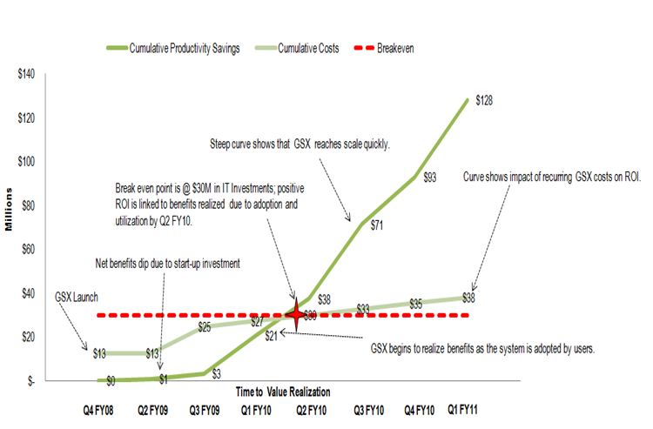
Figure 7. Business value realization break-even analysis
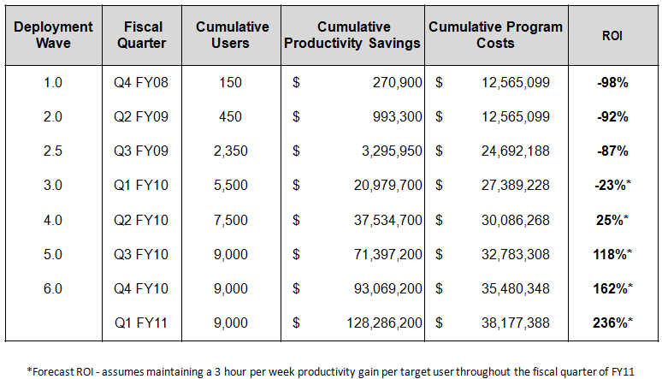
Figure 8. Cumulative users, costs, and savings over time
GSX Phase 2
GSX platform implementation will conclude with the retirement of the existing Siebel system, which will enable Microsoft to realize significant gains in TCO. In addition to the complete adoption of the GSX user experience application during phase 1, there is a moratorium on development directly against the Siebel back end, and aggressive steps to rationalize and migrate applications are under way. MSIT expects to save approximately $20 million a year after the old platform is retired.
Robust governance, including access controls and policies, should prevent the emergence of new complexity and shadow applications with the new GSX platform that would potentially cause diminishment of benefits over time.
The agility for SMSG to achieve much faster time-to-market for new sales programs and sales model capabilities will further allow for increased overall organizational effectiveness during GSX phase 2. MSIT will continue to seek ways to measure progress toward goals such as increasing agility to allow for a reduction in time-to-market for new business capabilities.
Conclusion
MSIT developed a strong business case to implement Microsoft Dynamics CRM as the foundation for GSX, identifying more than $120 million in productivity gains in the first full year alone. In addition, by eliminating the complexity of the old CRM platform, MSIT projects TCO savings of approximately $20 million annually in reduced operations and support costs for the new Microsoft Dynamics CRM–based platform.
MSIT has avoided many of the common pitfalls of enterprise CRM system implementations by choosing to take a four-pronged, comprehensive approach to the GSX program. At the heart of that approach is a user-centered design. This basis for design has enabled Microsoft to begin realizing many of the benefits projected in the business case. Surveys show an impressive initial NSAT score of 180, compared to an NSAT of 60 for the old platform, and an adoption rate of 90 percent within four weeks of implementation.
For More Information
For more information about Microsoft products or services, call the Microsoft Sales Information Center at (800) 426-9400. In Canada, call the Microsoft Canada information Centre at (800) 563-9048. Outside the 50 United States and Canada, please contact your local Microsoft subsidiary. To access information through the World Wide Web, go to:
http://www.microsoft.com
http://www.microsoft.com/technet/itshowcase
© 2009 Microsoft Corporation. All rights reserved.
This document is for informational purposes only. MICROSOFT MAKES NO WARRANTIES, EXPRESS OR IMPLIED, IN THIS SUMMARY. Microsoft, Microsoft Dynamics, Outlook, Silverlight, and SQL Server are either registered trademarks or trademarks of Microsoft Corporation in the United States and/or other countries. The names of actual companies and products mentioned herein may be the trademarks of their respective owners.

