Measuring System Resume Performance on Windows Vista
March 6, 2006
Abstract
This paper describes the background and methodology for measuring system resume from Standby (the ACPI S3 system power state) performance on computers running the Microsoft® Windows Vista™ operating system. This paper describes the phases of the S3 resume process, and includes information about the Microsoft Windows Vista infrastructure that provides accurate measurement of S3 resume times. This paper also demonstrates example methods for measuring S3 resume performance using tools in the Windows Driver Kit (WDK), discusses steps for measuring and optimizing resume from Hibernate (the ACPI S4 system power state), and provides tips for driver developers to ensure that device drivers support fast system resume performance.
This information applies for the following operating systems:
Microsoft Windows Vista
The current version of this paper is maintained on the Web at:
http://www.microsoft.com/whdc/system/sysperf/resumeperf.mspx
References and resources discussed here are listed at the end of this paper.
Contents
Introduction 3
System Sleep and Wake Improvements in Windows Vista 3
Standby as the Default "Off" State 3
System Startup Performance Instrumentation 4
Resume from Standby 4
S3 Resume Start and End 5
How Resume Times Are Measured 6
BIOS Initialization Phase 6
Device Initialization Phase 6
USER Initialization Phase 6
System Resume Events in the Windows System Event Log 7
S3 Resume and the Windows Logo Program 9
Measuring Resume Time using PwrTest 10
Using PwrTest To Measure Standby Resume Performance 10
Using the S3Resume Script with PwrTest 11
Optimizing Drivers for Fast Resume from Standby 12
Resume from Hibernate 12
Measuring S4 Resume Performance 13
Optimizing S4 Resume 13
Next Steps 13
Resources 13

Disclaimer
This is a preliminary document and may be changed substantially prior to final commercial release of the software described herein.

The information contained in this document represents the current view of Microsoft Corporation on the issues discussed as of the date of publication. Because Microsoft must respond to changing market conditions, it should not be interpreted to be a commitment on the part of Microsoft, and Microsoft cannot guarantee the accuracy of any information presented after the date of publication.

This White Paper is for informational purposes only. MICROSOFT MAKES NO WARRANTIES, EXPRESS, IMPLIED OR STATUTORY, AS TO THE INFORMATION IN THIS DOCUMENT.

Complying with all applicable copyright laws is the responsibility of the user. Without limiting the rights under copyright, no part of this document may be reproduced, stored in or introduced into a retrieval system, or transmitted in any form or by any means (electronic, mechanical, photocopying, recording, or otherwise), or for any purpose, without the express written permission of Microsoft Corporation.

Microsoft may have patents, patent applications, trademarks, copyrights, or other intellectual property rights covering subject matter in this document. Except as expressly provided in any written license agreement from Microsoft, the furnishing of this document does not give you any license to these patents, trademarks, copyrights, or other intellectual property.

Unless otherwise noted, the example companies, organizations, products, domain names, e-mail addresses, logos, people, places and events depicted herein are fictitious, and no association with any real company, organization, product, domain name, email address, logo, person, place or event is intended or should be inferred.

© 2006 Microsoft Corporation. All rights reserved.

Microsoft, Windows, and Windows NT are either registered trademarks or trademarks of Microsoft Corporation in the United States and/or other countries.

The names of actual companies and products mentioned herein may be the trademarks of their respective owners.

Introduction
The Microsoft® Windows Vista™ operating system contains significant improvements that increase system resume performance. As a result, systems running Windows Vista resume from the ACPI Standby state (S3) in significantly less time than systems running earlier versions of Windows, making it difficult to test resume performance using the traditional method of observing system resume and timing it with a stopwatch.
This paper describes system sleep and wake performance improvements in Windows Vista, new instrumentation and tools for measuring system resume performance, and tips for optimizing systems and drivers to ensure the best user experience for system resume.

System Sleep and Wake Improvements in Windows Vista
System sleep and wake performance improvements in Windows Vista extend the considerable investments made by the PC industry and Microsoft during the development of the Windows XP operating system to reduce the time needed to cold boot or wake a computer from the Standby and Hibernate sleep states (ACPI S3 and S4, respectively). These improvements spanned the PC ecosystem and included many optimizations to Windows XP as well as optimizations to system BIOS code and device drivers.
System sleep and wake performance improvements in Windows Vista include:
- Intelligent memory management of pages needed during resume from standby by ensuring that these pages remain resident in system memory, which avoids hard faults that require paging from the system drive.
- Increased efficiency of the kernel power manager during resume by increasing the number of IRP dispatch queues and by optimizing parallel IRP dispatch routines.
- Enhancements to the USB hub driver that remove serialization delays.
- Changes in the display power-on logic and timing that greatly improve user perception of system responsiveness to power state transitions.

Standby as the Default "Off" State
In Windows Vista, the ACPI S3 state becomes the default “off” state for both desktop and mobile computers. This makes resume-from- Standby performance both more important and more visible to users than ever before. Mobile computers can continue to transition from Standby to Hibernate (sometimes called the "S4 doze timeout") based on power policy, to avoid the drain on the system battery that occurs after long periods in Standby. However, the Windows Vista default power settings increase this transition time in order to maximize the use of the faster Standby state.
Most PCs that ship with Windows XP installed resume from Standby in fewer than 5 seconds. This number refers to the overall perceived user experience from pressing the power button to wake the system until the Windows desktop is visible, which includes the time needed to power on the system’s display after the operating system is fully running. Display power-on time is typically about two seconds, which means that the Windows operating system is fully running in about three seconds.
Systems that run Windows Vista can resume from Standby in 2 seconds or less, and optimally designed systems might resume in a second or less. This is faster than most displays can power on after system resume. Accordingly, on today's systems, it is no longer practical to measure system resume times by visual observation, using a stopwatch. Also, visual measurements can only reflect total system resume times, including the display power-on time; they cannot provide details about the amount of time spent in the BIOS S3 resume path, time spent initializing device drivers, and so on. Exposing this level of detail requires instrumentation in the operating system.

System Startup Performance Instrumentation
Windows XP includes tracing capabilities for measuring and recording several phases of system startup and resume. This tracing must be explicitly enabled in order to be used, and the resulting trace data must be post-processed to extract meaningful information. Microsoft provides a standalone tool named Bootvis that enables system startup and resume tracing and displays graphical and tabular views of the results.
Windows Vista includes enhanced resume tracing instrumentation and provides summary results of system resume transition times in the system event log. Enhancements to resume tracing in Windows Vista include:
- System resume tracing is on by default; it is not necessary to explicitly enable it.
- Every system resume transition is recorded in the system event log.
- System resume time can be viewed in the Windows Event Viewer; it is not necessary to use external tools.
- Tools external to the operating system can access and leverage system resume tracing information by reading the system event log.

The rest of this section provides details about:
- The resume-from-Standby process.
- How Windows Vista measures each phase of the resume process.
- Resume data that is available in the system event log.
- WDK tools that use resume trace data and help automate resume performance testing.

Resume from Standby
Resume-from-Standby (also called "S3 resume") follows a wake event such as the user pressing the system power button. The S3 resume process consists of three distinct phases, as shown in Figure 1:
- BIOS initialization
- Device initialization
- USER mode initialization
Figure 1. Phases of the S3 Resume Process
Starting at the left side of Figure 1:
System Power On. S3 resume is initiated when a wake event causes the computer to exit from the ACPI S3 state. System wake events that can initiate S3 resume are platform-dependent, but typically include a variety of sources such as the ACPI power or sleep buttons, the system real-time clock (RTC), or a wake-capable device such as a network controller or USB peripheral device. After the system hardware power-on event occurs, system logic typically handles any power-on synchronization, voltage regulator ramp up and stabilization, clock source stabilization, and so on, and the processor begins executing instructions at the power-on reset vector.
BIOS Initialization. After system power-up logic has restored power to the platform and the processor is executing instructions, BIOS initialization begins. During this phase, the BIOS typically restores any context the system hardware might have lost while in the S3 state by initializing the CPU, memory controller, enabling memory, configuring and enabling caches, and initializing the chipset. At the end of this phase, the CPU jumps to the operating system waking vector, and the operating system resumes execution.
Device Initialization. During the device initialization phase, the Windows power manager notifies all device drivers that the system is resuming by sending a device set-power IRP (an IRP_MJ_POWER request with a minor function code of IRP_MN_SET_POWER that specifies system power state of S0, sometimes called an S0 set-power IRP) to all devices. This phase is considered complete when all drivers have completed their S0 set-power IRPs.
USER Mode Initialization. During the USER initialization phase, user-mode applications and services are notified that the system has resumed by a WM_POWERBROADCAST message with a wParam value of PBT_APMRESUMESUSPEND.

S3 Resume Start and End
For S3 performance measurements on systems running Windows Vista (including Windows logo program requirements), S3 resume starts when the processor begins execution at the power-on reset vector. S3 resume ends after the operating system has notified all devices of the system power-on event. In the Windows Driver Model, that is the point when all devices have completed their S0 power IRPs.
Devices do not have to complete their device power IRPs (a set-power IRP that specifies a device power state of D0), nor do they have to complete any device-specific re-initialization needed for the device to become fully operational. For example, a wireless network adapter does not have to be fully functional in order for the user to interact with the computer; the wireless adapter might take some small amount of time to become fully functional after S3 resume, but this should not prevent the user from interacting with the system, such as entering password credentials to unlock the Windows session. The Windows operating system can respond to user input and continue any remaining initialization housekeeping after all devices have completed their S0 set-power IRPs.

How Resume Times Are Measured
When the operating system is running during the S3 resume process—that is, after the BIOS transfers control to the OS waking vector— Windows Vista utilizes Event Tracing for Windows (ETW) to record various events during the S3 resume process and it uses the resulting time stamps to calculate total resume times. ETW is an efficient, low-overhead kernel-level tracing facility that enables event logging to and from multiple consumers and providers. For more information about ETW, see "Resources" at the end of this paper.
In Windows Vista, the kernel power manager is instrumented to use ETW to record various points in the progress of the S3 resume process. The boundaries of each phase, as well as IRP handoff and IRP completion, are measured and recorded.

BIOS Initialization Phase
The BIOS initialization phase begins when the system processor first begins executing instructions at the power-on reset vector. The time required to complete the BIOS initialization phase is measured using the processor time-stamp counter (TSC). The frequency of the TSC is recorded immediately before the system enters the S3 sleep state.
The TSC is assumed to start at zero (0) when the system begins the S3 resume process. Immediately after the BIOS hands off control to the operating system through the waking vector, Windows Vista records the TSC value and calculates the BIOS initialization phase time. The kernel power manager then uses ETW to log this time in the system event log .

Device Initialization Phase
The device initialization phase begins almost immediately after Windows regains control from the BIOS through the OS resume vector. During this phase, the kernel power manager notifies all drivers that the system is resuming by sending S0 set-power IRPs to all devices. In handling these system power state change notifications, a device driver typically requests a D0 IRP be sent to its device.
The kernel power manager uses ETW to trace the dispatch and completion times of all set-power IRPs sent to each driver in the system. Both system (Sx) and device (Dx) IRPs are traced.
After every driver in the system has completed its S0 set-power IRP, the device initialization phase is complete. The kernel power manager again uses ETW to record this time in the system event log. This time represents the "resume complete" time for Windows Vista, although USER mode initialization is yet to follow. This is an important point to consider when evaluating improvements in order to achieve optimal system resume performance. Device drivers that do not complete their S0 set-power IRPs quickly can greatly impact the system’s resume performance. For more information, see “Figure 7. S3Resume Test Script Output” later in this paper.

USER Initialization Phase
The USER initialization phase begins immediately after the device initialization phase has ended. During this phase, the kernel power manager notifies user-mode applications and services that the system has resumed to the working state. The kernel power manager does this indirectly by using the USER subsystem and user-mode Plug and Play service as proxies for user-mode applications and services, respectively. The kernel power manager records the progress of the USER initialization phase using ETW.
- User-mode application notifications. The kernel power manager calls a private interface in the USER subsystem, which then sends all applications a WM_POWERBROADCAST window message with the wParam event parameter of PBT_APMRESUMESUSPEND. User-mode applications might receive a WM_POWERBROADCAST window message with the wParam event parameter of PBT_APMRESUMECRITICAL or PBT_APMRESUMEAUTOMATIC, instead of PBT_APMRESUMESUSPEND.
- User-mode service notifications. The kernel power manager calls a private interface in the user-mode Plug and Play manager, which then calls each service’s power management event handler, if the service has registered a handler.

From the kernel power manager’s point of view, user-mode notifications are asynchronous. The kernel power manager records USER initialization as complete as soon as it has finished its private calls to the USER subsystem and user-mode Plug and Play manager. Therefore, the USER initialization phase continues until all running applications and services have been notified of the resume. However, applications and services can continue to process their resume messages after this phase.

System Resume Events in the Windows System Event Log
Details of each sleep and resume transition are recorded by default in the Windows system event log. These events have a source of Microsoft-Windows-Power-Troubleshooter and an event ID of 1, as shown in Figure 2.
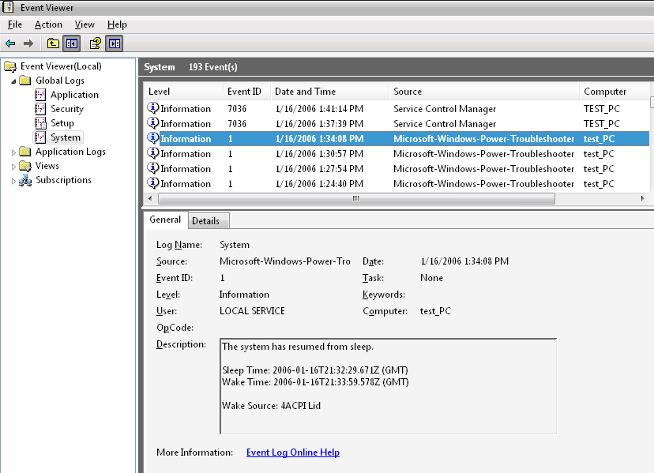
Figure 3. Windows Vista Event Viewer Showing a Resume Event
The Details tab provides a detailed breakdown of the system’s resume performance and other details about the sleep/resume transition, as shown in Figure 4.
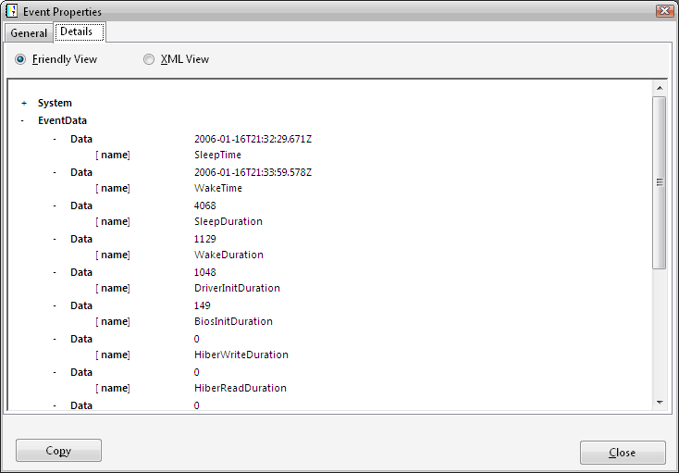
Figure 5. Resume Event Details

Resume Event Data Fields in the System Event Log
Table 1 lists the resume event data fields that are available in the system event log. All durations are displayed in milliseconds.
Table 1. Resume Event Data fields
Data Field Name | Example Value | Description
SleepTime | 2006-01-21T01:17:32.688Z | The date and time that this system transitioned to sleep, in GMT.
WakeTime | 2006-01-21T01:18:32.538Z | The date and time that this system resumed from sleep, in GMT.
SleepDuration | 4227 | The amount of time the system took to transition from the working state (S0) to the sleeping state (S3), in milliseconds.
WakeDuration | 1116 | The amount of time the system took to wake from the sleeping state (S3) to the working state (S0), in milliseconds.  Note that this time represents the sum of the device initialization and USER initialization phases of the standby-resume process.
DriverInitDuration | 1068 | The duration of the device initialization phase, in milliseconds.
BiosInitDuration | 149 | The duration of the BIOS initialization phase, in milliseconds.
HiberWriteDuration | 0 | The amount of time the system took to write the hiberfile to disk.
HiberReadDuration | 0 | The amount of time the system took to read the hiberfile from disk.
HiberPagesWritten | 0 | The number of pages written to the hiberfile.
Attributes | 4354 | Reserved for use by Windows.
TargetState | 4 | Represents the intended system sleep (Sx) state. This value is one of the SYSTEM_POWER_STATE enumeration types defined in ntpoapi.h  The example TargetState value 4 represents the enum type PowerSystemSleeping3, or Standby (ACPI S3).
EffectiveState | 4 | Represents the actual system sleep (Sx) state entered. This value is one of the SYSTEM_POWER_STATE enumeration types defined in ntpoapi.h  The example TargetState value 4 represents the enum type PowerSystemSleeping3, or Standby (ACPI S3).
WakeSourceType | 4 | Indicates the type of wake source.
WakeSourceTextLength | 8 | The string length of the friendly name of the device that woke the system.
WakeSourceText | ACPI Lid | The friendly name of the device that woke the system.

S3 Resume and the Windows Logo Program
The Windows Vista Hardware Logo Program includes a requirement (SYSFUND-0004, formerly SYS-ACPI-23) for fast system resume times. The goal of this requirement is to help ensure the best user experience and maximum PC availability when the system resumes from the ACPI S3 state.
The current version of this logo requirement is:
SYSFUND-0004 System resumes from ACPI S3 state in ≤2 s
Total system S3 resume time, from system wake event until resume complete, as measured by Windows system tracing, must complete in 2 seconds or less.
Total system resume time equals the sum of the BIOS S3 re-initialization time and Windows device initialization time, but does not include USER mode initialization. Resume complete is defined as the point at which all system devices have completed their S0 power IRP, but does not include the time required for devices to complete their D0 IRP or become fully functional.

It is important to note that, for Windows Vista logo compliance, the system S3 resume time is measured as the sum of the BIOS initialization and device initialization phases and does not include time from the USER initialization phase, nor does this include the time needed to power-on the display. This is a significant departure from resume measurements for Windows XP, which were often done using visual observation and a stopwatch, and manually timed from power button press to visual recognition of “display ready.”
Also note that Microsoft does not have a specific requirement for the BIOS S3 resume path as long as the system achieves a total system resume time of two seconds or less. Microsoft recommends that the BIOS S3 handoff time should be ≤250ms to allow sufficient time for device initialization, and to help ensure the best end-user experience.
Note
The measurements shown in Table 1 earlier in this paper are taken from a shipping, production-quality mobile PC system. Note that the resume performance of this system easily achieves the goal specified in SYSFUND-0004, including easily realizing BIOS handoff performance in well under the recommended 250ms.

The S3 resume time for the SYSFUND-0004 requirement is measured using the Power Management Test Tool (PwrTest) provided in the Windows Driver Kit (WDK). For availability of the WDK, see "Resources" at the end of this paper.

Measuring Resume Time using PwrTest
The PwrTest tool provided in the Windows Driver Kit (WDK) enables testing of several common power management scenarios, including suspend and resume transitions.
PwrTest registers with ETW to enable the kernel power manager’s ETW events and record them to a trace file. PwrTest then processes the ETW event file after the system has resumed, to display the system’s total resume times as well as the times required for each phase of the resume process.

Using PwrTest To Measure Standby Resume Performance
The time a system takes to resume from S3 can be measured by using the SLEEP scenario functionality of PwrTest. For example, the following PwrTest command line sends the host system through two S3 suspend-and-resume transitions.
PwrTest /sleep /s:3 /c:2 /h:n /l:sleep-resume-log
Figure 4 shows PwrTest output from this example.
C:\Tools\pwrtest>pwrtest /sleep /s:3 /c:2

NO.0 Transition--TargetState:S3
TargetState : S3
EffectiveState : S3
SleepTimeMs : 00004870
ResumeTimeMs : 00001098
DriverWakeTimeMs : 00001075
HiberWriteTimeMs : 00000000
HiberReadTimeMs : 00000000
BiosInitTimeMs : 00000149
Transition StartTime: 01/20/2006 17:14:57::915
Transition EndTime: 01/20/2006 17:15:57::619

NO.1 Transition--TargetState:S3
TargetState : S3
EffectiveState : S3
SleepTimeMs : 00004227
ResumeTimeMs : 00001116
DriverWakeTimeMs : 00001068
HiberWriteTimeMs : 00000000
HiberReadTimeMs : 00000000
BiosInitTimeMs : 00000149
Transition StartTime: 01/20/2006 17:17:33::199
Transition EndTime: 01/20/2006 17:18:33::149
Figure 6. PwrTest Output for S3 Resume Testing
The total system resume time for a transition can be determined by adding the times indicated by BiosInitTimeMs and DriverWakeTimeMs. In this example, the total system resume times are 1224ms and 1217ms for transition 0 and transition1, respectively.
After PwrTest cycles the system through S3 transitions, it places an XML log file named “sleep-resume-log.xml” in the current working directory. All time values in the PwrTest XML log are in milliseconds (ms).
For more information about using PwrTest, see the PwrTest documentation in the WDK. For an explanation of PwrTest command line parameters, run PwrTest /? from a command prompt.

Using the S3Resume Script with PwrTest
The sample script S3Resume.vbs provided in the WDK performs system S3 resume testing and programmatically parses and displays the PwrTest XML log file. S3Resume.vbs cycles the system through four S3 transitions and calculates resume time for the last three S3 transitions. The resume time is calculated as the sum of the BIOS initialization and driver initialization phases. Figure 5 shows sample output from the resume test script.
C:\Tools\pwrtest>S3Resume.vbs
Microsoft (R) Windows Script Host Version 5.6
Copyright (C) Microsoft Corporation 1996-2001. All rights reserved.

Transition # | BIOS Init | Driver Init | Total

0 (ignored) 149 1095 1244
1 149 1055 1204
2 149 1078 1227
3 149 1048 1197

The system resumed from S3 in less than 2 seconds for all tested transitions.

Minimum Total Time: 1197, Transition No. 3
Maximum Total Time: 1227, Transition No. 2
Average Total Time: 1209
Figure 7. S3Resume Test Script Output

Optimizing Drivers for Fast Resume from Standby
The information in this section applies to drivers for leaf node devices; that is, devices that have no child devices in the device hierarchy. Bus drivers have dependencies that require additional synchronization logic for power-on sequences with their child devices.
Driver for leaf node devices can achieve fast resume performance by following these best practices when handling S0 set-power IRPs:
1. Request a D0 set-power IRP immediately after receiving an S0 set-power IRP.
2. Complete the S0 set-power IRP immediately.
The driver should not wait to complete the S0 set-power IRP until the D0 set-power IRP is completed. The driver should also queue any I/O requests received and not handle any I/O while the D0 set-power IRP is being processed.
3. Complete any device initialization required to bring the device online.
4. Complete the D0 set-power IRP.
5. Begin handling any queued I/O requests.

Recall that Windows Vista records "resume complete" after all devices have completed their S0 set-power IRPs. Devices do not have to complete their D0 set-power IRPs or be fully functioning at this point. The \ kernel power manager has a limited set of IRP dispatch queues, and must notify all devices in the system of the return to the S0 state. Drivers that fail to complete their S0 set-power IRPs quickly prevent other devices from getting their S0 set-power IRPs, which can cause serialization delays and reduce overall system resume performance.
After a driver completes its S0 set-power IRP, it might receive I/O requests from applications that might have opened a handle to the device. Drivers must never fail I/O requests in this case, because doing so might cause applications to hang, produce timeout error messages, and result in a poor user experience. Instead, drivers must queue I/O requests until the device is ready to process them.

Resume from Hibernate
To avoid the battery drain caused by the ACPI S3 state, mobile computers running Windows Vista can continue to transition from S3 to the S4 Hibernate state based on power policy. (This transition is sometimes called the "S4 doze timeout") To ensure the best user experience, system designers should analyze and optimize resume from S4 as well as resume from S3..
System S4 resume consists of the following general phases:
- BIOS POST (power-on self-test)
- OS loader read of the hibernate image file
- Device initialization

After the system has completed POST and read the hibernate image file from disk, the device initialization phase for S4 resume is identical to device initialization for S3 resume. Any optimizations of a driver's resume performance apply to both S3 resume and S4 resume.
S4 resume performance is dominated by the time required to read the hibernate image file from the system disk into memory. On systems with large amounts of system memory installed and in use by the operating system when the hibernate transition occurs, the disk image of the hibernate file can be very large. Performance of the disk I/O routines used by the operating system for S4 resume is essential to S4 resume performance.

Measuring S4 Resume Performance
As part of the sleep and resume data recorded in the system event log, Windows Vista records the following information in the event record. (For a complete list of sleep and resume information recorded in the system event log, see Table 2 earlier in this paper):
- The number of pages written to the hibernate file (HiberPagesWritten).
- The time required to write the hibernate file (HiberWriteDuration).
- The time required to read the hibernate file (HiberReadDuration).

Manufacturers can use this information to calculate read and write throughput and to assess system hibernate performance. For example, consider the following trace data, shown in Table 3.
Table 4. Hibernate Resume Event Details
Data Field Name | Example Value
HiberPagesWritten | 38075
HiberWriteDuration | 17282
HiberReadDuration | 10964

Using this data, the hibernate file read performance can be calculated as:
HiberPagesWritten / HiberReadDuration = 38075 / 10964 = 3.5 pages/ms

Optimizing S4 Resume
Manufacturers can achieve optimal S4 resume performance by carefully analyzing and enhancing BIOS INT13 performance, because the operating system uses these routines for disk I/O to read the hibernate image file from the disk during S4 resume. Some optimizations to consider include:
- Tune INT13 performance for maximum read performance.
- Enable your disk controller for the highest available DMA mode in the INT13 calls.
- Optimize the INT13 calls for large read requests (64KB).
- Optimize for sequential sector reads; that is, multiple 64KB reads issued in a row, where requests are physically adjacent.

Next Steps
Manufacturers are encouraged to:
- Evaluate system performance for S3 resume to ensure that the system meets Windows Logo Program goals for systems running Windows Vista
- Use the PwrTest tool in the WDK to simplify standby and resume testing and to verify system reliability and performance.

Resources
ACPI Specification – Revision 3.0
http://www.acpi.info/
Fast System Startup for PCs Running Windows XP
http://www.microsoft.com/whdc/system/pnppwr/powermgmt/default.mspx
ACPI / Power Management – Architecture and Driver Support
http://www.microsoft.com/whdc/system/sysperf/fastboot/fastboot-winxp.mspx
Windows SDK
http://msdn.microsoft.com/windowsvista/building/documentation/default.aspx
Windows Driver Kit
http://msdn.microsoft.com/library/en-us/Intro_g/hh/Intro_g/ddksplash_d0c992d8-3d64-44cc-ab2c-13bcfa0faffb.xml.asp?frame=true
Event Tracing for Windows
http://msdn.microsoft.com/library/default.asp?url=/library/en-us/perfmon/base/about_event_tracing.asp.

