Step 4– Product Listing Wizard
Completing the Product Listing Wizard is the final step in registration. The information you provide will be displayed in the .NET Connected Directory. Before starting the Product Listing Wizard we encourage you to read the Product Listing Guidelines which can be found at: http://www.microsoft.com/winlogo/downloads/WinCat_EdGuide.doc

- Open the Windows Quality Online Services at https://winqual.microsoft.com/
Under Sign in, type your information in the User name and Password fields, and then click Sign in.
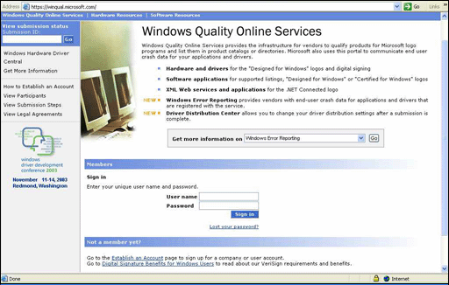

- In the left column, click Submission history and then double-click the submission for which you want to enter directory data. Or you enter the Submission ID from the final page of the submission process, then click Enter.
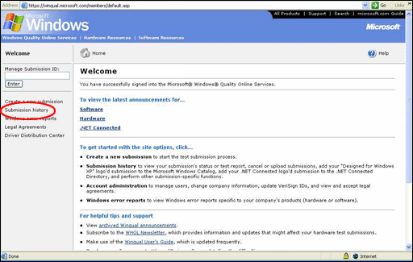

- The Submission status for the submission you choose must indicate Test Report in Process. Then click the red Start the Product Listing Wizard.
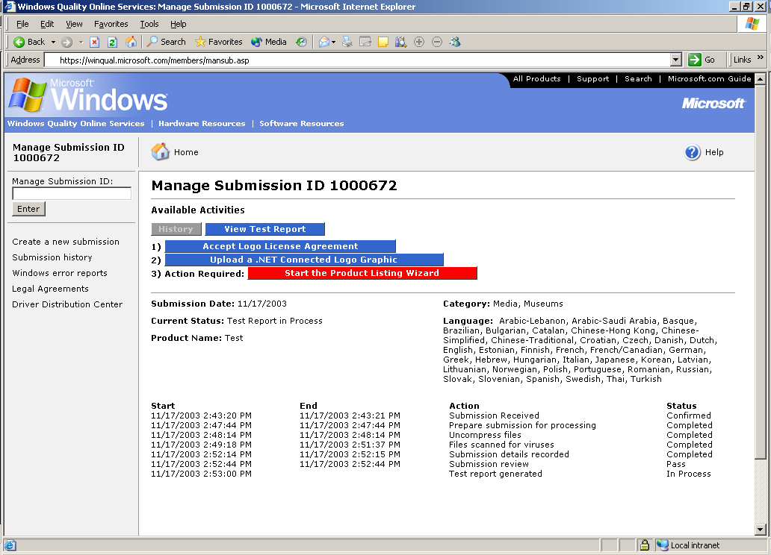

- Read the text and scroll to the bottom of the page. Click Next: Select Locale.
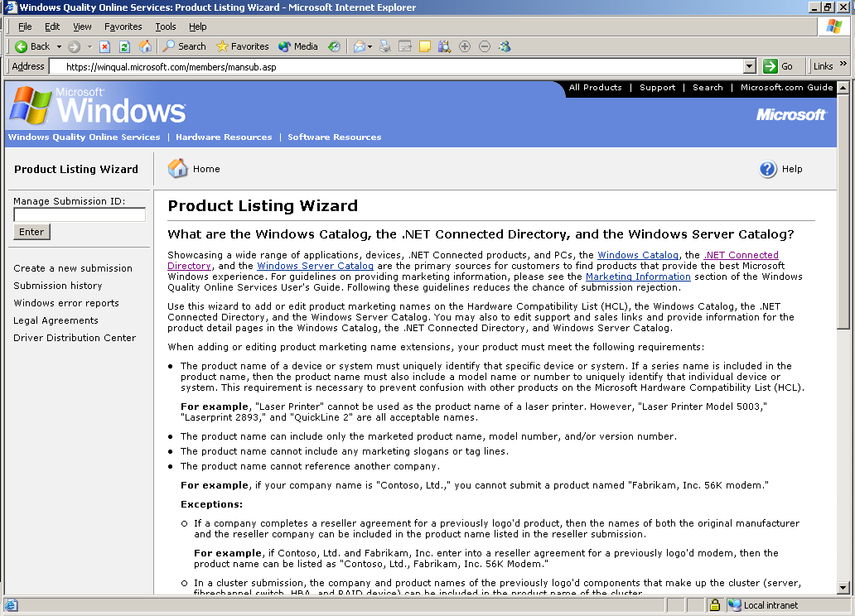
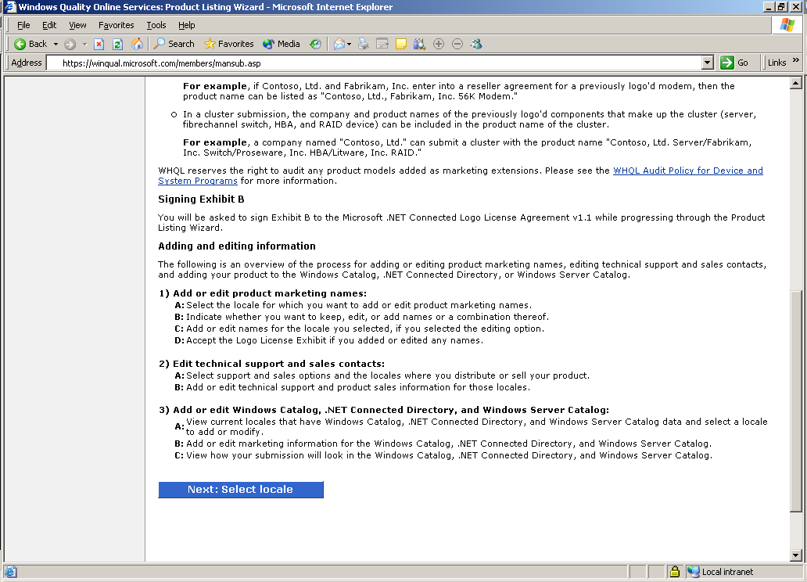

- Select English – United States to add or edit product names for the .NET Connected Directory data. You must enter English – United States as this is the only locale where the directory is currently published. You will have an opportunity to enter other locations in sales and marketing section later. Click Next: Select editing option
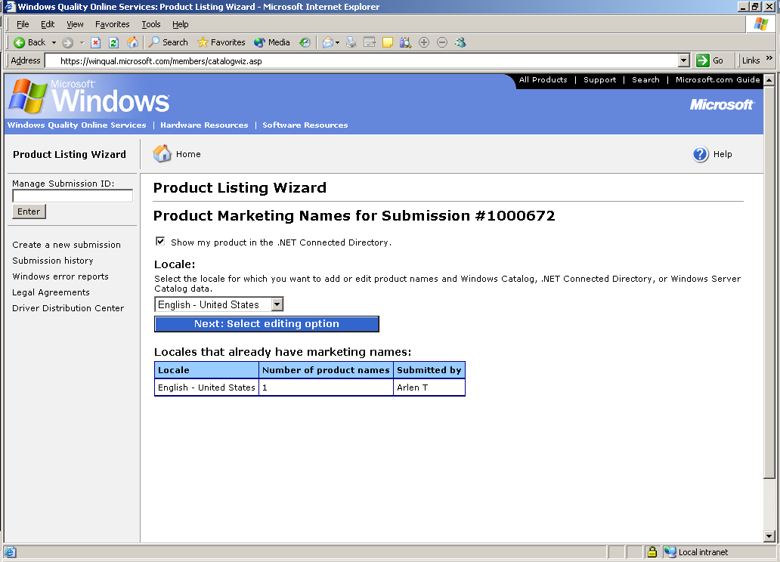

- Select the option you want, click Next, and then follow the on-screen instructions to proceed.
NOTE: If you opt to submit a new list of product names, any existing product names are erased.

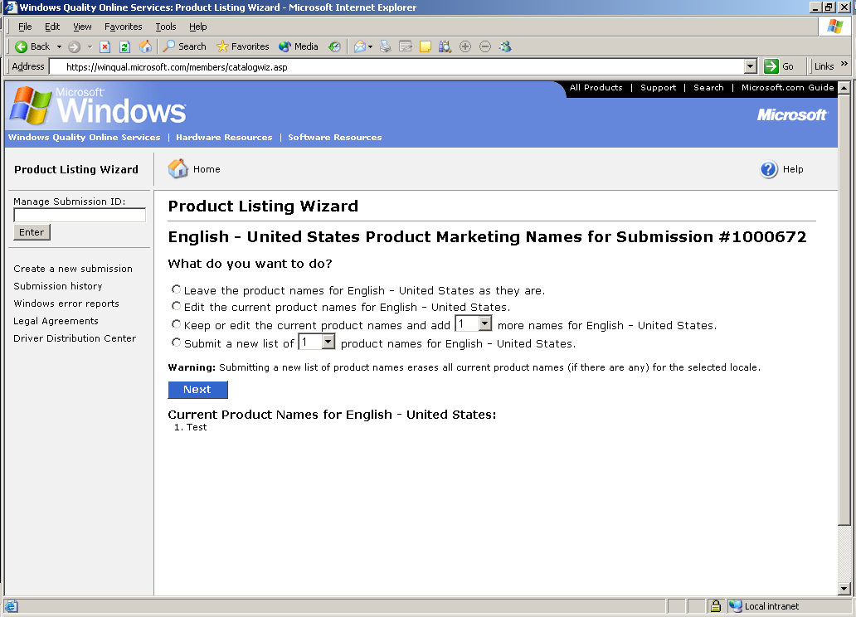
- On the Sales and Support Information page, complete steps 1 and 2. When finished, click Next: Add or edit sales and support information.
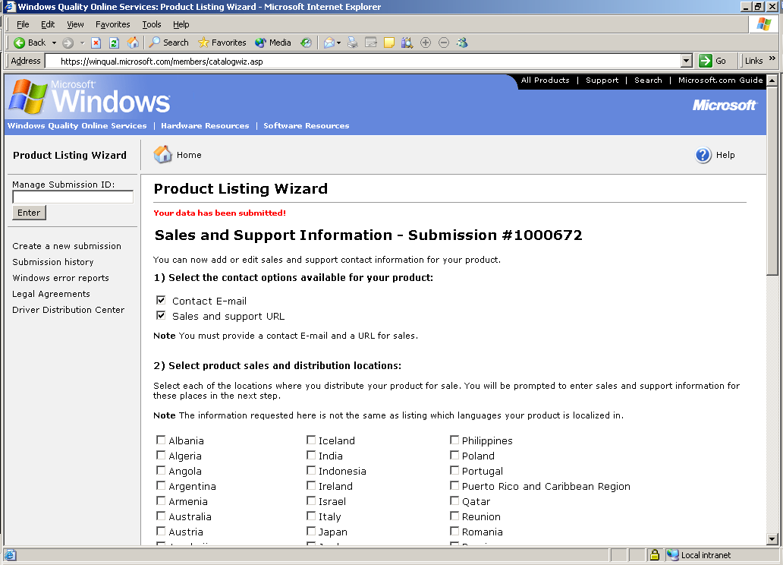

- Enter the product sales Web site address. When finished, click Next: Add or edit product listing information.
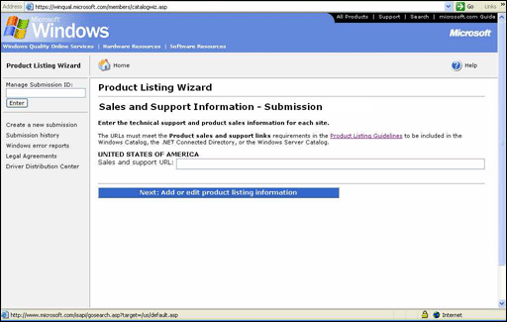
- Follow the on-screen instructions to complete the remaining steps.
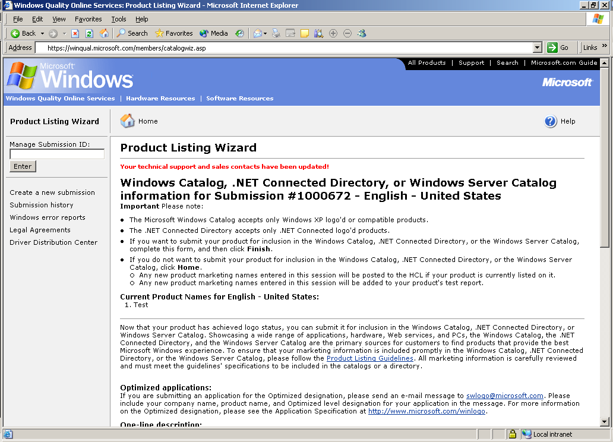
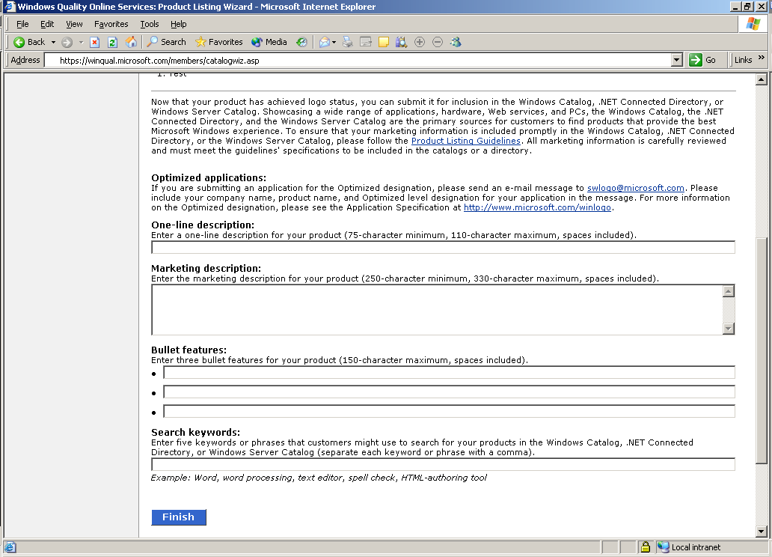
Your have now entered your marketing information. Your marketing information will be reviewed by the .NET Connected Directory Review Team and either approved or rejected. You will receive an e-mail review.

If there area any problems with the submitted marketing information you will receive specific instructions to correct your submission to ensure that your content passes the next review.

If you have any questions about the review, please contact the .NET Connected Directory Review Team at netdirrv@microsoft.com.

