Meeting the Information Challenges of Higher Education: The Campus Application Network Approach
connect

April, 2003
For the latest information, please see http://www.microsoft.com/education


Meeting the Information Challenges of Higher Education: The Campus Application Network Approach

Table of Contents
Introduction 2
Needs of the Higher Education “Information Organization” 2
The Campus Application Network – Plug & Play for Applications 3
Sidebar—Application Integration Approaches in Use Today 3
Sidebar—Campus Application Network Deployment Scenario: Campus Portals 6
Sidebar—Campus Application Network Deployment Scenario: Data Warehousing 7
Conclusion 7

Introduction

Information is the lifeblood of the higher education institution. As such, access to the most relevant, accurate and up-to-date information is integral to the success of any college or university in achieving its institutional mission. However, much of this information is housed in best-of-breed applications that do not necessarily share information with one another in the most efficient manner. This can hinder optimal performance and create barriers to information for students, faculty, staff, administrators and other constituents.

An effective and coordinated application integration strategy can help remove some of these information barriers and improve information flow. To that end, the Campus Application Network is an approach that enables colleges and universities to achieve long-term success by integrating their current applications and leveraging their existing investments.

In addition, large-scale information technology initiatives such as data warehouses and campus portals can be greatly enhanced by improved information flow resulting from the Campus Application Network approach, enabling institutions to gain even more benefit from existing resources and technology.

Needs of the Higher Education “Information Organization”

Colleges and universities could be considered the ultimate “information organizations.” Information is critical to the functioning of the higher education institution from two divergent yet related perspectives: academic and administrative. The primary objective of higher education institutions is the preservation, advancement and dissemination of knowledge. To fulfill this objective, colleges and universities enable students, faculty and researchers to collect, exchange and grow knowledge by creating and using information. Yet the administrative functions that support and enable this knowledge development also rely heavily on information. For example, administrators must create, access and analyze information to make decisions about budgets, course offerings, recruitment, marketing strategies, hiring needs and investments in IT projects. Without the efficient use of information for supporting the institution and making administrative decisions, the academic goals simply can not be met.

All the activities related to the academic and administrative aspects of the institution require convenient access to relevant, accurate and up-to-date information across and between campuses. However, despite the critical role of information in colleges and universities, access to information is limited and inconsistent. In their article on a next-generation infrastructure for higher education, Ed Lightfoot and Weldon Ihrig of the University of Washington offer a view of the current disconnected world of higher education:

“An open question is whether the systems have simplified or complicated life. There is a “system” for almost every function. In an attempt to become more user-friendly, these systems have evolved into a Web front-end, or in some cases, a portal. But all too often, the systems, Web sites, and portals are not interconnected, presenting the user with a fragmented view of the institution. Data from one system do not automatically transfer to another. Users must still register multiple times even though they are already affiliated with the institution. In some respects, the digital environment we have created replicates the offices on campus, but rather than walking from one place to another, the user must type in a different URL and log on to a different system. It may be faster and more efficient, but such fragmented approaches fall far short of the potential of the technology—and the needs of users.”

Higher education institutions have invested in network infrastructures, but they could benefit from a holistic, integrated system to achieve seamless connections within that infrastructure. With the advent of new technology, industry standards and best practices, a more integrated infrastructure is now possible, enhancing both the academic and administrative performance of institutions. Through seamless connections and improved information, colleges and universities can enable an optimal environment in which:
- Members have access to personalized information, services and tools anytime, anywhere.
- Access to information is determined by an individual’s needs, not by the system’s capabilities.
- Members can access relevant, accurate and current information for making decisions and taking action.
- Members can easily manage multiple roles and identities.
- Work processes are streamlined and routine tasks minimized.

Through a successful, coordinated application integration approach, information can flow seamlessly between systems and functions, removing barriers to information and improving both the academic and the administrative performance of the institution now and in the future.

The Campus Application Network – Plug & Play for Applications
As higher education institutions have attempted to address barriers to information flow, they have used application integration to bring data or functions of one application or system together with those of another. There are currently several approaches to application integration. A few of the more common approaches include point-to-point, application uniformity, hub and spoke, and publish and subscribe.

Application Integration Approaches in Use Today

Point-to-Point: The institution builds a custom interface between specific applications to perform specific interaction utilizing customer programs or an application server.

Application Uniformity: All applications are purchased from one vendor in an effort to eliminate integration challenges.

Hub and Spoke: Applications are connected to the integration architecture through a central point or hub. This decouples the “sender and receiver”. Documents can be transformed by the hub. Applications on either side of the hub can be modified independently of each other and the hub performs any mapping of documents between different application formats.

Publish and Subscribe: Extending the Hub and Spoke approach, “publish and subscribe” offers a standardized approach to create a complete decoupling of sources and targets for application integration. Applications on either side of the hub can be modified independently of each other and the hub performs any mapping of documents between different application formats. Subscribers can choose to subscribe and unsubscribe to messages and change their subscription properties at any time.

Today, many institutions face challenges resulting from a combination of these current and previous integration approaches. Vast amounts of IT time and resources are spent on supporting and maintaining previous integration efforts, leaving even less time for new application integration initiatives. Many of these previous integration efforts require ongoing tweaking and fixing, often creating unanticipated maintenance issues while diverting available IT resources away from more forward-looking, value-adding initiatives.

In situations where a “point-to-point” approach was used, for example, institutions developed labor-intensive custom code to tightly couple one application to another. This approach often creates maintenance challenges downstream, because when an application is added or replaced, every associated integration link has to be rebuilt. And as the number of interconnected applications increases, brittle connections and custom interfaces can often result, causing higher long-term integration costs when any type of application change is introduced. Figure 1 illustrates how this problem becomes compounded when multiple applications are integrated using a point-to-point approach. The number of integration points to maintain grows exponentially when each new application is added.

Other institutions have chosen the application uniformity approach, but often find that no single vendor can meet all of their application needs, leading to additional expense and custom programming for integration initiatives.
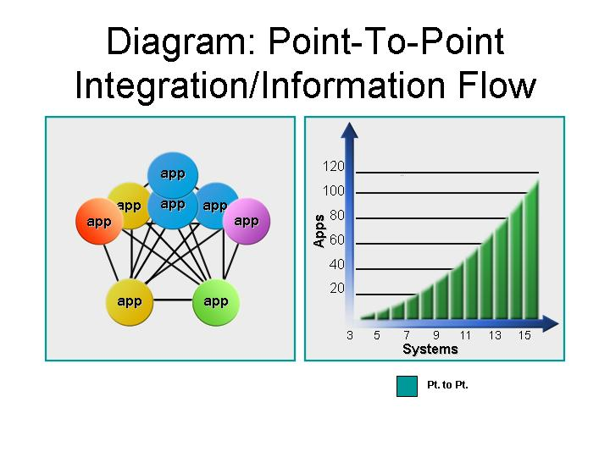
Figure 1: The complexity resulting from point-to-point application integration

And even as IT staff members struggle with the challenges of each previous integration approach in their present environment, they have no choice but to look to the future. They are faced with integrating even more applications and systems as new technologies are adopted, all in the face of rising expectations for improved information flow and services. Yet the same challenge exists: They are still working with limited time and resources. As a result of this situation, many institutions are exploring new integration approaches that consider both the long-term information needs of the institution and how to best meet those needs with available IT resources. Furthermore, these institutions are looking for integration approaches that:
- Accommodate heterogeneous platforms
- Unlock data from multiple enterprise and departmental applications
- Work within a backdrop of a distributed IT environment
- Offer effective and cost-efficient management of information flow within the IT-infrastructure
- Provide a framework that will allow for change as the information needs of the institution shift over time

Fortunately, recent advances in technology such as improved accessibility via the Web, the advent of XML and Web services, and various integration standards have provided an avenue for new application integration approaches that will further the goals of higher education institutions much more efficiently and effectively. The Campus Application Network approach offers one such avenue.

The Campus Application Network approach provides an integration architecture that meets many of the integration requirements and information flow challenges of higher education institutions today. The Campus Application Network, incorporating the benefits of “publish and subscribe” and “hub and spoke” integration approaches, leverages industry standards and recent advances to improve the ability of higher education institutions to access and share information (Figure 2).

Campus Application Network Enabling Technologies

The following provides an overview to the industry standards and technologies that enable the Campus Application Network integration approach.
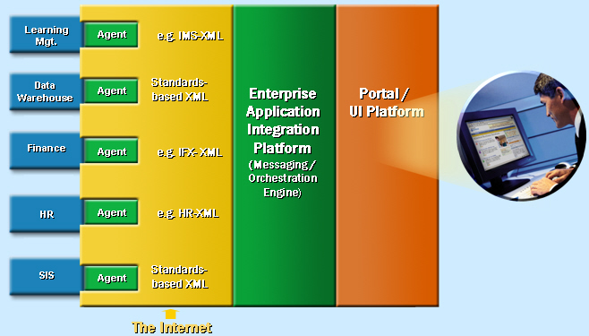

Industry Standards
XML, an open standard for describing data, is one of the most important drivers of the Campus Application Network. XML provides a way for organizations to describe data that can then be passed through a Web server interface. This architecture enables a standards-based data interchange strategy for applications irrespective of operating system or database platform.

One standard that has gained wide popularity in higher education is the IMS Enterprise Specification (www.imsproject.org). IMS is helping to define the technical specifications for interoperability of applications and services in distributed learning, and supports the incorporation of these specifications into products and services worldwide. The Campus Application Network approach takes full advantage of these and other industry standards.

Adapters and Agents
Adapters provide interoperability with a wide variety of applications and technologies. Microsoft and partners have built a range of adapters that serve to reduce the effort required to integrate systems across the Campus Application Network. If a standard adapter is not available, thin adapters or agents can be developed quickly and easily with an Agent Building Kit that Microsoft provides for customers. This kit allows institutions to quickly build agents to translate events and data from proprietary applications into XML format to be shared with other applications.

Orchestration and Messaging Engine
The Orchestration and Messaging Engine is used to coordinate and administer business processes across disparate applications of the Campus Application Network. Institutions can focus on defining, designing and deploying automated business processes that span applications and platforms. Adhering to a well-defined, formalized set of processes can enable higher education institutions to increase productivity and lower costs. There are a number of open industry standards such as the Business Process Execution Language for Web Services (BPEL4WS) that are evolving for the orchestration of transactions and business logic across various applications.
Figure 2: The standards and technologies that enable the Campus Application Network
With these enabling standards and core technology components, the Campus Application Network is the roadmap for a plug-and-play vision for higher education applications. As integration needs change, institutions can quickly add or “plug” new applications into the network with the use of adapters and agents. Once the application is plugged in, users and applications can “play” the information into existing business processes with XML and the Orchestration Engine, making the information available to all who need it. As the number of applications to be integrated increases, the Campus Application Network quickly becomes an optimal approach by providing the:

- Flexibility to accommodate heterogeneous platforms with open industry standards format
- Resources to unlock data from multiple enterprise and departmental applications with agents and adapters for virtually any application
- Easy-to-use GUI tools that enable the administration of the integration server
- Effective and cost-efficient integration with existing and future applications (e.g. portals, data warehouses, etc.)
- Adaptability to accommodate changes as the information needs and integration requirements of the institution shift over time

Campus Application Network Solution Profile: Campus Portals

Campus Portals
Students, staff and faculty today expect Web-based access to campus information and services that are relevant and personalized to their needs. In response institutions have created campus portals to enable new services and provide a wealth of information through a Web browser, but building and maintaining a campus portal is not without its challenges.

Campus Portal Challenges in Higher Education
Much of the cost of building and maintaining a portal lies in the development costs of connecting applications that feed into it. Creating and maintaining these point-to-point connections can be costly. And as new portals are created or applications are changed or added, the custom development starts all over again.

Campus Application Network Benefits
The Campus Application Network approach is based on standards where applications are “plugged in” to the integration architecture through a central point or hub. The portal is then connected into the hub or centralized campus data store, for its information. As applications are added or changed the integration only needs to be addressed at the hub, saving time and reducing cost and complexity. Reduced integration time also means information and new applications can be added and updated more quickly to meet student, staff and faculty expectations.

With the Campus Network Integration approach, colleges and universities can enhance academic and administrative performance with improved information access and exchange, as well as facilitate large-scale projects such as data warehouses and campus portals. The end result is an institutional environment in which students, faculty, staff and other constituents can access the information and services they need anytime, anywhere; information is accurate and timely; and work processes are streamlined. (See Campus Application Network Solution Profiles - Data Warehousing and Campus Portals)

Campus Application Network Solution Profile: Data Warehousing

Data Warehousing
Over the last few years, institutions have increasingly turned to data warehousing to improve information flow and decision support. A data warehouse can be a valuable asset in providing easy access to data for analysis and reporting. Unfortunately, building and maintaining an effective data warehouse has several challenges.

Data Warehousing Challenges in Higher Education
Today, much of the cost of building a data warehousing solution is tied up in custom programming for Extraction, Transformation and Loading (ETL) of data into the data warehouse from various applications. Higher education institutions can spend millions of dollars to develop ETL processing code. And the custom code developed can be very brittle, requiring additional maintenance over time.

Campus Application Network Benefits
The Campus Application Network approach provides a grid framework that automatically routes packets of data to the data warehouse. And the Orchestration Engine allows management of the process of extracting and coordinating the flow of data to the data warehouse. Additional functionality keeps data synchronized between applications and the data warehouse in near time. Improved information flow to and between data warehouses means decision makers have faster access to a wider variety of more accurate data. This improves the ability to sort, analyze and interpret data from multiple sources.

Conclusion
Access to the most relevant, accurate and up-to-date information is critical to the strategic success of colleges and universities. With new application integration approaches, information barriers in higher education institutions can be removed. The Campus Application Network presents an approach that enables institutions to achieve long-term success while integrating applications with minimal effort.

Education institutions have a number of options today for exploring opportunities with the Campus Application Network approach from Microsoft:

Microsoft QuickStart Sessions: Microsoft QuickStart Sessions are designed to help education institutions with expert technical services. The sessions start at the earliest stage of a deployment project when considering the Campus Application Network. Specific services include Architecture Design Sessions and Proof of Concept Workshops.

Architecture Design Sessions: This 2- to 7-day intensive workshop is designed to help CIOs and their staffs define the vision and architecture for the Campus Application Network. During the session, Microsoft experts assist in outlining the various systems that are available, and work collaboratively with your team to define the overall project vision and a potential pilot project. Specific outcomes from this session include:
- Institution Vision for the Project
- Project Business Case Justification
- Current Systems Architecture
- Pilot Proposal

Proof of Concept Workshops: This 15-day in-depth workshop is provided at one of four Microsoft Technology Centers throughout the US or at the customer location. Microsoft consultants work closely with key members of your technical staff to develop prototypes for custom solutions mapping out end-to-end integration scenarios (including internal and external applications) and deployment and maintenance implications. The workshop is an ideal way to compare products and minimize risk.

Contact a Microsoft Partner: You can start exploring an end-to-end solution through a Solution Provider, or evaluate individual components for your integration solution from an independent software vendor. Microsoft Education partners are integral to the Campus Application Network vision by providing depth of expertise and industry leading solutions built on Microsoft technologies.

To learn more about Microsoft’s efforts towards application integration in the educational environment, visit Microsoft’s Web site at http://www.microsoft.com/education/?ID=EAIHigherEd.

The information contained in this document represents the current view of Microsoft Corporation on the issues discussed as of the date of publication. Because Microsoft must respond to changing market conditions, it should not be interpreted to be a commitment on the part of Microsoft, and Microsoft cannot guarantee the accuracy of any information presented after the date of publication.

This White Paper is for informational purposes only. MICROSOFT MAKES NO WARRANTIES, EXPRESS, IMPLIED OR STATUTORY, AS TO THE INFORMATION IN THIS DOCUMENT.

Complying with all applicable copyright laws is the responsibility of the user. Without limiting the rights under copyright, no part of this document may be reproduced, stored in or introduced into a retrieval system, or transmitted in any form or by any means (electronic, mechanical, photocopying, recording, or otherwise), or for any purpose, without the express written permission of Microsoft Corporation.

Microsoft may have patents, patent applications, trademarks, copyrights, or other intellectual property rights covering subject matter in this document. Except as expressly provided in any written license agreement from Microsoft, the furnishing of this document does not give you any license to these patents, trademarks, copyrights, or other intellectual property.

2003 Microsoft Corporation. All rights reserved.

Microsoft is a registered trademark of Microsoft Corporation in the United States and/or other countries. The names of actual companies and products mentioned herein may be the trademarks of their respective owners.

“The Next-Generation Infrastructure,” Ed Lightfoot and Weldon Ihrig, University of Washington, EDUCAUSE Review, Volume 37, Number 6, November/December 2002

