
Project Budgeting

Microsoft Dynamics™ SL

Benefits
- Track your budget effectively
Manage the progress of your project
budgets from creation through closure,
with clear visibility into all aspects of
your budget. Budget revisions and
change orders are easily tracked and automatically update project statistics such as net profit and margin percentage.

- Manage your budgets more profitably
See the impact of change orders and
revisions on project profitability
before approving them. Easily monitor
the revised versions of the current
estimate-at-completion, forecast-at-completion, margin percentage, and
net profit.

- Fine-tune future bids
Compare budget detail with actuals at the
close of your project. By measuring the
accuracy of your budget and evaluating the impact on your profitability, you can easily fine tune your bidding process to ensure future competitive bids.

- Improve office productivity
Create new budgets simply and easily by
using templates based on earlier budgets,
or import budget estimates from external
sources. Approve budgets and budget
changes online quickly and efficiently.

- Achieve greater control over your
Budgets
With online budget routing and a detailed audit trail, you can view current budget details for your project and forecast future budget activity. Approvers and managers can see the bottom-line impact of budget changes before approving them, and know what is happening to the budget, with no surprises.

Take control of your project finances with powerful budgeting tools that allow you to significantly increase your project’s profitability. By tracking your budgeting process throughout the life of your project, you can view the impact of budget changes on profitability and manage the information you need to make your project successful.

Manage
the budget process from creation to final approval and from project initiation to completion.

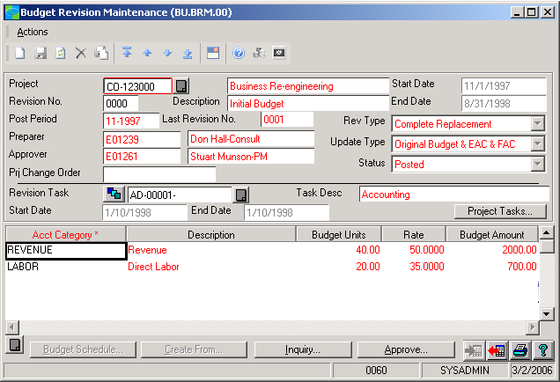



FEATURES

BENEFITS

Easy Budget Creation | Using a prior budget, estimate-at-completion, forecast-at-completion,  or actual amounts as a starting point, build a new budget with the same  or similar structure, revenue, and expenses. Then apply multipliers to  scale the budget and modify the data to fit the current project.
Easy Budget Import and Export | Easily build budgets from estimates by importing or exporting  information from external sources such as Microsoft® Excel or  estimating applications.
Simplified Budget Maintenance | Efficiently manage changes to your project budget by making, approving,  or rejecting changes and then entering or viewing comments about the  changes.
Revision Impact Previews | Preview the impact of proposed budget changes on project profitability  before making the changes. Managers can see the effects of changes on  current Estimate-at-Completion (EAC) and Forecast-at-Completion (FAC)  or on the margin percentage and project net profit.
Change Order Budget Tie-in | Tie budget revisions directly to change orders for easier management of  your project accounting.
Online Budget Approval | Review and approve budgets and budget revisions online. Approved  revisions automatically update the original budget, estimate-at-  completion, and forecast-at completion.
Complete Revision Audit Trail | Keep track of all changes made to a project budget with a complete  audit trail of budget revisions independent of current and original  budgets.
Seamless Data Sharing | Reduce errors and simplify data entry through single-point data entry  with integration across Microsoft Dynamics SL, including  project budgeting, payroll, distribution, and field service management  modules.

This document is for information purposes only.
MICROSOFT MAKES NO WARRANTIES, EXPRESS, IMPLIED, OR STATUTORY, AS TO THE INFORMATION IN THIS DOCUMENT.

© 2005 Microsoft Corporation. All rights reserved.
Microsoft, The Microsoft Dynamics Logo, are either registered trademarks or trademarks of Microsoft Corporation or Microsoft Business Solutions ApS in the United States and/or other countries. Microsoft Business Solutions ApS is a subsidiary of Microsoft Corporation.

For more information about Microsoft Dynamics™ SL, visit: http://www.microsoft.com/dynamics/sl

