# Role-Based Template for SharePoint My Sites: Customer Service Manager

***Technical Overview for***

***IT Professionals***

**Template Data and Integration**

Role-Based Templates for SharePoint**®** My Sites are pre-configured to display, in a common environment, role-relevant data from sources such as line of business systems, desktop tools, and portals. The templates make use of Microsoft**®** Office SharePoint Server 2007 capabilities, such as audience targeting, key performance indicators (KPIs), workflows, Excel**®** services, Business Data Catalog (BDC), and others. IT departments can integrate the Role-Based Templates for SharePoint My Sites with existing systems, as well as customize, extend and even replicate them. This enables quick deployment of role-based portals and provides cost-effective and easy-to-use solutions that integrate with important IT investments.

The templates are built using existing out-of-the-box SharePoint Web parts, and are flexible, providing a starting point for custom development. They come with a sample SQL Server™ 2005 database, a BDC application file and a SQL Server 2005 Analysis Services (SSAS) cube to show sample data. This datasheet describes the web parts and functionality Microsoft used when designing the templates. The role-based My Site template Setup Guide explains in detail how to configure them for your own data.

### Description of Template

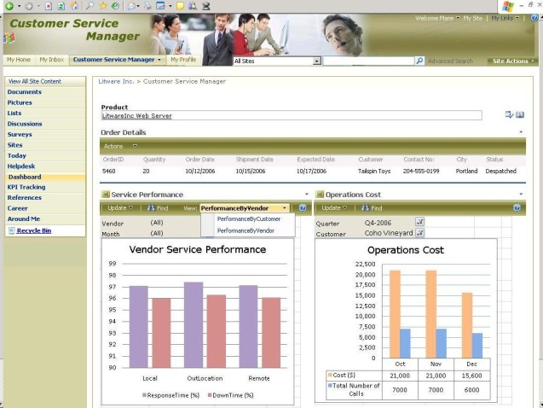The Customer Service Manager role-based template for SharePoint My Sites helps managers streamline the process of monitoring performance and enables the quick decision making that is usually required when addressing a customer’s complaints. The template provides a graphical view displaying call distribution, service performance, operation costs and representative quality indicators. It helps review order status and also displays key performance indicators for customer satisfaction and vendor performance. The overall design of this Role-Based My Site template is to help Customer Service Managers attain their goal of 100% customer satisfaction.

**Customized Pages and Web Parts Utilized in this Role-Based My Site Template**

The following is a list of all the custom pages that make up the Customer Service Manager role-based My Site template. Also included is a description of the web parts utilized on each page.

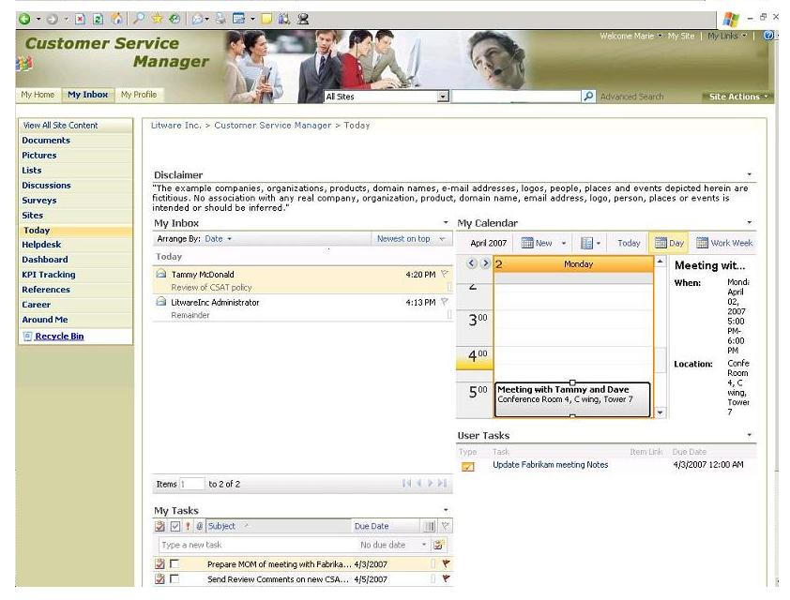**Today:** *Provides a quick glance into the user’s personal inbox, calendar and task list. It also displays user tasks assigned to them on SharePoint sites.*

* **My Inbox**, **My Calendar**, and **My Tasks** utilize Outlook**®** Web Access web parts to fetch data from the Microsoft Exchange Server and display the user’s personal inbox, calendar and task list. These web parts are configured with the mail server address and take in the user context by default to display their data from the Exchange Server.
* **User Tasks** web part displays the tasks assigned to the user in SharePoint tasks lists, enabling them to view and update the SharePoint tasks.

**Helpdesk:** *Shows help desk performance with a pivot table and call distribution chart. Also displays information pulled from Business Data Catalog (BDC) to create a view of call information logged against selected products.*

* **Helpdesk Performance** uses an Excel Web Access web part to display a pivot table showing values from various filters and parameters to determine the performance of the Helpdesk. The data is pulled from the backend system into the workbook through an Office Data Connection (.odc) file and published using Excel services. Conditional formatting is utilized to display status icons for the Call Closed Over Phone (%) values.
* 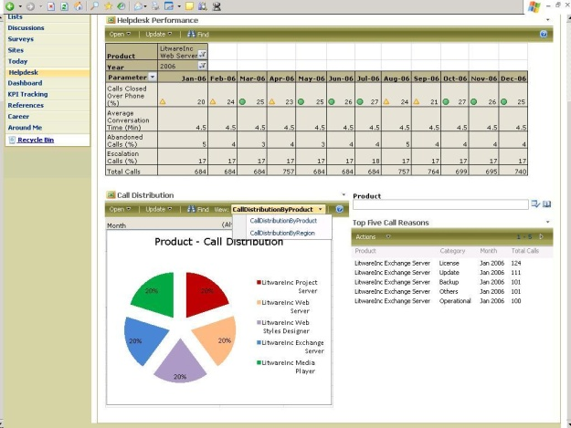**Call Distribution** also uses an Excel Web Access web part to display a chart representing the distribution of calls received. It provides two different views of the chart, one displaying call distribution by product and the other displaying call distribution by region. The Excel workbook pulls data from the backend system through an Office Data Connection (.odc) file.
* **Top Five Call Reasons** uses a Business Data List web part to display information on the Helpdesk page and is configured to fetch an entity from the BDC application data file. It displays the top five categories against which calls were logged for a product selected using the Product Filter. The Product Filter is implemented using a BDC Filter web part.

**Dashboard:** *Displays information pulled from BDC and creates dynamic data views, such as displaying order or showing service performance and operations cost charts.*

* **Order Details** uses a Business Data List web part to display information on the Dashboard page and is configured to fetch an entity from the BDC application data file. Order Details displays the details of orders corresponding to a product selected with the Product Filter. The Product Filteris implemented using a BDC Filter web part.
* **Service Performance** and **Operations Cost** use Excel Web Access web parts. Service Performance displays a chart depicting the performance in terms of Response Time and Down Time. Two different views display performance by customer and performance by vendor. Operations Cost is a chart displaying the cost incurred for rendering service for a selected customer during a selected month. The Excel workbook used for these charts is connected to the backend data through an Office Data Connection (.odc) file and is published with Excel Services.

**KPI Tracking:** *Shows Key Performance Indicators (KPIs) such as Customer Satisfaction and Vendor Performance.*

* 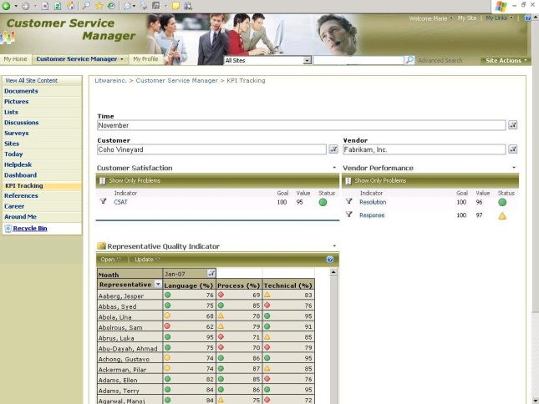The **Time, Customer and Vendor** filters are SQL Server Analysis (SSAS) Filter web parts that enable the Customer Service Manager to select desired options to view corresponding KPIs. Results are displayed in the Customer Satisfaction and Vendor Performance indicators. Customer Satisfaction indicator is filtered using Time and Customer filters; Vendor Performance indicators are filtered using Time and Vendor filters.
* **Customer Satisfaction** and **Vendor Performance** are KPI web parts connected to the SSAS Filter web parts mentioned above. The SSAS Filter web part is connected to the data through an Office Data Connection file (.odc) residing in the Data Connections library.
* **Representative Quality Indicators** is an Excel Web Access web part displaying an Excel pivot table. This table gives the manager a listing of scores obtained by the Customer Service Representatives for the three quality parameters (Language, Process and Technical) used to evaluate quality of service. Conditional formatting is utilized to display status icons for the values.

**References:** *Provides links, contacts, and a repository with frequently used documents and presentations.*

* **Management Documents, Presentations** and **Meeting Outcomes** are Library View web parts. Management Documents is attached to the Management Documents document library, a repository for documents relating to management information relevant to the Customer Service Manager. The Presentations document library is connected to the Presentations web part and has an Approval workflow that notifies their supervisor when a 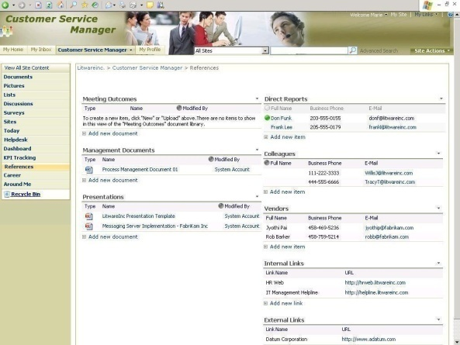new document is uploaded. The Meeting Outcomes web part is attached to the Meeting Outcomes Form Library and contains an InfoPath*®* form template.
* **Contacts** and **Links** are list view web parts. The Direct Reports and Colleagues Contacts lists are enabled with the presence icon. The two Links lists (Internal and External) display links to other systems and websites.

**Around Me** and **Career:** *Around Me provides one page to keep track of news, announcement and events relevant to the Customer Service Manager to keep them informed and in touch with the company. The Career page helps facilitate career planning by providing a place to keep track of objectives and performance.*

* *Around Me:* **Corporate News**, **International News** and **Industry News** are RSS Feed Viewer web parts and display news feeds from external web sites. **Corporate** and **System Downtime Announcements** are List View web parts displaying announcement details by the administrator. **Team Announcements** is a List View web part displaying announcements created by the Customer Service Manager. **Corporate, Industry** and **Marketing Events** are List View web parts that display corresponding events. An Alerts workflow is attached to these lists.
* *Career:* **Training Details**, **Awards and Rewards**, **Organization Objectives** and **Self Defined Objectives** are List View web parts that help keep a track of one’s career. All have personalized views so that only items created or modified by the logged-in Customer Service Manager are visible.

### Technical Dependencies

To use the Customer Service Manager template, you must have a server running the following:

* Microsoft Office SharePoint Server 2007
* Microsoft Office SharePoint Server 2007 Client Access License, Enterprise Edition

*For more information on additional dependencies, please review the Setup Guide.*

*Licensing information can be found at:* [*http://go.microsoft.com/fwlink/?LinkId=86927*](http://go.microsoft.com/fwlink/?LinkId=86927)

**More Information**

For more information on the technologies described in this article, please visit:

|  |  |
| --- | --- |
| Microsoft Office SharePoint Server 2007:  <http://www.microsoft.com/sharepoint> | Role-Based Templates for SharePoint My Sites:  <http://go.microsoft.com/?linkid=6060804> |
| Business Intelligence with Office SharePoint Server 2007:  <http://go.microsoft.com/fwlink/?LinkId=86668> | |