
Flat Rate Pricing

Microsoft Dynamics™ SL

Benefits
- Set up pricing flexibly
Define unlimited pricing plans, mark-up
plans, and printing groups or categories
during setup. To help ensure that every flat rate is profitable, Flat Rate Pricing lets you view profitability by pricing plan, line item detail, and product group class.

- Simplify data entry
Enter a new flat rate and add all the
components, including inventory items
needed for a specific task and labor hours needed to complete the job, all from a single screen. Even enter the warranty days for both parts and labor. Whether you’re entering a new flat rate or retrieving flat rate detail, the process has never been easier.

- Manage markups
Manage inventory and labor mark-up
breaks. Set up user-defined mark-up breaks by using the most recent or standard item costs from Microsoft Dynamics SL Inventory. Flat Rate Pricing helps you easily update and synchronize pricing of both the Flat Rate codes and Inventory items — simultaneously.

- Manage flat rates with ease
Capture valuable data with Flat Rate codes that specify information about Flat Rate types, warranties, service contracts, price revision dates, free notes, and much more. All of this information can be included for printing on your customized price catalog.

- Manage data better
Provide management with important
historical business data — such as how
many times each code has been used or sales history over a designated time period.

Take full control over every flat rate in your organization and inspire
more customer confidence in your organization. The flat rate pricing process, the standard in more service industries every day, is now easier than ever. With Microsoft Dynamics SL Flat Rate Pricing, you can stop purchasing expensive flat-rate books from an outside publisher and
enable your technicians to give on-the-spot printed price quotes on specific services from your pricing catalog.

Create
and modify Flat Rate Codes with ease.

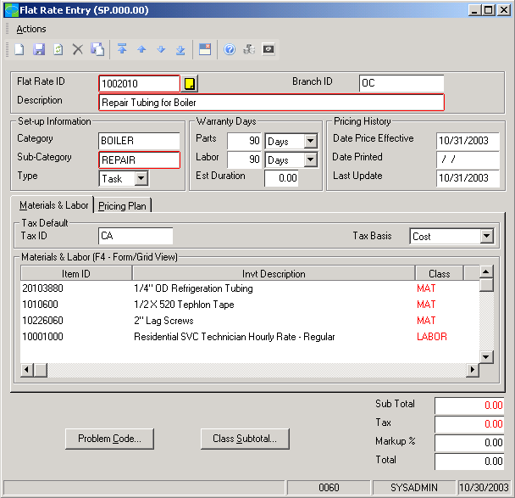

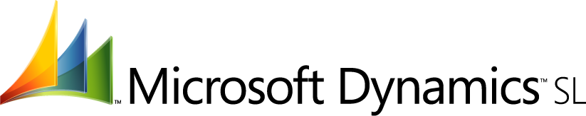

features

BENEFITS

Customized Catalog | Suit the needs of your organization by generating a pricing catalog  based on the sorting capabilities you need with advanced sort/select  capabilities.
Complete System Integration | Easily invoice using the flat rate pricing option instead of time and  material (T&M) via full integration with Microsoft Dynamics SL Service  Dispatch.
Flat-Rate Invoice Processing | Select the type of invoice during invoice entry by either T&M or Flat  Rate. For Flat Rate invoices, you can enter the Task and Add-on IDs that  will default the related labor and materials.
Multi-Level User-Defined Defaults | Accelerate and streamline data entry default field values. Default information can be overridden at any time by a user with access rights.
On-the-Fly Quoting | With Flat Rate Pricing, your customer service representatives have the ability to instantly quote possible Flat Rate prices linked to a particular Problem Code or Fault Code through Microsoft Dynamics SL Service Dispatch.
Presentation-Quality Reporting | Build and manage an impressive, customized pricing catalog fast. All  Flat Rate Pricing reports are created with Crystal Reports, which offers you numerous document enhancement capabilities.  S O L O M O N
Streamlined Data Entry | Add, modify, and delete labor and materials, and enter compensable  labor to push into Microsoft Dynamics SL Payroll — with no redundant  entry. Pricing information is easily synchronized with Microsoft Dynamics  SL Inventory items.
Inventory Integration | Develop and manage a flat rate system integrated with your inventory. Flat Rate Pricing enables management to continuously update the flat rate tasks and add-ons relative to today’s material costs (recent, last, and so on).
Profitability Analysis | Evaluate the profitability of flat rate price service calls. Flat Rate Pricing helps you view profitability by pricing plan, line item detail, and product group class on screen or in report form.
For more information about Microsoft Dynamics™ SL, visit: www.microsoft.com/dynamics/sl

This document is for information purposes only.
MICROSOFT MAKES NO WARRANTIES, EXPRESS, IMPLIED, OR STATUTORY, AS TO THE INFORMATION IN THIS DOCUMENT.

© 2005 Microsoft Corporation. All rights reserved.
Microsoft, The Microsoft Dynamics Logo, are either registered trademarks or trademarks of Microsoft Corporation or Microsoft Business Solutions ApS in the United States and/or other countries. Microsoft Business Solutions ApS is a subsidiary of Microsoft Corporation.

