Overview  Market Opportunity  Business Productivity Online Suite is a powerful solution for small and midsized businesses. Now Microsoft Partners offering managed services can add Business Productivity Online Suite to their product portfolio with confidence, knowing that they can easily include it as part of their managed services offerings.  Solution  Level Platform’s Managed Workplace is an agentless remote monitoring and management software platform that delivers end-to-end features for Microsoft Partners, allowing them to deliver advanced managed services to their SMB end customers.  Benefits  - Use the deep monitoring and alerting features of Managed Workplace to quickly identify IT issues occurring on premise that are affecting Business Productivity Online Suite services.  - Bundle Business Productivity Online Suite with Managed Services for a new revenue generation opportunity  - Minimize the need for escalation to Microsoft support services  - Secure your Trusted Advisor relationship with your clients |  |  | “Managed Workplace can handle it all: on-prem, hosted, even SaaS deployments of Microsoft’s Business Productivity Online Standard Suite. The far reach and adaptability is built in from day one, which is why Managed Workplace is the core of how we will provide support to customers moving forward.”  Steve Hand, Chief Technology Officer, Know Technology, LLC  Level Platforms’ Managed Workplace is a remote monitoring and management platform with end-to-end features for Microsoft Partners that enables them to deliver advanced managed services to their SMB end customers, including monitoring and alerting on the health and performance of Microsoft Business Productivity Online Suite, through a web-based central dashboard.  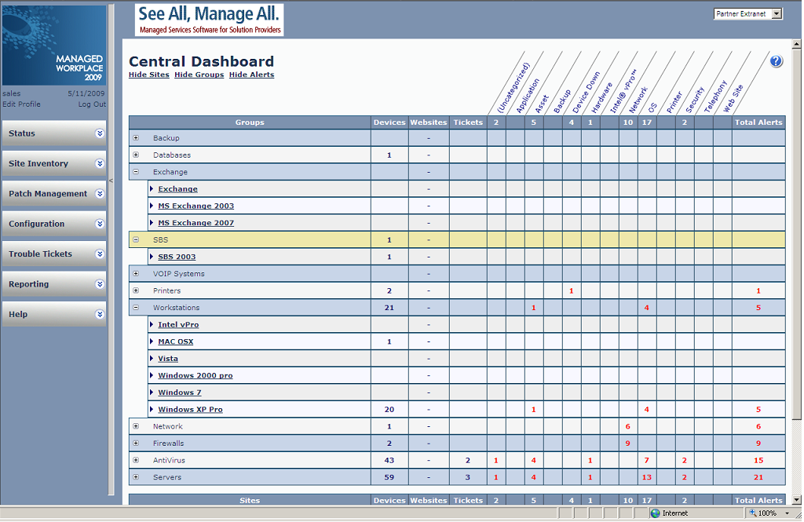

Solution Description
Managed Workplace consists of Onsite Managers and a Service Center.

Solution Components
Onsite Manager
A single, lightweight piece of software, installed once at each customer site. The Onsite Manager automatically performs secure, comprehensive scans of customer environments to gather the up-to-date information that solution providers need to manage their customers’ IT assets with unparalleled efficiency.

With an Onsite Manager, the Microsoft Partner can monitor and manage anything with an IP address, including: desktops, laptops, servers, managed switches, routers, firewalls, gateways, VoIP switches and phones, printers, faxes or scanners, off-the-shelf and custom applications, specialized equipment and environmental control devices, internal and external websites, software-as-a-service (SaaS) resources such as Microsoft Business Productivity Online Suite, virtual machines and much more.

Service Center
A powerful, web-based, centralized dashboard that allows the Microsoft Partner using Managed Workplace to:
- view the asset health and performance data sent by the Onsite Manager;
- “drill down” to details as required;
- perform rapid remote remediation;
- configure advanced services;
- produce a range of useful reports so you’ll know exactly what’s going on in your environment; and much more.

The Opportunity for Managed Services Providers
Managed Workplace opens up a range of opportunities for managed services providers, including the ability to:

- Extend 24/7 monitoring and alerting to include Business Productivity Online Suite hosted services

- Quickly triage and remediate issues across local network and Business Productivity Online Suite

- Establish a single point of responsibility for diagnosis and remediation

- Simplify the management of the Business Productivity Online Suite using the single web-based console

- Wrap a Managed Services offering around Business Productivity Online Suite services to generate recurring monthly revenue

- Resell the Business Productivity Online Suite to generate commission revenue

Value
- 24/7 deep monitoring and immediate alerting on the Business Productivity Online Suite
- Brand reports with your logo to deliver to your clients
- Dashboard view of the health, availability and performance of the Business Productivity Online Suite
- Faster customer diagnosis and remediation
- Clear single point of contact for customers issues
- Bundled pricing for all IT services including Business Productivity Online Suite

Benefits
- Use the deep monitoring and alerting features of Managed Workplace to identify IT issues that are on-premise and affecting Business Productivity Online Suite services, such as:
  - Workstation performance issues
  - Unreliable ISP connections
  - Customer network health
  - Customer firewall health
- Bundle Business Productivity Online Suite with Managed Workplace managed services for new revenue generation opportunity
- Minimize need for escalation to Microsoft support services
- Secure your Trusted Advisor relationship with your clients

Additional Project Opportunities
- Customer migration projects; for example, from on-premise to hosted environments
- Add/move/change services
- Customization and integration of Business Productivity Online Suite and on-premise applications

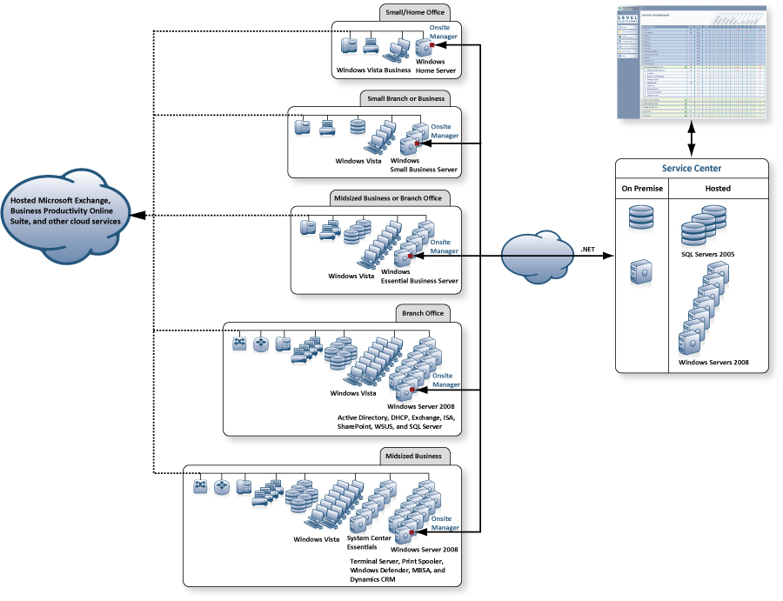

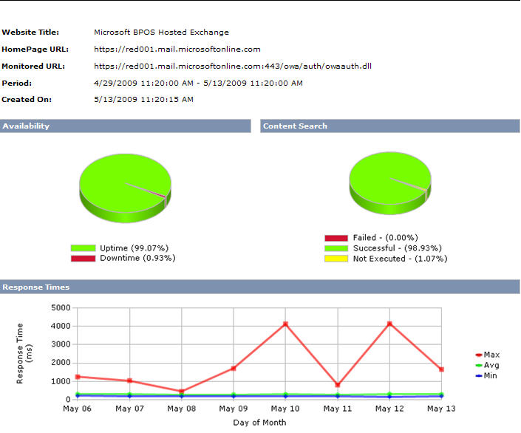

Benefits
Partner Benefits
Level Platforms Managed Workplace allows partners to:
- Generate new, recurring, and highly profitable revenue streams
- Achieve lower service delivery costs
- Identify and justify new project/product sales
- Acquire new customers

Customer Benefits
- Stabilize IT costs
- Increase availability of IT assets
- Achieve better ROI on IT investments
- Free up resources to focus on core business instead of IT

Introducing the Business Productivity Online Suite
Microsoft Online Services provide software delivered as a hosted service directly from Microsoft data centers, managed by Microsoft staff, and with a guaranteed 99.9 percent Service Level Agreement. These standardized solutions are designed so that partners can rapidly deploy services to their customers at a low, up-front investment with predictable, recurring costs.

The all-new Business Productivity Online Suite provides streamlined communications, simplified management, and business-class reliability and security.

The customer can order this service for as few as five seats at a time.

The Business Productivity Online Suite includes the following services, which can be purchased on a monthly subscription basis either separately or as part of a suite:

Microsoft Exchange Online, based on Microsoft Exchange Server 2007, offers businesses e-mail, calendaring, other messaging-based capabilities, and archiving. It also enables coexistence, which means new online users can interact with users on local servers.
(Introducing the Business Productivity Online Suite, Continued)
For More Information
For more information about Microsoft products and services, call the Microsoft Sales Information Center at (800) 426-9400. In Canada, call the Microsoft Canada Information Centre at (877) 568-2495. Customers who are deaf or hard-of-hearing can reach Microsoft text telephone (TTY/TDD) services at (800) 892-5234 in the United States or (905) 568-9641 in Canada. Outside the United States and Canada, please contact your local Microsoft subsidiary. To access information using the World Wide Web, go to www.microsoft.com

For more information about Microsoft Online Services, visit the Web site at
www.microsoft.com/online

About Level Platforms
With 3000 Partners in 30 countries, Level Platforms is the leading provider of managed services software for IT solution providers servicing small and midsized end customers through its award-winning agentless remote monitoring and management software, Managed Workplace.

For more information, visit the Level Platforms Web site at: http://www.levelplatforms.com

Microsoft Business Productivity Online Suite

- Microsoft Exchange Online
- Microsoft SharePoint Online
- Microsoft Office Communications Online
- Microsoft Office Live Meeting
- Microsoft Exchange Hosted Filtering

Microsoft SharePoint Online, based on Microsoft Office SharePoint Server 2007, provides a single integrated location where employees can efficiently collaborate with team members, find organizational resources, search, and manage content and workflow.

Microsoft Office Communications Online enables people to communicate easily with their colleagues across locations and time zones via instant messaging (text), voice, and video.

Microsoft Office Live Meeting is a hosted Web conferencing service that connects people in online meetings, training, and events through a reliable, enterprise-class hosted service.

Microsoft Exchange Hosted Filtering protects businesses’ inbound and outbound e-mail from spam, viruses, phishing scams, and e-mail policy violations.

About the Microsoft Business Productivity Online Suite
The Microsoft Business Productivity Online Suite provides businesses with virtually anywhere access to rich communication, collaboration, and productivity applications via subscription-based, Microsoft-hosted, online services. This hosted solution helps organizations offset the burden of managing and maintaining business systems, freeing information technology (IT) resources to focus on initiatives that can deliver competitive advantage to the business. The solution is part of the Microsoft’s Software-plus-Services delivery model to provide customers more choices than traditional, hosted, or on-premises solutions, allowing them to make deployment decisions that best fit the needs of their organization.

For more information about the partner opportunities provided by the Business Productivity Online Suite, see http://partner.microsoft.com/online.
© 2009 Microsoft Corporation. All rights reserved. This solution brief is for informational purposes only. MICROSOFT MAKES NO WARRANTIES, EXPRESS OR IMPLIED, IN THIS SUMMARY. Microsoft, SharePoint, Win32, and Windows are either registered trademarks or trademarks of Microsoft Corporation in the United States and/or other countries. The names of actual companies and products mentioned herein may be the trademarks of their respective owners.

Document published February 2009

