**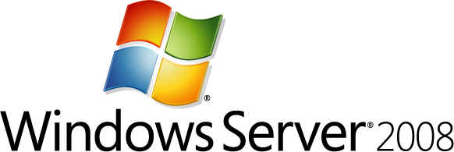**

Technical Overview of Windows Server 2008 Terminal Services

Microsoft Corporation

Published: January 2008

**Abstract:**

Windows Server® 2008 Terminal Services, a component of Microsoft Windows Server® 2008, enables organizations of all sizes to provide end-user access to Windows-based applications and data stored on a remote computer via a network. With Terminal Services, only the User Interface (UI) of an application is presented on the client system. Any input to it is redirected over the network to the server, where all application processing occurs.

The purpose of this technical whitepaper is to discuss the features, benefits and usage scenarios for Terminal Services and is intended for both server administrators who are already familiar with Terminal Services and server administrators who want to learn more about Microsoft’s presentation virtualization technologies.

## Disclaimer

**THIS IS NOT A PRODUCT SPECIFICATION.**

This document supports a preliminary release of a software product that may be changed substantially prior to final commercial release, and is the confidential and proprietary information of Microsoft Corporation. It is disclosed pursuant to a non-disclosure agreement between the recipient and Microsoft. This document is provided for informational purposes only and Microsoft makes no warranties, either express or implied, in this document. Information in this document, including Uniform Resource Locator (URL) and other Internet Web site references, is subject to change without notice. The entire risk of the use or the results from the use of this document remains with the user. Unless otherwise noted, the example companies, organizations, products, domain names, e-mail addresses, logos, people, places, and events depicted herein are fictitious, and no association with any real company, organization, product, domain name, e-mail address, logo, person, place, or event is intended or should be inferred. Complying with all applicable copyright laws is the responsibility of the user. Without limiting the rights under copyright, no part of this document may be reproduced, stored in or introduced into a retrieval system, or transmitted in any form or by any means (electronic, mechanical, photocopying, recording, or otherwise), or for any purpose, without the express written permission of Microsoft Corporation.

Microsoft may have patents, patent applications, trademarks, copyrights, or other intellectual property rights covering subject matter in this document. Except as expressly provided in any written license agreement from Microsoft, the furnishing of this document does not give you any license to these patents, trademarks, copyrights, or other intellectual property.

© 2008 Microsoft Corporation. All rights reserved.

Microsoft, Active Directory, SharePoint, Terminal Services RemoteApp, Windows, Windows Media, Windows Server, and Windows Vista are either registered trademarks or trademarks of Microsoft Corporation in the United States and/or other countries.

All other trademarks are property of their respective owners.

# Table of Contents

[Disclaimer 1](#_Toc194223291)

[Table of Contents 2](#_Toc194223292)

[Section 1: Introduction to Terminal Services 3](#_Toc194223293)

[When to Use Terminal Services 3](#_Toc194223294)

[Benefits of Windows Server 2008 Terminal Services 5](#_Toc194223295)

[Section 2: New and Updated Features 7](#_Toc194223296)

[Terminal Services RemoteApp 7](#_Toc194223297)

[Terminal Services Web Access 10](#_Toc194223298)

[Terminal Services Gateway 13](#_Toc194223299)

[Terminal Services Session Broker 16](#_Toc194223300)

[Terminal Services Easy Print 17](#_Toc194223301)

[Terminal Services Licensing 19](#_Toc194223302)

[Terminal Services and Windows System Resource Manager 21](#_Toc194223303)

[Other New Features 22](#_Toc194223304)

[At-a-Glance Features Comparison by Version 25](#_Toc194223305)

[Section 3: Planning and Deployment of Windows Server 2008 Terminal Services 27](#_Toc194223306)

[Planning for Windows Server 2008 Terminal Services 27](#_Toc194223307)

[Better Together: Microsoft Application Virtualization for Terminal Services 31](#_Toc194223308)

[Partners and Terminal Services 32](#_Toc194223309)

[Section 4: Summary 33](#_Toc194223310)

[Related Links 33](#_Toc194223311)

# Section 1: Introduction to Terminal Services

Businesses and employees are increasingly working in new ways, remotely or as a mobile workforce. Now more than ever, employees need access to critical data and business applications anywhere they happen to be—on the road, at home, from remote locations, on the shop floor, or in the office. Managing this workforce, and their technology needs, can be a daunting task for most IT departments. Remote or mobile workers need applications and systems that are secure and available, regardless of bandwidth. Critical updates need to be more easily or centrally managed. And IT professionals need solutions that are strategic, yet cost-effective.

Virtualization technologies can meet the needs of this ever-changing workforce. Virtualization technologies can separate one computing resource from others and can be applied from the data center to the desktop, impacting what and how resources and data are accessed. Microsoft supports four types of virtualization technologies: server, desktop, presentation, and application virtualization.

These expanded virtualization capabilities enable IT organizations to significantly reduce operating costs, drive up server utilization, and achieve better return on investment (ROI) through full featured virtualization solutions (see <http://technet.microsoft.com/en-us/infrastructure/default.aspx> for more information).

Presentation virtualization, using Microsoft Windows Server® 2008 Terminal Services, provides organizations with technologies that enable user access, from almost any computing device, to a server running Windows®-based programs or the full Windows desktop. Users can connect to a terminal server to run programs and use network resources on that server. With Terminal Services, applications are physically installed and are executing on data center servers, rather than the desktop.

Presentations virtualization is a strategic technology that can add value throughout an entire organization. An integral component of Windows Server 2008, Terminal Services provides organizations with a more secure, flexible, and manageable server-based computing environment. New options for application deployment and management and more efficient low bandwidth access to data enhances to the value of legacy and new, thin-client devices and makes Terminal Services an ideal solution for those organizations interested in optimizing resources.

## When to Use Terminal Services

To understand how Terminal Services can add value to your organization, it is useful to understand the functionality provided using the following scenarios or solutions. The solutions relate to both the type of employee base you are working with (location) as well as factors which need to be considered by the IT department (management).

**Mobile Workers**

If your organization needs to support employees who are mobile, work from home, or work while travelling, a Terminal Services solution can help you to enable employee productivity anywhere. It can also increase effective user collaboration without compromising security. Terminal Services can offer security-enhanced access to applications via low bandwidth connections, without requiring new applications to be distributed to every client. Your employees will see a consistent set of applications and can access their own data regardless of location.

**Task Workers—Factory Floor, Call Centers**

If your organization includes structured task workers, such as call center and retail branch employees, Terminal Services can provide a better and more productive user experience. Often these types of employees do not need to access many applications to complete tasks, or sometimes the location they are working from is not appropriate for PCs, for example, a factory floor. The same experience can be provided even if the client machine is a legacy desktop, a non-PC desktop, or a mobile device. This type of deployment can extend the reach of Windows–based applications within the enterprise and is a valuable, cost-effective way to deliver the right business tools.

**Branch Office**

In an environment with remote or branch offices, Terminal Services can provide enhanced capabilities to these sites and reduce the network bandwidth used by line-of-business (LOB) applications. For example, a bank might use essential financial software applications that would not be cost-effective to deploy and maintain in every branch. With Terminal Services, you can run the software at central headquarters; however employees in difference locations can access it remotely.

**Controlled Partner Access or Outsourcing**

In an environment where there are complex applications such as Line of Business or customized in-house software, Terminal Services can greatly reduce the burden of having to deliver access to these applications to outsourced firms or partners. The client machines can access the applications they require from a central source, rather than having to have everything installed on their local machine. It is possible to limit access to specific LOB applications, rather than providing access to the full corporate network.

**Merger Integration**

In the case of a merger, the merging companies will typically need to use consistent LOB applications on a variety of Windows operating system versions and configurations. Rather than going through the cost of deploying all of the LOB applications to all of the computers in the merged company, the LOB applications can be installed on a terminal server and made available through TS RemoteApp. This is especially useful when an application is difficult to patch or manage, can’t be distributed with Microsoft Systems Management Server (SMS), or has other management issues.

**Helping Ease the Burden of Regulatory Compliance**

By helping to secure an application and its data in a central location, it is possible to reduce the risk of accidental data loss caused by, for example, the loss of a laptop. Using Terminal Services zero footprint application and data delivery helps ensure that as little data as possible resides on the client device. With TS Gateway and TS RemoteApp, users, partners, or customers do not need full access to a company network or computers, and you can limit them to a single application, if needed.

## Benefits of Windows Server 2008 Terminal Services

Windows Server 2008 Terminal Services enables greater IT flexibility and increased security by running applications on a shared server:

**Accelerating Application Deployments and Operating System Migration**

* Accelerate application deployment and maintenance, and simplify ongoing management. Instead of updating applications on each individual desktop, only the single shared copy on the server needs to be installed initially and updated/patched.
* Deploy new applications to a wide variety of clients, including those on with the new application cannot run natively. PC hardware upgrades aren’t required to deploy new applications.
* Since applications are not installed locally, Terminal Services enables more streamlined desktop OS images on PCs, accelerating your organizations ability to adopt new operating systems such as Windows Vista and/or usage of thin clients, both of which can lower management costs.
* Allow applications that normally struggle at low bandwidth available over a variety of remote connection speeds.

**Helping Secure Data and Applications**

* With Terminal Services applications and data live in the datacenter, only encrypted keyboard and mouse strokes transmit over the network.
* Terminal Services centralization helps to radically simplify the challenges associated with regulatory compliance.
* Terminal Services capabilities simply & securely connect users outside the firewall, from home, hotels or customers sites to critical internal applications and data, without additional complex Virtual Private Network (VPN) infrastructure.
* In conjunction with Network Access Protection, client machines can be scanned for the latest anti-virus updates and patches to ensure unhealthy clients cannot access Terminal Services applications.

**Improving Worker Efficiency**

* Quickly and easily connect remote or mobile workers with the critical applications they need, from their laptop, home computer or airport kiosk, by accessing a secure web page to launch applications or access data that is not installed or available on the client machine.
* Terminal Services applications appear no differently than local applications and are tightly integrated with the task bar and new Windows Vista® features and thus, do not require retraining.
* Terminal Services optimizes application performance for high or low bandwidth connections. Data intensive applications (like ERP systems) that slow end-user productivity receive a performance boost when delivered via Terminal Services.

# Section 2: New and Updated Features

Terminal Services, a presentation virtualization technology delivered as a core component of Windows Server 2008, enables anywhere, anytime access a full Windows desktop or a server running Windows-based programs, from almost any computing device. Users can connect to a terminal server to run programs and use network resources on that server or to access the desktop. Now, Windows Server 2008 Terminal Services includes a number of important updates and new features to provide improved management of terminal servers and client machines in the Windows environment.

## Terminal Services RemoteApp

Previously in a Windows-based environment, Terminal Services provided only remote desktops with Windows Server 2003 Terminal Services-enabled applications. This is confusing to the user because some applications would be on their ‘remote desktop’ (via Terminal Services) and some applications would be on their local desktop. The challenge was remembering which desktop had which application.

Now, with Windows Server 2008, Terminal Services RemoteApp (TS RemoteApp) enables organizations to provide access to standard Windows-based programs from virtually any location to users of any Windows Vista SP1–based or Windows Server 2008–based computer, or to users of Windows XP with Service Pack 3– based computers that have the new Remote Desktop Connection (RDC) client installed.

In Windows Server 2008, the application rather than the entire remote desktop, launches, and runs in its own resizable window on the client computer’s desktop, eliminating confusion between the remote and the local applications. If the program uses a notification area icon, that icon appears in the client’s notification area. Pop-up windows are redirected to the local desktop and local drives and printers are redirected and made available within the remote program. Users may even be unaware that the remote program is any different than other local applications running side-by-side with the remote program on their desktop because similar functionality, such as cut and paste, are available.

### What New Functionality does TS RemoteApp Provide?

RemoteApp programs are programs that are accessed remotely through Terminal Services and appear as if they are running on the end user's local computer. Users can run programs from a terminal server and have the same experience as if the programs were running on their local computer, including resizable windows, drag-and-drop support between multiple monitors, and notification icons in the notification area.

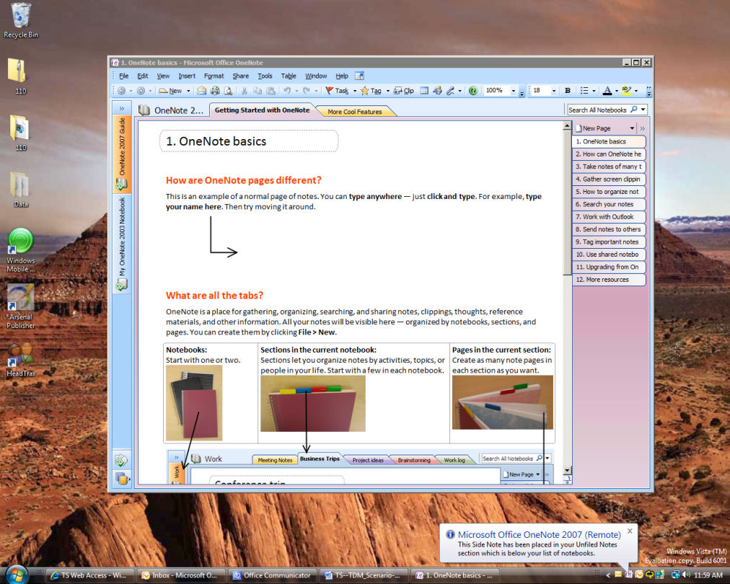

**Remote Systray Icon and Popup**

**Remote Application Window**

Figure 1. RemoteApp seamlessly integrates with the Windows Vista Desktop.

The functionality is important because, in addition to the user experience, it also opens new avenues for program deployment and reduces the amount of administrative effort required to support these programs.

Users can run RemoteApp programs side by side with their local programs. They can minimize, maximize, and resize the program window as well as cut and paste, and easily start multiple programs at the same time. If a user is running more than one RemoteApp program on the same terminal server, the RemoteApp programs will share the same Terminal Services session.

Instead of being presented to the user in the desktop of the remote terminal server, the RemoteApp program is integrated with the client desktop, running in its own resizable window with its own entry in the taskbar. If the program uses a notification area icon, this icon appears in the client's notification area. Popup windows are redirected to the local desktop. Local drives and printers can be redirected to appear in the RemoteApp program. Many users might not be aware that the RemoteApp program is any different than a local program.

Users can run RemoteApp programs in a number of ways:

* Double-click a Remote Desktop Protocol (.rdp) file that has been created and distributed by their administrator.
* Double-click a program icon on their desktop or Start menu that has been created and distributed by their administrator with a Windows Installer (.msi) package.
* Double-click a file whose extension is associated with a RemoteApp program. (This can be configured by their administrator with a Windows Installer package.)
* Access a link to the RemoteApp program on a Web site by using Terminal Services Web Access (TS Web Access).

TS RemoteApp can reduce complexity and reduce administrative overhead in many situations, including:

* Branch offices, where there may be limited local IT support and limited network bandwidth.
* Situations where users need to access applications remotely.
* Deployment of line-of-business (LOB) applications, especially custom LOB applications.
* Environments, such as "hot desk" or "hoteling" workspaces, where users do not have assigned computers.
* Deployment of multiple versions of an application, particularly if installing multiple versions locally would cause conflicts.

TS RemoteApp improves the user's experience, opens new avenues for program deployment, and reduces the amount of administrative effort required to support these programs. TS RemoteApp is installed as part of the Terminal Server role service in Windows Server 2008.

## Terminal Services Web Access

Terminal Services Web Access (TS Web Access) is a service within Terminal Services that lets you make TS RemoteApp programs, and a link to the terminal server desktop, available to users from a Web browser. Additionally, TS Web Access enables users to launch a connection from a Web browser to the remote desktop of any server or client computer where they have the appropriate access.

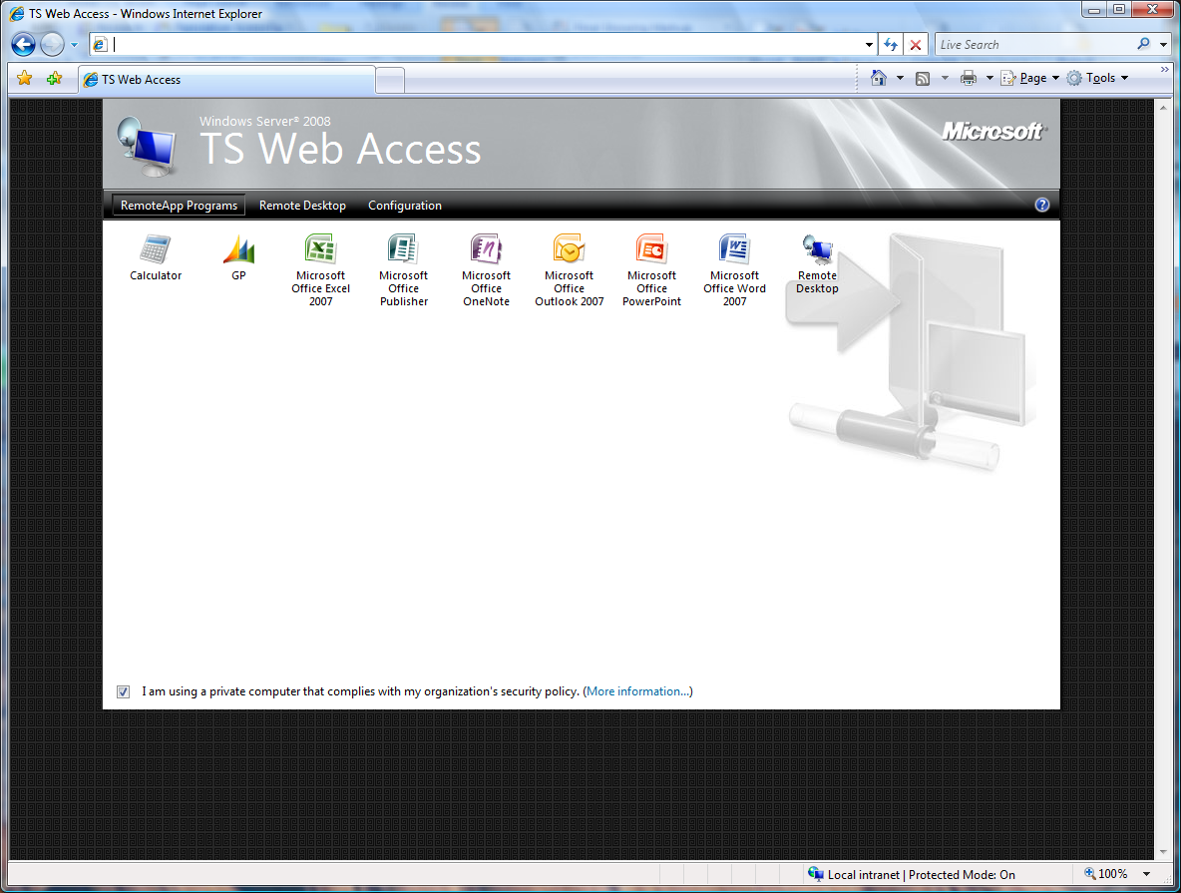

Figure 2. RemoteApp Manager Interface.

TS Web Access acts as the access or launch mechanism in conjunction with TS Gateway, to enable you to easily deploy RemoteApp programs over the internet in conjunction with TS Web Access. A user can visit a Web site, view a list of RemoteApp programs, and then simply click on a program icon to start the program. The RemoteApp programs are seamless, meaning that they appear like a local program. Users can minimize, maximize, and resize the program window, and can easily start multiple programs at the same time. For an administrator, TS Web Access is easy to configure and to deploy.

### What New Functionality does TS Web Access Provide?

In Windows Server 2008, TS Web Access provides a much improved end-user Web experience over earlier versions of Terminal Services:

* With TS Web Access, a user does not have to manually start the Remote Desktop Connection (RDC) client to start a RemoteApp program. Instead, they access the Web page, and then click a program icon.
* The RemoteApp programs look like they are running on the local desktop.
* If the user starts multiple RemoteApp programs and the RemoteApp programs are all running on the same terminal server, the programs run in the same session.
* Users do not have to download a separate ActiveX control to access TS Web Access. Instead, RDC 6.1 includes the required ActiveX control. (The RDC 6.1 client supports Remote Desktop Protocol 6.1.) RDC 6.1 is included in Vista SP1 and Windows XP SP3 and combines both the traditional RDC and the ActiveX control.
* TS Web Access replaces the older TS Web Connection software available for Windows TS 2003.

TS Web Access offers many benefits:

* Users can access RemoteApp programs from a Web site over the Internet or from an intranet. To start a RemoteApp program, they just click the program icon.
* If a user starts more than one RemoteApp program through TS Web Access, and the programs are running on the same terminal server, the RemoteApp programs run within the same Terminal Services session.
* By using TS Web Access, there is much less administrative overhead. You can easily deploy programs from a central location. Additionally, programs are running on a terminal server and not on the client computer so they are easier to maintain.
* TS Web Access includes support for Remote Desktop connections, which enables users to connect remotely to the desktop of any computer where Remote Desktop is enabled
* TS Web Access provides a solution that works with minimal configuration. The TS Web Access Web page includes a customizable Web Part, which can be incorporated into a customized Web page or a Windows SharePoint® Services site.

TS Web Access provides a customizable TS Web Access Web Part, where the list of RemoteApp programs is displayed. You can deploy the Web Part by using any one of the following methods:

* Deploy the Web Part as part of the TS Web Access Web page as the default out-of-the-box solution.
* Deploy the Web Part as part of a customized Web page using ActiveX and ASP (Terminal Services client is fully scriptable). For more information, please visit the MSDN library at <http://msdn2.microsoft.com/en-us/library/aa383022(VS.85).aspx>).
* Add the Web Part to a Windows SharePoint Services site.

The provided TS Web Access Web page and Web Part let you implement the TS Web Access site quickly and easily, and let you deploy TS Web Access by using a Web page or by using Windows SharePoint Services.

Now, with TS Web Access, you do not have to manually add a list of available programs to a Web page to provide centralized Web access to RemoteApp programs. The customizable Web Part gives you flexibility with regard to site appearance and deployment method.

This is important because Remote Desktop Web Connection enables users to connect remotely to the desktop of any computer where they have Remote Desktop access. For example, a user could connect remotely to their desktop at work if the remote computer is configured to accept Remote Desktop connections, and the user is a member of the Remote Desktop Users group on the remote computer.

In Windows Server 2008, the Remote Desktop Web Connection feature is available through the Remote Desktop tab on the TS Web Access Web page. Remote Desktop Web Connection is installed as part of the TS Web Access role service, instead of as an optional component of Internet Information Server (IIS7).

As an administrator, you can use IIS application settings to configure whether the Remote Desktop tab is available to users. Additionally, you can configure settings such as the TS Gateway server to use, the TS Gateway authentication method, and the default device and resource redirection options.

## Terminal Services Gateway

Terminal Services Gateway (TS Gateway) is a role service that allows authorized remote users to connect to terminal services based resources on an internal corporate or private network, from Internet-connected devices. The network resources can be terminal servers, terminal servers running RemoteApp programs, or computers with Remote Desktop enabled.

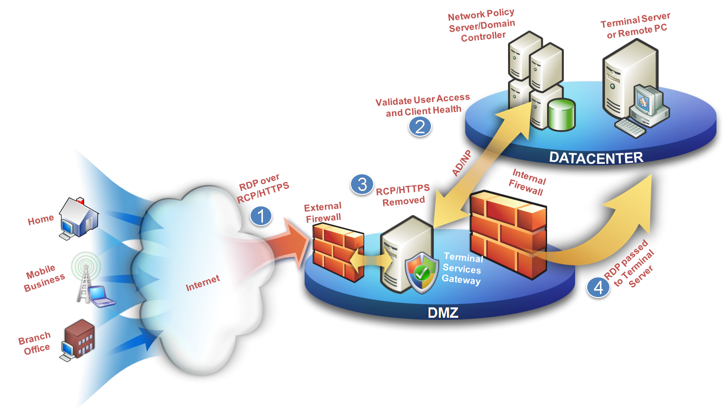

Figure 3. TS Gateway Architecture.

TS Gateway uses Remote Desktop Protocol (RDP) encapsulated in RPC over HTTPS to establish a secure, encrypted connection between remote users on the Internet and the internal network resources on which their productivity applications run.

### What New Functionality does TS Gateway Provide?

If your organization makes Terminal Services–based applications and computers that run Remote Desktop available to users from outside your network perimeter, TS Gateway can simplify network administration and reduce your exposure to security risks. TS Gateway can also make it easier for users because they do not have to configure VPN connections and can access TS Gateway servers from sites that can otherwise block outbound RDP or VPN connections.

**Note:** While TS Gateway allows access to a variety of Remote Desktop Protocol (RDP)-based computers and the resources they can access, it doesn’t provide direct connectivity for other protocols. When more than RDP (TCP Port 3389) is required, it is recommended that a VPN infrastructure be used such as Microsoft Intelligent Application Gateway (more information at <http://www.microsoft.com/forefront/edgesecurity/iag/default.mspx>).



TS Gateway provides many benefits, including:

* TS Gateway enables remote users to connect to internal network resources over the Internet, by using an encrypted connection, without needing to configure virtual private network (VPN) connections.
* TS Gateway provides a comprehensive security configuration model that enables you to control access to specific internal network resources.
* TS Gateway provides a secure yet flexible RDP connection allowing users access to anything to which their RDP host has access, rather than allowing remote users direct network connectivity to all internal network resources; helping protect the internal resources.
* TS Gateway enables most remote users to connect to internal network resources that are hosted behind firewalls in private networks and across Network Address Translation (NATs) devices. With TS Gateway, you do not need to perform additional configuration for the TS Gateway server or clients for this scenario.
* The TS Gateway Manager snap-in console enables you to configure authorization policies to define conditions that must be met for remote users to connect to internal network resources. For example, you can specify:
  + Who can connect to network resources (in other words, the user groups who can connect).
  + What network resources (computer groups) users can connect to.
  + Whether client computers must be members of Active Directory® security groups.
  + Whether device and disk redirection is allowed.
  + Whether clients need to use smart card authentication or password authentication, or whether they can use either method.
* You can configure TS Gateway servers and Terminal Services clients to use Network Access Protection (NAP) to further enhance security. NAP is a health policy creation, enforcement, and remediation technology that is included in Windows XP Service Pack 2, Windows Vista, and Windows Server 2008. With NAP, system administrators can enforce health requirements, which can include software requirements, security update requirements, required computer configurations, and other settings.

**note_ddNote:** Computers running Windows Server 2008 cannot be used as NAP clients when TS Gateway enforces NAP. Only computers running Windows XP SP3 and Windows Vista SP1 can be used as NAP clients when TS Gateway enforces NAP.

* You can use TS Gateway server with Microsoft Internet Security and Acceleration (ISA) Server to enhance security. In this scenario, you can host TS Gateway servers in a private network rather than a perimeter network and screened subnet), and host ISA Server in the perimeter network. The SSL connection between the Terminal Services client and ISA Server can be terminated at the ISA Server, which is Internet-facing.
  + For information about how to configure ISA Server as an SSL termination device for TS Gateway server scenarios, see the [TS Gateway Server Step-by-Step Setup Guide](http://go.microsoft.com/fwlink/?linkid=79605) on the TS Gateway page on the Windows Server 2008 TechCenter (<http://go.microsoft.com/fwlink/?linkid=79605>).
* The TS Gateway Manager snap-in console provides tools to help you monitor TS Gateway connection status, health, and events. By using TS Gateway Manager, you can specify events (such as unsuccessful connection attempts to the TS Gateway server) that you want to monitor for auditing purposes.
* Terminal Services Gateway securely connects applications and data to users outside the firewall and provides simple and secure delivery of critical applications and data to mobile employees without a VPN.

TS Gateway provides several new features to simplify administration and enhance security.

* **Monitoring Capabilities:** You can use TS Gateway Manager to view information about active connections from Terminal Services clients to internal corporate network resources through TS Gateway. This information includes the connection ID, the domain and user ID of the user logged on to the client, full name of the user logged on to the client, date and time when the connection was initiated, length of time the connection was active, length of time that the connection is idle- if applicable, name of the internal network computer to which the client is connected, IP address of the client.
* **Group Policy Settings for TS Gateway:** You can use Group Policy and Active Directory Domain Services to centralize and simplify the administration of TS Gateway policy settings. You use the Local Group Policy Editor to configure local policy settings, which are contained within Group Policy Objects (GPOs). You use the Group Policy Management Console (GPMC) to link GPOs to sites, domains, or organizational units (OUs) in Active Directory Domain Services. Group Policy settings for Terminal Services client connections through TS Gateway can be applied in one of two ways. These policy settings can either be suggested (that is, they can be enabled, but not enforced) or they can be enabled and enforced. Suggesting a policy setting allows users on the client to enter alternate TS Gateway connection settings. Enforcing a policy setting prevents a user from changing the TS Gateway connection setting, even if they select the Use these TS Gateway server settings option on the client**.**
* **TS CAPs:** Terminal Services connection authorization policies (TS CAPs) allow you to specify user groups, and optionally client computer groups, that can access a TS Gateway server. You can create a TS CAP by using TS Gateway Manager. TS CAPs simplify administration and enhance security by providing a greater level of control over access to computers on your internal network. TS CAPs also allow you to specify who can connect to a TS Gateway server. You can specify a user group that exists on the local TS Gateway server or in Active Directory Domain Services. You can also specify other conditions that users must meet to access a TS Gateway server. You can list specific conditions in each TS CAP. For example, you might require a user to use a smart card to connect through TS Gateway. Users are granted access to a TS Gateway server if they meet the conditions specified in the TS CAP.
* **TS RAPs:** Terminal Services remote authorization policies (TS RAPs) allow you to specify the internal corporate network resources that remote users can connect to through a TS Gateway server. When you create a TS RAP, you can create a computer group (a list of computers on the internal network to which you want the remote users to connect) and associate it with the TS RAP. Remote users connecting to an internal network through a TS Gateway server are granted access to computers on the network if they meet the conditions specified in at least one TS CAP and one TS RAP. Together, TS CAPs and TS RAPs provide two different levels of authorization to provide you with the ability to configure a more specific level of access control to computers on an internal network.

Remote users can connect through TS Gateway to internal network resources in a security group or a TS Gateway–managed computer group. The group can be any one of the following:

* Members of an existing security group. The security group can exist in Local Users and Groups on the TS Gateway server, or it can exist in Active Directory Domain Services.
* Members of an existing TS Gateway–managed computer group or a new TS Gateway-managed computer group. You can configure a TS Gateway–managed computer group by using TS Gateway Manager after installation.

For information about how to configure TS Gateway to use NAP for health policy enforcement for Terminal Services clients that connect to TS Gateway servers, see the [TS Gateway Server Step-by-Step Setup Guide](http://go.microsoft.com/fwlink/?linkid=79605) on the TS Gateway page on the Windows Server 2008 TechCenter (http://go.microsoft.com/fwlink/?linkid=79605).

## Terminal Services Session Broker

Terminal Services Session Broker (TS Session Broker) is a role service in Windows Server 2008 that allows a user to reconnect to an existing session in a load-balanced terminal server farm. TS Session Broker stores session state information that includes session IDs and their associated user names, and the name of the server where each session resides.

Windows Server 2008 introduces this new TS Session Broker Load Balancing feature that enables you to distribute the session load between servers in a load-balanced terminal server farm.

**note_ddNote:** In Windows Server 2008, the name of the Terminal Services Session Directory (TS Session Directory) feature was changed to Terminal Services Session Broker (TS Session Broker).

### What New Functionality does TS Session Broker Provide?

The new TS Session Broker Load Balancing feature enables you to evenly distribute the session load between servers in a load-balanced terminal server farm. With TS Session Broker Load Balancing, new user sessions are redirected to the terminal server with the fewest sessions.

**note_ddNote:** In Windows Server 2008, Terminal Services still supports the session broker functionality with third-party and Microsoft Network Load Balancing, if required.

TS Session Broker is a two phased load-balancing mechanism. In the first phase, initial connections are distributed by a preliminary load-balancing mechanism, such as DNS round robin. After a user authenticates, the terminal server that accepted the initial connection queries the TS Session Broker server to determine where to redirect the user.

In the second phase, the terminal server where the initial connection was made redirects the user to the terminal server that was specified by TS Session Broker. The redirection behavior is as follows:

* A user with an existing session will connect to the server where their session exists.
* A user without an existing session will connect to the terminal server that has the fewest sessions.

TS Session Broker Load Balancing sets a (total combined) limit of 16 for the maximum number of pending logon requests to a particular terminal server. This helps to prevent the scenario where a single server is overwhelmed by new logon requests; for example, if you add a new server to the farm, or if you enable user logons on a server where they were previously denied.

The TS Session Broker Load Balancing feature also enables you to assign a relative weight value to each server. By assigning a server weight value, you can help to distribute the load between more powerful and less powerful servers in the farm.

**Note:** To configure a server to participate in TS Session Broker Load Balancing, and to assign a server weight value, you can use the Terminal Services Configuration tool.

A User logon mode setting is provided that enables you to prevent new users from logging on to a terminal server that is scheduled to be taken down for maintenance. This mechanism provides for the ability to take a server offline without disrupting the user experience. If new logons are denied on a terminal server in the farm, TS Session Broker will allow users with existing sessions to reconnect, but will redirect new users to terminal servers that are configured to allow new logons.

**Note:** The User logon mode setting is located under General in the Edit settings area of the Terminal Services Configuration tool.

While any load-balancing mechanism can be used to distribute the initial connections, DNS round robin is the easiest mechanism to deploy. Deploying TS Session Broker Load Balancing with a network level load-balancing solution such as NLB or a hardware load balancer avoids the limitations of DNS, while still taking advantage of TS Session Broker session-based load balancing, the per server limit on the number of pending logon requests, and the user logon mode setting. The limitations of DNS round robin include the caching of DNS requests on the client, which can result in clients using the same IP address for each initial connection request, and the potential for a 30-second timeout delay if a user is redirected to a terminal server that is offline, but still listed in DNS.

## Terminal Services Easy Print

Terminal Services Easy Print (TS Easy Print) is a feature in Windows Server 2008 that enables users to reliably print from a TS RemoteApp program or from a TS remote desktop session to the correct printer on their client computer. In previous versions of Terminal Services, a user would connect to the terminal server and the closest matching server print driver would be selected. When a user accessed and ran Microsoft Office Word to print a document, the document would be rendered with the server printer driver and the print job would be sent back to the client printer for printing. Frequently, there would be no close printer driver match. So, although the user may have been running Microsoft Word on Terminal Services, they were not able to print. Or, when the document was rendered with the printer driver and sent back to the client printer, the output appeared corrupted. Another common problem was that upon connecting to Terminal Services, the user would see basic or different printer than would normally be seen on their local machine. This resulted in, for example, the user being unable to print in color even though this functionality was supported by the local printer. Overall, managing unreliable printer drivers was challenging and often resulted in distorted output.

Now, in Windows Server 2008, Terminal Services Easy Print leverages the client-side print driver (no server side driver needed) to enable fast and reliable printing to a local or network-attached printer. End users can more productively work from remote locations. It also enables users to have a much more consistent printing experience between local and remote sessions.

### What New Functionality does TS Easy Print Provide?

Terminal Services printing has been enhanced in Windows Server 2008 by the addition of the TS Easy Print and a Group Policy setting that enables you, by default, to redirect only the default client printer.

The **Redirect only the default client printer policy** setting allows you to specify whether the default client printer is the only printer that is redirected in Terminal Services sessions. This helps to limit the number of printers that the spooler must enumerate, therefore improving terminal server scalability.

To use the TS Easy Print driver, clients must be running both of the following:

* Remote Desktop Connection (RDC) 6.1
* Microsoft .NET Framework 3.0 Service Pack 1 (SP1)

Windows Server 2008, Windows Vista with SP1 and Windows XP SP3 include both of the required components.

The **Redirect only the default client printer** Group Policy setting allows you to control whether the default client printer is the only printer redirected in a Terminal Services session, or whether all printers are redirected in a session. By redirecting only the default printer you can reduce the number of printers the user has to choose and improve TS logon times and improve server reliability due to the need to enumerate fewer printers

The terminal server fallback printer driver is not included with Windows Server 2008. Although the **Specify terminal server fallback** printer driver behavior Group Policy setting still exists, it can only be used for Windows Server 2003 with SP1-based computers.

The new Terminal Services Easy Print driver offers organizations:

* Increased reliability of Terminal Services printing for both RemoteApp and remote desktop sessions.
* Support for legacy and new printer drivers without the necessity of installing these drivers on the terminal server.
* Scalability improvements over Windows Server 2003 in terms of printer enumeration performance. During the Winlogon process, the spooler only enumerates printers that are available for a user in a particular session instead of enumerating all redirected printers. Therefore, printers are enumerated on a per-session basis, instead of on a per-user basis.
* Enhanced available printer capabilities in that The Terminal Services Easy Print use the client side driver to ensure that all of the printer capabilities normally available to the user can also be used in remote sessions. All of the physical printer driver's capabilities are available for use when a user views the printing preferences.

The **Redirect only the default client printer** Group Policy setting allows you to control whether the default client printer is the only printer redirected in a Terminal Services session, or whether all printers are redirected in a session.

Also new in Windows Server 2008 Terminal Services is the **Use Terminal Services Easy Print printer driver first** Group Policy for Terminal Services printing located in the following node of the Local Group Policy Editor: Computer Configuration\Administrative Templates\Windows Components\Terminal Services\Terminal Server\Printer Redirection.

The **Use Terminal Services Easy Print printer driver first** Group Policy setting allows you to configure default settings to use the Terminal Services Easy Print driver to install all client printers. If for any reason the Terminal Services Easy Print driver cannot be used, a printer driver on the terminal server that matches the client printer will be used. If the terminal server does not have a printer driver that matches the client printer, the client printer will not be available for the Terminal Services session. By default, this policy setting is not configured.

## Terminal Services Licensing

Windows Server 2008 provides a license management system for Terminal Services: Terminal Services Licensing (TS Licensing). This system allows terminal servers to obtain and manage Terminal Services client access licenses (TS CALs) for devices and users that are connecting to a terminal server. TS Licensing supports terminal servers that run Windows Server 2008 as well as terminal servers running Windows Server 2003 or Windows 2000 Server.

**note_ddNote:** Remote Desktop on Windows Server supports two connections to allow remote administer of the server. You do not need a license server for these connections.

A terminal server is a computer on which the Terminal Server role service is installed. It provides clients access to Windows–based applications running entirely on the server and supports multiple user sessions on the server. As clients connect to a terminal server, the terminal server determines if the client or user needs a TS CAL, and then requests a TS CAL from a license server. TS Device CALs are distributed to the client device and the license is presented for validation at every connection. TS User CALs are automatically assigned to the user in Active Directory.

A Terminal Services license server is a computer on which the TS Licensing role service is installed. A license server tracks all TS CALs that have been installed for a group of terminal servers and tracks the TS CALs that have been issued. One license server can serve many terminal servers simultaneously. To issue permanent TS CALs to client devices, a terminal server must be able to connect to an activated license server. A license server that has been installed but not activated will only issue temporary TS CALs.

### What New Functionality does TS Licensing Provide?

New to Windows Server 2008 Terminal Services, Microsoft has included a Licensing Diagnosis tool to assist in managing and maintaining terminal servers. Licensing Diagnosis can analyze a terminal server and highlight potential network issues that might occur due to the configuration of the terminal server/ license server deployment. You can use Licensing Diagnosis to identify several situations:

* Whether a user or computing device will be allowed to connect to a terminal server.
* Which license servers are discoverable by the terminal server and whether these license servers have TS CALs available to issue to users or computing devices that are connecting to a terminal server.
* Any potential licensing problems and provide suggested resolutions to these problems.

TS Licensing is a role service in Windows Server 2008 that allows an administrator to manage all aspect of licensing deployment and compliance within the organization. In most large deployments, the license server is deployed on a separate server, though it can be installed on the terminal server in smaller deployments. TS Licensing is a low-impact service that requires very little CPU or memory for regular operations. Its hard disk requirements are small, even for a significant number of clients. Idle activities are negligible. Memory usage is less than 10 megabytes (MB). The license database grows in increments of 5 MB for every 6,000 TS CALs issued. The license server is only active when a terminal server is requesting a TS CAL, and its impact on server performance is very low, even in high-load scenarios.

TS Licensing includes the following features:

* Centralized administration for TS CALs
* License tracking and reporting for TS Per User CALs
* Simple support for various communication channels and purchase programs
* Minimal impact on network and servers

TS Licensing for Windows Server 2008 now includes the ability to track the issuance of TS Per User CALs by using TS Licensing Manager. Thus, if the terminal server is in Per User licensing mode, the user connecting to it must have a TS Per User CAL. If the user does not have the required TS Per User CAL, the terminal server will contact the license server to get the TS CAL for the user.

**note_ddNote:** TS Per User CAL tracking and reporting is supported only in domain-joined scenarios (the terminal server and the license server are members of a domain) and is not supported in workgroup mode. Active Directory Domain Services is used for license tracking in Per User mode. Active Directory Domain Services can be Windows Server 2008-based or Windows Server 2003–based. No updates to the Active Directory Domain Services schema are needed to implement TS Per-User CAL tracking and reporting.

After the license server issues a TS Per User CAL to the user, the administrator (who must have Active Directory privileges) can track the issuance of the TS CAL by using TS Licensing Manager.

## Terminal Services and Windows System Resource Manager

Windows System Resource Manager (WSRM), allows you to control how CPU and memory resources are dynamically allocated to applications, services, and processes. Managing resources in this way improves system performance and reduces the chance that applications, services, or processes will interfere with the rest of the system. It also creates a more consistent and predictable experience for users of applications and services running on the computer.

Windows System Resource Manager is designed for scenarios that involve running multiple applications on a single physical computer. Using Windows System Resource Manager, you can create resource-allocation policies, which determine how CPU and memory resources are allocated to running processes, and process-matching criteria, which use matching logic to group processes for easy management. Windows System Resource Manager supports the following scenarios:

* New per session policy added for Terminal Services.
* Allocating resources through server consolidation, to reduce the ability of applications to interfere with each other, such as when running multiple instances of a single application, or combining line-of-business applications with other applications or services.
* Managing users, either individually or by security group, in large terminal server systems by application, which limits the effect heavily used resources have on other users.
* Administering resource usage of multiple Microsoft SQL Server® instances sharing a server.
* Administering resource usage of IIS 6.0 application pools on a server, such as when one server hosts multiple Web sites.
* Reports on memory usage and CPU time to support service level agreement (SLA) metrics.

For more information about WSRM, see the following documentation:

* [Windows Server 2008 Windows System Resource Manager Step-by-Step Guide]((http:/go.microsoft.com/fwlink/?LinkId=83376).) on the Windows Server 2008 Technical Library Web site (http://go.microsoft.com/fwlink/?LinkId=83376).
* [Windows Server 2003 Help for Windows System Resource Manager](http://go.microsoft.com/fwlink/?LinkId=49774) on the Microsoft Download Center (http://go.microsoft.com/fwlink/?LinkId=49774).

## Other New Features

### Large Display Support/Custom Display Resolutions

Custom display resolution provides support for large display and additional display resolution ratios (up to 4096x2048). Additionally, only 4:3 display resolution ratios were supported, now can create custom ratios like 16:9 or 16:10. Finally, full 32-bit color depth is now enabled and with the new compression engine 32-bit color will typically consume less bandwidth than 24-bit color. You can set a custom display resolution in an .rdp file or from a command prompt.

Monitor spanning allows you to display your remote desktop session across multiple monitors (only support for horizontal spanning); you can enable it in an .rdp file or from a command prompt by including the /span switch.

### Desktop Experience

You can install the Desktop Experience feature on your Windows Server 2008 terminal server which will install features such as Windows Media Player, desktop themes, and photo management. To make the remote computer look and feel more like the user's local Windows Vista desktop experience, RDC 6.x software then reproduces the TS desktop on the user’s client computer.

### Font Smoothing

A Windows Server 2008 terminal server can be configured to provide ClearType functionality (referred to as Font Smoothing) when a client computer connects using RDC 6.x. This displays computer fonts so that they appear clear and smooth, especially when you are using an LCD monitor. When you allow font smoothing, you are specifying that the local settings on the client computer will help determine the user experience in the remote desktop connection; you are not changing the settings on the Windows Server 2008 terminal server.

Using font smoothing in a remote desktop connection will increase the amount of bandwidth used between the client computer and the Windows Server 2008 Terminal Server typically this feature should only be used with LAN-based connections.

### Display Data Prioritization

Display data prioritization automatically controls virtual channel traffic so that display, keyboard, and mouse data is given a higher priority over other virtual channel traffic, such as printing or file transfers. This prioritization is designed to ensure that your screen performance is not adversely affected by bandwidth intensive actions, such as large print jobs.

You can adjust the display data prioritization settings by making changes to the registry of the terminal server (the default setting is 70% display/input and 30% for all other traffic).

### RDP Protocol and Advanced Compression

Terminal Services delivers applications and data via the Remote Desktop Protocol (RDP), an optimized transport mechanism low bandwidth. Traditional client server applications that slow end-user productivity over a slow network connection, receive a performance boost when delivered via Terminal Services to remote users.

For many scenarios, especially those with high graphic content, the new 32bit color mode ensures maximum color clarity whilst offering in many scenarios less bandwidth than 24bit color mode offered by RDP.

With new Advanced RDP compression (set using group policy on the terminal server) it is possible to reduce RDP bandwidth in knowledge worker scenarios, by up to 50%. Note that enabling this setting requires an extra 8MB per connected user.

**Unified Window and ActiveX Client**

Previously the Windows Remote Desktop Connection (RDC) client and the Web ActiveX client shipped as separately. This meant whilst a user’s computer might have the latest windows client they often wouldn’t have the right version of the ActiveX web client. Worse still if the user was not an administrator they couldn’t install the latest ActiveX client. Starting with Vista SP1 and Windows XP SP3 these two clients have been unified. As long as the user’s machine has the latest service pack, they have both the clients they need.

**PnP Device Redirection Framework**

The PnP Device Redirection Framework enables driver vendors to create device drivers to ensure their hardware can be utilized remotely over RDP. Microsoft includes “out-of-the-box” support for MTP Devices (Cameras and MP3 players that have a Windows mode) and Windows Embedded Point of Service Devices (WePOS).

**Advanced Clipboard Redirection**

The clipboard had been improved with Windows Server 2008 Terminal Services to enable stream support. This improves the performance of redirected drives, enable support for more types of data to be exchange via cut and paste e.g graphics, files, office data etc.

**Wildcard SSL Certificate Support**

SSL certificates are used in TS Gateway, TS Web Access, RDP Signing and TLS Authentication. Obtaining multiple SSL certificates for all of these purposes can, for some customers, be both costly and a management challenge. TS supports Wildcard SSL certificates for all these purposes, Wildcard certificates provides a single certificate than can be used on multiple machines.

**RDP Signing**

RDP signing allows signing of RDP files and connections launched from TS Web Access. This helps the user be sure that they are not using malicious RDP files to potentially connect to hostile terminal servers. It is also possible, using group policy, to specify that a user can only launched signed files. This allows administrators to ensure that users only connect to know resources.

**Full IPv6 Support**

Windows Server 2008 Terminal Services is fully compatible with IPv6. A 100% IPv6 solution can be implemented, if desired, as TS RemoteApp, TS Web Access, TS Gateway, Session Broker, Licensing, management tools and the TS client all support IPv6.

## At-a-Glance Features Comparison by Version

Windows Server 2008 Terminal Services offers many new features and functionality over Windows Server 2003 Terminal Services and previous versions. The key features are highlighted in Table 1.

Table 1. Terminal Services Features Comparison

|  |  |  |  |
| --- | --- | --- | --- |
|  | **TS 2008** | **TS 2003** | **Requires Vista SP1 / XP SP3 RDC** |
| **Key Features** | | | |
| TS Remote Desktops | X | X |  |
| TS RemoteApp | X |  | X |
| TS Gateway | X |  | X |
| TS Web Access | X |  | X |
| TS Easy Print\*4 | X |  | X |
| Unified TS & Web Client | X |  | X |
| **Experience Features** | | | |
| 24 bit color | X | X |  |
| 32 bit color | X |  | X |
| Font Smoothing | X |  | X |
| Display data prioritization | X |  | X |
| Large Resolution Support (4096x2048) | X |  | X |
| Monitor Spanning | X |  | X |
| Advanced Compression\*1 | X |  | X |
| **Device Redirection** | | | |
| TS Legacy Printer Redirection | X | X |  |
| PnP Device Redirection Framework Support | X |  | X |
| Serial Port Redirection | X | X |  |
| Sound Redirection | X | X |  |
| Basic Clipboard Redirection | X | X |  |
| Advanced Clipboard Redirection | X |  | X |
| **Security** | | | |
| Smart Card Support | X | X |  |
| FIPS 140-1 Support | X | X |  |
| SSL Authentication | X | X |  |
| Network Level Authentication | X |  | X |
| CredSSP Single Sign-on\*5 | X |  | X |
| Network Access Protection Integration\*2 | X |  | X |
| RDP Signing | X |  | X |
| Wildcard SSL certificate support\*3 | X |  | X |
| **Enterprise Management** |  |  |  |
| Per User License Tracking | X |  |  |
| Per Device License Tracking & Enforcement | X | X |  |
| License Diagnosis & Support Tools | X |  |  |
| Session Broker (session based load balancing) | X |  |  |
| Session Directory (3rd party NLB support) | X | X |  |
| Windows System Resource Management Support | X |  |  |
| Full IPv6 Support | X |  | X |

\*1 set using group policy

\*2 requires TS Gateway

\*3 TS Gateway / NLA / RDP Signing

\*4 requires .NET Framework 3.0 SP1or higher

\*5 Windows Vista clients only

# Section 3: Planning and Deployment of Windows Server 2008 Terminal Services

## Planning for Windows Server 2008 Terminal Services

### Capacity Planning and Scaling

In a server-based computing environment, all application execution and data processing occur on the server. Therefore, it is extremely useful for IT managers to test the scalability and capacity of their servers to determine how many client sessions a server can typically support under a variety of different scenarios.

The results and analysis, however, should not be interpreted in isolation. The client applications used in the test may not be easy to characterize without accounting for the features or data sets an individual uses or creates. And, the actual applications, features, and data sets used in user scenarios cannot precisely mimic the experience of a real-life user on a moment-by-moment basis. The tests assume a rather robotic quality, with the simulated users taking no prolonged breaks and essentially using the same functions and data sets during a ten to thirty minute period of activity. In short, your results may vary.

By Microsoft and other industry standards, a server is considered to be at capacity when the server is 10 percent slower than it was with a single user load. With this in mind, consider buying a server that will, based on your final analysis, comfortably accommodate the required number of users under the expected peak workload, leaving room for expansion.

#### To Test or Pilot?

Given budget and resource restraints, you may wonder whether to test or to pilot. Unless you are prepared to spend large amounts of resources analyzing your users’ work habits and capturing these actions into a simulated script, you will find that it is more effective to go into a ’pilot’ mode after you have determined that your applications work in a Terminal Services environment.

Once you have chosen a server configuration as a starting point, you can gradually add users to determine the maximum number that a system configuration (terminal server/network architecture/infrastructure servers) can support.

It is recommended that you add small batches of users to the server at a time (in a similar fashion to the testing methodology used in this paper) to determine when the system slows down to unacceptable level. These batches of users should be added in intervals of hours or days, rather than minutes, as there is likely to be a delay in the performance impact to the system as each user becomes familiar with the new system. Once you have determined the terminal server configuration, you can expand the scenario by testing load balancing.

#### Considerations for Deployment

As an aid to understanding the various factors involved when running applications on a terminal server, the following items should also be taken into consideration.

#### Determining Application Suitability

Applications that make extensive use of graphics or multimedia (such as Windows Media® Player, voice recognition, or CAD applications), are not suited for running on a terminal server and may not scale effectively or even work at all. Other issues such as how the application writes to the screen, and whether the application uses large amounts of CPU while idle or when the user is typing will also determine its suitability for use on a terminal server.

However, if your application is frequently updated, needs to be accessed from a computer running an operating system other than Windows, or manipulates large amounts of data over a low-bandwidth connection, then that application may be a good candidate for running on a terminal server.

If it is determined that a terminal server is the most practical method of distributing the application, consider just running the application on the terminal server, and not on each desktop. This can save significant amounts of resources on the terminal server and may allow many more users to log on simultaneously.

#### Characterization of Users

User usage patterns have a significant impact on terminal server performance and should be considered carefully when sizing a terminal server. User usage characteristics will have a different effect on a terminal server than what is expected on a traditional Windows-based computer. In a computer-centric architecture, the speed at which a user inputs characters from the keyboard will not have a significant impact on CPU utilization. The same cannot be said for a terminal server. Because each character typed on the client requires processing on the terminal server, and many users can be typing at one time, the speed at which the users enter characters has a significant effect on scalability. Other factors, such as whether all of your users logon at the same time of day and how often they take breaks, will also have an effect on overall system responsiveness.

#### Network Environment

Understanding the network environment is especially important when designing a terminal server solution that involves WAN communications. Even infrequent network slowdowns can cause unacceptable performance to terminal server users. Both latency (the time it takes a packet to reach the other end of the network) and bandwidth (the amount of data that can travel over the network within a given period of time) are important factors. Because everything a user sees on their screen is generated by the terminal server, high latency has a serious impact on the perceived response of the system, while low bandwidth affects the time it takes to get large chunks of data like bitmaps) to the user’s screen. Therefore, variables such as the typing rate of the users, the amount of graphics used in an application, and how many users are working at any one time over a WAN connection all factor into the equation when asking, “How many users can I connect to a terminal server over this type of a connection?” The only reliable way of determining this is to test it in your actual network. Keep in mind that the user experience very much depends on there being sufficient bandwidth available when the application is writing large amounts of information to the screen. Connecting over a low-bandwidth connection has no significant impact on terminal server scaling.

#### Terminal Services in a 64-bit Environment

One of the major issues when running Terminal Server on the 32-bit Windows architecture is the limited space available for the operating system kernel virtual address space. The 32-bit operating system reserves a 2-GB virtual address space for the kernel data structures. This virtual address space is shared by all processes that are running on the system. When this space is exhausted, no new process (or any system object) can be created. This means that new users will no longer be able to log on to the system and that the currently logged-on users will be severely impacted in terms of performance.

The 64-bit architecture removes kernel virtual address space limitations that affect the number of sessions that are supported by the operating system in the 32-bit architecture. On a 32-bit system there is an effective limit of 300 user sessions for typical Knowledge Worker scenarios. (The actual user session limit is affected by the number of applications running in the session, resource consumption by each application, and user activity patterns.) On a 64-bit system, the theoretical user session limit is much higher.

In this context, the appeal of the 64-bit architecture is the ability to provide a significantly larger virtual address space for the kernel data structures (8 terabytes (8 TB)). From this specific point of view, the 64-bit architecture will typically accommodate significantly more user sessions. For more information, see [Terminal Services Scaling and Performance on x64-Based Versions of Windows Server 2003](http://www.microsoft.com/downloads/details.aspx?familyid=9B1A8518-D693-4BBB-9AF8-B91BBC0D2D55&displaylang=en).

Deciding whether to pilot or to test Terminal Services, like any new technology, is never an easy decision and will always be dependent upon the unique attributes of the organization. Additionally, available resources within the IT department may also dictate which strategy proves to most effective.

### Licensing Windows Server 2008 Terminal Services

For Terminal Services, there are two types of client access licenses (TS CALs):

* Per Device CALs
* Per User CALs

When Per Device licensing mode is used, and a client computer or device connects to a terminal server for the first time, the client computer or device is issued a temporary license by default. When a client computer or device connects to a terminal server for the second time, if the license server is activated and sufficient Terminal Services Per Device CALs are available, the license server issues the client computer or device a permanent, Terminal Services Per Device CAL.

A Terminal Services Per User CAL gives one user account the right to access a terminal server from an unlimited number of client computers or devices. Terminal Services Per User CALs are not enforced by Terminal Services Licensing. As a result, client connections can occur regardless of the number of Terminal Services Per User CALs installed on the license server.

In Windows Server 2008, you can use the TS Licensing Manager tool to track and generate reports on the issuance of Terminal Services Per User CALs. For more information, see *Tracking the Issuance of Terminal Services Client Access Licenses* at <http://technet2.microsoft.com/windowsserver2008/en/library/3374008a-578d-4327-be27-22b3a9684b971033.mspx?mfr=true>.

For more information on Terminal Services licensing, see the *Windows Server 2008 TS Licensing Step-by-Step Guide* at <http://technet2.microsoft.com/windowsserver2008/en/library/4b4dd54a-46df-4b18-813f-2424cbc865031033.mspx?mfr=true>.

.

## Better Together: Microsoft Application Virtualization for Terminal Services

Server growth is a costly issue for organizations that rely on Terminal Services. To avoid post-installation application conflicts, applications must be tested up front to determine which applications will collide and, therefore, must be separated and run on different Terminal Server silos – a time-consuming and costly process. Servers are routinely underutilized because each one is locked into a specific configuration, capable of serving only a limited set of non-conflicting applications, typically using just 25% of capacity. Microsoft Application Virtualization for Terminal Services (formerly known as Softgrid for Terminal Services) completely changes this situation.

### Microsoft Application Virtualization for Terminal Services: Features and Benefits

There are many features and benefits of Application Virtualization that can add value to your organization:

* Consolidate servers and end server siloing, increasing server farm ROI: Application virtualization allows any application to run alongside any other – even applications that normally conflict, multiple versions of the same application, and many applications that previously could not run under Terminal Services. This eliminates the need for server silos and significantly improves server utilization. As a result, the number of servers needed is much lower, operational costs for managing the remaining servers is reduced, and the server farm ROI is increased. Often, customers can see up to a 40% reduction in the number of terminal servers needed by using Application Virtualization.
  + End application conflicts and regression testing: By eliminating the need to permanently install applications on servers and shielding the operating system and applications from changes created when installed applications run, Application Virtualization for Terminal Services prevents problems that hinder deployments. The need to perform lengthy regression testing is also significantly reduced.
  + Deploy applications to users via terminal services, with no interruption to users or servers. Typically, when new applications are installed on a terminal server, all users must be logged off and often the server must be rebooted. Now, with virtualization of applications, it is possible to deploy the application to the server without a reboot and without impacting the system or the users that are currently logged on. This makes deploying and maintaining applications a much lower risk proposition and ensures that servers need less scheduled downtime, while improving business agility.
  + Build business continuity for applications: You can replicate your virtualized applications like any other enterprise data to maintain an instant-on failover plan for your applications. Applications can be kept up to date between live sites and back-up sites by automatically replicating virtualized application files on the live sites' servers to servers at a back-up site (using third-party tools).
  + Simplify operating system (OS) migrations and patching: Turn time-consuming migration and patching projects into largely automated, conflict-free processes. Applications typically do not have to be repackaged for OS migrations. Patching and migrations do not require regression testing.
  + Simplify packaging: Applications that use Microsoft Application Virtualization only need to be packaged once for desktop or Terminal Services platforms. This reduces the need for "double packaging" or creating two different processes and packages when providing the choice for running an application on a desktop or via a Terminal Server. This simplifies administration, troubleshooting, and support.
  + Scalability: Microsoft Application Virtualization’s unique approach enables applications to be centrally stored and then delivered and executed on Terminal Servers on demand. Application files are only delivered once from the Microsoft System Center Application Virtualization Management Server (SCAVM) to the Terminal Server, where they are cached for repeat use by multiple users. As a result, Microsoft Application Virtualization is a bandwidth-efficient method of distributing applications to Terminal Servers ensuring that the SCAVM server can support many Terminal Servers and thousands of connected users.
  + Integration with Microsoft SMS: With Application Virtualization for Microsoft Systems Management Server (SMS), IT administrators get the benefits of application virtualization and dynamic streaming from within the SMS infrastructure. This allows you the flexibility to choose the best way to deploy and run applications while maintaining OS level patches, updates, inventory, and asset tracking with a single, integrated management point.

## Partners and Terminal Services

Today, services organizations of all sizes face are experiencing a growing demand for technologies from their customers that push line-of-business applications and data to remote workers and branch offices securely, within limited IT budgets. Windows Server 2008 Terminal Services enables you to help your customers cost-effectively address their distributed-application needs.

### How Partners Extend the Platform

Microsoft partners offer products and services that enhance and support Windows Server 2008 Terminal Services. Key partners offer a range of solutions that address all aspects of a Windows-based Terminal Services environment including performance and scaling; optimization, monitoring and tuning of your Terminal Services environment and network; secure access; application management, availability and distribution; diagnostics; and bandwidth-optimized printing functionality.

These solutions build off the platform technologies in Windows Server 2008 and more information can be found on our partner web site: <http://www.microsoft.com/windowsserver2003/partners/termsrvs.mspx>.

# Section 4: Summary

From an IT management perspective, Windows Server 2008 Terminal Services provides a centralized system that allows quick and secure access to Windows-based applications from any network-connected location, and most devices, including new PCs, older hardware, and thin clients. In addition, all data and applications are stored centrally, ensuring a higher level of data security and enabling smoother regulatory compliance, as well as simplified management and support for branch offices and remote workers.

From a user or employee perspective, Terminal Services provides an environment where individuals, regardless of their location, have effective and efficient access to the business applications and the resources they need to get their jobs done. Presenting users with a familiar interface reduces the need for retraining.

Regardless of the size of your organization, deploying Windows Server 2008 Terminal Services provides the flexibility and functionality needed to ensure that any investment in IT is returning absolute value to the business.

## Related Links

For more information, please refer to the following links:

**Windows Server 2008 Terminal Services**<http://www.microsoft.com/windowsserver2008/terminal-services/default.mspx>

**Windows Server 2008 Terminal Services Tech Center**<http://technet2.microsoft.com/windowsserver2008/en/servermanager/terminalservices.mspx>

**Windows Server 2008**http://www.microsoft.com/windowsserver2008/default.mspx

**Microsoft’s Virtualization Strategy**<http://www.microsoft.com/virtualization/default.mspx>

**What’s New in Terminal Services for Windows Server 2008**<http://technet2.microsoft.com/windowsserver2008/en/library/e82ace33-9f7e-4034-8267-f475d0afefc01033.mspx?mfr=true>

**Licensing Windows Server Terminal Services – Step by Step Guide**<http://technet2.microsoft.com/windowsserver2008/en/library/4b4dd54a-46df-4b18-813f-2424cbc865031033.mspx?mfr=true>

**Technical Webcasts**<http://www.microsoft.com/events/series/windowsserver2008.aspx?tab=webcasts&id=42565>