FOR IMMEDIATE RELEASE Contact: Christine Welch, 714-573-0899 x25
christine@echomediapr.com

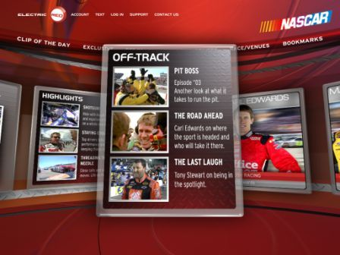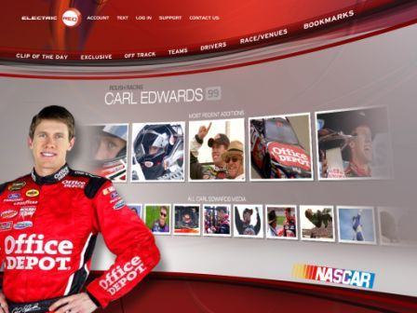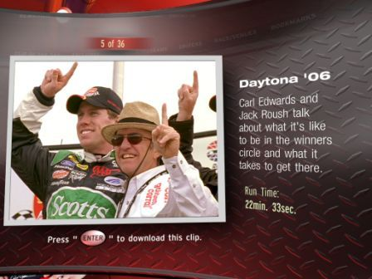

REZN8 AND ELECTRIC RED PUSH THE CREATIVE BOUNDARIES
WITH MICROSOFT WINDOWS PRESENTATION FOUNDATION AT MICROSOFT’S MIX06

NASCAR Racing Portal Demonstration Illustrates Future of Personalized Media Players

(LAS VEGAS – March 21, 2006) – Today at Microsoft’s MIX 06 event for Web designers and developers, REZN8, a graphical user interface and branding expert, demonstrated the potential of the Microsoft WinFX and Windows Presentation Foundation technology during general manager of Microsoft Corp.’s Windows Division John Dow’s keynote address.
REZN8, a long-time third-party design studio for Microsoft, has extensive experience in creating three-dimensional, interactive applications for the company and was called upon to illustrate how Windows Presentation Foundation enables developers and designers to create visually stunning, personalized interface applications. REZN8 created a demonstration version of a 3D, rich-media portal they are developing for their client Electric RED who designs and manufactures personal devices that come pre-loaded with transferable sports-specific digital media.
Exhibiting a NASCAR®-branded environment within Electric RED’s portal, the demonstration showcased how consumers can easily navigate, manage, shop and download their favorite sports-related content such as racing video footage, team data and schedules.

-more-
REZN8 Demonstrates Windows Presentation Foundation – Page 2

“REZN8 captured the emotional intensity that characterizes auto racing through the NASCAR portal,” said John Conway, CEO of Electric RED Corporation. “Windows Presentation Foundation allowed the design team to quickly build a graphically-rich application that is also extendable to other platforms with minimal effort. For us, that translates into very significant cost savings.”
Electric RED’s devices and portal, featuring REZN8’s graphics user interface, will launch to the public this summer. Windows Presentation Foundation, slated to roll out in late 2006, unifies how Windows Vista will create, display and manipulate documents, media and the user interface.
“Windows Presentation Foundation is one of the most efficient presentation environments available and offers significant technical advantages for application development,” said Andrew Whiddett, REZN8’s chief technical officer. “The productivity advantages of Microsoft technology enabled us to compress months of development into days to create the kind of rich interactive experience shown at MIX. Windows Presentation Foundation allows applications to be data driven in real time with minimal additional coding required.”
“REZN8 has succeeded in showing the kind of amazing results that Windows Presentation Foundation can enable,” said Parimal Deshpande, senior product manager of the WinFX and the .NET Developer Marketing Group at Microsoft Corp. “REZN8 is not only a leader in terms of design and creativity, but it is quickly becoming a master in optimizing what can be created using Windows Presentation Foundation.”
Rounding out the conference, Paul Sidlo, REZN8’s founder and CEO, will also be a featured speaker on the panel exploring “The Future of the Media and the Web.” The March 22 session will explore open syndication formats and protocols, the rise of user-generated content, and how advances in digital media technology are changing the way people incorporate media into their lifestyles. He will address how emerging trends offer consumers greater media options, and create new opportunities for publishers of micro-content.

-more-
REZN8 Demonstrates Windows Presentation Foundation – Page 3

About REZN8
Hollywood-based REZN8 (www.rezn8.com) established in 1987, is a leader in designing and developing Graphical User Interfaces (GUI), company branding, and real-time viewer experiences. The company's Emmy award-winning creations reflect its unique marriage of design with a deep understanding of technology and the foresight to anticipate its impact on the creative process. The company has been instrumental in developing the media vision for a broad spectrum of domestic and international clients across a range of platforms that includes broadcast, film, Internet, wireless and games.

About Electric RED Corporation
Electric RED (www.electricredusa.com) designs and manufacturers personal electronic devices branded with licensed professional sports teams. Electric Red also provides access to digital content such as video and music through their online portal being developed by REZN8. Electric RED is the first company to provide products that come pre-loaded with user-transferable digital media, such as audio and video highlights, graphics, and schedules of favorite sports teams.

###

Photos are available upon request.
All product and company names mentioned herein may be trademarks of their respective owners.

