# Role-Based Template for SharePoint My Sites: IT Manager

***Functional Overview for***

***Business Decision Makers***

### With personalization becoming an increasingly important business need and the key to effective collaboration, Microsoft® Office SharePoint® Server 2007 offers My Site, a personal site that pulls together summary views of personal information and provides full control over information "for me, by me, and about me." Role-Based Templates for SharePoint My Sites are custom templates designed for Office SharePoint Server 2007 and tailored to address the unique needs and requirements of specific roles. They are envisioned as extensions to the standard My Site functionality, providing a personal portal and dashboard data relevant to your role.

### Role-Based Templates for SharePoint My Sites can provide enhanced business insight and help drive company-wide productivity through a common interface to access priority information from varied sources and systems related to job roles, individual responsibilities, and surrounding processes. The templates display information in a way that is familiar and easy, and is built around the way people in the company work, enabling business decision-making with greater confidence.

### Description of Template

IT Managers are chiefly responsible for implementing, supporting and maintaining the IT infrastructure of an organization. They are also responsible for reviewing the overall end-to-end delivery process flow against resource levels, developing roadmaps for mid to long term planning, and managing staff to perform to the best of their abilities by providing support, direction, motivation and training.

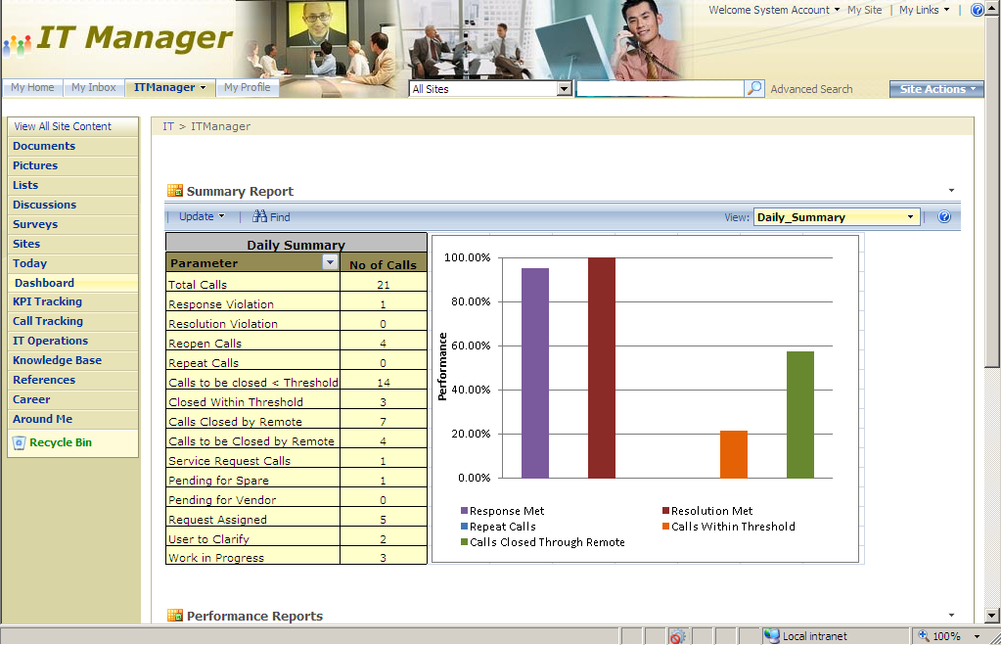The IT Manager role-based template for SharePoint My Sites focuses on the IT Manager in a maintenance division handling location support. The services rendered by the support team are governed by the Service Level Agreement (SLA), where service level is defined by response, resolution and threshold. IT Managers oversee the support services provided by the team of IT engineers for SLA adherence and coordinate with the team for backups and updates. They also oversee the incident calls and escalations being logged in the help desk. At a product level, IT Managers track license renewal and their respective roadmaps and updates.

**Sample Activities Performed in this Role-Based My Site Template**

Role-based My Site templates aim to provide a “one-stop shop” experience that enables users to view and access information relevant to their jobs by unlocking data buried in various business systems. These templates come with sample data. The following example shows how this template might be used in a typical organization.

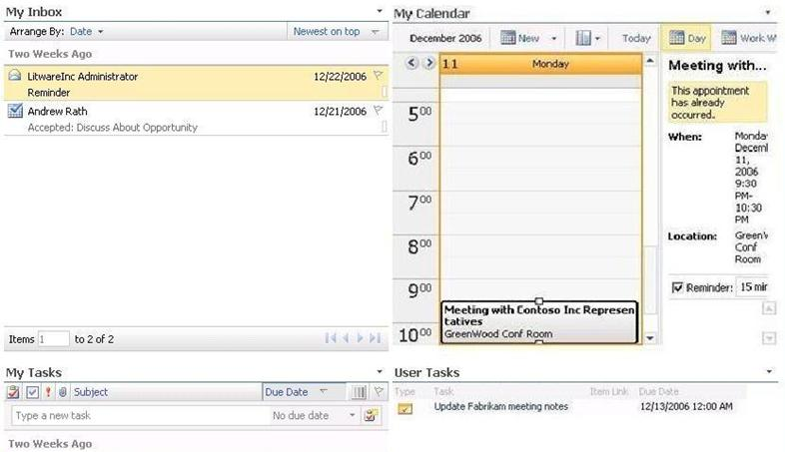Tim is an IT Manager in Litware Inc’s IT department. Like many information workers, he starts his day by accessing his personal productivity tool, Microsoft Office Outlook**®** 2007. Since his company has deployed Microsoft Office SharePoint Server 2007 and Role-Based My Site templates, he also logs into his personal My Site page. He recalls seeing a task in his My Task section for him to submit the Executive Summary Report. He also sees My Calendar and realizes that he has a meeting with his direct reports on performance trends.

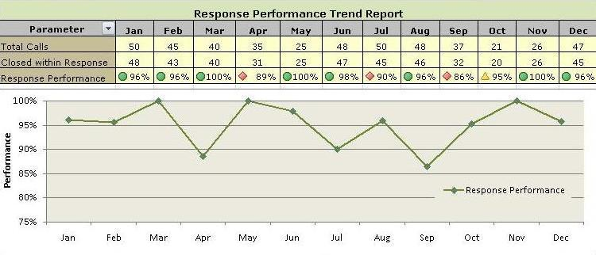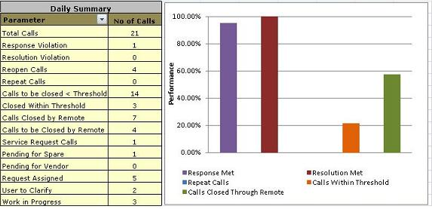As a part of his routine work, Tim visits the Dashboard page to view the performance of the IT help desk and is satisfied with the daily summary of calls. He changes the view to see the monthly summary which gives him a clearer picture on response and resolution levels handled for the month. Then he takes a look at the performance reports. He finds that response, resolution, and incident trend are all within the Service Level Agreements (SLA) norms.

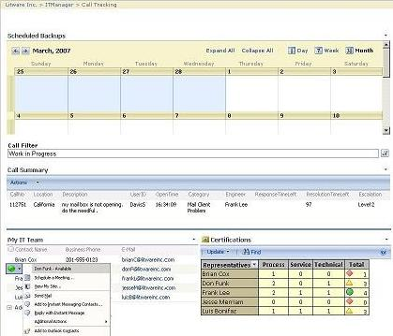Now it’s time for Tim to view the calls that are logged for the day. He goes to the Call Tracking page and checks the number of open calls. He looks at the time left to meet the response and resolution SLAs and looks at the escalation calls. Using the presence integration, Tim sees one of his direct reports online and sends an instant message to close the call as quickly as possible to avoid SLA violations. He gets a reminder email one hour in advance for the scheduled backups. He plans for the backup accordingly.

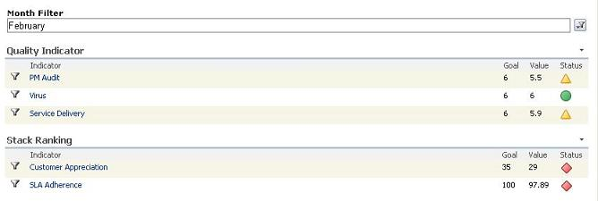Tim then receives a call from his supervisor to update him on the Executive Summary Report. He quickly navigates to the KPI Tracking page, which gives him the details about quality issues like PM audit, virus and service delivery. He goes to the References page to download a report template and fills out the information related to response/resolution violation stats and other quality indicators.

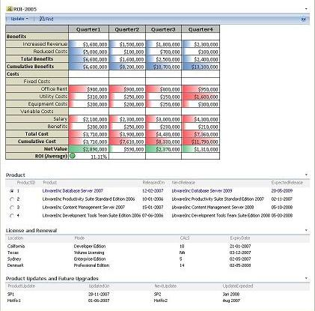Next, Tim navigates to the IT Operations page to check the Return on Investment (ROI) for the year and to look at the product roadmap and planned updates. He navigates to the Knowledge Base page to get the details about the case studies and related articles from the wiki page library. With all this information, he compiles the report and uploads it to the presentations library in his References page. This routes the document through an approval workflow to his supervisor.

Tim finishes his lunch and takes a quick look at his Today page. He realizes that he has a meeting with his direct reports on performance trends. He attends the meeting to get a status of the trends and gives his team a few suggestions to improve the support provided by the IT help desk. He documents the meeting minutes using an InfoPath**®** form and uploads it to the Recent Meeting Outcomes section on the References page.

At the end of the day, Tim navigates to the Career page to keep track of organization objectives. He views the status of the objectives and checks whether his objectives are met. He also checks to see if there is any training for him to attend the next day. He visits the Around Me page and checks the events that are happening in the industry. He also looks in on the technology news to keep himself up-to-date on the latest technology trends.

**About Microsoft Office SharePoint Server 2007**

Microsoft Office SharePoint Server 2007 is an integrated suite of server capabilities that can help improve organizational effectiveness by providing comprehensive content management and enterprise search, accelerating shared business processes, and facilitating information-sharing across boundaries for better business insight. Office SharePoint Server 2007 supports all intranet, extranet, and Web applications across an enterprise within one integrated platform, instead of relying on separate fragmented systems. Additionally, this collaboration and content management server provides IT professionals and developers with the platform and tools they need for server administration, application extensibility, and interoperability.

**More Information**

For more information on the technologies described in this article, please visit:

Microsoft Office SharePoint Server 2007:

<http://www.microsoft.com/sharepoint>

Role-Based Templates for SharePoint My Sites:

<http://go.microsoft.com/?linkid=6060804>